MEMORANDUM

To: | Interested Educators and Members of the Public
From: | Rob Curtin, Chief Officer for Data, Assessment, and Accountability
Date: | November 25, 2025
Subject: | Notice of Intent to Apply and Opportunity to Comment on DESE's Waiver Extension Request Related to the Percentage of Students Who Participate in the MCAS Alternate Assessment

The Massachusetts Department of Elementary and Secondary Education (DESE) intends to seek an extension of its existing waiver of the federal requirement that would limit the number of students in the state who take alternate assessments to one percent of students who take the general MCAS tests.
The purpose of this notice is to provide an opportunity for the public to comment on the request for a waiver by DESE for the 2025–2026 school year. A waiver of the 1-percent requirement was granted to Massachusetts by the U.S. Department of Education in 2017, and waiver extensions were granted each year since then.
One of the requirements of the reauthorized Elementary and Secondary Education Act, also known as the Every Student Succeeds Act (ESSA), stipulates that states must limit the total number of students that participate in an alternate assessment based on alternate achievement standards (i.e., the MCAS-Alt) to 1 percent of the total number of students who participate in each state assessment. This legislative requirement is designed to ensure that an excessive number of students with disabilities are not evaluated on alternate academic achievement assessments because an alternate assessment has lower academic expectations and may unnecessarily limit students’ exposure and expectations to the full range of grade-level academic content standards. Participation in alternate assessments may also delay or prevent students from eventually meeting their state or district graduation requirements. Only students that meet the state’s definition of a student with the most significant cognitive disabilities may be administered alternate assessments because these students are unable to participate in standard assessments and are working on standards that are significantly modified in depth, breadth, and complexity. A waiver, if granted, indicates that while some districts have made progress in reducing the percentage of students with disabilities participating in the alternate assessment, our state requires time to further educate and evolve our procedures to meet the 1-percent cap. In 2025–26, DESE will continue to develop procedures to assist districts with implementing procedures to designate students for an alternate assessment.
The percent of Massachusetts students who participated in the MCAS-Alt (in English language arts, mathematics, and/or science) since 2017 is shown below:
- 2016–2017: 1.6 percent
- 2017–2018: 1.5 percent
- 2018–2019: 1.4 percent
- 2019–2020 (estimate): 1.35 percent would have participated in the MCAS-Alt if the spring 2020 MCAS and MCAS-Alt administrations had not been canceled due to extended school closures related to the COVID-19 pandemic. (Projection based on district pre-enrollments and pre-orders of materials.)
- 2020–2021: 1.3%
- 2021–2022: 1.2%
- 2022–2023: 1.2% in English Language Arts and Mathematics and 1.1% in Science and Technology/Engineering
- 2023–2024: 1.2% in English Language Arts and Mathematics and 1.1% in Science and Technology/Engineering.
- 2024–2025: 1.2% in English Language Arts (a decrease of 149 students since 2024), 1.2% in Mathematics (a decrease of 177 students since 2024), and 1.0% in Science and Technology/Engineering (STE) (a decrease of 473 students from 2024)
Collectively, districts in Massachusetts have made steady progress to reduce the percentage of students participating in the MCAS-Alt. For the first time since the 1.- percent cap was established, we met the cap in science, and we hope to continue this trend in future years. Like other states, our ability to meet the 1.0 percent cap in English language arts and mathematics set by ESSA may take additional time.
To reach the 1.0 percent cap across all subjects, DESE has annually updated guidance and resources for Massachusetts schools and districts and will continue to provide LEAs with trainings, strategies, and oversight.
We are submitting this waiver extension request in response to the USED memo to states dated September 25, 2025, that provided “Requirements to Request a Waiver/Waiver Extension for the 2025-26 School Year from the 1.0 Percent Cap on the Percentage of Students with the Most Significant Cognitive Disabilities Who May Be Assessed with an Alternate Assessment Aligned with Alternate Academic Achievement Standards,” outlining the terms and criteria for submitting waiver and waiver extension requests.
We welcome your comments regarding our intent to apply for this waiver. Comments may be submitted via email to mcas@mass.gov until December 31, 2025.

Massachusetts “One Percent” ESSA Waiver Extension Request for School Year 2025–2026

Notice of intent to apply for a waiver and opportunity for public comment
On November 25, 2025, the DESE posted a Notice of Intent to Apply and Opportunity for Comment Regarding a Waiver Extension of the Federal Requirement Related to the Percentage of Students Who Participate in Statewide Alternate Assessments to solicit public comment by December 31, 2025.
- Notice of Intent (11/25/2025)
- MCAS Update (11/25/2025)
- MCAS-Alt Update (11/25/2025)
- Commissioner’s Weekly Update (12/1/2025)
The postings of the Notice of Intent will be documented at the end of the submitted document: Request a Waiver Extension for the 2025–2026 School Year from the 1.0 Percent Cap on the Percentage of Students with the Most Significant Cognitive Disabilities Who May Be Assessed with an Alternate Assessment Aligned with Alternate Academic Achievement Standards (AA-AAAS). Any comments and responses to those comments will be forwarded to the US Department of Education—Office of Elementary and Secondary Education following the closing of the public comment period.

Waiver request submitted at least 90 days before start of testing window [§200.6(c)(4)(i)]
The MCAS-Alt assessment window begins on the first day of the school year, although educators may begin the alternate assessment process at different points throughout the year. The testing window will end with submission of alternate assessments on Friday, March 27, 2026. We were unable to submit our extension waiver request earlier (in June 2025) because results of the annual assessment only became available in fall 2025. We found it necessary to review last year’s assessment participation reports and stakeholder feedback prior to determining if an extension of the 2024–2025 waiver would be warranted. Our review of participation data found that the alternate assessment participation numbers decreased in all subjects but also demonstrated that a renewal of the waiver request is warranted.

Assessment participation by number and percentage of all students and students in each subgroup [§200.6(c)(4)(ii)]
Table 1: Overall Rates of Assessment Participation for SY 2024–25
Subject Domains | ELA  Grades 3–8 and HS | ELA  Grades 3–8 and HS | Math  Grades 3–8 and HS | Math  Grades 3–8 and HS | Science and Technology/Engineering Grades 5, 8, and HS | Science and Technology/Engineering Grades 5, 8, and HS
Participation Factors by Groups | All students | Students with disabilities | All students | Students with disabilities | All students | Students with disabilities
Students Assessed | 472,164 | 102,782 | 471,692 | 102,628 | 203,756 | 42,362
Students Enrolled | 479,068 | 106,002 | 478,851 | 105,947 | 207,848 | 44,115
Assessment Participation Rate | 99% | 97% | 99% | 97% | 98% | 96%

Table 2: AA-AAAS Participation Rates by Subgroup for SY 2024–25—ELA
ELA | Total Number in Grades 3-8 & HS | Number Taking AA-AAAS in Grades 3-8 & HS | % Taking AA-AAAS in Grades 3-8 & HS
All Students | 472,164 | 5,576 | 1.18%
Hispanic or Latino | 120,146 | 1,645 | 1.37%
American Indian or Alaska Native | 1,082 | 14 | 1.29%
Asian | 36,220 | 445 | 1.23%
Black or African American | 47,287 | 977 | 2.07%
Native Hawaiian or Other Pacific Islander | 419 | 6 | 1.43%
White | 244,965 | 2,233 | 0.91%
Multi-Race, Not Hispanic or Latino | 21,904 | 255 | 1.16%
Male | 241,965 | 3,801 | 1.57%
Female | 229,587 | 1,773 | 0.77%
Nonbinary | 595 | 2 | 0.34%
English Learners | 61,087 | 925 | 1.52%
Low Income | 208,960 | 3,714 | 1.78%

Table 3: AA-AAAS Participation Rates by Subgroup for SY 2024–25—Mathematics
Mathematics | Total Number in Grades 3-8 & HS | Number Taking AA-AAAS in Grades 3-8 & HS | % Taking AA-AAAS in Grades 3-8 & HS
All Students | 471,692 | 5,662 | 1.20%
Hispanic or Latino | 119,994 | 1,696 | 1.41%
American Indian or Alaska Native | 1,071 | 14 | 1.31%
Asian | 36,293 | 457 | 1.26%
Black or African American | 47,281 | 986 | 2.09%
Native Hawaiian or Other Pacific Islander | 412 | 6 | 1.46%
White | 244,649 | 2,245 | 0.92%
Multi-Race, Not Hispanic or Latino | 21,800 | 257 | 1.18%
Male | 241,837 | 3,854 | 1.59%
Female | 229,252 | 1,806 | 0.79%
Nonbinary | 584 | 2 | 0.34%
English Learners | 61,411 | 1,022 | 1.66%
Low Income | 208,526 | 3,779 | 1.81%

Table 4: AA-AAAS Participation Rates by Subgroup for SY 2024–25—Science
Science and Technology/Engineering | Total Number in Grades 3–8 & HS | Number Taking AA-AAAS in Grades 3-8 & HS | % Taking AA-AAAS in Grades 3-8 & HS
All Students | 203,756 | 2,038 | 1.00%
Hispanic or Latino | 51,373 | 597 | 1.16%
American Indian or Alaska Native | 479 | 6 | 1.25%
Asian | 15,480 | 160 | 1.03%
Black or African American | 20,611 | 348 | 1.69%
Native Hawaiian or Other Pacific Islander | 197 | 3 | 1.52%
White | 104,466 | 848 | 0.81%
Multi-Race, Not Hispanic or Latino | 9,089 | 75 | 0.83%
Male | 104,503 | 1,346 | 1.29%
Female | 98,876 | 690 | 0.70%
Nonbinary | 373 | 2 | 0.54%
English Learners | 22,866 | 343 | 1.50%
Low Income | 88,876 | 1,382 | 1.55%

Table 5: AA-AAAS Rates by Subject, by year
School Year | ELA | Mathematics | Science
2017 | 1.50% | 1.61% | NA
2018 | 1.47% | 1.48% | -NA
2019 | 1.38% | 1.39% | 1.31%
2021 | 1.29% | 1.30% | 0.99%
2022 | 1.24% | 1.25% | 1.16%
2023 | 1.24% | 1.24% | 1.14%
2024 | 1.21% | 1.23% | 1.21%
2025 | 1.18% | 1.20% | 1.00%
2026 (estimate) | 1.15% | 1.15% | 1.0%

Table 6: 2025 MCAS and MCAS-Alt Participation by Nature of Primary Disability
(Note: Percentage may not total 100% due to rounding.)
Primary Disability^{b} | A:  Number of All Assessed Participants in Disability Categoryª | B:  Number of MCAS-Alt Participants in Disability Category | C:  % of All Assessed Students in Disability Category Who Took MCAS-Alt (B/A) | D:  % of MCAS-Alt Participants in Disability Category (B/5,698)
Autism | 16,851 | 3,239 | 19.2% | 56.8%
Communication | 11,653 | 94 | 0.8% | 1.6%
Developmental Delay | 2,034 | 64 | 3.1% | 1.1%
Emotional | 11,310 | 16 | 0.1% | 0.3%
Health | 23,110 | 110 | 0.5% | 1.9%
Intellectual | 3,994 | 1,272 | 31.8% | 22.3%
Multiple Disabilities | 631 | 249 | 39.5% | 4.4%
Neurological | 6,893 | 501 | 7.3% | 8.8%
Physical | 350 | 13 | 3.7% | 0.2%
Sensory/Deaf and Blind | 90 | 19 | 21.1% | 0.3%
Sensory/Hard of Hearing or Deaf | 641 | 32 | 5.0% | 0.6%
Sensory/Vision Impairment or Blind | 342 | 32 | 9.4% | 0.6%
Specific Learning Disabilities | 37,895 | 23 | 0.1% | 0.4%
Unidentified Disability | 189 | 34 | 18.0% | 0.6%
Total | 115,983 | 5,698 | 4.9% | 100.0%
ª The number of students with disabilities participating in standard MCAS and MCAS-Alt for accountability purposes in at least one subject.
^{b} Primary disability data were reported by districts to the Department's Student Information Management System (SIMS) in March and June 2025.

Include a statement of assurance in the waiver request that the State has verified that each LEA the State anticipates will assess more than 1.0 percent of all students assessed using an AA-AAAS in each subject for which the State is seeking a waiver has:

Followed the State’s guidelines for participation in the AA- AAAS; and

Will address any disproportionality in the percentage of students in any student group taking the AA-AAAS.
- The state reviewed the 2024–2025 MCAS-Alt statement of assurances from each LEA. We received statement of assurances from all 107 LEAs who were required to respond. Through reviewing each statement of assurances, DESE determined that the majority of LEAs implemented each requirement. Compared to previous years, the district responses suggest that comprehension of the alternate assessment eligibility safeguards and requirements is improving. LEAs continue to apply the revised alternate assessment eligibility criteria associated with the adoption of the new definition of students with the most significant cognitive disabilities. DESE has acknowledged the efforts of LEAs to retrain their special education staff on best practices to identify students for updated alternate assessment eligibility criteria.

We continue to require all schools to use the new Companion Document: Alternate Assessment Participation Tool for each student that participates in the MCAS-Alt. Our outreach and training efforts have yielded some success in reducing participation in the alternate assessment, especially in the science domain, but there is still a need for robust trainings and support from DESE, especially around the following participation guidelines:
https://www.doe.mass.edu/mcas/alt/default.html https://www.doe.mass.edu/mcas/participation.html https://www.doe.mass.edu/mcas/accessibility/default.html

- The updated statement of assurances required districts examine if any disproportionate designation exists and to explain their method to determine whether disproportionality is present. As a new procedure last year, DESE provided a risk ratio tool kit. DESE will offer additional trainings during the 2025–2026 school year and in-service hours for LEAs to determine how to apply the risk ratio tool.
As a continued member of the National Center for Education Outcome’s Community of Practice, DESE continues to meet with other SEA representatives at biweekly meetings to collaborate and share monitoring and training plans to help Massachusetts’ LEAs address disproportionality. DESE has adopted and customized the guidance tool described in the NCEO publication Disproportionality in the Alternate Assessment Calculator: A Tool for State and Local Education Agencies.
We also reviewed the NCEO Brief: Guidance for Examining Disproportionality of Student Group Participation in Alternate Assessments (#18) to determine if additional measures could be implemented in future years.

Require that each LEA that the State anticipates will assess more than 1.0 percent of all students assessed with an AA-AAAS in each subject for which the State is seeking a waiver has submitted information to the State justifying the need to exceed the 1.0 percent cap. States must show where these justifications are made publicly available, and that this information is easily accessible (see 34 CFR § 200.6(c)(3)(iv)). For example, the State could include a URL link to these justifications (or a URL link to a summary of these justifications) in the waiver request.
As previously described, DESE required all LEAs that assessed or anticipated to assess more than 1.0 percent of students with an alternate assessment in 2025 complete a statement of assurances with their justifications to exceed the 1.0-percent cap. All 107 LEAs that were identified based on 2024 participation rates were notified of the requirement to submit a statement of assurance in 2025. DESE collected each statement of assurance and notified the public that the LEA statement of assurances are publicly available upon request. This statement is displayed on DESE’s MCAS-Alt website (see exhibit).

Provide a current plan and timeline by which the State will do the following:

Improve the implementation of the State’s guidelines for participation in the AA-AAAS, including by reviewing and, if necessary, revising its definition of students with the most significant cognitive disabilities (see 34 CFR § 200.6(c)(4)(iv)(A)) so that less than 1.0 percent of all students assessed take an AA-AAAS.

In 2023, DESE released a new definition of a student with the most significant cognitive disabilities, and began providing technical assistance around the new definition (see exhibits). The state provided new materials and updated resources to educate districts—particularly districts that have exceeded the 1.0-percent threshold in previous years—and support them in lowering their alternate assessment participation rates.
DESE required that LEAs review specific cognitive and adaptive behavior functioning levels of all students designated for an alternate assessment. The eligibility criteria was emphasized in last year’s statement of assurances sent to all districts over the 1.0-percent cap.
The 2024–2025 school year continued our transition planning and period for schools to learn and adopt the new eligibility criteria. We reviewed feedback from our LEAs on their comprehension of the revised eligibility criteria for participating in the MCAS-Alt. Our LEAs communicated to DESE, through the submitted statement of assurances as well as informal questions and discussions, that some schools and educators still did not have the objective evaluation data required to comply with all aspects of the definition and criteria. In addition, information from DESE’s Public School Monitoring unit found that some LEAs did not complete the Alternate Assessment Eligibility Participation Tool. These LEAs are continuing to work on obtaining updated measures of cognitive and adaptative behavior for students designated for the alternate assessment.
The participation data provides evidence that the alternate assessment participation numbers decreased in all subjects. Our continued goal is to reach the 1.0-percent cap across all subjects. DESE will continue to evolve our monitoring practices and technical assistance to ensure LEAs are correctly and fully applying the updated eligibility criteria when determining eligibility for an AA-AAAS.
To improve our implementation and to continue to support schools and districts, DESE has completed the following steps:
- Delivered trainings on Alternate Assessment Participation Criteria in January and February 2025
- Held annual MCAS-Alt fall training sessions
- Scheduled trainings for special education leaders in targeted districts in fall 2025 (see next section below for more details)
- Offered pre-recorded webinars at the beginning of the school year and included specific information on the updated definition of students with the most significant cognitive disabilities (see exhibits)
- Added new MCAS-Alt office hours trainings sessions with a question-and-answer format for our LEA educators and administrators
We anticipate that approximately 3,000 educators or administrators will participate in these fall training sessions. These action steps are expected to yield further reduction in our state’s alternate assessment participation percentage.

Take additional steps to support and provide appropriate oversight to each LEA that the State anticipates will assess more than 1.0 percent of all students assessed with an AA-AAAS in each subject for which the State is seeking a waiver. This should include describing how the State will monitor and regularly evaluate each such LEA to ensure that the LEA provides sufficient training such that school staff who participate as members of an IEP Team or other placement team understand and implement the guidelines established by the State for participation in an AA-AAAS so that all students are appropriately assessed (see 34 CFR § 200.6(c)(4)(iv)(B)) .Last school year, DESE’s Office of Student Assessment Services partnered with the Office of Special Education Policy and Planning to deliver revamped training courses included in our monthly Special Education Leaders Meetings (see exhibits). The information sessions were attended primarily by special education directors. We described the updated participation requirements and new disproportionality calculator tool.
Student Assessment Services will continue our collaboration with the Offices of Special Education Policy and Planning, as well as the Office of Public School Monitoring. We are convening webinars on the eligibility and monitoring requirement associated with participation by students with disabilities in the MCAS-Alt. Our Public School Monitoring Team is adding the following language to their public resource Office of Public School Monitoring
Integrated Monitoring Review: Group A Pre-Review Checklist for Special Education.

1. All students with disabilities, including those enrolled in out-of-district placements, are included in the Massachusetts Comprehensive Assessment System (MCAS) and other district-wide assessment programs.
2. The district’s IEP Teams designate how each student will participate and, if necessary, provide an alternate assessment.
- For each student that is designated for the Alternate Assessment based on Alternate Academic Achievement Standards (MCAS- Alt), the IEP Team documents that the student met the definition of most significant cognitive disability and all other eligibility criteria for an alternate assessment….
Record Review Questions:
- If the student’s IEP includes MCAS testing accommodations, are those accommodations clearly delineated?
- If the student’s IEP indicates the student is taking the MCAS-Alt, does the record include the completed Alternate Assessment Participation Tool?
Per last year’s approved waiver extension, DESE identified 15 LEAs that assessed greater than 2 percent of their students with an alternate assessment and required them to participate in targeted webinar trainings focused on eligibility. The specialized in-service trainings were held on October 14, 15, and 17, 2025.
The state will continue to closely monitor each district regarding 1) the percentage of assessed students taking the MCAS-Alt; 2) progress and trends over two or more years in reducing the district’s overall MCAS-Alt percentage; 3) whether the district has identified and is addressing any disproportionality in their student subgroup participation in the MCAS-Alt; and 4) whether the district is using the revised definition for students with the most significant cognitive disabilities as their criteria. These priorities are again reflected in the revised statement of assurances sent to districts this year.
For next year, DESE will lower the targeted training threshold requirement to 1.75 percent. DESE will notify all LEAs with an MCAS-Alt participation rate of 1.75 percent or higher in any subject domain that their staff and administrators supporting the school’s alternate assessment must participate in a targeted MCAS-Alt eligibility training. We will continue to ask for a participation acknowledgement (e.g., names and titles of educators that attended that webinar).

Address any disproportionality in the percentage of students taking an AA-AAAS as identified through the State’s data (see 34 CFR § 200.6(c)(4)(iv)(C)).
As described in section 4(B) above, DESE will continue to use the publication issued by The National Center on Educational Outcomes (NCEO) to assist districts in understanding disproportionality in designation for alternate assessment. We have reviewed the statement of assurances to ensure the LEA explained how disproportionality was examined and whether disproportionality was present. A DESE-provided risk ratio tool has been made available (see exhibits) for districts to analyze participation by subgroup. The training sessions DESE launched this fall (see exhibits) describing how to use the risk ratio tool and other resources to address disproportionality. At the recent trainings, districts were able to ask questions and receive technical support.
During the development of the state’s definition for students with the most significant cognitive disabilities, we convened meetings with stakeholders in the state offices, LEAs, and advocacy organizations. Specifically, we engaged the Center for Law & Education to discuss methods to prevent students from historically marginalized subgroups being designated for alternate assessments. We intend to offer additional feedback sessions to gain more knowledge from our stakeholder groups, including the Massachusetts Advocates for Children.
As with previous years, a memo from the Commissioner and statement of assurances will be sent in early December to districts that exceeded 1.0 percent of tested students taking the MCAS-Alt in 2025. (See the Exhibits section for a draft of this communication.)

Demonstrate that the State reduced its AA-AAAS participation rates in each subject for which the State is seeking a waiver. The Department expects that a State requesting to extend a waiver will have decreased its AA-AAAS rates in SY 2024–25 compared to SY 2023–24. A State with relatively high rates of AA-AAAS participation should demonstrate a greater reduction in its AA-AAAS participation rates compared to States near the 1.0 percent cap.
Implementing the definition of a student with the most significant cognitive disabilities has been a substantial change for our districts. We are making progress reducing the statewide participation in alternate assessments and believe that we will continue to make progress in moving closer to the 1-percent participation rate.
The overall number and percentage of students who participated in the 2025 MCAS-Alt in each subject has decreased as follows.
- English Language Arts (ELA): 5,576/472,164 = 1.18 percent, a decrease of 149 students since 2024
- Mathematics: 5,662/471,692 = 1.20 percent, a decrease of 177 students since 2024
- Science and Technology/Engineering (STE): 2,038/203,756 = 1.00 percent, a decrease of 473 students from 2024
Since 2017, the state has annually taken steps that have achieved a steady reduction in the participation rate (see figure 1).

Table 7. MCAS-Alt Participation Rates by Subject, 2017–2025
Year | ELA | Math | Science
2017 | 1.60% | 1.61% | NA
2018 | 1.47% | 1.48% | NA
2019 | 1.38% | 1.39% | 1.31%
2021 | 1.29% | 1.30% | 0.99%
2022 | 1.24% | 1.25% | 1.16%
2023 | 1.24% | 1.24% | 1.14%
2024 | 1.21% | 1.23% | 1.21%
2025 | 1.18% | 1.20% | 1.00%

Summary of Waiver Extension Request
The state carefully reviewed the Requirements to Request a Waiver/Waiver Extension for the 2025–26 School Year from the 1.0 Percent Cap on the Percentage of Students with the Most Significant Cognitive Disabilities Who May Be Assessed with an Alternate Assessment Aligned with Alternate Academic Achievement Standards (AA-AAAS) and our previous actions and guidance. The state completed the following actions:
- conducted new and revised technical assistance training sessions to districts, explaining the 1% cap
- reviewed statements of assurances received from LEAs (all LEAS responded as required)
- posted updated revised technical assistance training documents and resources
- convened regular meetings with Acting State Director of Special Education, the Student Assessment Services Office, and the Special Education Planning and Policy Office (SEPP)
- collaborated with the One Percent Community of Practice (CoP), coordinated by the National Center on Educational Outcomes (NCEO) (ongoing)
- coordinated with other DESE offices on the topic of disproportionality in order to identify root causes (ongoing)
- identified districts with especially high rates of alternate assessment participation (i.e., greater than 2 percent) and provided targeted trainings)
- created opportunities for districts to share knowledge on how to reduce participation rates collaborate with high percentage rate districts
- reviewed all our strategies for reducing the MCAS-Alt participation rates
DESE has emphasized our updated alternate assessment resources, guidance, training sessions, and alternate assessment eligibility criteria the last two school years. The state’s 2024–25 overall participation in alternate assessment decreased, and the state met the 1% cap in science. One factor in meeting these caps is when a student IEP Team meets and designates a student for alternate assessment. IEP annual reviews do not occur at a specific point in time; rather, IEP team meet throughout the school year and may occur after a student has participated in the statewide content assessment. Given these factors, we anticipate that Massachusetts districts will continue to take time to fully and correctly implement the revised guidance and will likely exceed the 1-percent threshold for 2025–26 school year. The state’s steady alternate assessment participation reduction provides evidence of our commitment to meeting the 1.0-percent cap, which we have achieved through updated policies, monitoring, and resources to limit the number of students participating in alternate academic achievement assessments.
Since districts have begun implementing the revised guidance, DESE’s offices of Student Assessment Services and Public School Monitoring continue to receive questions on how to apply the revised alternate assessment eligibility criteria. DESE anticipates gradual reduction during the 2025–26 school year and looks forward to working closely with the districts to meet the 1-percent cap across all subjects in the near future.

EXHIBITS
Documents and guidance for district leaders and edcutors for reducing the number of students taking AA-AAS

Exhibit: Online Monitoring Checklist from the Web Based Monitoring (WBS) Program through the Office of Public School Monitoring (Updated)
The Web-based Monitoring System (WBMS) is a collaborative online portal used throughout the cycle that allows LEAs and PSM to review self-assessment data, reporting documentation, and progress reporting activities.

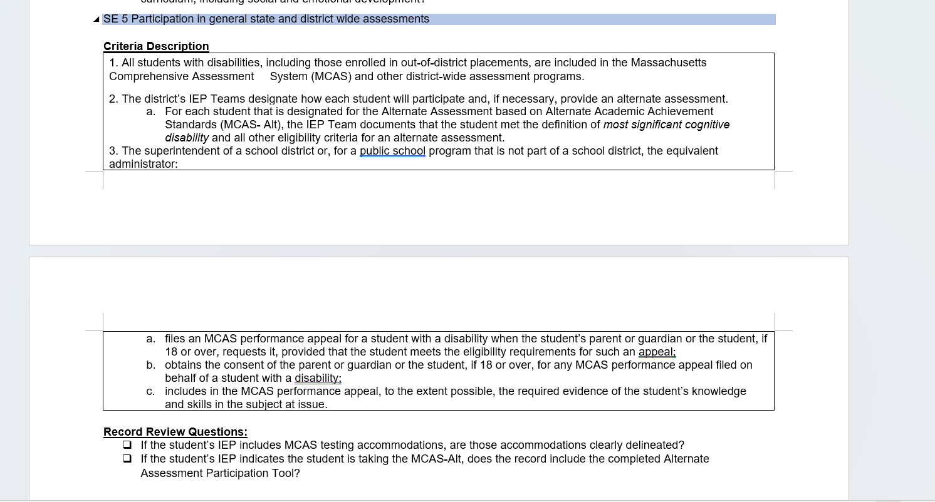

Exhibit: Decision-Making Tool for MCAS Participation
Use the definition and the questions below to guide discussions of how students will participate in MCAS testing.
Massachusetts defines “students with the most significant cognitive disabilities” as those who meet all of the following criteria:
- have cognitive disabilities evidenced by significant delays in attaining age-level academic achievement standards, even with systematic, extensive individually designed instruction, related services, and modifications
- have cognitive disabilities that significantly impact their educational performance and ability to apply learning from one setting to another
- require extensive, direct individualized instruction and substantial supports to achieve measurable gains on the challenging State academic content standards for the grade in which the student is enrolled
- perform significantly below average in general cognitive functioning and adaptive behavior.
Note: “Significantly below average” is defined as a student functioning two or more standard deviations below the mean on commonly accepted norm-referenced assessments in both cognitive functioning and adaptive behavior (e.g., two or more adaptive skill areas such as daily living skills, communication, self-care, social skills, and academic skills).

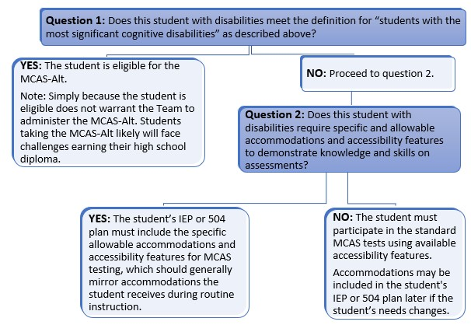

Exhibit: Alternate Assessment Participation Tool Companion Document
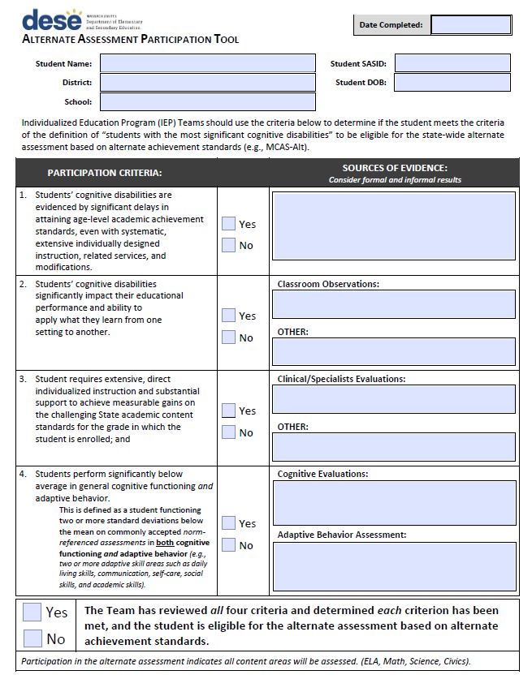
Exhibit: Sample Completed Alternate Assessment Participation Tool Companion Document
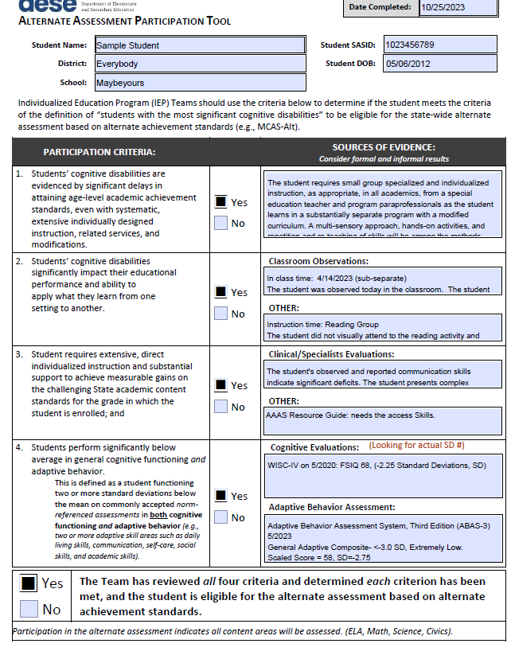

Exhibit: Updated Training Resources Materials for Districts on Alternate Assessment Eligibility, 2025–2026
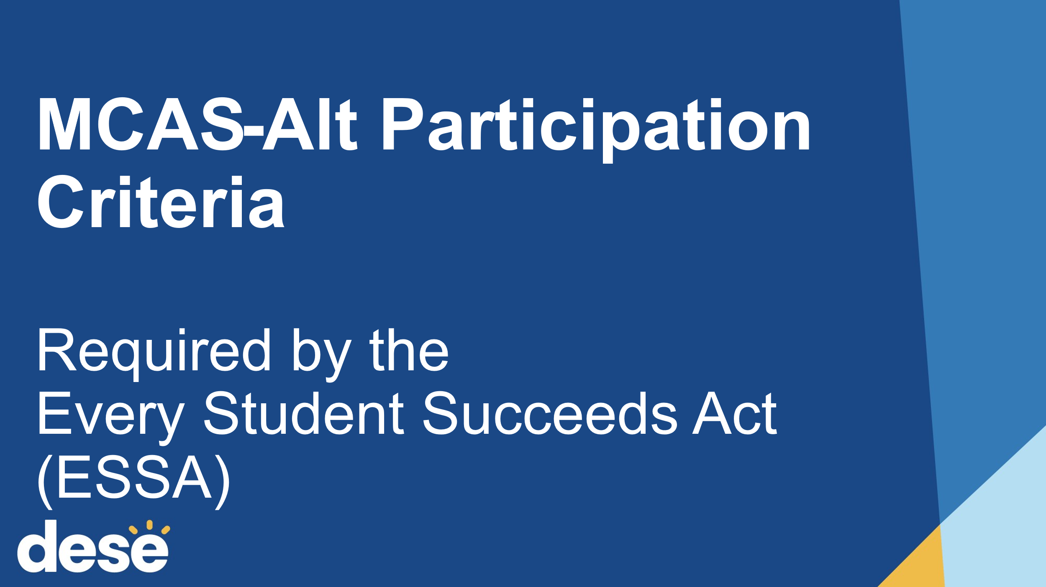

Exhibit: Sample Worksheet to Calculate Disproportionality Risk Ratio
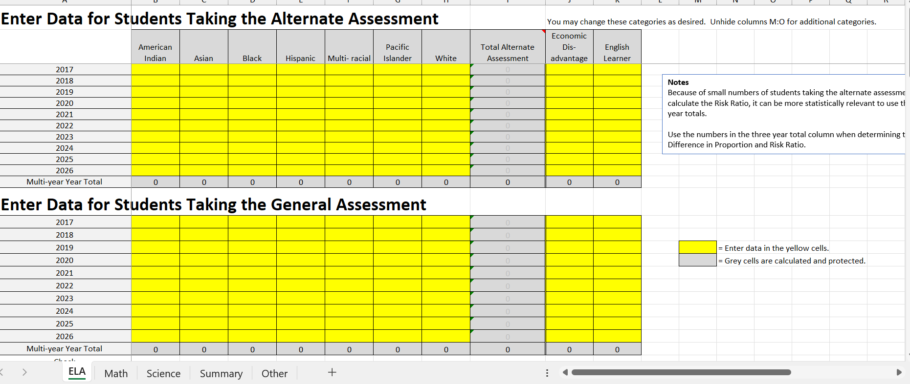

Exhibit: Alternate Assessment Training Notifications and Resources
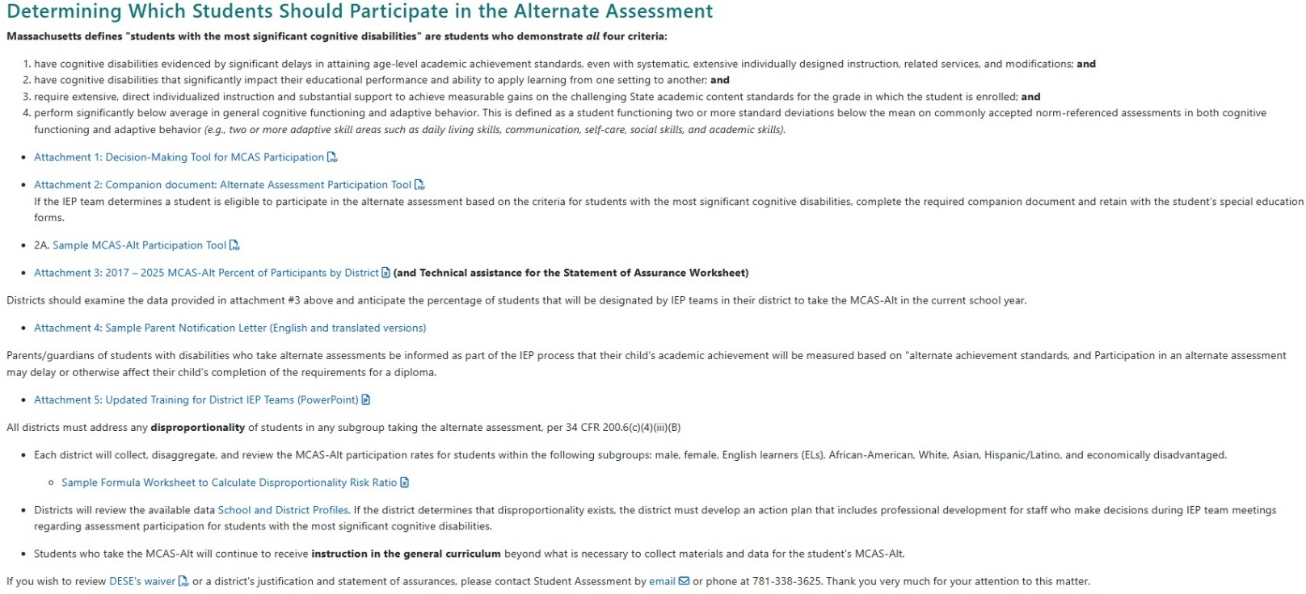

Exhibit: Notice to Special Education Leaders on MCAS-Alt Participation Requirements, Alternate Assessment Companion Tool, and Significant Disproportionality Analysis
Special Education Leaders Meeting November 7, 2025
The focus of this meeting was Special Education Updates and Key Special Education Topics, Professional Development and Technical Assistance, Participation Cap for Alternate Assessment Based on Alternate Achievement Standards, Fiscal Topics, Circuit Breaker, and Resources.

Exhibit: Evidence of Webinar Trainings and Resources on MCAS-Alt Eligibility
Student Assessment Update, October 15, 2025
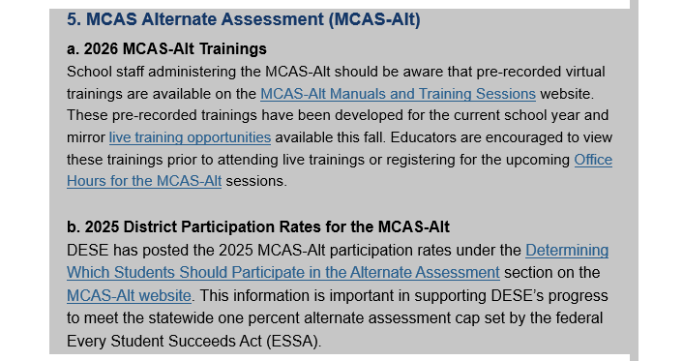

Exhibit: Statement of Assurances Sent to all LEAs with More than One-Percent MCAS-Alt Participation in 2025

Commissioner’s Memo and Statement of Assurances Request to Districts Regarding Exceeding One Percent Alternate Assessment Participation (Draft)



MEMORANDUM

To: | Interested Educators and Members of the Public
From: | Rob Curtin, Chief Officer for Data, Assessment, and Accountability
Date: | December 1, 2025
Subject: | Notice of Intent to Apply and Opportunity to Comment on the Department's Waiver Extension Request Related to the Percentage of Students Who Participate in the MCAS Alternate Assessment

The Every Student Succeeds Act (ESSA) places a 1.0 percent cap on the number of students with disabilities who may participate in statewide alternate assessments each year (ESSA Section 1111(b)(2)(d)(i)). This cap has been in effect since the 2016-2017 school year and applies to all states. Participation in alternate assessments is limited to only students that meet the eligibility definition of a student with the most significant cognitive disabilities.

Trainings and publications clarify the alternate assessment participation guidelines of the state’s eligibility definition of students with the most significant cognitive disabilities, plus additional relevant resources, including participation data for your district each year since 2017, is available at www.doe.mass.edu/mcas/alt/essa/. Your district has assessed more than one percent of the total number of assessed students on the MCAS-Alt. Educators and administrators in your district must closely examine which students are designated for those assessments. Although your district may already have made progress in reducing the number being alternately assessed, the overall percentage is still above the one percent threshold. We look forward to collaborating with your district to fully implement the revised MCAS-Alt eligibility definition and share evolved guidance to assist your IEP teams make evidenced-based decision on which students may participate in alternate assessments.

You or your designee must respond to this memorandum with the information requested in the attached Statement of Assurances no later than January 30, 2026. The information you provide will be used to support the Massachusetts application for a waiver of the “one percent cap” from the U.S. Department of Education for the 2025‒2026 school year.
This request is being sent by email rather than regular mail so that you (or your designee) can respond electronically and return your district’s response more efficiently. Please address your responses by January 30 to Robert W. Pelychaty, Manager of Inclusive Assessment, at robert.pelychaty@mass.gov. If you have questions or wish to discuss this further, please contact the office of Student Assessment Services at 781-338-3625 or by email at mcas@mass.gov.
Thank you for your attention to this timely and important information.

STATEMENT OF ASSURANCES
Please complete the information on this form and submit it no later than January 30, 2026, to Robert Pelychaty, Manager of Inclusive Assessment Office of Student Assessment, at Robert.Pelychaty@mass.gov.
- District:
- Name of person completing this form:
- Title:
- The superintendent has reviewed and approved the submission of the following responses to DESE. ☐ Yes ☐ No
(Please note that all responses are available to the public upon request.)
Please check one (* new for the 2025–2026 school year)
☐ My district does not expect to exceed 1.0 percent of the number of tested students taking the MCAS-Alt in the 2025–2026 school year. (Complete questions 1-3 on this form only.)
*☐ My district expects to exceed 1.0 percent but less than 1.75 percent of the number of tested students taking the MCAS-Alt in the 2025–2026 school year. (Complete all questions on this form.)
*☐ My district expects to exceed 1.75 percent of the number of tested students taking the MCAS-Alt in the 2025–2026 school year and acknowledges that this is significantly higher than the state average and a DESE-sponsored MCAS-Alt eligibility training may be warranted. (Complete all questions on this form.)
Your district’s MCAS-Alt participation data is available at www.doe.mass.edu/mcas/alt/essa/participants-district.xlsx.
- Please check Yes or No for each of the following statements.
Yes | No | Updated Assurances for 2025–2026 School Year
☐ | ☐ | IEP teams follow the state’s (DESE’s) previously updated guidelines and eligibility criteria for students with the most significant cognitive disabilities (available online at www.doe.mass.edu/mcas/alt/essa/) regarding which students should take the MCAS-Alt.
☐ | ☐ | For each student participating in the MCAS-Alt, the district completed and retained a copy of the required Companion document: Alternate Assessment Participation Tool.
☐ | ☐ | The district provides IEP teams with the updated annual trainings materials and presentation (available at www.doe.mass.edu/mcas/alt/essa/) on the requirements to limit the number of students taking the MCAS-Alt to one percent statewide.
☐ | ☐ | The district considered the use of special access accommodations (such as read-aloud, scribe, word prediction, and other assistive technology programs for the student to access the standard academic assessment, prior to designating the student to the MCAS-Alt.
☐ | ☐ | The district provides opportunities for interaction and collaboration among general and special educators to meet the need of adapting the academic curriculum for students with significant cognitive disabilities.
☐ | ☐ | The districts informs all parents, in writing, when their child is designated to take an alternate assessment. Written statements include information about how this designation may affect their child’s ability to eventually meet graduation requirements. (Notification of parents is required under ESSA. Sample Parent Notification Letters with translations are available at www.doe.mass.edu/mcas/alt/essa/).
☐ | ☐ | The district has provided or will provide professional development to general and special education staff in the following areas:  - Identification of appropriate accommodations for instruction and assessment.  - Implementation of universal design for learning principles in the classroom.  - Development of strategies to include students with the most significant cognitive disabilities in the general academic curriculum.

For any boxes marked “No” above, please describe the reason and how the district plans to address this in the coming school year:

- How did the district determine if any disproportionate representation exists with students assigned to the MCAS-Alt in the following subgroups: English Learners, Black or African American, Asian, American Indian or Alaska Native, Hispanic or Latino, White, Male, Female, Low Income?
(*DESE provides new tools and resources informed by the National Center on Educational Outcomes [NCEO] outlining specific steps for examining disproportionality in alternate assessments nceo.umn.edu/docs/OnlinePubs/NCEOBrief18.pdf.)
*Describe the method used to determine if disproportionality exists in the district.

Please check Yes or No to indicate whether your district is aware of disproportionality.
☐ No, at this time our district is not aware of the disproportionate representation of students taking the MCAS-Alt.
☐ Yes, the district is aware that there is disproportionate representation.
If yes, please describe the steps the district will take in the coming year (or the steps already taken) to find the root cause of and reduce the effects of any disproportionate representation of students in the above-referenced subgroups among those taking the MCAS-Alt:

- Please review the statements and indicate below whether these statements reflect your district’s practices.
When designating a student to take the MCAS-Alt, our district’s decisions are not based on whether the student:
- was absent excessively
- performed poorly (or for whom a poor performance was anticipated) on MCAS tests
- took MCAS-Alt previously
- is in a specific disability category
- is an English learner
- is from a low-income family or is a child in foster care
- would contribute positively to the school’s accountability rating if by teams the student took the MCAS-Alt.
☐ Yes, our district follows the above guidelines.
☐ No, our district does not follow the above guidelines.
If no, please describe the steps your district will take to implement these guidelines in the future:
Questions 4–10 should be completed only if your district expects to exceed one percent of the number of tested students taking the MCAS-Alt in 2025–2026.

- What was your district’s actual percentage of students participating in MCAS-Alt in SY 2024–25?
_____ %

- What is your district’s projection for the percentage of students participating in MCAS-Alt in SY 20245–26?
_____ %

- Are there unique circumstances in the district (e.g., specialized schools or programs) that might draw large numbers of students with the most significant cognitive disabilities to live in the district, which in turn might result in an excess of one percent of students taking the MCAS-Alt? If so, provide a description of those unique circumstances.

- How does your district’s primary disability categories data in SY 2024–25 compared to the state’s primary disability categories data, for students participating in the MCAS-Alt? You may use the worksheet on the last page of this document to help you make this comparison.
List primary disability categories in your district that were above state percentage in SY 2024–25:

List primary disability categories in your district that were below state percentage in SY 2024–2025:

- After reviewing data on students with the most significant cognitive disabilities, were there any patterns that emerged? For example, were students who attend a specific class or school more likely to participate in the alternate assessment? Does the participation rate vary by content area?

- Are IEP decisions in all schools within your district consistently implementing the state’s guidelines and criteria (available online at www.doe.mass.edu/mcas/alt/essa/ regarding which students should take the MCAS-Alt? Please consider the following for all IEP teams within your district, including students in outplacements.
  - Do the chairpersons meet on a regular basis?
  - Do all IEP teams understand the revised definition of students with the most significant disabilities?
  - Do all IEP teams first consider whether students could participate in the general assessment with appropriate support and accommodations in each content area?

- Describe your district’s action plan to assist schools to verify that only the eligible students (those that meet the new definition of a student most significant cognitive disabilities) are participating in the alternate assessment. (Plan should include actionable steps and how the district will monitor progress or address challenges, e.g., ensured evaluation teams are collecting specific evaluation scores on cognitive and adaptive behavior.)
District Worksheet: Percentage of Students in Each Primary Disability Category Taking the MCAS-Alt

Instructions: The table below may be used to compare your district’s rate of students taking the MCAS-Alt with the state average for students in each disability category. Complete the empty cells and compare this information with statewide percentages in the right-hand column.
By comparing your district’s percentage in each disability category with the state’s percentage, you will be able to determine whether any disability categories should be examined for over-representation among students taking the MCAS-Alt. The percentage of students assessed by MCAS-Alt in each disability category can be determined by dividing the number of students in a disability category taking the MCAS-Alt by the number of all students (MCAS + MCAS-Alt) assessed in that disability category.
For example, if 100 students with autism participated in MCAS and MCAS-Alt in grades 3–8 and 10, and 35 of those students took the MCAS-Alt, then 35/100 = 35%. Since this is higher than the percentage of students with autism statewide taking MCAS-Alt (21.3% from the table below), the autism disability category should be examined for over-representation among students taking MCAS-Alt, and students should be reconsidered to take the general assessment with accommodations.
District information on student assessment formats (i.e., tested versus alternate assessment) and the nature of primary disabilities can be found in your district’s DropBox at gateway.edu.state.ma.us/ in the file: Spring2025_MCAS_official_[your district code].csv. Additional instructions for using the district worksheet will be available at the MCAS-Alt’s ESSA website.
After completing the worksheet below, identify primary disability categories in your district that should be examined more closely for over-representation when compared with the state averages.

Content Area (Check one): ☐ ELA ☐ Mathematics ☐ Science and Technology/Engineering
Nature of Disability  (SIMS Disability Code) | # in Disability Category Taking  MCAS  (District) | # in Disability Category Taking  MCAS-Alt  (District) | % in Disability Category Taking  MCAS-Alt  (District) | % in Disability Category Taking  MCAS-Alt  (State)
Autism (11) |  |  |  | 19.2%
Communication (03) |  |  |  | 0.8%
Developmental Delay (13) |  |  |  | 3.1%
Emotional (05) |  |  |  | 0.1%
Health (07) |  |  |  | 0.5%
Intellectual Disability (01) |  |  |  | 31.8%
Multiple Disabilities (10) |  |  |  | 39.5%
Neurological (12) |  |  |  | 7.3%
Physical (06) |  |  |  | 3.7%
Sensory/Deafblind (09) |  |  |  | 21.1%
Sensory/Hard of Hearing or Deaf (02) |  |  |  | 5.0%
Sensory/Vision Impairment or Blind (04) |  |  |  | 9.4%
Specific Learning Disability (08) |  |  |  | 0.1%

