Hyɛ ase: Wɔn a wɔde di dwuma kan
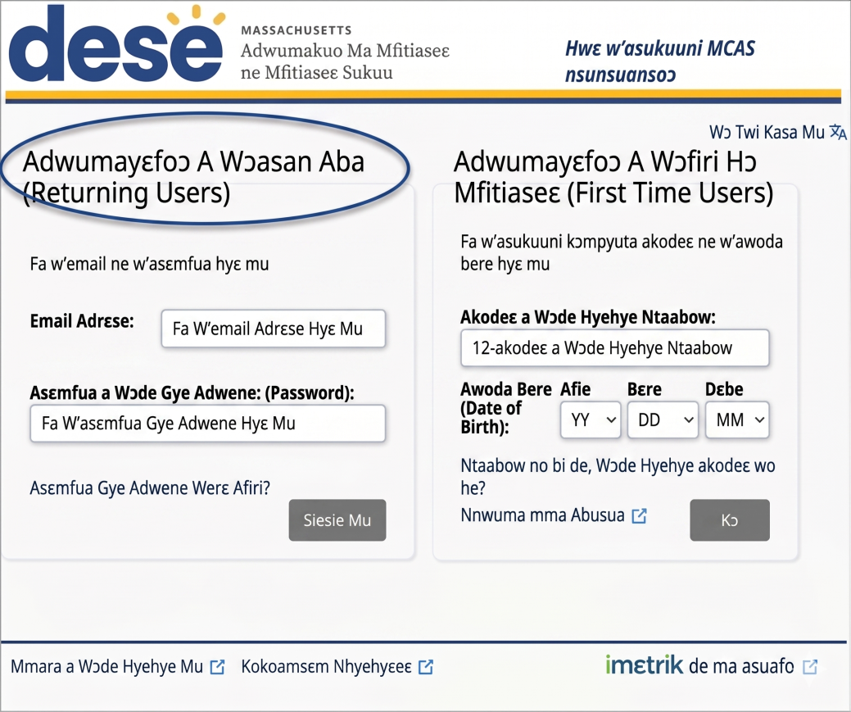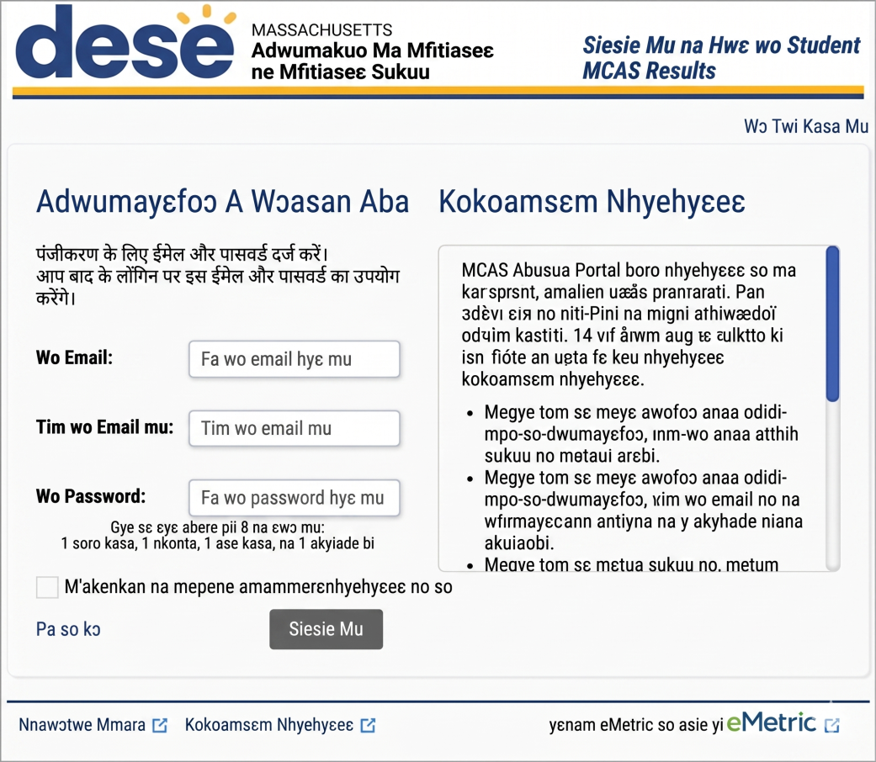
Hyehyɛ email address ne password na fa wo din hyɛ mu.
Wubehia eyinom na woatumi akɔ wo akontaabu mu akyiri yi.
Mmara a Wɔde Kyerɛw Wɔn Din: 472AC89F132A
Osuani Din: Nhwɛso Osuani
Wubehu registration code no wɔ krataa a efi wo sukuu mpɔtam hɔ no so..
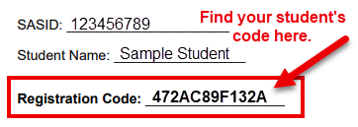

Hwehwɛ wo suani no code no wɔ ha.
Fa registration code ne awoɔ da no hyɛ mu.
Hwɛ Family Portal Help Guide no mu na nya nsɛm fa
- sɛnea wobɛka asuani aka wo account ho;
- sɛnea wubehu asuani no MCAS results; ne
- sɛnea wobɛsan ayɛ wo password no ho

Kenkan privacy agreement no. Hyɛ box no mu agyirae na klik Register.
Fa wo email address ne password yɛ account.
Nhyɛsoɔ: Wɔakyerɛkyerɛ screen no mfonini a ɛwɔ atifi hɔ no akɔ Twi mu ama reference nko ara. MCAS Family Portal no bɛda adi wɔ Borɔfo anaa Spanish kasa mu nko ara.

