Getting Started: First-Time Users
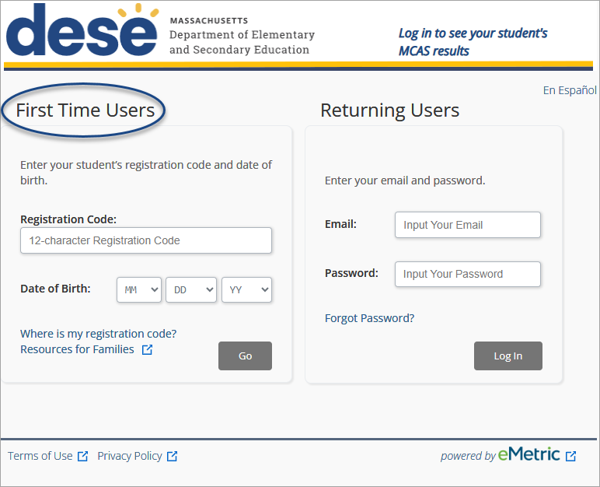
The registration code is found on the letter from your school district.
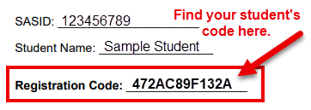

Enter the registration code and date of birth.
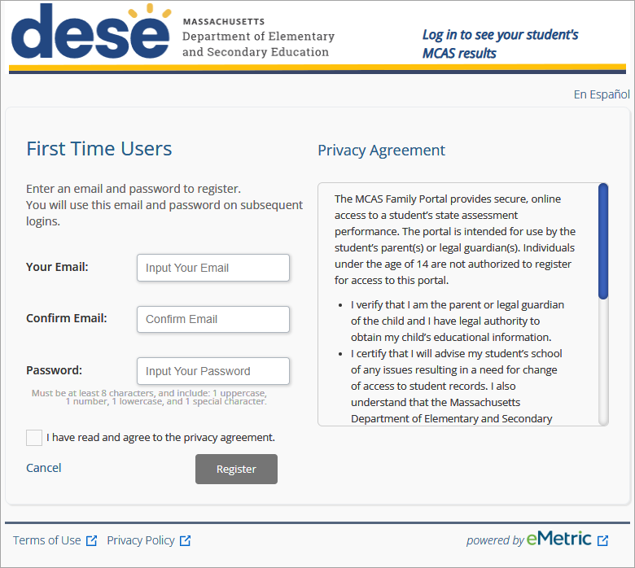
See the Family Portal Help Guide for information on
- adding students to your account;
- seeing students' MCAS results; and
- resetting your password.

Read the privacy agreement. Check the box and click Register.
Create an account using your email address and password.

