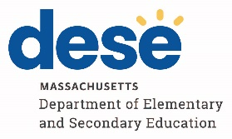
November 2025 ELA and Mathematics Retest
Participation Guidelines

Students may not earn the Competency Determination through participation in the November 2025 retests. However, DESE is continuing to offer the November retests to students who are attempting to qualify for the John and Abigail Adams Scholarship, the Stanley Z. Koplik Certificate of Mastery Award, and/or the Seal of Biliteracy as described below.

Questions about these participation guidelines should be directed to mcas@mass.gov, and questions about the Competency Determination should be referred to Competency.Determination@mass.gov.

Eligibility | Retest Participation Guidelines
Eligible to participate | - Students repeating grade 10 and students in grade 11 or 12 who have not yet taken the grade 10 ELA and/or Mathematics test(s), who are attempting to qualify for the Adams Scholarship and/or the Koplik Award  - Students repeating grade 10 and students in grade 11 or 12 who have previously taken the grade 10 ELA and/or Mathematics test(s), who are attempting to raise their score(s) to qualify for the Koplik Award  - ELA retest only:  Students who are repeating grade 10, and students in grade 11 or 12 who are attempting to qualify for the Seal of Biliteracy
Not eligible to participate | - Grade 9 students  - First-time grade 10 students

