Updates to the MCAS Student Kiosk and the MCAS Portal for the 2025–26 School Year
(updated January 5, 2026)

The MCAS Student Kiosk and MCAS Portal are being updated for 2025–26 MCAS testing. The updates are described in the tables below.

Updates to the MCAS Student Kiosk and MCAS Portal

Category | Summary/Description | Impacts/Screenshot
MCAS Portal – Test Schedule and MCAS Student Interface | Session Access Code has been renamed as Access Code. | “Session Access Code” has been renamed “Access Code.”  This change is visible in the MCAS Student Kiosk and MCAS Portal.  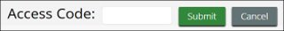  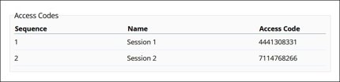

Updates to the MCAS Student Kiosk

Category | Summary/Description | Impacts/Screenshot
MCAS Student Interface | The student’s name will now appear in the top right corner of the item and directions pages within a test. | This feature is designed to help the test administrator and students confirm they are in the correct test.  - The student’s first name and last name are displayed on the top right corner of the directions page.  - The students’ first name and last initial are displayed on the top right corner of the item pages.  - Hovering over the name on the item page will reveal the student’s full name.  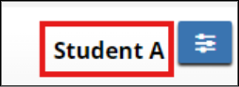
MCAS Student Interface | Ruler has been updated. | To provide better visibility and clarity, the ruler now has a blue color scheme with increased transparency. In addition, the numbers have been enlarged, and the tick marks have been darkened.  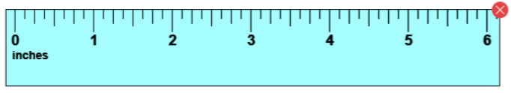
MCAS Student Interface | Calculators have been updated. | - The TI calculator has been updated to the latest version and is also updated to show degrees by default.  - The eMetric calculator shows degrees by default.  - The Desmos calculator has been updated to the latest version and continues to show degrees by default.
MCAS Student Interface | Students will be given a warning before timing out of a test. | - A timeout popup will appear when there are 60 seconds before the student times out of their test due to inactivity.  - The warning timer will count down from 60 seconds.  - If the student does not click the “continue” button before the timer runs out, the student will time out of the test.  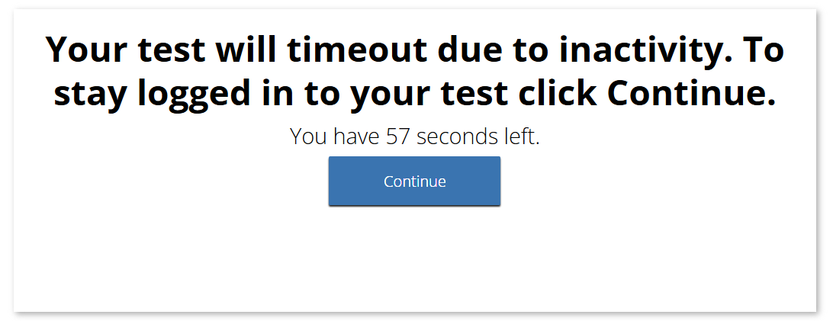
MCAS Student Interface – Accessibility features | The answer eliminator tool (UF7) is no longer available. | Students no longer have access to the answer eliminator tool (UF7), pictured below.  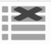  Students may continue to use the hiding options feature (UF6), as pictured below. The hiding options tool provides the same level of accessibility support as the answer eliminator.  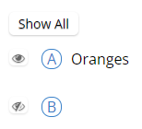
MCAS Student Interface – Accessibility features | The names of the color contrast options have been updated to be more descriptive. | 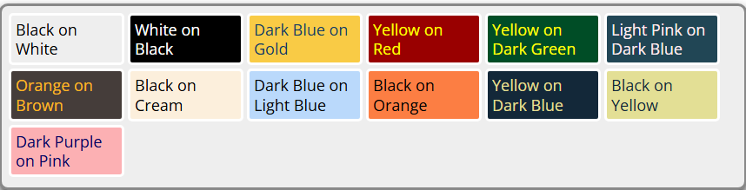
MCAS Student Interface – Accessibility features | Selected color contrast settings are now applied to the equation editor. | To ensure a consistent and accessible experience for students using the color contrast accessibility feature (UF2), color contrast settings are applied to equation editors.  - After selecting a color contrast option, click inside the equation editor.    The equation editor will now display with the color contrast.  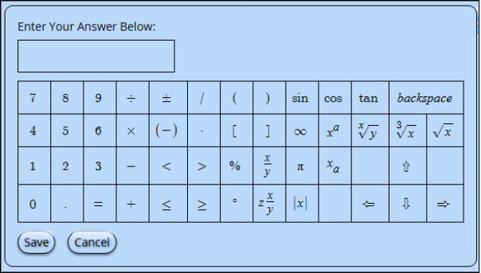
MCAS Student Interface – Accessibility features | Color contrast settings are now applied to reference sheets. There is also a more defined border applied to the reference sheet. | To ensure a consistent and accessible experience for students using the color contrast accessibility feature (UF2), color contrast settings are applied to reference sheets.  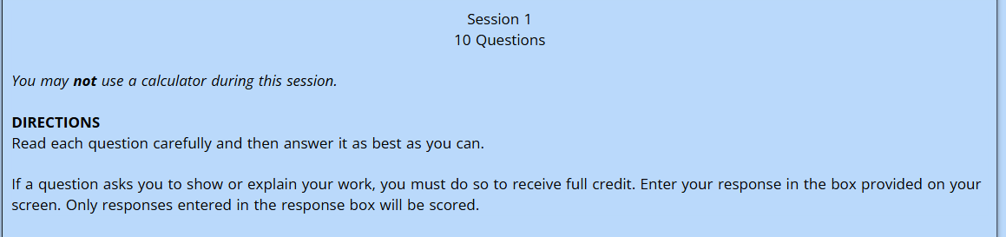

Updates to the MCAS Portal

Category | Summary/Description | Impacts/Screenshot
MCAS Portal – Users | New users only receive one email that provides them with their username and a link to set their password. | New users receive a single email containing their username and a link that takes the user directly to the page to create their password.  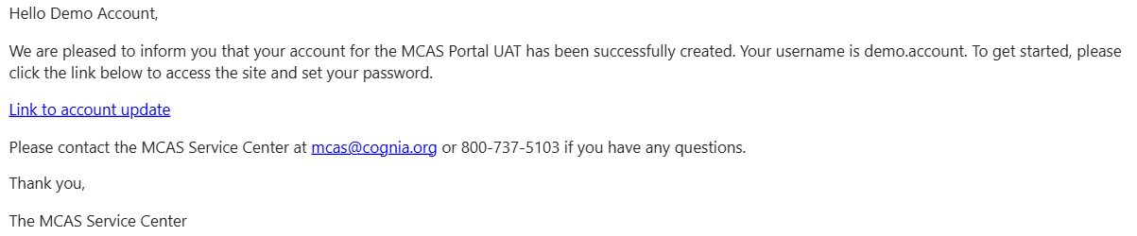
MCAS Portal – Test Scheduling | Test session progress metrics will be displayed for each student’s test sessions in test scheduling details. | On the View Details/Student Logins page, a new tab called “Progress View” has been added. This tab will list progress metrics as students move through the test. The page is updated every 60 seconds automatically. The table lists each student’s first and last name, the name of the form each student was assigned, the session(s) the students are assigned, and for each session of the test, you can view:  - Session Progress – How many items the student answered versus did not answer.  - Number of Items Visited – How many items the student viewed (This is different than the number of items answered.)  - Last Viewed – The item or passage number the student last viewed  - Last Activity – The last time the student responded to an item  - Time Spent – The amount of time the student has currently spent in the test  - Status – The overall status (not started, in progress, or finished) of the test session  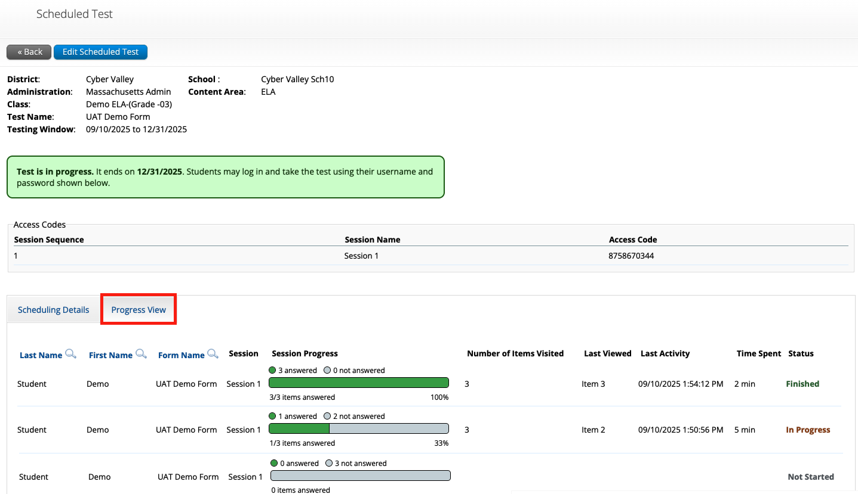
MCAS Portal – Test Scheduling | Test coordinators are able to export student logins in bulk at the school level. | Test coordinators can navigate to the Test Scheduling page and choose an option from the Exports drop-down menu to export student logins in bulk.  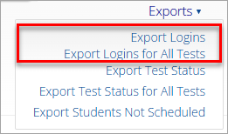
MCAS Portal – Students | Test coordinators are able to export student accommodations at the school level. | Test coordinators can navigate to the Students page and select Export Accommodations from the Exports drop-down menu to download an Excel file that lists all student accommodations in the school.  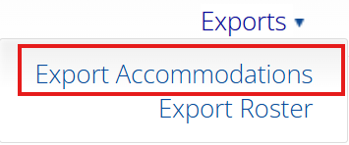
MCAS Portal – Classes | Test coordinators will be able to schedule course-level classes for February Science tests. | Test coordinators can add students from multiple grade levels to one class using course-level classes on the February Science tests. High schools will need to be sure to select the Course Level tab on the Classes page. See additional instructions in Appendix A of the Guide to the MCAS Portal.  