Updates to TestNav and PearsonAccess Next for the 2023–24 School Year

This is to inform you that PearsonAccess Next (PAN) and TestNav are being updated for 2023–24 MCAS testing. The updates are described in the tables below.

Updates to TestNav
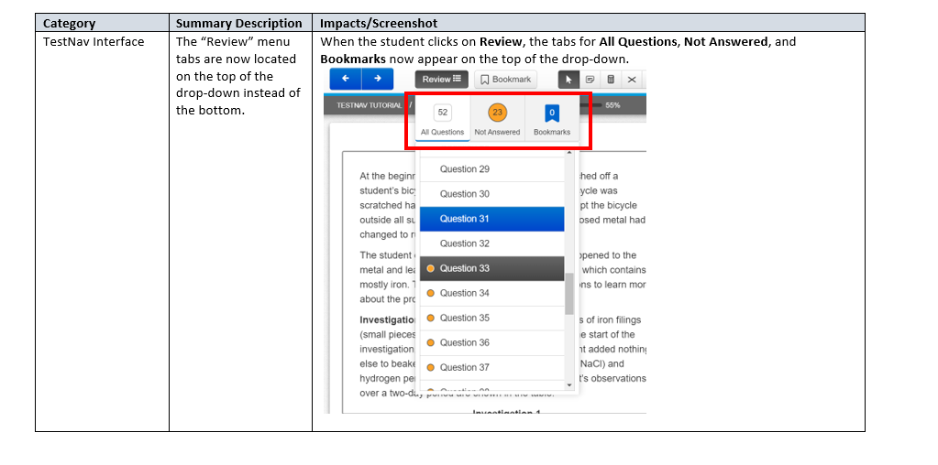
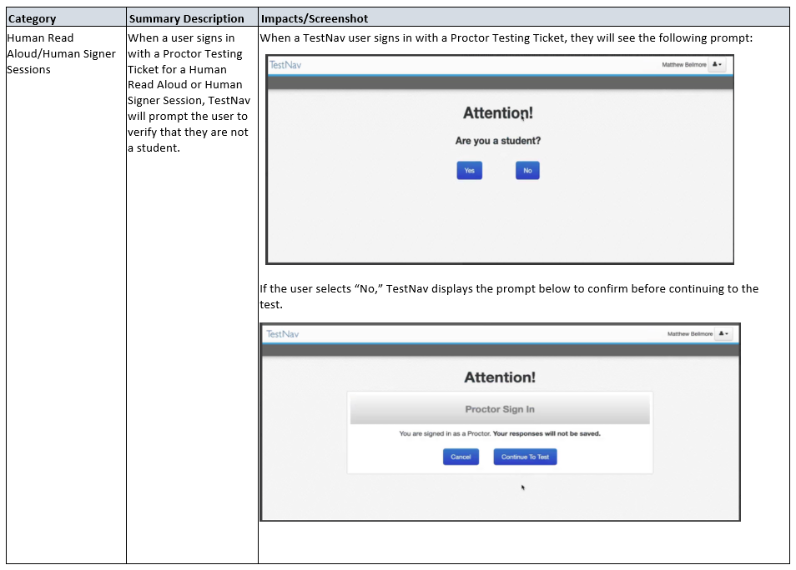

Category | Summary Description | Impacts/Screenshot
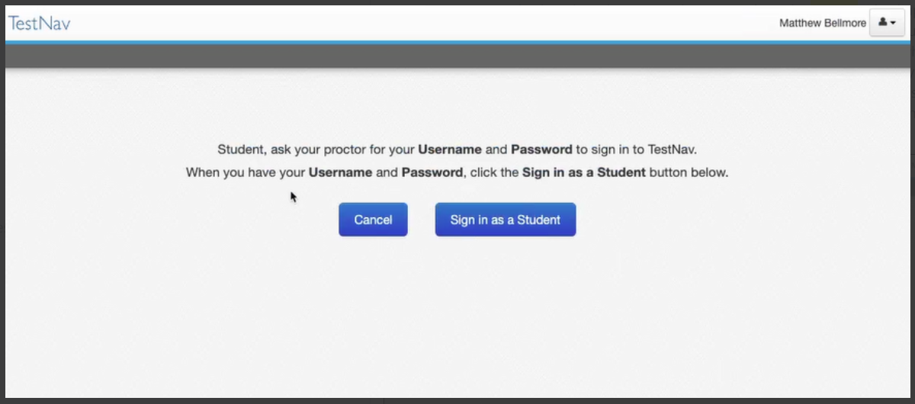
If the user selects “yes” on the first prompt, indicating that they are a student, TestNav displays the prompt below. Students should select Sign in as a Student.

Updates to PAN
