

Guidelines for Alternative Assessments to the MTEL
December 2025

Massachusetts Department of Elementary and Secondary Education
135 Santilli Hwy, Everett, MA 02149
Phone 781-338-3000 TTY: N.E.T. Relay 800-439-2370
www.doe.mass.edu

Purpose 3
A Regulatory Pilot 3
Piloted alternative assessments 4
Findings 5
Board Approval 5
Expectations for the Approval and Implementation Process 6
At the point of application 7
Assessment implementation 9
Ongoing monitoring 11
Submitting Alternative Assessments for Approval 12

Purpose
These Guidelines set expectations for approved alternative assessments to the Massachusetts Tests for Educator Licensure (MTEL), including approval processes for new alternative assessments and review processes for approved alternative assessments in alignment with the Department of Elementary and Secondary Education’s (the Department; DESE) Education Vision.
As part of the state’s Education Reform Act of 1993, in order to become licensed, all new teachers were required to:
“pass a test established by the board which shall consist of two parts: (A) a writing section which shall demonstrate the communication and literacy skills necessary for effective instruction and improved communication between school and parents; and (B) the subject matter knowledge for the certificate.” M.G.L. chapter 71, section 38G
To meet these requirements, the MTELs were developed and first administered in 1998 as one requirement to earn a Massachusetts educator license. Since then, the MTELs have served as the mechanism to determine if candidates have the statutorily required communication and literacy skills and subject matter knowledge required for educators. The Department currently contracts with a vendor to administer over 30 MTELs. Research has found that MTEL scores are a significant predictor of teachers' later performance ratings and student test scores.

A Regulatory Pilot
In a memo to the Board of Elementary and Secondary Education (the Board; BESE) in January of 2020, then Commissioner Jeffrey C. Riley shared that during his listening and learning tour of the Commonwealth, he frequently heard from the field about individuals who were or could be great teachers but had been unable to pass the MTEL. He shared the Department’s ongoing commitment to ensure that teachers know the content they are being asked to teach and have the deep knowledge they need to foster deeper learning for our students. He additionally noted the strength of the MTEL in assessing educator subject matter knowledge and cited research from the Center for Analysis of Longitudinal Data in Research Design (CALDER) that shows an individual’s performance on the MTEL is predictive of performance in the classroom and their students’ achievement. The memo proposed a regulatory pilot that would maintain the MTEL while exploring comparably effective alternative assessments, allowing educators another way to demonstrate their skills while continuing to uphold the Commonwealth’s rigorous expectations. Through the regulatory pilot, DESE sought to identify and study comparable assessment alternatives to the MTEL to support these efforts.
In October of 2020, BESE authorized a regulatory pilot to allow for alternative assessments to the MTEL. The pilot was designed to:
- Identify, pilot and learn more about alternative ways to assess prospective educators’ content knowledge and communication and literacy skills that are equally rigorous to the MTEL;
- Be responsive to feedback from the field; and
- Maintain a high standard for assessing educators’ knowledge and skills.

Piloted alternative assessments
The Department approved 26 alternative assessments over the course of the 5-year regulatory pilot. Alternative assessments were selected based on alignment to the MTELs in terms of both rigor and content, and capacity of the provider to implement the assessment at scale. Table 1 outlines the types of alternative assessments that were approved as part of the pilot.
Table 1.

Findings
The Department commissioned a study of the piloted assessments through the Center for Analysis of Longitudinal Data in Education Research (CALDER). The pilot study found that overall, individuals who pass an alternative assessment perform comparably to those who pass a traditional MTEL as measured by teacher contributions to student learning, teacher contributions to non-tested student outcomes, Views of Climate and Learning (VOCAL) student survey data, and educator evaluations. In addition, compared to educators who passed the traditional MTEL, educators who used the approved alternative assessments to meet their licensure assessment requirements were more likely to be educators of color, suggesting that access to approved alternative assessments is a potential mechanism to expanding and diversifying the profession.

Board Approval
Following the regulatory pilot, BESE voted on May 20, 2025 in support of regulations that provided the Commissioner of Elementary and Secondary Education with the ability to approve alternative assessments to the MTEL. The current regulations state:
Alternative Assessment Options
Any candidate who passes an alternative assessment approved by the Commissioner as comparable to the MTEL Communication and Literacy Skills test or a subject matter knowledge test will be deemed to have satisfied the requirements of 603 CMR 7.04 (2) (a) (2), or (a) (3), or 603 CMR 7.04 (2) (b) (2) or (b) (3), or 603 CMR 1.06 (4) (a), as applicable. The Commissioner will publicly report annual data on all approved alternative assessments, including the number of candidates taking the alternative assessments and assessment pass rates. The Department will issue Guidelines for the approval and sustainability of all alternative assessment options.
Following the passage of the regulations, DESE extended the approval for piloted alternative assessments for one additional year, and issued these Guidelines for the approval and sustainability of all approved alternative assessment options (603 CMR 7.04(2)(f)) in support of developing and sustaining a diverse and effective educator workforce.
All alternative assessments approved via these Guidelines will be accepted for the purposes of licensure in place of their corresponding MTEL.

Expectations for the Approval and Implementation Process
As defined by regulations, an alternative assessment is:
An alternative assessment to the communication and literacy skills, and subject matter knowledge MTEL that has been approved by the Commissioner based on Department issued Guidelines. An approved alternative assessment can be used by an educator licensure candidate to meet licensure requirements. (603 CMR 7.02).
Proposals for alternative assessments are approved through BIDs released by DESE as part of state procurement processes. Alternative assessments are not approved outside of the procurement process and are not accepted on an ad hoc basis. Candidates cannot submit assessments for consideration that have not been approved.
The Department considers a variety of structures and formats for alternative assessments provided they meet the criteria in Figure 1, which is further described below. Structures for assessments approved during the regulatory pilot included standardized tests, innovative assessments, assessments with specific eligibility criteria, and educator preparation subject matter attestations. The Department will continue to consider assessment structures approved during the pilot; as well as other innovative proposals under these Guidelines from vendors that meet criteria related to Viability below.
Educator preparation subject matter attestations may only be offered by sponsoring organizations that (1) are approved or approved with distinction, and (2) that offer initial teacher licensure programs corresponding to the relevant attestation(s) that are individually also approved or approved with distinction. Sponsoring organizations may only offer attestations to candidates who are enrolled in and in good standing with their approved initial teacher licensure preparation program, as documented in ELAR. Attestations, like all alternative assessments, are licensure assessments, and should be attempted when a candidate is appropriately prepared and ready. Sponsoring organizations will also be required to have candidates attempt the MTEL at least once prior to starting a subject matter attestation.

Figure 1 defines the criteria used to consider all alternative assessments at different points in the approval and implementation process.
Figure 1.
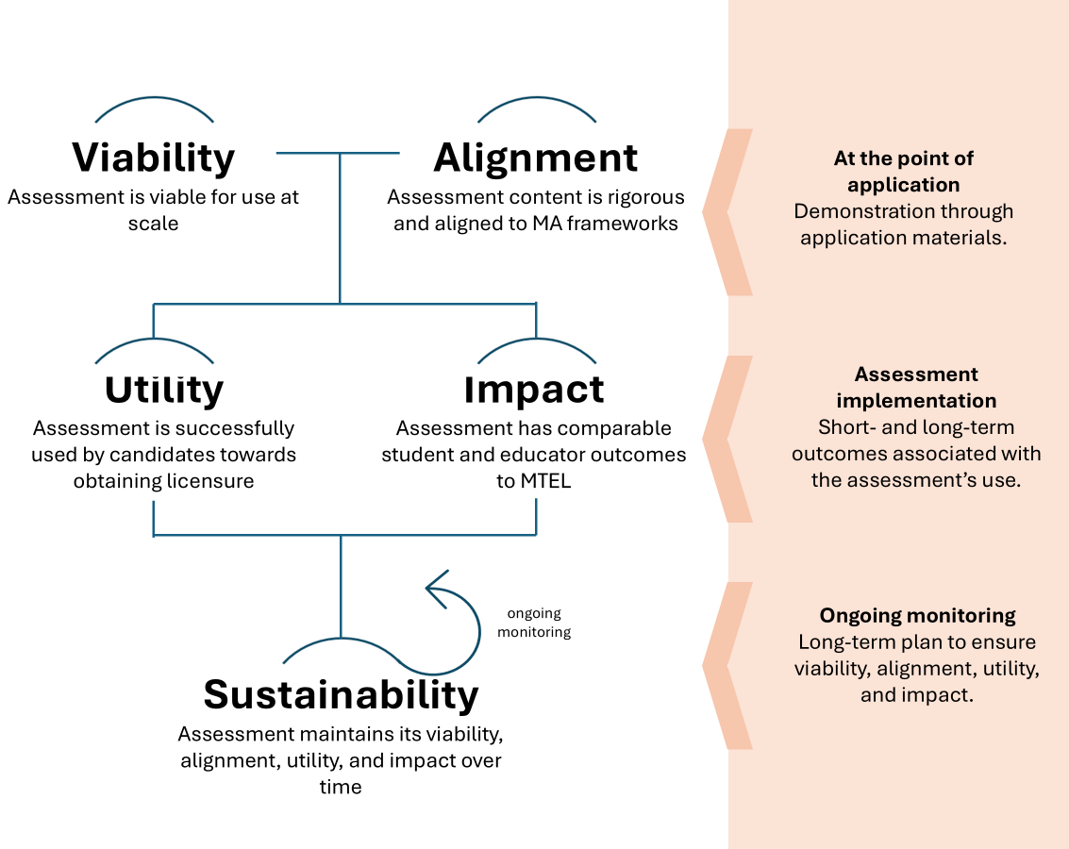

Application Requirements
All providers of alternative assessments are required to submit applications for consideration by the Commonwealth that demonstrate the proposed assessment’s viability and alignment, as outlined below.
Alignment: Assessment content is rigorous and aligned to the Massachusetts Curriculum Frameworks
All approved alternatives assessments to the MTEL must demonstrate alignment to the MTEL via, at minimum, a crosswalk of the content being assessed to the corresponding MTEL test objectives. MTEL test objectives are developed in alignment with the Massachusetts Curriculum Framework(s) and the Subject Matter Knowledge (SMK) requirements that correspond with the subject matter of the relevant MTEL. Alignment to these test objectives must be demonstrated when submitting the alternative assessment.

Communication and Literacy Skills MTEL:
The communication and literacy skills test (CLST) measures basic literacy and communication skills through a reading subtest and a writing subtest. Alternative assessments to the CLST MTEL must align to these MTEL test objectives.
Subject Matter Knowledge MTELs:
Subject matter knowledge (SMK) MTELs measure a functional level of content knowledge, as outlined in the Subject Matter Knowledge Guidelines. A functional level of content knowledge means that prospective educators can apply essential content effectively in a range of contexts. Please see the continuum in Figure 2 below. The same standard is held for all approved alternative subject matter assessments.
Figure 2.
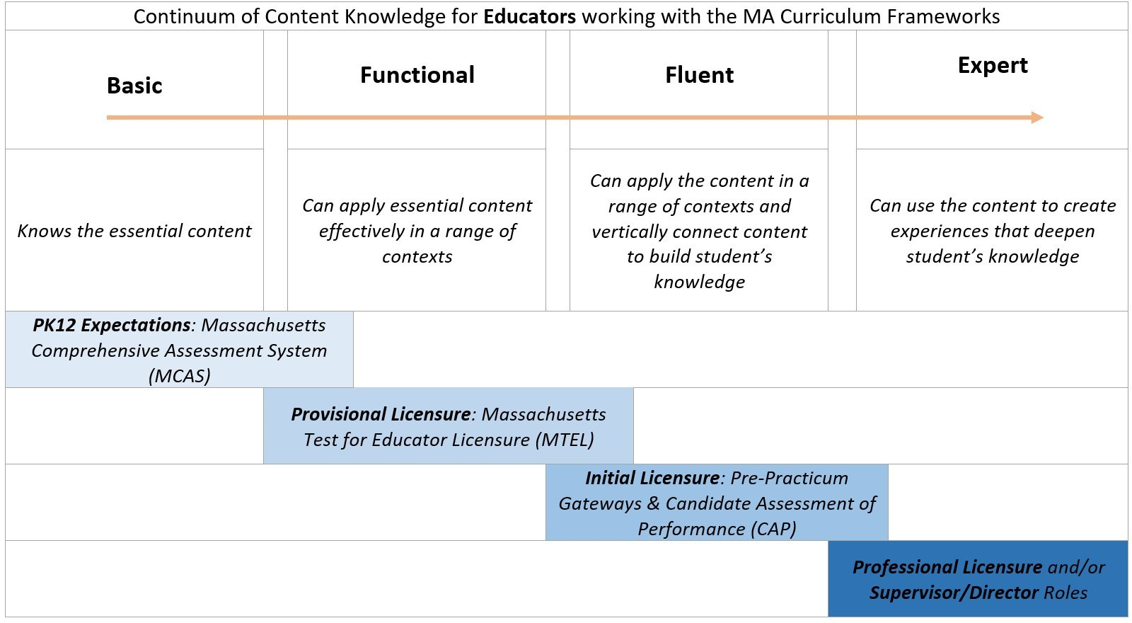
The boxes below the continuum illustrate the practical applications of the difference in depth and fluency of content knowledge as it relates to the Massachusetts licensure system and suite of required assessments used to determine varying levels of content knowledge. Alternative assessment providers must demonstrate how the assessment will measure candidates’ functional knowledge in their content area, and scorers or evaluators for alternative assessments must have content expertise in the field of the alternative assessment to assess candidates’ functional content knowledge in this area.
Candidates enrolled in educator preparation programs ultimately need to demonstrate content fluency, which extends beyond functional knowledge (see image above) as a requirement to attain an initial license. Content fluency, however, is measured through other mechanisms (e.g., the Candidate Assessment of Performance) and is not part of the requirements for alternative assessments.
Viability: Assessment is viable for use at scale
All approved alternative assessments to the MTEL must demonstrate viability. Evidence of viability may vary by assessment type (e.g., standardized test, portfolio-based assessment) but must at least address the following:
- Capacity of the provider to administer the assessment at the relevant scale (e.g., nationally, statewide, educator preparation organization). Capacity to administer the assessment includes considerations relative to content expertise for development, delivery, and scoring, as relevant;
- Process for setting and reviewing requirements for, and demonstration of, candidate eligibility for the alternative assessments;
- Quality, rigor, and validity of the assessment;
- Ability of the provider to securely report assessment results to DESE via the Educator Licensure and Renewal (ELAR) portal or other Department designated secure portal, as well as in a secure manner to individual candidates;
- Robust bias review process for assessment materials;
- Ability to provide alternative testing arrangements in compliance with state and federal law;
- Ability to monitor originality of submissions (including possible use/misuse of generative artificial intelligence);
- Ability to provide data reporting on assessment results including disaggregated pass rates;
- Affordability of the alternative assessment for candidates.

Assessment Implementation Requirements
Providers of alternative assessments are required to report implementation data annually to DESE in accordance with the assessment’s utility and impact, as outlined below. The Department will use data collected from providers together with other data sources (e.g. ELAR, EPIMS) for ongoing monitoring of all alternative assessments.
Utility: Assessment is successfully used by candidates towards obtaining licensure
All approved alternative assessments must demonstrate utility, meaning that candidates are able to select and access the assessment (if eligible) for the purposes of licensure. Providers are required to report data on candidate access to, and pass rates on, approved alternative assessments. The Department monitors pass rates in comparison to traditional MTELs and other approved alternative assessments. At minimum, providers are required to collect and report the following data for each candidate:
- Personal information, including first and last names, MEPID, date of birth, and last four digits of their social security number, as they appear in the Educator Licensure and Renewal (ELAR) system;
- Educator preparation program (as applicable);
- Race/ethnicity (if the candidate chooses to disclose);
- Primary language (if the candidate chooses to disclose);
- Email address;
- Scores, including Pass/Fail status for approved alternative assessment for each attempt; and
- Documentation of candidate eligibility (as applicable).
Providers are additionally required to submit annual reports with the following data and information:
- Total participation counts and counts by demographic groups;
- Pass rates and retake rates;
- Differential pass rates and retake rates between demographic groups; and
- Any changes to the implementation of approved alternative assessments, including but not limited to approved changes to eligibility requirements for candidates, approved changes to requirements for demonstration of skills or content knowledge, relevant staffing changes for scorers/content-experts, or changes to the scoring process for assessments.
The Department publicly reports annual aggregate and disaggregated assessment data for each approved alternative assessment with a participant size of 10 or larger to ensure anonymity of participants. Results are reported when cumulative participant sizes are above 10.
Impact: The assessment has comparable student and educator outcomes to the MTEL
All approved alternative assessments must demonstrate comparable impact on student and educator outcomes. Findings from the five-year regulatory pilot research study of approved alternative assessments found that candidates accessing licensure through the use of alternative assessments performed comparably in the classroom to those taking the traditional MTEL. In a final report to BESE, the researchers cautioned DESE to continue to assess the impact of approved alternative assessments as they might change over time. Therefore, DESE uses data submitted by alternative assessment providers to run analyses of the impact of alternative assessments that may include, but are not limited to, the following:
- Licensure and employment data
- Program completer data
- Educator retention rates
- Student assessment data
- Educator evaluation data
- School climate data (VOCAL)
- Non-test outcomes: aggregated attendance, discipline, graduation rates
- Survey data from alternative assessment participants via surveys administered by DESE
The results of these analyses are taken into consideration when determining the continuation of approved alternative assessments.

Ongoing Monitoring Requirements
Providers of alternative assessments must demonstrate the assessment’s sustainability over time through ongoing monitoring requirements.
Sustainability: Assessment maintains its viability, alignment, utility and impact over time
All approved alternative assessments must demonstrate sustainability. As noted in the final report of the Alternative Assessment Pilot Evaluation:
“the difficulty of the assessments might change if they were to become permanent... If the alternatives were continued, it may be necessary to continually monitor them to ensure that any alternative maintains adherence to the objective of the assessment program overall.”
The Department reports pass rates for alternative assessments using the annual reports provided by each alternative assessment provider (603 CMR 7.04(2)(f)). The Department uses providers’ annual reports for the ongoing monitoring of alternative assessments using all applicable measures as described in Figure 1 above.
The Department reserves the right to conduct an audit of the implementation of alternative assessments. These audits may include, but are not limited to, document reviews, focus groups, and surveys of candidates who have accessed approved alternative assessments. The Department reserves the right to suspend the implementation of any alternative assessment as necessary, based on the results of an audit or for any other emergent evidence, including a change in the approval status for sponsoring organizations or individual programs. Providers must retain submitted documents and materials from candidates regarding candidate eligibility and assessment submissions (as applicable) for at least seven years, and scores in perpetuity.

Submitting Alternative Assessments for Approval
Proposed alternative assessments are required to demonstrate viability and alignment at the point of application, as well as a commitment to the ongoing reporting requirements for implementation in order to demonstrate utility, impact and sustainability over time.
Additional information and criteria for potential vendors offering alternative assessments is provided in adherence to Departmental procurement procedures. BIDs for alternative assessments are posted publicly on COMMBUYS. Please see the Job Aids for Vendors Using COMMBUYS for helpful information about how to complete the vendor registration process in COMMBUYS, how to find open and rolling enrollment bids when logged into COMMBUYS, and how to create a quote in COMMBUYS, among other resources. The Department may prioritize specific aspects of submissions, including certain licensure areas based on workforce needs.

The state’s Early Literacy program approval process will meet this requirement for relevant programs. Sponsoring organizations that have not yet undergone an early literacy program review will be required to submit additional documentation during the procurement process.
All MTELs will be eligible for subject matter educator preparation attestation submissions except for the following: - Adult Basic Education - Reading Specialist - Sheltered English Immersion - Vocational Technical Literacy Skills - Bilingual Education - Communication and Literacy Skills
A table of MTELs and corresponding licensure areas is available at General Information: Subject Matter Test Requirements - Massachusetts Tests for Educator Licensure (MTEL).
Candidate performance on MTELs and all alternative assessments, including subject matter attestations, is one of multiple sources of evidence considered during formal reviews of sponsoring organizations, as described in the MTEL Use Advisory located here: https://www.doe.mass.edu/edprep/resources/guidelines-advisories/.

