Snipping Tool

The Snipping Tool should be used as an alternative to grouping objects together. This tool works similar to capturing a screenshot, except you will be able to capture only the section you need.
To access the Snipping Tool go to START > All Programs > Accessories. The Snipping Tool is located in the Accessories folder. It may be helpful to pin a shortcut to your Taskbar or your Start Menu, just right-click to select an option.
When you have an object that needs grouping open up Snipping Tool and your screen will appear whited-out.
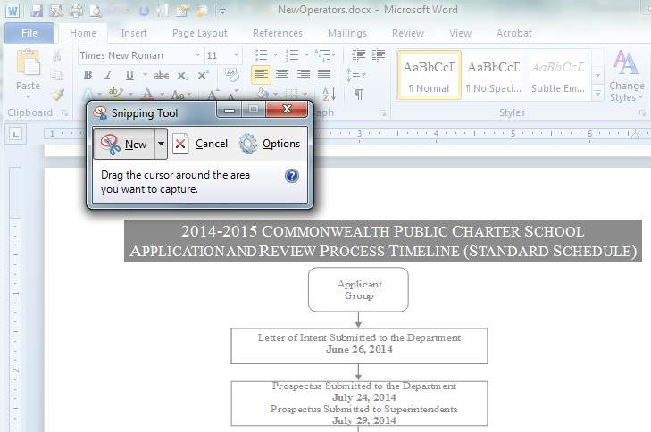
Drag your cursor around the area you would like to capture and let go.
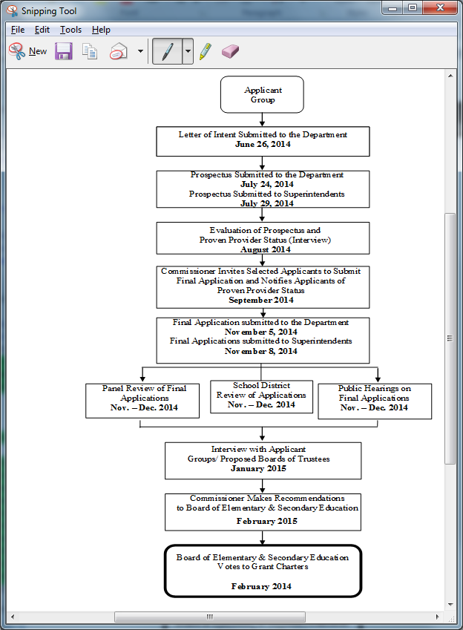
At this point your screen capture will now be added to your clipboard. You can either save the capture to your computer or just paste (Ctrl+v) it back into your file. Now your objects are captured as 1 image and alt text can be added.

