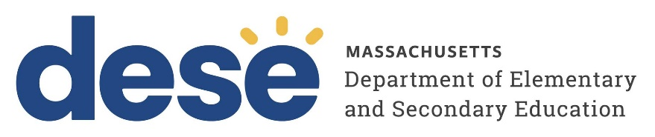

Request for Waiver as provided in
Special Education Regulations:
FORM C

Alternative Compliance

603 CMR 28.03(5)

/

School District/Collaborative/Approved Special Education School Program Proposed Effective Date

A school district, collaborative, or approved special education school program may submit in writing a proposal for approval
by the Department for the satisfaction of any requirement in 603 CMR 28.00 in a manner different from that specified in 603 CMR 28.00. The Department may approve such proposal if it shows substantial promise of contributing to improvements in the methods for meeting the goals of 603 CMR 28.00 and if such proposal does not conflict with any provision of law. No such proposal shall be implemented until approved by the Department.

Please respond briefly to each of the following: (Attach additional information as needed.)
The Department reserves the right to request additional information depending on the type of waiver sought.

- Provide a description of the proposed activity, method or approach for meeting requirements in a manner different from that specified in the regulation(s).

- Reference all pertinent paragraphs of the special education regulations that would be affected by the implementation of the proposal.

- Describe the circumstances that justify the request, details on other solutions that were considered and rejected as inappropriate, and specific reasons why this proposal shows substantial promise of contributing to improvements in the methods for meeting the goals of the state special education regulations.

- Provide the educational rationale for the waiver request and anticipated benefit to students.

- Provide information on the method(s) by which all affected teaching staff, administrators and parents of
affected students have been consulted in the development of this waiver request, and will be informed of the determination.

