Technical Memo on 2022 ECODIS Change in SIMS Data

Educational Opportunity in Massachusetts Team
Brown University
January 2023

Summary
In 2021-22, the definition of low-income students in the Massachusetts SIMS data expanded because the state’s 2019 Student Opportunity Act required DESE to modify its definition. In recent years (2015-2021), students were identified as “economically disadvantaged” (ECODIS) based on participation in one or more of the following state-administered programs:
- the Supplemental Nutrition Assistance Program (SNAP);
- the Transitional Assistance for Families with Dependent Children (TAFDC);
- the Department of Children and Families' (DCF) foster care program; and
- certain MassHealth (Medicaid) programs.

Starting in the 2021-22 academic year, the state has returned to the “low-income” descriptor and has expanded the definition to include three additional groups of students:
- MassHealth program participants up to 185% of the federal poverty level;
- students identified by districts as homeless, and
- students that districts have confirmed have met the low-income criteria through a supplemental process, which involves the collection of required supporting documentation (SIMS DOE056).
See the Redefining Low-income Under the Student Opportunity Act (SY 2021-22) for more information.

In the SIMS A collection from October 2021 (hereafter, SIMS22A), a total of 23,395 K-13 students statewide (3% of all students) were included in the low-income measure but would not have been identified under the older ECODIS measure. In this memo, we describe differences between the old & new measures and recommend that analysts not treat the new low-income measure as directly comparable to the historical ECODIS measure.

We examine the SIMS22A data to examine the differences between four groups of students, illustrated in Figure 1 below:
1. Low-Income: Students coded as low income using the new definition. This group is the sum of the ECODIS and Additional Low-Income students.
2. ECODIS: Students coded as economically disadvantaged using the historical definition.
3. Additional Low-Income: Students identified in the new low-income measure, but who would not have been identified using the historical ECODIS measure.
4. Higher-Income: Students not identified as low-income, either by the old or new definitions.

Analyses of SIMS22A data suggest that Additional Low-Income students have somewhat higher test scores and are somewhat less likely to be English learners, students with disabilities, or to attend urban schools than ECODIS students. However, the demographics of these Additional Low-Income students are more similar to ECODIS students than to Higher-Income students. About half of the Additional Low-Income students from 2022 had been labeled as ECODIS using the historical measure in the prior two years. In other words, these students appear to have lower family incomes than the average student not classified as ECODIS, but higher family incomes than students historically classified as ECODIS on average.

We find that the shift from ECODIS to the new Low-Income measure has important implications for data analysis and interpretation. For example, some districts saw large jumps in low-income identification relative to ECODIS both because some districts had more students near the eligibility cutoffs and because some districts appear to have undertaken a more comprehensive supplemental data collection.

Figure 1: Change from ECODIS to Low-Income Between 2021 & 2022
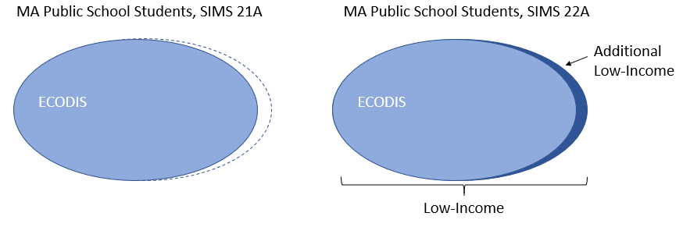

The remainder of this memo is organized as follows:

Section 1: Background
Section 2: Test Scores & Demographics
Section 3: Impact on Analyses
Section 4: Variation across Districts
Section 5: Conclusions & Recommendations

Section 1: Background
The new Low-Income measure only expands upon the prior definition; all students who would have been identified as ECODIS under the historical definition are still identified in the new measure. The Additional Low-Income group – those who are now considered Low-Income but would not have been under the old definition – totaled 23,395 students statewide in the SIMS22A collection. These students were relatively evenly distributed across grade levels, ranging from approximately 2.25% to 2.75% of students enrolled in each grade, with somewhat higher representation in middle and high schools. The table below displays the counts and percentages for each of the groups, along with the technical specification of variables and the names for the groups used throughout the rest of the memo.

Table 1: Income Category Groups & Counts, 2022 SIMS A Collection
Group | Group Name | Count | Percent
ecodis_old=0 & low_income=0 | Higher-Income | 520,910 | 56.2%
ecodis_old=0 & low_income=1 | Additional Low-Income | 23,395 | 2.5%
ecodis_old=1 & low_income=0 | N/A | 0 | 0%
ecodis_old=1 & low_income=1 | ECODIS | 382,961 | 41.3%
Note: Totals do not add up to exactly 100% due to rounding.

As discussed above, the policy change involved adding three groups of students to the low-income measure: students eligible for MassHealth with an income threshold of 185% of the federal poverty line, students who are homeless or in foster care, and those identified through the supplemental collection with additional documentation. In Figure 2, we show the distribution of Additional Low-Income students by eligibility category:

Figure 2: Composition of Additional Low-Income Students in 2022
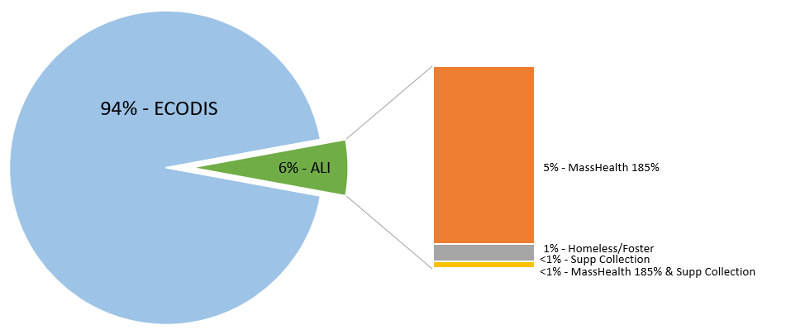
Note that the supplemental collection included many students who also met the historical ECODIS definition (and are therefore not included in the breakdown to the right of the figure above) – approximately 75% of students in the supplemental collection were already identified as ECODIS. We do not focus on these students in this memo, as their categorization did not change.

Also note that the finance department conducted an audit of the supplemental collection, which revealed that districts did not have valid documentation on file for many students identified in the supplemental collection. The SIMS low-income variable includes the unaudited figures, while the finance department will use their audited count. Thus, the number of low-income students reported in this document may not match the number used for financial purposes, including the allocation of Chapter 70 funding.

Section 2: Test Scores & Demographics
Tables 2 and 3 display test scores and demographics, respectively, for students who were in 4th-9th and 11th grades in 2022, and took the 3rd-8th grade or 10th grade MCAS in spring 2021.
Across all tested grades, the average MCAS performance of Additional Low-Income students lands between that of ECODIS students and Higher-Income students. On average, Additional Low-Income students outperformed ECODIS students by 0.2 to 0.25 standard deviations, a substantial difference. However, they underperformed Higher-Income students by 0.5 to 0.6 standard deviations (see Table 2).

Table 2: 2021 MCAS Scores for 3rd-8th & 10th Grade Test-takers in 2021 (4th-9th & 11th graders in 2022), by Income Category in 2022
 |  | Math |  | ELA
 |  | N | Std. Score | N | Std. Score
Grade | Low-Income | 84,256 | -0.49 | 83,983 | -0.42
3-5 | ECODIS | 79,549 | -0.51 | 79,292 | -0.43
 | Additional Low-Income | 4,707 | -0.24 | 4,691 | -0.23
 | Higher-Income | 107,966 | 0.39 | 107,885 | 0.33
Grade | Low-Income | 84,787 | -0.46 | 84,563 | -0.40
6-8 | ECODIS | 79,449 | -0.48 | 79,246 | -0.41
 | Additional Low-Income | 5,338 | -0.22 | 5,317 | -0.19
 | Higher-Income | 114,223 | 0.34 | 114,272 | 0.29
Grade 10 | Low-Income | 22,423 | -0.51 | 22,563 | -0.49
 | ECODIS | 20,883 | -0.53 | 21,024 | -0.51
 | Additional Low-Income | 1,540 | -0.26 | 1,539 | -0.23
 | Higher-Income | 39,536 | 0.33 | 39,614 | 0.33

Additional Low-Income students are somewhat less likely to be English Learners (EL), students with disabilities (SWD), or to go to school in an urban setting than ECODIS students. However, their demographics are much more similar to the ECODIS group than to Higher-Income students, as illustrated in Table 3.

Table 3: 2021 MCAS Test-Taker Demographics, by Income Category in 2022
 |  | Female | LEP | SPED | Urban
Grade 3-5 | Low-Income | 48.9% | 19.1% | 23.7% | 58.4%
 | ECODIS | 48.9% | 19.2% | 24.1% | 58.7%
 | Additional Low-Income | 49.0% | 17.3% | 17.4% | 52.8%
 | Higher-Income | 48.8% | 3.2% | 15.5% | 16.8%
Grade 6-8 | Low-Income | 48.6% | 12.8% | 24.0% | 55.4%
 | ECODIS | 48.5% | 13.0% | 24.4% | 55.8%
 | Additional Low-Income | 49.0% | 11.0% | 18.1% | 49.7%
 | Higher-Income | 48.4% | 1.9% | 14.3% | 16.4%
Grade 10 | Low-Income | 48.9% | 14.3% | 23.7% | 51.8%
 | ECODIS | 48.9% | 14.6% | 24.2% | 52.2%
 | Additional Low-Income | 48.2% | 11.0% | 17.0% | 46.3%
 | Higher-Income | 49.1% | 1.6% | 13.9% | 15.8%
Given the way Additional Low-Income students were identified and the patterns described above, we expect that many of them indeed do have higher family incomes than students historically identified as ECODIS. We explore this by examining family income histories for students who appeared in the SIMS collections for three consecutive years (2020, 2021 and 2022). As seen in the top row of Table 4, about 93% of elementary-school ECODIS students in 2022 had been classified as economically disadvantaged in at least one of the past two years (8.4% for one year, and 84.3% for both years). By contrast, only about half of the 2022 Additional Low-Income students (and only 5% of Higher-Income students) had been identified as economically disadvantaged in either of the past two years using the historical measure. These patterns are quite similar across grade bands and suggest that Additional Low-Income students have somewhat higher family income, on average, than students who qualified under the ECODIS measure.

Table 4: ECODIS Status in 2020 and 2021 for 2022 Students, by 2022 Income Category
 |  | ECODIS in Neither Year | ECODIS in One Year | ECODIS in Both Years
Grades | Low-Income | 9.5% | 9.2% | 81.4%
2-5 | ECODIS | 7.3% | 8.4% | 84.3%
 | Additional Low-Income | 48.0% | 22.3% | 29.7%
 | Higher-Income | 95.0% | 2.8% | 2.2%
Grades | Low-Income | 10.3% | 9.7% | 80.1%
6-8 | ECODIS | 7.6% | 9.0% | 83.4%
 | Additional Low-Income | 51.4% | 20.9% | 27.7%
 | Higher-Income | 94.9% | 3.0% | 2.2%
Grades | Low-Income | 10.6% | 10.3% | 79.1%
9-12 | ECODIS | 8.0% | 9.6% | 82.4%
 | Additional Low-Income | 49.6% | 21.5% | 28.9%
 | Higher-Income | 94.7% | 3.1% | 2.2%
Note: The first section is for Grades 2-5, instead of K-5, because almost all kindergarteners & 1st graders in 2022 were not in SIMS in both 2020 & 2021. Totals may not add up to exactly 100% due to rounding.

Additional Low-Income students are slightly more likely to be immigrants than ECODIS students but have been in MA public schools for about the same amount of time, on average. Again, these patterns are similar across grade bands (see Table 5).

Table 5: Immigration & Time in Massachusetts Public Schools, by Income Category
 |  | Ever-Immigrant | Average Years in State for Immigrants
Grades K-5 | Low-Income | 9.2% | 2.2
 | ECODIS | 9.1% | 2.2
 | Additional Low-Income | 10.6% | 2.3
 | Higher-Income | 3.0% | 2.2
Grades 6-8 | Low-Income | 12.0% | 4.3
 | ECODIS | 11.9% | 4.3
 | Additional Low-Income | 13.6% | 4.4
 | Higher-Income | 3.5% | 4.7
Grades 9-12 | Low-Income | 15.7% | 5.2
 | ECODIS | 15.5% | 5.2
 | Additional Low-Income | 18.7% | 4.9
 | Higher-Income | 4.2% | 6.1

Section 3: Impact on Analyses
The identification of Additional Low-Income students may complicate analytical comparisons by family income over time, much as the shift to ECODIS did in 2015. Here and in the next section, we focus on the new Low-Income measure, which includes all low-income students (ECODIS and Additional Low-Income students) in the SIMS 22A collection.

In Figure 3, we display the trend in the share of students with low family income across the entire state, ending with two values for 2022 – one using the ECODIS measure and one using the new Low-Income measure. With the latter, an upwards trend beginning in 2019 appears to accelerate, while we see a shallower, steady increase using the ECODIS measure. This suggests that treating the Low-Income measure as comparable to the ECODIS measure would overstate the increase in the share of students with low family income in Massachusetts over time.

Figure 3: Low-Income Students as a Percentage of Massachusetts Public-School Enrollment by Year

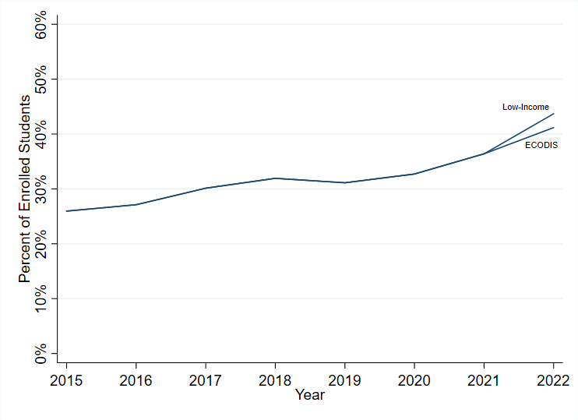
We also see differences across student groups. Here, we compare the shares of students in each group who would be identified as having low family income using the Low-Income and the ECODIS measures. All groups have higher percentages of students with low family income using the Low-Income measure, but differences are largest for ELs and Hispanic/Latino students (see Table 6).

Table 6: Percentages of EL, SWD & Racial/Ethnic Groups who are also Low-Income/ECODIS Students
 | Low-Income Measure | ECODIS | % Point Difference
English Learners | 80.0% | 75.5% | 4.5
Students with Disabilities | 56.0% | 53.6% | 2.4
Asian | 31.2% | 27.8% | 3.4
African American/Black | 71.1% | 67.6% | 3.5
Hispanic/Latino | 77.1% | 73.2% | 3.9
Multi-Race (Non-Hispanic/Latino) | 42.6% | 40.5% | 2.1
Native American | 63.8% | 60.2% | 3.6
White | 27.1% | 25.4% | 1.7
Note: This table compares the percentages of each demographic group who are low-income using the ECODIS and Low-Income measures (row percentages). This is different from Table 3, which use column percentages, or the percentages of low-income students who are also in these other groups.

Section 4: Variation Across Districts
The switch to the Low-Income measure had substantially different impacts on low-income identification across districts. Here, we focus on districts with more than 200 students across all grades. All but three of these districts show differences in student counts from ECODIS to the Low-Income measure; most saw changes below 3 percentage points, while a few of the smaller charter districts saw large shifts (upwards of 30 percentage points).

In Table 7, we display the average percentage point differences in low-income enrollment for different types of districts, using the two measures. Urban districts and urban charter schools generally saw higher increases in their low-income percentages using the Low-Income measure than did other districts in the state.

Table 7: Differences in 2022 Low-Income Enrollment by School Type (All Grades)
 | Low-Income | ECODIS | Percentage Point Change
Urban, Non-Charter Students | 72.3% | 68.7% | 3.6
Urban, Charter Students | 69.6% | 65.2% | 4.5
Non-Urban, Non-Charter Students | 28.9% | 27.0% | 1.9
Non-Urban, Charter Students | 33.0% | 30.1% | 2.9

There are at least two reasons for these differences. First, we expect larger differences for districts that serve more homeless/foster students and students near the ECODIS cutoff who would be captured by the Low-Income measure.

Second, districts differ greatly in their engagement with the supplemental collection process. Eighty percent of districts in the state – including 6 of the 10 largest districts – identified no students as Low-Income in the supplemental collection. However, a few districts experienced substantial changes in their share of Low-Income students because of the supplemental collection. For example, 7 districts – 3 smaller charter districts and 4 larger districts – saw their shares of Low-Income students increase by at least 2 percentage points through their efforts to identify additional students via the supplemental process. As the supplemental collection becomes more established in the state, these patterns bear additional consideration.

Section 5: Conclusions and Recommendations for Use
Given the differences highlighted in this memo, we recommend that researchers treat the ECODIS and Low-Income measures as two distinct variables. Additional Low-Income students appear to be more economically advantaged, have somewhat different demographics, and have much higher test scores than students identified using the ECODIS measure. As a result, direct comparisons of Low-Income students using the new measure to ECODIS students from previous cohorts could be problematic.

Furthermore, parts of the policy change, especially the supplemental collection, rely on individual districts to implement and are subject to variations in school and district practices for collection (e.g., actively offering and encouraging families to fill out additional paperwork to qualify). As demonstrated above, in 2021-22 districts engaged quite differently in the supplemental collection. This process requires continued analysis and attention in future years.

