
Status of the Massachusetts Educator Workforce
December, 2011
Massachusetts Department of Elementary and Secondary Education
75 Pleasant Street, Malden, MA 02148-4906
Phone 781-338-3000 TTY: N.E.T. Relay 800-439-2370
www.doe.mass.edu


This document was prepared by the
Massachusetts Department of Elementary and Secondary Education
Mitchell D. Chester, Ed.D.
Commissioner

Board of Elementary and Secondary Education Members
Ms. Maura Banta, Chair, Melrose
Ms. Beverly Holmes, Vice Chair, Springfield
Dr. Vanessa Calderón-Rosado, Milton
Ms. Harneen Chernow, Jamaica Plain
Mr. Gerald Chertavian, Cambridge
Mr. Matthew Gifford, Chair, Student Advisory Council, Brookline
Dr. Jeff Howard, Reading
Ms. Ruth Kaplan, Brookline
Dr. James E. McDermott, Eastham
Dr. Dana Mohler-Faria, Bridgewater
Mr. Paul Reville, Secretary of Education, Worcester

Mitchell D. Chester, Ed.D., Commissioner and Secretary to the Board

The Massachusetts Department of Elementary and Secondary Education, an affirmative action employer, is committed to ensuring that all of its programs and facilities are accessible to all members of the public.
We do not discriminate on the basis of age, color, disability, national origin, race, religion, sex or sexual orientation.
Inquiries regarding the Department’s compliance with Title IX and other civil rights laws may be directed to the
Human Resources Director, 75 Pleasant St., Malden, MA 02148-4906. Phone: 781-338-6105.

© 2011 Massachusetts Department of Elementary and Secondary Education
Permission is hereby granted to copy any or all parts of this document for non-commercial educational purposes. Please credit the “Massachusetts Department of Elementary and Secondary Education.”

Massachusetts Department of Elementary and Secondary Education
75 Pleasant Street, Malden, MA 02148-4906
Phone 781-338-3000 TTY: N.E.T. Relay 800-439-2370
www.doe.mass.edu


Table of Contents
Introduction 1
Overview of Massachusetts Educators 1
Demographics 3
Years of Service 5
Retention Rates 6
Preparation 11
Educator Supply and Demand 14
Educator Supply 15
Imbalances in Teacher Supply 18
Subject Area Shortages 21
Diversity Shortages 25
Strategies for Addressing Educator Shortages 28
Equitable Distribution of Massachusetts Educators 31
Licensure and Waivers 31
Years of Service 33
Retention & Turnover 35
Improving Educator Retention and Equitable Distribution 37
Looking Ahead 39

Introduction

On June 28, 2011 the Massachusetts Board of Elementary & Secondary Education voted in sweeping reforms regulating the evaluation of educators. With these reforms the Commonwealth of Massachusetts cemented its support of teaching as a profession, and started to look long-term at how a professional educator workforce can have a significantly positive impact on student learning and the state as a whole. There is a long way to go to meet the lofty goals outlined in the new regulations, but Massachusetts is committed to helping educators consistently improve their practice in service of the ultimate goal of better preparing students to be college and career ready.

This report is intended to help the Commonwealth support its educators by providing a clear understanding of the current status of our educator workforce in Massachusetts, both its strengths and also areas in which the Department of Elementary and Secondary Education (ESE), schools, districts, and educator preparation programs can improve. The term ‘educator’ is used intentionally to encompass all staff members who are responsible for student learning; including teachers, principals, and superintendents. The focus of most analyses is on teachers, but the report also includes data on principals, superintendents, and the overall educator workforce where appropriate. The data in this report comes primarily from two sources: data reported by districts to the state through the Education Personnel Information Management System (EPIMS), and data reported by preparation programs or districts to the state through the Educator Licensure and Recruitment system (ELAR).

The report begins with an overview of our educator workforce in the 2010-11 school year, focusing on its demographics, years of service, retention rates, and preparation. This same information is then examined in light of the hiring needs of the state, subject areas with teacher shortages, the demographics of our students and whether educators are equitably distributed across schools of different income levels. The report also looks at what the state is currently doing and is planning to do to address challenges in each of these areas. It concludes with a discussion of plans to collect additional data that will provide an even richer understanding of the state’s educator workforce and will better inform policies to support educators throughout their career continuum.

Overview of Massachusetts Educators

During the 2010-11 school year, the Commonwealth of Massachusetts employed almost 69,000 full-time equivalent (FTE) teachers in over 1,800 public schools across the state, including in charter schools and vocational/technical schools. Massachusetts’ teachers were about equally distributed across grade levels, with almost half teaching secondary school grades and the remaining teachers teaching elementary grades or multiple grades (Chart 1.1).
Chart 1.1: Massachusetts Teachers by Grade Level, 2010-11
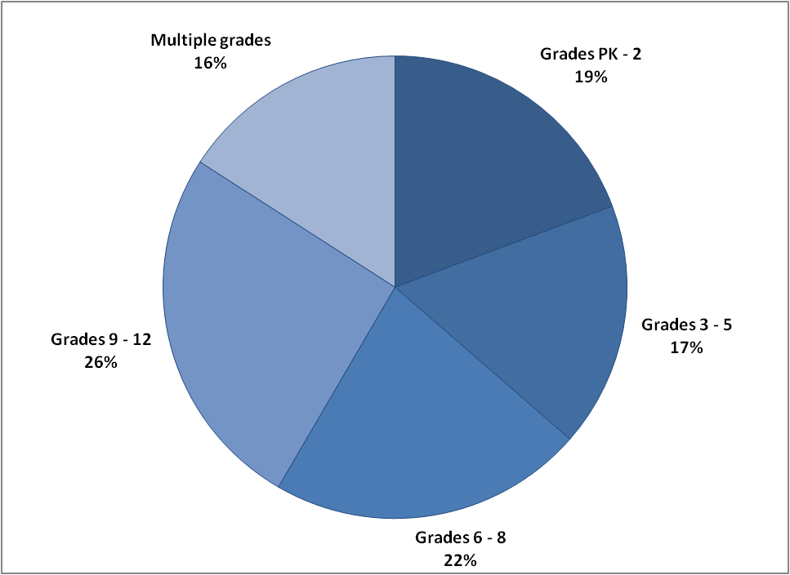
Source: Education Personnel Information Management System, Massachusetts Department of Elementary and Secondary Education

The vast majority of the Commonwealth’s teachers, 81 percent, work in general education. Another 14 percent are special education teachers, with the remaining 5 percent classified as English Language Learner or vocational/technical education teachers (Chart 1.2).
Chart 1.2: Massachusetts Teachers by Program Area, 2010-11
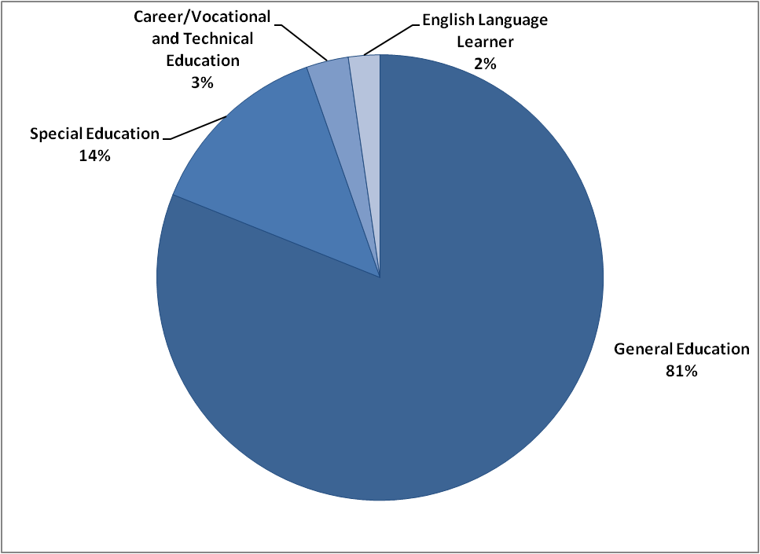
Source: Education Personnel Information Management System, Massachusetts Department of Elementary and Secondary Education

The Commonwealth also employs over 1,700 principals and 315 superintendents to lead its schools and districts. These educators, along with another 51,000 staff members, such as paraprofessionals, counselors, librarians, and nurses, served nearly 1 million students across 393 school districts in 2010-11 (Table 1.1).
Table 1.1: Summary of the Massachusetts Educator Workforce, 2010-2011
Number of Schools | 1,824
Number of Districts | 393
Total Staff (FTE) | 122,052
Teachers | 68,754
Principals | 1,782
Superintendents | 315
Source: Education Personnel Information Management System, Massachusetts Department of Elementary and Secondary Education

Demographics
Massachusetts’ educator workforce is overwhelmingly female and white: 81 percent of all public school staff are female and over 90 percent are white (Chart 1.3). But the percent of educators who are female varies substantially based on their role in the school system. Over 70 percent of teachers are women, compared with just 58 percent of principals and 37 percent of superintendents. Public schools nationwide follow a similar pattern: 76 percent of teachers are women, while 50 percent of principals and 24 percent of superintendents are female.

The racial distribution of Massachusetts educators, in contrast, is fairly consistent across positions, with less than 10 percent of teachers, principals, and superintendents identified as a racial or ethnic minority. As we discuss in more detail later in the report, the demographic profile of the educator workforce does not mirror that of Massachusetts public school students, which is 32 percent minority. Public schools across the country face a similar disparity—nationally, 45 percent of public school students identify as a racial or ethnic minority, compared with just 17 percent of teachers.

Chart 1.3: Race/Ethnicity and Gender of Massachusetts Educators, 2010-11
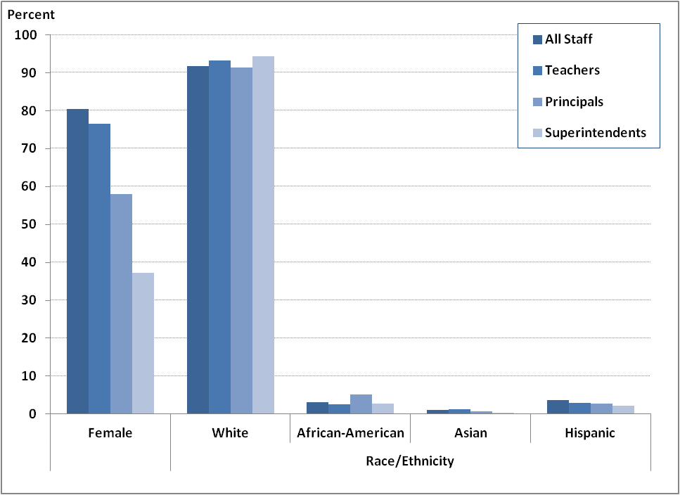
Source: Education Personnel Information Management System, Massachusetts Department of Elementary and Secondary Education

Compared with all workers in Massachusetts who attained a bachelor’s degree or higher (both public- and private-sector), teachers are less likely to be under the age of 25, but more likely to be between 26 and 32 years old. And while teachers are slightly more likely to be over 50, fewer teachers continue working past the age of 64 when compared with all workers in the state (Chart 1.4).
Chart 1.4: Age Distribution of Massachusetts Educators and All Workers, 2010-11
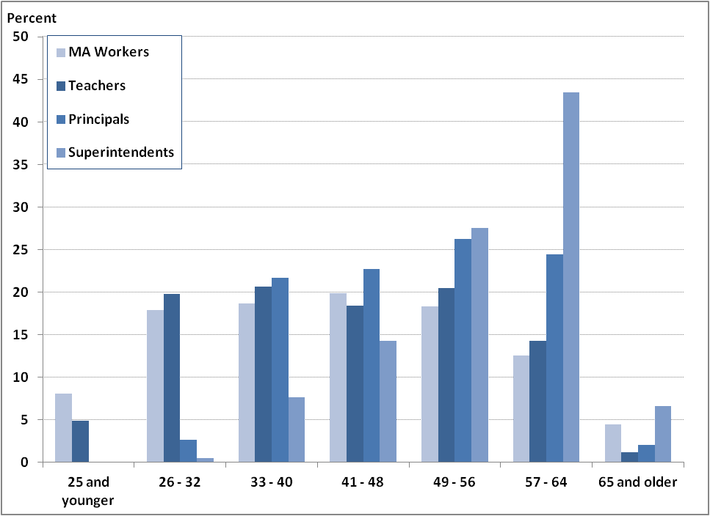
Source: Education Personnel Information Management System, Massachusetts Department of Elementary and Secondary Education, 2010 American Community Survey
Principals and superintendents, predictably, are older on average than teachers and also older than the overall Massachusetts workforce. Principals are more likely to be over 50 years old when compared with both teachers and all workers with bachelor’s degrees in the Commonwealth, though they are less likely to work past the age of 64 in comparison with other Massachusetts workers.

Years of Service
In the 2010-11 school year, 40 percent of teachers had taught for five or fewer years in their current district, while 23 percent had between 6 and 10 years of experience in their district, and another 24 percent taught between 11 and 20 years (Chart 1.5). Only 4 percent of teachers in the state have taught for more than 30 years in their current district.
Chart 1.5: Distribution of Massachusetts Educators by Years of Service in their District,
2010-11

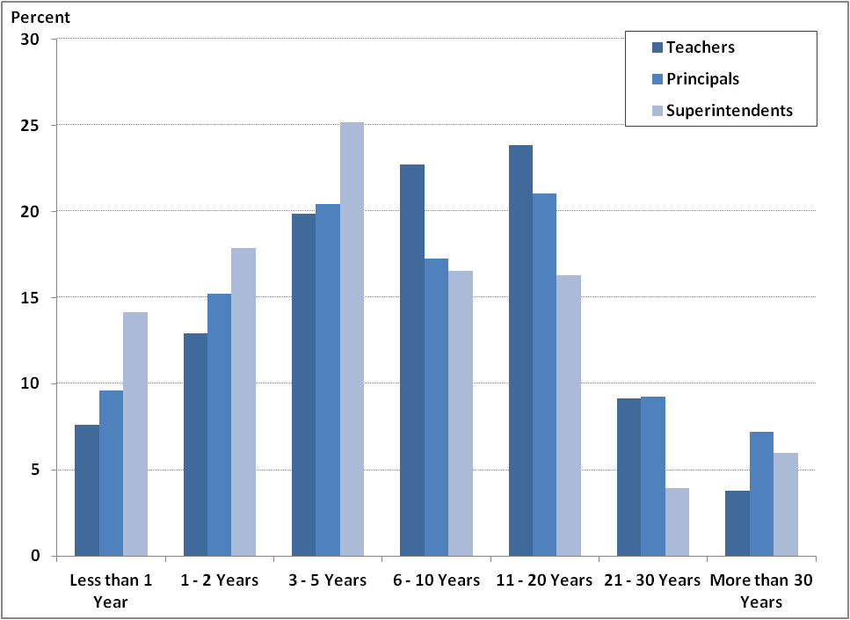
Source: Education Personnel Information Management System, Massachusetts Department of Elementary and Secondary Education
Principals’ years of service in their district follow a pattern similar to teachers’. Forty-five percent of principals worked in their district for five years or less in 2010-11, and just seven percent remained in their district for more than 30 years. Superintendents, in contrast, tend to have a shorter tenure in their districts, with 57 percent serving five or fewer years and just 10 percent remaining for more than 20 years.

Retention Rates
Among teachers who were teaching in 2008-09, 84 percent remained two years later, 81 percent remained in the same district and 75 percent remained in the same school (Chart 1.6). Of those teachers who were newly hired in 2008-09, just 76 percent were still teaching in Massachusetts public schools two years later, with 63 percent remaining in the same district and 56 percent remaining in the same school. A recent study found that 74 percent of 2007-08 beginning public school teachers were teaching in the same school two years later and 80 percent were teaching in the same district—higher numbers than Massachusetts’.
Chart 1.6: Percent of New Teachers and All Teachers Retained from 2008-09 to 2010-11
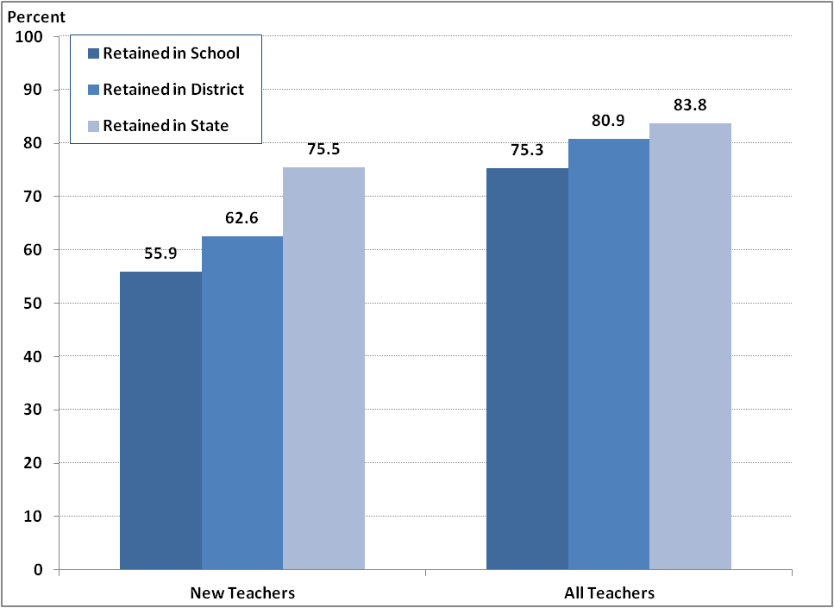
Source: Education Personnel Information Management System, Massachusetts Department of Elementary and Secondary Education
Among the new teachers who were hired in 2008-09, and then left within two years, 28 percent left for personal reasons, 26 percent did not have their contract with the district renewed and 20 percent left due to a layoff or were discharged by the district (Chart 1.7).
Chart 1.7: Reasons for Leaving: 2008-09 New Teacher Hires Who Left Teaching Within 2 Years
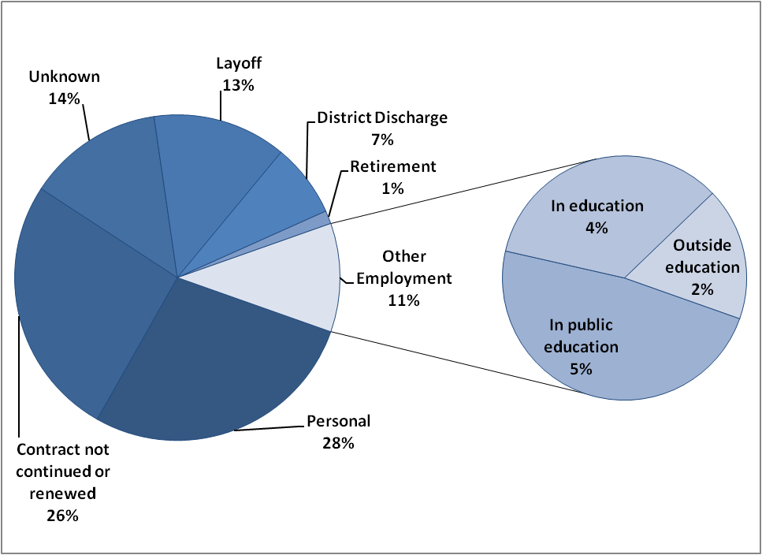
Source: Education Personnel Information Management System, Massachusetts Department of Elementary and Secondary Education

As Chart 1.8 shows, teachers with little experience and those with the longest service in their district had the highest rates of turnover. Between 2009-10 and 2010-11, almost 41 percent of all public school teachers with less than two years of service in their current district either left teaching or moved to another district, along with 43 percent of teachers with over 20 years of experience.
Chart 1.8: Percent of Teachers Exiting Teaching in Massachusetts or Moving across Districts by Years of Service in District, 2009-10 to 2010-11
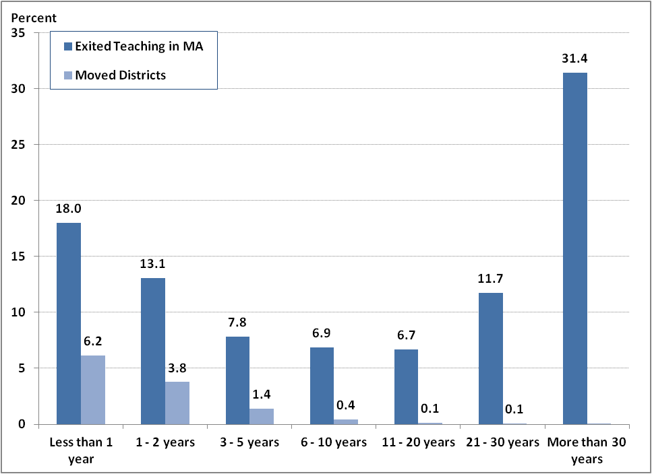Source: Education Personnel Information Management System, Massachusetts Department of Elementary and Secondary Education
Principals and superintendents have lower two-year retention rates than teachers, with 72 percent of principals and 69 percent of superintendents remaining in the state between 2008-09 and 2010-11. One-year retention rates for principals are similar to national numbers—the National Center for Education Statistics found that 80 percent of public school principals in 2007-08 remained at the same school one year later. As Chart 1.9 illustrates, in Massachusetts, both principals and superintendents have dramatically lower two-year retention rates than one-year.
Chart 1.9: One- and Two-year Retention Rates among Principals and Superintendents
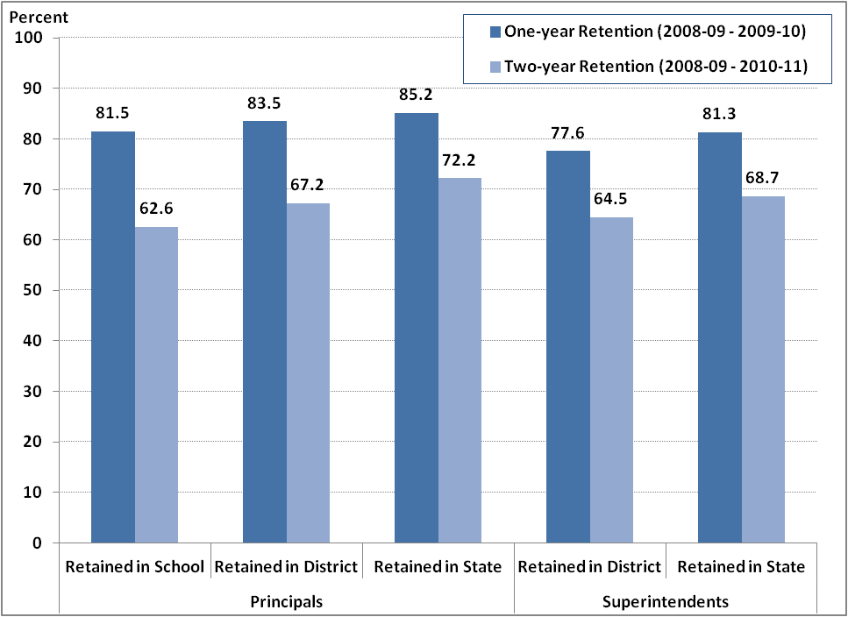
Source: Education Personnel Information Management System, Massachusetts Department of Elementary and Secondary Education

Among 2008-09 new administrator hires who left within two years, including principals and superintendents, 32 percent left for personal reasons, 13 percent retired and another 12 percent left because their contract was not renewed (Chart 1.10).
Chart 1.10: Reasons for Leaving: 2008-09 New Administrator Hires Who Left Within 2 Years
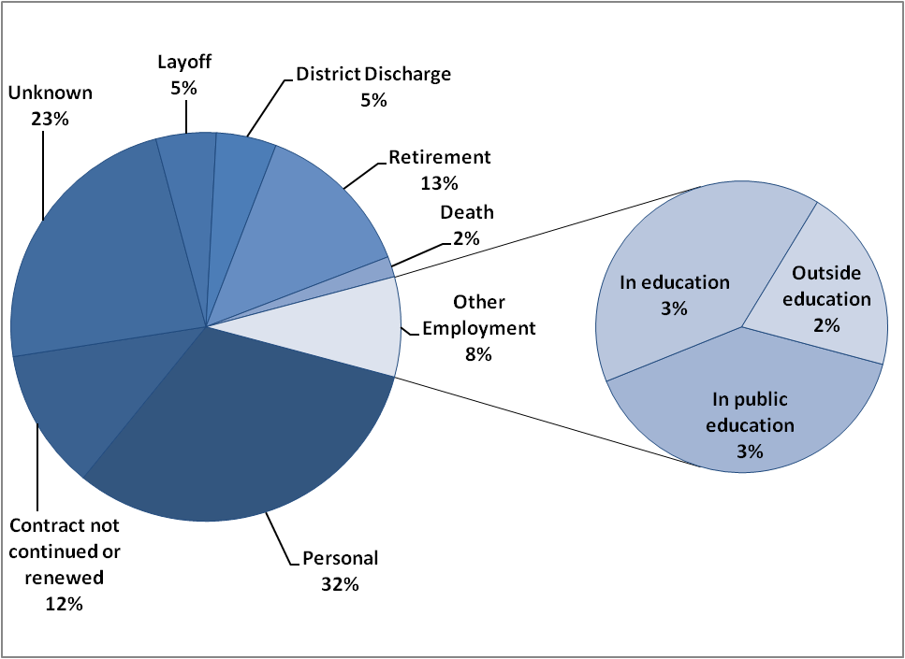
Source: Education Personnel Information Management System, Massachusetts Department of Elementary and Secondary Education

Preparation
Most of the educator supply in Massachusetts receives training from ESE approved preparation programs in order to meet state licensure requirements. Massachusetts has almost 90 organizations that sponsor educator preparation programs – both traditional institutions of higher education, as well as alternative programs, which may be operated by school districts, regional educational collaboratives, charter schools, or non-profit organizations. Alternative preparation programs accounted for seven percent of teacher preparation program graduates in 2009-10, but produced a larger share—20 percent—of principal and assistant principal candidates (Chart 1.11).
Chart 1.11: Distribution of Principal/Assistant Principal Program Completers by Program Type, 2009-10
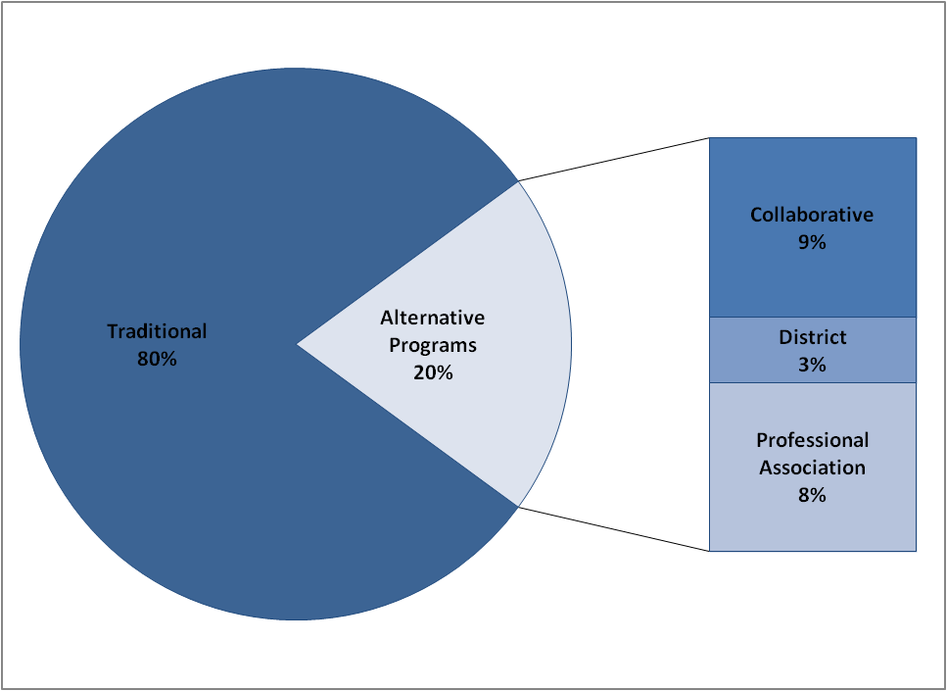
Source: Educator Licensure and Recruitment (ELAR) system, Massachusetts Department of Elementary and Secondary Education
The majority of Massachusetts teachers, 67 percent, are prepared in a post-baccalaureate preparation program. But this varies by subject area, with less than half of early childhood program completers graduating from post-baccalaureate programs while over 90 percent of those who complete English as a Second Language and special education programs receive their degree from a post-baccalaureate program (Chart 1.12).
Chart 1.12: Percent of Teacher Preparation Program Completers from Post-Baccalaureate Programs by Subject Area, 2009-10
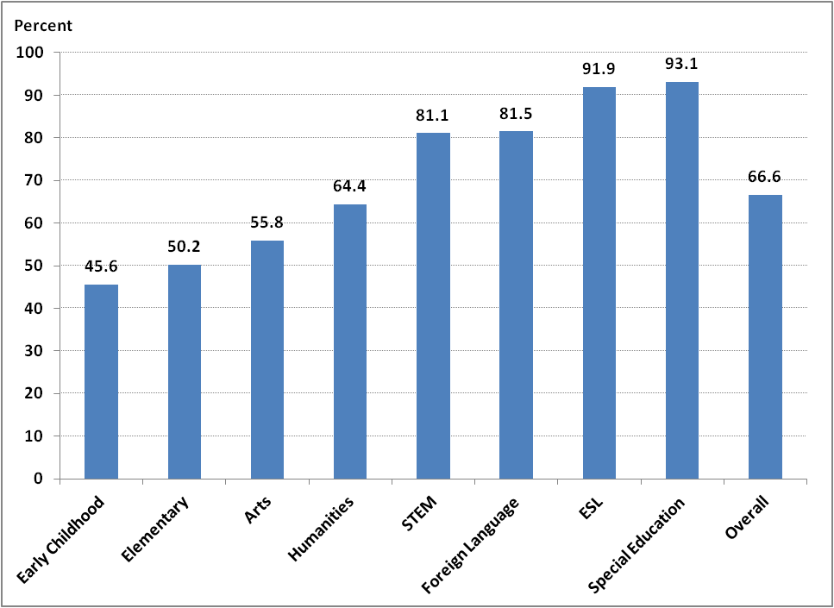
Source: Educator Licensure and Recruitment (ELAR) system, Massachusetts Department of Elementary and Secondary Education

Educator Supply and Demand
In theory, the supply of educators graduating from preparation programs should approximately match the hiring demands of school districts, thereby maximizing the chance that program graduates will find employment. But this is not always the case. For years, preparation programs in Massachusetts have graduated far more teachers licensed for elementary school positions than hiring demand warranted. Meanwhile, schools have struggled to find adequately prepared math, science and special education teachers.

But this is changing in Massachusetts. Preparation programs are producing fewer elementary teachers and more teachers in shortage areas, such as special education, mathematics and science. Recent trends in the percent of teachers who are licensed in their teaching assignment and the number of waivers granted to districts for teachers who are not properly licensed indicate that these increases in program completers is addressing shortages of licensed teachers in some high-need subject areas.

Educator Supply
As Chart 2.1 illustrates, the number of prospective teachers completing programs for their initial teaching license rose steadily between the 2001-02 and 2007-08 school years. In more recent years this number has declined slightly, and estimated data for 2010-11 indicates that this trend will continue. Administrative and non-teaching license programs, however, steadily increased in graduates through 2009-10, though estimated data indicates a slight decrease in 2010-11.
Chart 2.1: Total Completers from Initial License Programs, 2001-02 - 2010-11
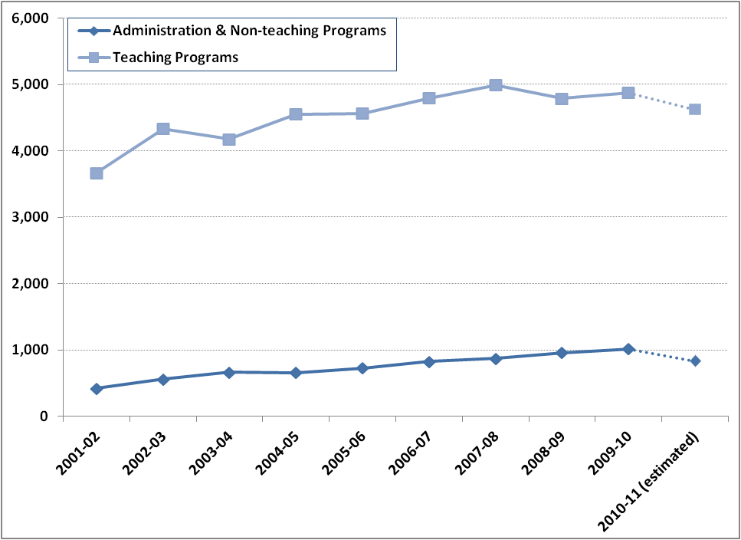
Source: Educator Licensure and Recruitment (ELAR) system, Massachusetts Department of Elementary and Secondary Education
As Chart 2.2 shows, the recent decline in teaching program completers is not consistent across all subject areas: The number of program completers in elementary license programs has declined substantially since 2007-08, while special education, humanities, and STEM (science, technology, engineering and math) programs have increased. Elementary remains the field with the most program completers, but estimated data for 2010-11 indicates that special education program completers may eventually match these numbers. This is good news for Massachusetts, which has typically seen an oversupply of elementary teachers completing preparatory programs and a shortage of special education teachers.
Chart 2.2: Teacher Preparation Program Completers by Subject Area, 2007-08 - 2010-11
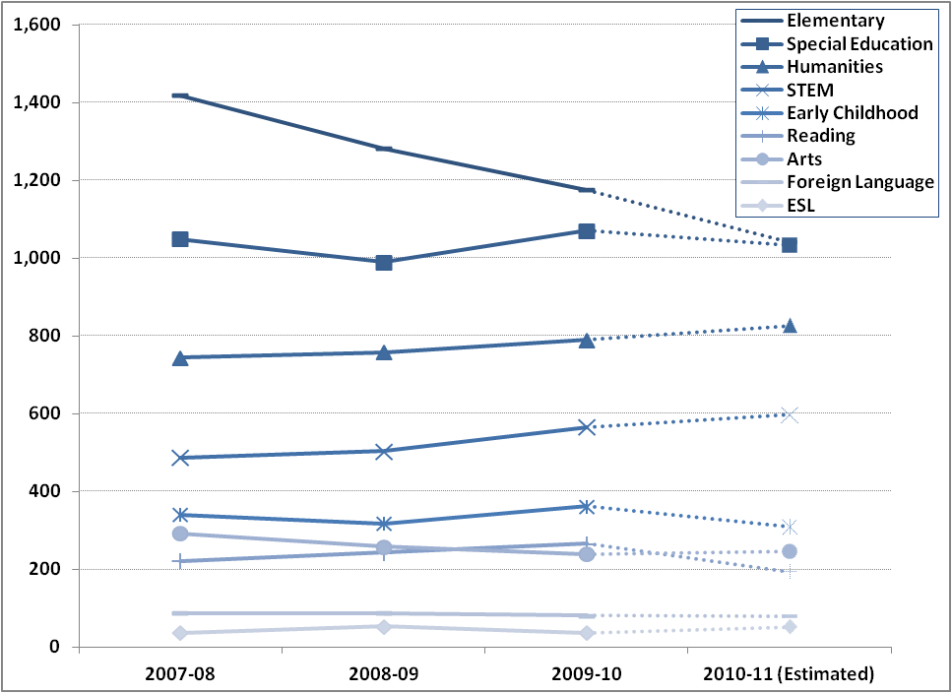
Source: Educator Licensure and Recruitment (ELAR) system, Massachusetts Department of Elementary and Secondary Education

Looking more closely at two high-need subject areas, special education and STEM, the growth in special education program completers came entirely from an increase in those completing programs for moderate disabilities, with no increase in severe disabilities licensure program completers (Chart 2.3). In STEM, however, all subject areas saw some increase in program completers, with the biggest percentage increases in mathematics, chemistry and general science.
Chart 2.3: Teacher Preparation Program Completers in Special Education and STEM Subjects, 2007-08 - 2009-10
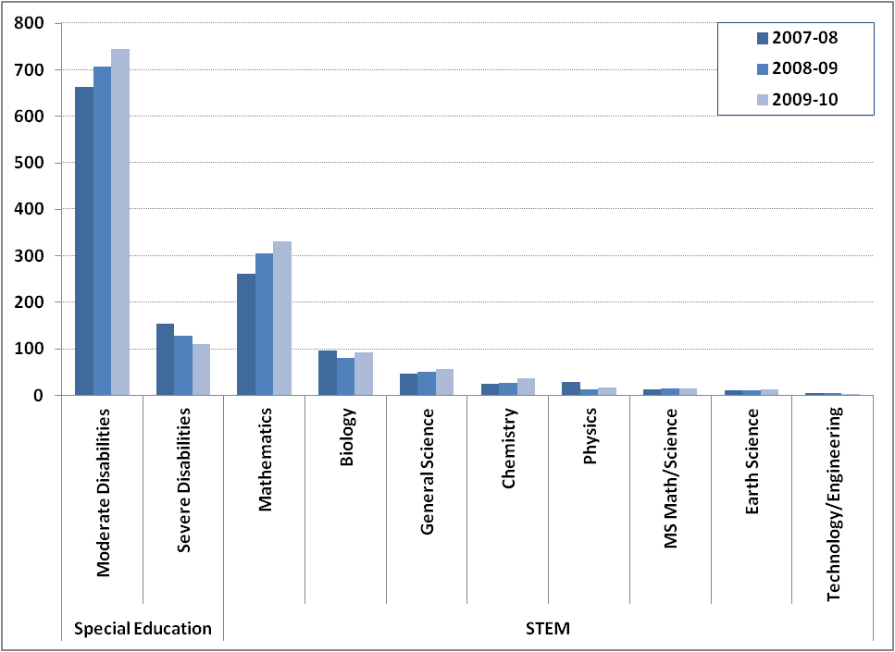
Source: Educator Licensure and Recruitment (ELAR) system, Massachusetts Department of Elementary and Secondary Education Error: Reference source not found

Looking at the fields included under administrative and non-teaching programs, increases in principal and assistant principal program completers drove most of the growth through 2009-10. While much smaller in number, superintendent and assistant superintendent program completers have also increased steadily since 2007-08 (Chart 2.4).
Chart 2.4: Administrative and Non-Teacher Preparation Program Completers,
2007-08 - 2009-10
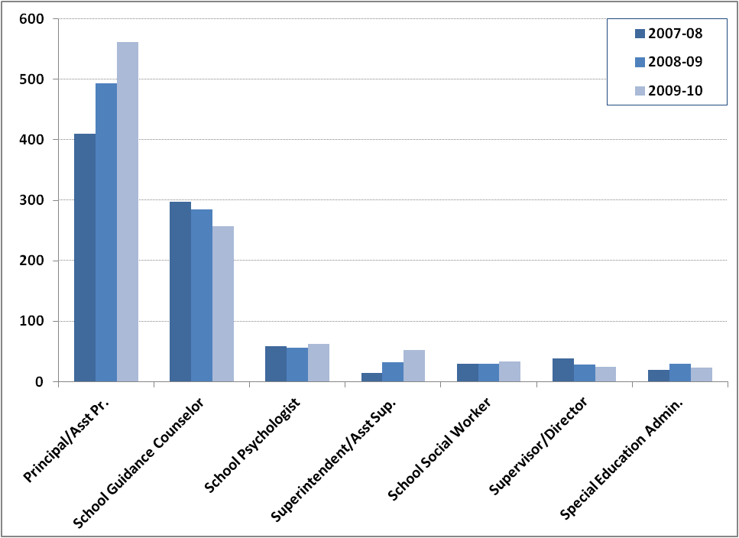
Source: Educator Licensure and Recruitment (ELAR) system, Massachusetts Department of Elementary and Secondary Education

Imbalances in Teacher Supply
Despite recent changes in graduates from teacher preparation programs, there are still too many graduates from preparation programs to meet districts’ hiring needs in some subjects, and too few in others. Chart 2.5 compares the total number of graduates from teacher preparation programs with the total number of new teacher hires in Massachusetts public schools the following year. From 2008-09 through 2010-11, preparation programs produced 59 percent more graduates than were hired by school districts. Because Massachusetts has many educator preparation programs, many of these graduates likely leave the Commonwealth to teach in other states or in private schools, and therefore the total number of program completers could overstate the actual teacher supply in Massachusetts. In the future, Massachusetts will be able to track the number of program completers who leave the state, teach in private schools or never enter teaching, and will have a better understanding of the true size of the state’s teacher supply.
Chart 2.5: New Teacher Hires and Prior Year Completers from Teacher Preparation Programs, 2008-09 - 2010-11
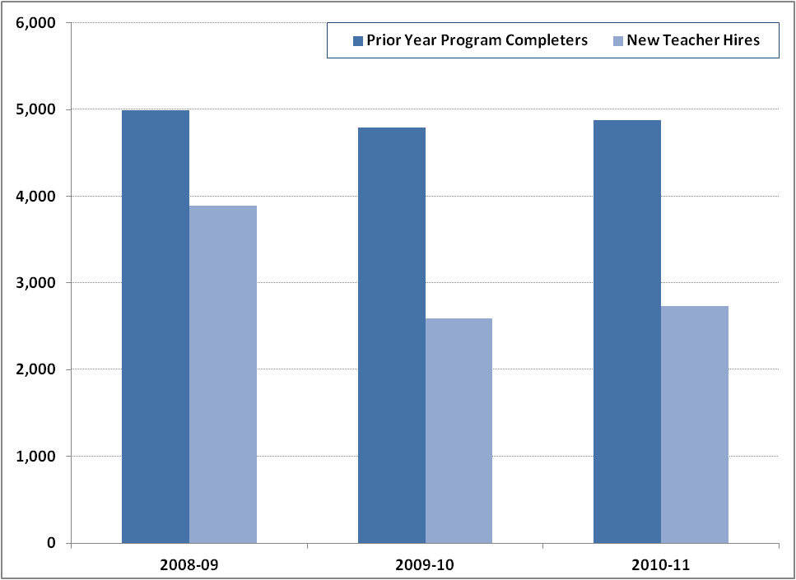
Source: Educator Licensure and Recruitment (ELAR) system and Education Personnel Information Management System, Massachusetts Department of Elementary and Secondary Education Error: Reference source not found

The American Association for Employment in Education has documented persistent teacher shortfalls in special education, mathematics, physical science, and bilingual education; their research also found surpluses in subjects like elementary education, English, and social studies. Comparing program completer and new hire data reveals similar supply and demand imbalances by academic subject in Massachusetts (Chart 2.6). In 2008-09, preparation programs produced far more teachers in elementary education, special education, history and the arts than school districts hired in 2009-10. In contrast, school districts hired more new teachers in foreign languages, science and English language arts than the number of new teachers graduating from preparation programs in the prior year.
Chart 2.6: 2010-11 New Teacher Hires and Prior Year Completers from Teacher Preparation Programs by Subject Area
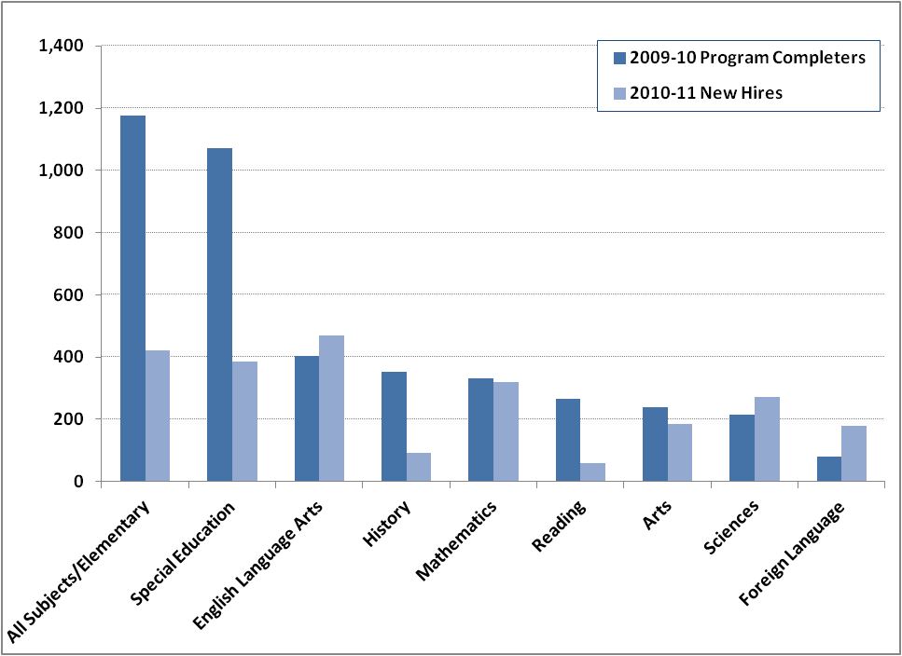
Source: Source: Educator Licensure and Recruitment (ELAR) system and Education Personnel Information Management System, Massachusetts Department of Elementary and Secondary Education Error: Reference source not found

As we discuss in the next section, shortages of adequately trained teachers in certain subjects results in fewer teachers who are licensed in the subject they are teaching. Information on the percent of teachers who are licensed in their teaching assignment along with waivers granted to districts for teachers who lack an appropriate license provide an indication of how changes in the teacher supply translate into changes in staffing in Massachusetts schools.

Subject Area Shortages
Massachusetts has seen a steady increase in the percent of teachers licensed in their teaching assignment since the 2003-04 school year. In 2010-11, 97.5 percent of teachers in Massachusetts were licensed in their teaching assignment (Table 2.1).
Table 2.1: Percent of Teachers Licensed in Their Teaching Assignment
2003-2004 | 93.9
2004-2005 | 93.9
2005-2006 | 94.4
2006-2007 | 95.4
2007-2008 | 95.8
2008-2009 | 96.6
2009-2010 | 97.1
2010-2011 | 97.5
Source: Education Personnel Information Management System, Massachusetts Department of Elementary and Secondary Education

But the percent of teachers licensed in their teaching assignment is not evenly distributed across subject areas. Mathematics, science, and foreign languages were the three core academic subjects most difficult to staff with licensed teachers in 2010-11 (Table 2.2).
Table 2.2: Percent of Teachers Licensed in their Teaching Assignment by Subject, 2010-11
Subject | Percent Licensed | Difference from State Average
History | 98.6 | +1.1
Core - All Subjects/Elementary | 98.5 | +1
Arts | 98.3 | +.8
English Language Arts | 98.1 | +.6
Social Sciences | 98 | +.5
Sciences | 97.7 | +.2
Mathematics | 97.5 | 0
Foreign Language | 94.8 | -2.7
Source: Education Personnel Information Management System, Massachusetts Department of Elementary and Secondary Education
When school districts can’t find a teacher who has the proper license for his/her teaching assignment, districts can apply to the state for a waiver, which allows them to hire someone who is not licensed to fill that assignment. Analysis of waivers granted to teachers in Massachusetts provides another window into teacher shortages, since districts can only apply for waivers if a properly licensed teacher is not available. Between 2003 and 2008 the number of waivers in Massachusetts grew overall, indicating an increase in teacher shortages, specifically in each of the subjects identified as experiencing shortages at the national level: special education and English as a Second Language, and science, mathematics, and foreign language.

From 2008 to 2011, however, waivers have declined, dropping 43 percent to 1,788. This decline occurred across high need areas, indicating that these teacher shortages are beginning to be met (Chart 2.7). In particular, the growth in graduates from preparation programs for moderate disabilities licenses appears to be helping to meet districts’ hiring needs because waivers for teachers in moderate disabilities dropped an impressive 41 percent between 2008 and 2011.
Chart 2.7: Waivers Granted in High Need Subject Areas, 2007-08 – 2010-11
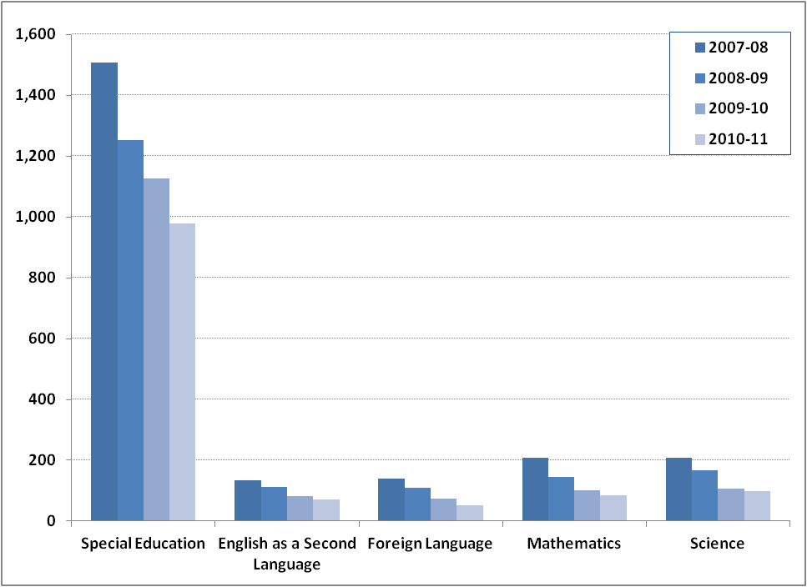
Source: Educator Licensure and Recruitment (ELAR) system, Massachusetts Department of Elementary and Secondary Education

Even with the decline in moderate disabilities waivers, special education continues to account for the largest share of all waivers in the state. In 2010-11, special education accounted for 54 percent of all waivers in Massachusetts while the other shortage areas each accounted for less than 6 percent (Chart 2.8). Among special education waivers, almost half were granted to private special education schools.
Chart 2.8: Distribution of Waivers Granted, by Subject Area, 2010-11
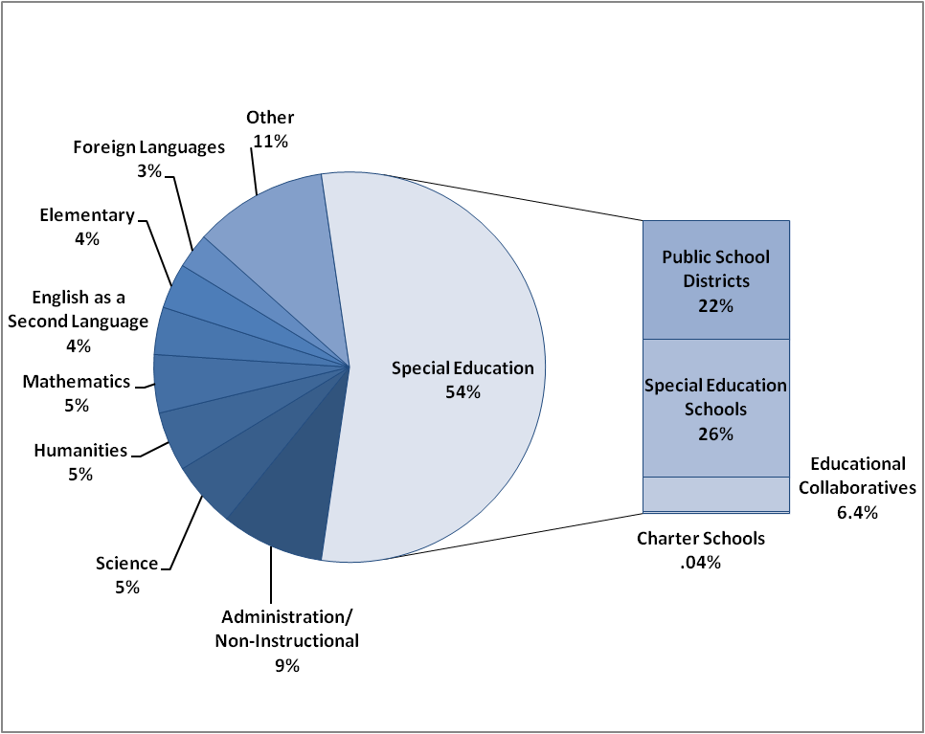
Source: Educator Licensure and Recruitment (ELAR) system, Massachusetts Department of Elementary and Secondary Education Error: Reference source not found

Diversity Shortages
The Commonwealth of Massachusetts faces a shortage of male and minority teachers. While the percent of minority students in the public school system grew three percent over the past four years, the share of minority teachers remained unchanged over that time (Chart 2.9). Likewise, the share of male teachers in public schools has remained below 20 percent since 2008.
Chart 2.9: Percent Minority Teachers and Students in Massachusetts Public Schools, 2007-08 - 2010-11
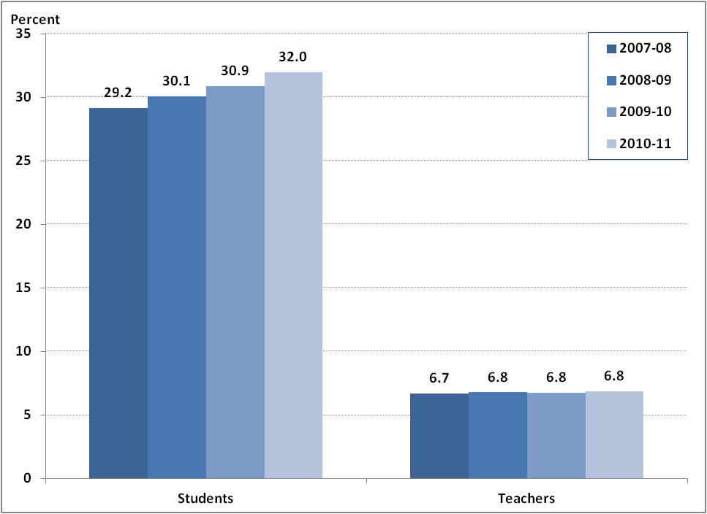
Source: Education Personnel and Information Management System, Massachusetts Department of Elementary and Secondary Education

The racial breakdown of teachers varies across the Commonwealth. Districts with high enrollments of minority students have more diverse teacher workforces. For example, in 2010-11, there were 18.5 full-time equivalent minority teachers per every 1,000 minority students in districts with high minority student enrollment (Chart 2.10). In comparison, districts with lower minority student enrollment employed between 10 – 14 minority teachers for every 1,000 minority students.
Chart 2.10: Minority Teachers for every 1,000 Minority Students by District Minority Student Enrollment, 2010-11
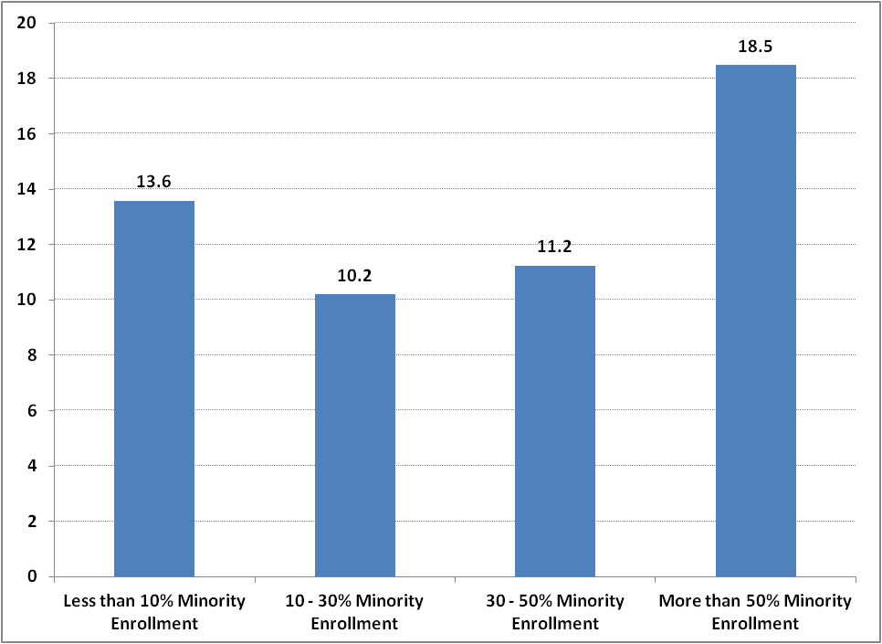
Source: Education Personnel and Information Management System, Massachusetts Department of Elementary and Secondary Education
The lack of male and minority teachers presents a serious challenge, since the current pipeline of teachers looks much the same. And as the number of minority student enrollments continues to increase, the educator workforce will become less and less reflective of the students in the public school system without dramatic changes in the demographics of new educators. Data on the state’s licensure exam test-takers provides an indication of the demographics of the educator pipeline, since many preparation programs require candidates to pass the Massachusetts Test for Educator Licensure (MTEL) before enrollment or program completion. Much like the current educator workforce, the number of white and minority candidates taking the MTEL over the past four years has remained steady with white test-takers accounting for more than 87 percent of test-takers (Chart 2.11).
Chart 2.11: Distribution of MTEL Test Takers by Race/Ethnicity, 2007-08 – 2010-11
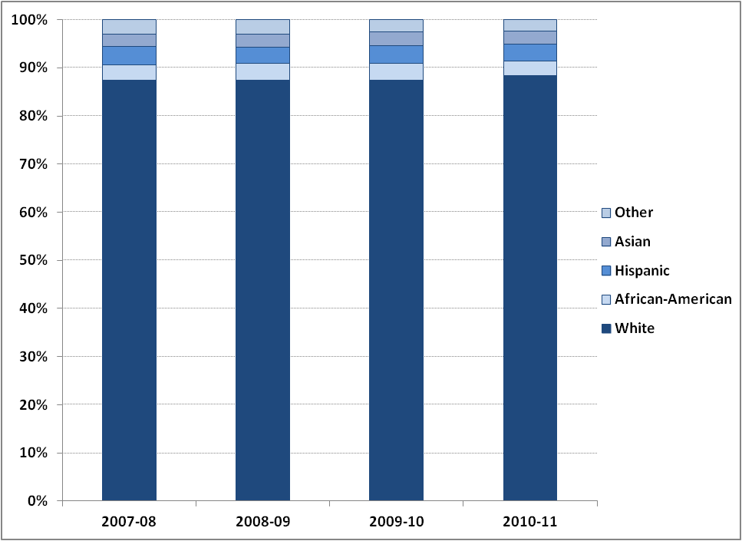Source: Evaluation Systems group, Pearson Education

Strategies for Addressing Educator Shortages
Massachusetts has a number of policies in place to address shortages in educator supply. Alternative preparation programs, for example, were authorized by ESE in 2001 specifically to provide an alternate path to licensure in areas where supply was not meeting demand, and in 2009-10, alternative preparation programs produced a large share of program graduates in some high need areas. While alternative programs produced just seven percent of teaching program completers, they produced 17 percent of completers in STEM fields and 10 percent of completers in foreign languages. Another indicator that alternative programs are helping to meet the demand for teachers in the areas of highest need is that they are graduating a low percentage of candidates in fields where numbers are already strong in traditional programs. For example, alternative programs produced just three percent of elementary program completers in 2009-10.

Recent research indicates that alternative programs nationally are also addressing diversity shortages by preparing a larger share of minority teachers than traditional programs. Program enrollment data indicates that this is also the case in Massachusetts. Among preparation programs that reported enrollment information for the 2009-10 school year, 44 percent of students enrolled in an alternative program were male and 38 percent were a racial or ethnic minority, compared with 18 percent and 9 percent, respectively, at traditional programs (Chart 2.12).
Chart 2.12: Percent Male and Minority Enrollment at Alternative and Traditional Preparation Programs, 2009-10
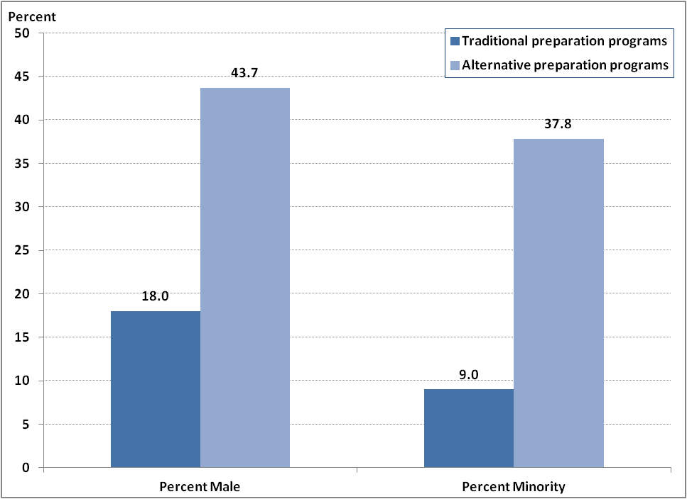Source: Educator Licensure and Recruitment (ELAR) system, Massachusetts Department of Elementary and Secondary Education
The National Center for Educational Statistics (NCES) reported that nationwide 21 percent of high school mathematics teachers and 14 percent of high school science teachers are not certified in their subject area. Massachusetts is doing much better than the national average—less than three percent of the state’s math and science teachers are not licensed in their subject—but the state’s goal is for all teachers to have the license they need for their teaching assignment. One way that Massachusetts is planning to achieve this goal is through the replication of the innovative UTeach program, founded in 1997 at the University of Texas at Austin.

UTeach actively recruits undergraduate students in science, technology, engineering, and mathematics (STEM) majors to try out a teaching course free-of-charge. The program has been so successful that an institute was formed to help expand the program to colleges in other states. In 2011 the University of Massachusetts-Lowell was awarded a $1.6 million grant through the Commonwealth’s Race to the Top funds to implement their own UTeach program, with the goal of increasing the number of licensed STEM teachers in the state.
The Commonwealth is committed to expanding the number of highly effective minority educators through targeted recruitment efforts. In 2012, the Department will launch a statewide Diversity Summit. The summit is expected to produce specific and actionable recommendations that will lead to achieving the goals of recruiting and retaining a diverse and culturally proficient educator workforce.
Massachusetts is also in the process of revamping its online teacher recruitment tool. Currently, there are three different websites designed for statewide educator recruitment. ESE’s website houses two of those sites: a job search engine, the Massachusetts Educator Career Center (MECC), and Gateway for Educators (GEM), an interactive tool for exploring the requirements, opportunities, and incentives available to current and prospective educators. The third is the aMAzing Teachers campaign, which was launched to recruit educators with a track record of being highly effective into the Commonwealth’s lowest performing schools and districts. The newly enhanced recruitment tool will streamline these three programs (MECC, GEM, and aMAzing Teachers) into one coherent and user friendly tool that has the potential of aiding the staffing needs of schools and districts throughout Massachusetts.

Equitable Distribution of Massachusetts Educators

Along with addressing statewide teacher shortages, Massachusetts must also ensure that the most experienced teachers and those with the preparation they need for their teaching assignment are distributed equitably across the schools in the state. Research nationally has demonstrated that this is often not the case—that schools with higher enrollments of low-income students often have the highest teacher and leader turnover rates, the lowest percentages of teachers licensed in their subject area, and the highest numbers of young, inexperienced teachers.

This section will examine in depth how well Massachusetts is doing with regard to the equitable distribution of educators. It is important to note that all of the indicators we examine—licensure rates, experience levels, and retention rates—only serve as proxies for the actual effectiveness of educators. As districts across the Commonwealth implement the new educator evaluation system, future reports will be able to look at the distribution of educators based on evaluators’ ratings of their performance and based on educators’ impact on student learning, thereby providing a better understanding of the distribution of effective educators across schools.

Licensure and Waivers
With 97 percent of teachers licensed in their teaching assignment, Massachusetts is doing well in ensuring that every student is taught by a teacher licensed in his subject area. But, like much of the nation, this varies by school poverty level. As Chart 3.1 shows, in schools with the highest poverty levels, 96 percent of teachers have the licenses they need in their subject area as compared with 98 percent of teachers in schools with the lowest poverty levels.
Chart 3.1: Percent of Teachers Licensed in their Teaching Assignment by School Poverty Quartile, 2010-11
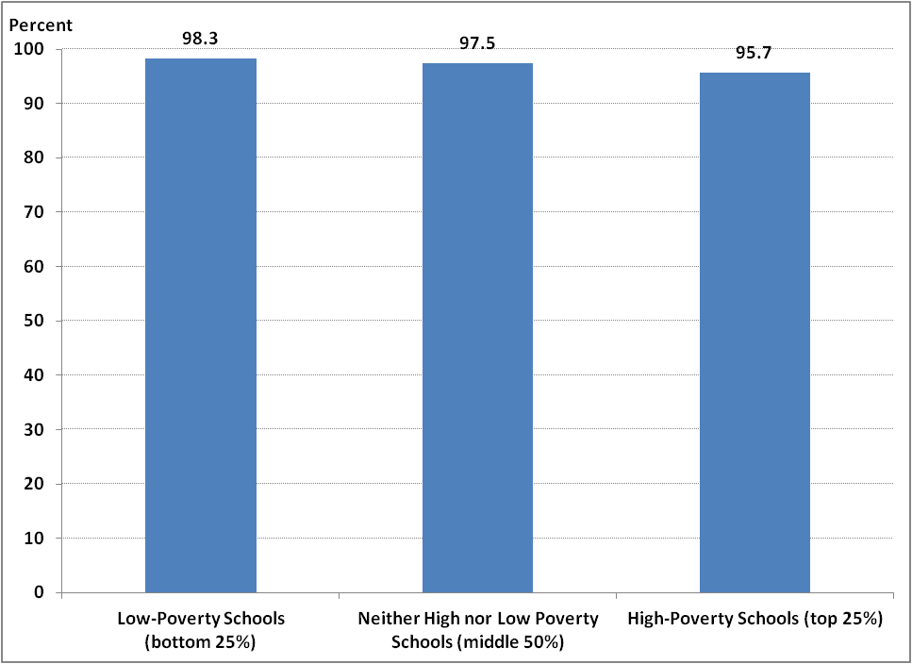
Source: Education Personnel and Information Management System, Massachusetts Department of Elementary and Secondary Education

These differences are also reflected in the data on waivers: Even with the declines in waivers between 2008 and 2011, individuals teaching under a waiver are not distributed evenly across school districts. In 2010-11, low-income districts were more likely to hire teachers with waivers—they employed an average of 2 teachers on waivers per 1,000 students, compared with only 1.2 teachers in high-income areas (Chart 3.2).
Chart 3.2: Waivers per 1,000 Students by District Low-income Enrollment, 2007-08 – 2010-11
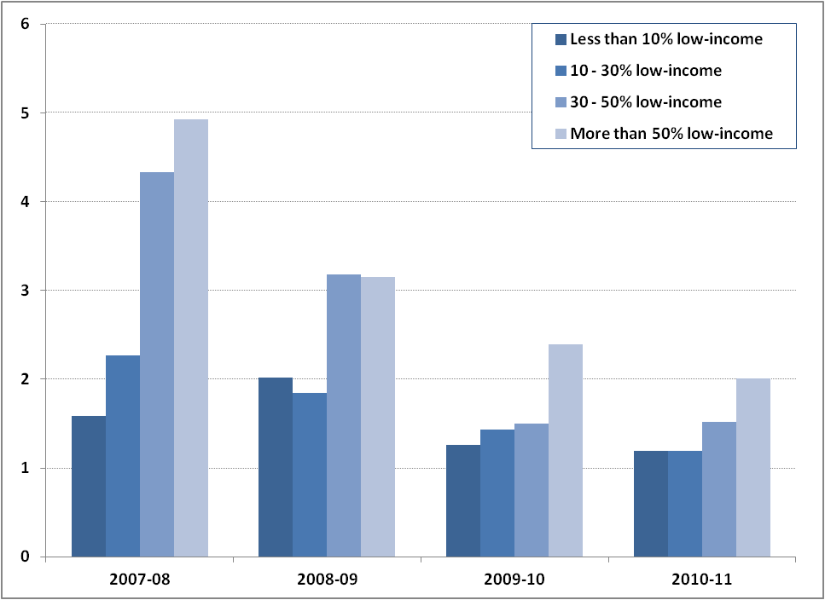
Source: Educator Licensure and Recruitment (ELAR) system, Massachusetts Department of Elementary and Secondary Education

Years of Service
Academic research indicates that years of experience in a classroom tend to increase teacher effectiveness, though the payoff does not grow indefinitely throughout years of teaching. The positive impact of experience on teacher quality appears to be highest in the first 3 to 5 years of teaching, leveling off after that. Because of the way the Commonwealth collects records about teachers, information regarding total years of teaching experience in the state are unavailable. As a proxy, this report uses length of service in a teacher’s current school district.

When compared with districts with less than 10 percent low-income enrollment, districts with low-income enrollment above 50 percent have a higher percent of teachers with 20 or more years of service in the district and a lower percent of teachers with tenure of 6 to 10 years in the district (Chart 3.3). The share of teachers with less than two years of experience in the district is about equal between low-poverty and high-poverty districts.
Chart 3.3: Massachusetts Teachers by Years of Service in District and District Low-income Enrollment, 2010-11
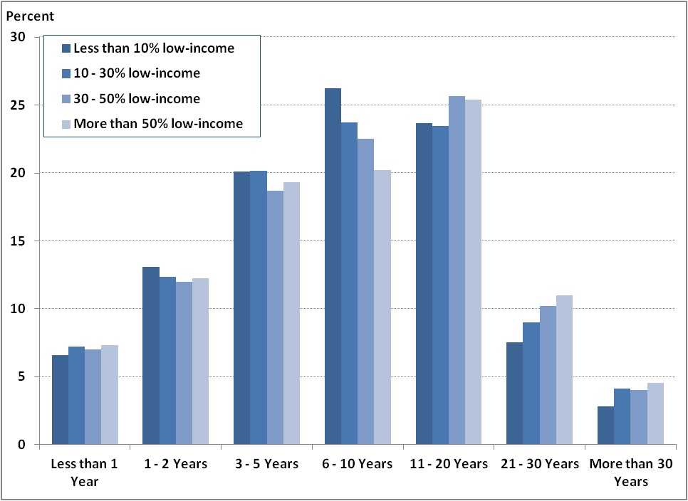 Source: Education Personnel and Information Management System, Massachusetts Department of Elementary and Secondary Education

Principals in high-poverty districts are also more likely to have a longer tenure in their district when compared with principals in low-poverty districts. Districts with low-income enrollment above 50 percent had a higher percent of principals with 11 or more years of service and a lower percent of principals with less than 10 years in the district (Chart 3.4).
Chart 3.4: Massachusetts Principals by Years of Service in District and District Low-income Enrollment, 2010-11
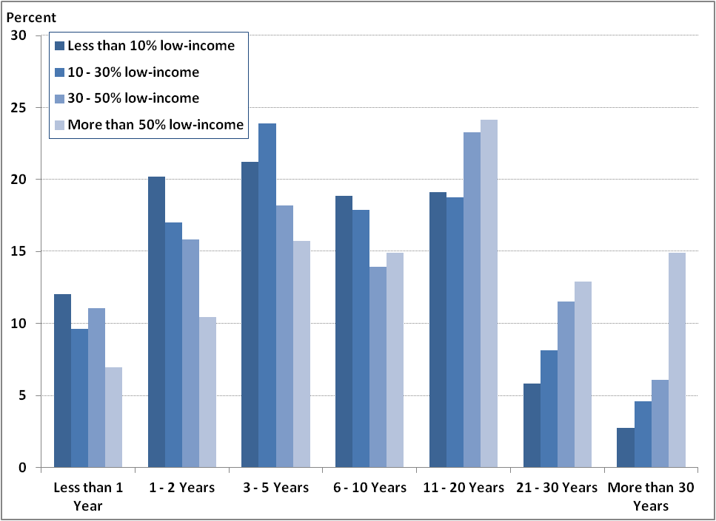
Source: Education Personnel and Information Management System, Massachusetts Department of Elementary and Secondary Education

Retention & Turnover
In Massachusetts, schools with large numbers of low-income and minority students have higher teacher turnover rates. Between 2008-09 and 2010-11, teachers in the highest poverty schools were more likely to leave teaching or transfer schools, compared with teachers in the lowest poverty schools, which had a 10 percent higher two-year retention rate (Chart 3.5).

Chart 3.5: Percent of Teachers Retained in their School from 2008-09 to 2010-11, by School Poverty Quartile
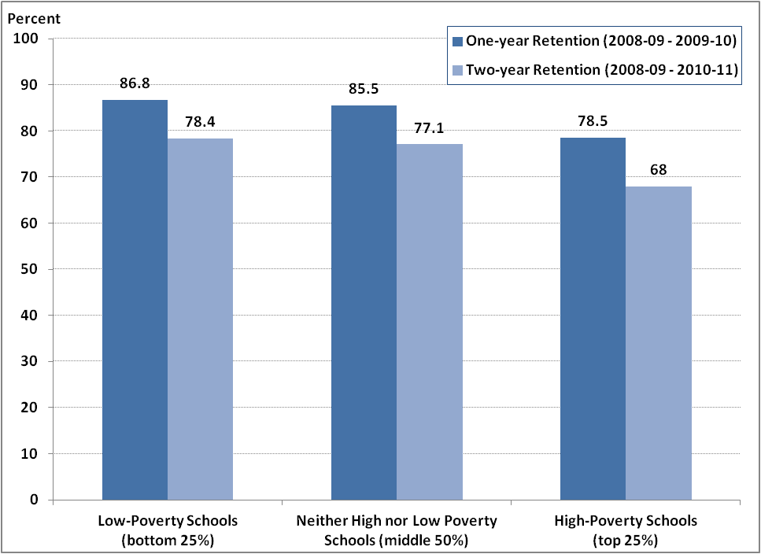
Source: Education Personnel and Information Management System, Massachusetts Department of Elementary and Secondary Education
This pattern is repeated among principals. The two-year principal retention rate at low-poverty schools was ten percent higher than the retention rate at high-poverty schools. A National Center for Education Statistics study found a similar disparity nationally, with the retention rate among principals of the lowest poverty schools 8 percent higher than the retention rate of principals at the highest poverty schools.
Chart 3.6: Percent of Principals Retained in their School from 2008-09 to 2010-11, by School Poverty Quartile
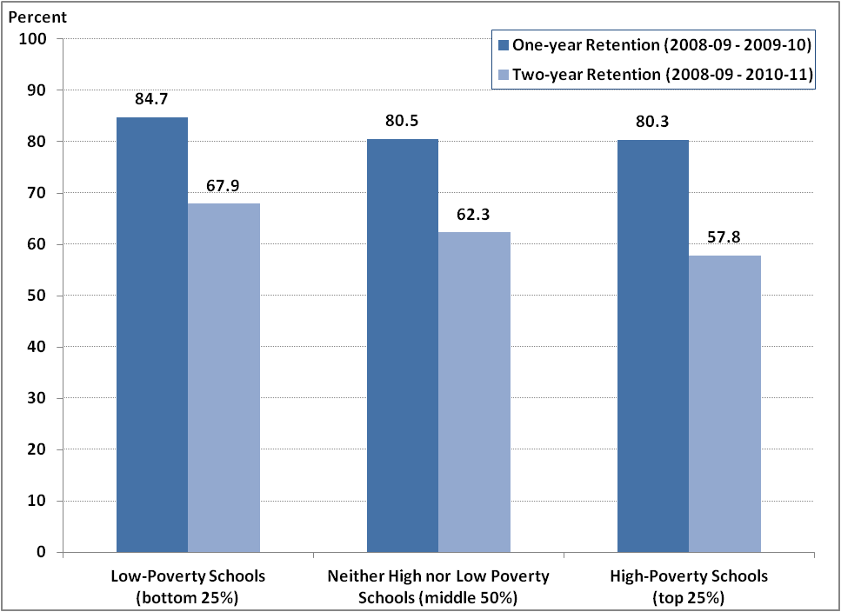
Source: Education Personnel and Information Management System, Massachusetts Department of Elementary and Secondary Education

Improving Educator Retention and Equitable Distribution
The Commonwealth is piloting innovative programs in order to increase the retention and equitable distribution of effective teachers across the state. The largest investment in this effort comes through the federal Teacher Incentive Fund (TIF) grant. TIF is designed to enable districts to attract, support, evaluate, reward and retain effective educators. The initiative focuses on the state’s two largest urban districts—Boston and Springfield—which have 63 percent of the lowest-performing schools in the state. Attracting and retaining highly effective educators to work in these 21 schools is a key component in a comprehensive approach to turning around the performance of their 13,000 students.

ESE is developing a mentoring training program that provides online and in-person training to veteran teachers interested in mentoring new teachers. This hybrid program is an opportunity to significantly increase the pool of effectively trained mentors and, consequently, improve teaching practices among a larger number of new teachers during their first years of teaching. The program will help to lower the current attrition rates of new teachers, particularly in schools and districts serving low performing and/or high needs student populations.

In the area of teacher retention, three districts are participating in the Human Resources (HR) Pilot project, which is designed to identify and promote the most efficient, effective, and supportive school and district HR systems in Massachusetts. This work stems from research on effective HR strategies that improve educator performance and can be replicated in other districts.

The Commonwealth is taking a number of proactive steps in order to support and retain principals and superintendents as well. Many of the resources for this important work stemmed from grants provided to the state by The Wallace Foundation. Research funded by these grants informed ESE about the most successful ways to recruit, support, and retain quality administrators at the school and district level.

To increase the success and tenure rate of district superintendents, ESE and the Massachusetts Association of School Superintendents (MASS) collaborated to create the New Superintendent’s Induction Program – a three-year support program for new superintendents across the Commonwealth. The program is currently in its second year working with superintendents from 60 districts. The induction program provides an eight-day professional development series to assist new superintendents in developing key skills and knowledge that are integral to their leadership role. Retired Massachusetts superintendents are trained as coaches by the program and commit to spending eight hours monthly advising new superintendents based on the unique needs of each district.

For school leaders, the National Institute for School Leadership (NISL) training is a comprehensive professional development program to enhance educator effectiveness and leadership development in Massachusetts. The 18- to 24-month NISL Executive Development for School Leadership curriculum focuses on training in standards-based instructional systems aligned with the Massachusetts state curriculum frameworks as well as in analysis of student achievement data. It also focuses on empowering school leaders to create a culture that fosters instructional collaboration and high achievement. A study put out by the Center for Educational Partnerships at Old Dominion University in 2010 indicated that average test scores of students in schools with NISL-trained principals are higher on average than students whose principals did not attend NISL training.

Looking Ahead
Since the introduction of Massachusetts’ Education Personnel Information Management System (EPIMS) in 2007, the state has greatly expanded the amount of data it collects on educators in its public schools. Because of EPIMS, we now know educator hiring patterns, retention rates and diversity. But there are still important gaps in our knowledge about the characteristics, and, most importantly, the effectiveness of our state’s educators. Funding through the federal Race to the Top program and Longitudinal Data Systems grants will allow the state to begin filling these gaps.

By the 2013-14 school year, Massachusetts will collect teacher evaluation ratings from all districts across the state as part of Race to the Top. Under the new educator evaluation system, districts will be required to collect and report information on observational ratings of teacher performance and teachers’ impact on student learning growth based on at least two measures. As this data becomes available, future Massachusetts Educator Workforce reports will be able to paint a more detailed picture of the educator workforce and its impact on student learning.

Massachusetts also plans to collect more information on our educator pipeline using funding from the Longitudinal Data Systems grant. Under this grant, the state will link the Educator Licensing and Recruitment (ELAR) system, which tracks all preparation program completers in the state, with EPIMS. This connection will allow Massachusetts to track prospective educators’ paths from the time they enter an educator preparation program through their employment in Massachusetts public schools and will provide a more accurate picture of the state’s educator career continuum.

New regulations governing the approval and monitoring of educator preparation programs will be rolled out in 2012 and will help identify how well educator preparation programs are meeting the hiring needs of school districts and how effective their graduates are once they reach schools and classrooms. With better data on the educator pipeline and the role preparation programs play in contributing to an effective and diverse workforce, Massachusetts will be well positioned to hold programs accountable for how well they prepare educators to succeed in the state’s public schools.

Due to the investment of energy and resources by the educators and citizens of this state, Massachusetts has made significant strides to improve public education and challenge all students to learn to high standards. Over the next three years, the state and districts will be revamping their data management systems in order to streamline and improve the information collected on our educator workforce. The next great challenge for the Commonwealth will be learning how to use this data effectively in order to better support educators in improving teaching and learning across Massachusetts.
Data Notes

The most recent data available from the Education Personnel Information Management System is from the 2010-11 school year. Estimated data on graduates from preparation programs is available for the 2010-11 school year and the most recent official data is available for the 2009-10 school year. District reported data on waivers is available in ELAR through the 2010-11 academic year.
The full-time equivalent (FTE) totals are slightly lower than the headcount of educators because some educators work part-time and are counted as partial FTE employees (a teacher working half of each week, for example, would be counted as .5 FTE).
Charter schools are counted as both schools and districts. The number of schools and principals, and districts and superintendents does not match because some principals or superintendents may work part-time or across multiple schools or districts, therefore not every school or district may have a full-time principal or superintendent.
Kowalski, T., McCord, R., Peterson, G., Young, P., & Ellerson, N. M. (2011). The American school superintendent: 2010 Decennial study. Alexandria, VA: American Association of School Administrators.
Snyder, T.D. and Dillow, S.A., Digest of Education Statistics: 2010, (Washington, D.C.: U.S Department of Education National Center for Education Statistics, April 2011).
Kaiser, A. & Cross, F., (2011) Beginning Teacher Attrition and Mobility: Results from the First through Third Waves of the 2007-08 Beginning Teacher Longitudinal Study, (Washington, D.C.: U.S. Department of Education National Center for Education Statistics, September.
The term “new teacher” refers to all teachers new to Massachusetts’ public schools.
Two-year retention rates are defined as having stayed in the position for three full academic years, and one-year retention rates are defined as having stayed in the position for two full academic years.
Battle, D. & Gruber, K. (2010) Principal Attrition and Mobility: Results from the 2008-09 Principal Follow-up Survey, (Washington, D.C.: U.S. Department of Education National Center for Education Statistics).
Teachers coming from out-of-state may receive a temporary license to teach in Massachusetts public schools. After passing the state licensure exam, they receive an initial license and do not need to complete an ESE-approved preparation program. Teachers can also earn their initial license through the Performance Review Program for Initial Licensure (PRPIL), which allows teachers with three years of experience under a preliminary license to gain an initial license without completing a full initial license preparation program. A preliminary license allows teachers who have not completed an ESE-approved preparation program to teach for up to five years before earning their initial license.
A baccalaureate preparation program prepares teachers for licensure as part of a bachelor’s degree, whereas a post-baccalaureate program prepares candidates only after they have received a bachelor’s degree.
Preparation programs have not yet reported official program completer data for the 2010-11 school year. Estimated numbers are based on the number of prospective teachers who reported completing a program between September 2010 and August 2011 and were endorsed as successful completers by their preparation program.
In Massachusetts, all teacher and specialist candidates are required to demonstrate subject matter knowledge related to their license by passing the appropriate Massachusetts Tests for Educator Licensure (MTEL) exams.
Boser, U., Teacher Diversity Matters: A State-by-State Analysis of Teachers of Color, (Washington, D.C.: Center for American Progress, November 2011).
Jason G. Hill and Kerry J. Gruber, Education and Certification Qualifications of Departmentalized Public High School-level Teachers of Core Subjects: Evidence From the 2007-08 Schools and Staffing Survey, (Washington, D.C.: U.S. Department of Education National Center for Education Statistics, May 2011).
For more information on the UTeach program, visit http://www.uteach-institute.org
Borman, G.D. and Dowling, N.M. (2008). “Teacher Attrition and Retention: A Meta-Analytic and Narrative Review of the Research,” Review of Educational Research, 78 (3): 367-409. Fact Sheet: Teacher Equity, (Washington, D.C.: The Education Trust)
Rockoff, J.E. (2004). “The Impact of Individual Teachers on Student Achievement: Evidence from Panel Data.” American Economic Review, 94 (2): 247-252.
Battle, D. & Gruber, K. (2010) Principal Attrition and Mobility: Results from the 2008-09 Principal Follow-up Survey, (Washington, D.C.: U.S. Department of Education National Center for Education Statistics).
Saphier, J., Haley-Speca, M. A., & Gower, R. R. (2008). The skillful teacher, building your teaching skills. Research for Better Teaching.
Nunnery, J., Ross, S. & Yen, C. (2010). An Examination of the Effect of a Pilot of the National Institute for School Leadership’s Executive Development Program on School Performance Trends in Massachusetts (Norfolk, VA: The Center for Educational Partnerships at Old Dominion University).
Beginning in the 2011-12 school year, 34 schools will implement the new evaluation ratings along with 15 early adopter districts and educational collaboratives. In 2012-13, all Race to the Top districts will implement the evaluation system.
This data is based on district reports of teachers’ actual job placements and may differ from the distribution of teachers based on their grade level licenses.
This data is based on district reports of teachers’ actual job placements and may differ from the distribution of teachers based on their subject area licenses.
To make data on subject areas easier to understand, similar subject areas are grouped into larger categories throughout the report. Below is a list of the subjects and licenses included in each category: CategorySubject AreasArtsCommunication and Performing Arts, Dance, Music, Theater and Visual ArtsHumanitiesEnglish, History, Latin and Classical Humanities, Middle School Humanities, Social Studies, STEMBiology, Chemistry, Earth Science, General Science, Mathematics, Middle School Mathematics/Science, Physics, Technology/EngineeringForeign LanguageChinese, French, German, Hebrew, Italian, Japanese, Portuguese, Russian, SpanishEnglish Language LearnersEnglish as a Second Language, English Language Learners, Transitional Bilingual EducationSpecial EducationDeaf and Hard of Hearing, Moderate Disabilities, Severe Disabilities, Speech Language and Hearing Disorders, Visually Impaired
Reading licensure programs are excluded from this analysis because all reading licensure programs are offered at the post-baccalaureate level.
Data only includes initial license programs.
Data only includes initial license programs. School business administrator data is excluded because there were too few program completers in each year.
Waiver data includes waivers granted to public school districts, educational collaborative, private special education programs and schools, and charter schools
Approximately 13 percent of districts have minority student enrollments higher than 50 percent, 9 percent have minority enrollment between 30 and 50 percent, 37 percent have minority enrollment between 10 and 30 percent, and 42 percent have minority enrollment below 10 percent. In low-income enrollment, approximately 11 percent of districts have low-income enrollment above 50 percent, 16 percent are between 30 and 50 percent, 46 percent are between 10 and 30 percent, and 27 percent have less than 10 percent low-income enrollment. The authors chose to distinguish between districts by enrollment thresholds rather than divide districts into enrollment quartiles in order to show differences between districts at the very low and very high ends of enrollment. Among schools, quartiles are sufficient for showing differences among schools at the low and high ends of low-income student enrollment, therefore high poverty schools are defined as being in the top quartile of low-income enrollment in the state.
Percentages are based on numbers of test-takers for the Communication and Literacy Skills test because all educator licenses require passage of this test of reading and writing skills.
This data includes Commonwealth charter schools, which are not required to have teachers licensed in their subject area, but are required to demonstrate that teachers have subject matter competency. Teachers can demonstrate subject matter competency through having appropriate licensure or, in some cases, having an academic major or National Board certification in the subject area.
Data is only for Massachusetts public school districts.

