Issue Brief: Time Use in Massachusetts
Expanded Learning Time (ELT) Schools

Introduction and Purpose

Expanded learning time seems to be a simple idea: by lengthening the school day (or year), students have more time to learn. Yet as schools revisit their schedules and decide how to allocate time in their academic calendars, they can and do face challenging decisions related to time allocations. This brief highlights lessons learned from some schools’ experiences with redistributing time for students, focusing specifically on schools that participated in the Massachusetts Expanded Learning Time (ELT) initiative. This set of schools participated in a multi-year study of the ELT initiative., The information presented below draws primarily from interviews with principals and master schedules for 5th and 8th grade students, and secondarily from surveys of teachers, and surveys of 5th and 8th grade students in 17 ELT and 19 matched comparison schools. The data all refer to the 2010-2011 school year.

About the ELT Initiative
ELT schools in Massachusetts receive state-funded grants from the Massachusetts Department of Elementary and Secondary Education (ESE) to expand their school year by at least 300 hours. The additional time represents about eight additional hours a week, on average, for core academics, academic support and enrichment for students, and common planning time for teachers. Participating ELT schools receive an additional $1,300 per pupil per academic year to implement a redesigned and expanded schedule.
Future Consideration: Student Assessment
One challenging issue for schools is determining how best to assess student progress in enrichment classes. Fewer than half of teachers (47%) in ELT schools reported that students were assessed similarly in both core academic and enrichment classes, and almost half of teachers (46%) reported that student behavior was problematic during enrichment, although concerns about student behavior appeared to decrease over the course of the evaluation.

Strategies for Allocating Time in ELT Schools
ELT schools differed in how they allocated time across academic subjects (e.g., reading/literature, mathematics, science, and social studies), other special subject areas (e.g. art, music, and physical education), enrichment opportunities (i.e targeted academic support for students struggling in particular content areas), and other non-instructional parts of the school day (e.g., homeroom, lunch and recess). Because so many schools—not just ELT schools—regularly assess how they allocate time, we examine both ELT and comparison schools that were not receiving ELT funding from the state.
ELT schools individually determined how to add 300 hours to their schedules. The ELT study found that all ELT schools opted to incorporate the additional time by extending the length of their school day even though schools had the option of shortening spring vacations, extending the school year into the summer, or reconfiguring the calendar to provide year-round instruction. On average, the ELT school day was seven hours and 40 minutes long, approximately 90 minutes longer than the average day in matched comparison schools.
One core component of ELT that may be of particular interest to teachers and administrators is collaborative planning time. Shared planning time can provide teachers with opportunities to collaborate on lesson plans, strategize about students, and engage in professional development. While this brief focuses on students’ time in ELT schools, a separate brief will focus on collaborative planning time for educators.

Amount of Time Allocated to Instructional Activities in ELT Schools Per Day,
by School and Grade, 2010-11
Source: Abt Associates’ Interviews of MA ELT and Matched Comparison School Principals, Spring 2011, Item 11.

Variation in Time Use
On average, ELT schools allocated 61% of time to core academic instruction, 13% to specials, 6% to dedicated academic support, 5% to enrichment activities, and 15% to other blocks or transitions such as lunch, recess, passing periods and homeroom.
ELT schools varied considerably in the patterns of time allocation across various activities. Not surprisingly, the majority of time was devoted to core academic instruction in all of the ELT schools in the study. However, as shown in the chart above, some schools scheduled about four hours a day of core academic instruction for 5th graders, while others allocated over five hours a day (see the purple portions of each bar). The variation in amount of time dedicated to core academics for 8th graders was even greater, ranging from slightly more than three to over five hours each day.
All 19 ELT school schedules included specials, all but two incorporated enrichment activities, and all but four offered stand-alone academic support blocks. Relative to matched comparison schools, ELT schools devoted over 40 additional minutes to core academic subjects, 17 additional minutes to enrichment, and 10 additional minutes to academic support, on average, every day. However, some matched comparison schools also allocated time in their schedules to enrichment and academic support activities. Below, we provide specific examples of how ELT schools and an illustrative comparison school chose to allocate time and organize their schedules.

Key Theme: Extended Blocks for Core Academic Subjects
Five elementary and two middle schools offered longer English Language Arts (ELA) and Mathematics blocks. One elementary school’s typical weekly schedule for a 5th grade student illustrates this approach below. This school’s schedule included a two-hour ELA block every morning and a two-hour Math block every afternoon for its fifth grade students. Teachers typically divided the longer time blocks into some whole group instruction followed by further instruction for students needing extra support. While the teacher provided target support to those students, the remainder of the class worked on independent practice or small group work. The ELA and math blocks represented only part of the increased amount of time; this school had three other periods each day, which were devoted to instruction in writing or social studies, science, and specials such as physical education, art, and music.
Sample 1: Extended ELA and Math Blocks Schedule: 5th Grade Elementary School Student
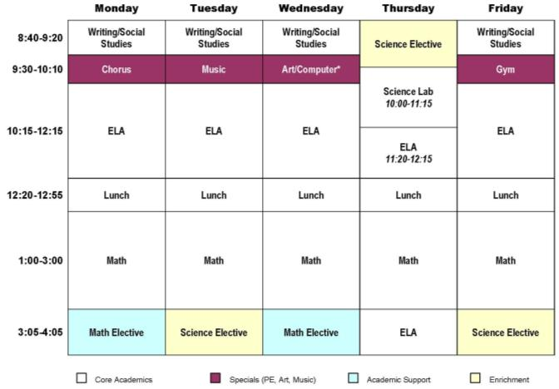
Source: Abt Associates’ Interviews of MA ELT and Matched Comparison School Principals, Spring 2011, Item 11.

Some middle schools also offered extra time for core academic subjects. One ELT school, for example, scheduled large blocks for its eighth graders, including a 150-minute Humanities block each morning that incorporated ELA and social studies as well as a 105-minute block each afternoon for math. The exhibit below depicts a sample weekly student schedule from this school.
Sample Extended Block Weekly Schedule: 8th Grade Middle School Student
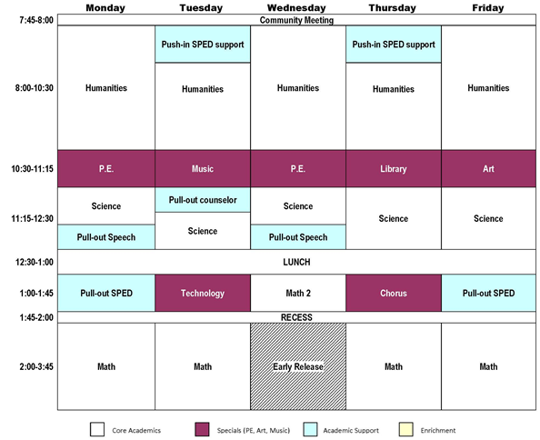
Source: Abt Associates’ Interviews of MA ELT and Matched Comparison School Principals, Spring 2011, Item 11.

Key Theme: Dividing English Language Arts Into Composite Skill Areas
Three ELT elementary schools and one middle school divided ELA into separate skill areas (e.g., reading, writing, spelling) such that each skill area had its own class. One school scheduled distinct one-hour blocks of literacy and writing, and a 45 minute block of Elements of Reading each day. Another school scheduled two daily 60-minute blocks of ELA, as well as a writing class that occurs twice every week.

Key Theme: Variation in Schools’ Scheduling of Academic Support and Enrichment
ELT schools generally relied upon one of three different approaches to scheduling academic support (targeted instruction for students who are struggling in particular subjects) and enrichment (distinct class sessions or supplemental activities woven into traditional core academic courses)—both of which are designed to provide students more depth in learning. The most common approach used by ELT schools was to schedule academic support or enrichment instruction at the end of the day. Schools using this approach rotated the schedule for other subjects such that the schedule varied each day, yet enrichment and/or academic support classes were always in the last block. Academic support was taught in the last block at five elementary schools and one middle school, and at 10 elementary schools and three middle schools, enrichment was taught last.
A second approach integrated academic support and/or enrichment classes into the regular school day. Two of the 10 elementary ELT schools integrated their schedules this way; one integrated academic support, and one integrated enrichment into their schedules. Of the eight middle schools, five integrated academic support and three integrated enrichment. A sample schedule from a middle school that integrated academic support and enrichment into the school day is displayed below.
Sample Weekly Integrated Academic Support and Enrichment Schedule: 8th Grade Middle School Student
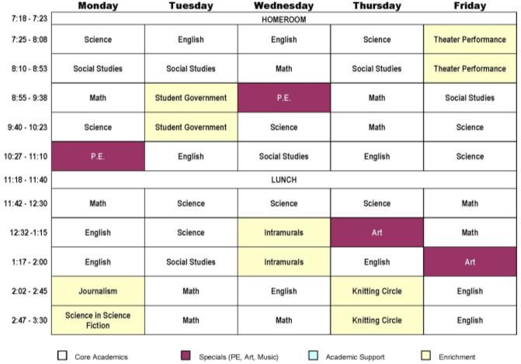
Source: Abt Associates’ Interviews of MA ELT and Matched Comparison School Principals, Spring 2011, Item 11.

In the third group of schools (four elementary and two middle), academic support was provided to students by pulling them out of their regular core content classrooms and providing individualized attention from other teachers or paraprofessionals, or the reverse, by additional staff entering into students’ regular classrooms specifically to provide targeted attention to individual or small groups of students (called “pull-out” and “push-in” instruction, respectively). A schedule from an ELT school that provided academic support using the pull-out and push-in model for academic support is shown on page 4 of this brief.
Additional Ideas: Time Use in Comparison Schools
About half of the comparison schools in the study sample incorporated longer blocks for core subjects, specials, academic support, and/or enrichment activities into their school schedules, even though the schools were not implementing ELT. Ten of 19 comparison schools allocated time to dedicated academic support periods for students. One school scheduled daily reading and math workshops, grouping students according to academic focus and areas for growth. Another school offered daily math MCAS prep classes for all students.

A sample schedule from one comparison school that incorporated time for both academic support and enrichment is presented below.

Sample Weekly Comparison School Schedule Integrating Academic Support and Enrichment
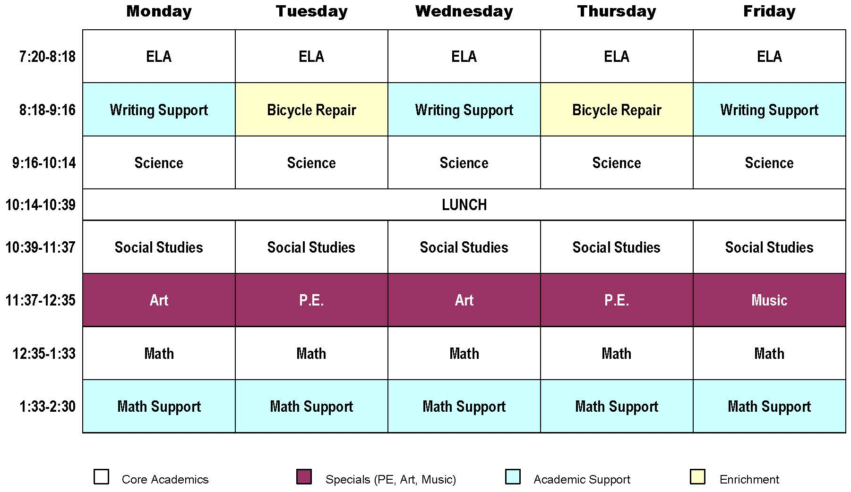
Source: Abt Associates’ Interviews of MA ELT and Matched Comparison School Principals, Spring 2011, Item 11.

Conclusions
As school and district administrators consider the redesign of their schools’ schedules, time allocation is a key factor. ELT schools used a variety of approaches to arrange instructional and other learning experiences for their students. The longer school day clearly increased the amount of time for core academic subjects as well as non-core classes and specials.
It is also important for school leaders to consider the quality of additional instructional time. A recent report notes that “time” can have different meanings, from allocated time, the total number of hours in a school day, to the amount of instructional time, the amount of time students are in academic classes, and to the academic learning time, “that precise period when an instructional activity is perfectly aligned with a student’s readiness and learning occurs” Drawing on Aronson et al. and Silva’s research, this report reiterates the important point that “while time in school is necessary for learning, time alone is not sufficient.”
Abt Associates is a mission-driven, global leader in research and program implementation in the fields of health, social and environmental policy, and international development. Known for its rigorous approach to solving complex challenges, Abt Associates was ranked as one of the top 20 global research firms in 2012 and also named one of the top 40 international development innovators. The company has multiple offices in the U.S. and program offices in nearly 40 countries.
Questions about this brief can be directed to Amy Checkoway at 617-520-2366 or Amy_checkoway@abtassoc.com

Note that one K-8 campus functioned as two separate schools, each with its own principal.
This brief was prepared by Meghan Caven, Amy Checkoway, Beth Gamse and Sally Wu of Abt Associates Inc.
Information presented in this brief is from a multi-year study conducted by Abt Associates Inc. that examined both implementation and outcomes for the ELT initiative; please see a comprehensive report at http://abtassociates.com/Reports/2012/-ELT-Year-5-Final-Report.aspx .
ECONorthwest. A Review of Research on Extended Learning Time in K-12 Schools. 2008.
Aronson, J., J. Zimmerman, and L. Carlos. Improving Student Achievement by Extending School: Is it Just a Matter of Time. San Fransisco: WestEd, 1999.
Ibid.
Silva, E. On the Clock: Rethinking the Way Schools Use Time. Washington, DC: Education Sector, 2007.

