Charter School Data Annual Report
2014 Charter School Enrollment Data [G.L. c. 71, § 89(kk)]
December 2014
Massachusetts Department of Elementary and Secondary Education
75 Pleasant Street, Malden, MA 02148-4906
Phone 781-338-3000 TTY: N.E.T. Relay 800-439-2370
www.doe.mass.edu

This document was prepared by the
Massachusetts Department of Elementary and Secondary Education
Mitchell D. Chester, Ed.D.
Commissioner

Board of Elementary and Secondary Education Members
Ms. Margaret McKenna, Chair, Boston
Dr. Vanessa Calderón-Rosado, Milton
Ms. Harneen Chernow, Jamaica Plain
Ms. Katherine Craven, Brookline
Ms. Karen Daniels, Milton
Dr. Matthew Malone, Secretary of Education, Roslindale
Mr. James Morton, Springfield
Dr. Pendred Noyce, Weston
Mr. David Roach, Sutton
Ms. Mary Ann Stewart, Lexington
Mr. Donald Willyard, Chair, Student Advisory Council, Revere

Mitchell D. Chester, Commissioner
Secretary to the Board

The Massachusetts Department of Elementary and Secondary Education, an affirmative action employer, is committed to ensuring that all of its programs and facilities are accessible to all members of the public.
We do not discriminate on the basis of age, color, disability, national origin, race, religion, sex, gender identity, or sexual orientation.
Inquiries regarding the Department’s compliance with Title IX and other civil rights laws may be directed to the
Human Resources Director, 75 Pleasant St., Malden, MA 02148-4906. Phone: 781-338-6105.

© 2014 Massachusetts Department of Elementary and Secondary Education
Permission is hereby granted to copy any or all parts of this document for non-commercial educational purposes. Please credit the “Massachusetts Department of Elementary and Secondary Education.”

This document printed on recycled paper

Massachusetts Department of Elementary and Secondary Education
75 Pleasant Street, Malden, MA 02148-4906
Phone 781-338-3000 TTY: N.E.T. Relay 800-439-2370
www.doe.mass.edu

Massachusetts Department of
Elementary & Secondary Education

75 Pleasant Street, Malden, Massachusetts 02148-4906 Telephone: (781) 338-3000
TTY: N.E.T. Relay 1-800-439-2370

December 2014

Dear Members of the General Court:

I am pleased to submit this Report to the Legislature: Charter School Data Annual Report for 2013-2014. The charter school enrollment data provided in this report was compiled from the Department’s Student Information Management System (SIMS). Data profiles of each charter school for FY2014 (school year 2013-2014) as well as prior years are available on the Department’s School and District Profiles website at District and School Profiles.

If you have any questions about this report, please feel free to contact Cliff Chuang, Associate Commissioner of the Office of Charter Schools and School Redesign at cchuang@doe.mass.edu or at 781-338-3227.

Sincerely,

Mitchell D. Chester, Ed.D.
Commissioner of Elementary and Secondary Education

Table of Contents
Introduction 1
Subgroup Percentages 2

Introduction

The Department of Elementary and Secondary Education (“the Department”) respectfully submits this Report to the Legislature: Charter School Data Annual Report for FY2014 pursuant to the requirement under G.L. c. 71, § 89(kk) that states:

The commissioner shall collect data on the racial, ethnic and socio-economic make-up of the student enrollment of each charter school in the commonwealth. The commissioner shall also collect data on the number of students enrolled in each charter school who have individual education plans pursuant to chapter 71B and those requiring English language learners programs under chapter 71A. The commissioner shall file said data annually with the clerks of the house and senate and the joint committee on education not later than December 1.

The charter school enrollment data for FY2014, compiled from the Department’s Student Information Management System (SIMS) information collection, is provided in the following table. Data profiles of each charter school for FY2014 and prior years are available at District and School Profiles1 on the Department’s website.

Subgroup Percentages
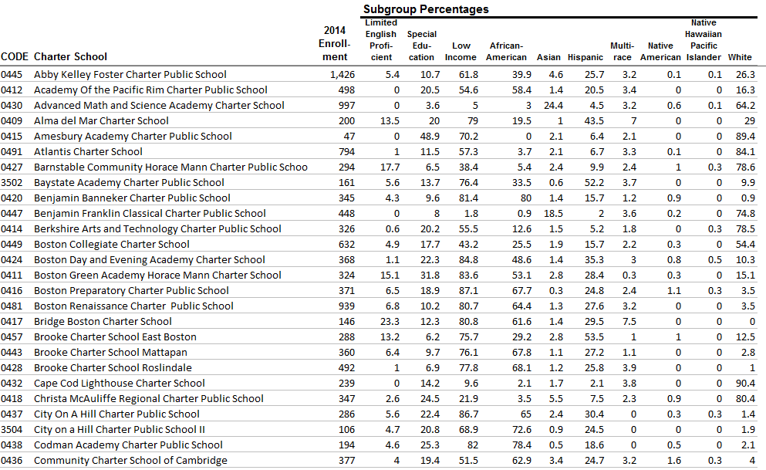
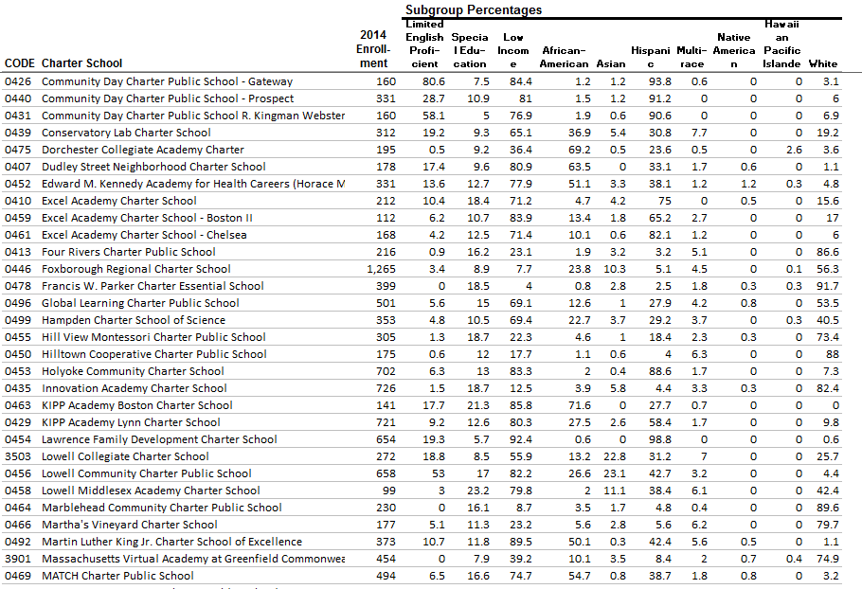

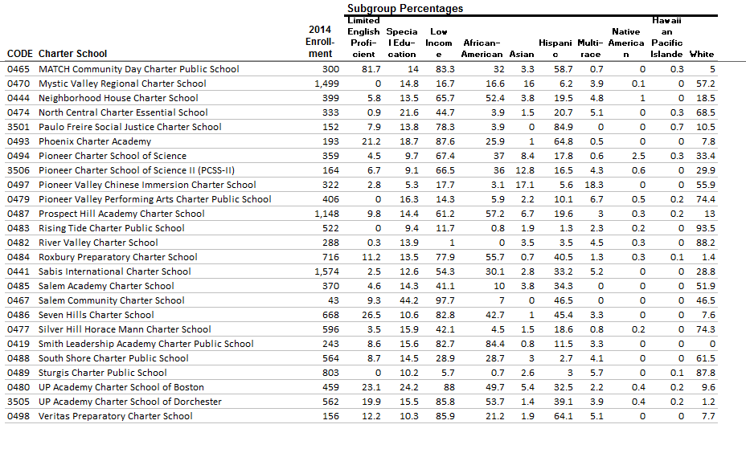
Subgroup Percentag

http://profiles.doe.mass.edu/search/search.aspx?leftNavId=

