2016 METCO Program Report
Report on the impact of the grant program on student outcomes, the expenditure of funds by districts, and the extent to which the services rendered by Metropolitan Council for Educational Opportunity support the goals of the grant program

March 2017

Massachusetts Department of Elementary and Secondary Education
75 Pleasant Street, Malden, MA 02148-4906
Phone 781-338-3000 TTY: N.E.T. Relay 800-439-2370
www.doe.mass.edu

This document was prepared by the
Massachusetts Department of Elementary and Secondary Education
Mitchell D. Chester, Ed.D.
Commissioner

Board of Elementary and Secondary Education Members
Mr. Paul Sagan, Chair, Cambridge
Mr. James Morton, Vice Chair, Boston
Ms. Katherine Craven, Brookline
Dr. Edward Doherty, Hyde Park
Dr. Roland Fryer, Concord
Ms. Margaret McKenna, Boston
Mr. Michael Moriarty, Holyoke
Dr. Pendred Noyce, Boston
Mr. James Peyser, Secretary of Education, Milton
Ms. Mary Ann Stewart, Lexington
Mr. Nathan Moore, Chair, Student Advisory Council, Scituate

Mitchell D. Chester, Commissioner
Secretary to the Board

The Massachusetts Department of Elementary and Secondary Education, an affirmative action employer, is committed to ensuring that all of its programs and facilities are accessible to all members of the public.
We do not discriminate on the basis of age, color, disability, national origin, race, religion, sex, gender identity, or sexual orientation.
Inquiries regarding the Department’s compliance with Title IX and other civil rights laws may be directed to the
Human Resources Director, 75 Pleasant St., Malden, MA 02148-4906. Phone: 781-338-6105.

© 2017 Massachusetts Department of Elementary and Secondary Education
Permission is hereby granted to copy any or all parts of this document for non-commercial educational purposes. Please credit the “Massachusetts Department of Elementary and Secondary Education.”

This document printed on recycled paper

Massachusetts Department of Elementary and Secondary Education
75 Pleasant Street, Malden, MA 02148-4906
Phone 781-338-3000 TTY: N.E.T. Relay 800-439-2370
www.doe.mass.edu

Table Contents
Introduction 1
METCO Overview 2
2016-2017 Referral and Placement to Districts 3
Transportation Department 5
METCO Student Outcomes 6
School Districts Expenditure of Funds 9

Introduction

The Department of Elementary and Secondary Education respectfully submits this Report to the Legislature pursuant to Chapter 182 of the Acts of 2008, line item 7010- 0012:

“For grants to cities, towns and regional school districts for payments of certain costs and related expenses for the program to eliminate racial imbalance, established under section 12A of chapter 76 of the General Laws; provided, that funds shall be made available for payment for services rendered by the Metropolitan Council for Educational Opportunity (METCO) Inc. and Springfield public schools; provided further, that all grant applications submitted to and approved by the department of elementary and secondary education shall include a detailed line item budget specifying how such funds shall be allocated and expended; and provided further, that the department of elementary and secondary education shall submit a report on the impact of the grant program on student outcomes, the expenditure of funds by districts, and the extent to which the services rendered by METCO, Inc. support the goals of the grant program to the joint committee on education and the house and senate committees on ways and means not later than December 1, 2016…..”

METCO Overview

METCO, Inc. (METCO) has a contract with the Department of Elementary and Secondary Education to support participating districts and have been the service provider for fifty years with the primary role of providing direct services to participating students, families and school districts. The districts provide a broad based educational program for all students, and METCO, Inc. provides additional options for tutorial programs, enrichment, remedial and referral services for METCO students in need of additional support.

METCO serves as the Boston based central office for all Boston METCO parents, students and the general public requesting information about the program. When schools are in session, METCO is open from six-thirty in the morning until eight o’clock at night. and some Saturdays from 10:00 a.m. – 1:00 p.m. for specific purposes. They provide meeting space for parent groups, the MPLC (METCO Parent Legislative Committee) and the alumni association and maintain and monitor the waiting list for interested families. Currently, there are approximately 8,750 students on the waiting list.

METCO also conducts information sessions for families on the waiting list to educate them about the program. They also have an annual orientation in August for new families entering the program and distribute the METCO parent handbook, which is also uploaded to the website. In August 2016 they had more than 100 families attend.

New Applicants on Waiting List During the Period July 1, 2015 – June 30, 2016

Breakdown by Race

Total Students - 725
African American | 451
Asian | 28
Caucasian | 7
Hispanic | 176
Native American | 0
Other | 61
Undesignated | 2

Breakdown by Grade

Grade | Number Registered | Grade | Number Registered
PK | 426 | 6 | 26
K | 77 | 7 | 20
1 | 37 | 8 | 21
2 | 32 | 9 | 10
3 | 30 | 10 | 1
4 | 21 | 11 | 0
5 | 24 | 12 | 0

Active Waitlist as of June 30, 2016 – Breakdown by Race

Total Students on Active Waiting list – 8,750
African American | 5,478
Asian | 337
Caucasian | 77
Hispanic | 2,047
Native American | 42
Other | 584
Undesignated | 185

Active Waitlist as of June 30, 2016 – Breakdown by Grade

Grade | Number  Registered | Grade | Number  Registered
PK | 3,615 | 5 | 615
K | 1,103 | 6 | 430
1 | 720 | 7 | 70
2 | 666 | 8 | 56
3 | 699 | 9 | 16
4 | 759 | 10, 11 & 12 | 1

2016-2017 Referral and Placement to Districts

METCO’s placement process for the 2016-17 year began in October 2015 when parents of children who had been referred but had not been placed were asked to update their child’s referral/placement packet.

In late November and December mailings went out to parents of students on the waiting list in grades K-9 inviting them to an information session. 12 sessions were conducted with over 850 parents attending.

In May 2016, 950 placement packets folders were referred to districts and as of July 2016, 250 of those students were placed in the districts.

Demographic Report 2016-2017

District | Total | Fem | Male | AA | Hisp. | Mixed Race | Asian | Nat Haw | Amer Indian | White | K | 1 | 2 | 3 | 4 | 5 | 6 | 7 | 8 | 9 | 10 | 11 | 12
Arlington | 75 | 35 | 40 | 65 | 6 | 0 | 4 | 0 | 0 | 0 | 0 | 2 | 6 | 4 | 10 | 4 | 12 | 6 | 9 | 6 | 7 | 6 | 3
Bedford | 98 | 50 | 48 | 76 | 18 | 2 | 0 | 0 | 0 | 2 | 2 | 7 | 7 | 7 | 5 | 8 | 8 | 9 | 7 | 10 | 11 | 8 | 9
Belmont | 104 | 54 | 50 | 64 | 24 | 11 | 3 | 0 | 0 | 2 | 0 | 7 | 6 | 4 | 10 | 4 | 11 | 7 | 10 | 12 | 14 | 10 | 9
Braintree | 18 | 7 | 11 | 15 | 3 | 0 | 0 | 0 | 0 | 0 | 0 | 1 | 0 | 0 | 1 | 2 | 0 | 2 | 0 | 2 | 5 | 1 | 4
Brookline | 292 | 165 | 127 | 189 | 71 | 16 | 13 | 0 | 0 | 3 | 24 | 24 | 19 | 20 | 19 | 22 | 21 | 19 | 26 | 28 | 18 | 19 | 33
Cohasset | 44 | 33 | 11 | 36 | 2 | 3 | 0 | 0 | 1 | 2 | 4 | 4 | 4 | 2 | 4 | 4 | 3 | 3 | 2 | 3 | 3 | 5 | 3
Concord | 86 | 45 | 41 | 64 | 20 | 1 | 1 | 0 | 0 | 0 | 9 | 8 | 8 | 9 | 5 | 14 | 10 | 11 | 12 | 0 | 0 | 0 | 0
Concord-Carlisle | 51 | 25 | 26 | 41 | 8 | 2 | 0 | 0 | 0 | 0 | 0 | 0 | 0 | 0 | 0 | 0 | 0 | 0 | 0 | 13 | 11 | 14 | 13
Dover | 7 | 3 | 4 | 6 | 0 | 0 | 0 | 0 | 0 | 1 | 0 | 0 | 1 | 3 | 2 | 1 | 0 | 0 | 0 | 0 | 0 | 0 | 0
Dover-Sherborn | 24 | 14 | 10 | 24 | 0 | 0 | 0 | 0 | 0 | 0 | 0 | 0 | 0 | 0 | 0 | 0 | 6 | 2 | 3 | 4 | 4 | 1 | 4
East Longmeadow | 38 | 23 | 15 | 21 | 13 | 1 | 1 | 0 | 0 | 2 | 4 | 2 | 0 | 2 | 1 | 4 | 4 | 3 | 1 | 4 | 3 | 5 | 5
Foxborough | 35 | 20 | 15 | 28 | 7 | 0 | 0 | 0 | 0 | 0 | 0 | 0 | 0 | 0 | 0 | 2 | 5 | 2 | 1 | 8 | 3 | 7 | 7
Hampden-Wilbraham | 19 | 12 | 7 | 13 | 5 | 1 | 0 | 0 | 0 | 0 | 0 | 0 | 0 | 2 | 2 | 0 | 0 | 4 | 5 | 0 | 0 | 3 | 3
Hingham | 40 | 18 | 22 | 31 | 9 | 0 | 0 | 0 | 0 | 0 | 0 | 2 | 7 | 1 | 1 | 9 | 3 | 2 | 4 | 1 | 3 | 4 | 3
Lexington | 243 | 139 | 104 | 176 | 50 | 7 | 9 | 0 | 0 | 1 | 12 | 16 | 27 | 25 | 18 | 26 | 10 | 27 | 14 | 14 | 10 | 16 | 28
Lincoln | 90 | 48 | 42 | 48 | 35 | 5 | 2 | 0 | 0 | 0 | 11 | 9 | 12 | 11 | 12 | 9 | 5 | 11 | 10 | 0 | 0 | 0 | 0
Lincoln-Sudbury | 91 | 53 | 38 | 58 | 23 | 5 | 3 | 1 | 1 | 0 | 0 | 0 | 0 | 0 | 0 | 0 | 0 | 0 | 0 | 23 | 25 | 25 | 18
Longmeadow | 35 | 17 | 18 | 24 | 8 | 3 | 0 | 0 | 0 | 0 | 4 | 3 | 2 | 4 | 3 | 4 | 0 | 2 | 1 | 2 | 1 | 4 | 5
Lynnfield | 40 | 18 | 22 | 28 | 11 | 1 | 0 | 0 | 0 | 0 | 4 | 3 | 4 | 4 | 4 | 4 | 4 | 1 | 2 | 3 | 3 | 2 | 2
Marblehead | 76 | 39 | 37 | 60 | 13 | 3 | 0 | 0 | 0 | 0 | 0 | 3 | 3 | 4 | 3 | 10 | 9 | 5 | 6 | 7 | 9 | 11 | 6
Melrose | 125 | 69 | 56 | 101 | 19 | 5 | 0 | 0 | 0 | 0 | 0 | 2 | 4 | 10 | 8 | 21 | 13 | 5 | 8 | 12 | 15 | 18 | 9
Natick | 54 | 32 | 22 | 38 | 11 | 2 | 2 | 1 | 0 | 0 | 0 | 0 | 0 | 0 | 0 | 0 | 7 | 12 | 7 | 7 | 8 | 7 | 6
Needham | 181 | 114 | 67 | 86 | 66 | 13 | 14 | 0 | 0 | 2 | 18 | 24 | 16 | 20 | 13 | 13 | 12 | 4 | 5 | 18 | 12 | 15 | 11
Newton | 427 | 225 | 202 | 265 | 105 | 25 | 30 | 0 | 0 | 2 | 15 | 36 | 42 | 42 | 38 | 22 | 27 | 35 | 41 | 46 | 26 | 23 | 34
Reading | 70 | 35 | 35 | 63 | 6 | 1 | 0 | 0 | 0 | 0 | 0 | 9 | 4 | 9 | 7 | 12 | 4 | 4 | 4 | 6 | 5 | 1 | 5
Scituate | 67 | 39 | 28 | 56 | 7 | 2 | 1 | 1 | 0 | 0 | 0 | 6 | 4 | 5 | 7 | 4 | 5 | 9 | 7 | 7 | 7 | 1 | 5
Sharon | 65 | 31 | 34 | 40 | 17 | 4 | 1 | 1 | 0 | 2 | 0 | 3 | 3 | 2 | 1 | 5 | 3 | 7 | 5 | 7 | 7 | 8 | 14
Sherborn | 8 | 6 | 2 | 6 | 1 | 1 | 0 | 0 | 0 | 0 | 0 | 3 | 2 | 2 | 1 | 0 | 0 | 0 | 0 | 0 | 0 | 0 | 0
South-Toll-Granv Reg | 19 | 11 | 8 | 16 | 1 | 1 | 0 | 0 | 0 | 1 | 2 | 1 | 1 | 2 | 2 | 2 | 1 | 1 | 1 | 1 | 2 | 1 | 2
Sudbury | 70 | 36 | 34 | 54 | 12 | 3 | 0 | 0 | 1 | 0 | 0 | 6 | 9 | 10 | 13 | 9 | 10 | 4 | 9 | 0 | 0 | 0 | 0
Swampscott | 55 | 25 | 30 | 35 | 14 | 3 | 0 | 0 | 2 | 1 | 0 | 0 | 1 | 3 | 6 | 2 | 4 | 7 | 4 | 4 | 9 | 7 | 8
Wakefield | 63 | 36 | 27 | 38 | 19 | 1 | 3 | 1 | 0 | 1 | 1 | 6 | 0 | 1 | 6 | 7 | 6 | 4 | 7 | 5 | 8 | 8 | 4
Walpole | 41 | 30 | 11 | 30 | 10 | 0 | 0 | 0 | 0 | 1 | 0 | 6 | 4 | 1 | 4 | 2 | 4 | 1 | 6 | 5 | 6 | 2 | 0
Wayland | 139 | 78 | 61 | 110 | 15 | 7 | 3 | 2 | 0 | 2 | 0 | 6 | 11 | 17 | 16 | 11 | 11 | 11 | 14 | 15 | 6 | 11 | 10
Wellesley | 157 | 86 | 71 | 128 | 16 | 11 | 1 | 0 | 0 | 1 | 9 | 12 | 11 | 10 | 18 | 10 | 5 | 13 | 9 | 18 | 10 | 18 | 14
Weston | 169 | 92 | 77 | 114 | 34 | 11 | 3 | 1 | 0 | 6 | 14 | 16 | 12 | 12 | 15 | 11 | 12 | 13 | 13 | 13 | 11 | 14 | 13
Westwood | 44 | 26 | 18 | 38 | 5 | 1 | 0 | 0 | 0 | 0 | 0 | 0 | 0 | 0 | 0 | 0 | 14 | 6 | 7 | 8 | 4 | 3 | 2
Totals | 3260 | 1789 | 1471 | 2285 | 684 | 152 | 94 | 8 | 5 | 32 | 133 | 227 | 230 | 248 | 255 | 258 | 249 | 252 | 260 | 312 | 266 | 278 | 292

Transportation Department

METCO provides and executes the administration of contracts with bus companies for fourteen school districts. Terms of the bid specifications and contracts are monitored for quality performance of the vendor to each school district.

The school districts are:

- Arlington
- Belmont
- Braintree
- Cohasset
- Dover/Sherborn
- Hingham
- Foxboro
- Lexington
- Lincoln
- Lincoln/Sudbury
- Natick
- Scituate
- Sudbury
- Walpole

Bus vendors are expected to supply quality service and are monitored for fiscal and operational compliance. The management services include monitoring timely service on a daily basis for both a.m. and p.m. trips, work with the Business Manager to review invoices for accuracy, “field” telephone inquiries and problem solve. They are also expected to meet and communicate with bus company management personnel as necessary. In addition, they enforce disciplinary codes for safe riding and meet or communicate with school district personnel and METCO Directors.

METCO Student Outcomes
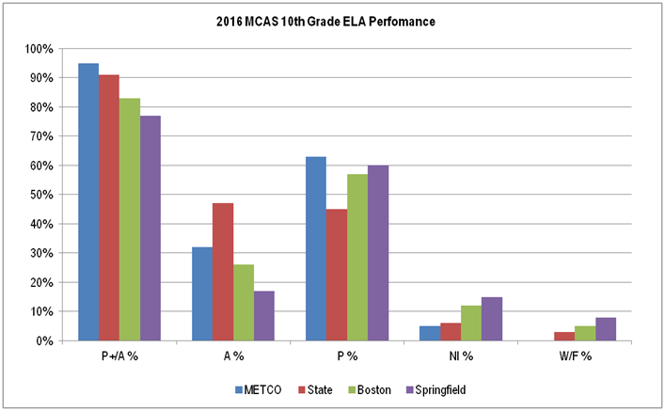
Source: Massachusetts Department of Elementary and Secondary Education, 2016 MCAS Assessment file
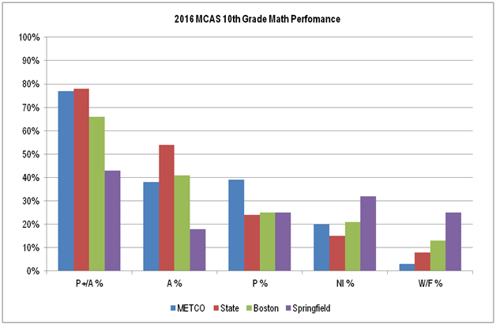
Source: Massachusetts Department of Elementary and Secondary Education, 2016 MCAS Assessment file

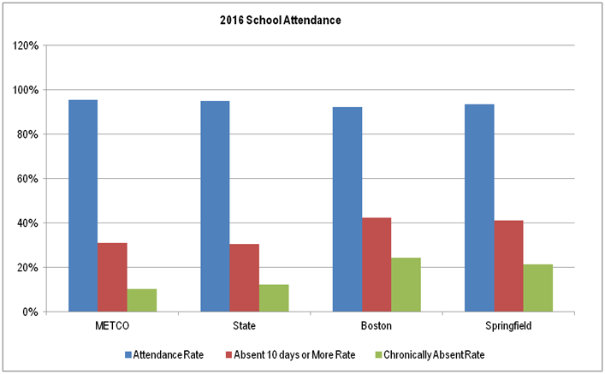
Source: Massachusetts Department of Elementary and Secondary Education, Student Information Management System (SIMS)

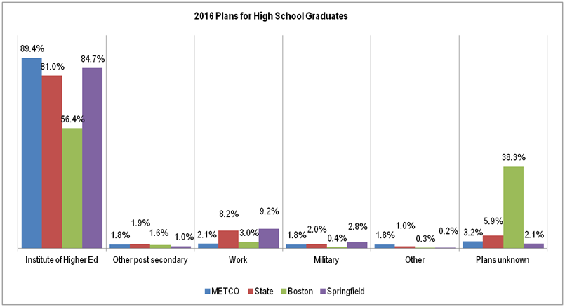
Source: Massachusetts Department of Elementary and Secondary Education, Student Information Management System (SIMS)

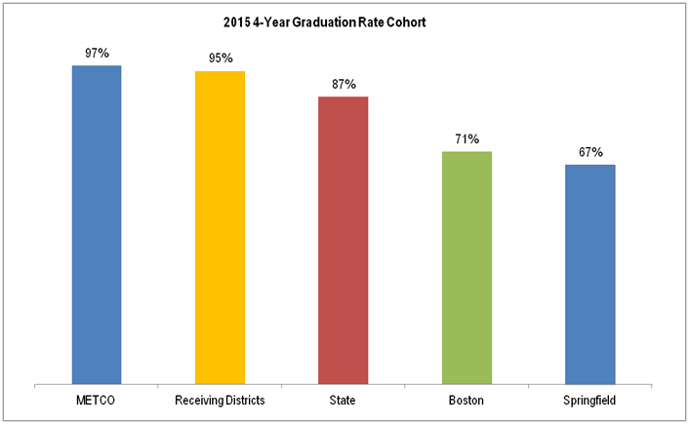
Source: Massachusetts Department of Elementary and Secondary Education, Student Information Management System (SIMS)

School Districts Expenditure of Funds
FY16 Fund Use | Admin | Professional | Support | Fringe | Contract | Supplies | Travel | Other | Indirect | Total
 |  | Staff | Staff | Benefits | Services | Materials |  | Cost | Costs | Grant
Arlington P. S. | 89,777 | 102,859 | 34,243 |  | 6,880 | 15,780 | 2,600 | 163,790 |  | 415,929
Bedford P.S. | 127,125 | 3,000 | 57,740 |  | 60,848 | 1,677 | 3,796 | 298,145 |  | 552,331
Belmont P.S. | 91,695 | 187,038 | 77,684 | 46,308 |  | 5,456 | 2,400 | 152,960 |  | 563,541
Braintree P.S. | 50,000 |  | 46,425 |  |  |  |  | 114,295 |  | 210,720
Brookline P.S. | 124,989 | 687,741 | 213,521 |  | 23,550 | 3,500 | 3,300 | 401,530 | 17,435 | 1,475,566
Cohasset P.S. | 76,915 |  | 29,289 |  | 4,254 | 10,117 | 540 | 155,268 |  | 276,383
Concord P.S. | 34,500 | 84,224 | 248,548 |  | 3,000 |  |  | 138,599 |  | 508,871
East Longmeadow P.S. |  | 167,667 |  |  |  | 800 |  | 81,342 |  | 249,809
Foxboro P.S. | 42,263 | 74,147 | 41,727 |  |  |  |  | 87,070 |  | 245,207
Hingham P.S. | 55,062 | 23,883 | 10,565 |  | 4,500 | 4,720 | 2,900 | 112,300 |  | 213,930
Lexington P.S. | 125,241 | 369,894 | 324,347 |  | 53,009 | 18,055 | 4,000 | 594,338 |  | 1,488,884
Lincoln P.S. | 25,000 | 264,204 | 32,713 |  | 3,575 | 3,200 |  | 173,274 |  | 501,966
Longmeadow P.S. | 3,000 | 78,460 | 37,968 |  |  | 7,300 |  | 87,214 |  | 213,942
Lynnfield P.S. | 60,610 |  | 73,934 |  | 5,000 | 2,016 |  | 87,500 |  | 229,060
Marblehead P.S. | 91,549 | 70,127 | 39,713 | 37,470 | 43,000 | 22,000 | 793 | 194,850 |  | 499,502
Melrose P.S. | 82,529 | 270,000 | 65,462 |  | 25,000 | 5,500 | 11,000 | 220,622 |  | 680,113
Natick P.S. | 79,560 | 91,982 |  | 20,000 | 3,286 | 1,900 | 1,600 | 140,594 |  | 338,922
Needham P.S. | 85,866 | 187,497 | 248,629 |  | 28,690 | 64,188 | 8,450 | 306,688 | 10,840 | 940,848
Newton P.S. | 110,684 | 1,185,599 | 138,273 | 84,728 | 20,000 | 6,552 | 16,540 | 848,500 |  | 2,410,876
Reading P.S. | 73,130 | 100,000 | 10,500 |  | 6,855 | 4,330 | 2,375 | 190,200 |  | 387,390
Scituate P.S. | 83,242 | 80,000 | 11,520 | 7,345 | 13,000 | 6,000 |  | 203,850 |  | 404,957
Sharon P.S. | 59,770 | 59,949 | 19,024 |  | 34,453 | 51,682 | 4,700 | 194,386 |  | 423,964
Springfield P.S. | 26,112 |  | 3,644 | 5,815 | 2,500 | 1,354 |  | 1,000 | 1,411 | 41,836
Sudbury P.S. | 46,000 | 22,676 | 189,155 |  | 14,061 | 7,618 | 2,150 | 155,032 |  | 436,692
Swampscott P.S. | 56,000 | 174,496 | 29,000 |  |  | 3,000 |  | 144,803 |  | 407,299
Wakefield P.S. | 68,913 |  | 34,895 |  | 33,500 | 3,346 | 3,950 | 151,286 |  | 295,890
Walpole P.S. | 84,526 | 66,106 |  | 10,000 |  |  |  | 108,593 |  | 269,225
Wayland P.S. | 98,791 | 272,472 | 76,845 |  | 7,327 | 26,263 | 9,272 | 231,897 |  | 722,867
Wellesley P.S. | 118,605 | 261,621 | 91,368 | 70,120 | 8,984 | 6,136 | 844 | 335,204 |  | 892,882
Weston P.S. | 61,019 | 564,957 | 40,058 |  |  |  |  | 267,754 |  | 933,788
Westwood P.S. | 88,288 |  | 38,883 |  | 12,042 | 11,674 | 4,000 | 87,218 |  | 242,105
Concord-Carlisle RSD | 80,500 | 86,449 | 32,419 |  | 12,000 | 11,195 | 5,000 | 148,901 |  | 376,464
Dover-Sherborn RSD | 74,285 |  | 25,049 |  | 5,560 | 8,033 | 1,701 | 98,130 |  | 212,758
Hampden-Wilbraham RSD | 2,760 | 80,944 |  |  | 535 |  | 615 | 47,776 |  | 132,630
Lincoln-Sudbury RSD | 46,000 | 144,246 | 15,000 | 7,797 | 40,600 | 24,400 | 5,000 | 195,116 | 14,561 | 492,720
Southwick/Tolland RSD |  | 82,075 |  |  |  |  | 200 | 58,969 |  | 141,244
Total | $2,424,306 | $ 5,844,313 | $,338,141 | $289,583 | $476,009 | $337,792 | $97,726 | $6,978,994 | $44,247 | $18,831,111

