Charter School Data Annual Report
2018 Charter School Enrollment Data (G.L. c. 71, § 89(kk))
February 2018
Massachusetts Department of Elementary and Secondary Education
75 Pleasant Street, Malden, MA 02148-4906
Phone 781-338-3000 TTY: N.E.T. Relay 800-439-2370
www.doe.mass.edu

This document was prepared by the
Massachusetts Department of Elementary and Secondary Education
Jeff Wulfson
Acting Commissioner

Board of Elementary and Secondary Education Members
Mr. Paul Sagan, Chair, Cambridge
Ms. Katherine Craven, Brookline
Mr. Edward Doherty, Hyde Park
Ms. Amanda Fernández, Belmont
Ms. Margaret McKenna, Boston
Mr. Michael Moriarty, Holyoke
Mr. James Morton, Vice Chair, Springfield
Mr. James Peyser, Secretary of Education, Milton
Ms. Mary Ann Stewart, Lexington
Ms. Hannah Trimarchi, Chair, Student Advisory Council, Marblehead
Dr. Martin West, Newton

Jeff Wulfson, Acting Commissioner and Secretary to the Board

The Massachusetts Department of Elementary and Secondary Education, an affirmative action employer, is committed to ensuring that all of its programs and facilities are accessible to all members of the public.
We do not discriminate on the basis of age, color, disability, national origin, race, religion, sex, gender identity, or sexual orientation.
Inquiries regarding the Department’s compliance with Title IX and other civil rights laws may be directed to the
Human Resources Director, 75 Pleasant St., Malden, MA 02148-4906. Phone: 781-338-6105.

© 2018 Massachusetts Department of Elementary and Secondary Education
Permission is hereby granted to copy any or all parts of this document for non-commercial educational purposes. Please credit the “Massachusetts Department of Elementary and Secondary Education.”

This document printed on recycled paper

Massachusetts Department of Elementary and Secondary Education
75 Pleasant Street, Malden, MA 02148-4906
Phone 781-338-3000 TTY: N.E.T. Relay 800-439-2370
www.doe.mass.edu

Massachusetts Department of
Elementary & Secondary Education

75 Pleasant Street, Malden, Massachusetts 02148-4906 Telephone: (781) 338-3000
TTY: N.E.T. Relay 1-800-439-2370

Jeff Wulfson
Acting Commissioner

February 12, 2018

Dear Members of the General Court:

I am pleased to submit this Report to the Legislature: Charter School Data Annual Report for 2017-2018. The charter school enrollment data provided in this report was compiled from the Department of Elementary and Secondary Education’s (Department) Student Information Management System (SIMS). Data profiles of each charter school for FY2018 (school year 2017-2018) as well as prior years are available on the Department’s School and District Profiles website at District and School Profiles.

If you have any questions about this report, please feel free to contact Alison Bagg, Director of the Office of Charter Schools and School Redesign at abagg@doe.mass.edu or at 781-338-3227.

Sincerely,

Jeff Wulfson
Acting Commissioner of Elementary and Secondary Education

Table of Contents
Introduction 1
Charter Schools: Total Enrollment and Subgroup Percentages 2

Introduction

The Department of Elementary and Secondary Education (“the Department”) respectfully submits this Report to the Legislature: Charter School Data Annual Report for FY2018 pursuant to the requirement under G.L. c. 71, § 89(kk) that states:

“The commissioner shall collect data on the racial, ethnic and socio-economic make-up of the student enrollment of each charter school in the commonwealth. The commissioner shall also collect data on the number of students enrolled in each charter school who have individual education plans pursuant to chapter 71B and those requiring English language learners programs under chapter 71A. The commissioner shall file said data annually with the clerks of the house and senate and the joint committee on education not later than December 1.”

The charter school enrollment data for FY2018, compiled from the Department’s Student Information Management System (SIMS) information collection, is provided in the following table. Data profiles of each charter school for FY2018 and prior years are available at District and School Profiles on the Department’s website.

Charter Schools: Total Enrollment and Subgroup Percentages
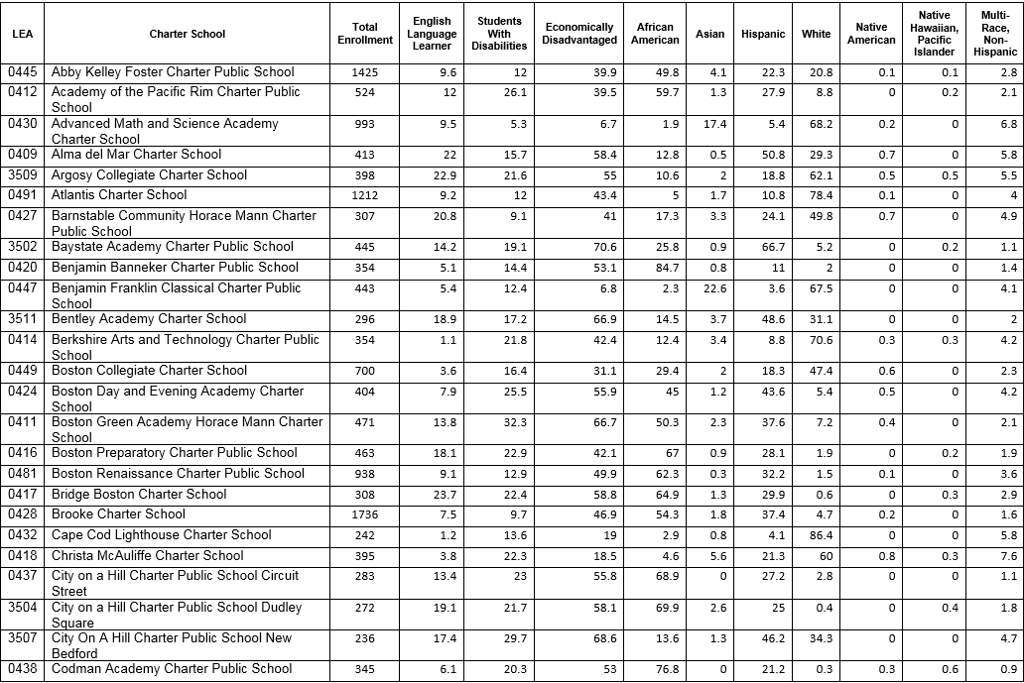
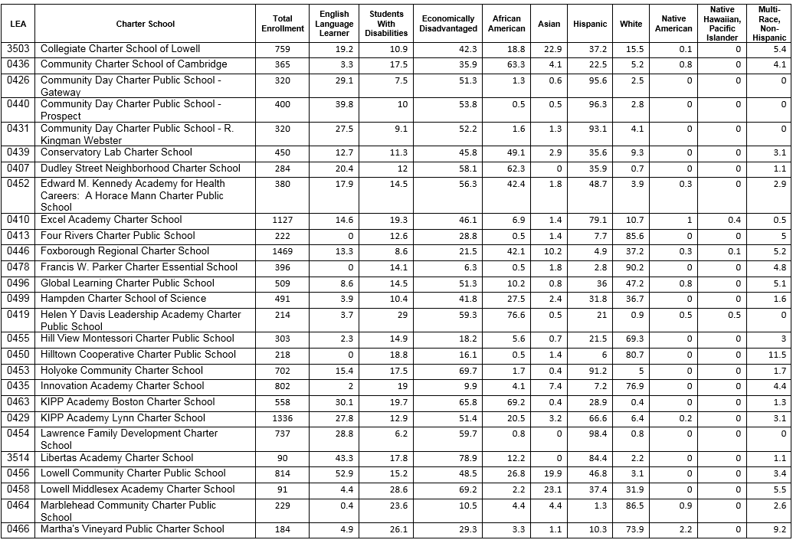

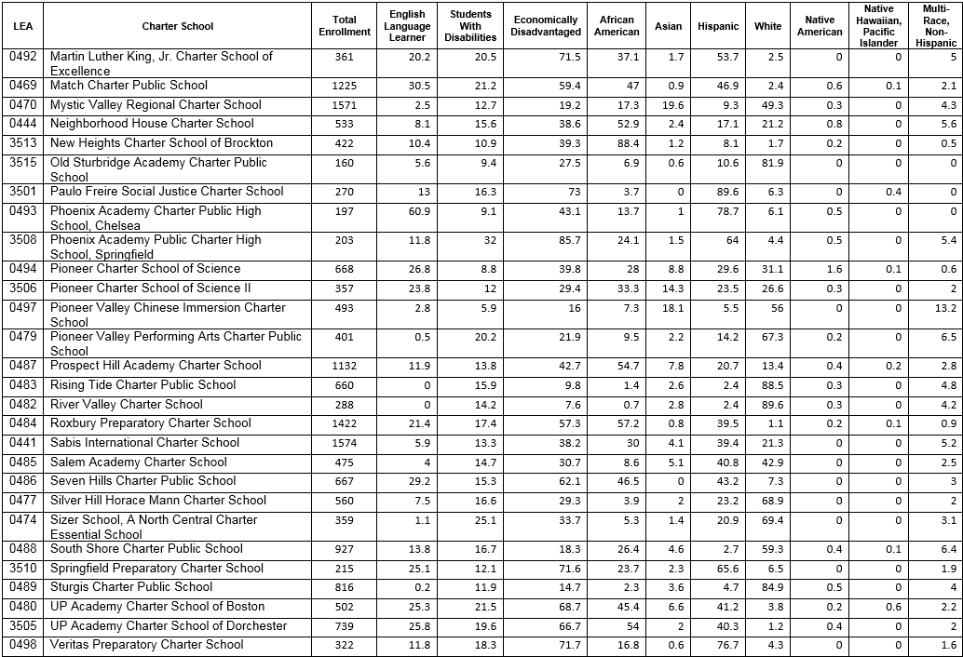

http://profiles.doe.mass.edu/

