Education Evaluation Grant Program
June 2018
Massachusetts Department of Elementary and Secondary Education
75 Pleasant Street, Malden, MA 02148-4906
Phone 781-338-3000 TTY: N.E.T. Relay 800-439-2370
www.doe.mass.edu

This document was prepared by the
Massachusetts Department of Elementary and Secondary Education
Jeffrey C. Riley
Commissioner

Board of Elementary and Secondary Education Members
Mr. Paul Sagan, Chair, Cambridge
Ms. Katherine Craven, Brookline
Mr. Edward Doherty, Hyde Park
Ms. Amanda Fernández, Belmont
Ms. Margaret McKenna, Boston
Mr. Michael Moriarty, Holyoke
Mr. James Morton, Vice Chair, Springfield
Mr. James Peyser, Secretary of Education, Milton
Ms. Mary Ann Stewart, Lexington
Ms. Hannah Trimarchi, Chair, Student Advisory Council, Marblehead
Dr. Martin West, Newton

Jeffrey C. Riley, Commissioner and Secretary to the Board

The Massachusetts Department of Elementary and Secondary Education, an affirmative action employer, is committed to ensuring that all of its programs and facilities are accessible to all members of the public.
We do not discriminate on the basis of age, color, disability, national origin, race, religion, sex, gender identity, or sexual orientation.
Inquiries regarding the Department’s compliance with Title IX and other civil rights laws may be directed to the
Human Resources Director, 75 Pleasant St., Malden, MA 02148-4906. Phone: 781-338-6105.

© 2018 Massachusetts Department of Elementary and Secondary Education
Permission is hereby granted to copy any or all parts of this document for non-commercial educational purposes. Please credit the “Massachusetts Department of Elementary and Secondary Education.”

This document printed on recycled paper

Massachusetts Department of Elementary and Secondary Education
75 Pleasant Street, Malden, MA 02148-4906
Phone 781-338-3000 TTY: N.E.T. Relay 800-439-2370
www.doe.mass.edu

Massachusetts Department of
Elementary & Secondary Education

75 Pleasant Street, Malden, Massachusetts 02148-4906 Telephone: (781) 338-3000
TTY: N.E.T. Relay 1-800-439-2370

Jeffrey C. Riley
Commissioner

June 23, 2018

Members of the General Court:

Attached is the Department of Elementary and Secondary Education’s final report on the grant program established in fiscal year 2016 for evaluation of state-funded education programming.

These grants funded evaluations of two state programs:
- Academic Support, which provided remediation for students at risk of not meeting the state’s high school graduation requirement until the program ended in FY17, and
- Educator preparation and licensure programs, which work to improve the quality of the state’s educator workforce.
All studies from these evaluation are now complete, and we are happy to share three final reports from this work.

We appreciate your support in helping us to evaluate the implementation, outcomes, and costs and benefits of our state programs.

Sincerely yours,

Jeffrey C. Riley
Commissioner of Elementary and Secondary Education

Legislative report

The Department of Elementary and Secondary Education respectfully submits this Report to the Legislature pursuant to Chapter 46 of the Acts of 2015, line item 7010-0050:

“…provided further, that organizations receiving funds through this item shall report biannually to the house and senate committees on ways and means, the joint committee on education and the joint committee on higher education on: (1) the status and preliminary results of evaluations funded through this item; and (2) any obstacles encountered in access to data or other information that is negatively affecting the completion of the study.”

The purpose of this funding was to support evaluation of state-funded education programming. The legislature provided $300,000 for this purpose in fiscal year 2016 and stipulated specific requirements for the analyses to be conducted with the funding.

In the grant competition, the agency prioritized proposals related to the state academic support program for students at risk of not meeting the high school graduation requirement and the state’s educator preparation and licensure programs. ESE also allowed proposals to evaluate other state-funded education programs so long as the proposals studied a topic of significant interest to the agency and sufficient data were available to meet the legislative requirements for this grant program.

Per the statutory requirement, proposals specified how the researcher would analyze the following six areas:
- The quantifiable effect of the program on the population enrolled in the program;
- Fidelity of program implementation;
- An estimate of the cost to the Commonwealth of the education problem being addressed through the program;
- A comparison of the cost of the program and the estimated short-term and long-term benefits received by program recipients through the program;
- Data limitations in estimating the effect of the program; and
- Recommendations for further study.

ESE received five applications: three for the educator preparation and licensure priority and two for the academic support priority. No applicants proposed projects outside the two prioritized programs.

After review, the UMass Donahue Institute was awarded a $150,000 grant to study the state’s academic support program and the American Institutes of Research was awarded a $150,000 grant to study educator preparation and licensure.

Executive summaries of the three final reports resulting from these awards follow in this document, along with links to the full reports posted on ESE’s public web page.

Evaluation of Academic Support Programs: Final Report
University of Massachusetts Donahue Institute
http://www.doe.mass.edu/research/reports/2017/06aspeval.docx

The Massachusetts state legislature funded the Academic Support grants annually to enhance academic support services to assist all eligible students in meeting the Commonwealth’s Competency Determination, a requirement for high school graduation. Academic Support services were informed by evidence-based practices, as defined by ESE, and data collected by individual sites. The Academic Support grants funded four types of school year and summer grant programs: (1) Allocation grant program; (2) Work and Learning program; (3) Partnerships for Pathways to Success program; and (4) Collaborative Partnerships for Student Success (CPSS) program. The Allocation grant program was based on a formula that includes the number of high school students who scored at the “failing” level on their most recently available high school MCAS exam in English language arts (ELA), mathematics, and science and technology/engineering (STE). The other three grants were awarded through a competitive application process.

The Massachusetts Department of Elementary and Secondary Education (ESE) engaged the University of Massachusetts Donahue Institute (UMDI) as a third party independent research organization to evaluate the programs funded by the Academic Support grants, with the objective of helping the state legislature and ESE to better understand program implementation, costs, benefits, and outcomes. This report describes findings from all research activities conducted for the project, from January 2016 through June 2017.

A total of 25,047 students participated in Academic Support programs from SY13 to SY14.

Quantitative analyses revealed a complex picture regarding the outcomes associated with participation in Academic Support programs. Findings suggest that participating students were 1.4 times more likely to gain their Competency Determination than similar non-participating students. Additionally, results indicated that participants were 0.5 times less likely to drop out one year after participation than similar non-participants. Participating students also saw slight increases in their rate of attendance (by 1–2 school days) the year after participation. Contrary to these positive findings, however, results suggested that participants were 0.8 times less likely than similar non-participants to graduate one year after participation.

After outcomes were assessed, we estimated the economic cost/benefit of the program to the Commonwealth resulting from fewer students dropping out of high school after participating in the Academic Support programs. Conservative estimates suggest a total lifetime savings of $40.9 million as a result of student participation in the Academic Support programs in SY13 and SY14 after accounting for the cost of programming. Non-conservative estimates suggest a total savings of $131.3 million for SY13 and SY14 after accounting for the cost of programming.

Nearly all Academic Support program administrators reported—through survey and/or interview—that their program(s) met the goal of improving student performance on MCAS, which supported findings from the quantitative analysis. Most respondents also agreed that the program(s) had additional positive outcomes like increased connectedness to adults, increased confidence in academic ability, increased connections with school, increased college and career readiness skills, and earning course credits. Administrators reported that students were attracted to Academic Support programs because they provided small group or targeted instruction, the programs were free and convenient, and the program staff were engaging and supportive.

Demographic analyses indicate that Academic Support programs served High Needs students —including English language learners, students with disabilities, and those eligible to receive free or reduced-price lunch— at a higher rate when compared to statewide percentages of the same groups.

Nearly all sites said that budget cuts were a significant challenge. Budget cuts resulted in reductions in the number of students being served, elimination of summer programming, and termination of program incentives. Other challenges included attendance issues, student retention, scheduling, student motivation, recruiting and maintaining contact with overaged students, and engaging parents/guardians. Although the majority of respondents highlighted the importance of their Academic Support program(s) for increasing students' likelihood of gaining their Competency Determination, only 4 percent of respondents indicated that they would likely continue all of their current Academic Support activities without continued funding. More than half of respondents said their programs would cease entirely without continued support.

Massachusetts Educator Preparation and Licensure: Year 1 Report
American Institutes for Research
http://www.doe.mass.edu/research/reports/2017/05EdPrep-Year1Report.pdf

Background
Preparing and licensing teachers is an important leverage point for state education agencies in influencing the quality of the teacher workforce. This is particularly so in Massachusetts, whose diverse teacher preparation landscape includes about 70 educator preparation providers (EPPs) and 2,000 distinct programs within these EPPs at both traditional programs housed in colleges and universities and other providers that offer alternative routes into the profession. This report describes results from the first year of research in a partnership between the National Center for the Analysis of Longitudinal Data in Education Research (CALDER) and the Department of Elementary and Secondary Education (ESE) to study teacher preparation and licensure in Massachusetts.
Specifically, we examine how three outcomes—student achievement on state standardized tests, summative performance ratings from educator evaluation, and teacher attrition—vary among teacher candidates from different licensure pathways, preparation program types, and specific EPPs and programs. These findings are based on a statewide analysis of Massachusetts teachers who completed educator preparation programs or earned a first teaching license in Massachusetts between 2010 and 2014.
It is important to emphasize that there are limitations to this non-experimental research. Although the methods used in this report are designed to separate the effectiveness of teachers from the context in which they work, the results are sensitive to different assumptions (described more fully in the report) about the influence of schools on each of the performance measures. In addition, estimates of program and pathway effects reflect more than just differences in the quality of teacher preparation, because programs and pathways may differ in the academic preparation, innate teaching skills, or prior teaching experiences of their candidates out of state. This summary focuses primarily on results that are consistent across different assumptions, and the limitations of this research are described in more detail in the last section of this summary and in the report.

Key Findings

Key Finding #1: Relative to teachers who receive their teaching license from an undergraduate program, teachers who receive their teaching license from postgraduate or alternative programs tend to receive higher summative performance ratings. Evidence of a relationship between program type and value added is mixed.
Teachers from postgraduate programs are more effective at raising ELA achievement (but not math achievement) than teachers from undergraduate programs. In Figure ES.1., we plot the expected outcomes on each performance measure for alternative, postgraduate, and undergraduate institutions from our baseline models. The first two panels illustrate findings from the value added models, but these results tend to be sensitive to methodological choices. Although the baseline results shown suggest that teachers from alternative programs have students with higher student achievement gains, this result is not supported by models with more robust controls for student background than the one shown here. Taken as a whole, the results do not provide consistent evidence of differences in value added across program pathways.
The differences across pathways on the summative ratings are more consistent. Teachers who receive their first teaching license from a postgraduate or alternative program tend to receive higher summative performance ratings than teachers who receive their teaching credential through an undergraduate program. We measure performance on each of the standards in the summative ratings by awarding a point for each rating category (unsatisfactory is coded as a 1; exemplary is coded as a 4) and then adjust for school characteristics and district rating standards. Teachers from postgraduate programs earn ratings about 0.03 points higher than those from undergraduate programs, while teachers from alternative programs earn ratings about 0.11 points higher. The difference in summative ratings between undergraduate and postgraduate programs is nearly as large as that between a novice and second year teacher; the difference between undergraduate and alternative programs is similar to that between a novice teacher and a teacher with five years of experience.

Figure ES.1. Program Pathways and Teacher Outcomes
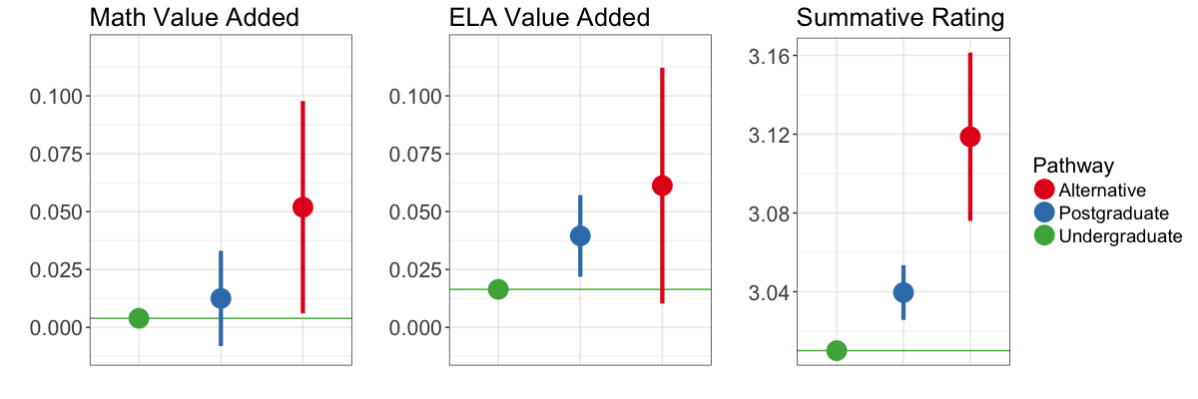
Notes: We plot estimated teacher outcomes for each program pathway at the average values in the dataset. Effects for alternative and postgraduate programs are estimated using baseline models presented in the text. Value added is defined in standard deviations of student test performance; summative performance rating effects are in mean points on the rating scale across the four standard scores; attrition effects are in probability units. The vertical bars depict the 95% confidence interval for the estimated pathway effects relative to undergraduates.

Key Finding #2: Relative to teachers with initial licenses, out-of-state teachers with temporary licenses tend to receive higher summative performance ratings, while those with preliminary licenses that do not require prior program completion tend to receive lower summative performance ratings. Evidence for value added is mixed, but there is some evidence that teachers with preliminary licenses are less effective in math instruction.
We consider three licensure pathways: teachers with a preliminary license (offered to teachers who have passed the state licensure testing requirements but not yet completed an approved EPP), an initial license (offered to teachers who have completed a preparation program and state testing requirements), and a temporary license (offered to teachers with at least 3 years of experience in another state who have not completed state licensure testing requirements). We plot mean outcomes by pathway in Figure ES.2.
As is the case with program pathways, no clear differences in value-added emerge. Teachers who enter with a preliminary license have lower math value added than teachers who enter with an initial license, although the difference is modest (less than one month of student learning in these grades). We do not observe differences in ELA value added. There is also little evidence of any difference in value added between teachers with an initial and temporary license. Differences in effectiveness are again more apparent in the summative ratings data. Teachers with preliminary licenses tend to receive lower summative performance ratings, and teachers with temporary licenses receive higher ratings, than new teachers with initial licenses. The difference in ratings between teachers with preliminary and temporary licenses corresponds to about 0.06 points or the difference between a novice and third-year teacher.

Figure ES.2. Licensure Pathways and Teacher Outcomes
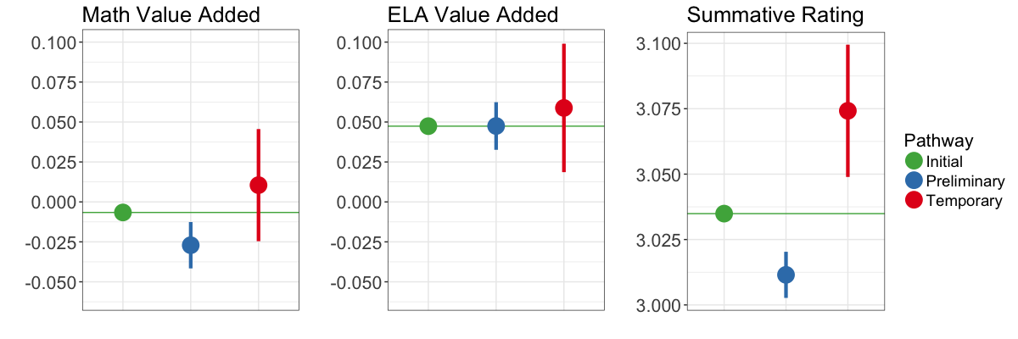
Notes: We plot estimated teacher outcomes for each program pathway at the average values in the dataset. Effects for alternative and postgraduate programs are estimated using baseline models presented in the text. Value added is defined in standard deviations of student test performance; summative performance rating effects are in mean points on the rating scale across the four standard scores; attrition effects are in probability units. The vertical bars depict the 95% confidence interval for the estimated pathway effects relative to initial licenses.

Key Finding #3: Teachers who enter the profession through alternative programs or with non-standard licenses are more likely to leave teaching than teachers from traditional, in-state EPPs.
A consistent finding is that teachers entering the profession with an initial license after completing an approved EPP have the lowest rates of attrition. We illustrate differences in attrition rates by program and license type in Figure ES.3. The average early-career attrition rate for teachers completing in-state programs is about 6% (a probability of 0.06). For example, teachers from alternative programs are about 2 percentage points – or about 33% – more likely to leave teaching in Massachusetts schools in a given year than teachers from undergraduate programs. Similarly, the second panel in Figure ES.3 shows that teachers with preliminary and temporary licenses are also more likely to exit teaching than those with initial licenses. In fact, teachers from outside of Massachusetts are nearly 60% more likely to exit than those with initial licenses from in-state EPPs.
Figure ES.3. Pathways and Teacher Attrition
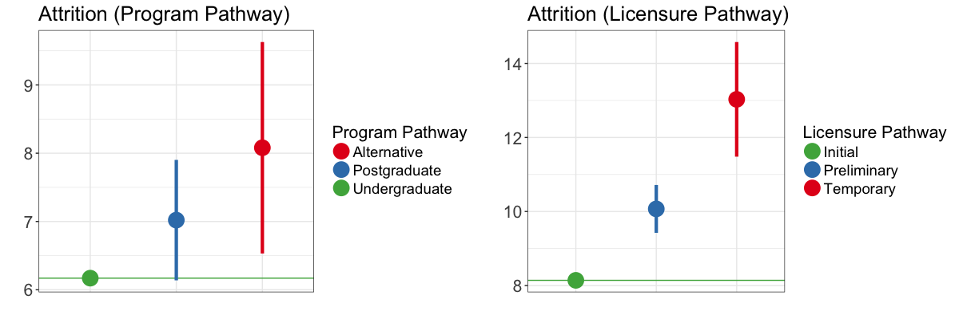
Notes: We plot estimated teacher attrition for each program and licensure pathway at the average values of teacher covariates in the dataset. Effects for alternative, postgraduate, preliminary, and temporary pathways are estimated using baseline models presented in the text. Attrition effects are in probability units. The vertical bars depict the 95% confidence interval for the estimated pathway effects relative to postgraduate programs or initial licenses.

Key Finding #4: Outcomes for most EPPs in Massachusetts are not statistically distinguishable from the average outcome across EPPs, but the variation explained by individual EPPs in Massachusetts is on the high end of what has been found in other states.
The teacher effectiveness measures for most EPPs in Massachusetts are not statistically distinguishable from the average across Massachusetts EPPs, a finding that is consistent with research in several other states. Although a few EPPs stand out at each extreme, differences in average value added among the EPPs in the middle of the distribution may be driven by random year-to-year fluctuations in the performance of individual teachers or students. In the full report, we discuss alternative methods of estimating differences in EPP outcomes; some program estimates vary significantly across modeling choices. In particular, estimates for EPPs with low enrollment or geographically concentrated placements are especially sensitive to modeling choices.
Despite the fact that most estimated EPP performance measures are statistically insignificant, there are educationally significant differences among programs. Researchers have estimated that typical annual learning gains in the grades we consider are about 0.40 standard deviations per year in math and about 0.30 standard deviations per year in ELA. Given those figures, the estimated achievement differences between the most effective EPPs and the state average correspond to about 5 to 20 weeks of student learning in math and about 9 to 36 weeks of learning in ELA. Overall, the variation in student achievement gains explained by individual EPPs is on the higher end of what has been observed in other states. The EPPs and individual programs jointly explain about 10 to 25% of the variation in teacher value added and about 2% of the variation in summative performance ratings. The institution and program a candidate attended predict future effectiveness about as well as other measures that can be collected during the teacher recruitment process (e.g., endorsements, educational attainment, test scores, and teacher screening tools).

Key Finding #5: Different programs within the same EPP vary substantially in teacher value added.
The individual EPP estimates mask considerable diversity within institutions. In the prior section, we characterize the variation in teacher effectiveness across institutions in Massachusetts. We also conduct a similar analysis to compare average effectiveness for different programs in the same institution. For example, if an EPP prepares candidates in five different licensure areas or prepares candidates at both the graduate and undergraduate levels, we can estimate the average effectiveness measures for each of these groups separately. When we do so, we find that teacher outcomes vary as much from program to program as they do across institutions.
This means that average teacher effectiveness is more variable among programs within an institution than across EPPs.
When the program portion of the variance is large, as it is in Massachusetts, teachers tend to look more like other teachers from their program and less like teachers from other programs in their institution. The empirical importance of individual programs implies that recruitment, preparation, or placement factors that differ among programs within an institution are more consequential than those that are fixed for all programs. Program-specific policies may therefore be an important focal point for improving teacher preparation.
Implications
As noted above, these estimates should be interpreted as reflecting both the effects of teacher training and pre-existing teacher candidate characteristics, rather than causal effects of teacher preparation. Nonetheless, the key findings discussed above have a number of potential implications for policymaking in Massachusetts:
- The variability in teacher outcomes among providers in this study is toward the higher end of comparable analyses in other states, so provider accreditation and support may be a more promising policy lever in Massachusetts than elsewhere.
- Individual programs within EPPs vary substantially in the effectiveness of their graduates. Policymakers may therefore wish to consider the strength of both programs and EPPs when evaluating teacher preparation. Furthermore, to the extent that teacher effectiveness varies across programs within an institution, EPPs may benefit from careful study of the features that distinguish their more effective programs.
- The providers and pathways that produce more effective teachers are not always those whose teachers remain in the profession the longest. In fact, the EPP teacher effectiveness measures are positively correlated with teacher attrition; in other words, the EPPs that graduate more effective teachers also tend to graduate teachers who are more likely to leave the workforce. Nonetheless, the available empirical evidence suggests that the impact of attrition on student outcomes is likely small relative to the direct effects on placing students with more effective teachers. Differences between programs and pathways in terms of teacher attrition are therefore likely less important to student outcomes than differences in their direct effects on student achievement.
The findings in this report provide a framework for considering the relationship between pre-service preparation experiences and teacher effectiveness. However, we only consider a narrow range of outcomes. When reviewing individual EPPs, including multiple indicators of effectiveness may provide policymakers with more reliable judgments about program effectiveness. Using a variety of measures also broadens the range of skills an evaluation system might consider. Emerging research on teacher effectiveness suggests that teaching is multidimensional and that important teaching skills are not fully captured either by test-based measures or by classroom observational tools.

Massachusetts Teacher Preparation and Licensure: Performance Review Program for Initial Licensure Study
American Institutes for Research
http://www.doe.mass.edu/research/reports/2018/01prpil-analysis.docx
The Performance Review Program for Initial Licensure (PRPIL) is a pathway to initial licensure for Massachusetts teachers who did not complete an educator preparation program before entering the classroom. Created in 2003, PRPIL was intended to open teacher licensure opportunities for mid-career individuals with prior work experience or content expertise by allowing them to demonstrate that they offer the same teaching competencies as other pre-professional license teachers without completing a preparation program.
Most teachers in Massachusetts begin their teaching careers with an initial license: the license offered to candidates who complete a teacher preparation program at an approved institution of higher education (IHE) or alternative program and which is valid for five years. However, about 22 percent of teachers in Massachusetts began teaching on a preliminary license, offered to candidates who pass the state’s Massachusetts Tests for Educator Licensure (MTEL) and meet other eligibility criteria, but have not completed a preparation program. The preliminary license is only valid for five years, so in order to continue teaching in Massachusetts public schools, teachers on preliminary licenses must have their license “advanced” to an initial license. Most do so by completing an educator preparation program through an IHE, but teachers can also earn their initial teaching license through PRPIL or by completing an approved educator preparation program through an alternative provider outside an IHE.
At the time of the data on which this report is based, PRPIL was only available as a route to licensure for educators teaching in districts that did not offer their own approved preparation programs, and only for teachers in certain subjects and grades. PRPIL requires teachers to document courses and experiences relevant to the Professional Standards for Teachers and complete the Massachusetts Candidate Assessment for Performance (CAP). Unlike other routes to initial licensure, teachers must have worked for three years in their licensure area under a preliminary license before they advance their license through PRPIL. As part of this route, teachers work with a mentor and instructional consultant to demonstrate their qualifications for an initial license. Following satisfactory completion of these requirements, a teacher candidate is recommended for initial licensure. PRPIL costs less than most other initial licensure programs, at $2,500 plus any expenses for additional coursework, as needed.
In this study, we examine the credentials of teachers that receive their initial licenses through PRPIL and the characteristics of the districts and schools in which they serve. We also study their effectiveness using student achievement data and teacher evaluation ratings and estimate the costs to teachers of employing this route to initial licensure versus other alternative options. In each case, we compare outcomes and experiences of teachers who have advanced to an initial license through PRPIL to other teachers who have earned an initial license through one of Massachusetts’ other pathways.
Key Finding 1: PRPIL is the most commonly used non-traditional route to initial licensure in Massachusetts.
Teachers on preliminary licenses have three options for advancing to an initial license: a traditional educator preparation program based at an institute of higher education, an alternative educator preparation program (usually based in a district or consortium of districts), or PRPIL. In any given year, PRPIL accounts for 5 to 8% of the program completions leading to an initial license.
We refer to alternative programs and PRPIL together as “non-traditional routes to initial licensure.” Figure ES.1 shows the number of individuals using the PRPIL and other alternative routes between 2010 and 2015. The number of teachers who advance their license from preliminary to initial through PRPIL is about equal to the total number of teachers who complete all alternative programs combined. However, in each year, the number of completers from traditional programs (which include some teachers who have preliminary licenses) is several times larger than the number from alternative pathways.
Figure ES.1. PRPIL and Alternative Program Completers by Year
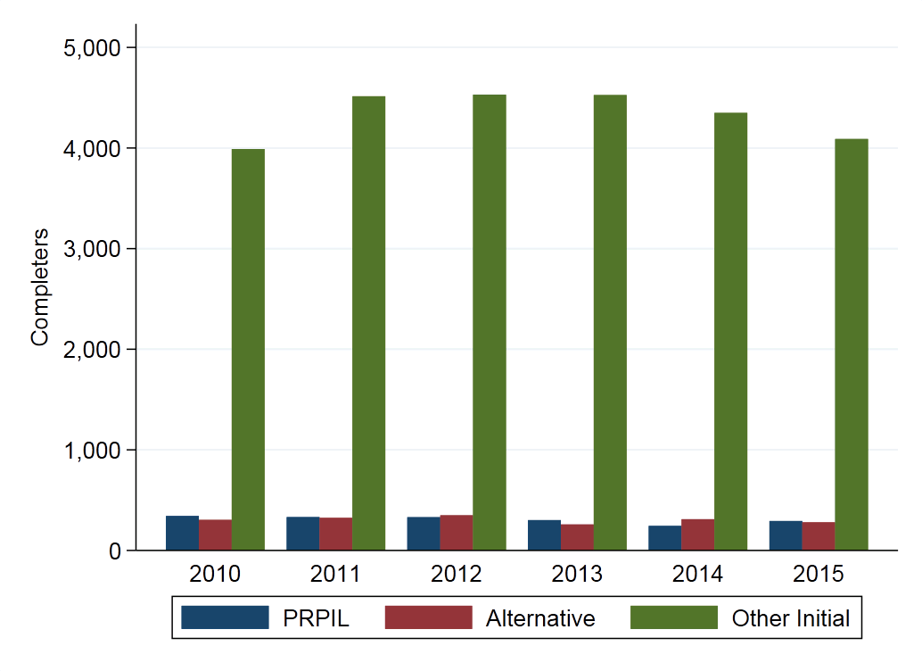
Key Finding 2: PRPIL teachers lead about 5 percent of high school classes in foreign languages, mathematics, and science.
Despite the fact that PRPIL teachers comprise only 2 percent of the teacher workforce, they are disproportionately likely to teach high school courses in high demand areas such as foreign languages, mathematics, and science. These fields are consistently on Massachusetts’ annual lists of shortage areas (Cross, 2016). As shown in Figure ES.2, PRPIL teachers are responsible for 5.5 percent of all high school foreign language classes, 4.8 percent of all high school math classes, and 5.0 percent of high school science classes.
Figure ES.2. Percentage of High School Classes Taught by PRPIL and Other Preliminary Teachers
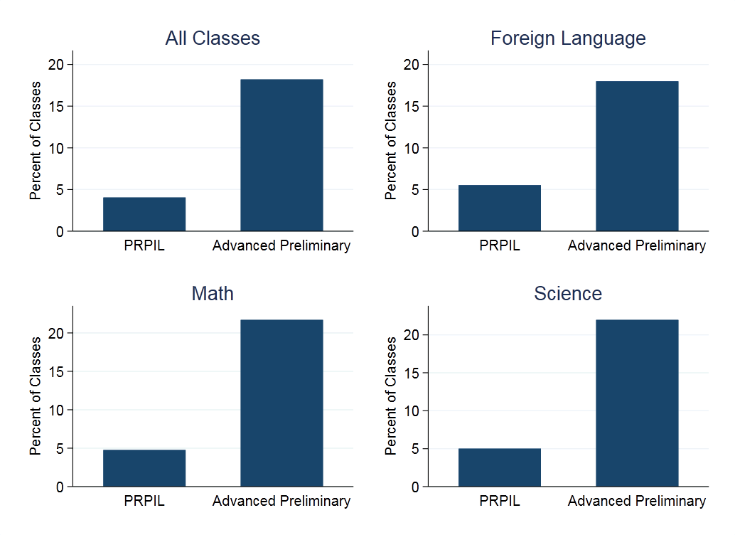
Notes: Percentage of high school level classrooms in each subject taught by teachers who have advanced their license through PRPIL and all teachers who have advanced from preliminary to initial licenses.
The disproportionate representation of PRPIL teachers in these courses partially reflects the fact that teachers that begin teaching with preliminary licenses are more likely to advance shortage area licenses in general. Figure ES.2 also shows that teachers who have advanced from preliminary to initial licenses (through any route) teach about 20 percent of these classes at the high school level. Relative to their overall representation in the profession, the assignment patterns of PRPIL teachers are more similar to other teachers with preliminary licenses than to teachers who enter the profession with an initial license. As we show in the full report, PRPIL teachers are somewhat more likely to advance foreign language licenses and about equally likely to advance math and science licenses as teachers who advance preliminary licenses and work in the same schools.
Key Finding 3: PRPIL teachers serve higher achieving, higher income students and work in higher performing districts and schools.
PRPIL teachers work in significantly different classroom settings than other teachers in Massachusetts. In classrooms taught by teachers who have advanced their license through PRPIL, about 30 percent of students are economically disadvantaged (Figure ES.3). For other teachers who have advanced their preliminary licenses to an initial licensure, about 40 percent of students – or about one third more – are economically disadvantaged. However, much of this difference is explained by the sorting of PRPIL teachers across school districts. Comparing PRPIL teachers to non-PRPIL teachers who work in the same school district, the gap in economic disadvantage is only about one quarter as large.
Figure ES.3. Average Classroom Economic Disadvantage by PRPIL Status
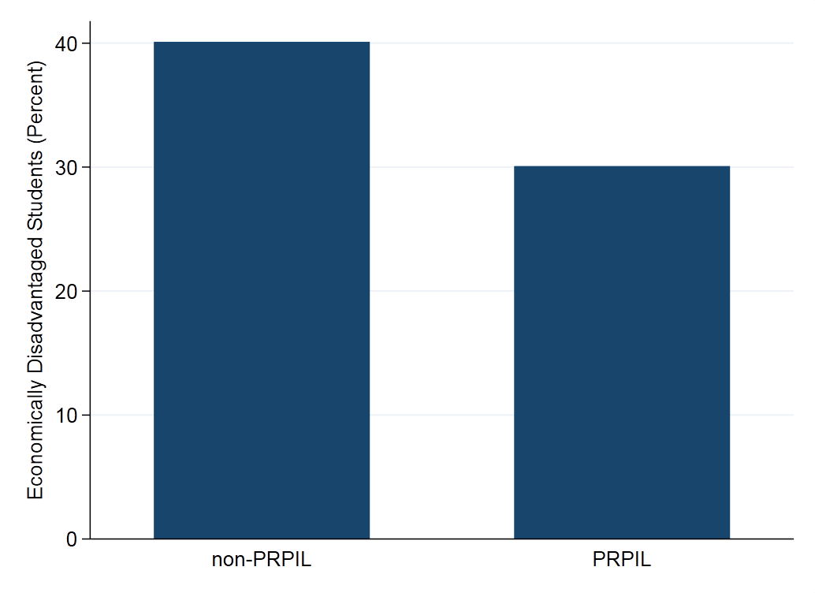
Notes: Student economic disadvantage by PRPIL status. PRPIL teachers are those who have advanced their license via the PRPIL pathway. Non-PRPIL teachers include all those who have advanced a preliminary license to an initial licensure through some other pathway.
Students of PRPIL teachers also have higher prior scores on standardized tests. Again, most of the variation in the classroom composition between PRPIL and non-PRPIL teachers can be explained by the districts in which they teach, although they are also more likely to teach subjects, such as foreign languages, where average student achievement is higher.
Key Finding 4: PRPIL teachers earn similar performance ratings as other teachers with initial or professional licenses.
We use teacher performance on the Massachusetts educator evaluation framework to compare the effectiveness of PRPIL teachers to other teachers. Because all teachers in Massachusetts are evaluated, these performance measures are available for a much wider set of teachers than achievement based measures (such as teacher value-added) that are commonly used in studies of teacher credentials. Teachers who were advanced to initial by PRPIL perform similarly on their performance evaluations as teachers who have earned an initial license either by completing a traditional educator preparation program or through some other alternative pathway. Their performance is also quite close to other teachers who have advanced a preliminary license.
Key Finding 5: In the short run, the PRPIL pathway is significantly less expensive than other methods of obtaining initial licensure.
Because it is not a formal educator preparation program, the PRPIL pathway has the lowest tuition of any method of advancing to initial licensure in Massachusetts. This makes it less costly to teachers than other alternative programs where teachers also work in public schools while meeting the requirements for initial licensure. The costs of traditional programs – where candidates may study fulltime – may be substantially higher if candidates do not work while they prepare for licensure. Because teachers progressing through the PRPIL pathway work fulltime while completing their licensure requirements, they do not forego earnings while they study. This makes PRPIL less costly in the short run than fulltime post-baccalaureate programs, although completing these programs leads to higher pay over time because districts pay higher salaries to teachers with advanced degrees. However, if teachers work fulltime while they complete post-baccalaureate programs, the additional pay may make their costs comparable to earning licensure through PRPIL within 6 years of graduation.
Implications
This study provides a descriptive overview of where PRPIL teachers work, the students they serve, and the skills they bring to the workforce. But it does not directly assess how authorizing the PRPIL pathway affects the educator workforce in Massachusetts or the distribution of full licensed, effective teachers across the state. These comparisons are important for assessing whether teachers advanced through this pathway perform similarly as other teachers in Massachusetts. However, merely offering the PRPIL pathway may change the career decisions of current or prospective teachers. There is very little evidence on how state licensure requirements shape the career choices of prospective teachers, but researchers have found suggestive evidence that testing and other requirements affect the composition of the teacher workforce (Angrist & Guryan, 2008; Larsen, 2015). Thus, an examination of the experiences of only those who complete PRPIL may miss some of the broader effects of the pathway on the teaching profession.
Although PRPIL teachers are more likely than other new entrants to the profession to specialize in and teach in high needs subjects, this descriptive study leaves a number of important questions about how the pathway affects the teacher workforce in Massachusetts:
- PRPIL teachers are more likely than other teachers on initial or professional licenses to teach in high-need subjects, but this study does not address whether the existence of the PRPIL pathway increases the overall supply of these teachers. Some may have chosen to enter the profession through other routes, potentially at higher cost, although some may not have. Two key factors to consider are the sensitivity of prospective teachers in high need subject areas to the cost of obtaining licensure and the capacity of other programs to train the teachers currently enrolled in PRPIL. If prospective teachers are not sensitive to cost, or if other programs can expand to enroll PRPIL teachers, then the pathway may not significantly influence the supply of teachers. Otherwise, it is likely that PRPIL has some effect on the supply of teachers.
- PRPIL teachers work with higher income and higher achieving students, but we do not know whether this reflects a preference of teachers or the resources of schools. Although it is plausible that the differences in the characteristics of students taught by PRPIL teachers reflect the preferences of individual teachers, it may also be that high income school districts have the resources to offer more advanced coursework and thus hire PRPIL teachers because they are disproportionately licensed in these subject areas. The current distribution of PRPIL teachers may also reflect eligibility restrictions or recruitment choices by the current vendor, and these are likely to change under new regulations.
- This study focuses on teachers credentialed through PRPIL, but does not consider teachers who may have considered the pathway and dropped out before completing it. The PRPIL pathway may encourage more teachers to enter the profession. However, teacher attrition from the profession is highest during the first few years in the classroom, and in prior work, we found that it is disproportionately high for teachers who enter with preliminary licenses. It is possible that the PRPIL pathway increases the number of inexperienced teachers in the workforce by encouraging more teachers to enter the profession through the preliminary route. Similarly, PRPIL may encourage some teachers who would have completed an educator preparation program to forego this training and earn initial licensure by PRPIL instead. Either of these possibilities may lower the effectiveness of the teacher workforce in ways that we do not consider in this study. However, given that PRPIL teachers are a relatively small subset of the total teaching profession, it is unlikely that reduced teaching experience has a significant effect on average teacher effectiveness.
- The current study finds little evidence of differences in the effectiveness of PRPIL teachers and teachers who advance to initial licensure through other routes, but this finding may depend on program features specific to the current vendor. Currently, there is only one vendor, Class Measures, executing the PRPIL option for candidates. The regulations provide for relative flexibility in terms of how Class Measures operationalizes PRPIL and the results of this study may be sensitive to some of those decisions. In particular, recent research has linked the quality of mentorship during the student teaching internship to future effectiveness in the workforce (Goldhaber et al., 2016; Ronfeldt 2012, 2015). If teachers accrue some benefit by participating in the PRPIL process, it may be difficult to predict how teachers prepared through other similar pathways sponsored by other providers would fare in the workplace.
Understanding these issues, particularly how the PRPIL pathway affects the overall supply and distribution of teachers, will be important for assessing the effects of potential changes to the licensure regulations. The recent regulatory changes in Massachusetts may provide opportunities to answer some of these questions and assess how the pathway operates in other settings.

Competency Determination is based on performance on the state’s high school MCAS tests in English language arts, mathematics, and science and technology/engineering.
Throughout the report, we follow the conventional terminology and refer to estimated effects on student achievement as “value added.” These estimates are derived from statistical models run for this research project and not from the state-calculated student growth percentiles.
In July 2017, the Massachusetts Board of Elementary and Secondary Education approved numerous changes to the teacher licensure regulations, one of which was changing the name of this type of license from preliminary to provisional. Our data precede this regulatory change, so we refer to preliminary licenses throughout this report.
The aforementioned regulatory changes also expanded the eligibility for advancing a license through PRPIL. During the time period covered in this study, PRPIL did not advance elementary licenses and was it only available to teachers working in locations without access to other alternative programs for mid-career teachers. These restrictions were removed in July 2017. We list the subject areas covered by PRPIL in the data considered in this study in Appendix A.
We use the shortage areas reported to the U.S. Department of Education Office of Postsecondary Education for student financial aid programs (Cross, 2016). The list varies by year, but generally includes English as a Second Language, English/Language Arts, Mathematics, Foreign Languages, Science, and Special Education.
We also evaluate PRPIL teachers by their value added, although small samples of PRPIL teachers in tested grades and subjects limits the precision and generalizability of the results. We discuss these findings in the main text.

