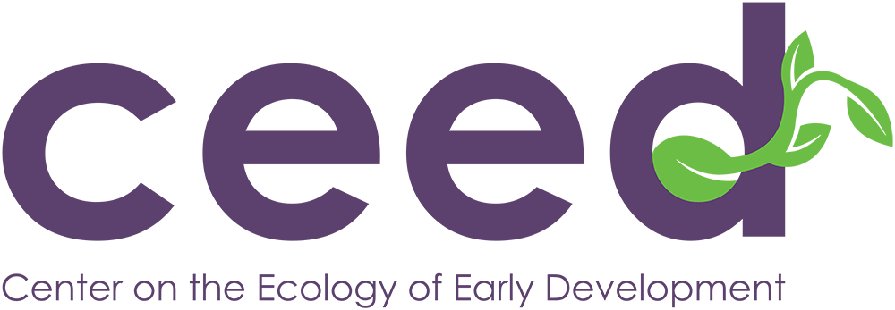
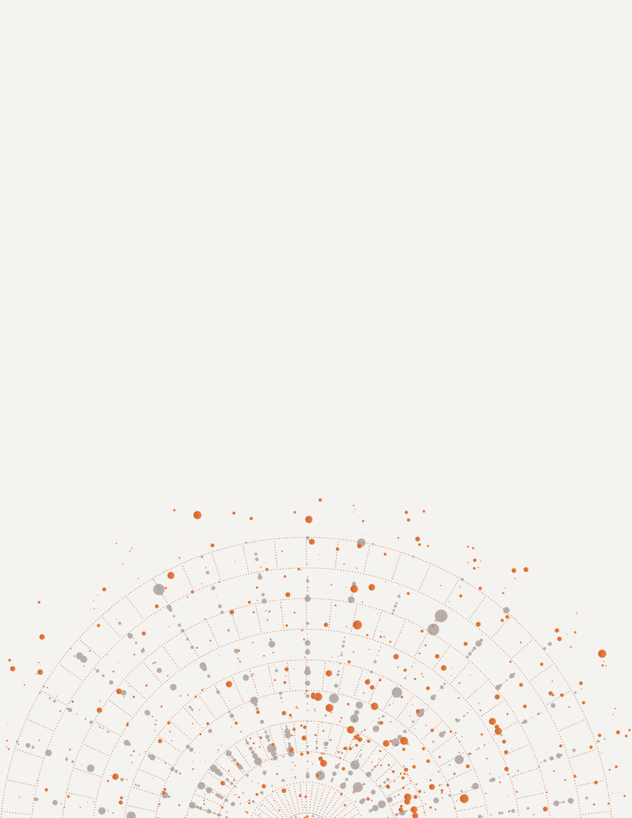

FY2025 eVALUATION Report
June 2025

Playful Learning Institute Evaluation
Educator Advisory Group &
Baseline Classroom Observations
Presented by:  NORC at the University of Chicago  Center on the Ecology of Early Development (CEED) at Boston University  Point of Contact  Cristina Carrazza  Project Director and Principal Investigator  carrazza-cristina@norc.org |  | Presented to:  Massachusetts Department of Elementary and Secondary Education  Office of Student and Family Support  Kendra Winner, Research and Evaluation Coordinator  kendra.l.winner@state.ma.us  Donna Traynham, Early Learning Team Lead  donna.j.traynham@mass.gov

Table of Contents
Executive Summary 1
Evaluation Overview 3
Evaluation Goals 3
Spring 2025 Data Collection 3
Educator Advisory Group 4
Overview and Methods 4
Key Themes and Findings 5
Playful learning practices increased student engagement 5
Students feel empowered to participate and express their learning 6
Teachers experienced better behavior management 8
Students gain opportunities to demonstrate understanding through play 8
Benefits of PLI practices extended beyond Playful Learning studio time 9
Teachers value play but feel pressure to meet academic expectations 10
Scheduling and planning PLI can be a challenge 10
Teachers were initially overwhelmed but grew to embrace the PLI 11
Teachers would like more collaboration to see the PLI in action 12
Administrative support and coaching were key for fostering teachers’ success 14
Baseline Classroom Observations 15
Overview 15
Methods 15
Sample 16
Summary of Findings 17
Learning Activity Characteristics 18
Student Instructional Materials 19
Learning Activity Features 20
Student Practices 21
Ratings of Instruction Quality 24
Teacher Responsiveness 25
Cognitive Demand 27
Overall Classroom Ratings 28
Behavior Management 29
Peer Interactions 30
Students’ Emotional and Behavioral Self-Regulation 31
Evaluation Next Steps 32
References 33
List of Exhibits
Figure 1. Teacher and Student Activity Setting 18
Figure 2. Quality Ratings of Teacher Responses to Student Thinking 25
Figure 3. Quality Ratings of Teacher Questions 26
Figure 4. Quality Ratings of Cognitive Demand 27
Figure 5. Quality Rating of Classroom Behavior Management 29
Figure 6. Quality Rating of Peer Interactions 30
Figure 7. Quality Rating of Students’ Emotional and Behavioral Self-Regulation 31
Figure 8. 2025-2026 Data Collection Activities 32

List of Tables
Table 1. Spring 2025 Data Collection Activities by Cohort 4
Table 2. Number of Observed Classrooms by Grade Level 17
Table 3. Proportion of Episodes by Instructional Content 17
Table 4. Proportion of Episodes by Activity Setting 19
Table 5. Proportion of Episodes with Student Instructional Materials 20
Table 6. Proportion of Episodes with Learning Activity Features 21
Table 7. Proportion of Episodes by Student Practices 22
Table 8. Student Practices by Activity Setting 23
Table 9. Average Instruction Quality Ratings 24
Table 10. Average Overall Classroom Ratings 28

Executive Summary
The evaluation of the Playful Learning Institute (PLI), conducted by NORC at the University of Chicago and the Center on the Ecology of Early Development (CEED) at Boston University, provides a comprehensive look at the second year of PLI implementation across Massachusetts school districts. The evaluation focused on two cohorts: Cohort 1, in their second year of the PLI, and Cohort 2, newly engaged in the institute.
This report summarizes findings from data collection activities completed in FY2025:
- Educator Advisory Group with Cohort 1
- Baseline observations conducted in Cohort 2 classrooms
Educator Advisory Board: The evaluation team engaged teachers from three Cohort 1 districts to participate in a series of focus groups. Our goal with these discussions was to gather insights from teachers who had participated in the PLI for over a year at the time of data collection about their experiences with and feedback on the PLI to inform our evaluation and the institute’s continuous improvement. Teachers felt that the PLI substantially enhanced student engagement and participation, and improved classroom behavior. Teachers described how playful learning created inclusive classroom environments where students felt safe to express themselves and collaborate. While their initial implementation was challenging due to time constraints and planning demands, educators ultimately reported embracing the approach, citing increased student joy and deeper learning. Teachers also emphasized the crucial role of administrative support, effective coaching, and opportunities for collaboration with fellow teachers in supporting implementation.
Baseline Classroom Observations: The evaluation team observed 14 Cohort 2 classrooms across preschool through 3rd grade, with two classrooms in each district. The goal of these baseline observations was to capture classroom practices prior to teachers’ participation in professional development and to identify potential areas for growth as they begin engaging with the PLI. Observers visited each classroom for three hours and utilized the Active Playful Learning Episodic Classroom Observation System tool to capture learning episodes (APL-ECOS; Farran, Nesbitt, Rainey & Active Playful Learning Consortium, 2025). Findings describe different types of learning activities that teachers and students engaged in, as well as rating the quality of instruction and the classroom environment. On average, classrooms featured 23 learning episodes, with most activities involving independent work. Only 20% of activities offered student choice, and just 5% included teacher adaptation for individual needs. Observers noted that associative student interactions occurred in 26% of episodes. Students explained their reasoning in 14% and discussed instructional content in 33% of episodes. On average, teachers scored a 2.61 in responsiveness and 2.16 in cognitive demand (out of 5), with 3rd grade classrooms scoring slightly higher than other grades. On average, teachers scored a 3 out of 5 in overall classroom ratings of behavior management, peer interaction, and student self-regulation, with preschool-K and 1st-2nd grade classrooms generally performing better than 3rd grade classrooms in these areas. These findings establish a baseline for evaluating the impact of PLI professional development and coaching in the coming year.

Evaluation Overview
NORC at the University of Chicago (NORC) and the Center on the Ecology of Early Development (CEED) at Boston University (BU) are partnering with the Massachusetts (MA) Department of Elementary and Secondary Education (DESE) on the ongoing evaluation of the Playful Learning Institute (PLI). Now in its second year of implementation, the PLI includes two cohorts of school districts across the state:
- Cohort 1 consists of four districts that participated in the pilot year (2023-24) and were in their second year (2024-25) of implementation at the time of data collection.
- Cohort 2 includes seven districts that began participating in PLI activities during the 2025-26 school year.
The evaluation team engaged in data collection with both cohorts in spring 2025.

Evaluation Goals
The ongoing evaluation is guided by the following goals:
- To understand if and how the PLI is helping educators implement playful learning practices with fidelity
- To inform future measures of PLI student outcomes
- To convene educators from participating school districts as advisory partners
Through this work, the evaluation aims to develop a comprehensive understanding of the fidelity of PLI implementation, identify successes and challenges, assess student and teacher engagement, examine the role of professional learning and coaching practices, and explore how the PLI influences classroom instruction.

Spring 2025 Data Collection
Evaluation activities conducted in spring 2025 varied by cohort, as outlined in Table 1. For Cohort 1, the evaluation team conducted three focus groups with an advisory group of eight teachers from three participating schools. For Cohort 2, baseline classroom observations were carried out in 14 classrooms prior to the teachers’ engagement in the PLI’s asynchronous professional development.

Table 1. Spring 2025 Data Collection Activities by Cohort
Method | Cohort 1 | Cohort 2
Sample | Eight teachers in three of the school districts that began participation in school year 2023-24  (Year 2 of PLI activities at the time of data collection) | 14 classrooms in seven school districts beginning participation in school year 2025-26  (Year 0 of PLI activities at the time of data collection)
Data Collection | Focus group with PLI educators | Classroom observations in PLI educator classrooms
Goals | Engage teachers and administrators as thought partners to understand 1) PLI successes and barriers, 2) student and teacher engagement with the PLI and playful learning practices​, and 3) student outcomes that should be measured to capture PLI impact | Baseline measure of teacher’s playful learning classroom practices prior to engaging in professional development and coaching

Educator Advisory Group

Overview and Methods
The evaluation team conducted three half-hour focus groups over Zoom with a select group of educators from three Cohort 1 districts in May 2025. The participating teachers were identified and invited to participate by DESE. Each focus group brought together teachers from the same school to meet with the evaluation team. Overall, participating teachers included: one preschool teacher, one kindergarten teacher, one 1st grade teacher, one 2nd grade teacher, three 3rd grade teachers, and one special education teacher (a reading specialist who worked in a partial inclusion classroom model and co-taught with a general education teacher).
Our goal with these discussions was to gather insights from experienced teachers about their experience with the PLI to inform our evaluation and the institute’s continuous improvement. We also wanted to capture teachers’ thoughts about the barriers to PLI implementation reported in the baseline survey, ways in which these barriers could be remediated in the future, and anecdotal evidence about successes and student engagement shared with DESE at showcase gatherings and other PLI participant gatherings where participating teachers shared their playful learning practices.
The evaluation team, in collaboration with DESE, developed an extensive discussion guide and asked the following questions to guide the facilitation of every conversation:
- What made you a believer in the PLI?
- How, if at all, do you see your role as a teacher differently than before participating in the PLI?
- What changes in your classroom have you experienced since participating in the PLI?
- What can DESE do to better scaffold the initial experience of implementing playful learning practices?
- What outcomes do you think should be measured when examining the effects of play?
The sessions were recorded and transcribed. Our qualitative thematic analysis of the discussion aimed to explore various themes regarding teachers’ experience with the PLI, including any successes and barriers, changes to classroom practices, and perceived student outcomes.
In our summary of findings below, we highlight quotes to illustrate the key themes of educators’ PLI experiences. While individual quotes are credited to the individual teachers who shared them, all insights highlighted here reflect a consensus among educators unless otherwise noted. Not every instance of agreement is quoted directly as teachers also shared their consensus through nonverbal cues and verbal affirmations.

Key Themes and Findings

Playful learning practices increased student engagement
All teachers reported that they thought the PLI substantially increased student engagement in a variety of ways. First, students were more engaged with the learning material. One teacher shared, “I feel like the learning is deeper and longer...They’re staying in areas longer because they’re more engaged and there’s more materials, and there’s more opportunities...I have seen much deeper and better and cooperative play.”
Another teacher at this school agreed, noting that the shift in student engagement was one of the key factors that made her a strong supporter of the PLI. “One of the things that caused [me] to be a believer [in the PLI] was the student engagement and their level of excitement to participate in this work…they are most excited about the materials…and they are so jazzed about using different materials.”
Teachers noted that the PLI not only increased students’ engagement with academic content but also enhanced their interactions with peers. One teacher described how the PLI environment encouraged student collaboration and connection.
“In my class last year, I had kids that probably never conversed at all during the year. Then, when we would do playful learning activities, you saw those kids have an opportunity to kind of interact with peers that normally didn’t fall in their traditional friend group.”
A teacher in another district elaborated, explaining how the PLI learning environment effectively engaged students who would typically struggle to participate. She highlighted how the PLI’s studio model created an inclusive space for students receiving additional support through the reading support program.
“I feel like studios is the one place where everyone is on level playing ground. Whenever we have people come in the room, they’re always like, we can’t tell who the kids are that are in the program and who the kids are that are not, because everyone’s on a level playing field. [Students are] making [their] own choice[s] about what [they] want to do.”

Students feel empowered to participate and express their learning
Teachers observed that as students became more engaged through the PLI, they also grew more comfortable participating in learning. This led students to become more confident, take more risks, and feel safer expressing themselves. One teacher shared,
“I have seen some examples of an increase in student engagement, which led to…risks that they’re taking feel like a lower risk…I have a student for example who might get a rise if the work is challenging, and [say] ‘no I don’t want to do this.’ ‘This is stupid’... But this feels low-risk, and so they’re more willing to take a chance and give it a go. I have seen student behavior improve and students being more willing to get something wrong, or make a mistake than with traditional academic activities…part of it is absolutely part of the playful learning and becoming used to maybe being uncomfortable and putting yourself out there”
A teacher from a different school elaborated on how the PLI environment helped students feel more comfortable participating in group settings.
“A few kids last year at the beginning of the year really did not want to share and talk when we did our morning meeting or community meeting. And as the year went on, they became more comfortable, and they did start sharing. I think the reason being PLI creates a safe environment…And it helps the kids—or what I have noticed is they start becoming risk takers, which they might not have been. It’s okay to be embarrassed when you’re doing story acting. It’s okay to feel shy and not want to do it. It's okay to make a mistake...So PLI versus when I did not have PLI, one main takeaway is like social-emotional comfort and safety and confidence.”
This benefit of the PLI was also echoed by the special education teacher, who emphasized how the studio model fosters inclusion: “[Students in the reading support program] can still participate and feel part of that classroom and feel connected, which was a struggle before. The confidence in the classroom has increased because they feel more part of the learning community. They’re taking more risks...”
Teachers across all schools shared anecdotes of specific students who, through the PLI, became more comfortable participating in general instruction. One kindergarten teacher in particular shared how one of her students was able to engage in a way that was not disruptive or distracting to the rest of their classmates:
“Last year I had someone who was very resistant to paper-pencil tasks, and in kindergarten, we’re just starting to get that rolling. And so the storytelling, story acting was an avenue for that student to feel relaxed and come and tell his stories. And his engagement went right through the roof...This is a bridge for them to experience things in a [way that is] more... productive, and it’s to an end, and they see value in themselves, and they realize that they have something to bring to the group every day. And they don’t see themselves as an outsider looking in, or other kids don’t view them as a bad student...that keeps them regulated so therefore it gives them a window in.”
A teacher in another school also expanded on how one of her students who had struggled to participate has now become more comfortable with participating in classroom activities through the PLI.
“Earlier in the year [one student] did not want to participate, was crying at the beginning of the year when we were doing acting. And the other day, we were doing something...she raised her hand and I figured she was gonna say ‘Can I go to the bathroom?’ like she always does because she wants to avoid it. She asked for a part!”

Teachers experienced better behavior management
Another important aspect of increased student engagement through the PLI involved teachers noticing a reduction in disruptive behaviors. As one teacher shared,
“The amount of behavioral issues that we have to address during studio time is dramatically decreased to the point where I don’t really...they’re doing what they want, and they’re engaged. That in itself is—how is it beneficial? Well, the level of engagement is so high, and the [disruptive] behaviors are so minimal.”
A teacher from another district echoed this observation, adding “I feel like the [disruptive] behaviors have gone down as PLI has come up.” One teacher credited the skills students developed during play with building their socio-emotional management skills, explaining, “academic standards are so high…these kids don’t get a lot of opportunity, especially in older grades, for play, and for softer skill type things like collaborating and sharing materials.”

Students gain opportunities to demonstrate understanding through play
Playful learning allowed students to demonstrate their understanding in diverse and creative ways. Across all schools, teachers shared anecdotes illustrating how studio time has enabled them to recognize their students’ understanding in ways that are not evident in more traditional learning settings.
“I’ve had kids that are not as great writers, and I look at their essay and...they don’t score so well, and I’m like did they even know what was going on in this unit? And then I go over to their studio and they’re telling me any and everything they know that we learned...and I’m like oh, they actually do know all of this. That’s been helpful for me. You understand way more when you can show [it] in the way that makes sense to you.”
Another teacher from this school described how incorporating play encouraged students to take ownership of their learning and become excited to share their knowledge with the class.
“To see how the kids that you don’t necessarily see shine...so enthusiastic and so excited to show you what their knowledge is. It’s not this ‘Look, I finished. Now what do I do?’ It’s like ‘Let me show you what I did!’ And it’s a huge shift. That’s how it should be. When we let the kids have that voice and choice and a little bit of play, look at what they’re able to show us that they know, and it’s awesome to see.”
A teacher in another school elaborated on how students took pride in their work and owned their work in ways that would not be observed in traditional classroom activities or captured in typical assessments.
“I’m walking around and I’m listening and I’m observing their creations, or their thoughts...they’re so happy! And they are proud of themselves. Which is not something that you see on a typical pen and paper assessment…I think that’s the best part, is the ownership, the self-ownership, and their own autonomy, that they have so much dictated to them all the time that even as 8-year-olds and 7-year-olds having that choice and having that power is so valuable.”

Benefits of PLI practices extended beyond Playful Learning studio time
Teachers noted that the benefits of PLI practices often extended beyond designated studio times, influencing their classroom practices more generally. As one teacher explained, “it definitely spills over. Absolutely spills over. Even in math…We started putting it everywhere...it’s kind of hard not to. You start and then all of a sudden it’s more just like your way of the whole day...doesn’t matter what subject.”
Another teacher elaborated on how playful learning helped students build their vocabulary and collaborate with each other, even beyond the time designated for studios.
“I’ve noticed kids inspiring each other and them using that actual vocabulary. Like ‘Oh that inspired me, I’m gonna try that,’ or ‘What were your challenges when you tried this?’ The whole thinking and feedback really gives them pause to explore their metacognition, like ‘What did you think about that when you did that?’ and then provide feedback to each other. So I as an educator have adopted that language, like what inspired you? And then you can just see the light go off in the student to think about what did inspire them to make this clay structure or creation. That they can get inspired from one another and that we are resources to one another. That’s been exciting that it’s not just me filling them, it’s them collaborating with each other. That is the true joy in the moment.”
Beyond engaging students, the joy of playful learning practices extended to teachers as well. Many educators reported feeling more involved in their students’ learning during PLI activities. One teacher shared that the PLI had rekindled her passion for teaching, explaining, “I get so sucked into their learning, because I’m so happy and excited to see what they’re doing that I forget to record it, or I forget to take those notes so I can share them, because I’m so invested in that moment with the kids.”

Teachers value play but feel pressure to meet academic expectations
While teachers overwhelmingly recognized the value of play, they felt tension between play and academic expectations. Teachers described working to strike a balance between incorporating playful learning practices and meeting curriculum requirements.
“We want kids to play, and we have loved doing this, but we have to keep that academic and that grade level expectation focus...they have those different choices, but [we] always [include] some sort of written or even spoken [component to the classroom activities]...as a way of keeping them on task and focused. That’s how we document and assess.”
One kindergarten teacher explained the challenges of prioritizing play while ensuring that students meet academic milestones.
“The pushdown is real...I’ve been excited having been at this a minute or two to get back to our roots of child-centered play. But the reality for me is that it takes time to navigate that world, as well as the pushdown of ‘they have to be at this reading level,’ or ‘there’s an 80-minute math program that you now have to see to in a 6-hour day.’ So it’s been a challenge in that way to make sure everything gets done.”
A first grade teacher expanded on this challenge, adding that there was a lingering stigma that play would detract from typical instruction time: “I think some teachers when they come in, they’re like are they just playing? How do you get all your curriculum in if kids are playing during these times? So that’s really one of the things that we’ve really tried to increase is adding some sort of writing piece in every [studio].”

Scheduling and planning PLI can be a challenge
Across all grades, teachers agreed that time constraints were a barrier to implementing the PLI. Teachers described how fitting the PLI into an already packed schedule was difficult. “The biggest question everyone asks us for third grade is when you find time in your schedule. Like something’s gotta give. When do you find time for that?” Another teacher expressed feeling overwhelmed at the beginning of the PLI, as she underestimated the amount of planning time it would take to implement it effectively. She said, “In order to do this work well, I believe it takes a lot of teacher time. And I don’t know that it really was a thought when we first embarked on this important work.”
This first teacher explained that while planning for PLI activities was initially time-intensive, it became easier with experience.
“What we hear the most from people that we meet with is the time, the planning and the fitting in academics. And to be completely honest, that was our fear to start all of this. Because we don’t have common planning....I tell people this doesn’t have to be an everyday thing. We do it once a month for a week in the afternoons so you have the month to plan it. You tie it into your curriculum.”
This teacher added that introducing play into the classroom required lots of planning: “You have to make it work for you. There is no way we could do it all day every day. You just can’t. But it’s about finding time to fit it in. The planning is heavy up front, but once you do it, it’s a breeze after that. And year two, we literally have it all. It’s the same curriculum.”
A third grade teacher noted that in the upper grades, it could be challenging to support students' play-based thinking without additional classroom staff to help scaffold their learning.
“I’m the only adult in the classroom, which is fine, but that sometimes makes it tricky, because it’s difficult for me to get to all of the different learning adventures during studios. So sometimes kids will be stuck, and then they’ll be stuck for a really long time because maybe I didn’t notice, or they’ll go off on a tangent. My hope was that I had an opportunity to guide them differently through that or encourage them to dig deeper. So it’s just a tricky business when you’re on your own.”

Teachers were initially overwhelmed but grew to embrace the PLI
Teachers described feeling initially hesitant about participating in the PLI. One teacher shared the pressure she felt implementing something new, saying, “It did feel at times overwhelming because you wanted to make sure you’re putting time and effort into really having the kids understand, ‘What are the expectations? What should you be looking like while you’re doing these things?’”
This teacher explained that part of the challenge involved the time and effort required to set up learning materials.
“It’s worth the time and effort that you put in...There is a lot of prep involved...But I think last year, it seemed way more daunting, because you were trying to establish what you were going to use. Now I have an art cart with all the materials on it, so I’m not pulling different things each week. It’s all organized ready to go.”
A teacher at a different school district also spoke about the steep learning curve involved in implementing the PLI.
“Well we left the two-day training—I was like, there’s no way. Because I feel like there needs to be much more training and much more [conversation] in the way beginning. Because we didn’t realize all the materials we were gonna need…We didn’t know things soon enough fast enough...then I did start to like it...But it took a long time. It’s a lot of prep work, and it’s a lot of time and it’s a lot of just getting things together…So I feel like more training and deeper training would really have benefited me being on board sooner.”
Despite their initial frustrations, the teachers in the focus groups described how they ultimately embraced the PLI, agreeing that the benefits outweighed the initial challenges. For example, one third grade teacher acknowledged feeling reluctant and frustrated when she first enrolled in the PLI. She was initially skeptical about how it would apply to her classroom and expressed a lack of interest in participating:
“We were ‘voluntold’ that we had to attend a PLI PD all-day thing, and that we were going to adopt it and we were gonna follow it… And we were pretty not happy about it. We were like, what in the world is PLI and why am I doing it? I’m in third grade. I teach third grade. What are we doing here?”
Over time, however, her perspective shifted. This teacher grew to appreciate the approach and now strongly believes in the benefits the PLI brought to both her teaching and to her students’ learning.
“The way I would explain it to any of the people who are new to this is yes it’s overwhelming, yes you really have no idea what you’re doing going into it, so let’s do this depending on what grade you’re in, let’s focus on two things....and then add an activity to it…Once I felt comfortable with it, the kids loved it. They begged me to do it…I loved it and ended up being really good at it…We started off with me not wanting to do it because I was kind of mad...I’ve been on all these meetings and I can tell every teacher who’s overwhelmed that you can do it. Take a breath, and someone’s gonna coach you through it.”

Teachers would like more collaboration to see the PLI in action
Teachers expressed a desire for more structured guidance, collaboration, or examples to help implement the PLI. One 3rd grade teacher noted that seeing examples of playful learning practices in other classrooms would have been a valuable resource.
“I would love to have…a menu of options of things that other people have done that gives me an idea of what studios looks like in other classrooms. And what it could look like. Just as a starting place...I’m like does my studio even look like other people’s studios? I bet mine’s really awful. Or maybe it’s great. And I’m making this harder than it has to be, and I’m stressing out about how much time it’s taking.”
Another teacher at this school echoed the need for more collaboration with fellow PLI educators.
“Having grade level conversations [across schools in the district] would have been—even cross-grade, vertical conversations would have been astronomically helpful. I think out of all the trainings, the most beneficial one that I got anything out of was when we met for maybe an hour with the four other districts that were doing it and just talked and breakout sessions....getting this collaboration....our best teaching is always through collaboration and getting ideas.”
One teacher at another school shared that it could be hard to conceptualize what playful learning looks like in practice without seeing it in action. She explained that being able to see examples of successful implementation in actual classrooms would be helpful for her.
“A lot of like video clips of it being implemented, either her running things, you seeing it in action, because I feel at times...it was hard to conceptualize, like what does this look like? We even had a school district from [another state] come out and observe us this year, and they were like, this is so helpful, like seeing it in action...Watching adults do it [in trainings/PDs] is quite different than watching kids experience it.” .
This teacher also reflected on the value of sharing their school’s experiences with other participating districts.
“Me and [another teacher] have gone on a couple calls with other districts who are implementing, just so that they can ask questions. It’s even about organization, or how long does this take...That’s why we’re willing to do this [advisory board], because we see the benefit of it and we want it to be successful for other [districts] as well. Doing it, but also seeing a teacher or watching a teacher like implement into a real classroom with real students that are real behaviors.”
Another teacher from this school agreed that this collaboration was critical for future success of the PLI since it allows teachers to see the feasibility of playful learning. “If you see it in action, you see the kids, you see the teacher, you see the school, you see the principal, you see the supplies. Just huge. You’re like okay this is very doable, I can go back to my class tomorrow and do a little bit of it.”
The first teacher from this school emphasized the value of early collaboration between participating districts and expressed a desire for such support from the beginning: “Another district shared a funding list for us...Like this is the kind of materials that we bought with the funding that we got, which was helpful so we weren’t starting at scratch. That would be something [that] would be helpful for them to share out.”

Administrative support and coaching were key for fostering teachers’ success
Teachers noted that successful implementation of the PLI depended heavily on administrative support. Some teachers described some initial challenges with receiving this support.
“To what end is this work gonna get us? Is this just a flash in the pan? And by the way you have to do this and this. You know, if this is just a probiotic that is gonna help us digest what’s on our plate, and we just keep adding to our plate, it’s gonna be hard for teachers to get on board. And administrators more exclusively [need to get on board] because our administrators are always like to what end are we devoting this time? Why am I getting you a sub for this work? That’s the pushback we still feel. Even being in the piloting phase of this.”
A teacher from another district noted that “a supportive administration does make a huge difference.” This teacher explained that administrative support was particularly essential for ensuring that teachers had the materials required to implement the PLI.
“[Our principal] made sure we had coverage so that we could do our breakdown meetings. He was willing to order supplies as quickly as we needed them...If I was running [low on] something …this is what I need in the next couple weeks, he would make sure we had those materials and things like that. He was also flexible with our schedule.”
Teachers across all the focus groups identified support from coaches as a crucial resource. Effective coaching was a key factor in teacher success and confidence. One third grade teacher described how transformative her coach’s support was for her.
“When [my coach] came in and sat down, I’m very honest, and I said to her, none of us wanted to do it. And we were told that we had to, and I always have a positive attitude about everything [but] I said ‘I’m really sorry...like what is going on?’ She was so fantastic. Because the way I would explain it to any of the people who are new to this is, ‘Yes it’s overwhelming, yes you really have no idea what you’re doing going into it.’...[The coach] modeled it for me the first time...I watched her and I’m like oh wow this is kind of cool.”
In another school, teachers shared that they had had a more positive coaching experience with their first coach compared to a second, different coach, and that the turnover with coaches had been a challenge for them. “The trainings that we went to early on, those folks seemed to be at the ground level of playful learning. And this year, I don’t know...it just seemed very disconnected. This coach came out of nowhere.” Another teacher agreed, adding “it was my opinion that...the coaches last year were more helpful. They seemed to be at the root of playful learning and really own it in a way that...this year...it felt disconnected.”

Baseline Classroom Observations

Overview
In March and April of 2025, the evaluation team conducted classroom observations across all Cohort 2 districts. This work was carried out in collaboration with researchers from the Active Playful Learning (APL) initiative, led by Dr. Kim Nesbitt, to align data collection tools and protocols. The primary goal of these baseline observations was to capture classroom practices prior to teachers’ participation in PD and to identify potential areas for growth as they begin engaging with the PLI.

Methods
APL staff trained CEED observers on the Active Playful Learning Episodic Classroom Observation System (APL-ECOS; Farran, Nesbitt, Rainey & Active Playful Learning Consortium, 2025). APL-ECOS is an observational tool that captures elements of teaching and learning across grades. The APL Episodic Observation System was adapted from the Mathematics Coherence - PreK through 2nd Grade Classroom Observation Instrument (Farran, Durkin, & Rainey, 2022) which was developed based on the Classroom Observation of Early Mathematics-Environment and Teaching (COEMET version 4; Sarama & Clements, 2010) and the Advanced Narrative Record of Early Childhood Classroom Observations (Farran, Meador, Keene, Bilbrey & Vorhaus, 2015) and the Post Observation Rating Scale (Farran, Meador & Yun, 2015).
The APL-ECOS system focuses on the instructional lessons, or episodes, provided to students. Observers complete a separate learning episode for each observed instructional activity. To count as an episode, the activity must be set up and/or conducted intentionally by the teacher and involve several interactions with one or more students, or the teacher must set up or conduct an activity intentionally to develop specific content knowledge (this would not include, for instance, a single, informal comment). Observers then code each episode based on key instructional features and provide notes to describe the nature of the instructional activity. Note that learning episodes are not meant to capture playful learning episodes specifically, but rather all episodes that meet the criteria above.
To ensure the reliability of the tool, observers complete approximately 8 hours of virtual training on the ECOS, including the completion of practice video coding. All observers completed live in-classroom practice visits with an established, reliable observer to receive formative feedback and clarify coding rules. Following practice, observers were required to complete live in-classroom reliability visits with an established, reliable APL-ECOS observer. During reliability visits, both observers coded the classroom independently, and interrater reliability was calculated as the percent agreement for each of the APL-ECOS variables. To pass reliability, a new observer had to have at least 80% reliability with the established observer overall and for the individual variables before completing independent classroom observations. The team’s overall percent agreement ranged from 89.8% to 93.0% for the Spring 2025 data collection.
The final sample of Cohort 2 observations were conducted by four CEED observers. The research coordinator worked closely with schools to identify appropriate times for classroom observations. Each trained coder independently observed their assigned classroom from the beginning of the school day until three hours of instructional time were recorded, using the APL-ECOS. Depending on the schedule, observation visits ranged from three to five hours, accounting for non-instructional periods such as recess, lunch, or specials. Observers moved throughout the classroom to ensure all observable instructional content was accurately documented and coded without disrupting the learning environment.
The APL-ECOS tool emphasizes detailed, typed records of classroom instruction, including direct quotes and rich descriptions, along with episodic captures of each instructional segment. After completing their notes, observers responded to a series of dichotomous and Likert-scale questions aligned with each instructional episode. At the conclusion of the observation, coders completed post-rating scale (PRS) questions, providing detailed justifications for their ratings. These responses were submitted to the broader APL team for data verification. Each coder then addressed any feedback specific to their classroom observation. Once the data checking process was finalized, the each classroom observation was considered complete.

Sample
We conducted observations in 14 classrooms, two classrooms for each Cohort 2 district. Table 2 outlines the number of observations conducted by grade level. For analyses, we collapsed classrooms into three categories to explore any differences in classroom practices by grade level: pre-K to kindergarten, 1st to 2nd grade, and 3rd grade.
Table 2. Number of Observed Classrooms by Grade Level
Pre-K | Kindergarten | 1st Grade | 2nd Grade | 3rd Grade
2 | 5 | 1 | 2 | 4

Summary of Findings
Observers recorded the number of learning episodes that occurred during the observation period. To qualify as an episode in this tool, an activity must be intentionally planned and/or facilitated by the teacher, involve multiple interactions with one or more students, or be purposefully designed to develop specific content knowledge.
An average of 23.21 learning episodes were observed (range 10 – 32). On average, classrooms had 7.43 activities where teacher involvement or instruction lasted at least 3 minutes (range 3 – 13) and 15.79 shorter activities that lasted between 1 and 3 minutes (7 – 23).
Table 3 outlines the instructional content of all learning episodes and disaggregated by grade. Ranges for each grade group are shown in parentheses under the average. Content areas included Math, ELA, Science, Social Studies, SEL, and Other, which included art, dramatic play, building with blocks, or any other activity that did not fall under another content area category. Observers assigned each episode a single content code that reflected the primary learning objective of the activity.
Table 3. Proportion of Episodes by Instructional Content
Instructional Content | Overall | Pre-k – K | 1st – 2nd Grade | 3rd Grade
Math | 22% | 15%  (0% – 49%) | 21%  (14% – 30%) | 35%  (16% – 54%)
ELA | 33% | 28%  (1% – 54%) | 52%  (50% – 54%) | 28%  (3% – 47%)
Science | 10% | 11%  (0% – 36%) | 2%  (0% – 6%) | 12%  (0% – 43%)
Social Studies | 2% | 2%  (0% – 9%) | 0%  (0% – 1%) | 1%  (0% – 2%)
SEL | 0.5% | 1%  (0% – 5%) | 0%  (0% – 0%) | 0%  (0% – 0%)
Other | 27% | 47%  (26% – 73%) | 8%  (0% – 15%) | 6%  (2% – 11%)

Learning Activity Characteristics
Figure 1 illustrates the various categories of teacher and student participation observed during the learning episodes. Table 4 displays the average proportion of episodes by activity setting, both across all classrooms and disaggregated by grade. Across all grades, the most commonly observed activity type was independent work.
Figure 1. Teacher and Student Activity Setting
 |  | 
Whole Group with Teacher | Small Group with Teacher | Teacher and 1 Student
Most of the class (75%+) are doing the same activity under the direction of the teacher | A small group of students (2+) is working with a teacher | The Teacher is working with a single student for 3 minutes of more.
 |  | 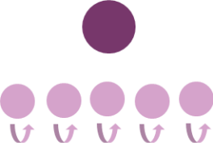
Small Group | Pair | Independent
A small group of students (3+) is working jointly together without a teacher | Students are working together in pairs on joint activity  (teacher may be circulating) | Students are working independently  (teacher may be circulating)

Table 4. Proportion of Episodes by Activity Setting
Activity Setting | Overall | Pre-k – K | 1st – 2nd Grade | 3rd Grade
Whole Group with Teacher | 25% | 24%  (12% – 29%) | 25%  (21% – 28%) | 27%  (17% – 40%)
Small Group with Teacher | 11% | 13%  (0% – 26%) | 7%  (0% – 13%) | 10%  (0% – 16%)
Teacher and 1 Student | 2% | 3%  (0% – 9%) | 0%  (0%) | 2%  (0% – 8%)
Small Group | 9% | 10%  (0% – 25%) | 11%  (7% – 16%) | 4%  (0% – 12%)
Pair | 8% | 8%  (0% – 22%) | 8%  (3% – 13%) | 7%  (0% – 10%)
Independent | 39% | 47%  (24% – 88%) | 33%  (29% – 36%) | 31%  (27% – 39%)

Student Instructional Materials
Observers also noted the instructional materials used by students during the instructional episodes. Table 5 describes the average proportion of episodes with materials, both across all classrooms and disaggregated by grade. The protocol defined tools or aids to enhance learning as those that help students explore problems or explain their thinking. The protocol did not consider paper and pencils to be tools to enhance learning. Overall, only 5% of episodes involved hands-on learning with learning tools or aids. The use of worksheets and technology (e.g., iPads or tablets) were more common in the older grades.
Table 5. Proportion of Episodes with Student Instructional Materials
Instructional Materials | Overall | Pre-k – K | 1st – 2nd Grade | 3rd Grade
Tools or aids to enhance learning | 5% | 3%  (0% – 20%) | 8%  (4% – 16%) | 6%  (0% – 12%)
Technology | 13% | 10%  (0% – 29%) | 13%  (4% – 28%) | 20%  (0% – 50%)
Worksheets | 25% | 16%  (0% – 35%) | 35%  (17% – 53%) | 33%  20% – 43%)

Learning Activity Features
Table 6 displays the proportion of episodes with coded activity features, across all classrooms and disaggregated by grade. The APL observation protocol defined teacher adaptation as teachers making modifications to an activity to support individual students’ understanding or provide a challenge for a student. Student choice, as defined by the APL protocol, involved students being able to decide on their strategies or materials to approach an activity. The two activity features were not mutually exclusive, and episodes could get both codes if applicable. On average, 5% of learning activities involved teacher adaptation and 20% involved student choice.
Table 6. Proportion of Episodes with Learning Activity Features
Activity Feature | Overall | Pre-k – K | 1st – 2nd Grade | 3rd Grade
Teacher adapts the activity for individual students | 5% | 3%  (0% – 10%) | 6%  (0% – 19%) | 6%  (0% – 19%)
Students have a choice in how they participate in the activity | 20% | 22%  (0% – 42%) | 13%  (6% – 27%) | 21%  (0% – 50%)

Student Practices
Observers also noted the strategies students engaged in during the learning activity. Students in 3rd grade were more likely to explain their reasoning during learning activities, with 24% of activities reflecting this behavior, compared to 11% in pre-k and kindergarten, and 8% in 1st and 2nd grades. In contrast, student talk related to the instructional focus occurred at a consistent rate across all grade levels, averaging 33% of learning activities Table 7 includes the proportion of episodes that featured each of the three student practices coded across all classrooms and disaggregated by grade. Associative interactions refer to whether students collaboratively built their understanding through meaningful, interactive engagement with peers or teachers. This co-construction is dynamic and dependent on each participant’s involvement. Associative interactions were least common in 3rd grade compared to the other grades. Table 8 shows the students’ practices disaggregated by activity setting.
Table 7. Proportion of Episodes by Student Practices
Student Practice | Overall | Pre-k – K | 1st – 2nd Grade | 3rd Grade
Students engage in associative interactions | 26% | 27%  (12% – 50%) | 32%  (15% – 47%) | 20%  (8% – 30%)
Students explain their reasoning | 14% | 11%  (0% – 20%) | 8%  (0% – 13%) | 24%  (10% – 35%)
Students talk to each other about instructional focus | 33% | 31%  (16% – 55%) | 37%  (19% – 50%) | 33%  (15% – 48%)

Table 8. Student Practices by Activity Setting
Student Practice | Overall | Whole Group | Small Group | Teacher + 1 Student | Small Group | Pair | Independent
Students engage in associative interactions | 26% | 7% | 16% | 8% | 92% | 85% | 28%
Students explain their reasoning | 14% | 19% | 36% | 17% | 8% | 3% | 6%
Students talk to each other about instructional focus | 33% | 16% | 16% | 8% | 92% | 91% | 25%

Ratings of Instruction Quality
Observers ranked the quality of instruction for learning activities that lasted longer than 3 minutes. Instruction quality included ratings of teacher and student involvement. The observation protocol defined teacher responsiveness to student thinking as comprising teacher responses to and questions of students. Teacher responsiveness included the extent to which teachers thoughtfully responded to students’ questions and requests for attention either verbally or nonverbally. Teacher questions involved the depth of questions teachers asked of students, ranging from exclusively factual recall questions or not asking questions to open-ended questions offering the chance for students to explain their thinking.
Cognitive demand referred to the level of instruction, ranging from low-level instructional demand (e.g., playing non-instructional songs or motor skills) to high inferential learning (e.g., interactive inferential learning process where the teacher makes connections between multiple experiences, students raising questions and hypotheses to test and build critical thinking skills in a process of innovative problem-solving). Table 9 shows the average quality rating across all classrooms and disaggregated by grade.
Table 9. Average Instruction Quality Ratings
Quality Rating | Overall | Pre-k – K | 1st – 2nd Grade | 3rd Grade
Teacher Response (1-5) | 2.61 | 2.55  (1.80 – 3.63) | 2.55  (2.33 – 2.90) | 2.75  (2.11 – 3.31)
Teacher Questions (1-5) | 2.91 | 2.72  (2.00 – 3.38) | 2.94  (2.83 – 3.00) | 3.23  (2.78 – 3.93)
Cognitive Demand (1-4) | 2.16 | 2.00  (1.75 – 2.38) | 2.23  (2.14 – 2.33) | 2.40  (2.00 – 2.60)
Observers rated the average level of each behavior across the episode, using defined behavioral anchors as reference points. In the graphs below, these anchors are displayed in boxes next to their corresponding ratings.
Each colored dot represents data from an individual classroom, while the black diamond indicates the group mean, accompanied by standard error bars.

Teacher Responsiveness
Two items rate the quality of the teacher’s interactions with students, with one item evaluating the quality of teachers’ responses to students and the other item evaluating teachers’ questions of students. The first rating captured teachers’ responsiveness to student thinking and the quality of their response to student questions and comments (Figure 2). On average, classrooms scored a 2.61 out of 5. Teacher ratings were similar across grade levels. 3rd grade teachers had the highest responsiveness to questions, scoring 2.75, compared to 2.55 for preschool to kindergarten teachers and 1st to 2nd grade teachers.
Figure 2. Quality Ratings of Teacher Responses to Student Thinking
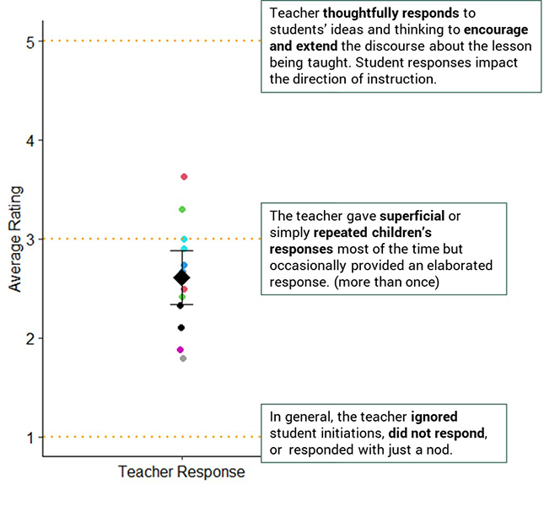
The second teacher responsiveness rating captured the quality of their questions to students during the activity (Figure 3). On average, classrooms scored a 2.91 out of 5. 3rd grade teachers had the highest responsiveness to questions, scoring 3.23, compared to 2.72 for pre-k to kindergarten teachers and 2.94 for 1st to 2nd grade teachers.
Figure 3. Quality Ratings of Teacher Questions
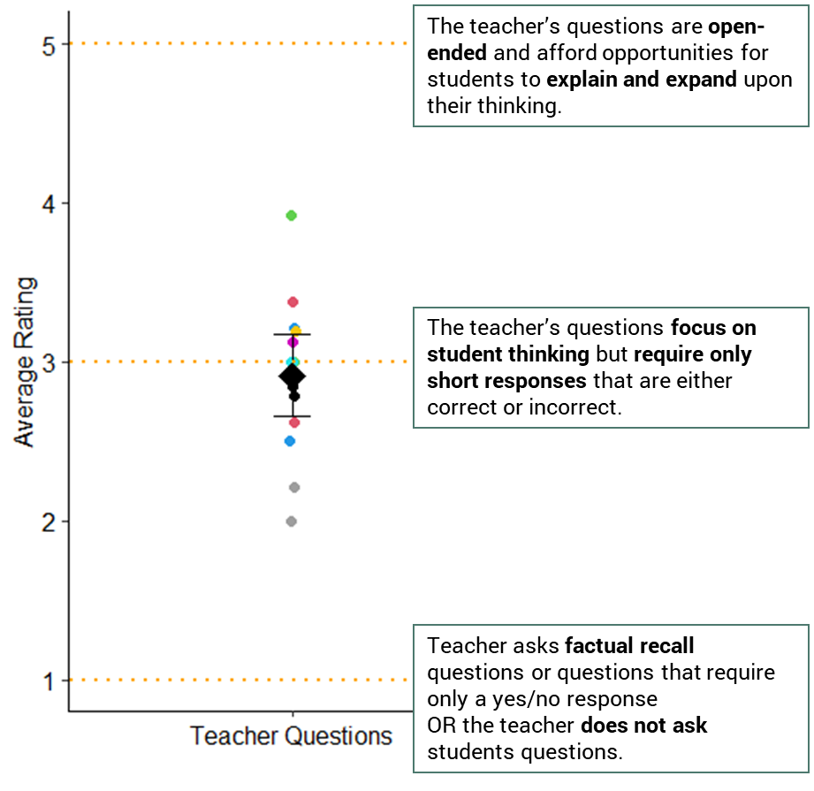

Cognitive Demand
Observers also rated the highest level of cognitive demand that they observed during the activity (Figure 4). On average, classrooms scored a 2.16 out of 4. 3rd grade had the highest level of cognitive demand, scoring 2.40, compared to an average rating of 2.00 for pre-k to kindergarten and 2.23 for 1st to 2nd grade.
Figure 4. Quality Ratings of Cognitive Demand
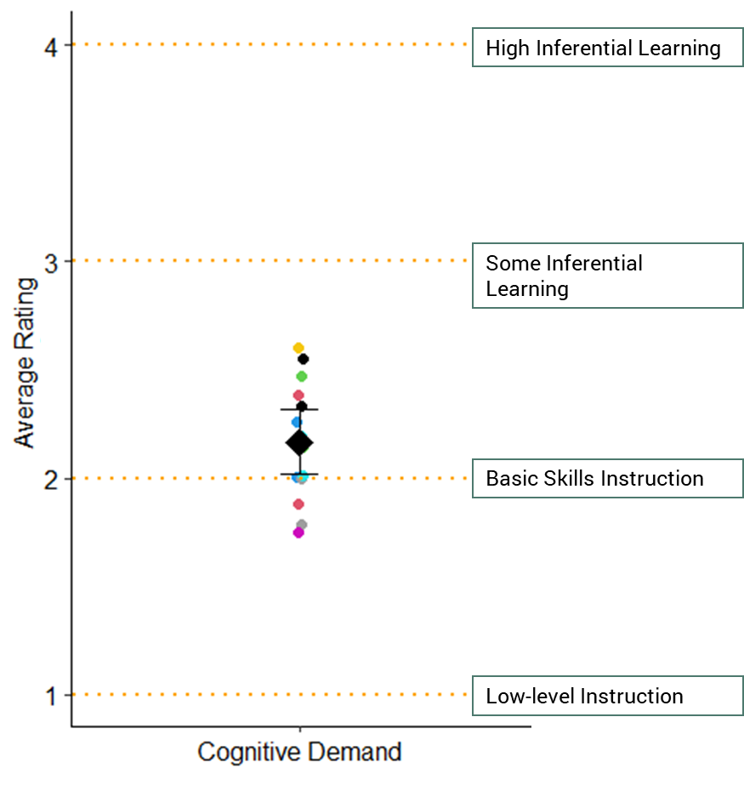

Overall Classroom Ratings
At the end of the observation period, observers also rated classroom-level characteristics and behaviors. Table 10 shows the average classroom rating out of 5 across all classrooms and disaggregated by grade. We focused on these items because of the insights that the Educator Advisory Group shared about classroom behaviors that they might expect to shift as a result of participating in the PLI.
Table 10. Average Overall Classroom Ratings
Classroom Rating | Overall | Pre-k – K | 1st – 2nd Grade | 3rd Grade
Behavior Management | 3.00 | 3.14  (2 – 5) | 3.00  (1 – 4) | 2.75  (1 – 4)
Peer Interactions | 3.50 | 3.28  (2 – 5) | 3.67  (3 – 5) | 3.75  (2 – 5)
Student Self-Regulation | 3.29 | 3.43  (2 – 5) | 3.33  (3 – 4) | 3.00  (1 – 5)

Behavior Management
This item rated the extent to which behavioral incidents or teacher efforts to manage behavior disrupted the flow of instruction during lessons or activities (Figure 5). On average, classrooms scored a 3.00 out of 5. Preschool and kindergarten classrooms had the highest behavior management score (3.14), followed by 1st and 2nd grade (3.00), and 3rd grade (2.75).
Figure 5. Quality Rating of Classroom Behavior Management
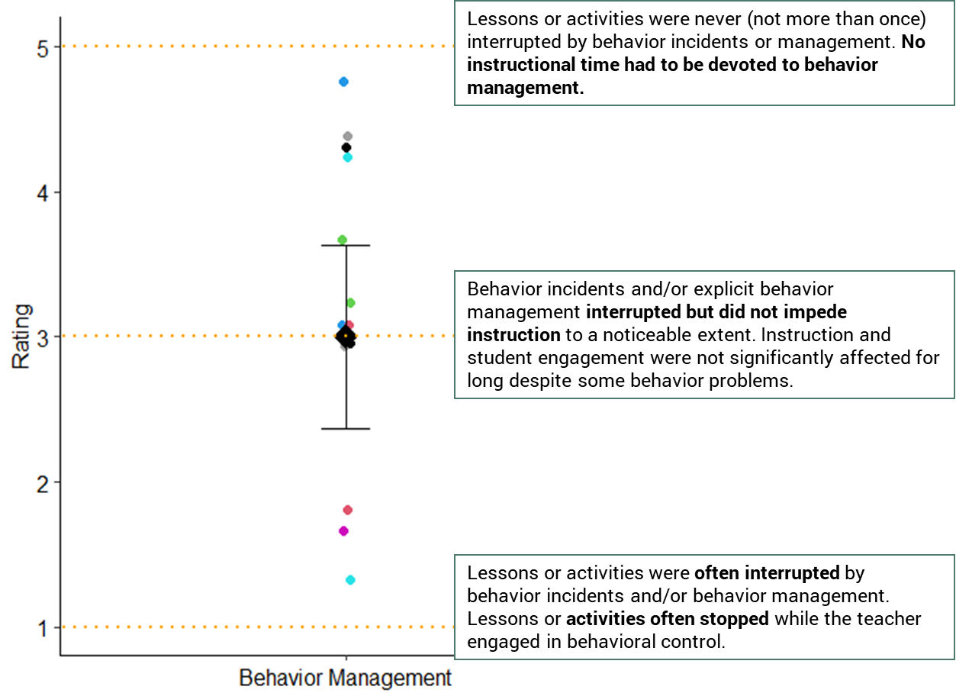

Peer Interactions
This item rated the quality of interactions among students. On average, classrooms scored a 3.50 out of 5. 3rd grade had the highest peer interaction score (3.75), followed by 1st and 2nd grade (3.67), and preschool and kindergarten (3.28). Figure 6 indicates the distribution of each classroom’s average peer interaction score.
Figure 6. Quality Rating of Peer Interactions
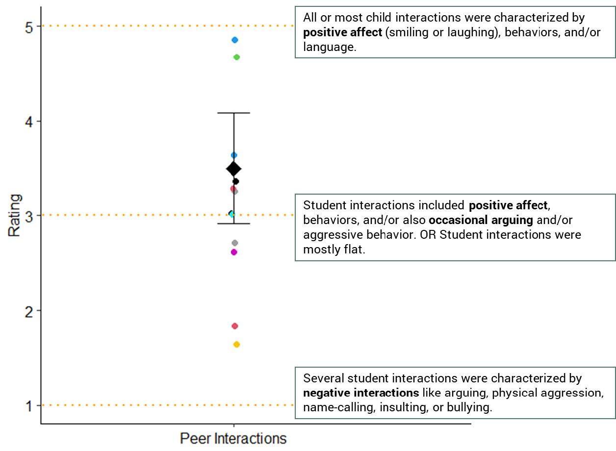

Students’ Emotional and Behavioral Self-Regulation
This item rated how well students regulate their behavior and emotions without teacher prompts (Figure 7). Controlling behaviors included following directions and acting appropriately in different contexts. Controlling emotions included students’ the ability to calm down after becoming upset or angry as well managing their excitement. On average, classrooms scored a 3.29 out of 5. Preschool and kindergarten classrooms had the highest self-regulation score (3.43), followed by 1st and 2nd grade (3.33), and 3rd grade (3.00).
Figure 7. Quality Rating of Students’ Emotional and Behavioral Self-Regulation
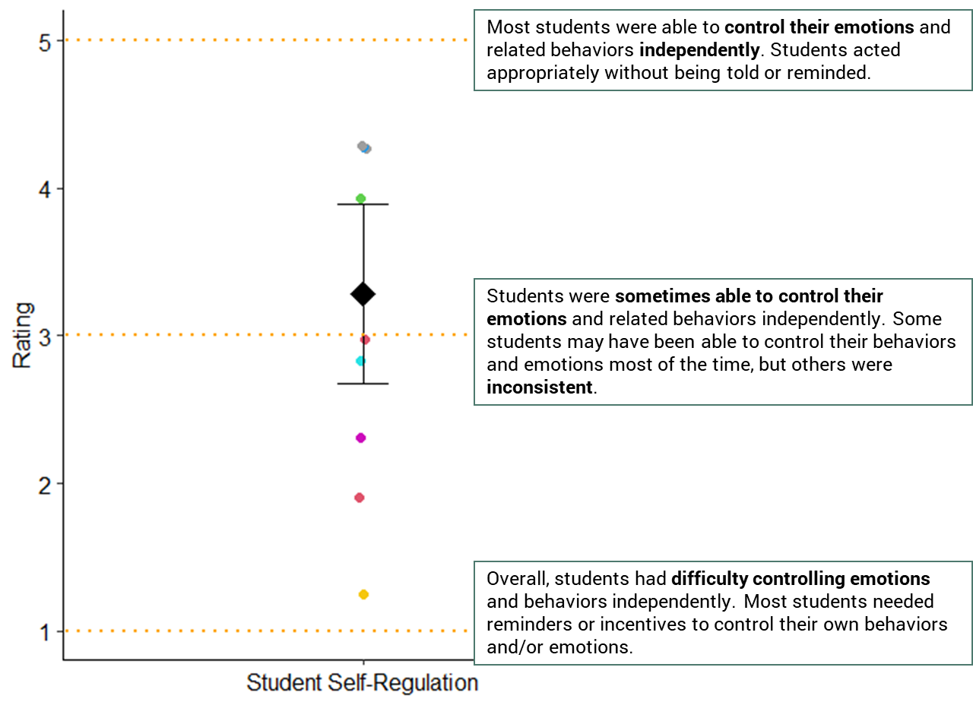

Evaluation Next Steps
Figure 8 outlines the planned data collection activities for the 2025–2026 school year. We will conduct observations in 21 Cohort 2 classrooms (three per district) during both the fall and spring. Fall observations will assess classroom practices following asynchronous professional development but prior to the start of coaching. Spring observations will evaluate implementation fidelity after coaching has taken place. Observation data from both time points will be compared to the baseline data presented in this report to assess the impact of PLI supports on classroom practices. Additionally, we will collaborate with coaches from Neighborhood Villages to revise and analyze data from their coaching logs. This will allow us to measure teachers’ alignment with PLI pillars and the extent to which their implementation reflects their action plans.
Figure 8. 2025-2026 Data Collection Activities
Baseline Classroom Observations
Spring 2025
PLI teachers engage in asynchronous professional development

Post-PD
Classroom Observations

PLI Teachers receive coaching
Post-coaching
Classroom Observations

Coaching logs

Fall 2025
Spring 2026

References
Farran, D., Durkin, K., & Rainey, L. (2022). Manual for Early Mathematics Coherence—PreK through 2nd Grade Classroom Observation Instrument.
Farran, D., Meador, D., Keene, A., Bilbrey, C., & Vorhaus, E. (2015). Advanced Narrative Record Manual.
Farran, D. C., Nesbitt, K. T., Rainey, L., & Active Playful Learning Consortium (2025). Active Playful Learning Episodic Classroom Observation System (APL-ECOS). Active Playful Learning Consortium. https://activeplayfullearning.com/
Sarama, J., & Clements, D. (2010). Classroom Observation of Early Mathematics-Environment and Teaching (COEMET version 4).
Yun, C., Farran, D., Lipsey, M., Vorhaus, E., & Meador, D. (2015). Post Observation Rating Scale for the Tools of the Mind Curriculum (PRS – ToM) Observer Manual.

