Students Experiencing Homelessness in Massachusetts
DESE and District Efforts to Support Students and Families Experiencing Homelessness

September 2025

Students Experiencing Homelessness in Massachusetts
DESE and District Efforts to Support Students and Families Experiencing Homelessness

Project Leaders  Christina Citino  Jeremiah Johnson  Project Managers  Jill Capitani  Anthony Rainey | Project Staff  Felicia Dennis  Caroline Gurek  Sarah Young  Project Consultant  Melanie Wilson, Youth Catalytics
Established in 1971, the UMass Donahue Institute is a public service and engagement arm of the University of Massachusetts. Our mission is to advance equity and social justice, foster healthy communities, and support inclusive economies that alleviate poverty and promote opportunity. In collaboration with partner organizations and clients, we carry out our mission through research, education and training, capacity building, and direct services to strengthen our collective impact.
The Institute’s Applied Research and Program Evaluation group partners with organizations across multiple sectors to design and implement utilization-focused studies that address the social determinants of health. We believe that research is most meaningful when findings can be applied to public benefit. We also believe that evaluative work is a key driver in advancing equity and strive to utilize culturally responsive and inclusive evaluation practices in all our work.
For more information, www.donahue.umass.edu.

Acknowledgements
The UMass Donahue Institute research team wishes to acknowledge and thank the many individuals who generously provided their time and expertise to support this study.
Specifically, we offer our appreciation to:
Shirley Fan-Chan, Homeless Education State Coordinator, and Kendra Winner, Research and Evaluation Coordinator, at the Department of Elementary and Secondary Education (DESE) for their support and guidance throughout this project.
DESE Educational Stability Team and McKinney Vento Regional Homeless Education Liaisons for their insights and suggestions during the early phases of the qualitative work.
The McKinney Vento District Homeless Education Liaisons who devoted many hours to helping us schedule district site visits and ensuring that all relevant voices were invited to participate.
District site visit participants, including district, school, and community partner staff, for sharing their experiences and recommendations for improving services for students and families experiencing homelessness.
Community partners for helping connect us with young adults and parents/caregivers.
Young adults and parents/caregivers who shared their experiences of homelessness and lent their voices to this work.

Contents
Executive Summary 1
Introduction 1
Trends in the Number of High Mobility Students 2
Characteristics, Risk Factors, and Educational Stability 2
Academic Outcomes 4
Qualitative Study Key Findings 5
Recommendations 8
Chapter I: Introduction 9
The Massachusetts Department of Elementary and Secondary Education’s Vision 9
Study Purpose 9
Background 10
Chapter II: Methodology 12
Overview 12
Quantitative Analysis 12
Qualitative Data Collection and Analysis 21
Limitations 26
Chapter III: Trends Among High Mobility Student Groups 28
Chapter Organization and Contents 28
Key Findings: Trends in the Number of High Mobility Students 29
Historical and Emerging Trends Among Students Experiencing Homelessness 30
Historical Trends Among Students in Foster Care, Students in Migrant Worker Families, and Students in Military Families 37
Chapter IV: Characteristics, Risk Factors, and Educational Stability of High Mobility Student Groups 40
Chapter Organization and Contents 40
Key Findings: Characteristics, Risk Factors, and Educational Stability 41
Characteristics 42
Risk Factors 49
Educational Stability 52
Chapter V: Academic Outcomes 57
Chapter Organization and Contents 57
Key Findings: Academic Outcomes 58
Academic Outcomes: Comparison of High Mobility and Non-Mobile Students 60
Academic Outcomes: Quasi-Experimental Design (QED) Analysis 73
Academic Outcomes: Descriptive Comparisons of Homeless and Non-Mobile Students 75
Chapter VI: Qualitative Study Findings 98
Chapter Overview 98
Organizational Capacity and Challenges to Operationalization 101
Identifying Students and Families Experiencing Homelessness 117
Supporting MKV-Eligible Students and Families 125
Young Adults and Parents/Caregivers with Lived Experience 140
Chapter VII: Conclusion and Recommendations 153
Conclusion 153
Recommendations 154

NOTE: Report appendices can be found in a separate Supplemental Report. The Supplemental Report includes:
Appendix A: Foundational Interview Protocols
Appendix B: District Site Visit Interview Protocols
Appendix C: Young Adult and Parent/Caregiver Interview Protocols
Appendix D: Tables of Academic Outcomes for High Mobility Students by Characteristics and Risk Factors
Appendix E: Examples of Support Services Available for Students and Families Experiencing Homelessness

Table 1: Ever Homeless Cohorts for QED Analysis 16
Table 2: Ever Foster Care Cohorts for QED Analysis 17
Table 3: Ever Military Family Cohorts for QED Analysis 18
Table 4: QED Sample Sizes 20
Table 5: District Participation in Site Visits 23
Table 6: Number and Percentage of Students Experieincing Homelessness by School Level 31
Table 7: Change in Students Experiencing Homelessness by School Level: 2018–19 to 2020–21 31
Table 8: Number of Unaccompanied Youth 34
Table 9: Nighttime Residence of Students Experiencing Homelessness 35
Table 10: Number and Percentage of Students in Foster Care by School Level 38
Table 11: Number and Percentage of Students Experiencing Dual Incidence 42
Table 12: Percentage of Students Attending Two or More Districts During the Academic Year 44
Table 13: Percentage of Students Attending Two or More Schools During the Academic Year 44
Table 14: High Mobility Student Groups and Non-Mobile Students by Gender 45
Table 15: High Mobility Student Groups and Non-Mobile Students by Race and Ethnicity 48
Table 16: Selected Risk Factors Among Non-Mobile and High Mobility Student Groups 51
Table 17: Attendance Rate Among Non-Mobile and High Mobility Student Groups 54
Table 18: Mean Number of Days Absent Among Non-Mobile and High Mobility Student Groups 54
Table 19: Suspension Rate Among Non-Mobile and High Mobility Student Groups 55
Table 20: Mean Number of Days Suspended Among Non-Mobile and High Mobility Student Groups 55
Table 21: Dropout Rate Among Non-Mobile and High Mobility Student Groups 56
Table 22: Number of 3rd Grade Students with English Language Arts MCAS Results 60
Table 23: Percentage of 3rd Grade Students Meeting or Exceeding Expectations on the ELA Assessment 60
Table 24: 3rd Grade ELA Assessment Achievement Gap between Non-Mobile and High Mobility Students 61
Table 25: Number of 6th Grade Students with ELA and Math Assessment Results 62
Table 26: Percentage of 6th Grade Students Meeting or Exceeding Expectations on the ELA and Math Assessments 62
Table 27: 6th Grade ELA and Math Assessment Achievement Gap between Non-Mobile and High Mobility Students 63
Table 28: Number of 9th Grade Students with At Least One Completed and Graded Course 65
Table 29: Percentage of 9th Grade Students Passing All Courses 65
Table 30: Passing All 9th Grade Courses Achievement Gap between Non-Mobile and High Mobility Students 66
Table 31: Number of Students in the 4-Year Graduation Cohort 67
Table 32: Percentage of Students Who Graduated High School Within Four Years of Entering 9th Grade 68
Table 33: 4-Year Graduation Rate Achievement Gap between Non-Mobile and High Mobility Students 69
Table 34: Number of Students Who Graduated High School Within Four Years 70
Table 35: Percentage of 4-Year High School Graduates Enrolled in College within One Year of Graduation 71
Table 36: College Enrollment Rate Achievement Gap between Non-Mobile and High Mobility Students 72
Table 37: Likelihood of Achieving Academic Outcomes 74
Table 38: Percentage of Students Achieving Academic Outcomes by Housing Status: Comparison of Hispanic or Latino Students and White Students 79
Table 39: Academic Outcome Achievement Gaps by Housing Status: Comparison of Hispanic or Latino Students and White Students 80
Table 40: Percentage of Students Achieving Academic Outcomes by Housing Status: Comparison of African American or Black Students and White Students 83
Table 41: Academic Outcome Achievement Gaps by Housing Status: Comparison of African American or Black Students and White Students 84
Table 42: Percentage of Students Achieving Academic Outcomes by Housing Status: Comparison of English Learners and English Speakers 87
Table 43: Academic Outcome Achievement Gaps by Housing Status: Comparison of English Learners and English Speakers 88
Table 44: Percentage of Students Achieving Academic Outcomes by Housing Status: Comparison of Students Who Are Low Income and Students Who Are Not Low Income 92
Table 45: Academic Outcome Achievement Gaps by Housing Status: Comparison of Students Who Are Low Income and Students Who Are Not Low Income 93
Table 46: Percentage of Students Achieving Academic Outcomes by Housing Status: Comparison of Students With Disabilities and Students Without Disabilities 96
Table 47: Academic Outcome Achievement Gaps by Housing Status: Comparison of Students With Disabilities and Students Without Disabilities 97
Table 48: Length of Time Holding District MKV Liaison Role 103
Table 49: Districts with Formalized Relationships with Community Partners 110

Figure 1: Number of K–12 Students Experiencing Homelessness and Year-to-Year Change: 2009–10 to 2021–22 30
Figure 2: Number of K–12 Students in Foster Care and Year-to-Year Change: 2017–18 to 2021–22 37
Figure 3: Number of K–12 Students in Migrant Worker Families and Year-to-Year Change: 2009–10 to 2021–22 38
Figure 4: Number of K–12 Students in Military Families and Year-to-Year Change: 2014–15 to 2021–22 39
Figure 5: Percentage of Students Who are Hispanic or Latino 46
Figure 6: Percentage of Students Who are African American or Black 46
Figure 7: Percentage of Students Who are White 47
Figure 8: Percentage of Students Who are English Learners 49
Figure 9: Percentage of Students Who are Low Income 50
Figure 10: Percentage of Students with a Disability 50
Figure 11: Attendance Rate Among Non-Mobile and High Mobility Student Groups 53
Figure 12: Mean Number of Days Absent Among Non-Mobile and High Mobility Student Groups 53
Figure 13: Percentage of Students Suspended Among Non-Mobile and High Mobility Student Groups 54
Figure 14: Mean Number of Days Suspended Among Non-Mobile and High Mobility Student Groups 55
Figure 15: Dropout Rate Among Non-Mobile and High Mobility Student Groups 56
Figure 16: Percentage of 3rd Grade Students Meeting or Exceeding Expectations on the ELA Assessment 61
Figure 17: Percentage of 6th Grade Students Meeting or Exceeding Expectations on the ELA and Math Assessments 63
Figure 18: Percentage of 9th Grade Students Passing All Courses 66
Figure 19: Percentage of Students Who Graduated High School Within Four Years of Entering 9th Grade 68
Figure 20: Percentage of 4-Year High School Graduates Enrolled in College within One Year of Graduation 71
Figure 21: Percentage of 3rd Grade Students Meeting or Exceeding Expectations on the ELA Assessment by Housing Status: Comparison of Hispanic or Latino Students and White Students 76
Figure 22: Percentage of 6th Grade Students Meeting or Exceeding Expectations on the ELA and Math Assessments by Housing Status: Comparison of Hispanic or Latino Students and White Students 77
Figure 23: Percentage of 9th Grade Students Passing All Courses by Housing Status: Comparison of Hispanic or Latino Students and White Students 77
Figure 24: Percentage of Students Who Graduated High School Within Four Years of Entering 9th Grade by Housing Status: Comparison of Hispanic or Latino Students and White Students 77
Figure 25: Percentage of 4-Year High School Graduates Enrolled in College within One Year of Graduation by Housing Status: Comparison of Hispanic or Latino Students and White Students 78
Figure 26: Percentage of 3rd Grade Students Meeting or Exceeding Expectations on the ELA Assessment by Housing Status: Comparison of African American or Black Students and White Students 81
Figure 27: Percentage of 6th Grade Students Meeting or Exceeding Expectations on the ELA and Math Assessments by Housing Status: Comparison of African American or Black Students and White Students 81
Figure 28: Percentage of 9th Grade Students Passing All Courses by Housing Status: Comparison of African American or Black Students and White Students 82
Figure 29: Percentage of Students Who Graduated High School Within Four Years of Entering 9th Grade by Housing Status: Comparison of African American or Black Students and White Students 82
Figure 30: Percentage of 4-Year High School Graduates Enrolled in College within One Year of Graduation by Housing Status: Comparison of African American or Black Students and White Students 82
Figure 31: Percentage of 3rd Grade Students Meeting or Exceeding Expectations on the ELA Assessment by Housing Status: Comparison of English Learners and English Speakers 85
Figure 32: Percentage of 6th Grade Students Meeting or Exceeding Expectations on the ELA and Math Assessments by Housing Status: Comparison of English Learners and English Speakers 85
Figure 33: Percentage of 9th Grade Students Passing All Courses by Housing Status: Comparison of English Learners and English Speakers 86
Figure 34: Percentage of Students Who Graduated High School Within Four Years of Entering 9th Grade by Housing Status: Comparison of English Learners and English Speakers 86
Figure 35: Percentage of 4-Year High School Graduates Enrolled in College within One Year of Graduation by Housing Status: Comparison of English Learners and English Speakers 86
Figure 36: Percentage of 3rd Grade Students Meeting or Exceeding Expectations on the ELA Assessment by Housing Status: Comparison of Students Who Are Low Income and Students Who Are Not Low Income 89
Figure 37: Percentage of 6th Grade Students Meeting or Exceeding Expectations on the ELA and Math Assessments by Housing Status: Comparison of Students Who Are Low Income and Students Who Are Not Low Income 90
Figure 38: Percentage of 9th Grade Passing All Courses by Housing Status: Comparison of Students Who Are Low Income and Students Who Are Not Low Income 90
Figure 39: Percentage of Students Who Graduated High School Within Four Years of Entering 9th Grade by Housing Status: Comparison of Students Who Are Low Income and Students Who Are Not Low Income 90
Figure 40: Percentage of 4-Year High School Graduates Enrolled in College within One Year of Graduation by Housing Status: Comparison of Students Who Are Low Income and Students Who Are Not Low Income 91
Figure 41: Percentage of 3rd Grade Students Meeting or Exceeding Expectations on the ELA Assessment by Housing Status: Comparison of Students With Disabilities and Students Without Disabilities 94
Figure 42: Percentage of 6th Grade Students Meeting or Exceeding Expectations on the ELA and Math Assessments by Housing Status: Comparison of Students With Disabilities and Students Without Disabilities 94
Figure 43: Percentage of 9th Grade Passing All Courses by Housing Status: Comparison of Students With Disabilities and Students Without Disabilities 95
Figure 44: Percentage of Students Who Graduated High School Within Four Years of Entering 9th Grade by Housing Status: Comparison of Students With Disabilities and Students Without Disabilities 95
Figure 45: Percentage of 4-Year High School Graduates Enrolled in College within One Year of Graduation by Housing Status Comparison of Students With Disabilities and Students Without Disabilities 95

Executive Summary

Introduction
The Educational Stability Team within the Massachusetts Department of Elementary and Secondary Education’s (DESE) Office of Student and Family Support works to ensure that students who are experiencing homelessness, in foster care, part of a migrant worker family, or part of a military family have full access to a consistent public education.
These four student groups share two important characteristics:

They tend to be high mobility students, meaning that they change schools, and possibly districts, for reasons not related to grade promotion. This may include changing schools between academic years but is more commonly associated with changing schools during the academic year.

They are ensured educational rights under the Every Student Succeeds Act (ESSA) and the Massachusetts Valor Act.

In alignment with the Department’s Educational Vision and to better inform program development and improvement, DESE commissioned a study of students experiencing homelessness and the efforts that districts, schools, and community-based organizations are making to support these students and their families. In partnership with DESE, the UMass Amherst Donahue Institute (UMDI) developed a mixed-methods study with two components:
- Quantitative analysis of DESE’s existing student-level data pertaining to students experiencing homelessness with comparisons to other high mobility student groups and non-mobile students
- Qualitative exploration of a variety of topics relevant to supporting students experiencing homelessness and their families
This study represents the first comprehensive analysis of students experiencing homelessness using student-level data reported to DESE by districts. The quantitative analyses include descriptive statistics about the characteristics, risk factors, educational stability, and academic outcomes for students experiencing homelessness with comparisons to other high mobility students and non-mobile students. In addition, multi-level, mixed-effect, logistic regressions were conducted to assess the impact of homelessness, foster care placement, and military family status on five academic outcomes aligned with DESE’s Early Warning Indicator System.
The qualitative component includes a thematic summary of individual and small group interviews conducted between December 2023 and October 2024 with over 150 individuals who had either professional expertise or lived experience related to student and family homelessness in Massachusetts.

Trends in the Number of High Mobility Students
Overall, there was a net increase in the number of students in high mobility groups from the earliest year data were available through the 2021–22 academic year.
- The number of K–12 students experiencing homelessness increased by 72 percent from 2009–10 (12,316 students) to 2021–22 (21,226 students), representing a net increase of nearly 9,000 students. Interviewees from 19 of the 21 school districts participating in this study noted an increased number of students experiencing homelessness since the 2021–22 academic year, with a particular emphasis on steep increases during the 2023–24 academic year.
- The number of students in foster care increased each successive year from 2017–18 (5,257 students) to 2021–22 (7,369 students), representing a 40 percent increase over five years.
- The number of students in migrant worker families increased by nearly 200 percent from 149 students in 2009–10 to 446 students in 2021–22.
- The number of K–12 students in military families increased by 59 percent from 5,554 students in 2014–15 to 8,849 students 2021–22.
The most common nighttime residence reported for students experiencing homelessness is doubled-up, with more than 60 percent of students experiencing homelessness from 2017–18 through 2021–22 living with friends or relatives due to economic hardship, loss of housing, or other reasons.
- During the 2021–22 academic year, 68 percent of students experiencing homelessness were living in doubled-up situations—sharing housing with others due to loss of housing or economic hardship.
- District site visit interviewees reported an increase in families living in overcrowded conditions, either while doubled-up with other families or residing in motels and room rentals.
- Interviewees also noted a rise in the number of students and families who are unsheltered. They described first-time occurrences of families living in cars or on the streets in many study districts. Others reported families residing in condemned buildings or structures at high risk of fire.

Characteristics, Risk Factors, and Educational Stability
From 2017–18 through 2021–22, students experiencing homelessness and students in foster care had higher mobility rates (i.e., attending multiple districts or multiple schools in a single academic year) than students in other high mobility groups and non-mobile students.
- In 2021–22, 12 percent of students in foster care and 8 percent of students experiencing homelessness attended two or more districts during the academic year.
- In 2021–22, 15 percent of students in foster care and 11 percent of students experiencing homelessness attended two or more schools within a single district or across multiple districts during the academic year.
- In 2021–22, the percentage of students in migrant worker families attending two or more districts (5.3%) or schools (8.3%) was lower than among students in foster care or students experiencing homelessness.
- Although students in military families are considered a high mobility student group, the percentage attending two or more districts (2.1%) or schools (2.5%) during the 2021–22 academic year mirrored that of non-mobile students (1.8% and 2.5%, respectively).
Historically marginalized student groups, including those who are Hispanic or Latino, African American or Black, English learners, low income, or have disabilities, are over-represented among students experiencing homelessness, students in foster care, and students in migrant worker families.
- In 2021–22, 95 percent of students in migrant worker families and 55 percent of students experiencing homelessness were Hispanic or Latino compared to 23 percent of non-mobile students.
- In 2021–22, 17 percent of students in foster care and 16 percent of students experiencing homelessness were African American or Black compared to 9 percent of non-mobile students.
- In 2021–22, 86 percent of migrant worker family students and 41 percent of students experiencing homelessness and were English learners compared to 12 percent of non-mobile students.
- In 2021–22, 95 percent of students in foster care, 85 percent of students experiencing homelessness, and 84 percent of students in migrant worker families were low income compared to 41 percent of non-mobile students.
- In 2021–22, the percentage of students with a disability was highest among students in foster care (46.5%) compared to other high mobility groups and non-mobile students.
Students experiencing homelessness, students in foster care, and students from migrant worker families had lower attendance rates, higher suspension rates, and higher dropout rates than non-mobile students.
- From 2017–18 through 2021–22, students experiencing homelessness and students in foster care consistently had lower attendance rates than students in migrant worker families, students in military families, and non-mobile students.
- During the 2021–22 academic year, the suspension rate among students in foster care (16.5%) was twice as high as students experiencing homelessness (8.1%) and more than four times as high as non-mobile students (4.0%), students in migrant worker families (3.6%), and students in military families (3.1%).
- In 2021–22, students in migrant worker families had the highest dropout rate (11.7%), followed by students experiencing homelessness (7.8%) and students in foster care (7.1%).
The mobility rates, characteristics, risk factors, and educational stability of military family students were more consistent with non-mobile students than other high mobility groups.

Academic Outcomes
Across academic outcomes, students experiencing homelessness, students in foster care, and students in migrant worker families performed lower than non-mobile students. Despite being considered a high mobility group, students in military families performed similarly to or better than non-mobile students on all five academic outcomes studied.
- In 2021–22, the percentage of students experiencing homelessness and students in foster care who met or exceeded expectations on the 3rd grade ELA assessment was 27 percentage points lower than non-mobile students.
- In 2021–22, the percentage of students experiencing homelessness who met or exceeded expectations on the 6th grade ELA and math assessments was 25 percentage points lower than non-mobile students and the percentage of students in foster care who met or exceeded expectations on the 6th grade ELA and math assessments was 24 percentage points lower than non-mobile students.
- In 2021–22, the percentage of students experiencing homelessness who passed all 9th grade courses was 27 percentage points lower than non-mobile students, the percentage of students in foster care who passed all 9th grade courses was 28 percentage points lower than non-mobile students, and the percentage of students in migrant worker families who passed all 9th grade courses was 26 percentage points lower than non-mobile students.
- In 2021–22, the percentage of students experiencing homelessness who graduated within four years was 14 percentage points lower than non-mobile students, the percentage of students in foster care who graduated within four years was 20 percentage points lower than non-mobile students, and the percentage of students in migrant worker families who graduated within four years was 10 percentage points lower than non-mobile students.
- In 2020–21, the percentage of students experiencing homelessness who enrolled in college was 32 percentage points lower than non-mobile students and the percentage of students in foster care who enrolled in college was 33 percentage points lower than non-mobile students.
Overall, the evidence from a quasi-experimental design analysis indicates that students who were ever homeless and students who were ever in foster care were significantly less likely to meet each of the five EWIS educational outcomes examined. For students who were ever part of a military family, the evidence is mixed.
- Students who ever experienced homelessness are significantly less likely to achieve important educational outcomes than their non-mobile peers. Specifically, students who were ever homeless were 0.67 times as likely to meet or exceed expectations on the 3rd grade ELA assessment, 0.60 times as likely to meet or exceed expectations on the 6th grade ELA and math assessment, 0.60 times as likely to pass all 9th grade courses, 0.52 times as likely to graduate high school in four years, and 0.62 times as likely to enroll in college than their non-mobile peers.
- Students who were ever in foster care are significantly less likely to achieve important educational outcomes than their non-mobile peers. Students who were ever in foster care were 0.71 times as likely to meet or exceed expectations on the 3rd grade ELA assessment, 0.66 times as likely to meet or exceed expectations on the 6th grade ELA and math assessment, 0.44 times as likely to pass all 9th grade courses, 0.39 times as likely to graduate high school in four years, and 0.67 times as likely to enroll in college than their non-mobile peers.
- Evidence concerning students from military families suggests that they are less likely to achieve some educational outcomes than their non-mobile peers, (i.e., meeting or exceeding expectations on the 6th grade ELA and math assessments and enrolling in college) and equally as likely to achieve others (i.e., meeting/exceeding expectations on the 3rd grade ELA assessment, passing all 9th grade courses, graduating high school in four years).
Students who were homeless and part of a historically marginalized student group (i.e., students who are Hispanic or Latino, African American or Black, English learners, low income, or have a disability) generally had lower achievement rates than those who were not homeless or part of historically marginalized group regardless of the academic outcome.
- White students who were not homeless outperformed Hispanic or Latino students and African American or Black students regardless of housing status.
- Students who were homeless and Hispanic or Latino had the lowest achievement rates across all five outcomes and all academic years.
- English learners who were homeless generally had the lowest achievement rates for three of the five outcomes, including 3rd grade ELA assessment, 4-year graduation, and college enrollment.
- For most years and most outcomes, students who were low income and homeless and students who had a disability and were homeless had the lowest academic achievement rates.

Qualitative Study Key Findings
During individual and small group interviews conducted in 21 Massachusetts school districts, study participants shared what is working well, identified the barriers and challenges they face, and offered recommendations for improvement—underscoring the need for more effective support systems for students and families experiencing homelessness. Across all interviews, common themes emerged related to organizational capacity, identification of students experiencing homelessness, and providing direct supports to students and families experiencing homelessness. Furthermore, interviews with young adults and parents/caregivers who have experienced homelessness confirmed key findings from the district site visits. Their perspectives provided first-hand accounts of the barriers to accessing support and offered suggestions for how services could be improved.

Organizational Capacity and Challenges to Operationalization
Implementing the federal MKV Act is a challenging task for districts and schools.
Challenges to implementation include limited staffing capacity that often falls short of meeting the current needs of students and families, constrained financial resources and complex funding structures, and inconsistent coordination and communication both within districts and between districts, schools, community partners, and other agencies.

All districts and interview groups reported the lack of awareness about what constitutes homelessness and districts’ responsibilities under the MKV Act as a common challenge for identification and provision of support services to students experiencing homelessness.
Interviewees consistently emphasized the need for additional training at all levels, including regional and district MKV liaisons, school staff who interact regularly with students and families, and community providers who partner with districts. They also noted the need for public awareness efforts to educate students, families, and community members about the MKV Act among.

Identifying Students and Families Experiencing Homelessness
While the number of MKV identified students has increased, there is a consensus that not all students experiencing homelessness are being identified.
Educators, community providers, and individuals with lived experience pointed to fears among students and families—such as concerns about increased scrutiny, potential involvement from the Department of Children and Families (DCF), and social stigma—as major barriers to disclosure. Additional challenges included limited awareness of the MKV Act, lack of knowledge about what qualifies as homelessness, and language barriers that can hinder communication.
The identification of students and families experiencing homelessness primarily occurs during the enrollment and registration process.
District and school staff agreed that identification strategies and practices are strongest at the point of enrollment and registration when enrollment staff request documents, such as proof of address or a housing questionnaire, which offer insight into a student’s current living situation.
Students experiencing homelessness are more difficult to identify when homelessness occurs after the point of enrollment and registration.
While procedures are in place to identify students experiencing homelessness during enrollment and registration, it is more challenging to identify students who become homeless later in the school year. Ongoing identification practices outside of enrollment are less formalized and often rely on staff observations, information from community partners or other agencies, or self-disclosure by students or families. Interviewees noted that older youth and unaccompanied youth are especially difficult to identify, as they are more likely to conceal their housing situation.

Supporting MKV-Eligible Students and Families
School and community partner representatives and individuals with lived experience emphasized the importance of prioritizing students’ basic needs and overall well-being.
Interviewees emphasized that students cannot focus on academics when their basic needs are unmet. Lacking weather-appropriate clothing, experiencing hunger, or facing uncertainty about where they will sleep at night impedes the ability to concentrate and learn. Providing essential items, such as food and clothing, was the most frequently mentioned service offered directly by schools to MKV-eligible students.

Most academic support, enrichment programming, and basic needs support for students experiencing homelessness is delivered through districts’ existing offerings.
Many wraparound services available to MKV-eligible students are accessible to any student in need. While most districts in the study did not offer specialized services exclusively to students experiencing homelessness, several districts noted offering targeted academic, enrichment, and wraparound services specifically to students and families residing in emergency shelters.
Fostering a welcoming, inclusive, and supportive school climate and learning environment was cited as a key factor in effectively supporting students experiencing homelessness.
Interviewees highlighted several effective strategies for fostering a supportive learning environment, including the integration of trauma-informed practices, culturally and linguistically appropriate services, strengthened communication and outreach efforts, the development of trusted relationships, and meaningful family engagement. To foster stronger connections with families and promote a sense of community and belonging, many districts have established dedicated support services for parents and caregivers.
Community partners play a vital role in filling service gaps that schools cannot address.
While districts have incorporated some wraparound supports in-house, most continue to rely on local community service providers to meet the growing and complex needs of students and families experiencing homelessness. Schools particularly depend on these partners to deliver services related to housing, mental health, healthcare, and immigration. Several interviewees emphasized the value of partnering with community organizations that function as one-stop resource centers, offering more comprehensive case management than schools can provide on their own. Although referrals to community service providers are common, interviewees described wide variation in how these referrals are managed across and within districts.
Despite school and community provider efforts to support the needs of students experiencing homelessness, substantial challenges and gaps remain.
District and school staff acknowledged that existing academic supports may not be sufficient to meet the needs of students experiencing homelessness, particularly older MKV-eligible students and unaccompanied youth. Several interviewees highlighted the need for alternative educational programming to better engage high school students, improve retention, and support graduation outcomes. School staff and community partners identified affordable housing and mental health services as the most common unmet need for students and families.
The lack of affordable, reliable, and accessible transportation emerged as a top challenge for districts, schools, students, and parents/caregivers.
Both district staff and parents/caregivers with lived experience shared concerns about long student commutes leading to chronic absenteeism, behavioral issues, and poor academic outcomes. Specific transportation challenges mentioned include a severe shortage of providers and bus drivers, exorbitant costs, poor communication and coordination between districts, conflicting local policies and practices that hinder compliance, and the lack of late buses to access extracurricular activities. School staff also reported that many middle and high school students experiencing homelessness are reluctant to use school transportation that might reveal their housing status—raising concerns about social stigma and peer bullying.

Young Adults and Parents/Caregivers with Lived Experience
Young adults experiencing homelessness face a variety of interconnected challenges in their educational environments from unmet basic needs to social isolation.
Young adults shared that homelessness had a profound impact on their academic performance, social experiences, and mental health. Many described feeling ashamed of their appearance, struggling to concentrate in class, and experiencing isolation due to bullying, stigma, and difficulty forming friendships. Gaps in outreach, inconsistent relationship-building, and limited connections to community services were frequently cited as areas in need of improvement.
Interviews with parents and caregivers experiencing homelessness or housing instability uplifted both the existing strengths and challenges of working with schools.
Many parents and caregivers emphasized the vital role schools play in creating a safe and supportive environment for their children during periods of housing instability. However, families also reported facing challenges such as bias and judgmental attitudes from school staff, poor communication, and limited follow-up on essential supports. These issues often compounded the difficulties of navigating school systems and hindered families’ ability to fully engage with their child’s education, particularly for immigrant families experiencing homelessness.

Recommendations
The recommendations presented in the full report reflect the collective voices of interviewees from 21 districts and communities. Given that each district has its own unique community context and capacity, not all recommendations may be universally applicable or feasible.
Overall, the recommendations are framed as suggested best practices and approaches for districts, schools, community partners, and DESE to consider. Interviewees’ primary recommendations to effectively support students and families experiencing homelessness include the following:
- Foster a welcoming environment and school climate.
- Increase public awareness of MKV.
- Strengthen coordination and collaboration.
- Expand direct support services.
- Strengthen and expand MKV training and professional development.
- Increase awareness of and guidance from DESE on MKV and MKV-related topics.
- Develop a compilation of resources and best practices on MKV-related topics.
- Increase MKV-related funding and staffing resources.
- Review and address policy barriers to supporting students experiencing homelessness.
- Develop and/or strengthen data systems.

Chapter I: Introduction

The Massachusetts Department of Elementary and Secondary Education’s Vision
In September 2023, the Department of Elementary and Secondary Education (DESE) released its Educational Vision and Catalog of Aligned Supports, a new resource to guide and support districts in advancing equitable learning experiences for the students of the Commonwealth.
The Department believes that to provide the learning experiences to all students as described in the vision, it must first focus on supporting the whole student, so they feel connected and ready to learn. Secondly, students must engage in grade-level work that is relevant and meaningful, particularly in the secondary schools where research shows student engagement drops. And lastly, none of this work is possible without a diverse and well-prepared workforce that fosters a sense of belonging and provides access to deeper learning experiences every day.
With this belief, the Department develops strategic objectives to engage students, families, and schools in achieving those objectives. In alignment with those objectives, the Department’s Educational Stability Team plans to examine and review services and practices that are culturally responsive and engaging with families and students, and to ensure that students feel valued and connected while learning.

Study Purpose
In alignment with the Department’s vision and to better inform program development and improvement, DESE commissioned a study of students experiencing homelessness and the efforts that districts, schools, and community-based organizations are making to support these students and their families. In partnership with DESE, the UMass Amherst Donahue Institute (UMDI) developed a mixed-methods study with two components:
- Quantitative analysis of DESE’s existing student-level data pertaining to students experiencing homelessness with comparisons to other high mobility student groups and non-mobile students
- Qualitative exploration of a variety of topics relevant to supporting students experiencing homelessness and their families
This study represents the first comprehensive analysis of students experiencing homelessness using DESE’s student-level data. In addition, through extensive qualitative data collection, this study provided individuals with a wide array of backgrounds, professional experience, and lived experience across the Commonwealth the opportunity to bring voice to the reality of supporting students and families who are experiencing homelessness.

Background
The Educational Stability Team within the Massachusetts Department of Elementary and Secondary Education’s (DESE) Office of Student and Family Support works to ensure that students who are experiencing homelessness, in foster care, part of a migrant worker family, or part of a military family have full access to consistent public education.
These four student groups share two important characteristics:
They tend to be high mobility students, meaning that they change schools, and possibly districts, for reasons not related to grade promotion. This may include changing schools between academic years but is more commonly associated with changing schools during the academic year.
They are ensured educational rights under the Every Student Succeeds Act (ESSA) and the Massachusetts Valor Act.

Educational rights and supports are available to high mobility student groups through the following:
McKinney-Vento Homeless Education Assistance for Children and Youth Experiencing Homelessness
Through the Education of Homeless Children and Youth Program, DESE’s Educational Stability Team works to ensure enrollment, attendance, and the opportunity to succeed in school for children and youth experiencing homelessness. DESE monitors district compliance with McKinney-Vento federal mandates and collaborates with other state agencies, school districts, and community providers to support implementation of the provisions for providing educational stability for students experiencing homelessness and their families, as outlined in ESSA.
Students Experiencing Homelessness are defined by ESSA (Title IX Part A or McKinney Vento Homeless Assistance Act Subpart 7B) as students who lack a fixed, regular, and adequate nighttime residence, including those who are sharing the housing of others due to economic hardship, loss of housing, or other similar reasons, those living temporarily in a shelter or motel, and those living in unsafe housing or in places not intended as residences (e.g., cars, parks, campgrounds).
Through the McKinney Vento (MKV) Homeless Assistance Act and ESSA, all districts are required to ensure enrollment, attendance, and the opportunity to succeed in school for children and youth experiencing homelessness. Federal funds administered by DESE provide competitive grants to districts with substantial numbers of students experiencing homelessness. In FY24, DESE distributed MKV Homeless Education grants to 30 districts and one educational collaborative for one or more of the following funding categories:
- Support Services to address the basic and ongoing needs of students who are homeless. These funds were available to districts with 50 or more MKV enrolled students. Twenty-nine districts received this grant funding in FY24.
- School-Housing Partnerships to stabilize and re-house homeless families with school-age children or unaccompanied homeless youth by partnering with a homeless or housing services provider. Six districts received this grant funding in FY24.
- Homeless Migrant Student Support to collaborate with the Massachusetts Migrant Education Program (MMEP) to provide racially equitable and culturally responsive academic support—including summer programming, English language services, tutoring, and school supplies and uniforms—to students who are part of migrant worker families. In FY24, six districts received this funding.
- Regional Homeless Education Liaisons to form a network of experienced homeless liaisons that provide technical assistance, training, and mentoring to other districts in collaboration with the state coordinator of homeless education and other DESE staff. Six districts, including one educational collaborative, received this funding in FY24.
Support for Students in Foster Care
DESE’s Educational Stability team works to ensure enrollment, attendance, and the opportunity to succeed in school for children and youth in foster care. DESE collaborates with the Massachusetts Department of Children and Families (DCF) and local school districts to implement the provisions for providing educational stability for students in foster care, as outlined in ESSA.
Students in Foster Care are defined by ESSA (Title 1, Part A) as students in 24-hour out-of-home care, placed away from their parents or guardians, and for whom the DCF has placement and care responsibilities.
Migrant Education Program for Students Who Are Part of a Migrant Worker Family
The Migrant Education Program supports the children of migrant workers in meeting high academic standards through supplemental services that address educational barriers due to frequent moves, educational interruption, cultural and language differences, and health-related problems.
Students in Migrant Worker Families are defined by ESSA (Title 1, Part C) as students who are part of a family where the parent(s)/guardian(s) are employed as migratory agricultural workers, migratory fishers, or migratory food/fish processors who moved within the preceding 36 months. It is important to note that this group does not include immigrants, refugees, asylees, or other recent arrivals often referred to as “migrants.”
Military Interstate Children's Compact Commission (MIC3)
In accordance with the Valor Act of 2012, which established Massachusetts as a member of the MIC3, DESE provides support and assistance to the students of active-duty military families to ensure the timely enrollment and graduation of this student group.
Students in Military Families are defined by the Massachusetts Valor Act as students whose parent/guardian is an active member of the uniformed services, or has been medically discharged, retired, or died in active duty within the past year.​

Chapter II: Methodology

Overview
The findings in this report represent the results of a mixed methods research study with the following components:
- Descriptive quantitative analysis of DESE’s student-level data regarding the characteristics, risk factors, educational stability (e.g., school discipline, attendance, and dropout), and academic outcomes of students experiencing homelessness with comparisons to students in other high mobility groups and non-mobile students.
- Quasi-experimental quantitative analysis using multi-level, mixed-effect, logistic regressions to assess the impact of homeless/foster care/military family status on five academic outcomes.
- Qualitative data collection and analysis of information gathered from DESE’s Education Stability Team, regional homeless education liaisons, district-level and school-level staff, representatives from community organizations working in partnership with schools, families experiencing homelessness with children currently enrolled in school, and young adults experiencing homelessness who were recently or are currently enrolled in high school.

Quantitative Analysis

Research Questions
The quantitative analysis component of this study was guided by the following research questions:
- What are the characteristics, risk factors, educational stability (e.g., attendance, school discipline, and dropout), and academic outcomes of school-age children and youth experiencing homelessness, in foster care, part of a migrant worker family, or part of an active military family? How do students experiencing homelessness compare to other high mobility groups and non-mobile students?
- How likely are students who are experiencing homelessness, in foster care, part of a migrant worker family, or part of an active military family to achieve positive educational outcomes? How does this likelihood compare to the likelihood that students who are not part of one of these groups to achieve positive educational outcomes?
- How likely are students who have ever had an experience of homelessness, foster care placement, or military family status to achieve positive educational outcomes?

Descriptive Analysis
The descriptive analyses included all Massachusetts K–12 students for academic years 2017–18 through 2021–22 and summarized the number and percentage of students who experienced homelessness or were in foster care, part of a migrant worker family, or part of a military family. Counts and percentages were calculated for each high mobility group by grade, gender, race/ethnicity, English learner (EL) status, disability status, low income status, enrollment in two or more districts, and enrollment in two or more schools (either within a single district or across multiple districts). For students experiencing homelessness, counts and percentages were calculated by type of homelessness (e.g., in shelter, doubled-up).
To describe students’ educational stability, the metrics related to school attendance, school discipline, and high school dropout listed below were computed at the state level for each of the four high mobility groups and non-mobile students:
- Rate of attendance (total number of days attended / total number of days in membership)
- Average number of absences
- Suspended/disciplined at least once during the school year
- Average number of days missed due to suspension/discipline events among those who were suspended at least once
- Number of students who left school for a reason other than transferring to another school or graduating and who did not return to school the following school year by October 1st
To describe students’ academic outcomes, the metrics listed below were computed at the state level for each of the four high mobility groups:
- Meeting or exceeding expectations on the 3rd grade English Language Arts (ELA) MCAS
Note: Data not available for academic year 2019–2020 due to COVID-19 pandemic.
- Meeting or exceeding expectations on both the 6th grade ELA and math MCAS
Note: Data not available for academic year 2019–2020 due to COVID-19 pandemic.
- Passing all 9th grade courses
- Graduating high school within 4 years of entering the 9th grade
- Enrolling in college within one year of graduating high school (4-year high school graduates only)

Quasi-Experimental Design (QED) Analysis
Differences in treatment (i.e., high mobility students) and comparison (i.e., non-mobile students) group students were assessed using a quasi-experimental, matched comparison group design. Treatment groups included students experiencing homelessness, students in foster care, and students who were members of a military family. Although descriptive analyses for students who were members of a migrant worker family were conducted, sample size restrictions prevented their inclusion in the quasi-experimental analyses.
Multi-level, mixed-effect, logistic regressions were conducted to assess the impact of homeless/foster care/military family status on five academic outcomes aligned with DESE’s Early Warning Indicator System (EWIS), including:
- Meeting or exceeding expectations on the 3rd grade English Language Arts (ELA) MCAS
Note: Data not available for academic year 2019–2020 due to COVID-19 pandemic.
- Meeting or exceeding expectations on both the 6th grade ELA and math MCAS
Note: Data not available for academic year 2019–2020 due to COVID-19 pandemic.
- Passing all 9th grade courses
- Graduating high school within 4 years of entering the 9th grade
- Enrolling in college within one year of graduating high school (4-year high school graduates only)
EWIS indicators of academic performance were chosen for the analyses for a variety of reasons, including:
- DESE recognizes these specific outcomes as important indicators of student academic progress and achievement.
- The indicators span students’ K–12 educational experiences and are generally well aligned with key educational milestones.
- The indicators are generally well aligned with ongoing policy conversations regarding student assessment and performance.
- The indicators are familiar to a variety of interested parties (e.g., DESE, school leaders, teachers, policy makers, researchers).
- The indicators calculated for high mobility students can be compared to those of other student groups that are regularly calculated through a variety of efforts (e.g., standard DESE reporting, Massachusetts E2C data dashboards, regular monitoring, and evaluation activities).
Students were nested within school districts. Carefully selected covariates were included in each analysis to minimize the potential for bias. These covariates included:
- Gender
- Race/Ethnicity (White, Black, Asian, American Indian/Alaskan Native, Native Hawaiian/Pacific Islander, Multi-racial Non-Hispanic, and Hispanic/Latino)
- English Learner status
- Low income status
- Disability status
This design enabled strong inferences about the performance of high mobility students as compared to the expected level of student performance for those who were non-mobile.
High mobility and non-mobile students differed on several key characteristics (e.g., a much greater share of students experiencing homelessness were low income compared to housed students). To account for and reduce differences between these groups, propensity score weighting procedures were used, thereby improving the validity of the estimates of the impact of high mobility status on academic outcomes.
In total, 15 models were analyzed. For all the models assessed in this study, propensity score weighting results were within the parameters specified in the U.S. Department of Education’s What Works Clearinghouse “Standards Handbook Version 4.1” (2020). Data were pooled across the academic years (2017–18 to 2021–22), reflecting an assumption that the effects of high mobility status were similar across years of the analysis.

Sample Selection
The QED analyses compared students who had ever been identified as homeless, in foster care, or in a military family to similar students who had never been identified as a high mobility student. Ideally, it would be feasible to look back to kindergarten for every cohort, high mobility group, and academic outcome. However, limitations associated with data availability prevent going back to kindergarten every time. For students experiencing homelessness, data are available from 2009–10 through 2021–22. For foster care students, data are available from 2017–18 through 2021–22, and for military family students, data are available from 2014–15 through 2021–22. This affects how far back different categories of high mobility can be determined.

Ever Homeless
As shown in Table 1, the number of academic years included in the definition of ever homeless differs depending upon the outcome. Students considered ever homeless for the 3rd grade MCAS include those identified as homeless at least once from kindergarten to 3rd grade. Among 3rd graders in 2017–18, this includes students identified as homeless at any point during the academic years 2014–15 to 2017–18. Among 3rd graders in 2019, this includes students identified as homeless at any point during the academic years 2015–16 to 2018–19. This is repeated for 3rd graders in 2020–21 and 2021–22.
Students considered ever homeless for the 6th grade MCAS include those identified as homeless at least once from kindergarten to 6th grade. Among 6th graders in 2017–18, this includes students identified as homeless at any point during the academic years 2011–12 to 2017–18. Among 6th graders in 2018–19, this includes students identified as homeless at any point during the academic years 2012–13 to 2018–19. This is repeated for 6th graders in 2020–21 and 2021–22.
However, because the analytic dataset only includes data on homelessness from 2009–10 to 2021–22, determining ever homeless for the outcome of passing all 9th grade courses is limited to assessing homelessness from 1st through 9th grade. To assess ever homeless from kindergarten to 9th grade, data from the 2008–09 academic year would have been needed. Among 9th graders in 2017–18, this includes students identified as homeless at any point during the academic years 2009–10 to 2017–18. Among 9th graders in 2018–19, this includes students identified as homeless at any point during the academic years 2010–11 to 2018–19. This is repeated for 9th graders in 2019–20, 2020–21, and 2021–22.
Similarly, determining ever homeless status for the outcomes of high school graduation and college enrollment is limited to assessing homelessness from 4th grade to 12th grade. To assess ever homeless from kindergarten to 12th grade, data from 2005–06, 2006–07, 2007–08, and 2008–09 academic years would have been needed. Among 12th graders in 2017–18, this includes students identified as homeless at any point during the academic years 2009–10 to 2017–18. Among 12th graders in 2018–19, this includes students identified as homeless at any point during the academic years 2010–11 to 2018–19. This is repeated for 12th graders in 2019–20, 2020–21, and 2021–22. It is important to note that college enrollment data from the National Student Clearinghouse college enrollment records did not include data on students who graduated high school in 2022. Therefore, there is no 2021–22 cohort for college enrollment.
In all cases, cohorts were constructed to avoid cascading definitions. This means that the number of years of data used across each cohort was kept consistent to make cohorts as comparable as possible. For example, among 12th graders in 2018–19, ever homeless could have included students identified as homeless at any point from 3rd grade to 12th grade. However, among 12th graders in 2019–20, ever homeless could have included students identified as homeless at any point from 2nd grade to 12th grade, and so on. Given that this would affect comparability across cohorts, the determination of ever homeless was restricted to nine academic years for all cohorts.
Table 1: Ever Homeless Cohorts for QED Analysis
3rd Grade MCAS | 2010 | 2011 | 2012 | 2013 | 2014 | 2015 | 2016 | 2017 | 2018 | 2019 | 2020 | 2021 | 2022
2018 Cohort |  |  |  |  |  | K | 1st | 2nd | 3rd
2019 Cohort |  |  |  |  |  |  | K | 1st | 2nd | 3rd
2021 Cohort |  |  |  |  |  |  |  |  | K | 1st | 2nd | 3rd
2022 Cohort |  |  |  |  |  |  |  |  |  | K | 1st | 2nd | 3rd
6th Grade MCAS | 2010 | 2011 | 2012 | 2013 | 2014 | 2015 | 2016 | 2017 | 2018 | 2019 | 2020 | 2021 | 2022
2018 Cohort |  |  | K | 1st | 2nd | 3rd | 4th | 5th | 6th
2019 Cohort |  |  |  | K | 1st | 2nd | 3rd | 4th | 5th | 6th
2021 Cohort |  |  |  |  |  | K | 1st | 2nd | 3rd | 4th | 5th | 6th
2022 Cohort |  |  |  |  |  |  | K | 1st | 2nd | 3rd | 4th | 5th | 6th
9th Grade Courses | 2010 | 2011 | 2012 | 2013 | 2014 | 2015 | 2016 | 2017 | 2018 | 2019 | 2020 | 2021 | 2022
2018 Cohort | 1st | 2nd | 3rd | 4th | 5th | 6th | 7th | 8th | 9th
2019 Cohort |  | 1st | 2nd | 3rd | 4th | 5th | 6th | 7th | 8th | 9th
2020 Cohort |  |  | 1st | 2nd | 3rd | 4th | 5th | 6th | 7th | 8th | 9th
2021 Cohort |  |  |  | 1st | 2nd | 3rd | 4th | 5th | 6th | 7th | 8th | 9th
2022 Cohort |  |  |  |  | 1st | 2nd | 3rd | 4th | 5th | 6th | 7th | 8th | 9th
High School Graduation & College Enrollment | 2010 | 2011 | 2012 | 2013 | 2014 | 2015 | 2016 | 2017 | 2018 | 2019 | 2020 | 2021 | 2022
2018 Cohort | 4th | 5th | 6th | 7th | 8th | 9th | 10th | 11th | 12th
2019 Cohort |  | 4th | 5th | 6th | 7th | 8th | 9th | 10th | 11th | 12th
2020 Cohort |  |  | 4th | 5th | 6th | 7th | 8th | 9th | 10th | 11th | 12th
2021 Cohort |  |  |  | 4th | 5th | 6th | 7th | 8th | 9th | 10th | 11th | 12th
2022 Cohort (graduation only) |  |  |  |  | 4th | 5th | 6th | 7th | 8th | 9th | 10th | 11th | 12th

Ever Foster Care
As shown in Table 2, data on students in foster care are available beginning in 2017–18. As such, the determination of ever foster care for all outcomes and cohorts in limited to one year. In other words, for 3rd graders in 2017–18, only a single year of data on foster care status is available. Therefore, for 3rd graders in 2018–19, 2020–21, and 2021–22, only a single year of data were used to determine ever foster care status even though earlier data does exist for those cohorts.
Table 2: Ever Foster Care Cohorts for QED Analysis
3rd Grade MCAS | 2018 | 2019 | 2020 | 2021 | 2022
2018 Cohort | 3rd
2019 Cohort |  | 3rd
2021 Cohort |  |  |  | 3rd
2022 Cohort |  |  |  |  | 3rd
6th Grade MCAS | 2018 | 2019 | 2020 | 2021 | 2022
2018 Cohort | 6th
2019 Cohort |  | 6th
2021 Cohort |  |  |  | 6th
2022 Cohort |  |  |  |  | 6th
9th Grade Courses | 2018 | 2019 | 2020 | 2021 | 2022
2018 Cohort | 9th
2019 Cohort |  | 9th
2020 Cohort |  |  | 9th
2021 Cohort |  |  |  | 9th
2022 Cohort |  |  |  |  | 9th
High School Graduation & College Enrollment | 2018 | 2019 | 2020 | 2021 | 2022
2018 Cohort | 12th
2019 Cohort |  | 12th
2020 Cohort |  |  | 12th
2021 Cohort |  |  |  | 12th
2022 Cohort (graduation only) |  |  |  |  | 12th

Ever Military Family
As shown in Table 3, the number of academic years included in the definition of ever military family differs depending upon the outcome. Students considered ever military family for the 3rd grade MCAs include those identified as being part of a military family at least once from kindergarten to 3rd grade. Among 3rd graders in 2017–18, this includes students identified as being part of a military family at any point during the academic years 2014–15 to 2017–18. Among 3rd graders in 2018–19, this includes students identified as being part of a military family at any point during the academic years 2015–16 to 2018–19. This is repeated for 3rd graders in 2020–21 and 2021–22.
Table 3: Ever Military Family Cohorts for QED Analysis
3rd Grade MCAS | 2015 | 2016 | 2017 | 2018 | 2019 | 2020 | 2021 | 2022
2018 Cohort | K | 1st | 2nd | 3rd
2019 Cohort |  | K | 1st | 2nd | 3rd
2021 Cohort |  |  |  | K | 1st | 2nd | 3rd
2022 Cohort |  |  |  |  | K | 1st | 2nd | 3rd
6th Grade MCAS | 2015 | 2016 | 2017 | 2018 | 2019 | 2020 | 2021 | 2022
2018 Cohort | 3rd | 4th | 5th | 6th
2019 Cohort |  | 3rd | 4th | 5th | 6th
2021 Cohort |  |  |  | 3rd | 4th | 5th | 6th
2022 Cohort |  |  |  |  | 3rd | 4th | 5th | 6th
9th Grade Courses | 2015 | 2016 | 2017 | 2018 | 2019 | 2020 | 2021 | 2022
2018 Cohort | 6th | 7th | 8th | 9th
2019 Cohort |  | 6th | 7th | 8th | 9th
2020 Cohort |  |  | 6th | 7th | 8th | 9th
2021 Cohort |  |  |  | 6th | 7th | 8th | 9th
2022 Cohort |  |  |  |  | 6th | 7th | 8th | 9th
High School Graduation & College Enrollment | 2015 | 2016 | 2017 | 2018 | 2019 | 2020 | 2021 | 2022
2018 Cohort | 9th | 10th | 11th | 12th
2019 Cohort |  | 9th | 10th | 11th | 12th
2020 Cohort |  |  | 9th | 10th | 11th | 12th
2021 Cohort |  |  |  | 9th | 10th | 11th | 12th
2022 Cohort (graduation only) |  |  |  |  | 9th | 10th | 11th | 12th

However, because the analytic dataset only includes data on military families from 2014–15 to 2021–22, students considered ever military family for the 6th grade MCAS include those identified as being part of a military family at least once from 3rd grade to 6th grade. Among 6th graders in 2017–18, this includes students identified as being part of a military family at any point during the academic years 2014–15 to 2017–18. Among 6th graders in 2018–19, this includes students identified as being part of a military family at any point during the academic years 2015–16 to 2018–19. This is repeated for 6th graders in 2020–21 and 2021–22.
Students considered ever military family for the outcome of passing all 9th grade courses include those identified as being part of a military family at least once from 6th grade to 9th grade. Among 9th graders in 2017–18, this includes students identified as being part of a military family at any point during the academic years 2014–15 to 2017–18. Among 9th graders in 2018–19, this includes students identified as being part of a military family at any point during the academic years 2015–16 to 2018–19. This is repeated for 9th graders in 2019–20, 2020–21, and 2021–22.
Students considered ever military family for the outcomes of high school graduation and college enrollment include those identified as being part of a military family at least once from 9th grade to 12th grade. Among 12th graders in 2017–18, this includes students identified as being part of a military family at any point during the academic years 2014–15 to 2017–18. Among 12th graders in 2018–19, this includes students identified as being part of a military family at any point during the academic years 2015–16 to 2018–19. This is repeated for 12th graders in 2019–20, 2020–21, and 2021–22. It is important to note that college enrollment data from the National Student Clearinghouse college enrollment records did not include data on students who graduated high school in 2022. Therefore, there is no 2021–22 cohort for college enrollment.

Non-mobile Students
The comparison group for each educational outcome consists of students who were never considered to be part of any of the high mobility student groups during the same span of time used to identify ever high mobility status. For example, among 3rd graders in 2017–18, non-mobile students would be those who were never documented as being homeless from 2014–15 to 2017–18, and were never in foster care in 2017–18, and were never considered to be part of a military family from 2014–15 to 2017–18.

Inclusion Criteria
Depending on the outcome indicator, different groups of students were included in each analysis. Specifically:
- Meeting or exceeding expectations on the 3rd grade ELA MCAS
Outcomes for 3rd grade students who were ever high mobility were compared to similar non-mobile students. Students were included in the analysis if they had a valid score on the 3rd grade ELA MCAS in any of the years between 2017–18 and 2021–22. MCAS was not administered during the 2019–20 academic year due to the COVID-19 pandemic.
- Meeting or exceeding expectations on both the 6th grade ELA and math MCAS
Outcomes of 6th grade students who were ever high mobility were compared to similar non-mobile students. Students were included in the analysis if they had a valid score on both the 6th grade ELA MCAS and the 6th grade math MCAS in the same academic year in any of the years between 2017–18 and 2021–22. MCAS was not administered during the 2019–20 academic year due to the COVID-19 pandemic.
- Passing all 9th grade courses
Outcomes of 9th grade students who were ever high mobility were compared to similar non-mobile students. Students were included in the analysis if they had at least one completed, graded 9th grade course in any of the years between 2017–18 and 2021–22.
- Graduating high school within 4 years
Outcomes of students who were ever high mobility were compared to similar non-mobile students. Students were included in the analysis if they had a valid 4-year graduation score in any of the years between 2017–18 and 2021–22. Because students could graduate or fail to graduate at a variety of different grade levels (e.g., one student may graduate in the 11th grade, whereas another student may fail to graduate in the 9th grade after being held back for several years in a row), we used their grade at the time in which their 4-year graduation score was recorded to determine their ever high mobility or non-mobile status.
- Enrolling in college within one 1 year after graduating high school
Outcomes of students who were ever high mobility were compared to similar non-mobile students. Students were included in the analysis if they successfully graduated from high school within 4 years. College enrollment data was gathered from NSC college enrollment records. Students who graduated from high school in 2021–22 were not included because of data limitations for college enrollment.
Table 4 includes samples sizes of “treatment” groups (i.e., homeless, foster care, or military family students), control groups (i.e., non-mobile students), and clusters (the number of districts). For a district to be included in an analysis, the district must have contained at least one member of the treatment group. Sample sizes were insufficient to conduct analyses for migrant worker family students. Specifically, samples sizes among migrant worker family students across the five outcomes ranged from 106 to 381 students, representing between 17 and 37 districts.
Table 4: QED Sample Sizes
Outcome | Student Group | Treatment N | Control N | Districts
3rd Grade ELA MCAS | Homeless | 11,749 | 242,597 | 306
3rd Grade ELA MCAS | Foster Care | 1,838 | 211,298 | 236
3rd Grade ELA MCAS | Military Family | 3,117 | 235,026 | 272
6th Grade ELA/math MCAS | Homeless | 16,078 | 250,493 | 341
6th Grade ELA/math MCAS | Foster Care | 1,679 | 207,034 | 235
6th Grade ELA/math MCAS | Military Family | 3,027 | 237,262 | 285
9th Grade Course Passing | Homeless | 24,454 | 338,356 | 334
9th Grade Course Passing | Foster Care | 2,817 | 307,652 | 282
9th Grade Course Passing | Military Family | 4,079 | 326,202 | 279
4-year Graduation | Homeless | 18,706 | 332,745 | 305
4-year Graduation | Foster Care | 2,158 | 293,449 | 242
4-year Graduation | Military Family | 3,263 | 304,653 | 253
College Enrollment | Homeless | 10,834 | 245,583 | 299
College Enrollment | Foster Care | 1,012 | 197,507 | 204
College Enrollment | Military Family | 2,403 | 216,509 | 237
To minimize any differences that may have existed between the treatment and comparison groups prior to the intervention, rigorous propensity-score-weighting procedures were used to weight each of the comparison students according to their similarities with the treatment group.

Description of Modeling Procedures
Mixed-effects logistic regression models were developed to assess the impact of the intervention on the likelihood of achieving a positive educational outcome (e.g., meeting or exceeding expectations on the 3rd grade MCAS). Mixed-effects logistic regression contains both fixed effects and random effects. The following equation represents the general modeling procedure:
Y_{ij} = β₀ + β₁(HFMM_{ij}) + β₂(Female_{ij}) + β₃(White_{ij}) + β₅(Black_{ij}) + β₆(Asian_{ij}) + β₇(AIAN_{ij}) + β₈(NHPI_{ij}) + β₉(MR_{ij}) + β₁₀(Hispanic_{ij}) + β₁₁(EL_{ij}) + β₁₂(SWD_{ij}) + β₁₃(ECODIS_{ij}) + u_{0j} + e_{ij}
For i = 1, … , n_{j} students, and j = 1, … , n_{i} districts.
Random effects were included to account for district and individual student effects by adding a random error term for each district (u_{i}), and individual observations (e_{ij}). β₀ represents the intercept. The coefficients β₁ through β₁₃ represent the fixed effects of a given covariate on the outcome (Y_{ij}). Outcomes (i.e., values for Y_{ij}) were binary. For this study, the coefficient of greatest interest was β₁, which represents the estimated impact of high mobility status on students’ performance on the educational outcome of interest.

Qualitative Data Collection and Analysis

Research Questions
The qualitative data collection and analysis component of this study was guided by the following research questions:
- How do districts identify students who are experiencing homelessness? What policies, procedures, or practices are most effective in identifying students?
- What policies, procedures, and practices are in place to support students who are experiencing homelessness?
- To what extent are districts able to fully operationalize their policies and procedures for identifying and supporting students experiencing homelessness? What barriers or challenges hinder full operationalization?
- What policies, procedures, or practices are most effective in supporting access and academic success? What policies, procedures, or practices hinder access or limit opportunities for success?
- What technical assistance, training, or other support could the Regional Homeless Education Liaisons and/or DESE’ Educational Stability Team offer to districts to improve the accessibility and effectiveness of supports for these student groups?
- To what extent do students/families feel able to access the full range of educational opportunities?
Data collection to address these questions occurred over three phases of the study.

Phase 1: Foundational Interviews
During November and December 2023, the research team conducted interviews with the following two groups:
- DESE Educational Stability Team
UMDI held a 1-hour group interview with four staff of the DESE Educational Stability team.
- Regional Homeless Education Liaisons
UMDI conducted 1-hour individual interviews with each of the six regional homeless education liaisons funded by DESE through MKV grants.
The purpose of these discussions was to learn more about both DESE’s and the regional liaisons’ work with districts and to gain insight into the overarching strengths and challenges facing districts and schools in meeting the needs of students and families experiencing homelessness. These interviews also included questions exploring the extent to which students and families experiencing homelessness intersected with other high mobility groups including students in foster care placement, students who are part of migrant worker families, and students who are part of an active miliary family. The information gathered from these interviews was used to refine the study’s original research questions and deepen understanding of critical areas to explore further during the district site visits.
Two interview protocols were developed in November 2023—one protocol was developed for the Education Stability Team group interview, and the other for the regional MKV homeless education liaison individual interviews. See Appendix A in Supplemental Report for foundational interview protocols.

Phase 2: District Site Visits

District Selection and Sample
The research team conducted virtual site visits with representatives of 21 Massachusetts school districts between March and May 2024. UMDI worked closely with the DESE Educational Stability Team to identify a diverse group of districts with a range of characteristics and experiences, including level of incidence of homelessness, geographic location, community type, district capacity, and community conditions that contribute to the complexity of serving student experiencing homelessness. As shown in Table 5, site visits were conducted with 9 districts that received MKV grant funds for more than one category of funding, 6 that received only one category of MKV funding, and 6 districts that did not receive any MKV funding.

Table 5: District Participation in Site Visits
 | # of FY24 Massachusetts Districts | FY24 MKV Grant $ Amounts Awarded | # of Districts Participating in Study | FY24 MKV Grant $ Amounts Awarded to Study Districts
Receiving MKV Homeless Education Grant for More Than One Category of Funding | 11* | Avg: $95,095  Range: $40K–$150K | 9 | Avg: $98,889  Range: $40K–$145K
Receiving MKV Homeless Education Grant for One Category of Funding | 19 | Avg: $18,158  Range: $15K–$25K | 6 | Avg: $19,167  Range: $15K–$25K
Not Receiving Any MKV Homeless Education Funding | 368 | $0 | 6 | $0
* Cape Cod Collaborative also received an MKV Homeless Education Grant for more than one category of funding.
A key factor when selecting districts was strong representation from districts receiving MKV Homeless Education grant funding. In FY24, DESE distributed MKV Homeless Education grants to 30 districts and one educational collaborative to provide support services to students experiencing homelessness, develop school-housing partnerships, provide racially equitable and culturally responsive academic support to students who are part of migrant worker families, and/or to create a network of regional homeless education liaisons. Eleven school districts and one educational collaborative across Massachusetts received MKV grant funds for more than one category of funding (e.g., support services and school housing partnerships or support services and regional homeless liaison). In total, 10 of the 11 MKV grant districts who received funding for more than one category of funding were invited to participate, and nine participated in the study.
The Boston Public School (BPS) district was not asked to participate in the district site visits given the uniqueness of the district in terms of size, resources, and existing knowledge. Moreover, BPS requires additional steps and time to conduct research in their district, which was not feasible given this study’s timelines. The Cape Cod Collaborative was not included since they are not a school district. However, the Cape Cod Collaborative’s Regional MKV Liaison was interviewed as part of Phase I of the qualitative work.
The remaining 12 district site visits were evenly distributed between those districts receiving an MKV grant for a singular focus (e.g., support services or migrant student support) and those not receiving MKV grant funding. Eight of the 19 districts receiving a single component of MKV grant funds were invited to participate. Of these, six participated and two districts declined. Finally, 10 non-grantee districts were invited to participate. Of these, six participated and four districts declined.

Site Visit Participants and Protocols
The purpose of the district site visits was to gather in-depth information about current efforts in place to identify and support students and their families experiencing homelessness as defined under MKV. UMDI sought to gather reflections and insight from a variety of perspectives to better understand current efforts, challenges, and factors for success, as well as to identify any notable trends or differences across the participating school districts and/or the interviewees’ role. As such, each site visit was comprised of three distinct 1-hour interviews with staff in each of the following three roles:
- District-Level Staff, consisting of up to 3 individuals, including the district MKV homeless liaison as well as other key district-level contacts engaged in the identification and/or support of students and families experiencing homelessness. Other district administrators commonly represented in these group interviews included the assistant superintendent, foster care and migrant liaison points of contact, and directors and administrators responsible for registration and enrollment, student support services, health services and wellness, attendance, curriculum, instruction and assessment, social and emotional learning, extended learning, transportation, multilingual services, family and community engagement, or school-housing partnerships.
- Building-Level or Touch Point Staff, consisting of up to 3 individuals who may be the first point of contact working directly with students experiencing homelessness and their families. Roles represented during these interviews included enrollment or registration coordinators/specialists, family engagement liaisons and welcome center specialists, wraparound support coordinators and SNAP specialists, guidance counselors and social workers, transportation specialists, school adjustment counselors and attendance coordinators, school-based MKV liaisons, EL coordinators and interpreters, community engagement liaisons, and data specialists, as well as school administrators representing principals and assistant principals, student services, family and community engagement, social and emotional learning, and mental health and behavioral health services. It is important to note that no teachers were represented in these interviews.
- Community Partners comprised of representatives from up to 3 community partners that collaborate directly with the school district/MKV liaison to support the needs of students and families experiencing homelessness. Districts were encouraged to include at least one partner that supported students and families with housing-related services. Other key service areas represented during these interviews included organizations providing housing and shelter services, wraparound support services, food security and basic needs assistance, health and mental health services, substance abuse support services, immigration and legal assistance, multilingual counseling, domestic violence support services, unaccompanied youth supports, after school and summer programming, academic support, migrant and newcomer services, parent education, workforce preparation, and youth employment.
District MKV contacts were asked to complete an online registration form, selecting a virtual site visit date and time, and identifying contacts for each of the three roles highlighted above. In total, UMDI conducted 66 small group interviews across 21 school districts. Across the 66 interviews, UMDI interviewed 49 district-level staff, 43 building-level or touch point staff, and 40 community partners representing 33 service organizations.
Researchers from the UMDI developed interview protocols tailored for each of the three representative groups, organized around the following common themes: reflections on pressing needs and trends in their district/community, identification practices, support services, partnering with community-based organizations/school districts, and recommendations for improvement. It is important to note that this study was not an evaluation of districts’ work or services provided to students experiencing homelessness and their families, but rather an opportunity to inform DESE about the reality of what is happening on the ground and to offer recommendations for improvement. Furthermore, interviewees were guaranteed confidentiality at the individual-, district-, and community partner-level, with the understanding that key findings and lessons learned would be presented to DESE in aggregate. See Appendix B in Supplemental Report for site visit interview protocols.

Phase 3: Interviews with Young Adults and Parents/Caregivers with Lived Experience
Of critical importance to the study was the inclusion of individual interviews with young adults and parents/caregivers who have experienced homelessness as defined by MKV in recent years.

Recruitment Process
As a first step, UMDI contacted community partners that participated in the site visit interviews to gauge interest in partnering in the third phase of the study. Namely, community partners were asked if they would assist with identifying individuals who might be interested in lending their voice and insight to this study. In total, community partners were asked to identify 8–10 individuals for each of the following two groups:
- Young adults, aged 18–22, who were either current Massachusetts high school students or had attended high school within the last two years, regardless of whether they graduated, and either currently or recently experienced homelessness or lived in unsafe or unstable housing. UMDI intentionally reached out to community partners who work with unaccompanied youth to ensure their voice was included.
- Parents/caregivers with at least one child who was attending either elementary or middle school in Massachusetts, and either currently or recently experienced homelessness or lived in unsafe or unstable housing.
Community partner contacts were encouraged to identify individuals who could share a diverse range of experiences (e.g., types of services received, levels of engagement, citizenship status/length of time living in Massachusetts, school enrollment, or graduation status). Participation was voluntary. Community partner and participant confidentiality was guaranteed. As compensation, UMDI provided $45 Visa cash gift cards to young adults and parents/caregivers for their participation and time.
UMDI conducted outreach to and communicated with 18 community-based organizations to participate in this final phase of the research. While the vast majority expressed interest, many could not participate for a variety of reasons (e.g., short time frame to participate, staff capacity, lack of interest from clients). In total, UMDI partnered with five community-based organizations, and received a total of 24 referrals (14 young adults and 10 parents/caregivers). The interview recruitment process, which primarily relied on phone calls and text messages, yielded the following outcomes: 17 interviews completed; three interviews resulted in no-shows, with participants unreachable for rescheduling; two referred candidates never responded to communication attempts; four candidates were deemed ineligible, primarily due to attending high school in a different state; and one candidate could not participate due to language barriers.

Interview Participants and Process
In total, eight young adults and nine parents/caregivers participated in individual interviews, representing nine towns across six of the 14 Massachusetts counties. It is important to note that interview participants’ demographic information was not formally collected. Rather, participants disclosed what they were comfortable sharing. Of the 17 interviewees, nine were born in the United States, including three born in Massachusetts. Eight interviewees were immigrants from countries including Ghana, Haiti, El Salvador, Cape Verde, and Peru. Two participants were newcomers, meaning they have been in the U.S. for one year or less. Five participants were bi- or multi-lingual. The sample included at least one interviewee with undocumented status, three who had previously been in foster care, and one from a military family. The nine parents/caregivers interviewed represent 31 children. Of these, three were younger than five years of age, 14 were elementary school aged, three were middle school aged, six were high school aged, and 6 were older than 18 years of age.
The purpose of these interviews was to gather firsthand perspectives from those who have experienced housing insecurity to better understand their experiences in school and to learn how services and supports could be improved in the future. Through the discussion, UMDI sought to learn about whether schools or school staff helped and supported students and their families (and in what ways) and what, if anything, could have been done differently or better while they were experiencing housing insecurity. Furthermore, if they did not receive any services, the interview sought to understand the reasons and what types of services would be most helpful for schools to provide or improve. See Appendix C in Supplemental Report for the young adult and parent/caregiver interview protocols.
The interview format was determined individually by each interviewee with support from the community partner that provided the referral. As such, interviews were conducted in multiple formats, including on the phone, virtually using Zoom, and in-person at the community partner office. Interviews were held in August through October 2024 and ran for 30–45 minutes in length.

Analysis
Group and individual interview transcripts were autogenerated by Zoom and cleaned and verified by the study team. Interview transcripts were coded in NVivo, a software program used to code and analyze qualitative data. UMDI used the interview protocol structure as a guide for coding and identified emergent themes through team brainstorming sessions. All quotes were verified by the evaluation team and have been lightly edited for clarity (e.g., removal of filler words and false starts) and to remove identifying information.
Following coding, the study team conducted a thematic analysis to identify, analyze, and report recurring patterns or "themes" within the data. This process allowed the study team to extract meaningful concepts and underlying ideas throughout the many small group discussions and interviews.

Limitations

Quantitative
Extensive descriptive statistics of students experiencing homelessness for the academic years 2017–18 through 2021–22 (the most recent year data was available at the time of the analysis) have been produced. However, the qualitative information collected for this research has shown that the trends for students experiencing homelessness are different in the 2022–23 and 2023–24 academic years compared to previous years. As such, trends in the student homelessness from 2017–18 through 2021–22 should not be viewed as representative of the situation across the Commonwealth as of the date this report was produced.
Quantitative analyses suggest that the COVID-19 pandemic impacted educational outcomes in Massachusetts. Most notably, the percentages of students meeting or exceeding expectations on the 3rd and 6th grade MCAS generally were lower in academic years 2020–21 and 2021–22 compared to pre-COVID results in academic years 2017–18 and 2018–19. In March 2020, Governor Baker issued an executive order closing all schools in Massachusetts beginning on March 17, 2020. The order was extended through the remainder of the academic year. Throughout the following academic year (2020–21), in-person, hybrid, and full virtual learning varied from district to district throughout most of the academic year. Therefore, the first full academic year not impacted by COVID-related disruptions was 2021–22. Interpretation of trends should be made with caution because the descriptive statistics in this report only show a single year of data after schools returned to full in-person instruction (2021–22).

Qualitative
Due to relatively small sample sizes and the lack of randomized selection of districts and site visit participants, limitations regarding the generalizability of the qualitative research findings should be noted. In relation to district site visits, the sample includes 21 districts, representing approximately 5 percent of all Massachusetts school districts. DESE representatives and the research team jointly determined which districts were invited to participate based on substantive characteristics of those districts (e.g., prevalence of homelessness, MKV subgrant, geographic location), resulting in a sample that does not fully reflect the diversity of all Massachusetts districts. For example, all 21 were Title 1 districts, and while geographic distribution was considered, the participating districts were primarily urban and suburban districts located in mid-sized cities or large suburban areas.
In addition, site visit participants within districts were not randomly selected: District MKV liaisons selected site visit participants. Notably, no teachers or school nurses participated in the site visits. Similarly, district liaisons selected community partners based on the strength of their established relationships with schools, which may have influenced the perspectives shared.
Similarly, the young adults and parents/caregivers who participated in the interviews are a small sample and were not randomly selected. Hence, generalizability should be considered when interpreting the findings from these interviews. The recruitment strategy, which relied on referrals from community partners, introduced selection bias as participants necessarily had existing connections to support services and resources, excluding perspectives from individuals who are disconnected from the social service system. Moreover, nearly all the young adults interviewed held high school diplomas; a notably higher proportion than homeless students overall as revealed by the data. Additionally, while the study aimed to understand diverse experiences of homelessness, all participants had some form of temporary or transitional housing at the time of the interview, meaning the results lack insights from individuals experiencing unsheltered homelessness. Finally, interviews were conducted solely in English and Spanish, excluding potential participants who speak other languages.

Chapter III: Trends Among High Mobility Student Groups

Chapter Organization and Contents
This chapter presents information about the number of students across four high mobility student groups—students experiencing homelessness, students in foster care, students in migrant worker families, and students in military families. This chapter contains three sections.
The first section, Key Findings, highlights the results from this chapter.
The second section, Historical and Emerging Trends Among Students Experiencing Homelessness, presents a quantitative analysis of the number of students experiencing homelessness, including counts by academic year, changes over time, and information about students’ dwelling arrangement also known as nighttime residence. The most recent DESE administrative data available at the time of the quantitative analysis was for the 2021–22 academic year. To supplement this information, qualitative data was collected through district site visits. During the site visits, interviews were conducted with district, school, and community provider staff between March and May of 2024. One area of focus during the interviews related to staff perceptions of the number of students and families experiencing homelessness in their districts and communities, as well as emerging needs among this student group. The analysis of this qualitative information allowed for an exploration of trends related to student and family homelessness more recently.
The final section, Historical Trends Among Students in Foster Care, Students in Migrant Worker Families, and Students in Military Families, presents a quantitative analysis of the number of students in foster care, those who are part of migrant worker families, and students who are part of military families, including counts by academic year and changes over time.

Key Findings: Trends in the Number of High Mobility Students
Overall, there was a net increase in the number of students in high mobility groups from the earliest year data were available for this study through the 2021–22 academic year.
- The number of K–12 students experiencing homelessness increased by 72 percent from 2009–10 (12,316 students) to 2021–22 (21,226 students), representing a net increase of nearly 9,000 students. Interviewees from 19 of the 21 school districts participating in this study noted an increased number of students experiencing homelessness since the 2021–22 academic year, with a particular emphasis on steep increases during the 2023–24 academic year.
- The number of students in foster care increased each successive year from 2017–18 (5,257 students) to 2021–22 (7,369 students), representing a 40 percent increase over five years.
- The number of students in migrant worker families increased by nearly 200 percent from 149 students in 2009–10 to 446 students in 2021–22.
- The number of K–12 students in military families increased by 59 percent from 5,554 students in 2014–15 to 8,849 students 2021–22.
The most common nighttime residence reported for students experiencing homelessness is doubled-up, with more than 60 percent of students experiencing homelessness from 2017–18 through 2021–22 living with friends or relatives due to economic hardship, loss of housing, or other reasons.
- During the 2021–22 academic year, 68 percent of students experiencing homelessness were living in doubled-up situations—sharing housing with others due to loss of housing or economic hardship.
- District site visit interviewees reported an increase in families living in overcrowded conditions, either while doubled-up with other families or residing in motels and room rentals.
- Interviewees also noted a rise in the number of students and families who are unsheltered. They described first-time occurrences of families living in cars or on the streets in many study districts. Others reported families residing in condemned buildings or structures at high risk of fire.

Historical and Emerging Trends Among Students Experiencing Homelessness
Beginning in 1987 with the passage of the McKinney-Vento Homeless Assistance Act, states were required to track and report data on students experiencing homelessness. In Massachusetts, students who are identified as homeless at enrollment or identified at some point after enrollment are documented in the Student Information System (SIS) using the homeless flag. Data on student homelessness are cumulative for each school year and are certified and submitted at the end of the school year. For this study, the quantitative data and analysis of the number of students experiencing homelessness includes academic years 2009–10 through 2021–22. The number of students experiencing homelessness reported in this research report differs from the figures published on DESE’s website because it includes only those students whose records could be matched with other DESE student-level data files.
This section presents a quantitative analysis of the number of students experiencing homelessness, including counts by academic year, changes over time, and information about students’ dwelling arrangement also known as nighttime residence. In addition, qualitative data gathered through interviews with district, school, and community provider staff highlight trends related to student and family homelessness more recently.

Counts of Students Experiencing Homelessness
Overall, the number of documented K–12 students experiencing homelessness increased by 72 percent from 2009–10 to 2021–22 (Figure 1).
From 2009–10 to 2021–22, there was a net increase of 8,910 students identified as experiencing homelessness. With one exception (2016–17), the number of students experiencing homelessness increased each successive year from 2009–10 to 2018–19, starting at 12,316 students in 2009–10 and peaking in 2018–19 with 23,243 students. The largest increase in this student group occurred from 2016–17 to 2017–18 when the number of students increased by 2,757—or 14 percent—over a single academic year. However, the upward trend reversed from 2018–19 to 2020–21, when the number of students experiencing homelessness decreased by 3,244 students, representing a 14 percent decrease over two academic years. During the 2021–22 academic year, the number of students experiencing homelessness increased by 1,227 students, representing a 6 percent increase.
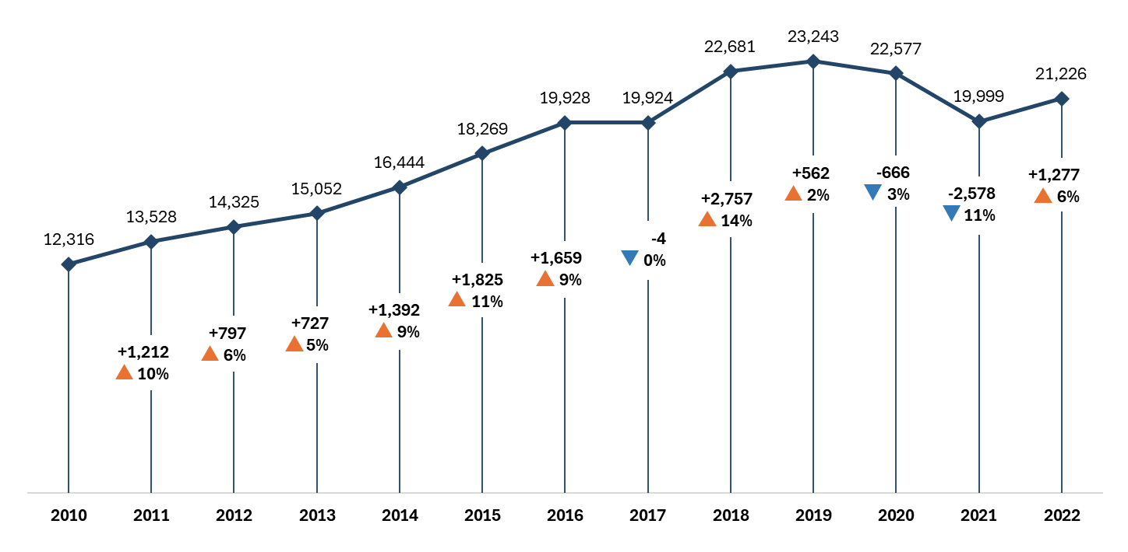
Figure 1: Number of K–12 Students Experiencing Homelessness and Year-to-Year Change: 2009–10 to 2021–22

From 2017–18 to 2021–22, kindergarten and elementary school students were the largest group among students experiencing homelessness (Table 6).
During the 2021–22 academic year, 9,362 students in grades K–5 were identified as experiencing homelessness—representing 44 percent of all students experiencing homelessness. While elementary school students continued to be the largest group of students experiencing homelessness, their numbers declined each year from 2017–18 through 2020–21, followed by an increase in 2021–22. Over the five-year period, the share of students experiencing homelessness who were in grades K–5 decreased by six percentage points.
Table 6: Number and Percentage of Students Experieincing Homelessness by School Level
Number of Students  Experiencing Homelessness | 2018 | 2019 | 2020 | 2021 | 2022
Grades K–5 | 11,410 | 11,376 | 10,834 | 9,027 | 9,362
Grades 6–8 | 4,640 | 5,042 | 5,060 | 4,643 | 4,845
Grades 9–12 | 6,572 | 6,793 | 6,631 | 6,296 | 6,991
Of Students Who Are Homeless, Percentage by School Level | 2018 | 2019 | 2020 | 2021 | 2022
Grades K–5 | 50.4% | 49.0% | 48.1% | 45.2% | 44.2%
Grades 6–8 | 20.5% | 21.7% | 22.5% | 23.3% | 22.9%
Grades 9–12 | 29.1% | 29.3% | 29.4% | 31.5% | 33.0%
Over a three-year period (2018–19 through 2020–21), the number of kindergarten and elementary school students experiencing homelessness decreased by 20.6 percent (Table 7). This decrease is more than twice the decrease observed among middle school students (-7.9%) and nearly three times the decrease observed among high school students (-7.3%) experiencing homelessness during the same period.
Table 7: Change in Students Experiencing Homelessness by School Level: 2018–19 to 2020–21
 | Number | Percent
Grades K–5 | -2,349 | -20.6%
Grades 6–8 | -399 | -7.9%
Grades 9–12 | -497 | -7.3%

The decline in the number of students experiencing homelessness after the peak in 2018–19 may be related to the COVID-19 pandemic in at least two ways.
First, district and school staff interviewed for this study in 2024 shared that in-person observation of students is a primary way in which they identify students experiencing homelessness after enrollment and registration. Virtual education during school closures may have made it more difficult for district and school staff to identify students and families experiencing homelessness, which may have resulted in under-reporting. Second, pandemic-related policies, such as the eviction moratorium, relief programs, and emergency rental assistance, may have prevented at-risk families from losing their housing, resulting in an actual decline in the number of students experiencing homelessness. Although the number of students experiencing homelessness increased to 21,226 in 2021–22, this number continued to represent an overall decline from the peak number of students in 2018–19 (23,243 students).

Emerging Trends in Homelessness Reported by District, School, Community Provider Staff
District and school staff report increasing numbers of students experiencing homelessness since the 2021–22 academic year.
Between March and May 2024, interviews were conducted with district, school, and community provider staff. One area of focus related to staff perceptions of the number of students and families experiencing homelessness in their districts and communities.
Interviewees from 19 of the 21 school districts participating in this study noted an increased number of students experiencing homelessness since the 2021–22 academic year, with a particular emphasis on steep increases during the 2023-24 academic year. The remaining two districts cited stable numbers or slight fluctuations in the number of students experiencing homelessness.
The number keeps rising. Every year, there are more and more families experiencing homelessness. -- District Staff
Interviewees described growing economic hardship in their communities and shared their perceptions that the number of community residents who are homeless or housing insecure is evident across their communities at large. Staff spoke of families being “one paycheck away from disaster” and “struggling to afford the basic necessities.” School staff emphasized that without improvements in economic stability or access to affordable housing, they expect homelessness among students and families to keep rising.
Regional MKV liaisons and district staff also noted that students experiencing homelessness were now being seen in districts where these students had not previously been enrolled. They attributed the increase to several factors, including the lack of affordable housing (i.e., rapidly increasing rents and shortage of affordable housing options), end of COVID relief interventions, and emergency family shelter caps.
Rents can run between $3,200 to $4,800 a month. There is no way one family or even two or three families can support that. -- District Staff
School and community partner staff shared that the increased cost of housing and the lack of affordable housing are both pressing needs and primary gaps that negatively impact the educational stability and success of their students. Interviewees also shared that many families are unaware of their rights as tenants and are sometimes evicted illegally, which not only leaves them without shelter but also makes it harder to find housing in the future.
District personnel, school staff, and community partners also noted that students experiencing homelessness need a broader range of support services than in the past. They explained that the need for mental health services has increased among all students and that there is a particular need for mental health services among students experiencing homelessness.

In addition to concerns about economic insecurity and homelessness, interviewees highlighted that the arrival of students and families new to the U.S., often referred to as “newcomers,” is contributing to the rising number of students experiencing homelessness in their districts. Staff from approximately 85 percent of participating school districts reported a noticeable overlap between students experiencing homelessness and newcomer students, many of whom are English learners (EL) or students with limited or interrupted formal education (SLIFE). However, it is important to note that while newcomer students are increasingly represented among those experiencing homelessness, they do not make up the majority of this group.
Families coming into the district are immigrants coming from other countries who are fleeing disaster or seeking asylum. Many of those families end up being homeless or doubling up or ending up in shelters. These families are probably eight out of every 10 enrollments [among homeless students] we've received so far this year. -- School Staff
Staff reported that newcomer families often arrive with little warning and limited resources, noting that many of these students and families—some of whom are refugees or asylum seekers—require extensive support with a wide range of issues. They shared that newcomer students frequently lack school or medical records, may have had little or no formal education, and have often experienced frequent moves, sometimes across schools, districts, states, or even countries
In addition to facing unstable housing and unmet basic needs, newcomer students and families also face trauma, mental and behavioral health challenges, limited access to healthcare, and language barriers. Staff noted a growing number of students and families who speak languages other than English or Spanish, further complicating communication and access to services.
The kiddos coming in have little to no education. We have older students coming that have never been in school or not for a very long time. Not only are they coming in with little to no English language, but they are also coming in not understanding the structure of American schools. –- District Staff

Unaccompanied Youth
Under the MKV Act, unaccompanied youth include those students who are not in the physical custody of their parents/guardians and are experiencing homelessness. Therefore, by definition, unaccompanied youth are a subset of students experiencing homelessness. However, recognizing that some students not in the physical custody of parents or guardians are housed, DESE student-level data does not include unaccompanied youth as a subset of students experiencing homelessness. Rather, data about these students are documented separately and were not included in the quantitative analysis of students experiencing homelessness. The information about the number of unaccompanied youth presented below was provided by DESE’s Office of Student and Family Support.
The number of unaccompanied youth increased by 26 percent from 2017–18 to 2021–22 (Table 8).
From 2017–18 to 2021–22, there was a net increase of 351 students identified as unaccompanied youth throughout Massachusetts. The largest increase in this student group occurred from 2020–21 to 2021–22 when the number of unaccompanied youth increased by 487 or 40 percent over a single academic year.
Table 8: Number of Unaccompanied Youth
 | 2018 | 2019 | 2020 | 2021 | 2022
Unaccompanied Youth | 1,349 | 1,408 | 1,393 | 1,213 | 1,700

During site visit interviews, nearly every school district cited unaccompanied youth as an important subset of students experiencing homelessness due to their housing insecurity and circumstances which often surround separation from parents/guardians. School and community provider staff revealed a variety of circumstances which result in separation from parents/guardians, including abuse or neglect, divorce, pregnancy, sexual orientation, gender identity, substance abuse, or death of a family member. They noted that circumstances such as these may lead to family conflicts, with youth “being kicked out” or “running away” and consequently lacking a fixed, adequate nighttime residence. Other less frequently noted circumstances include youth who age out of the foster care system as well those migrating to the U.S. without family members. While the numbers of unaccompanied youth currently identified in most districts are relatively small, representatives of school and community partners agreed that the actual number of unaccompanied youth is likely larger because they are among the most difficult to identify.

Nighttime Residence
MKV defines homelessness as lacking a fixed, regular, and adequate nighttime residence. Nighttime residence refers to the dwelling or location where a person sleeps. In Massachusetts, districts report information about the dwelling arrangements for students experiencing homelessness. These data include four types of nighttime residence—doubled-up, in a shelter, in a motel, and unsheltered. Doubled-up refers to living with friends or relatives due to economic hardship, loss of housing, or other reasons. In a shelter refers to being temporarily housed in a congregate shelter, scattered site shelter, or co-shelter. In a motel refers to being temporarily housed in a hotel or motel room either paid through the state’s shelter system or paid directly by families. Unsheltered refers to living in places not meant for human habitation (e.g., cars, parks, abandoned buildings).
The most common nighttime residence for students experiencing homelessness is doubled-up, with more than 60 percent of students experiencing homelessness from 2017–18 to 2021–22 living with friends or relatives (Table 9).
We used to only see doubled-up. Currently, we are also seeing a lot of motels. And this is the first year that I have seen people living in cars and on the street. They have nowhere to go literally. -- District Staff
During the 2021–22 academic year, nearly 70 percent of students experiencing homelessness were living with friends or family. The prevalence of being doubled-up is not unique to Massachusetts. According to national data on student homelessness for the 2021–22 academic year, over 70 percent of students experiencing homelessness across the country are living with friends or relatives.
Table 9: Nighttime Residence of Students Experiencing Homelessness
 | 2018 | 2019 | 2020 | 2021 | 2022
Doubled-up | 65.1% | 63.9% | 65.1% | 65.0% | 68.2%
In Shelter | 28.7% | 29.8% | 29.1% | 28.6% | 25.3%
In Motel | 6.6% | 6.6% | 5.6% | 5.7% | 6.0%
Unsheltered | 0.8% | 0.9% | 1.0% | 1.1% | 1.1%

District, school, and community provider staff shared concerns that the nighttime residence for an increasing number of students and families is unstable and unsafe.
District, school, and community provider staff interviewed for this study in 2024 confirmed that the most common nighttime residence among students experiencing homelessness is doubled-up. While this remains true, interviewees noted that all forms of nighttime residence for students and families experiencing homelessness are increasingly unstable and unsafe. Regarding students and families who are sheltered (i.e., doubled-up, in shelter or motels, or renting rooms), interviewees emphasized that students and families have little control over their situation and are often asked to leave “at a moment’s notice,” leaving them to seek alternatives where none may exist. They noted that the sudden loss of a nighttime residence is common when doubled-up, but also occurs in the shelter system, in hotels/motels, and in room rentals. In addition to instability, interviewees shared that they are seeing more families living in overcrowded conditions either while doubled-up with other families or in motels and room rentals. One community partner shared that motels and room rentals are an increasing concern with “families of five or six are living in one room.” Finally, interviewees noted that while these students and families are “sheltered,” these options, including family shelters, often represent unsafe, unlivable conditions.
Interviewees also described increases in the number of students and families who are unsheltered. They referred to students and families living out of their cars and on the street, a first-time occurrence in many of these districts. Others described families residing in condemned buildings or buildings at high risk of fire. One district representative noted seeing “people utilize the emergency rooms in the evening” for the first time in that community. Seasonal trends in homelessness were also reported by districts in popular summer vacation areas along the state’s eastern and western borders. During peak tourist season, when housing rental market costs are at their highest, families in these communities opt to sleep at campgrounds, beaches, or other outdoor locations during warm weather months when there are no affordable housing rental options.

Historical Trends Among Students in Foster Care, Students in Migrant Worker Families, and Students in Military Families
The section presents a quantitative analysis of the number of students in foster care, those who are part of migrant worker families, and students who are part of military families, including counts by academic year and changes over time.

Counts of Students in Foster Care
Beginning in 2015 with the passage of the Every Student Succeeds Act (ESSA), states were required to track and report data on students in foster care. In Massachusetts, students who are identified as being in foster care at enrollment or identified at some point after enrollment are documented in the Student Information System (SIS) using the foster care flag. Data on students in foster care are cumulative for each school year and are certified and submitted at the end of the school year. DESE began working with districts to develop data collection procedures during the 2016–17 academic year and began requiring districts to document students in foster care beginning in 2017–18. For this study, data on the number of students in foster care includes academic years 2017–18 through 2021–22.
The number of documented students in foster care increased each successive year from 2017–18 to 2021–22, representing a 40 percent increase over five years (Figure 2).
As shown in Figure 2, the most substantial year-over-year increase occurred from 2017–18 to 2018–19 when an additional 1,627 students were documented as being in foster care, representing a 31 percent increase in one academic year. However, given that 2017–18 was the first time foster care data were reported to DESE, the number for that year may represent an undercount associated with districts developing new processes and procedures to document this student group.
Figure 2: Number of K–12 Students in Foster Care and Year-to-Year Change: 2017–18 to 2021–22
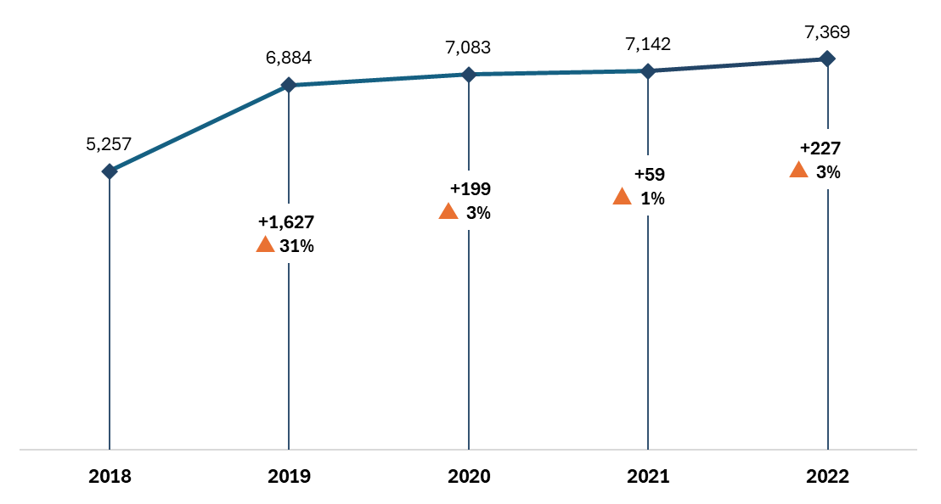

As shown in Table 10, the number of K–5 students in foster care increased by nearly 600 students from 2017–18 to 2018–19 and then decreased slightly each successive year through 2021–22. The number of foster care students in middle and high school increased each successive year. From 2017–18 to 2021–22, the number of middle school students in foster care increased by over 500 students, and the number in high school increased by over 1,000.
Table 10: Number and Percentage of Students in Foster Care by School Level
Number of Students in Foster Care | 2018 | 2019 | 2020 | 2021 | 2022
Grades K–5 | 2,433 | 3,020 | 3,018 | 2,993 | 2,985
Grades 6–8 | 1,164 | 1,517 | 1,647 | 1,653 | 1,699
Grades 9–12 | 1,653 | 2,340 | 2,407 | 2,485 | 2,678
Of Students Who Are in Foster Care, Percentage by School Level | 2018 | 2019 | 2020 | 2021 | 2022
Grades K–5 | 46.3% | 43.9% | 42.7% | 42.0% | 40.5%
Grades 6–8 | 22.2% | 22.1% | 23.3% | 23.2% | 23.1%
Grades 9–12 | 31.5% | 34.0% | 34.0% | 34.8% | 36.4%

Counts of Students in Migrant Worker Families
Data on students who are part of migrant worker families are documented by the Massachusetts Migrant Education Program (MMEP) vendor. Districts do not report these data. For this study, data on the number of students in migrant worker families includes academic years 2009–10 through 2021–22.
From 2009–10 through 2021–22, the number of documented students in migrant worker families increased by nearly 200 percent—from 149 students to 446 students (Figure 3).
The number of students in migrant worker families increased each successive year from 2009–10 to 2016–17, followed by some fluctuation. The most substantial year-over-year increase occurred from 2011–12 to 2012–13 when an additional 101 students (41%) were documented as being part of a migrant worker family.
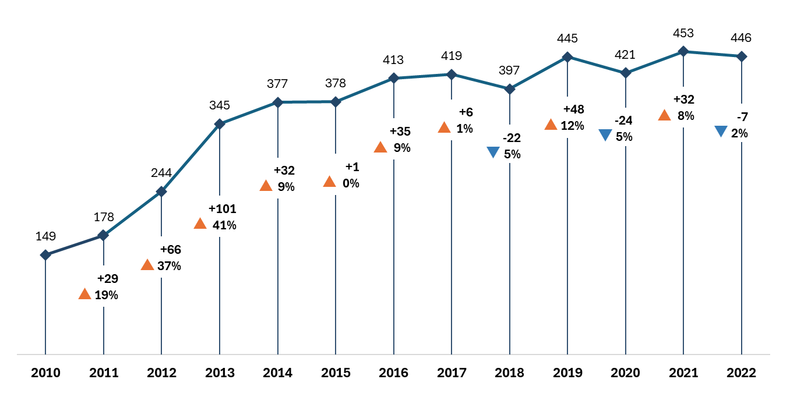
Figure 3: Number of K–12 Students in Migrant Worker Families and Year-to-Year Change: 2009–10 to 2021–22

Counts of Students in Military Families
Beginning in 2015 with the passage of the Every Student Succeeds Act (ESSA), states were required to track and report data on students in military families. In Massachusetts, parents must be provided with the opportunity to voluntarily self-identify as active military. Students who are identified as being part of a military family are documented in the Student Information System (SIS). DESE began requiring districts to document military family students beginning in 2015. For this study, data on the number of students in military families includes the academic years 2014–15 through 2021–22.
Overall, the number of documented K–12 students in military families increased by 59 percent from 2014–15 to 2021–22 (Figure 4).
With one exception (2017–18), the number of students in military families increased each successive year from 2014–15 to 2021–22, beginning with 5,554 students in 2014–15 and peaking in 2021–22 with 8,849 students.
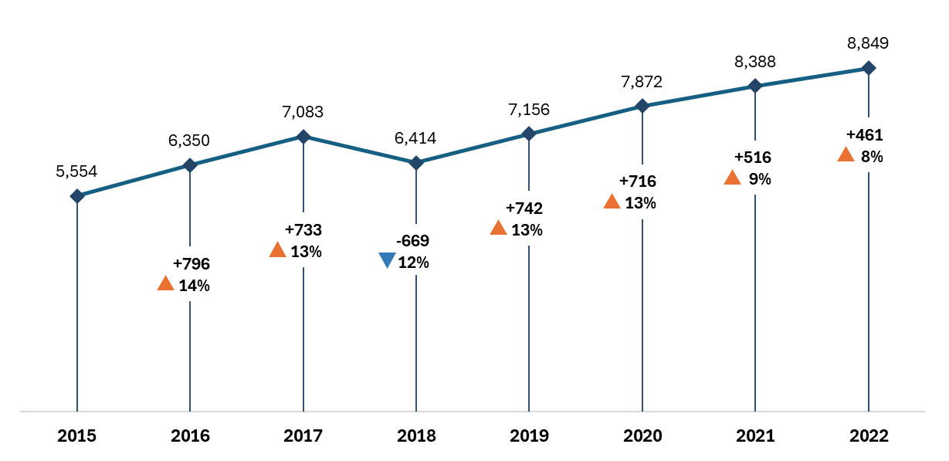
Figure 4: Number of K–12 Students in Military Families and Year-to-Year Change: 2014–15 to 2021–22

Chapter IV: Characteristics, Risk Factors, and Educational Stability of High Mobility Student Groups

Chapter Organization and Contents
This chapter presents information about the characteristics of students experiencing homelessness with comparisons to students in foster care, students in migrant worker families, students in military families, and non-mobile students (i.e., students who are not identified as being part of a high mobility group). The four high mobility student groups are not homogenous; they and differ in relation to changing schools or districts within an academic year, race and ethnicity, prevalence of selected risk factors (i.e., English learner status, disability status, and low-income status), and educational stability (i.e., attendance, school discipline, and school dropout). Characteristics, risk factors, and educational stability of high mobility students and non-mobile students are summarized for the five academic years that data are available for all four high mobility student groups (2017–18 through 2021–22).
The first section, Key Findings, highlights the results from this chapter.
The second section, Characteristics, presents quantitative data about dual incidence, mobility, and the demographic characteristics of students experiencing homelessness with comparisons to other high mobility student groups and non-mobile students. The dual incidence subsection addresses the overlap among homelessness, foster care placement, migrant worker family status, and military family status. In addition to student data regarding dual incidence, qualitative data gathered through interviews with district, school, and community provider staff offer perspectives related to dual incidence more recently. The mobility subsection presents a quantitative analysis of students who attend more than one school and more than one district within an academic year. The demographic characteristics subsection presents a quantitative analysis of gender and race and ethnicity.
The third section, Risk Factors, presents a quantitative analysis of English learner students, low-income students, and students with disabilities. Information is presented for students experiencing homelessness with comparisons to other high mobility student groups and non-mobile students.
The last section, Educational Stability, presents a quantitative analysis of school attendance, school discipline, and school dropout. Information is presented for students experiencing homelessness with comparisons to other high mobility student groups and non-mobile students.

Note: Each figure presented in this chapter has an associated table that includes all percentages for each student group, as well as any relevant notes about the data.

Key Findings: Characteristics, Risk Factors, and Educational Stability
From 2017–18 through 2021–22, students experiencing homelessness and students in foster care had higher mobility rates (i.e., attending multiple districts or multiple schools in a single academic year) than students in other high mobility groups and non-mobile students.
- In 2021–22, 12 percent of students in foster care and 8 percent of students experiencing homelessness attended two or more districts during the academic year.
- In 2021–22, 15 percent of students in foster care and 11 percent of students experiencing homelessness attended two or more schools within a single district or across multiple districts during the academic year.
- In 2021–22, the percentage of students in migrant worker families attending two or more districts (5.3%) or schools (8.3%) was lower than among students in foster care or students experiencing homelessness.
- Although students in military families are considered a high mobility student group, the percentage attending two or more districts (2.1%) or schools (2.5%) during the 2021–22 academic year mirrored that of non-mobile students (1.8% and 2.5%, respectively).
Historically marginalized student groups, including those who are Hispanic or Latino, African American or Black, English learners, low income, or have disabilities, are over-represented among students experiencing homelessness, students in foster care, and students in migrant worker families.
- In 2021–22, 95 percent of students in migrant worker families and 55 percent of students experiencing homelessness were Hispanic or Latino compared to 23 percent of non-mobile students.
- In 2021–22, 17 percent of students in foster care and 16 percent of students experiencing homelessness were African American or Black compared to 9 percent of non-mobile students.
- In 2021–22, 86 percent of migrant worker family students and 41 percent of students experiencing homelessness and were English learners compared to 12 percent of non-mobile students.
- In 2021–22, 95 percent of students in foster care, 85 percent of students experiencing homelessness, and 84 percent of students in migrant worker families were low income compared to 41 percent of non-mobile students.
- In 2021–22, the percentage of students with a disability was highest among students in foster care (46.5%) compared to other high mobility groups and non-mobile students.
Students experiencing homelessness, students in foster care, and students from migrant worker families had lower attendance rates, higher suspension rates, and higher dropout rates than non-mobile students.
- From 2017–18 through 2021–22, students experiencing homelessness and students in foster care consistently had lower attendance rates than students in migrant worker families, students in military families, and non-mobile students.
- During the 2021–22 academic year, the suspension rate among students in foster care (16.5%) was twice as high as students experiencing homelessness (8.1%) and more than four times as high as non-mobile students (4.0%), students in migrant worker families (3.6%), and students in military families (3.1%).
- In 2021–22, students in migrant worker families had the highest dropout rate (11.7%), followed by students experiencing homelessness (7.8%) and students in foster care (7.1%).
The mobility rates, characteristics, risk factors, and educational stability of military family students were more consistent with non-mobile students than other high mobility groups.

Characteristics
As part of the this research, DESE was interested in understanding the extent to which students experiencing homelessness intersect or overlap with other high mobility groups, and how the characteristics of students experiencing homelessness compare to other high mobility groups and non-mobile students.
This section includes quantitative data about “dual incidence” students; students who were identified as being part of more than one high mobility student group in an academic year with additional information about district, school, and community provider staff perspectives about dual incidence obtained through site visits conducted from March to May 2024.
This section also includes an analysis of student mobility within a single academic year (i.e., the percentage of students in each group who attended two or more districts in one academic year and the percentage of students in each group who attended two or more schools within a single district or across multiple districts in a single academic year). The extent to which students attend multiple districts or schools throughout their K–12 experience was not part of this study.
Finally, this section summarizes demographic characteristics, including gender and race and ethnicity.

Dual Incidence
Quantitative analyses of student data demonstrate that less than 1.5 percent of students in the four high mobility student groups experienced dual incidence (Table 11).
From 2017–18 through 2021–22, the number of high mobility students ranged from 34,036 students in 2017–18 to 37,181 students in 2021–22. Of these, more than 98 percent were documented in the data as being part of one high mobility student group, suggesting that the occurrence of dual incidence or overlap is uncommon. It is important to note that students documented as being part of a migrant worker family who are also experiencing homelessness may not be counted as dual incidence due to the data being tracked by a vendor rather than districts. As a result, dual incidence may be somewhat under-reported. However, the difference is likely small considering that the number of students in migrant worker families in 2021–22 is less than 450 students.
Table 11: Number and Percentage of Students Experiencing Dual Incidence
 | 2018 | 2019 | 2020 | 2021 | 2022
Number of High Mobility Students | 34,036 | 36,707 | 37,101 | 35,211 | 37,181
Number of Students in 1 High Mobility Group | 33,680 | 36,197 | 36,675 | 34,826 | 36,827
Number of Students with Dual Incidence | 357 | 511 | 426 | 386 | 355
Percentage of Students with Dual Incidence | 1.0% | 1.4% | 1.1% | 1.1% | 1.0%

Information provided by regional MKV liaisons and district MKV liaisons confirmed that overlap among the four high mobility student groups is uncommon.
Regional and district-level liaisons confirmed that dual incidence among students experiencing homelessness and students in foster care is low, with only five of the 21 participating districts mentioning “occasional overlap” between these two student groups. District MKV liaisons, who often also serve as the foster care point of contact for their district, shared that the two groups are largely independent of each other. The lack of dual incidence among these two student groups may relate to the Every Students Succeeds Act (ESSA), which, in 2015, removed “awaiting foster care” as a condition of homelessness under MKV and created similar, but separate, provisions for students in foster care. Due to the ESSA change, students cannot be homeless and in foster care at the same time. There are, however, certain situations that would result in a student being identified as homeless and in foster care in the same academic year. For example, a high school student who ages out of foster care and lacks a fixed, regular, and adequate nighttime residence would be identified as both in foster care and homeless in the same academic year. Similarly, a student who experiences homelessness prior to a foster care placement would be identified as both homeless and in foster care in the same academic year.
During the 2021–22 academic year, 446 students were identified as being part of a migrant worker family across 30 Massachusetts school districts. During district site visits, staff from seven of the 21 participating districts reported working with at least one student from a migrant worker family. District and school staff from study districts that have students in migrant worker families shared that there is overlap between students who are part of migrant worker families and students experiencing homelessness. However, they noted that students in migrant worker families represent a small subset of their homeless student group.
None of the district or school staff interviewed described an overlap between students experiencing homelessness and students in military families. At most, interviewees described a single relevant incidence across their years working for the district.

Mobility
From 2017–18 through 2021–22, students experiencing homelessness and students in foster care had higher mobility rates (i.e., attending multiple districts or multiple schools in a single academic year) than students in other high mobility groups and non-mobile students (Tables 12 and 13).
In 2021–22, 12 percent of students in foster care and 8 percent of students experiencing homelessness attended two or more districts during that academic year. Furthermore, 15 percent of students in foster care and 11 percent of students experiencing homelessness attended two or more schools within a single district or across multiple districts.
In 2021–22, the percentage of students in migrant worker families attending two or more districts (5.3%) or schools (8.3%) was lower than among students in foster care or students experiencing homelessness. Although students in military families are considered a high mobility student group, the percentage attending two or more districts (2.1%) or schools (2.5%) mirrors that of non-mobile students (1.8% and 2.5%, respectively).
Across all student groups, mobility rates were lowest during the 2020–21 academic year. To some extent, this may be a result of attending school virtually during COVID-related school closures.
Table 12: Percentage of Students Attending Two or More Districts During the Academic Year
 | 2018 | 2019 | 2020 | 2021 | 2022
Non-Mobile Students | 1.7% | 1.7% | 1.6% | 1.4% | 1.8%
Students Experiencing Homelessness | 10.9% | 9.6% | 8.6% | 5.6% | 8.1%
Students in Foster Care | 18.8% | 14.7% | 11.2% | 9.6% | 12.4%
Students in Migrant Worker Families | 4.2% | 4.5% | 2.2% | 1.5% | 5.3%
Students in Military Families | 1.9% | 1.8% | 1.7% | 1.6% | 2.1%

Table 13: Percentage of Students Attending Two or More Schools During the Academic Year
 | 2018 | 2019 | 2020 | 2021 | 2022
Non-Mobile Students | 2.4% | 2.4% | 2.1% | 1.9% | 2.5%
Students Experiencing Homelessness | 13.6% | 13.5% | 10.9% | 7.0% | 10.5%
Students in Foster Care | 22.2% | 17.8% | 13.8% | 11.5% | 14.6%
Students in Migrant Worker Families | 6.7% | 8.2% | 3.0% | 3.4% | 8.3%
Students in Military Families | 2.1% | 2.1% | 2.0% | 1.9% | 2.5%

Demographic Characteristics

Gender
DESE student-level data on gender includes three categories—male, female, and non-binary. The addition of non-binary as a gender recorded in student-level data began in 2016–17. In 2021–22, nearly 1,000 students self-identified as non-binary. Among high mobility student groups in 2021–22, the number of students who self-identified as non-binary is relatively small. In 2021–22, for instance, 22 students experiencing homelessness, 24 students in foster care, and eight students in military families self-identified as non-binary. Given the small sample sizes, non-binary students were not included in the analyses of high mobility student groups.
As shown in Table 14, the gender of K–12 students experiencing homelessness, in foster care, and in military families remained consistent from 2017–18 to 2021–22 with the percentage of male students being slightly higher than female students, mirroring the gender breakdown of non-mobile students. However, the percentage of students in migrant worker families who are male increased from 49 percent in 2017–18 to 56 percent in 2021–22.
Table 14: High Mobility Student Groups and Non-Mobile Students by Gender
Non-Mobile | 2018 | 2019 | 2020 | 2021 | 2022
Male | 51.5% | 51.4% | 51.4% | 51.4% | 51.5%
Female | 48.5% | 48.6% | 48.5% | 48.5% | 48.4%
Students Experiencing Homelessness | 2018 | 2019 | 2020 | 2021 | 2022
Male | 51.6% | 51.9% | 51.9% | 52.0% | 51.8%
Female | 48.4% | 48.1% | 48.1% | 48.0% | 48.2%
Students in Foster Care | 2018 | 2019 | 2020 | 2021 | 2022
Male | 50.1% | 51.0% | 50.8% | 50.8% | 51.0%
Female | 49.9% | 49.0% | 49.2% | 49.2% | 49.0%
Students in Migrant Worker Families | 2018 | 2019 | 2020 | 2021 | 2022
Male | 48.8% | 52.2% | 54.0% | 56.9% | 56.4%
Female | 51.2% | 47.8% | 46.0% | 43.1% | 43.6%
Students in Military Families | 2018 | 2019 | 2020 | 2021 | 2022
Male | 50.8% | 50.7% | 50.8% | 51.1% | 50.7%
Female | 49.2% | 49.3% | 49.2% | 48.9% | 49.3%
Note: Students who self-identify as non-binary are not included due to small sample sizes.

Race and Ethnicity
With the exception of students in military families, students who identify as Hispanic or Latino and students who identify as Black or African American are over-represented among high mobility student groups compared to students in Massachusetts who are not high mobility (Table 15 and Figures 5–7).
Figure 5: Percentage of Students Who are Hispanic or Latino
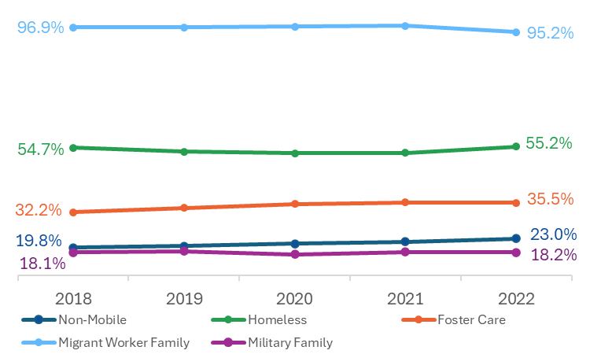
From 2017–18 through 2021–22, over 95 percent of students in migrant worker families were Hispanic or Latino and 55 percent of students experiencing homelessness were Hispanic or Latino. Over the same period, less than 36 percent of students in foster care, less than 25 percent of non-mobile students, and less than 20 percent of students in military families were Hispanic or Latino.

Figure 6: Percentage of Students Who are African American or Black
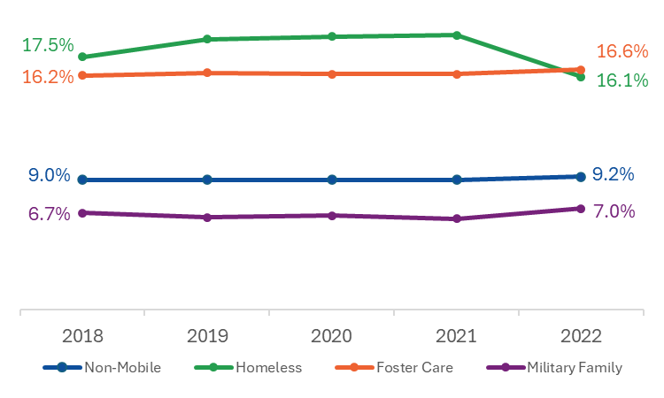
From 2017–18 through 2021–22, over 16 percent of students experiencing homelessness and students in foster care were African American or Black compared to less than 10 percent of non-mobile students and military family students.

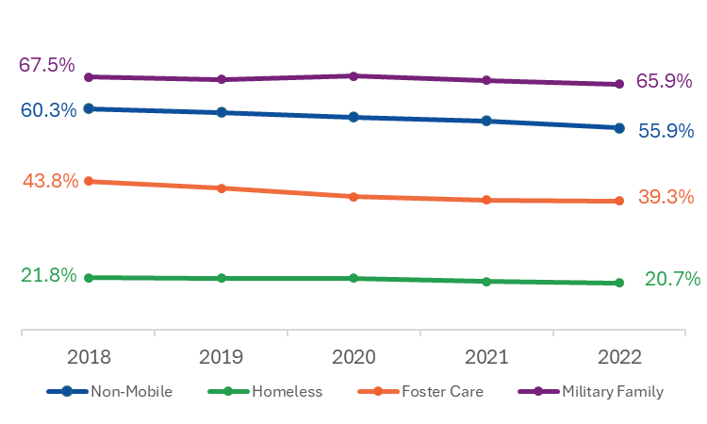
Figure 7: Percentage of Students Who are White

From 2017–18 through 2021–22, over 65 percent of military family students were White and over 55 percent of non-mobile students were White. By comparison, less than 45 percent of students in foster care were white and less than 22 percent of students experiencing homelessness were white over the same period.

Students Experiencing Homelessness
From 2017–18 through 2021–22, Hispanic or Latino students were the largest racial or ethnic group among students experiencing homelessness, followed by White students, and African American or Black students. During each of the five years, more than one-half of all students experiencing homelessness were Hispanic or Latino.
Hispanic or Latino students and African American or Black students are overrepresented among students experiencing homelessness when compared to non-mobile students. In 2021–22, Hispanic or Latino students made up 55 percent of the students experiencing homelessness, compared to just 23 percent of non-mobile students. Similarly, African American or Black students represented 16 percent of students experiencing homelessness, compared to 9 percent of non-mobile students.

Students in Foster Care
From 2017–18 through 2021–22, the most common racial identity among students in foster care was White, followed by Hispanic or Latino, and African American or Black. Although White students were the largest group among students in foster care, they were under-represented compared to non-mobile students. In 2021–22, White students accounted for 39 percent of students in foster care compared to 56 percent of non-mobile students. In comparison, Hispanic or Latino and African American or Black students are over-represented among students in foster care compared non-mobile students. In 2021–22, Hispanic or Latino students accounted for 36 percent of all students in foster care, compared to 23 percent of non-mobile students. Similarly African American or Black students accounted for 17 percent of all students in foster care, compared to 9 percent of non-mobile students.

Students in Migrant Worker Families
From 2017–18 through 2021–22, over 95 percent of students in migrant worker families were Hispanic or Latino.

Students in Military Families
From 2017–18 through 2021–22, White students were the largest racial or ethnic group among students in military families, followed by Hispanic or Latino students and African American or Black students. Unlike other high mobility student groups, White students were overrepresented in military families. In 2021–22, 66 percent of students in military families were White, compared to 56 percent of non-mobile students.

The following table provides the percentages of non-mobile students and high mobility student groups by race and ethnicity for the academic years 2017–18 through 2021–22. Selected percentages from this table are displayed in Figures 5, 6, and 7.
Table 15: High Mobility Student Groups and Non-Mobile Students by Race and Ethnicity
Non-Mobile Students | 2018 | 2019 | 2020 | 2021 | 2022
African American/Black | 9.0% | 9.0% | 9.0% | 9.0% | 9.2%
American Indian or Alaskan Native | 0.2% | 0.2% | 0.2% | 0.2% | 0.2%
Asian | 7.0% | 7.2% | 7.3% | 7.3% | 7.4%
Hispanic/Latino | 19.8% | 20.4% | 21.2% | 21.8% | 23.0%
Multi-Racial Non-Hispanic | 3.6% | 3.7% | 3.9% | 4.1% | 4.2%
Native Hawaiian or Pacific Islander | 0.1% | 0.1% | 0.1% | 0.1% | 0.1%
White | 60.3% | 59.4% | 58.4% | 57.5% | 55.9%
Students Experiencing Homelessness | 2018 | 2019 | 2020 | 2021 | 2022
African American/Black | 17.5% | 18.7% | 18.9% | 19.0% | 16.1%
American Indian or Alaskan Native | 0.3% | 0.3% | 0.2% | 0.3% | 0.3%
Asian | 1.7% | 2.1% | 2.2% | 2.6% | 3.6%
Hispanic/Latino | 54.7% | 53.4% | 52.8% | 53.0% | 55.2%
Multi-Racial Non-Hispanic | 3.8% | 3.8% | 4.0% | 4.1% | 4.0%
Native Hawaiian or Pacific Islander | 0.1% | 0.1% | 0.1% | 0.1% | 0.1%
White | 21.8% | 21.7% | 21.7% | 21.0% | 20.7%
Students in Foster Care | 2018 | 2019 | 2020 | 2021 | 2022
African American/Black | 16.2% | 16.4% | 16.3% | 16.3% | 16.6%
American Indian or Alaskan Native | 0.6% | 0.6% | 0.5% | 0.5% | 0.5%
Asian | 1.3% | 1.1% | 1.4% | 1.2% | 1.2%
Hispanic/Latino | 32.2% | 33.7% | 35.1% | 35.6% | 35.5%
Multi-Racial Non-Hispanic | 5.9% | 6.0% | 6.4% | 6.8% | 6.8%
Native Hawaiian or Pacific Islander | 0.1% | 0.1% | 0.1% | * | 0.1%
White | 43.8% | 42.2% | 40.3% | 39.5% | 39.3%
Students in Migrant Worker Families | 2018 | 2019 | 2020 | 2021 | 2022
Hispanic/Latino | 96.9% | 96.9% | 97.2% | 97.4% | 95.2%
Non-Hispanic/Latino* | 3.1% | 3.1% | 2.8% | 2.6% | 4.8%
Students in Military Families | 2018 | 2019 | 2020 | 2021 | 2022
African American/Black | 6.7% | 6.4% | 6.5% | 6.3% | 7.0%
American Indian or Alaskan Native | 0.3% | 0.4% | 0.3% | 0.3% | 0.3%
Asian | 2.2% | 2.0% | 2.0% | 2.1% | 2.3%
Hispanic/Latino | 18.1% | 18.5% | 17.4% | 18.3% | 18.2%
Multi-Racial Non-Hispanic | 5.0% | 5.7% | 5.9% | 6.0% | 6.1%
Native Hawaiian or Pacific Islander | 0.3% | 0.2% | 0.3% | 0.2% | 0.2%
White | 67.5% | 66.9% | 67.7% | 66.7% | 65.9%
* Race/ethnicity categories other than Hispanic/Latino were combined into one group due to small cell sizes.

Risk Factors
As part of this research, DESE was interested in understanding how risk factors, such as English learner (EL) status, low income status, and disability status, among students experiencing homelessness compared to other high mobility groups and non-mobile students.
DESE defines English learners as students who have indicated a language other than English on the Home Language Survey and are less than proficient on the English language proficiency assessment and are unable to perform ordinary classroom work in English.
Low income status for this analysis uses DESE’s Economically Disadvantaged (ECODIS) variable. Students who are economically disadvantaged are defined as students who participated in one or more of the following state administered programs: Supplemental Nutrition Assistance Program (SNAP), Transitional Assistance for Families with Dependent Children (TAFDC), Department of Children and Families’ foster care, and MassHealth (Medicaid).
DESE defines students with disabilities as special education students who receive special education services in a number of settings: primarily within the general education classroom (full inclusion), partially outside the general education classroom (partial inclusion), in a substantially separate classroom, or in some other facility or location (e.g., public or private day school or residential school).
Trends observed below may be different than what districts and schools experienced during the 2022–23 and 2023–24 academic years due to the changing characteristics of students experiencing homelessness that were noted during district site visits.
The percentages of students who are English learners, low income, or have a disability vary across high mobility groups and non-mobile students (Table 16 and Figures 8–10).
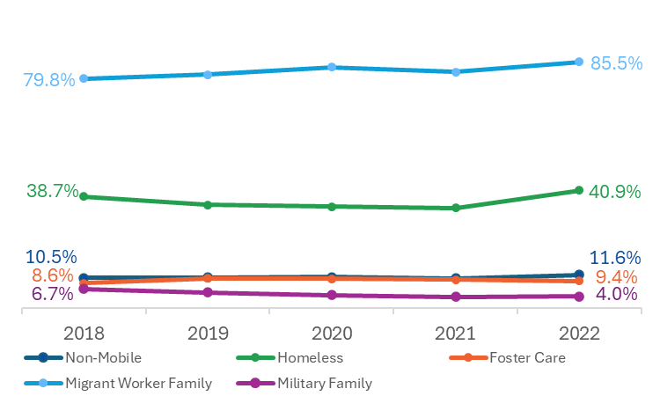
Figure 8: Percentage of Students Who are English Learners

In 2021–22, 41 percent of students experiencing homelessness were English learners compared to 12 percent of non-mobile students, 9 percent of students in foster care and 4 percent of students in military families.
During the same academic year, 86 percent of students in migrant worker families were English learners, representing a 6 percentage point increase from 2017–18.

Figure 9: Percentage of Students Who are Low Income
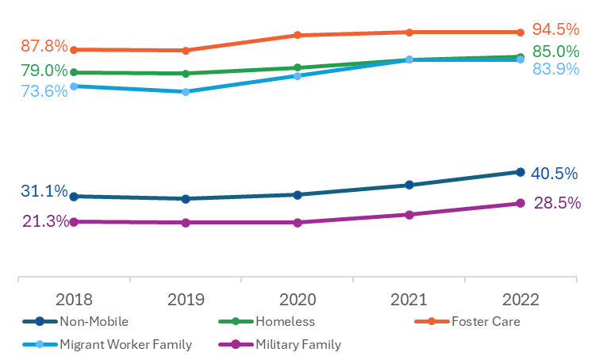
From 2017–18 through 2021–22, the percentage of students who were low income increased among all student groups, including non-mobile students.
In 2021–22, 95 percent of students in foster care, 85 percent of students experiencing homelessness, and 84 percent of students in migrant worker families were low income compared to 41 percent of non-mobile students and 29 percent of military family students.

Figure 10: Percentage of Students with a Disability
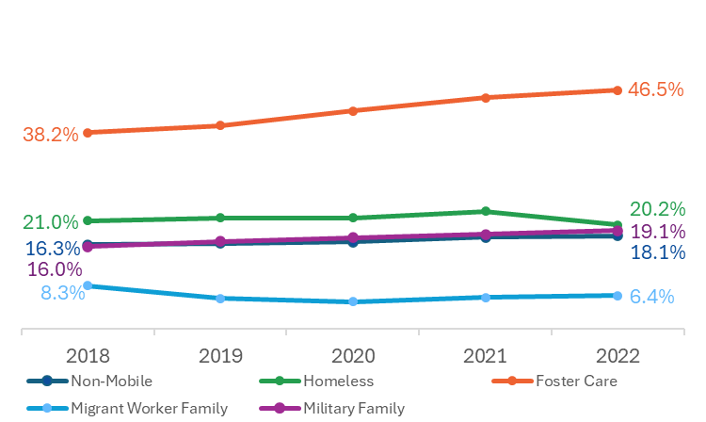
From 2017–18 through 2021–22, the percentage of students with a disability was highest among students in foster care. In 2021–22, 47 percent of foster care students had a disability compared to 20 percent of students experiencing homelessness, 19 percent of military family students, 18 percent of non-mobile students, and 6 percent of students in migrant worker families.

The following table provides percentages of non-mobile students and high mobility students with selected risk factors for academic years 2017–18 through 2021–22. Percentages in this table are displayed in Figures 8, 9, and 10.
Table 16: Selected Risk Factors Among Non-Mobile and High Mobility Student Groups
Non-Mobile Students | 2018 | 2019 | 2020 | 2021 | 2022
English Learner Students | 10.5% | 10.6% | 10.8% | 10.3% | 11.6%
Students who are Low Income | 31.1% | 30.2% | 31.7% | 35.5% | 40.5%
Students with Disabilities | 16.3% | 16.6% | 16.9% | 17.8% | 18.1%
Students Experiencing Homelessness | 2018 | 2019 | 2020 | 2021 | 2022
English Learner Students | 38.7% | 35.8% | 35.3% | 34.8% | 40.9%
Students who are Low Income | 79.0% | 78.5% | 80.9% | 84.0% | 85.0%
Students with Disabilities | 21.0% | 21.6% | 21.6% | 22.9% | 20.2%
Students in Foster Care | 2018 | 2019 | 2020 | 2021 | 2022
English Learner Students | 8.6% | 10.3% | 10.2% | 9.8% | 9.4%
Students who are Low Income | 87.8% | 87.5% | 93.4% | 94.5% | 94.5%
Students with Disabilities | 38.2% | 39.6% | 42.5% | 45.0% | 46.5%
Students in Migrant Worker Families | 2018 | 2019 | 2020 | 2021 | 2022
English Learner Students | 79.8% | 81.2% | 83.7% | 82.1% | 85.5%
Students who are Low Income | 73.6% | 71.6% | 77.7% | 83.9% | 83.9%
Students with Disabilities | 8.3% | 5.9% | 5.2% | 6.0% | 6.4%
Students in Military Families | 2018 | 2019 | 2020 | 2021 | 2022
English Learner Students | 6.7% | 5.4% | 4.5% | 3.9% | 4.0%
Students who are Low Income | 21.3% | 21.0% | 21.0% | 24.0% | 28.5%
Students with Disabilities | 16.0% | 17.0% | 17.7% | 18.4% | 19.1%

Educational Stability
As part of this research, DESE was interested in understanding how measures of educational stability, such as attendance, school discipline, and school dropout, among students experiencing homelessness compared to other high mobility groups and non-mobile students.
The quantitative analysis of attendance includes the rate of attendance, calculated as the total number of days attended school across all districts divided by the total number of days in membership (i.e., enrolled) across all districts, and the average number of absences. It is important to note that for the academic years 2020–21 and 2021–22, the attendance numbers reported are a combination of two variables that capture in-person attendance and remote attendance. Remote attendance was especially high during the 2020–21 academic year.
The quantitative analysis of school discipline includes the percentage of students who were suspended at least once during the academic year and the average number of days missed due to suspension among those who were suspended at least once.
The quantitative analysis of school dropout includes the percentage of high school students (grades 9–12) who left school for a reason other than transferring to another school or graduating and who did not return to school the following school year by October 1st. The annual high school dropout rate includes students who dropped out of school each year and does not follow a particular cohort of students across four years.
Trends observed from 2017–18 through 2021–22 may be different than what districts and schools experienced during the 2022–23 and 2023–24 academic years due to the increased numbers of students experiencing homelessness and the changes in the characteristics of students experiencing homelessness that were noted during district site visits (e.g., students with more complex issues). Furthermore, data presented for academic year 2019–20, when the COVID-19 pandemic began, and 2020–21, the first full academic year impacted by the COVID-19 pandemic, may not be fully comparable to findings from previous or subsequent years.

Attendance
Across all student groups, the rate of attendance peaked during the 2019–20 academic year and declined in each successive academic year. The rate of attendance for all student groups reached a five-year low during the 2021–22 academic year (Table 17 and Figure 11).
Figure 11: Attendance Rate Among Non-Mobile and High Mobility Student Groups

From 2017–18 through 2021–22, students experiencing homelessness and students in foster care consistently had lower rates of attendance than students in migrant worker families, students in military families, and non-mobile students.

Across all student groups, the mean number of days absent was lowest during the 2019–20 academic year, when the COVID-19 pandemic began, and increased each successive academic year. The mean number of days absent for all student groups reached a five-year high during the 2021–22 academic year (Table 18 and Figure 12).
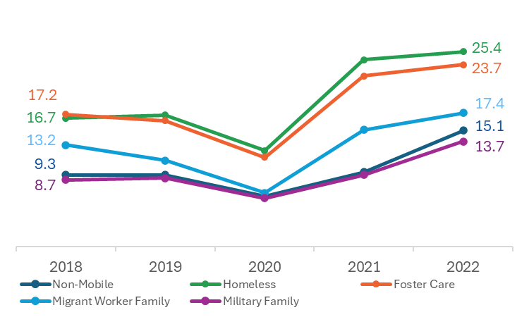
Figure 12: Mean Number of Days Absent Among Non-Mobile and High Mobility Student Groups

From 2017–18 through 2021–22, students experiencing homelessness and students in foster care consistently had higher average absences than students in migrant worker families, students in military families, and non-mobile students.

The following table provides the attendance rates for non-mobile students and high mobility students for academic years 2017–18 through 2021–22. Percentages in this table are displayed in Figure 11.
Table 17: Attendance Rate Among Non-Mobile and High Mobility Student Groups
 | 2018 | 2019 | 2020 | 2021 | 2022
Non-Mobile Students | 94.5% | 94.5% | 95.6% | 93.8% | 91.0%
Students Experiencing Homelessness | 88.6% | 88.8% | 90.9% | 83.9% | 83.2%
Students in Foster Care | 89.3% | 89.8% | 91.6% | 85.9% | 85.4%
Students in Migrant Worker Families | 91.2% | 92.6% | 94.8% | 90.0% | 88.4%
Students in Military Families | 94.7% | 94.7% | 95.8% | 94.0% | 91.8%
The following table provides the mean number of days absent for non-mobile students and high mobility students for academic years 2017–18 through 2021–22. Mean absences in this table are displayed in Figure 12.
Table 18: Mean Number of Days Absent Among Non-Mobile and High Mobility Student Groups
 | 2018 | 2019 | 2020 | 2021 | 2022
Non-Mobile Students | 9.3 | 9.3 | 6.5 | 9.7 | 15.1
Students Experiencing Homelessness | 16.7 | 17.1 | 12.5 | 24.3 | 25.4
Students in Foster Care | 17.2 | 16.4 | 11.6 | 22.2 | 23.7
Students in Migrant Worker Families | 13.2 | 11.2 | 7.0 | 15.2 | 17.4
Students in Military Families | 8.7 | 8.9 | 6.3 | 9.3 | 13.7

School Discipline
Across all student groups, there was a downward trend in the suspension rate and the average number of days suspended from 2017–18 to 2020–21, followed by an increase in both (Tables 19 and 20 and Figures 13 and 14).
During the 2020–21 academic year, the first full academic year impacted by the COVID-19 pandemic, suspension rates and the average days suspended declined markedly from previous years. The 2020–21 dip in suspension rates across all groups may be due to the limited amount of in-person instruction due to COVID-19.
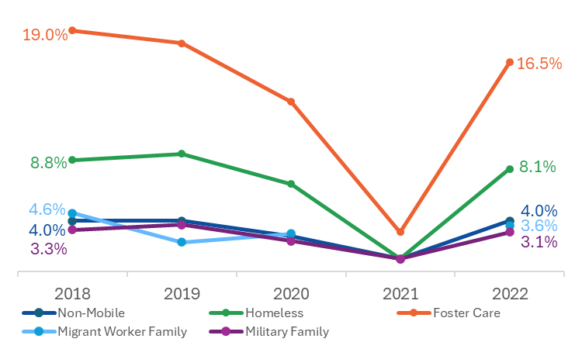
Figure 13: Percentage of Students Suspended Among Non-Mobile and High Mobility Student Groups
From 2017–18 through 2021–22, the percentage of students with at least one suspension was highest among students in foster care. During the 2021–22 academic year, the suspension rate among students in foster care (16.5%) was twice as high as students experiencing homelessness and more than four times as high as non-mobile students (4.0%), students in migrant worker families (3.6%), and students in military families (3.1%).
Figure 14: Mean Number of Days Suspended Among Non-Mobile and High Mobility Student Groups

From 2017–18 through 2021–22, students experiencing homelessness and students in foster care consistently had higher average suspension days than students in migrant worker families, students in military families, and non-mobile students.

The following table provides the suspension rates for non-mobile students and high mobility students for academic years 2017–18 through 2021–22. Percentages in this table are displayed in Figure 13.
Table 19: Suspension Rate Among Non-Mobile and High Mobility Student Groups
 | 2018 | 2019 | 2020 | 2021 | 2022
Non-Mobile Students | 4.0% | 4.0% | 2.8% | 1.0% | 4.0%
Students Experiencing Homelessness | 8.8% | 9.3% | 6.9% | 1.0% | 8.1%
Students in Foster Care | 19.0% | 18.0% | 13.4% | 3.1% | 16.5%
Students in Migrant Worker Families | 4.6% | 2.3% | 3.0% | * | 3.6%
Students in Military Families | 3.3% | 3.7% | 2.4% | 1.0% | 3.1%
* Percentages based on cell sizes of fewer than six cases are not reported.
The following table provides the mean number of days suspended for non-mobile students and high mobility students for academic years 2017–18 through 2021–22. Mean days suspended in this table are included in Figure 14.
Table 20: Mean Number of Days Suspended Among Non-Mobile and High Mobility Student Groups
 | 2018 | 2019 | 2020 | 2021 | 2022
Non-Mobile Students | 4.0 | 4.1 | 3.9 | 3.5 | 4.8
Students Experiencing Homelessness | 4.8 | 4.5 | 4.2 | 3.1 | 5.1
Students in Foster Care | 6.0 | 6.0 | 4.8 | 4.2 | 7.1
Students in Migrant Worker Families | 5.9 | 3.1 | 2.5 | * | 4.6
Students in Military Families | 4.1 | 3.8 | 4.1 | 2.7 | 4.1
* Means based on cell sizes of fewer than six cases are not reported.

School Dropout
Across all student groups, dropout rates were lowest in academic year 2019–20, when the COVID-19 pandemic began, and in 2020–21, the first full academic year impacted by the pandemic (Table 21 and Figure 15).
Figure 15: Dropout Rate Among Non-Mobile and High Mobility Student Groups
From 2017–18 through 2021–22, the dropout rate among students experiencing homelessness, students in foster care, and students in migrant worker families exceeded the rate among students in military families and non-mobile students. In 2021–22, students in migrant worker families had the highest dropout rate (11.7%) followed by students experiencing homelessness (7.8%) and students in foster care (7.1%).

The following table provides the dropout rates for non-mobile students and high mobility students for academic years 2017–18 through 2021–22. Percentages in this table are displayed in Figure 15.
Table 21: Dropout Rate Among Non-Mobile and High Mobility Student Groups
 | 2018 | 2019 | 2020 | 2021 | 2022
Non-Mobile Students | 1.6% | 1.5% | 1.4% | 1.3% | 1.8%
Students Experiencing Homelessness | 5.5% | 6.4% | 4.8% | 5.1% | 7.8%
Students in Foster Care | 5.8% | 7.0% | 4.2% | 4.0% | 7.1%
Students in Migrant Worker Families | 10.2% | 6.8% | * | * | 11.7%
Students in Military Families | 1.5% | 1.3% | 1.0% | 1.4% | 1.0%
* Percentages based on cell sizes of fewer than six cases are not reported.

Chapter V: Academic Outcomes

Chapter Organization and Contents
This chapter presents quantitative analyses of five academic performance outcomes aligned with DESE’s Early Warning Indicator System. Students experiencing homelessness are compared to students in foster care, students from migrant worker families, students from military families, and non-mobile students. In addition to presenting data for high mobility and non-mobile students, this chapter also compares students who experienced homelessness and students who did not experience homelessness by selected demographic characteristics and risk factors (i.e., race and ethnicity, English language status, low income status, and disability status) for each of the five academic outcomes.
The first section, Key Findings, highlights the results from this chapter.
The second section contains descriptive statistics related to the 3rd grade MCAS English Language Arts (ELA) assessment for the academic years 2017–18 through 2021–22. MCAS data for the 2019–20 academic year are not available due to school closures and the cancellation of state assessments related to COVID-19 pandemic.
The third section contains descriptive statistics related to the 6th grade MCAS English Language Arts (ELA) and math assessments for the academic years 2017–18 through 2021–22. MCAS data for the 2019–20 academic year are not available due to school closures and the cancellation of state assessments related to COVID-19 pandemic.
The fourth section contains descriptive statistics related to 9th grade students who passed all their courses for the academic years 2017–18 through 2021–22.
The fifth section contains descriptive statistics related to students who graduated high school within four years of entering 9th grade for the academic years 2017–18 through 2021–22.
The sixth section contains descriptive statistics related to college enrollment rates among 4-year high school graduates for the academic years 2017–18 through 2020–21. At the time of this analysis, National Student Clearinghouse enrollment data were not available for students who graduated at the end of the 2021–22 academic year; therefore, enrollment rates for students who graduated in 2021–22 are not included.
The seventh section presents the results of multi-level, mixed-effect, logistic regressions conducted to assess the impact of homelessness, foster care placement, and military family status on five academic outcomes aligned with DESE’s Early Warning Indicator System.
The last section, Descriptive Comparisons of Homeless and Non-Mobile Students, compares students who experienced homelessness and students who did not experience homelessness by selected demographic characteristics and risk factors (i.e., race and ethnicity, English language status, low income status, and disability status) for each of the five academic outcomes.

Note: Each figure presented in this chapter has an associated table that includes all percentages for each student group, as well as any relevant notes about the data.

Key Findings: Academic Outcomes
Across academic outcomes, students experiencing homelessness, students in foster care, and students in migrant worker families performed lower than non-mobile students. Despite being considered a high mobility group, students in military families performed similarly to or better than non-mobile students on all five academic outcomes.
- In 2021–22, the percentage of students experiencing homelessness and students in foster care who met or exceeded expectations on the 3rd grade ELA assessment was 27 percentage points lower than non-mobile students.
- In 2021–22, the percentage of students experiencing homelessness who met or exceeded expectations on the 6th grade ELA and math assessments was 25 percentage points lower than non-mobile students and the percentage of students in foster care who met or exceeded expectations on the 6th grade ELA and math assessments was 24 percentage points lower than non-mobile students.
- In 2021–22, the percentage of students experiencing homelessness who passed all 9th grade courses was 27 percentage points lower than non-mobile students, the percentage of students in foster care who passed all 9th grade courses was 28 percentage points lower than non-mobile students, and the percentage of students in migrant worker families who passed all 9th grade courses was 26 percentage points lower than non-mobile students.
- In 2021–22, the percentage of students experiencing homelessness who graduated within four years was 14 percentage points lower than non-mobile students, the percentage of students in foster care who graduated within four years was 20 percentage points lower than non-mobile students, and the percentage of students in migrant worker families who graduated within four years was 10 percentage points lower than non-mobile students.
- In 2020–21, the percentage of students experiencing homelessness who enrolled in college was 32 percentage points lower than non-mobile students and the percentage of students in foster care who enrolled in college was 33 percentage points lower than non-mobile students.
Overall, the evidence from a quasi-experimental design analysis indicates that students who were ever homeless and students who were ever in foster care were significantly less likely to meet each of the five EWIS educational outcomes examined. For students who were ever part of a military family, the evidence is mixed.
- Students who ever experienced homelessness are significantly less likely to achieve important educational outcomes than their non-mobile peers. Specifically, students who were ever homeless were 0.67 times as likely to meet or exceed expectations on the 3rd grade ELA assessment, 0.60 times as likely to meet or exceed expectations on the 6th grade ELA and math assessment, 0.60 times as likely to pass all 9th grade courses, 0.52 times as likely to graduate high school in four years, and 0.62 times as likely to enroll in college than their non-mobile peers.
- Students who were ever in foster care are significantly less likely to achieve important educational outcomes than their non-mobile peers. Students who were ever in foster care were 0.71 times as likely to meet or exceed expectations on the 3rd grade ELA assessment, 0.66 times as likely to meet or exceed expectations on the 6th grade ELA and math assessment, 0.44 times as likely to pass all 9th grade courses, 0.39 times as likely to graduate high school in four years, and 0.67 times as likely to enroll in college than their non-mobile peers.
- Evidence concerning students from military families suggests that they are less likely to achieve some educational outcomes compared to their non-mobile peers, (i.e., meeting or exceeding expectations on the 6th grade ELA and math assessments and enrolling in college) and equally as likely to achieve others (i.e., meeting/exceeding expectations on the 3rd grade ELA assessment, passing all 9th grade courses, graduating high school in four years).
Students who were homeless and part of a historically marginalized student group (i.e., students who are Hispanic or Latino, African American or Black, English learners, low income, or have a disability) generally had lower achievement rates than those who were not homeless or part of historically marginalized group regardless of the academic outcome.
- White students who were not homeless outperformed Hispanic or Latino students and African American or Black students regardless of housing status.
- Students who were homeless and Hispanic or Latino had the lowest achievement rates across all five outcomes and all academic years.
- African American or Black students who were homeless either outperformed or had similar achievement compared to White students who were homeless on three outcomes, including passing all 9th grade courses, 4-year graduation, and college enrollment.
- English learners who were homeless generally had the lowest achievement rates for three of the five outcomes, including 3rd grade ELA assessment, 4-year graduation, and college enrollment.
- For most years and most outcomes, students who were low income and homeless and students who had a disability and were homeless had the lowest academic achievement rates.

Academic Outcomes: Comparison of High Mobility and Non-Mobile Students

3rd Grade MCAS English Language Arts (ELA) Assessment
This section contains descriptive statistics related to the 3rd grade MCAS English Language Arts (ELA) assessment for the academic years 2017–18 through 2021–22. MCAS data for the 2019–20 academic year are not available due to school closures and the cancellation of state assessments related to COVID-19 pandemic.
Descriptive statistics include the percentage of 3rd grade students with an assessment result that met or exceeded expectations for the four high mobility student groups and non-mobile students (i.e., students who were not homeless, in foster care, part of the migrant worker family, or part of a military family).
As shown in Table 22, each year, between 63,000 and 70,000 3rd graders had an ELA assessment result. Of these, less than 4 percent were high mobility students. Due to the small number of migrant worker family students with an ELA assessment result, descriptives for this group may not be reported, and those that are reported should be viewed with caution.
Table 22: Number of 3rd Grade Students with English Language Arts MCAS Results
 | 2018 | 2019 | 2021 | 2022
All Students | 69,217 | 67,807 | 63,510 | 64,490
Non-Mobile Students | 66,818 | 65,228 | 61,055 | 62,026
High Mobility Students* | 2,399 | 2,579 | 2,455 | 2,464
Students Experiencing Homelessness | 1,517 | 1,647 | 1,381 | 1,320
Students in Foster Care | 383 | 433 | 500 | 515
Students in Migrant Worker Families | 29 | 20 | 32 | 32
Students in Military Families | 523 | 561 | 594 | 646
Note: MCAS was not administered during the 2019–20 academic year due to the COVID-19 pandemic.
* The total number of high mobility students does not equal the sum of the four mobility student groups due to dual incidence (i.e., being part of more than one group each year).
As shown in Table 23, among high mobility student groups and non-mobile students, the percentages of students meeting or exceeding expectations on the 3rd grade ELA assessment were lower in academic year 2021–22 compared to the previous academic year and to the academic years preceding the COVID-19 pandemic (2017–18 and 2018–19).
Table 23: Percentage of 3rd Grade Students Meeting or Exceeding Expectations on the ELA Assessment
 | 2018 | 2019 | 2021 | 2022
Non-Mobile Students | 52.5% | 57.1% | 51.6% | 44.8%
Students Experiencing Homelessness | 23.5% | 27.4% | 19.6% | 17.9%
Students in Foster Care | 30.8% | 27.9% | 26.2% | 17.5%
Students in Migrant Worker Families | 37.9% | 30.0% | * | *
Students in Military Families | 50.7% | 51.0% | 55.4% | 44.0%
Note: MCAS was not administered during the 2019–20 academic year due to the COVID-19 pandemic.
* Percentages based on cell sizes of fewer than six cases are not reported.
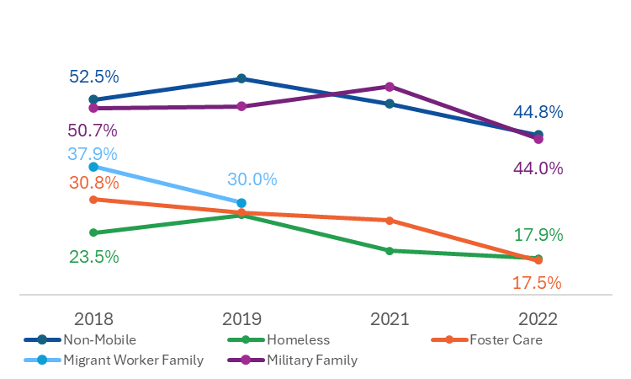
Figure 16: Percentage of 3rd Grade Students Meeting or Exceeding Expectations on the ELA Assessment
From 2017–18 through 2021–22, non-mobile students and students in military families consistently outperformed students experiencing homelessness, students in foster care, and students who were part of a migrant worker family on the 3rd grade ELA assessment (Figure 16 and Table 23). Despite being considered a high mobility student group, students in military families performed similarly to non-mobile students on this academic outcome.

In 2021–22, less than 20 percent of students experiencing homelessness (17.9%) and students in foster care (17.5%) met or exceeded expectations on the 3rd grade ELA assessment compared to nearly 45 percent of non-mobile students (44.8%) and military family students (44.0%).
From 2017–18 through 2021–22, the percentage of students experiencing homelessness who met or exceeded expectations on the 3rd grade ELA assessment was at least 27 percentage points lower than non-mobile students and the percentage of students in foster care who met or exceeded expectations was at least 22 percentage points lower than non-mobile students (Table 24).
During the 2021–22 academic year, the percentage of students experiencing homelessness and students in foster who met or exceeded expectations on the 3rd grade ELA assessment was 27 percentage points lower than non-mobile students.
Table 24: 3rd Grade ELA Assessment Achievement Gap between Non-Mobile and High Mobility Students
 | 2018 | 2019 | 2021 | 2022
Percentage of Non-Mobile Students Achieving Outcome | 53% | 57% | 52% | 45%
Percentage Point Difference Compared to Non-Mobile Students**
Students Experiencing Homelessness | -29 | -30 | -32 | -27
Students in Foster Care | -22 | -29 | -25 | -27
Students in Migrant Worker Families | -15 | -27 | * | *
Students in Military Families | -2 | -6 | +4 | -1
Note: MCAS was not administered during the 2019–20 academic year due to the COVID-19 pandemic.
* Results based on cell sizes of fewer than six cases are not reported.
** The numbers reported represent the point difference between the percentage of non-mobile students and the percentage of high mobility students achieving the academic outcome.

6th Grade MCAS Results: English Language Arts (ELA) and Math Assessments
This section contains descriptive statistics related to the 6th grade MCAS English Language Arts (ELA) and math assessments for the academic years 2017–18 through 2021–22. MCAS data for the 2019–20 academic year are not available due to school closures and the cancellation of state assessments related to COVID-19 pandemic.
Descriptive statistics include the percentage of 6th grade students with ELA and math assessment results that met or exceeded expectations for the four high mobility student groups and non-mobile students (i.e., students who were not homeless, in foster care, part of the migrant worker family, or part of a military family).
As shown in Table 25, each year, between 65,000 and 72,000 6th graders had ELA and math assessment results. Of these, less than 4 percent were high mobility students. Due to small sample sizes, results for students in migrant worker families are not available for this academic outcome.
Table 25: Number of 6th Grade Students with ELA and Math Assessment Results
 | 2018 | 2019 | 2021 | 2022
All Students | 70,504 | 71,936 | 65,796 | 65,777
Non-Mobile Students | 68,490 | 69,559 | 63,506 | 63,553
High Mobility Students* | 2,014 | 2,377 | 2,290 | 2,224
Students Experiencing Homelessness | 1,235 | 1,493 | 1,275 | 1,204
Students in Foster Care | 316 | 416 | 471 | 459
Students in Migrant Worker Families | 24 | 18 | 25 | 28
Students in Military Families | 478 | 498 | 579 | 578
Note: MCAS was not administered during the 2019–20 academic year due to the COVID-19 pandemic.
* The total number of high mobility students does not equal the sum of the four mobility student groups due to dual incidence (i.e., being part of more than one group each year).
As shown in Table 26, among high mobility student groups and non-mobile students, the percentages of students meeting or exceeding expectations on the 6th grade ELA and math assessments were lower in academic year 2020–21 compared to the academic years preceding the COVID-19 pandemic (2017–18 and 2018–19).
Table 26: Percentage of 6th Grade Students Meeting or Exceeding Expectations on the ELA and Math Assessments
 | 2018 | 2019 | 2021 | 2022
Non-Mobile Students | 39.8% | 42.9% | 29.2% | 32.8%
Students Experiencing Homelessness | 11.0% | 15.3% | 4.9% | 7.5%
Students in Foster Care | 11.7% | 15.4% | 5.7% | 8.7%
Students in Migrant Worker Families | * | * | * | *
Students in Military Families | 33.3% | 39.4% | 25.2% | 29.4%
MCAS was not administered during the 2019–20 academic year due to the COVID-19 pandemic.
* Percentages based on cell sizes of fewer than six cases are not reported.
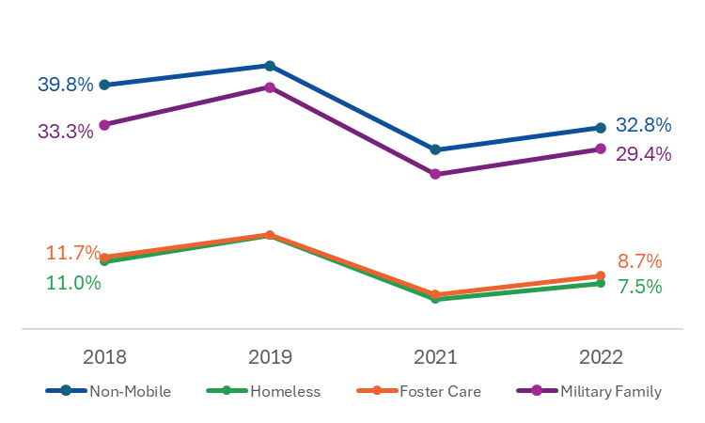
Figure 17: Percentage of 6th Grade Students Meeting or Exceeding Expectations on the ELA and Math Assessments
From 2017–18 through 2021–22, non-mobile students and students in military families consistently outperformed students experiencing homelessness and students in foster care on the 6th grade ELA and math assessments (Figure 17 and Table 26). Despite being considered a high mobility student group, students in military families performed similarly to non-mobile students.

In 2021–22, less than 10 percent of students experiencing homelessness (7.5%) and students in foster care (8.7%) met or exceeded expectations on the 6th grade ELA and math assessments compared to approximately 30 percent of non-mobile students (32.8%) and military family students (29.4%).
From 2017–18 through 2021–22, the percentage of students experiencing homelessness and students in foster care who met or exceeded expectations on the 6th grade ELA and math assessments was at least 24 percentage points lower than non-mobile students (Table 27).
During the 2021–22 academic year, the percentage of students experiencing homelessness who met or exceeded expectations on the 6th grade ELA and math assessments was 25 percentage points lower than non-mobile students and the percentage of students in foster care who met or exceeded expectations on the 6th grade ELA and math assessments was 24 percentage points lower than non-mobile students.
Table 27: 6th Grade ELA and Math Assessment Achievement Gap between Non-Mobile and High Mobility Students
 | 2018 | 2019 | 2021 | 2022
Percentage of Non-Mobile Students Achieving Outcome | 40% | 43% | 29% | 33%
Percentage Point Difference Compared to Non-Mobile Students**
Students Experiencing Homelessness | -29 | -28 | -24 | -25
Students in Foster Care | -28 | -28 | -24 | -24
Students in Migrant Worker Families | * | * | * | *
Students in Military Families | -7 | -4 | -4 | -3
Note: MCAS was not administered during the 2019–20 academic year due to the COVID-19 pandemic.
* Results based on cell sizes of fewer than six cases are not reported.
** The numbers reported represent the point difference between the percentage of non-mobile students and the percentage of high mobility students achieving the academic outcome.

Passing All 9th Grade Courses
This section contains descriptive statistics related to 9th grade students who passed all their courses for the academic years 2017–18 through 2021–22. Statistics include 9th grade students with at least one completed and graded course; courses which were incomplete or from which the student withdrew or was excused are not included. Descriptive statistics include the percentage of students with at least one completed and graded course that passed all courses on record for the four high mobility student groups and non-mobile students (i.e., students who were not homeless, in foster care, part of the migrant worker family, or part of a military family).
The percentages of 9th grade students who passed all their courses reported in this section are slightly higher than reported by DESE. On average, the passing rates are approximately two to three percentage points higher than what is reported by DESE. However, for some student groups the differences are greater. For example, passing rates for English learners are approximately four to seven percentage points higher than reported by DESE.
The observed differences between this analysis and what is reported by DESE is the result of using a different definition of “passing.” The decision to use an alternative definition than commonly used by DESE for EWIS is that students’ passing status can be ambiguous or conflicting in the Student Course Schedule dataset. In an effort to be as inclusive as possible when identifying course passers, the definition used for this analysis differed in two ways. First, for EWIS, DESE only considers earning full credit as evidence of passing a course. The definition used for this analysis considers earning any amount of credit in a course as evidence of passing the course. Second, this analysis treated letter and numeric marks equally, meaning a passing letter or numeric were both sufficient to indicate passing, whereas EWIS prioritizes the letter mark over the numeric mark.
In spring 2020, DESE provided guidance to schools on grading practices during the shift to remote learning due to the COVID-19 pandemic. While acknowledging that districts and schools have control over their grading practices, DESE encouraged “thoughtful approaches that provide students with flexibility, including incentives to maximize learning while ‘holding harmless’ students who could not adapt to the change to remote learning for a variety of reasons.” Changes adopted by districts and schools at the end of the 2019–20 academic year likely affected the passing rates reported in this section.

As shown in Table 28 each year, between 73,000 and 78,000 9th graders had at least one completed and graded course. Of these, 4 percent or less were high mobility students.
Due to the small number of migrant worker family students with at least one completed and graded course, descriptives for this group should be viewed with caution.
Table 28: Number of 9th Grade Students with At Least One Completed and Graded Course
 | 2018 | 2019 | 2020 | 2021 | 2022
All Students | 77,233 | 76,949 | 76,002 | 73,131 | 77,119
Non-Mobile Students | 74,523 | 74,085 | 72,964 | 70,573 | 73,909
High Mobility Students* | 2,710 | 2,864 | 3,038 | 2,558 | 3,210
Students Experiencing Homelessness | 1,801 | 1,796 | 1,964 | 1,436 | 1,985
Students in Foster Care | 489 | 636 | 639 | 599 | 629
Students in Migrant Worker Families | 26 | 28 | 41 | 23 | 54
Students in Military Families | 450 | 485 | 477 | 556 | 608
As shown in Table 29 and Figure 18, during the 2019–20 academic year, there was an increase in the percentage of high mobility and non-mobile students who passed all 9th grade courses compared to 2018–19. This was likely the result of more flexible grading policies adopted by districts and schools, such as utilizing pass/fail or credit/no credit grading or awarding partial credit, following school closures related to COVID-19 pandemic. The increase was particularly notable for students experiencing homelessness, students in foster care, and students in migrant worker families.
Furthermore, the fluctuations across all five academic years among students in migrant worker families are noteworthy. The passing rate among migrant worker family students increased 18 percentage points from 2017–18 (50.0%) to 2018–19 (67.9%) and increased an additional 18 percentage points in 2019–20 (85.4%) followed by a 50 percentage point decrease in 2020–21(34.8%) and 20 percentage point increase in 2021–22 (55.6%). Factors affecting the passing rate for this student group are unknown. However, the relatively small sample sizes for this student group may be contributing to the large fluctuations (see Table 28).
Table 29: Percentage of 9th Grade Students Passing All Courses
 | 2018 | 2019 | 2020 | 2021 | 2022
Non-Mobile Students | 82.4% | 82.2% | 86.7% | 79.0% | 81.3%
Students Experiencing Homelessness | 52.7% | 53.5% | 67.5% | 47.9% | 54.6%
Students in Foster Care | 42.9% | 46.2% | 58.2% | 46.4% | 53.3%
Students in Migrant Worker Families | 50.0% | 67.9% | 85.4% | 34.8% | 55.6%
Students in Military Families | 85.1% | 81.0% | 86.8% | 83.3% | 87.0%

Figure 18: Percentage of 9th Grade Students Passing All Courses
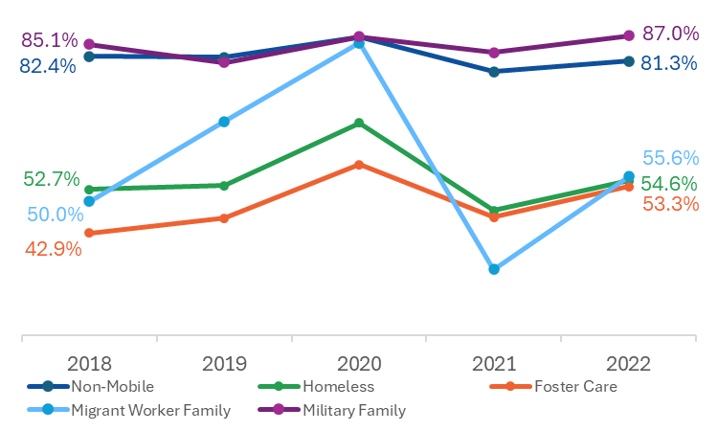
From 2017–18 through 2021–22, non-mobile students and students in military families consistently outperformed students experiencing homelessness and students in foster care in regard to passing all 9th grade courses (Figure 18 and Table 29). Except for 2019–20, this pattern was also true for students in migrant worker families. Despite being considered a high mobility student group, students in military families performed similarly to non-mobile students on this academic outcome.

In 2021–22, less than 60 percent of students experiencing homelessness (54.6%), students in foster care (53.3%), and students in migrant worker families (55.6%) passed all courses compared to over 80 percent of non-mobile students (81.3%) and military family students (87.0%).
From 2017–18 through 2021–22, the percentage of students experiencing homelessness who passed all 9th grade courses was at least 19 percentage points lower than non-mobile students and the percentage of students in foster care who passed all 9th grade courses was at least 28 percentage points lower than non-mobile students (Table 30).
During the 2021–22 academic year, the percentage of students experiencing homelessness who passed all 9th grade courses was 27 percentage points lower than non-mobile students, the percentage of students in foster care who passed all 9th grade courses was 28 percentage points lower than non-mobile students, and the percentage of students in migrant worker families who passed all 9th grade courses was 26 percentage points lower than non-mobile students.
Table 30: Passing All 9th Grade Courses Achievement Gap between Non-Mobile and High Mobility Students
 | 2018 | 2019 | 2020 | 2021 | 2022
Percentage of Non-Mobile Students Achieving Outcome | 82.4% | 82.2% | 86.7% | 79.0% | 81.3%
Percentage Point Difference Compared to Non-Mobile Students*
Students Experiencing Homelessness | -30 | -29 | -19 | -31 | -27
Students in Foster Care | -40 | -36 | -29 | -33 | -28
Students in Migrant Worker Families | -32 | -14 | -1 | -44 | -26
Students in Military Families | +3 | -1 | 0 | +4 | +6
* The numbers reported represent the point difference between the percentage of non-mobile students and the percentage of high mobility students achieving the academic outcome.

4-Year High School Graduation
This section contains descriptive statistics related to students who graduated high school within four years of entering 9th grade for the academic years 2017–18 through 2021–22. Descriptive statistics include the percentage of students who graduated high school within four years for the four high mobility student groups and non-mobile students (i.e., students who were not homeless, in foster care, part of the migrant worker family, or part of a military family).
The percentages of students who graduated within four years of entering 9th grade differ from what is reported by DESE for academic years 2017–18 and 2018–19. This difference is a result of the way the analytic dataset for this study was constructed. Because the dataset included only those students found in the SIMS file from 2017–18 to 2021–22, students who left school prior to 2017–18 could not be matched. In other words, the graduation information of a student who was part of the 2017–18 4-year cohort but left school prior to 2017–18 due to dropping out, graduating early, or for some other reason was not included. This results in a slight positive bias in graduation rates compared to what is reported by DESE. For example, this analysis found a 90.6% graduation rate among students in 2017–18, whereas DESE reports an 87.9% graduation (a difference of 2.7 percentage points). The bias is highest for 2017–18, lower for 2018–19 (a difference of 1.3 percentage points), and becomes negligible for academic years 2019–20, 2020–21, and 2021–22.
Graduation rates reported below for the academic years 2019–20, 2020–21, and 2021–22 are affected by temporary modifications to Competency Determination (CD) requirements in response to the suspension of in-person instruction and the cancellation of the spring 2020 MCAS assessments due to the COVID-19 pandemic adopted by the Board of Elementary and Secondary Education in spring 2020. Prior to the modification, students had to earn a passing score on the 10th grade MCAS tests in English Language Arts (ELA) and Mathematics, and one of the high school Science and Technology/Engineering (STE) tests to meet their CD requirement. The modified CD waived the ELA and Mathematics MCAS requirement for the 2019–20 through 2021–22 graduating classes and the STE MCAS requirement for the 2019–20 through 2022–23 graduating classes. In place of the MCAS assessments, DESE identified ELA, mathematics, and science courses that fulfilled the modified CD requirements.
As shown in Table 31, each year, between 71,000 and 74,500 students were included in the 4-year graduation cohort. Of these, approximately 3 percent were high mobility students. Due to the small number of migrant worker family students in the 4-year graduation cohort, descriptives for this group may not be reported, and those that are reported should be viewed with caution.
Table 31: Number of Students in the 4-Year Graduation Cohort
 | 2018 | 2019 | 2020 | 2021 | 2022
All Students | 71,926 | 74,011 | 74,025 | 74,258 | 73,936
Non-Mobile Students | 70,024 | 71,788 | 71,900 | 72,044 | 71,522
High Mobility Students* | 1,902 | 2,223 | 2,125 | 2,214 | 2,414
Students Experiencing Homelessness | 1,357 | 1,463 | 1,318 | 1,300 | 1,361
Students in Foster Care | 256 | 256 | 446 | 429 | 528
Students in Migrant Worker Families | 3 | 25 | 24 | 11 | 15
Students in Military Families | 321 | 370 | 385 | 520 | 557
* The total number of high mobility students does not equal the sum of the four mobility student groups due to dual incidence (i.e., being part of more than one group each year).

As shown in Table 32, among students experiencing homelessness, students in foster care, and students in migrant worker families, 4-year high school graduation rates increased from 2018–19 to 2019–20. This increase, which was maintained or continued to improve for these student groups in subsequent years, was likely the result of suspending the MCAS graduation requirement due to the COVID-19 pandemic. This modified competency determination requirement applied to academic years 2019–20, 2020–21, and 2021–22. Other factors that may have contributed to the spike in graduation rates noted among students in migrant worker families from 2019–20 (58.3% graduation rate) to 2020–21 (81.8% graduation rate) are unknown. However, the relatively small sample size for this student group may be a contributing factor to the large fluctuation (see Table 31).
Table 32: Percentage of Students Who Graduated High School Within Four Years of Entering 9th Grade
 | 2018 | 2019 | 2020 | 2021 | 2022
Non-Mobile Students | 91.0% | 89.8% | 89.6% | 90.1% | 90.3%
Students Experiencing Homelessness | 70.2% | 70.3% | 76.3% | 76.4% | 76.4%
Students in Foster Care | 60.5% | 60.5% | 67.7% | 65.7% | 70.5%
Students in Migrant Worker Families | * | 48.0% | 58.3% | 81.8% | 80.0%
Students in Military Families | 93.8% | 94.6% | 94.3% | 95.6% | 95.5%
* Percentages based on cell sizes of fewer than six cases are not reported.

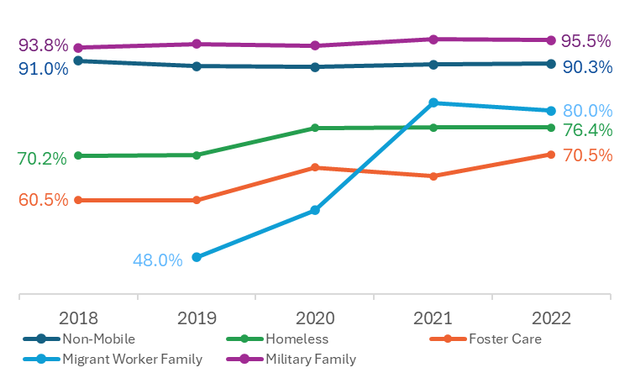
Figure 19: Percentage of Students Who Graduated High School Within Four Years of Entering 9th Grade
From 2017–18 through 2021–22, non-mobile students and students in military families consistently outperformed students experiencing homelessness, students in foster care, and students who were part of a migrant worker family in regard to the 4-year high school graduation rate (Figure 19 and Table 32). Despite being considered a high mobility student group, students in military families had higher 4-year graduation rates than non-mobile students.

In 2021–22, 76 percent of students experiencing homelessness, 71 percent of students in foster care, and 80 percent of students in migrant worker families graduated high school within four years of entering 9th grade compared to over 90 percent of non-mobile students (90.3%) and military family students (95.5%).

From 2017–18 through 2021–22, the percentage of students experiencing homelessness who graduated within four years was at least 13 percentage points lower than non-mobile students and the percentage of students in foster care who graduated within four years was at least 20 points lower than non-mobile students (Table 33).
During the 2021–22 academic year, the percentage of students experiencing homelessness who graduated within four years was 14 percentage points lower than non-mobile students, the percentage of students in foster care who graduated within four years was 20 percentage points lower than non-mobile students, and the percentage of students in migrant worker families who graduated within four years was 10 percentage points lower than non-mobile students. The 2021–22 achievement gaps between these student groups and non-mobile students are smaller than observed in 2018–19, the last full academic year prior to the COVID-19 pandemic. As previously noted, this is likely due to the changes to the competency determination that remained in effect through the 2021–22 academic year.
Table 33: 4-Year Graduation Rate Achievement Gap between Non-Mobile and High Mobility Students
 | 2018 | 2019 | 2020 | 2021 | 2022
Percentage of Non-Mobile Students Achieving Outcome | 91.0% | 89.8% | 89.6% | 90.1% | 90.3%
Percentage Point Difference Compared to Non-Mobile Students**
Students Experiencing Homelessness | -21 | -20 | -13 | -14 | -14
Students in Foster Care | -31 | -29 | -22 | -24 | -20
Students in Migrant Worker Families | * | -42 | -31 | -8 | -10
Students in Military Families | +3 | +5 | +5 | +5 | +5
* Results based on cell sizes of fewer than six cases are not reported.
** The numbers reported represent the point difference between the percentage of non-mobile students and the percentage of high mobility students achieving the academic outcome.

College Enrollment
This section contains descriptive statistics related to college enrollment rates among 4-year high school graduates for the academic years 2017–18 through 2020–21. At the time of this analysis, National Student Clearinghouse enrollment data were not available for students who graduated at the end of the 2021–22 academic year; therefore, enrollment rates for students who graduated in 2021–22 are not included.
Descriptive statistics include the percentage of 4-year high school graduates who were enrolled in college within one year of graduating high school for the four high mobility student groups and non-mobile students (i.e., students who were not homeless, in foster care, part of the migrant worker family, or part of a military family).
The percentages of students who enrolled in college within one year of graduating high school differ slightly from what is reported by DESE. This difference is a result of the definitions used to define college enrollment. First, DESE reports on college enrollment for all high school graduates, whereas this analysis is limited to 4-year high school graduates (i.e., those students who graduated high school within 4 years of entering the 9th grade). The decision to restrict the analysis to 4-year graduates was made because 4-year graduation is a EWIS benchmark and because this analysis only looked at 4-year graduates to determine graduation rates. In addition, DESE defines college enrollment as being enrolled within 16 months after graduation, whereas this analysis defines it as enrollment within one full year after high school graduation. The decision to use a12-month benchmark was that it is aligned with EWIS’ college enrollment benchmark indicator. Due to these differences in measurement, the descriptives reported generally differ by 2–4 percentage points when compared with DESE reports.
It is important to note that the year for each data point is the year of the students' graduation from high school. In other words, for the 2017–18 academic year, the percentage enrolled in college represents the percentage of students who graduated within four years in 2017–18 and were enrolled in college within one year of graduation.
As shown in Table 34, each year, between 65,000 and 67,000 students graduated from high school within four years of starting 9th grade. Of these, less than 3 percent were high mobility students.
Due to the small number of migrant worker family students graduating within four years, descriptives for this group are not reported in this section.
Table 34: Number of Students Who Graduated High School Within Four Years
 | 2018 | 2019 | 2020 | 2021
All Students | 65,137 | 66,057 | 66,075 | 66,635
Non-Mobile Students | 63,745 | 64,436 | 64,426 | 64,880
High Mobility Students* | 1,392 | 1,621 | 1,649 | 1,755
Students Experiencing Homelessness | 953 | 1,029 | 1,006 | 993
Students in Foster Care | 155 | 266 | 302 | 282
Students in Migrant Worker Families | 2 | 12 | 14 | 9
Students in Military Families | 301 | 350 | 363 | 497
* The total number of high mobility students does not equal the sum of the four mobility student groups due to dual incidence (i.e., being part of more than one group each year).

As shown in Table 35, college enrollment rates declined for all student groups since the 2017–18 academic year. Among students experiencing homelessness, students in military families, and non-mobile students, the decline in college enrollment began with the cohort of students who graduated in the 2019–20 academic year, the year the COVID-19 pandemic began, and declined further for students who graduated in 2020–21. Among students in foster care, the decline in college enrollment began with the 2018–19 cohort of graduates and the rate continued to decline each subsequent year.
Table 35: Percentage of 4-Year High School Graduates Enrolled in College within One Year of Graduation
 | 2018 | 2019 | 2020 | 2021
Non-Mobile Students | 72.7% | 71.8% | 66.4% | 64.8%
Students Experiencing Homelessness | 42.5% | 42.5% | 37.1% | 33.0%
Students in Foster Care | 56.1% | 48.1% | 38.4% | 31.9%
Students in Migrant Worker Families | * | * | * | *
Students in Military Families | 72.4% | 71.1% | 68.0% | 60.8%
Note: At the time of this analysis, National Student Clearinghouse enrollment data were not available for students who graduated at the end of the 2021–22 academic year; therefore, enrollment rates for students who graduated in 2021–22 are not included.
* Percentages based on cell sizes of fewer than six cases are not reported.

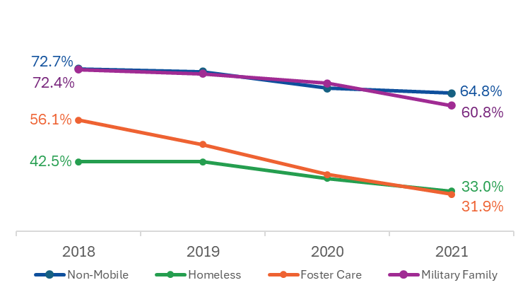
Figure 20: Percentage of 4-Year High School Graduates Enrolled in College within One Year of Graduation
From 2017–18 through 2020–21, non-mobile students and students in military families consistently outperformed students experiencing homelessness and students in foster care in regard to college enrollment (Figure 20 and Table 35). Despite being considered a high mobility student group, students in military families performed similarly to non-mobile students on this academic outcome.

In 2020–21, 33 percent of students experiencing homelessness and 32 percent of students in foster care enrolled in college within one year of graduation compared to over 60 percent of non-mobile students (64.8%) and military family students (60.8%).

From 2017–18 through 2020–21, the percentage of students experiencing homelessness who enrolled in college was at least 29 percentage points lower than non-mobile students and the percentage of students in foster care who enrolled in college was at least 17 points lower than non-mobile students (Table 36).
During the 2020–21 academic year, the percentage of students experiencing homelessness who enrolled in college was 32 percentage points lower than non-mobile students and the percentage of students in foster care who enrolled in college was 33 percentage points lower than non-mobile students.
Table 36: College Enrollment Rate Achievement Gap between Non-Mobile and High Mobility Students
 | 2018 | 2019 | 2020 | 2021
Percentage of Non-Mobile Students Achieving Outcome | 72.7% | 71.8% | 66.4% | 64.8%
Percentage Point Difference Compared to Non-Mobile Students**
Students Experiencing Homelessness | -30 | -29 | -29 | -32
Students in Foster Care | -17 | -24 | -28 | -33
Students in Migrant Worker Families | * | * | * | *
Students in Military Families | 0 | -1 | +2 | -4
* Results based on cell sizes of fewer than six cases are not reported.
** The numbers reported represent the point difference between the percentage of non-mobile students and the percentage of high mobility students achieving the academic outcome.

Academic Outcomes: Quasi-Experimental Design (QED) Analysis
This section presents the results of multi-level, mixed-effect, logistic regressions conducted to assess the impact of homelessness, foster care placement, and military family status on five academic outcomes aligned with DESE’s Early Warning Indicator System. Differences between high mobility students and non-mobile students were assessed using a quasi-experimental, matched comparison group design. A detailed description of the QED analysis methods, including sampling, inclusion criteria, modeling, and the definitions of ever homeless, ever in foster care, and ever part of a military family, can be found in Chapter 2: Methodology.
The descriptive statistics presented in previous sections of this chapter are for students who were part of a high mobility student group that academic year. For example, the analysis of 3rd grade ELA assessment results compares 3rd graders who were homeless the year they took the test to 3rd graders who were not homeless the year they took the test and does not consider a student’s history of homelessness. Because the QED analysis explores the impacts of high mobility on student outcomes, the QED analysis includes students who were ever homeless, ever in foster care, and ever members of a military family. Although descriptive analyses for students who were members of a migrant worker family were conducted and presented in previous sections, sample size restrictions prevented their inclusion in the QED analyses.
For this analysis, ever high mobility students are compared to non-mobile students who were never identified as being homeless, in foster care, or members of a military family with similar characteristics and risk factors (e.g., race, gender, EL status) to determine the likelihood of achieving academic outcomes. The models presented in this section generally resulted in odds ratios of less than one (e.g., 0.67). An odds ratio of less than one indicates that the high mobility student group is less likely to achieve an academic outcome than the non-mobile students to which they are being compared.
As shown in Table 37, when compared to non-mobile students, students who were ever homeless and students who were ever in foster care were consistently less likely to meet each EWIS educational outcome examined. For students who were ever part of a military family, the evidence is mixed.
Overall, the analysis indicates that students who ever experienced homelessness are significantly less likely to achieve important educational outcomes than their non-mobile peers. Specifically, students who were ever homeless were 0.67 times as likely to meet or exceed expectations on the 3rd grade ELA assessment, 0.60 times as likely to meet or exceed expectations on the 6th grade ELA and math assessment, 0.60 times as likely to pass all 9th grade courses, 0.52 times as likely to graduate high school in four years, and 0.62 times as likely to enroll in college than their non-mobile peers.
Furthermore, the analysis indicates that students who were ever in foster care are significantly less likely to achieve important educational outcomes than their non-mobile peers. Students who were ever in foster care were 0.71 times as likely to meet or exceed expectations on the 3rd grade ELA assessment, 0.66 times as likely to meet or exceed expectations on the 6th grade ELA and math assessment, 0.44 times as likely to pass all 9th grade courses, 0.39 times as likely to graduate high school in four years, and 0.67 times as likely to enroll in college than their non-mobile peers.

Evidence concerning students from military families suggests that they are less likely to achieve some educational outcomes, (i.e., meeting or exceeding expectations on the 6th grade ELA and math assessments and enrolling in college) and equally as likely to achieve others (i.e., meeting/exceeding expectations on the 3rd grade ELA assessment, passing all 9th grade courses, graduating high school in four years).
Table 37: Likelihood of Achieving Academic Outcomes
 | High Mobility Student Group* Unweighted Percent | Non-Mobile Students Unweighted Percent | Odds Ratio | Significance | 95% Confidence Interval
3rd Grade MCAS ELA Assessment
Ever Homeless | 23% | 52% | 0.67 | 0.001 | [0.64, 0.71]
Ever in Foster Care | 25% | 50% | 0.71 | 0.001 | [0.63, 0.79]
Ever Part of a Military Family | 50% | 52% | 0.81 |  | [0.64, 1.02]
6th Grade MCAS ELA & Math Assessments
Ever Homeless | 10% | 37% | 0.60 | 0.001 | [0.56, 0.64]
Ever in Foster Care | 10% | 35% | 0.66 | 0.001 | [0.53, 0.81]
Ever Part of a Military Family | 33% | 38% | 0.80 | 0.05 | [0.67, 0.96]
Passing All 9th Grade Courses
Ever Homeless | 59% | 85% | 0.60 | 0.001 | [0.56, 0.63]
Ever in Foster Care | 49% | 84% | 0.44 | 0.001 | [0.40, 0.49]
Ever Part of a Military Family | 85% | 85% | 0.89 |  | [0.79, 1.00]
4-Year High School Graduation
Ever Homeless | 74% | 93% | 0.52 | 0.001 | [0.48, 0.55]
Ever in Foster Care | 64% | 92% | 0.39 | 0.001 | [0.34, 0.45]
Ever Part of a Military Family | 93% | 93% | 0.88 |  | [0.74, 1.05]
College Enrollment
Ever Homeless | 41% | 70% | 0.62 | 0.001 | [0.59, 0.66]
Ever in Foster Care | 42% | 67% | 0.67 | 0.001 | [0.57, 0.78]
Ever Part of a Military Family | 67% | 69% | 0.88 | 0.05 | [0.80, 0.98]
* Students who were ever part of a migrant worker family are not included due to insufficient sample size.

Academic Outcomes: Descriptive Comparisons of Homeless and Non-Mobile Students
This section compares students who have experienced homelessness with those who have not, examining selected characteristics and risk factors—such as race and ethnicity, English learner status, low income status, and disability status—across five academic outcomes. The purpose of this analysis is to understand how housing status intersects with other forms of historic marginalization to affect student performance. For each academic outcome, five key comparisons are made:
- Hispanic or Latino students (homeless and not homeless) to White students (homeless and not homeless)
- African American or Black students (homeless and not homeless) to White students (homeless and not homeless)
- English learners (homeless and not homeless) to English speakers (homeless and not homeless)
- Low-income students (homeless and not homeless) to students who are not low income (homeless and not homeless)
- Students with disabilities (homeless and not homeless) to students without disabilities (homeless and not homeless)
Tables of academic outcomes for all high mobility students by characteristics and risk factors can be found in Appendix D of the Supplemental Report.
Overall, findings from this section suggest that students who were not homeless and did not belong to historically marginalized groups—specifically, students who are White, English-speaking, not low income, and without disabilities—consistently outperformed all other student groups across all five academic outcomes.
In most cases, the achievement gaps between these students and their peers who were homeless and/or part of a histocially marginalized group were substantial. For example, in academic year 2021–22, White students who were not homeless outperformed both White students who were homeless and Hispanic or Latino students regardless of housing status by at least 26 percentage points on the 3rd grade ELA assessment, 25 percentage points on the 6th grade ELA and math assessments, 20 percentage points in passing all 9th grade courses, and 12 percentage points in 4-year graduation rates. Similar achievement gaps were observed across most student groups and outcomes. Furthermore, students who were both homeless and part of a historically marginalized group generally had the lowest achievement rates. Specifically:
- Hispanic or Latino students who were homeless had the lowest performance across all five outcomes nearly every academic year.
- English learners who were homeless generally had the lowest achievement rates on three outcomes, including the 3rd grade ELA assessment, 4-year graduation, and college enrollment. However, they outperformed English-speaking students who were homeless in passing all 9th grade courses. Data for the 6th grade ELA and math assessments were insufficient for analysis.
- Low-income students who were homeless had the lowest achievement across all five outcomes nearly every academic year.
- Students with disabilities who were homeless had the lowest performance across all outcomes except the 6th grade ELA and math assessments, which lacked sufficient data for analysis.

Academic Outcomes by Housing Status: Comparison of Hispanic or Latino Students and White Students
For all five academic outcomes and across all academic years, White students who were not homeless consistently outperformed White students who were homeless and Hispanic or Latino students regardless of their housing status (Figures 21–25 and Tables 38 and 39). For the most recent academic year, there were large achievement gaps (20 percentage points or greater) between White students who were not homeless compared to White students who were homeless and Hispanic or Latino students regardless of housing status for all outcomes except the 4-year graduation rate. Furthermore, Hispanic or Latino students who were homeless consistently had the lowest rates of achievement compared to Hispanic or Latino students who were not homeless and White students.
During the 2021-22 academic year, Hispanic or Latino students who were not homeless and White students who were homeless perfomed similalry (within 5 percentage points of each other) on three of the five academic outcomes (3rd grade ELA assessment, 6th grade ELA and math assessments, and 4-year graduation). For passing all 9th grade courses and college enrollment, Hispanic or Latino students who were not homeless outperformed White students who were homeless by at least eight percentage points.
Figure 21: Percentage of 3rd Grade Students Meeting or Exceeding Expectations on the ELA Assessment by Housing Status: Comparison of Hispanic or Latino Students and White Students
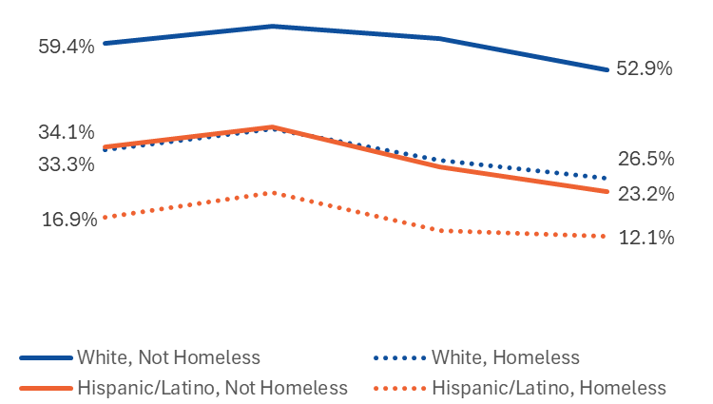
Compared to White students who were not homeless in 2021–22, the percentage of students meeting or exceeding expectations on the 3rd grade ELA assessment was 26 percentage points lower for White students who were homeless, 30 points lower for Hispanic or Latino students who were not homeless, and 41 points lower for Hispanic or Latino students who were homeless.

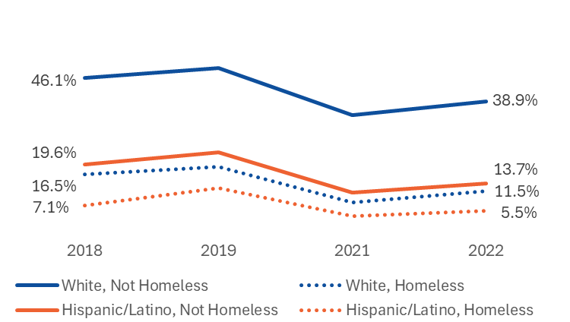
Figure 22: Percentage of 6th Grade Students Meeting or Exceeding Expectations on the ELA and Math Assessments by Housing Status: Comparison of Hispanic or Latino Students and White Students

Compared to White students who were not homeless in 2021–22, the percentage of students meeting or exceeding expectations on the 6th grade ELA and math assessments was 25 percentage points lower for Hispanic or Latino students who were not homeless, 27 points lower for White students who were homeless, and 33 points lower for Hispanic or Latino students who were homeless.

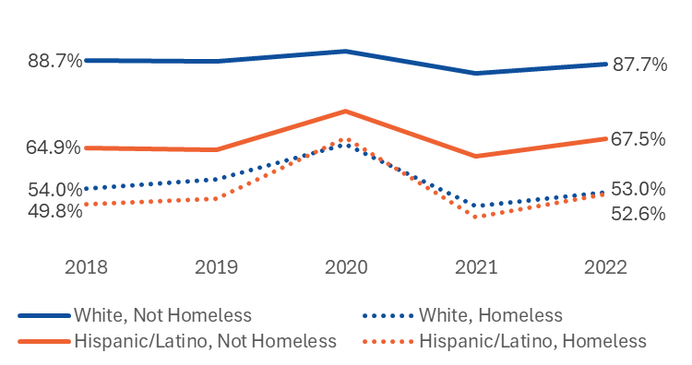
Figure 23: Percentage of 9th Grade Students Passing All Courses by Housing Status: Comparison of Hispanic or Latino Students and White Students

Compared to White students who were not homeless in 2021–22, the percentage of students passing all 9th grade courses was 20 percentage points lower for Hispanic or Latino students who were not homeless, 35 points lower for White students who were homeless, and 35 points lower for Hispanic or Latino students who were homeless.

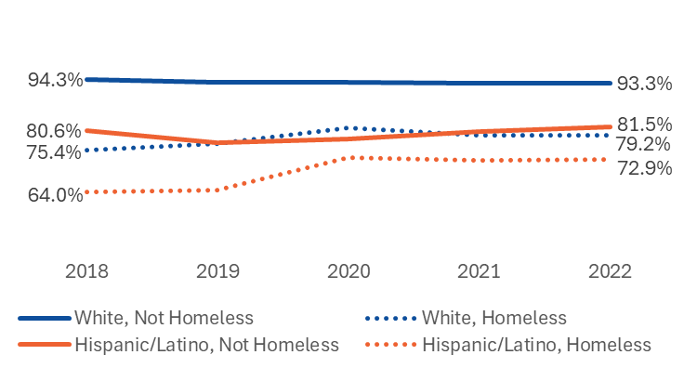
Figure 24: Percentage of Students Who Graduated High School Within Four Years of Entering 9th Grade by Housing Status: Comparison of Hispanic or Latino Students and White Students

Compared to White students who were not homeless in 2021–22, the percentage of students graduating within four years of entering high school was 12 percentage points lower for Hispanic or Latino students who were not homeless, 14 points lower for White students who were homeless, and 20 points lower for Hispanic or Latino students who were homeless.

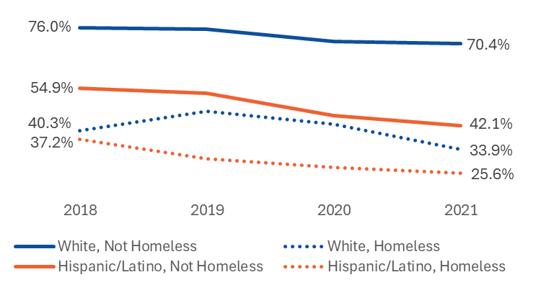
Figure 25: Percentage of 4-Year High School Graduates Enrolled in College within One Year of Graduation by Housing Status: Comparison of Hispanic or Latino Students and White Students

Compared to White students who were not homeless in 2020–21, the percentage of students enrolled in college within one year of graduation was 28 percentage points lower for Hispanic or Latino students who were not homeless,
37 points lower for White students who were homeless, and 45 points lower for Hispanic or Latino students who were homeless.

Table 38: Percentage of Students Achieving Academic Outcomes by Housing Status: Comparison of Hispanic or Latino Students and White Students
 | 2018 | 2019 | 2020 | 2021 | 2022
Met or Exceeded Expectations on 3rd Grade ELA Assessment
White, Not Homeless | 59.4% | 63.5% | -- | 60.6% | 52.9%
White, Homeless | 33.3% | 38.4% | -- | 30.9% | 26.5%
Hispanic or Latino, Not Homeless | 34.1% | 38.9% | -- | 29.2% | 23.2%
Hispanic or Latino, Homeless | 16.9% | 22.9% | -- | 13.7% | 12.1%
Met or Exceeded Expectations on 6th Grade ELA and Math Assessments
White, Not Homeless | 46.1% | 49.2% | -- | 34.6% | 38.9%
White, Homeless | 16.5% | 18.9% | -- | 7.9% | 11.5%
Hispanic or Latino, Not Homeless | 19.6% | 23.4% | -- | 11.0% | 13.7%
Hispanic or Latino, Homeless | 7.1% | 12.3% | -- | 3.7% | 5.5%
Passed All 9th Grade Courses
White, Not Homeless | 88.7% | 88.4% | 91.1% | 85.3% | 87.7%
White, Homeless | 54.0% | 56.5% | 66.1% | 49.2% | 53.0%
Hispanic or Latino, Not Homeless | 64.9% | 64.5% | 74.9% | 62.7% | 67.5%
Hispanic or Latino, Homeless | 49.8% | 51.2% | 67.8% | 46.2% | 52.6%
Graduated Within Four Years of Entering 9th Grade
White, Not Homeless | 94.3% | 93.6% | 93.6% | 93.2% | 93.3%
White, Homeless | 75.4% | 77.0% | 81.2% | 79.4% | 79.2%
Hispanic or Latino, Not Homeless | 80.6% | 77.4% | 78.3% | 80.3% | 81.5%
Hispanic or Latino, Homeless | 64.0% | 64.7% | 73.3% | 72.7% | 72.9%
Enrolled in College Within One Year of Graduating
White, Not Homeless | 76.0% | 75.5% | 71.1% | 70.4% | --
White, Homeless | 40.3% | 47.1% | 42.4% | 33.9% | --
Hispanic or Latino, Not Homeless | 54.9% | 53.3% | 45.6% | 42.1% | --
Hispanic or Latino, Homeless | 37.2% | 30.5% | 27.6% | 25.6% | --
Note: MCAS was not administered during the 2019–20 academic year due to the COVID-19 pandemic. At the time of this analysis, National Student Clearinghouse enrollment data were not available for students who graduated at the end of the 2021–22 academic year; therefore, enrollment rates for students who graduated in 2021–22 are not included.

Table 39: Academic Outcome Achievement Gaps by Housing Status: Comparison of Hispanic or Latino Students and White Students
 | 2018 | 2019 | 2020 | 2021 | 2022
Met or Exceeded Expectations on 3rd Grade ELA Assessment
Percentage of White Students, Not Homeless Achieving Outcome | 59.4% | 63.5% | -- | 60.6% | 52.9%
Percentage Point Difference Compared to White, Not Homeless Students
White, Homeless | -26 | -25 | -- | -30 | -26
Hispanic or Latino, Not Homeless | -25 | -25 | -- | -31 | -30
Hispanic or Latino, Homeless | -43 | -41 | -- | -47 | -41
Met or Exceeded Expectations on 6th Grade ELA and Math Assessments
Percentage of White Students, Not Homeless Achieving Outcome | 46.1% | 49.2% | -- | 34.6% | 38.9%
Percentage Point Difference Compared to White, Not Homeless Students
White, Homeless | -30 | -30 | -- | -27 | -27
Hispanic or Latino, Not Homeless | -27 | -26 | -- | -24 | -25
Hispanic or Latino, Homeless | -39 | -37 | -- | -31 | -33
Passed All 9th Grade Courses
Percentage of White Students, Not Homeless Achieving Outcome | 88.7% | 88.4% | 91.1% | 85.3% | 87.7%
Percentage Point Difference Compared to White, Not Homeless Students
White, Homeless | -35 | -32 | -25 | -36 | -35
Hispanic or Latino, Not Homeless | -24 | -24 | -16 | -23 | -20
Hispanic or Latino, Homeless | -39 | -37 | -23 | -39 | -35
Graduated Within Four Years of Entering 9th Grade
Percentage of White Students, Not Homeless Achieving Outcome | 94.3% | 93.6% | 93.6% | 93.2% | 93.3%
Percentage Point Difference Compared to White, Not Homeless Students
White, Homeless | -19 | -17 | -12 | -14 | -14
Hispanic or Latino, Not Homeless | -14 | -16 | -15 | -13 | -12
Hispanic or Latino, Homeless | -30 | -29 | -20 | -21 | -20
Enrolled in College Within One Year of Graduating
Percentage of White Students, Not Homeless Achieving Outcome | 76.0% | 75.5% | 71.1% | 70.4% | --
Percentage Point Difference Compared to White, Not Homeless Students
White, Homeless | -36 | -28 | -29 | -37 | --
Hispanic or Latino, Not Homeless | -21 | -22 | -26 | -28 | --
Hispanic or Latino, Homeless | -39 | -45 | -44 | -45 | --
Note: MCAS was not administered during the 2019–20 academic year due to the COVID-19 pandemic. At the time of this analysis, National Student Clearinghouse enrollment data were not available for students who graduated at the end of the 2021–22 academic year; therefore, enrollment rates for students who graduated in 2021–22 are not included.

Academic Outcomes by Housing Status: Comparison of African American (AA) or Black Students and White Students
For all five academic outcomes and across all academic years, White students who were not homeless consistently outperformed White students who were homeless and African American or Black students regardless of their housing status (Figures 26–30 and Tables 40 and 41). In most instances, there were large achievement gaps between White students who were not homeless compared to White students who were homeless, African American or Black students who were not homeless, and African American or Black students who were homeless. However, unlike Hispanic or Latino students who were homeless, African American or Black students who were homeless did not consistently have the lowest rates of achievement. African American or Black students who were homeless performed similarly to or better than White students who were homeless on three of the five outcomes, including passing all 9th grade courses, gradutaing within four years of entering 9th grade, and enrolling in college.
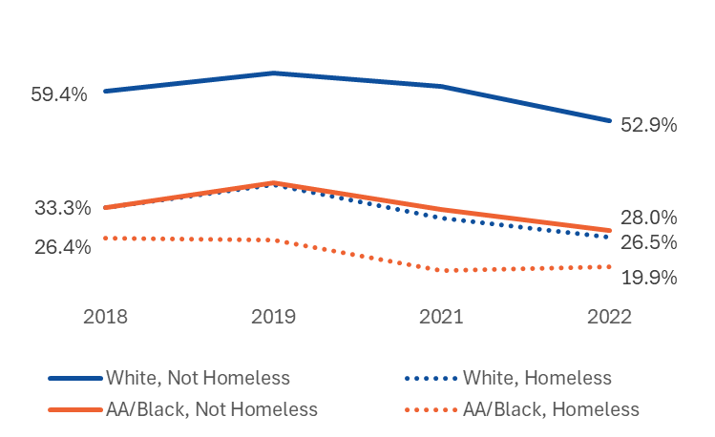
Figure 26: Percentage of 3rd Grade Students Meeting or Exceeding Expectations on the ELA Assessment by Housing Status: Comparison of African American or Black Students and White Students
Compared to White students who were not homeless in 2021–22, the percentage of students meeting or exceeding expectations on the 3rd grade ELA assessment was 25 percentage points lower for African American or Black students who were not homeless, 26 points lower for White students who were homeless, and 33 points lower for African American or Black students who were homeless.

Figure 27: Percentage of 6th Grade Students Meeting or Exceeding Expectations on the ELA and Math Assessments by Housing Status: Comparison of African American or Black Students and White Students
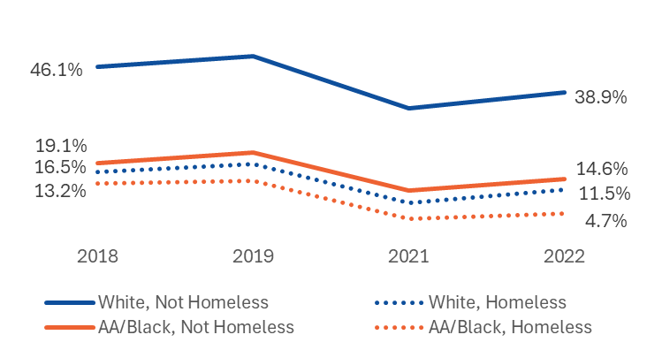
Compared to White students who were not homeless in 2021–22, the percentage of students meeting or exceeding expectations on the 6th grade ELA and math assessments was 24 percentage points lower for African American or Black students who were not homeless, 27 points lower for White students who were homeless, and 34 points lower for African American or Black students who were homeless.

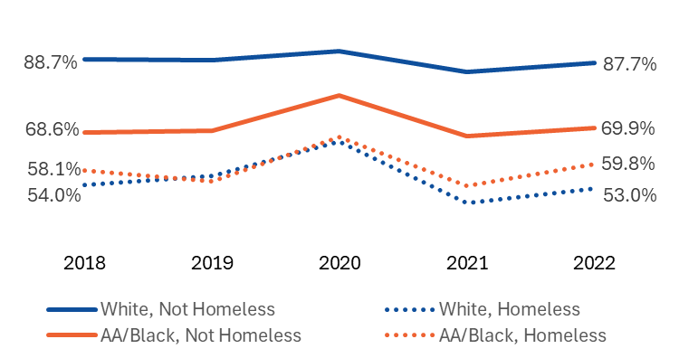
Figure 28: Percentage of 9th Grade Students Passing All Courses by Housing Status: Comparison of African American or Black Students and White Students
Compared to White students who were not homeless in 2021–22, the percentage of students 9th graders passing all courses was 18 percentage points lower for African American or Black students who were not homeless, 28 points lower for African American or Black students who were homeless, and 35 points lower for White students who were homeless.

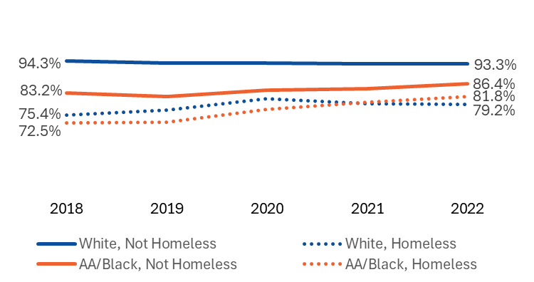
Figure 29: Percentage of Students Who Graduated High School Within Four Years of Entering 9th Grade by Housing Status: Comparison of African American or Black Students and White Students

Compared to White students who were not homeless in 2021–22, the percentage of students who graduated within four years of entering 9th grade was 7 percentage points lower for African American or Black students who were not homeless, 12 points lower for African American or Black students who were homeless, and 14 points lower for White students who were homeless.

Figure 30: Percentage of 4-Year High School Graduates Enrolled in College within One Year of Graduation by Housing Status: Comparison of African American or Black Students and White Students
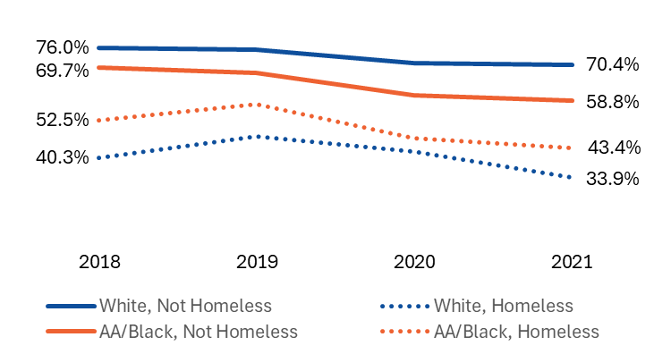
Compared to White students who were not homeless in 2020–21, the percentage of students who enrolled in college within one year of graduation was 12 percentage points lower for African American or Black students who were not homeless, 27 points lower for African American or Black students who were homeless, and 37 points lower for White students who were homeless.

Table 40: Percentage of Students Achieving Academic Outcomes by Housing Status: Comparison of African American or Black Students and White Students
 | 2018 | 2019 | 2020 | 2021 | 2022
Met or Exceeded Expectations on 3rd Grade ELA Assessment
White, Not Homeless | 59.4% | 63.5% | -- | 60.6% | 52.9%
White, Homeless | 33.3% | 38.4% | -- | 30.9% | 26.5%
African American/Black, Not Homeless | 33.3% | 38.8% | -- | 32.9% | 28.0%
African American/Black, Homeless | 26.4% | 25.8% | -- | 19.1% | 19.9%
Met or Exceeded Expectations on 6th Grade ELA and Math Assessments
White, Not Homeless | 46.1% | 49.2% | -- | 34.6% | 38.9%
White, Homeless | 16.5% | 18.9% | -- | 7.9% | 11.5%
African American/Black, Not Homeless | 19.1% | 22.0% | -- | 11.4% | 14.6%
African American/Black, Homeless | 13.2% | 14.0% | -- | 3.3% | 4.7%
Passed All 9th Grade Courses
White, Not Homeless | 88.7% | 88.4% | 91.1% | 85.3% | 87.7%
White, Homeless | 54.0% | 56.5% | 66.1% | 49.2% | 53.0%
African American/Black, Not Homeless | 68.6% | 69.1% | 78.9% | 67.7% | 69.9%
African American/Black, Homeless | 58.1% | 55.1% | 67.3% | 53.9% | 59.8%
Graduated Within Four Years of Entering 9th Grade
White, Not Homeless | 94.3% | 93.6% | 93.6% | 93.2% | 93.3%
White, Homeless | 75.4% | 77.0% | 81.2% | 79.4% | 79.2%
African American/Black, Not Homeless | 83.2% | 81.8% | 84.2% | 84.6% | 86.4%
African American/Black, Homeless | 72.5% | 72.9% | 77.4% | 79.9% | 81.8%
Enrolled in College Within One Year of Graduating
White, Not Homeless | 76.0% | 75.5% | 71.1% | 70.4% | --
White, Homeless | 40.3% | 47.1% | 42.4% | 33.9% | --
African American/Black, Not Homeless | 69.7% | 67.9% | 60.6% | 58.8% | --
African American/Black, Homeless | 52.5% | 57.7% | 46.7% | 43.4% | --
Note: MCAS was not administered during the 2019–20 academic year due to the COVID-19 pandemic. At the time of this analysis, National Student Clearinghouse enrollment data were not available for students who graduated at the end of the 2021–22 academic year; therefore, enrollment rates for students who graduated in 2021–22 are not included.
Table 41: Academic Outcome Achievement Gaps by Housing Status: Comparison of African American or Black Students and White Students
 | 2018 | 2019 | 2020 | 2021 | 2022
Met or Exceeded Expectations on 3rd Grade ELA Assessment
Percentage of White, Not Homeless Students Achieving Outcome | 59.4% | 63.5% | -- | 60.6% | 52.9%
Percentage Point Difference Compared to White, Not Homeless Students
White, Homeless | -26 | -25 | -- | -30 | -26
African American/Black, Not Homeless | -26 | -25 | -- | -28 | -25
African American/Black, Homeless | -33 | -38 | -- | -42 | -33
Met or Exceeded Expectations on 6th Grade ELA and Math Assessments
Percentage of White, Not Homeless Students Achieving Outcome | 46.1% | 49.2% | -- | 34.6% | 38.9%
Percentage Point Difference Compared to White, Not Homeless Students
White, Homeless | -30 | -30 | -- | -27 | -27
African American/Black, Not Homeless | -27 | -27 | -- | -23 | -24
African American/Black, Homeless | -33 | -35 | -- | -31 | -34
Passed All 9th Grade Courses
Percentage of White, Not Homeless Students Achieving Outcome | 88.7% | 88.4% | 91.1% | 85.3% | 87.7%
Percentage Point Difference Compared to White, Not Homeless Students
White, Homeless | -35 | -32 | -25 | -36 | -35
African American/Black, Not Homeless | -20 | -19 | -12 | -18 | -18
African American/Black, Homeless | -31 | -33 | -24 | -31 | -28
Graduated Within Four Years of Entering 9th Grade
Percentage of White, Not Homeless Students Achieving Outcome | 94.3% | 93.6% | 93.6% | 93.2% | 93.3%
Percentage Point Difference Compared to White, Not Homeless Students
White, Homeless | -19 | -17 | -12 | -14 | -14
African American/Black, Not Homeless | -11 | -12 | -9 | -9 | -7
African American/Black, Homeless | -22 | -21 | -16 | -13 | -12
Enrolled in College Within One Year of Graduating
Percentage of White, Not Homeless Students Achieving Outcome | 76.0% | 75.5% | 71.1% | 70.4% | --
Percentage Point Difference Compared to White, Not Homeless Students
White, Homeless | -36 | -28 | -29 | -37 | --
African American/Black, Not Homeless | -6 | -8 | -11 | -12 | --
African American/Black, Homeless | -24 | -18 | -24 | -27 | --
Note: MCAS was not administered during the 2019–20 academic year due to the COVID-19 pandemic. At the time of this analysis, National Student Clearinghouse enrollment data were not available for students who graduated at the end of the 2021–22 academic year; therefore, enrollment rates for students who graduated in 2021–22 are not included.

Academic Outcomes by Housing Status: Comparison of English Learners and English Speakers
For all five academic outcomes and across all academic years, English speakers who were not homeless consistently outperformed English speakers who were homeless and English learners regardless of their housing status (Figures 31–35 and Tables 42 and 43). In most instances, there were large achievement gaps between English speakers who were not homeless compared to English speakers who were homeless, English learners who were not homeless, and English learners who were homeless. English learners who were homeless generally had the lowest rates of achievement on three of the five academic outcomes, including the 3rd grade ELA assessment, 4-year graduation, and college enrollment. During the most recent academic year, English speakers who were homeless outperformed English learners who were not homless by at least five percentage points on four of the five academic outcomes (3rd grade ELA assessment, 6th grade ELA and math assessments, 4-year graduation, and college enrollment).
Figure 31: Percentage of 3rd Grade Students Meeting or Exceeding Expectations on the ELA Assessment by Housing Status: Comparison of English Learners and English Speakers
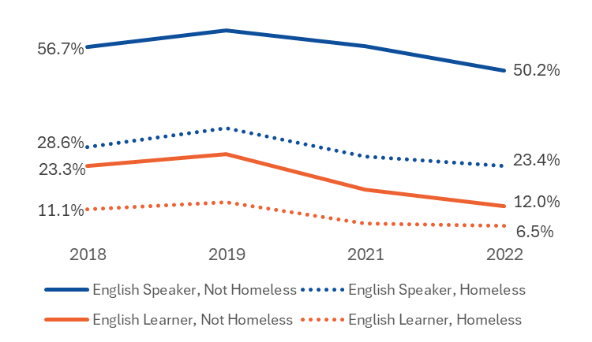
Compared to English speakers who were not homeless in 2021–22, the percentage of students meeting or exceeding expectations on the 3rd grade ELA assessment was 27 percentage points lower for English speakers who were homeless, 38 points lower for English learners who were not homeless, and 44 points lower for Enlish learners who were homeless.

Figure 32: Percentage of 6th Grade Students Meeting or Exceeding Expectations on the ELA and Math Assessments by Housing Status: Comparison of English Learners and English Speakers
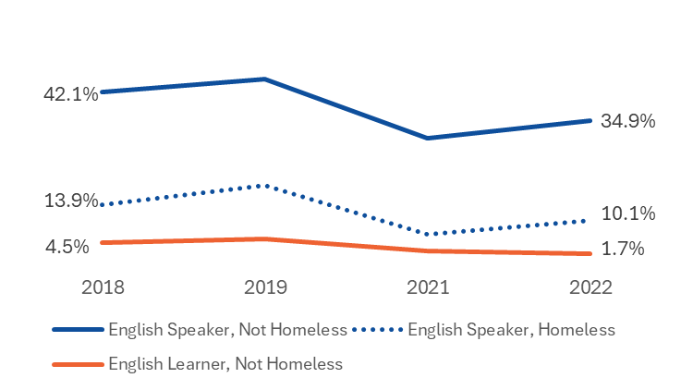
Compared to English speakers who were not homeless in 2021–22, the percentage of students meeting or exceeding expectations on the 6th grade ELA and math assessments was 25 percentage points lower for English speakers who were homeless and 33 points lower for English learners who were not homeless.
There was an insufficient number of English learners who were homeless and had both an ELA and math assessment result to calculate percentages.

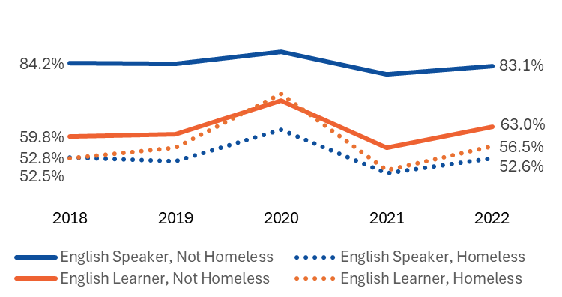
Figure 33: Percentage of 9th Grade Students Passing All Courses by Housing Status: Comparison of English Learners and English Speakers
Compared to English speakers who were not homeless in 2021–22, the percentage of students passing all 9th grade courses was 20 percentage points lower for English learners who were not homeless, 27 points lower for English learners who were homeless, and 31 percentage points lower for English speakers who were homeless. This represents one instance where English learners, regargless of housing status, have higher rates of achievement than English speakers who were homeless.

Figure 34: Percentage of Students Who Graduated High School Within Four Years of Entering 9th Grade by Housing Status: Comparison of English Learners and English Speakers
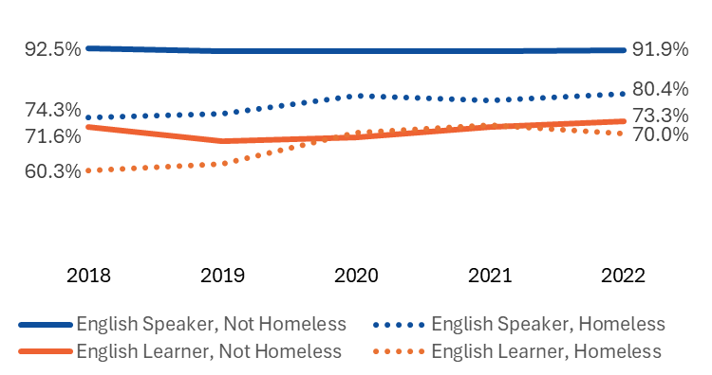
Compared to English speakers who were not homeless in 2021–22, the percentage of students who graduated within four years of entering 9th grade was 12 percentage points lower for English speakers who were homeless, 19 points lower for English learners who were not homeless, and 22 percentage points lower for English learners who were homeless.

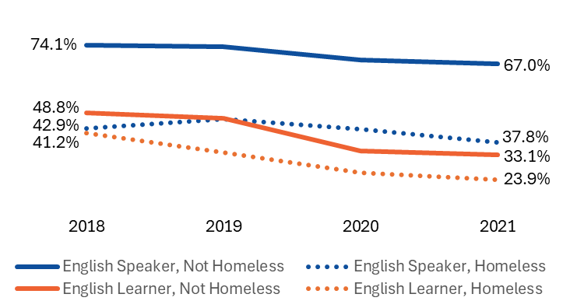
Figure 35: Percentage of 4-Year High School Graduates Enrolled in College within One Year of Graduation by Housing Status: Comparison of English Learners and English Speakers

Compared to English speakers who were not homeless in 2020–21, the percentage of students who enrolled in college within one year of graduation was 29 percentage points lower for English speakers who were homeless, 34 points lower for English learners who were not homeless, and 42 points lower for English learners who were homeless.

Table 42: Percentage of Students Achieving Academic Outcomes by Housing Status: Comparison of English Learners and English Speakers
 | 2018 | 2019 | 2020 | 2021 | 2022
Met or Exceeded Expectations on 3rd Grade ELA Assessment
English Speaker, Not Homeless | 56.7% | 61.5% | -- | 57.1% | 50.2%
English Speaker, Homeless | 28.6% | 34.0% | -- | 26.0% | 23.4%
English Learner, Not Homeless | 23.3% | 26.7% | -- | 16.8% | 12.0%
English Learner, Homeless | 11.1% | 13.2% | -- | 7.2% | 6.5%
Met or Exceeded Expectations on 6th Grade ELA and Math Assessments
English Speaker, Not Homeless | 42.1% | 45.3% | -- | 30.7% | 34.9%
English Speaker, Homeless | 13.9% | 18.8% | -- | 6.5% | 10.1%
English Learner, Not Homeless | 4.5% | 5.4% | -- | 2.4% | 1.7%
English Learner, Homeless | * | 4.4% | -- | * | *
Passed All 9th Grade Courses
English Speaker, Not Homeless | 84.2% | 83.9% | 88.0% | 80.5% | 83.1%
English Speaker, Homeless | 52.8% | 51.5% | 62.0% | 47.6% | 52.6%
English Learner, Not Homeless | 59.8% | 60.5% | 71.6% | 56.0% | 63.0%
English Learner, Homeless | 52.5% | 56.0% | 73.9% | 48.4% | 56.5%
Graduated Within Four Years of Entering 9th Grade
English Speaker, Not Homeless | 92.5% | 91.7% | 91.6% | 91.7% | 91.9%
English Speaker, Homeless | 74.3% | 75.2% | 79.9% | 78.8% | 80.4%
English Learner, Not Homeless | 71.6% | 67.9% | 68.9% | 71.7% | 73.3%
English Learner, Homeless | 60.3% | 61.9% | 70.2% | 72.2% | 70.0%
Enrolled in College Within One Year of Graduating
English Speaker, Not Homeless | 74.1% | 73.5% | 68.7% | 67.0% | --
English Speaker, Homeless | 42.9% | 46.5% | 42.6% | 37.8% | --
English Learner, Not Homeless | 48.8% | 46.8% | 34.4% | 33.1% | --
English Learner, Homeless | 41.2% | 34.0% | 26.4% | 23.9% | --
Note: MCAS was not administered during the 2019–20 academic year due to the COVID-19 pandemic. At the time of this analysis, National Student Clearinghouse enrollment data were not available for students who graduated at the end of the 2021–22 academic year; therefore, enrollment rates for students who graduated in 2021–22 are not included.
* Results based on cell sizes of fewer than six cases are not reported.

Table 43: Academic Outcome Achievement Gaps by Housing Status: Comparison of English Learners and English Speakers
 | 2018 | 2019 | 2020 | 2021 | 2022
Met or Exceeded Expectations on 3rd Grade ELA Assessment
Percentage of English Speakers, Not Homeless Achieving Outcome | 56.7% | 61.5% | -- | 57.1% | 50.2%
Percentage Point Difference Compared to English Speakers, Not Homeless
English Speaker, Homeless | -28 | -28 | -- | -31 | -27
English Learner, Not Homeless | -33 | -35 | -- | -40 | -38
English Learner, Homeless | -46 | -48 | -- | -50 | -44
Met or Exceeded Expectations on 6th Grade ELA and Math Assessments
Percentage of English Speakers, Not Homeless Achieving Outcome | 42.1% | 45.3% | -- | 30.7% | 34.9%
Percentage Point Difference Compared to English Speakers, Not Homeless
English Speaker, Homeless | -28 | -27 | -- | -24 | -25
English Learner, Not Homeless | -38 | -40 | -- | -28 | -33
English Learner, Homeless | * | -41 | -- | * | *
Passed All 9th Grade Courses
Percentage of English Speakers, Not Homeless Achieving Outcome | 84.2% | 83.9% | 88.0% | 80.5% | 83.1%
Percentage Point Difference Compared to English Speakers, Not Homeless
English Speaker, Homeless | -31 | -32 | -26 | -33 | -31
English Learner, Not Homeless | -24 | -23 | -16 | -25 | -20
English Learner, Homeless | -32 | -28 | -14 | -32 | -27
Graduated Within Four Years of Entering 9th Grade
Percentage of English Speakers, Not Homeless Achieving Outcome | 92.5% | 91.7% | 91.6% | 91.7% | 91.9%
Percentage Point Difference Compared to English Speakers, Not Homeless
English Speaker, Homeless | -18 | -17 | -12 | -13 | -12
English Learner, Not Homeless | -21 | -24 | -23 | -20 | -19
English Learner, Homeless | -32 | -30 | -21 | -20 | -22
Enrolled in College Within One Year of Graduating
Percentage of English Speakers, Not Homeless Achieving Outcome | 74.1% | 73.5% | 68.7% | 67.0% | --
Percentage Point Difference Compared to English Speakers, Not Homeless
English Speaker, Homeless | -31 | -27 | -26 | -29 | --
English Learner, Not Homeless | -25 | -27 | -34 | -34 | --
English Learner, Homeless | -33 | -40 | -42 | -43 | --
Note: MCAS was not administered during the 2019–20 academic year due to the COVID-19 pandemic. At the time of this analysis, National Student Clearinghouse enrollment data were not available for students who graduated at the end of the 2021–22 academic year; therefore, enrollment rates for students who graduated in 2021–22 are not included.
* Results based on cell sizes of fewer than six cases are not reported.

Academic Outcomes by Housing Status: Comparison of Students Who Are Low Income and Students Who Are Not Low Income
With one exception (2020–21 graduation rate), students who were not low income and not homeless consistently outperformed students who were not low income and homeless and low-income students regardless of their housing status (Figures 36–40 and Tables 44 and 45) on all five academic outcomes and across all academic years. In most instances, there were large achievement gaps between students who were not low income and not homeless compared to students who were not low income and were homeless, low-income students who were not homeless, and low-income students who were homeless.
For the most recent academic year, low income students who were homeless had the lowest rates of achievement on all five academic outcomes. Furthermore, on three of the five academic outcomes (3rd grade ELA assessment, 6th grade ELA and math assessments, and 9th grade courses), students who were not low income and were homeless performed similarly (within 5 percentage points) to those who were low-income and not homeless.
Figure 36: Percentage of 3rd Grade Students Meeting or Exceeding Expectations on the ELA Assessment by Housing Status: Comparison of Students Who Are Low Income and Students Who Are Not Low Income

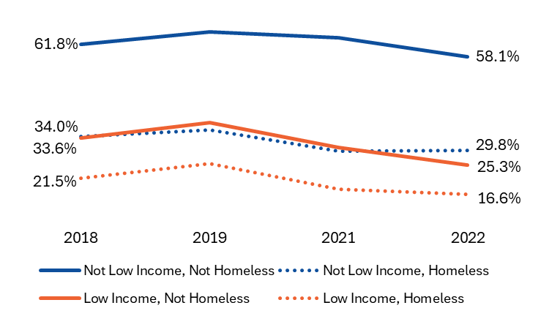
Compared to students who were not low income and not homeless in 2021–22, the percentage of students meeting or exceeding expectations on the 3rd grade ELA assessment was 28 percentage points lower for students who were not low income and were homeless, 33 points lower for low-income students who were not homeless, and 42 points lower for low-income students who were homeless.

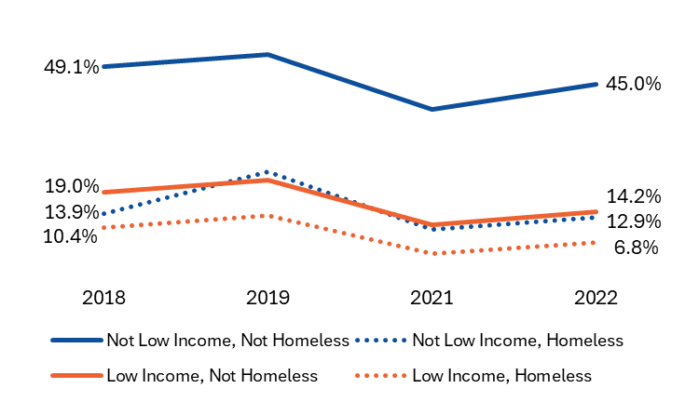
Figure 37: Percentage of 6th Grade Students Meeting or Exceeding Expectations on the ELA and Math Assessments by Housing Status: Comparison of Students Who Are Low Income and Students Who Are Not Low Income
Compared to students who were not low income and not homeless in 2021–22, the percentage of students meeting or exceeding expectations on the 6th grade ELA and math assessments was 31 percentage points lower for low-income students who were not homeless, 32 points lower for students who were not low income and were homeless, and 38 points lower for low-income students who were homeless.

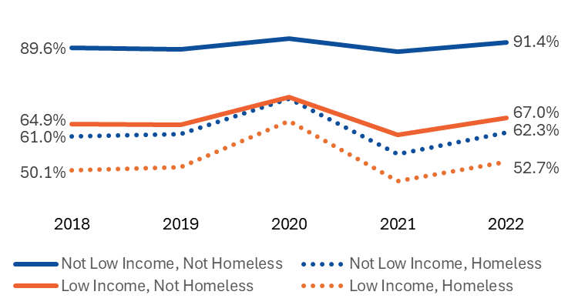
Figure 38: Percentage of 9th Grade Passing All Courses by Housing Status: Comparison of Students Who Are Low Income and Students Who Are Not Low Income
Compared to students who were not low income and not homeless in 2021–22, the percentage of students passing all 9th grade courses was 24 percentage points lower for low-income students who were not homeless, 29 points lower for students who were not low income and were homeless, and 39 points lower for low-income students who were homeless.

Figure 39: Percentage of Students Who Graduated High School Within Four Years of Entering 9th Grade by Housing Status: Comparison of Students Who Are Low Income and Students Who Are Not Low Income
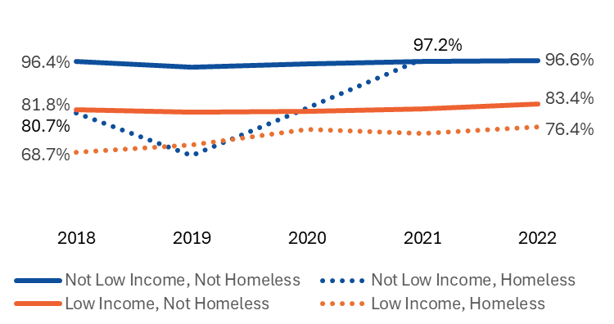
Compared to students who were not low income and not homeless in 2021–22, the percentage of students graduating within four years was 13 percentage points lower for low-income students who were not homeless and 20 points lower for low-income students who were homeless.
There was an insufficient number students who were not low income and were homeless in the 4-year graduation cohort to calculate the percentage for 2021–22.
Figure 40: Percentage of 4-Year High School Graduates Enrolled in College within One Year of Graduation by Housing Status: Comparison of Students Who Are Low Income and Students Who Are Not Low Income
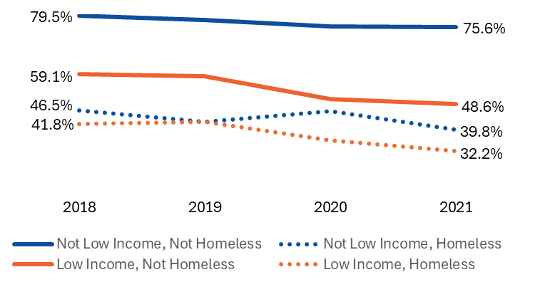
Compared to students who were not low income and not homeless in 2020–21, the percentage of students enrolled in college within one year of graduation was 27 percentage points lower for low-income students who were not homeless, 36 points lower for students who were not low income and were homeless, and 43 points lower for low-income students who were homeless.

Table 44: Percentage of Students Achieving Academic Outcomes by Housing Status: Comparison of Students Who Are Low Income and Students Who Are Not Low Income
 | 2018 | 2019 | 2020 | 2021 | 2022
Met or Exceeded Expectations on 3rd Grade ELA Assessment
Not Low Income, Not Homeless | 61.8% | 65.6% | -- | 63.7% | 58.1%
Not Low Income, Homeless | 34.0% | 36.1% | -- | 29.7% | 29.8%
Low Income, Not Homeless | 33.6% | 38.1% | -- | 30.8% | 25.3%
Low Income, Homeless | 21.5% | 25.8% | -- | 18.1% | 16.6%
Met or Exceeded Expectations on 6th Grade ELA and Math Assessments
Not Low Income, Not Homeless | 49.1% | 52.0% | -- | 39.0% | 45.0%
Not Low Income, Homeless | 13.9% | 23.9% | -- | 9.9% | 12.9%
Low Income, Not Homeless | 19.0% | 21.9% | -- | 11.0% | 14.2%
Low Income, Homeless | 10.4% | 13.4% | -- | 4.1% | 6.8%
Passed All 9th Grade Courses
Not Low Income, Not Homeless | 89.6% | 89.1% | 92.6% | 88.3% | 91.4%
Not Low Income, Homeless | 61.0% | 61.7% | 73.1% | 55.2% | 62.3%
Low Income, Not Homeless | 64.9% | 64.7% | 73.6% | 61.5% | 67.0%
Low Income, Homeless | 50.1% | 51.0% | 66.0% | 46.4% | 52.7%
Graduated Within Four Years of Entering 9th Grade
Not Low Income, Not Homeless | 96.4% | 94.7% | 95.6% | 96.5% | 96.6%
Not Low Income, Homeless | 80.7% | 67.8% | 82.1% | 97.2% | --
Low Income, Not Homeless | 81.8% | 80.9% | 81.1% | 81.9% | 83.4%
Low Income, Homeless | 68.7% | 71.1% | 75.6% | 74.5% | 76.4%
Enrolled in College Within One Year of Graduating
Not Low Income, Not Homeless | 79.5% | 78.2% | 76.0% | 75.6% | --
Not Low Income, Homeless | 46.5% | 42.4% | 46.1% | 39.8% | --
Low Income, Not Homeless | 59.1% | 58.5% | 50.4% | 48.6% | --
Low Income, Homeless | 41.8% | 42.5% | 35.9% | 32.2% | --
Note: MCAS was not administered during the 2019–20 academic year due to the COVID-19 pandemic. At the time of this analysis, National Student Clearinghouse enrollment data were not available for students who graduated at the end of the 2021–22 academic year; therefore, enrollment rates for students who graduated in 2021–22 are not included.
Table 45: Academic Outcome Achievement Gaps by Housing Status: Comparison of Students Who Are Low Income and Students Who Are Not Low Income
 | 2018 | 2019 | 2020 | 2021 | 2022
Met or Exceeded Expectations on 3rd Grade ELA Assessment
Percentage of Students Who Are Not Low Income, Not Homeless Achieving Outcome | 61.8% | 65.6% | -- | 63.7% | 58.1%
Percentage Point Difference Compared to Not Low Income, Not Homeless Students
Not Low Income, Homeless | -28 | -30 | -- | -34 | -28
Low Income, Not Homeless | -28 | -28 | -- | -33 | -33
Low Income, Homeless | -40 | -40 | -- | -46 | -42
Met or Exceeded Expectations on 6th Grade ELA and Math Assessments
Percentage of Students Who Are Not Low Income, Not Homeless Achieving Outcome | 49.1% | 52.0% | -- | 39.0% | 45.0%
Percentage Point Difference Compared to Not Low Income, Not Homeless Students
Not Low Income, Homeless | -35 | -28 | -- | -29 | -32
Low Income, Not Homeless | -30 | -30 | -- | -28 | -31
Low Income, Homeless | -39 | -39 | -- | -35 | -38
Passed All 9th Grade Courses
Percentage of Students Who Are Not Low Income, Not Homeless Achieving Outcome | 89.6% | 89.1% | 92.6% | 88.3% | 91.4%
Percentage Point Difference Compared to Not Low Income, Not Homeless Students
Not Low Income, Homeless | -29 | -27 | -20 | -33 | -29
Low Income, Not Homeless | -25 | -24 | -19 | -27 | -24
Low Income, Homeless | -40 | -38 | -27 | -42 | -39
Graduated Within Four Years of Entering 9th Grade
Percentage of Students Who Are Not Low Income, Not Homeless Achieving Outcome | 96.4% | 94.7% | 95.6% | 96.5% | 96.6%
Percentage Point Difference Compared to Not Low Income, Not Homeless Students
Not Low Income, Homeless | -16 | -27 | -14 | +1
Low Income, Not Homeless | -15 | -14 | -15 | -15 | -13
Low Income, Homeless | -28 | -24 | -20 | -22 | -20
Enrolled in College Within One Year of Graduating
Percentage of Students Who Are Not Low Income, Not Homeless Achieving Outcome | 79.5% | 78.2% | 76.0% | 75.6% | --
Percentage Point Difference Compared to Not Low Income, Not Homeless Students
Not Low Income, Homeless | -33 | -36 | -30 | -36 | --
Low Income, Not Homeless | -20 | -20 | -26 | -27 | --
Low Income, Homeless | -38 | -36 | -40 | -43 | --
Note: MCAS was not administered during the 2019–20 academic year due to the COVID-19 pandemic. At the time of this analysis, National Student Clearinghouse enrollment data were not available for students who graduated at the end of the 2021–22 academic year; therefore, enrollment rates for students who graduated in 2021–22 are not included.

Academic Outcomes by Housing Status: Comparison of Students With Disabilities and Students Without Disabilities
For all academic outcomes and across all academic years, students without disabilities who were not homeless consistently outperformed students without disabilities who were homeless and students with disabilities regardless of their housing status (Figures 41–45 and Tables 46 and 47). In most instances, there were large achievement gaps between students without disabilities who were not homeless compared to students withough disabilities who were homeless, students with disabilities who were not homeless, and students with disabilities who were homeless. Students with disabilitites who were homeless had the lowest rates of achievement for all academic outcomes.
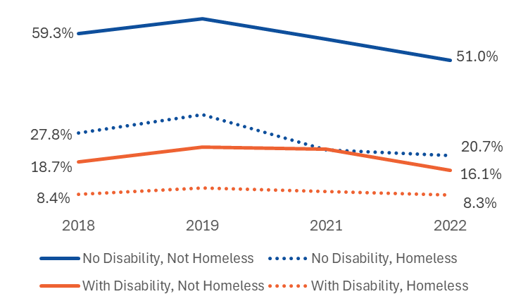
Figure 41: Percentage of 3rd Grade Students Meeting or Exceeding Expectations on the ELA Assessment by Housing Status: Comparison of Students With Disabilities and Students Without Disabilities
Compared to students who did not have a disability and were not homeless in 2021–22, the percentage of students meeting or exceeding expectations on the 3rd grade ELA assessment was 30 percentage points lower for students who did not have a disability and were homeless, 35 points lower for students with a disability who were not homeless, and 43 points lower for students with a disability who were homeless.

Figure 42: Percentage of 6th Grade Students Meeting or Exceeding Expectations on the ELA and Math Assessments by Housing Status: Comparison of Students With Disabilities and Students Without Disabilities
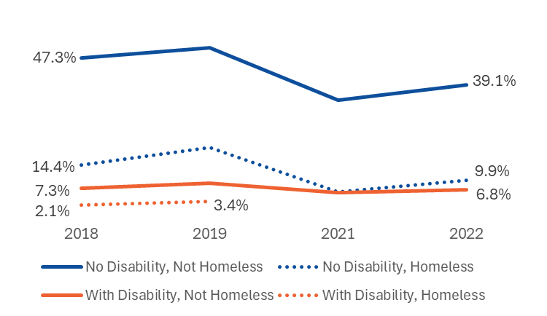
Compared to students who did not have a disability and were not homeless in 2021–22, the percentage of students meeting or exceeding expectations on the 6th grade ELA and math assessments was 29 percentage points lower for students who did not have a disability and were homeless and 32 points lower for students with a disability who were not homeless.
There was an insufficient number of students with a disability who were homeless that had both an ELA and math assessment result to calculate percentages for 2020–21 and 2021–22.

Figure 43: Percentage of 9th Grade Passing All Courses by Housing Status: Comparison of Students With Disabilities and Students Without Disabilities
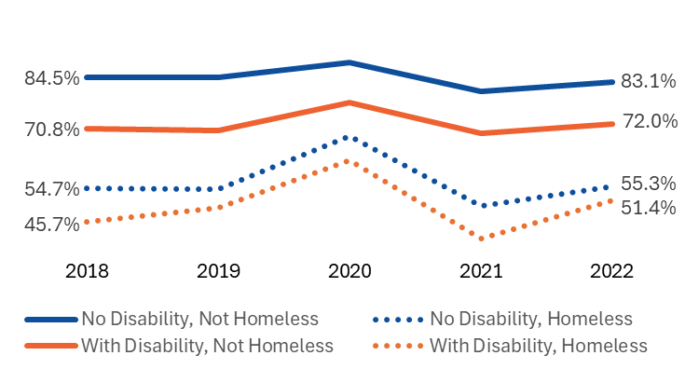
Compared to students who did not have a disability and were not homeless in 2021–22, the percentage of students passing all 9th grade courses was 11 percentage points lower for students with a disability who were not homeless, 28 points lower for students who did not have a disability and were homeless, and 32 points lower for students with a disability who were homeless.

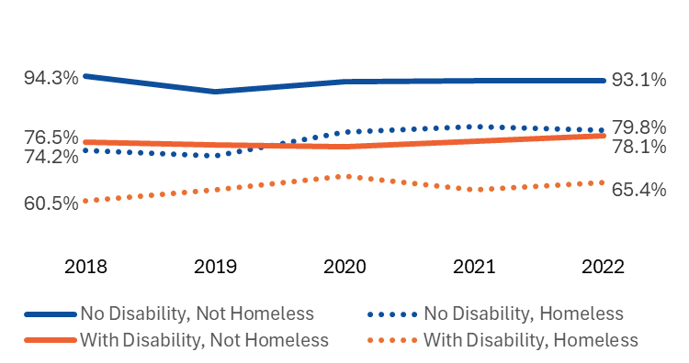
Figure 44: Percentage of Students Who Graduated High School Within Four Years of Entering 9th Grade by Housing Status: Comparison of Students With Disabilities and Students Without Disabilities

Compared to students who did not have a disability and were not homeless in 2021–22, the percentage of students graduating within four years was 13 percentage points lower for students who did not have a disability and were homeless, 15 points lower for students with a disability who were not homeless, and 28 points lower for students with a disability who were homeless.

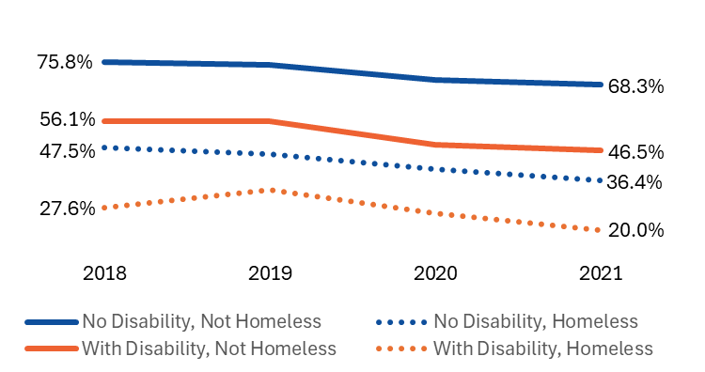
Figure 45: Percentage of 4-Year High School Graduates Enrolled in College within One Year of Graduation by Housing Status Comparison of Students With Disabilities and Students Without Disabilities

Compared to students who did not have a disability and were not homeless in 2020–21, the percentage of students enrolled in college within one year of graduation was 22 percentage points lower for students with a disability who were not homeless, 32 points lower for students who did not have a disability and were homeless, and 48 points lower for students with a disability who were homeless.

Table 46: Percentage of Students Achieving Academic Outcomes by Housing Status: Comparison of Students With Disabilities and Students Without Disabilities
 | 2018 | 2019 | 2020 | 2021 | 2022
Met or Exceeded Expectations on 3rd Grade ELA Assessment
No Disability, Not Homeless | 59.3% | 64.0% | -- | 57.7% | 51.0%
No Disability, Homeless | 27.8% | 33.7% | -- | 22.6% | 20.7%
With Disability, Not Homeless | 18.7% | 23.5% | -- | 22.7% | 16.1%
With Disability, Homeless | 8.4% | 10.4% | -- | 9.4% | 8.3%
Met or Exceeded Expectations on 6th Grade ELA and Math Assessments
No Disability, Not Homeless | 47.3% | 50.6% | -- | 34.5% | 39.1%
No Disability, Homeless | 14.4% | 19.9% | -- | 6.3% | 9.9%
With Disability, Not Homeless | 7.3% | 9.0% | -- | 6.0% | 6.8%
With Disability, Homeless | 2.1% | 3.4% | -- | * | *
Passed All 9th Grade Courses
No Disability, Not Homeless | 84.5% | 84.3% | 88.4% | 80.8% | 83.1%
No Disability, Homeless | 54.7% | 54.4% | 68.7% | 50.0% | 55.3%
With Disability, Not Homeless | 70.8% | 70.3% | 77.6% | 69.5% | 72.0%
With Disability, Homeless | 45.7% | 49.6% | 62.3% | 41.4% | 51.4%
Graduated Within Four Years of Entering 9th Grade
No Disability, Not Homeless | 94.3% | 90.3% | 92.9% | 93.2% | 93.1%
No Disability, Homeless | 74.2% | 72.8% | 79.3% | 80.7% | 79.8%
With Disability, Not Homeless | 76.5% | 75.6% | 75.2% | 76.8% | 78.1%
With Disability, Homeless | 60.5% | 63.4% | 67.2% | 63.5% | 65.4%
Enrolled in College Within One Year of Graduating
No Disability, Not Homeless | 75.8% | 74.8% | 69.8% | 68.3% | --
No Disability, Homeless | 47.5% | 45.3% | 40.3% | 36.4% | --
With Disability, Not Homeless | 56.1% | 56.1% | 48.3% | 46.5% | --
With Disability, Homeless | 27.6% | 33.3% | 25.6% | 20.0% | --
Note: MCAS was not administered during the 2019–20 academic year due to the COVID-19 pandemic. At the time of this analysis, National Student Clearinghouse enrollment data were not available for students who graduated at the end of the 2021–22 academic year; therefore, enrollment rates for students who graduated in 2021–22 are not included.
* Results based on cell sizes of fewer than six cases are not reported.

Table 47: Academic Outcome Achievement Gaps by Housing Status: Comparison of Students With Disabilities and Students Without Disabilities
 | 2018 | 2019 | 2020 | 2021 | 2022
Met or Exceeded Expectations on 3rd Grade ELA Assessment
Percentage of Students with No Disability, Not Homeless Achieving Outcome | 59.3% | 64.0% | -- | 57.7% | 51.0%
Percentage Point Difference Compared to No Disability, Not Homeless Students
No Disability, Homeless | -32 | -30 | -- | -35 | -30
With Disability, Not Homeless | -41 | -41 | -- | -35 | -35
With Disability, Homeless | -51 | -54 | -- | -48 | -43
Met or Exceeded Expectations on 6th Grade ELA and Math Assessments
Percentage of Students with No Disability, Not Homeless Achieving Outcome | 47.3% | 50.6% | -- | 34.5% | 39.1%
Percentage Point Difference Compared to No Disability, Not Homeless Students
No Disability, Homeless | -33 | -31 | -- | -28 | -29
With Disability, Not Homeless | -40 | -42 | -- | -29 | -32
With Disability, Homeless | -45 | -47 | -- | * | *
Passed All 9th Grade Courses
Percentage of Students with No Disability, Not Homeless Achieving Outcome | 84.5% | 84.3% | 88.4% | 80.8% | 83.1%
Percentage Point Difference Compared to No Disability, Not Homeless Students
No Disability, Homeless | -30 | -30 | -20 | -31 | -28
With Disability, Not Homeless | -14 | -14 | -11 | -11 | -11
With Disability, Homeless | -39 | -35 | -26 | -39 | -32
Graduated Within Four Years of Entering 9th Grade
Percentage of Students with No Disability, Not Homeless Achieving Outcome | 94.3% | 90.3% | 92.9% | 93.2% | 93.1%
Percentage Point Difference Compared to No Disability, Not Homeless Students
No Disability, Homeless | -20 | -18 | -14 | -13 | -13
With Disability, Not Homeless | -18 | -15 | -18 | -16 | -15
With Disability, Homeless | -34 | -27 | -26 | -30 | -28
Enrolled in College Within One Year of Graduating
Percentage of Students with No Disability, Not Homeless Achieving Outcome | 75.8% | 74.8% | 69.8% | 68.3% | --
Percentage Point Difference Compared to No Disability, Not Homeless Students
No Disability, Homeless | -28 | -30 | -30 | -32 | --
With Disability, Not Homeless | -20 | -19 | -22 | -22 | --
With Disability, Homeless | -48 | -42 | -44 | -48 | --
Note: MCAS was not administered during the 2019–20 academic year due to the COVID-19 pandemic. At the time of this analysis, National Student Clearinghouse enrollment data were not available for students who graduated at the end of the 2021–22 academic year; therefore, enrollment rates for students who graduated in 2021–22 are not included.
* Results based on cell sizes of fewer than six cases are not reported.

Chapter VI: Qualitative Study Findings

Chapter Overview

McKinney Vento Homeless Assistance Act Background and Associated Federal Funding
The McKinney-Vento Homeless Assistance Act (MKV Act) authorizes the Education for Homeless Children and Youth (EHCY) program and serves as the primary federal legislation addressing the education of children and youth experiencing homelessness. Reauthorized in December 2015 under Title IX, Part A of the Every Student Succeeds Act (ESSA), the MKV Act and EHCY program ensure that students in grades K–12 who are experiencing homelessness have equal access to the same educational opportunities and supports as their peers, with the goal of promoting academic success. The legislation requires states to review and revise policies and practices to eliminate barriers to the identification, enrollment, attendance, and academic achievement of students experiencing homelessness. It also emphasizes the importance of keeping these students integrated within the mainstream school environment.
There are two ongoing federal funding sources specifically designated to support students experiencing homelessness: Title I, Part A set-aside funds and MKV Act grant funds. Additionally, the American Rescue Plan Act (ARPA) provided a temporary, time-limited funding source through COVID-19 relief efforts. However, all ARPA funds had to be expended by the end of the 2024–2025 school year.

Title I Part A Set Aside Funds
To help close academic achievement gaps for low-income students, the U.S. Department of Education provides annual Title I, Part A appropriations to state educational agencies. These funds are then distributed to local educational agencies (LEAs), hereafter referred to as school districts, based on the number or percentage of students from low-income backgrounds residing in each district. School districts are required to reserve a portion of their Title I, Part A funds—using “such sums as may be necessary”—to provide educationally related services to students experiencing homelessness. While districts have the autonomy to determine the set-aside amount, they are expected to conduct a needs assessment to guide this decision. Districts must document both the reserved amount and the method used to calculate it and report this information to the state educational agency and the U.S. Department of Education.

McKinney-Vento Act Grant Funds
The U.S. Department of Education allocates MKV funds to states based on the proportion of Title I, Part A funding each state receives. These funds are used to establish or designate a state-level office responsible for coordinating the education of children and youth experiencing homelessness. This office is tasked with collecting and maintaining comprehensive data on students experiencing homelessness and ensuring that school districts comply with the MKV Act. It also plays a critical role in upholding students’ rights to equal access to free and appropriate public education.
States are required to distribute no less than 75% of their MKV federal grant funds through a competitive subgrant process to school districts. These subgrants are intended to support the identification, enrollment, attendance, and academic success of students experiencing homelessness. Awards are based on both the number of students experiencing homelessness in a district and the quality of the application submitted.
In FY24, DESE’s Office of Student and Family Support awarded competitive MKV subgrants to 30 school districts and one educational collaborative, representing fewer than 10% of all districts in the state. Funding was awarded across one or more of the following categories:
- Support Services: Designed to address the basic and ongoing needs of students experiencing homelessness. Funding is available to districts with 50 or more MKV-enrolled students. In FY24, 29 districts received this funding.
- School-Housing Partnerships: Aimed at stabilizing and re-housing homeless families with school-age children or unaccompanied homeless youth through partnerships with homeless/housing service providers. In FY24, 6 districts received this funding.
- Homeless Migrant Student Support: In collaboration with the Massachusetts Migrant Education Program (MMEP), this funding supports racially equitable and culturally responsive academic services such as summer programming, English language instruction, tutoring, school supplies, and uniforms for students from migrant worker families. In FY24, 6 districts received this funding.
- Regional Homeless Education Liaisons: Supports a network of experienced liaisons who provide technical assistance, training, and mentoring to other districts in coordination with the state coordinator of homeless education and DESE staff. In FY24, 6 districts, including one educational collaborative received this funding.
It is important to note that all school districts, regardless of whether they receive MKV grant funding, are required to comply with the MKV Act. This includes removing barriers to the identification, enrollment, attendance, and full participation of students experiencing homelessness, ensuring they have equal access to a free, appropriate public education. District responsibilities include:
- Providing training and technical assistance to school and district staff
- Identifying highly mobile and homeless students
- Coordinating and delivering support services to students and families
- Publicizing the educational rights of students experiencing homelessness
- Collaborating with community partners to support students and families

Chapter Organization and Contents
This chapter presents a thematic analysis of individual and small-group interviews with more than 150 individuals who possess either professional expertise or lived experience related to students and families experiencing homelessness in Massachusetts. The analysis draws on insights gathered through interviews with regional MKV liaisons and virtual site visits with representatives from 21 school districts across the state. These districts varied in their characteristics and capabilities—including differences in homelessness rates, geographic location, community type, district resources, and local conditions. Among the 21 districts, nine received multiple MKV subgrants, six received a single MKV subgrant, and six did not receive a MKV subgrant in FY24.
Site visits included interviews with district staff, school personnel, and representatives from community-based organizations partnering with districts and schools. Interviews focused on current policies and practices for identifying and supporting students and families experiencing homelessness, as well as the key facilitators, barriers, and recommendations for effective implementation of the MKV Act. In addition, individual interviews were conducted with eight young adults and nine parents/caregivers who have current or recent lived experience of homelessness. These interviews provided deeper insight into their experiences and offered critical perspectives on how services and supports could be improved.
The qualitative study was guided by six research questions focused on the following areas: identifying students experiencing homelessness; providing support services; operationalizing the MKV Act; identifying facilitators and barriers to educational access and success; exploring opportunities for technical assistance and professional development; and understanding the lived experiences of parents, caregivers, and young adults.
Due to the overlap among these research questions, this chapter is not organized by question. Instead, findings are presented across the following four thematic sections:

1. Organizational Capacity and Challenges to Operationalization
This section presents insights from participating school districts regarding their organizational structures and capacity to implement the MKV Act. It highlights key findings at both the district and school levels, including current training and professional development efforts. Additionally, it explores the barriers and challenges that hinder full operationalization of the Act, as well as the strategies districts use to engage and collaborate with community partners.

2. Identifying Students and Their Families Experiencing Homelessness
This section examines the methods and practices employed by Massachusetts school districts to identify students experiencing homelessness. It also explores the key facilitators, challenges, and barriers that impact the effectiveness of identification efforts.

3. Supporting Students and Their Families Eligible for MKV
This section outlines the strategies and services provided by districts and their community partners to support MKV-eligible students and families. It emphasizes efforts to ensure equal access to educational rights and services, including immediate enrollment, school choice, and transportation. The section also discusses the coordination of academic, enrichment, and wraparound services—such as referrals to community providers—that are essential for promoting educational stability. Facilitators and challenges to delivering these supports are also addressed.

4. Young Adults and Parents/Caregivers with Lived Experience
This section shares key findings from interviews with young adults and parents/caregivers who have current or recent lived experience of homelessness. Their perspectives offer insights into the challenges they face in accessing education and support services, as well as the factors that have helped them navigate these systems more effectively.

Organizational Capacity and Challenges to Operationalization
This section outlines the primary mechanisms through which school districts implement the MKV Act, including staffing roles and capacity related to MKV, professional development and training efforts, coordination and collaboration with community partners, and the key challenges and barriers to effective implementation.

MKV-Related Staffing Roles, Capacity, and Training Supports
The MKV Act requires each local education agency (LEA) or school district to designate a district-level homeless education liaison, hereafter referred to as the district MKV liaison. In Massachusetts, competitive MKV subgrants of up to $25,000 support a limited number of part-time regional MKV liaisons, who assist district MKV liaisons in fulfilling their responsibilities. To gain insights into these roles, interviews were conducted with regional MKV liaisons, district MKV liaisons, and school staff. The purpose was to identify the challenges they face in implementing the MKV Act and to assess the training and professional development they currently receive—as well as the professional development they recommend to enhance their effectiveness.

Regional Homeless Education Liaisons
In FY24, DESE awarded regional MKV liaison subgrants to six districts. Priority was given to districts proposing liaisons with prior experience in the role, ensuring continuity and expertise. DESE established the regional liaison role over five years ago to expand support for school districts implementing the MKV Act.
Regional MKV liaisons provide technical assistance to local district MKV liaisons, offering guidance on individual cases, sharing best practices and resources, supporting district trainings, and mentoring new liaisons. Their contact information (i.e., name, email, and phone number) is publicly available on DESE’s website, along with other MKV-related resources.
The regional MKV liaison is a part-time role, typically held by current or former district MKV liaisons. In FY24, five of the six regional liaisons also served concurrently as district MKV liaisons. The sixth, employed by an educational collaborative, was the only one not holding a dual role and reported the highest weekly time commitment—up to two and a half days per week. Others reported spending as little as a few hours weekly, with time varying throughout the school year. Most of the regional liaisons expressed the need for more time to fulfill their responsibilities.
Regional liaisons did not receive formal onboarding or training specific to their regional role. Instead, they participated in DESE’s general orientation for district MKV liaisons and relied heavily on their prior experience. While all had substantial individual experience and expertise, a comprehensive understanding about and confidence in fulfilling the regional role varied. For instance, some regional MKV liaisons expressed uncertainty about which districts they were responsible for supporting.
All six regional liaisons reported strong working relationships with one another. They described a collaborative network characterized by shared expertise and mutual support. The group meets monthly and communicates as needed to resolve case-specific issues. In the past year, they have also increased engagement with DESE’s Homeless Education State Coordinator.
Regional MKV liaisons varied in how they approached their responsibilities. Some adopted a proactive approach—conducting outreach, sharing resources, offering training, and participating in community meetings. Others took a reactive approach, responding to inquiries as they arose.
Each of the regional MKV liaisons has their own individual tracking system to monitor requests for assistance. A standardized system for tracking requests and services has not yet been implemented, leaving each liaison to develop their own tracking methods. However, DESE has recently initiated efforts to standardize data collection, including monthly reporting.
Regional MVK liaisons reported an increase in inquiries in academic year 2023–24 from both district MKV liaisons and families experiencing homelessness or housing insecurity. Common requests for assistance involved student identification, eligibility, and transportation, with many district liaisons seeking assistance with specific complex cases. While liaisons primarily support districts within their assigned regions, they noted that calls often come from across the state. As one liaison explained, “I just think that they go through the list on the DESE website and talk with whoever picks up the phone first.”

District MKV Homeless Education Liaison
Under the MKV Act, every school district is required to designate a district MKV liaison to serve as the primary point of contact for homeless education. This role is governed by federal statute [42 U.S.C. § 11432(g)(6)(A)] and includes a range of responsibilities aimed at ensuring that students experiencing homelessness have equitable access to education. Key responsibilities of the district MKV liaison include:
- Identifying and enrolling students experiencing homelessness
- Ensuring access to appropriate educational resources and opportunities
- Facilitating equal participation in school for students experiencing homelessness
- Referring students and families to health care, dental, mental health, substance abuse, housing, and other support services
- Publicizing MKV rights in locations frequented by parents, guardians, and youth, using language and formats that are accessible and understandable
- Informing parents/guardians and unaccompanied youth of available educational and related opportunities
- Providing meaningful opportunities for families to engage in their children’s education
- Participating in and ensuring relevant school personnel receive professional development aligned with MKV requirements
It is important to note that while the MKV Act mandates the designation of a district liaison and outlines their duties, it does not provide direct federal funding for this position or specify the amount of time that should be allocated to it. Each district must determine locally how to fund the liaison role and define the time commitment required. While Title I, Part A set-aside funds may be used to fully or partially support the position, MKV competitive subgrant funds may not be used for this purpose.
Among district MKV liaisons, there is wide variation in tenure and experience. As part of the site visit registration process, participating districts provided information about their MKV liaison, including the length of time the individual had served in the role. As shown in Table 48, responses from the 21 participating districts varied widely. Seven district MKV liaisons had been in their position for less than two years, four had served between two and five years, and ten had been in their positions for at least five years. The variability in tenure was consistent across districts, regardless of geographic location, student population size, number of students experiencing homelessness, or receipt of MKV grant funding. Both newer liaisons and those reflecting on their early experiences noted that the role required substantial “on-the-job learning,” often with limited initial support or prior knowledge of the MKV Act.
Table 48: Length of Time Holding District MKV Liaison Role
Tenure | Number | Percent
Less than 1 year | 5 | 24%
1 year to less than 2 years | 2 | 10%
2 years less than 5 years | 4 | 19%
5 years to less than 10 years | 8 | 38%
10 or more years | 2 | 10%
The majority of district MKV liaison positions in Massachusetts are part-time and often combined with multiple other roles and responsibilities. Among the districts participating in this study—including many with the highest rates of student homelessness—over 70% reported that their MKV liaison role was part-time. These individuals frequently hold additional titles, such as foster care point of contact, assistant or deputy superintendent, charter school director, director of student services, Title I director, Title III director, Title IV director, ELL or multilingual education program director, transportation director, guidance director, special education director, after school and out of school time coordinator, community engagement manager, and grants/special programs coordinator. Notably, all six districts with a full-time MKV liaison also indicated that the individual served as the foster care point of contact, meaning their time was still divided across responsibilities.
The average number of hours dedicated to the MKV liaison role among part-time staff varied—from as few as two hours to as many as 20 hours per week. In general, the time allocated to MKV duties tended to decrease as the number of other roles held by the liaison increased. Regardless of whether the position was full-time or part-time, district MKV liaisons consistently reported that the workload required to fulfill the role exceeds available staffing capacity.
When I first took this job, I was told “This is a little job.” It is not a little job. It is overwhelming. -- District Staff
Even though we're doing a lot, we still feel that there's so much more work that could be done. -- District Staff
Holding multiple roles presents both advantages and challenges in effectively administering the MKV program. The demands of holding multiple roles and “wearing multiple hats” was described as both a strength and a challenge. On one hand, serving in multiple capacities often enhanced their understanding of interconnected systems, enabled quicker access to resources, and fostered relationships that helped them navigate the complexities of their work more effectively. On the other hand, both district and school staff emphasized that juggling multiple responsibilities, especially within limited hours, led to competing priorities and reduced the time available for MKV-specific tasks. Several regional and district MKV liaisons noted that this challenge is particularly acute in smaller districts, where high-level administrators, such as assistant superintendents, may also serve as the district MKV liaison while managing numerous other demanding responsibilities.

Training and Support for District MKV Liaisons
District MKV liaisons often do not receive formal onboarding or role-specific training upon assuming their position. While some have served in the role for many years, others are relatively new. Newer liaisons—and those reflecting on their early experiences—shared that they had to “self-advocate” and learn quickly on the job, often with limited support from their district.
I was just thinking about the need for an onboarding process for new homeless McKinney Vento District Liaisons. In my experience most of it, I learned on my own. -- District Staff
State-level MKV training is available but not required for all district MKV liaisons. The DESE Educational Stability Office offers three to four in-person MKV orientation sessions annually, which provide an overview of the MKV Act, its inclusive definition of homelessness, and guidance on awareness, identification, and enrollment. Districts receiving MKV grants are required to attend at least two of these sessions during the year. While these trainings are promoted to all district MKV liaisons, attendance is not mandatory for non-grantee districts.
Several regional and district MKV liaisons expressed concern about inconsistent participation from non-grantee districts, particularly smaller, low-incidence districts that may lack experience in identifying and supporting students experiencing homelessness. One district liaison reflected on their prior experience in such a district, noting that the role was “more about compliance … and documenting situations” than providing direct support.
There [are many] things that smaller places have never experienced … Then the people who need these services aren’t getting them, because they have no idea this family really does qualify. They haven't had the appropriate training. -- Regional Liaison
There is variation in the extent to which district MKV liaisons utilize the regional MKV liaisons as a resource. While some frequently reach out to their regional liaison for technical assistance and support, others do so less often or not all. As noted earlier, several regional liaisons have increased their outreach efforts to raise awareness of their role and availability to provide guidance and support.

Role of School Staff in Supporting Students Experiencing Homelessness
To better understand how school staff contribute to identifying and supporting students experiencing homelessness, the research team asked district MKV liaisons to identify up to three school-based staff members—aside from the formal district MKV liaison—who work directly with these students and their families. The identified staff varied across districts but generally fell into four categories:
- Enrollment Specialists and Welcome Center Staff: Often the first point of contact for students and families registering for school, these staff play a critical role in early identification and referral.
- Student and Family Outreach and Engagement Staff: These individuals support efforts to build relationships with students and families, often serving as a bridge between home and school.
- Community Outreach Staff: These staff focus on developing and maintaining partnerships with community-based organizations to expand available supports.
- Other Professional Staff: This group includes school-based professionals who interact with students throughout the day, such as guidance counselors, social workers, school adjustment counselors, attendance coordinators, and staff supporting English learners.
Notably, none of the 21 participating districts identified a teacher to be interviewed during site visits.
Approximately half of the participating districts reported having designated MKV contacts at the school-building level. As part of the site visit registration process, district MKV liaisons indicated whether their districts had school-based MKV contacts to support the ongoing identification of and referrals for students experiencing homelessness. Twelve of the 21 participating districts reported having designated MKV contacts in every school. These roles were commonly filled by individuals who serve as on-site resources for both students and staff, such as school adjustment counselors, guidance or school counselors, and social workers.
Districts with school-level MKV contacts emphasized the value of having a trusted, familiar adult in each building who is knowledgeable about the MKV Act and district-level supports. These individuals play a critical role in connecting students and families to services throughout the school year.
We have … homeless point persons in the schools. I am at the administration building, not at the school. They can communicate on a daily basis, because they are the faces that the students and parents see daily. [Students and families] trust that person because they see that person regularly. -- District Staff
While the role of school-level MKV liaison is widely recognized as critical, it is not a full-time position. Instead, these responsibilities are typically added to existing full-time roles. District-level interviewees emphasized the importance of allocating sufficient time for school-level MKV tasks, noting that these duties are often layered onto already demanding positions. Only three districts reported providing modest stipends for school-level MKV liaisons, funded through their MKV competitive subgrants. Interviewees stressed that additional funding is necessary to properly staff these roles as distinct part-time or full-time positions, ensuring that liaisons have the capacity to effectively support students and families experiencing homelessness.
One school staff member noted that their district designates one MKV liaison per school, regardless of the school’s individual needs. They recommended that staffing for homelessness-related services be based on the prevalence of homelessness and the percentage of high-needs students in each school, rather than distributing resources equally across all schools.
The liaisons at the schools have full-time jobs …. We’re paying them a very small stipend.
You could have two full-time positions at the high school in that role … not just a step-in. And it has been harder to [staff] these positions. People haven't jumped forward because they know how much work it is when you figure out the number of hours that they put into it. -- District Staff
Another important building-level role frequently cited by district and school interviewees is that of the family liaison. Several districts participating in this study have established Family or Community Engagement Departments to proactively connect with parents and guardians. These efforts are often supported by school-based family liaisons—also referred to as home liaisons, family/community engagement liaisons, or wraparound coordinators—who are often linguistically and culturally aligned with the communities they serve.
Family liaisons play a vital role in building trusted relationships between schools and families. They help connect families to school-related information, community resources, and support services. While they serve all families with enrolled children, many district and school staff emphasized that family liaisons are especially important for MKV-eligible students and their families, ensuring they receive accurate, timely information and are connected to the supports they need.
We did research in other neighboring cities … [We learned] they have family engagement departments. We are looking to hire 5 to 10 liaisons to … work in different schools. -- District Staff
School staff lack the time, resources, and expertise needed to fully address the complex needs of all students and families. During interviews, school-level staff spoke at length about the limited capacity to support students with high needs, including, but not limited to, those experiencing homelessness. Interviewees cited overall staffing shortages and a lack of specialized personnel as key barriers, resulting in insufficient time, resources, and expertise to support the diverse and complex needs of students and families.
Teachers were described as struggling to balance classroom management with the individualized needs of students, including those who are homeless, Students with Limited or Interrupted Formal Education (SLIFE), and English learners. Staff also shared that heavy workloads often extend beyond the school day, with some using personal funds to assist families in need.
District- and school-level staff expressed concern about the insufficient number of multilingual and multicultural staff to support the wide diversity of students currently enrolled in their schools. While interviewees generally reported having Spanish-speaking staff, they noted a growing need for teachers and/or translators who can communicate in languages such as Haitian Creole, K’iche,’ Arabic, Portuguese, Vietnamese, and Hmong, among others. Interviewees emphasized that having linguistically and culturally aligned staff is essential for building trust, fostering meaningful relationships, and increasing awareness of available services.
Although translation apps were acknowledged as helpful tools, there was broad agreement that in-person, culturally responsive communication is far more effective. Additionally, staff noted that some families are not literate in English or their native language, making oral communication—rather than written materials—essential for effective outreach and engagement.

In-District Training and PD Efforts
One of the core responsibilities of district MKV liaisons, as outlined in the MKV Act, is to ensure that school personnel receive training to identify students experiencing homelessness and to build awareness and capacity to meet their unique educational needs. District and school-level interviewees described a range of in-district training efforts aimed at increasing staff awareness. These trainings typically cover the MKV definition of homelessness, common indicators of homelessness, and the potential impacts of homelessness on student engagement and behavior.
However, MKV training efforts vary widely across districts. District staff reported differences in the type and intensity of professional development, including whether these trainings are mandatory or optional, standalone or integrated into other training, formal or informal, one-time or ongoing, and whether they are offered to a narrow or broad group of staff. Some school-level staff noted that MKV is often just one of many topics covered during mandatory back-to-school trainings, raising concerns about the depth of understanding gained and staff retention of the information. One interviewee noted, “Although they're participating in it, I don't know if the training had the intended effect for everyone.”
Districts receiving MKV grants generally offer more structured and consistent training opportunities than non-grantee districts. While the extent of training in non-participating districts is unknown, several regional and district liaisons expressed concern that low-incidence districts—which may lack experience identifying and supporting students experiencing homelessness—are the least likely to provide adequate training.
Positions that most commonly receive targeted MKV training include school enrollment and registration specialists, school-level MKV liaisons, school adjustment counselors, and guidance counselors. Districts with designated school-level MKV contacts emphasized the importance of the district liaison providing ongoing training and convening regular meetings with these contacts to support continuous learning and information sharing. They stressed that this ongoing engagement is essential to ensure all school personnel understand their responsibilities in supporting MKV initiatives and in fostering a school-wide culture of awareness, responsiveness, and support for students experiencing homelessness.
Interviewees widely agreed that additional training is needed, particularly for district and school leadership and for those who regularly interact with students and their families. The positions identified as needing additional MKV-related training include central office staff, building administrators, teachers, and other direct service staff such as paraprofessionals, clerical and front-office staff, lunch room staff, custodians, nurses, and bus drivers. These staff members are often the first points of contact for students and families and play a key role in creating a welcoming and supportive school environment.
District and school staff frequently shared that teachers and building-level staff lack a general understanding of MKV and the districts’ responsibilities outlined under the MKV Act. Several interviewees also raised concerns about bias and stigma toward students and families experiencing homelessness. They recommended that MKV training go beyond legal definitions and compliance, incorporating trauma-informed approaches to deepen staff understanding and “their compassion meter.”
When I was working in the school district as a guidance counselor, I was told, ‘don't worry about McKinney Vento. That's for the principal.’ I'm not finger pointing. I'm saying we need more education throughout the district. -- District staff
Training school staff beyond just the school liaison is very important because oftentimes those red flags come out in the classroom, or with a counselor, or between a parent and a school clerk. -- District Staff
If there was a way to front load [staff] education about different cultural norms, I think we could avoid some of the barriers that are created innocently. -- District Staff
I wish there was more empathy. We get constant messages from educators wanting to report families. I follow-up with the family [and must explain that] I’m not going to file with DCF if they are in communication with me or I know they’re moving to another shelter. -- School Staff
Interviewees provided the following examples of effective in-district training and professional development approaches that they found helpful:
- Tailoring training content to district and community context.
For example, one district included targeted information about the increase in newcomer students during an all-staff training and invited guest speakers from the community to build awareness and cultural understanding. Another district conducted focused training at schools with the highest rates of newcomer enrollment, where the district MKV liaison discussed the challenges these families may face, behaviors their children might exhibit in the classroom, and available district and community resources. A third district incorporated updates on the emergency expanded shelter population and the district’s efforts to support students and families.
- Providing MKV training tailored to specific staff roles.
One district used MKV grant funds to purchase a training series designed for various school-based roles, including front-office staff, social workers, guidance counselors, teachers, recess aides, cafeteria workers, after-school staff, and bus drivers.
- Integrating trauma-informed practices into MKV training.
Several districts highlighted the importance of embedding trauma-informed strategies into MKV training. One district offered hands-on training for enrollment specialists to improve their ability to identify and support students in sensitive situations. Another district provided trauma-informed training for elementary school staff, as most of their emergency shelter students were in K-5. Experts were brought in to help staff strengthen trauma-informed strategies and integrate social-emotional learning to foster supportive classroom environments.
- Utilizing district PD days for MKV training.
One district used a professional development day to offer a 1.5-hour MKV training session to attendance officers, school adjustment counselors, and family engagement staff. Over 100 participants attended the morning session, with an afternoon session offered for additional staff. The training concluded with a brief quiz to reinforce learning and identify areas needing further attention.
- Offering optional extended PD opportunities.
In addition to targeted training for school-level MKV liaisons, one district offered a 10-hour PD opportunity open to all staff. Held over the course of a month, the training included presentations from the district MKV liaison and local community providers. This PD qualified for Professional Development Points (PDPs), applicable toward educator recertification or licensure renewal.

Coordination and Collaboration with Local Community-Based Service Providers
In addition to staffing and capacity-building efforts at the regional, district, and school levels, the study also explored the role of community-based partners in supporting students and families experiencing homelessness. Researchers conducted interviews with both district and school representatives, as well as up to three representatives from key community partners per district site visit. These interviews examined the nature of collaboration between schools and community organizations, the benefits of partnership, key success factors, challenges, and recommendations for improvement.
Collaborations between schools and community-based providers are often informal and operate with limited funding. Most community service providers do not receive direct financial support from school districts to serve students. Instead, they described their involvement as part of their broader, mission-driven work, with schools being just one of many referral sources. District and school staff frequently spoke about referring MKV-eligible students and families to these partners, emphasizing the critical programmatic and financial value these services provide to both schools and the families they serve.
In cases where school districts provided funding to community partners, it was typically through MKV competitive subgrants—particularly the School-Housing Partnership subgrant—or time-limited ARPA COVID relief funds. For example, some districts used MKV subgrant funds to partially support a housing case manager employed by a community partner, who served as a dedicated liaison between the school and MKV-eligible families. Another district used ARPA funds to provide modest stipends to three nonprofit partners to deliver wraparound services on-site at a high school during the 2023–24 academic year. This included bringing in a bilingual mental health counselor to support newcomer students who were ineligible for MassHealth—many of whom were MKV-eligible.
Districts receiving MKV grants were more likely than non-grantee districts to report active partnerships with community service organizations and to have formal Memorandums of Understanding (MOUs) in place. As part of the study, districts were asked to identify up to three key community partners supporting families experiencing homelessness. As shown in Table 49, three districts did not identify any community partners to participate in the site visit, and six reported having no formal MOUs with the partners who participated in the study. Six districts had MOUs with at least one of their participating partners, while the remaining six had formal agreements with all of them. Districts were most likely to have MOUs in place with housing-focused organizations, compared to other types of community partners.

Table 49: Districts with Formalized Relationships with Community Partners
School Districts  Participating in Study | Community Partner Not Identified | No MOUs | Some w/ MOUs | All w/ MOUs
Received Multiple FY24 MKV Subgrants | 0 | 1 | 4 | 4
Received Single FY24 MKV Subgrant | 0 | 3 | 2 | 1
Did Not Receive FY24 MKV Subgrant | 3 | 2 | 0 | 1
Total | 3 | 6 | 6 | 6
It is very important that we work together with our nonprofit community partners, … pull our resources together so we're not duplicating services, not competing with each other, and maximizing what each organization has to help families. -- District Staff
Successful partnerships are often rooted in strong district leadership. Both district staff and community partners emphasized the critical role of district-level leaders in championing effective collaboration. However, community partners also cautioned that when these champions depart, initiatives can lose momentum and long-standing relationships may unravel.
I truly applaud our district leadership and superintendent particularly. She is a huge supporter of community-based organizations. … By having those strong leadership connections which are much broader, much more strategic, we develop strong relationships with the [community] agencies, and that's just as important as the individual relationships. -- District Staff
A consistent theme among district, school, and community partner staff was the importance of having designated points of contact within both the district and community provider organizations. District and community partner staff emphasized that a dedicated district-level role focused on cultivating and sustaining partnerships is essential to effective collaboration. School staff echoed this perspective, underscoring the value of having a consistent liaison at community agencies. Strong relationships between district and community provider points of contact were seen as key to fostering transparent, timely communication—ultimately leading to stronger, more coordinated support for students and families.
It's incredibly valuable to have somebody with the dedicated time to do the work and create partnerships. Absent that, it does fall by the wayside of other tasks and responsibilities. You really need someone to be a connector and to help keep those relationships moving and help schools and partners navigate each other. -- District Staff
Outreach to community providers is widely recognized as a foundational step in developing and sustaining strong partnerships. Many described the process of reaching out to community agencies to better understand the range of services available in their region, particularly as they work to reconnect with former partners and identify new ones. District staff consistently emphasized that this work requires a considerable investment of time and effort. As one district staff member explained: “It’s taken this full year to pull these folks to the table, to get people on board. … It’s been a lot of cold calling and internet searching and learning who are the people and providers that can help us help our families.” This kind of proactive outreach lays the groundwork for more inclusive, responsive, and sustainable collaboration with community-based organizations. This is especially critical for low-incidence districts that are just beginning to build these relationships.
We started revisiting all the organizations again and just really talked to them. Trying to see if we could meet families in their spaces … where they feel the most comfortable and … safe. -- District Staff
Regular meetings with individual partners and broader community collectives are another key strategy. These gatherings create space to build relationships, share pressing needs, and better understand the community’s strengths and challenges in relation to addressing homelessness and housing insecurity. Some collectives are newly formed by school districts, while others build on existing networks such as Continuum of Care (CoC) programs, first responder groups, and service provider networks. These meetings help reduce duplication, share expertise, and foster more effective collaboration.
We participate in many community sharing and partnership meetings, work together to create awareness, build relationships, identify available resources, and pool and leverage resources effectively to better support our families and students. -- District Staff
Collaborate, collaborate, collaborate. It’s coming together as one, sharing the resources, sharing data, and making sure we're not overlapping. -- Community Partner

Challenges and Barriers to Operationalization
Districts face several organizational challenges in operationalizing the MKV Act. Key barriers include limited staffing capacity, funding constraints and restrictions, insufficient awareness and understanding of MKV, and inconsistent coordination and communication within districts, across districts, and with community partners. While many of these challenges fall outside of DESE’s authority or control, it is important to highlight the issues raised by interviewees.

Limited Staffing Capacity
School staffing levels do not align with the current needs—both in terms of numbers and the complexity—of students experiencing homelessness and their families. As discussed in the staffing section, interviewees consistently emphasized the need for increased staffing capacity at the regional, district, and school levels to ensure MKV-designated staff have the time and resources necessary to identify and support students effectively. This challenge is compounded by high staff turnover, which requires ongoing training, on-the-job learning, and the rebuilding of trust and relationships with colleagues, community partners, students, and families. Additionally, interviewees noted a shortage of multilingual and multicultural staff, which limits the ability to effectively serve the diverse students and families experiencing homelessness.
Community service providers face similar capacity issues, including frequent staff turnover and insufficient staffing to meet current demand. Several interviewees also highlighted the need for more multilingual and culturally representative staff within these organizations to better reflect and serve the families they support.
We need capacity. A $10,000 award doesn't fund any person other than a stipend on top of their full-time job. We can't find part-time, hourly people. -- District Staff
Our community partners … are struggling. They've switched leadership. [One] shut down for 4 months. [Another] closed their building and is transitioning to a very different service model. -- District Staff

Funding Limitations and Restrictions
Districts face substantial challenges providing comprehensive support to students experiencing homelessness due to limited and inconsistent funding. District-level interviewees almost universally acknowledged that current funding levels were inadequate to support the increasing number and growing needs of students experiencing homelessness. Many available funding sources fluctuate annually and are not dedicated solely to MKV students. District staff noted that MKV grant amounts have declined over time and often fail to align with the growing number of students in need. As a result, many districts piece together support from multiple funding streams, including Title I Part A set-aside funds, MKV competitive subgrants, ARPA COVID-relief funds, and external grants or donations.
An example of the impact of inconsistent funding was the temporary ARPA Homeless Children and Youth (HCY) COVID relief funds. These time-limited funds were designed to address the effects of the pandemic on students experiencing homelessness and to strengthen districts’ efforts to identify and support these students. District staff appreciated the flexibility of ARPA-HCY funds, which allowed them to support staffing and provide wraparound services such as food, gift cards, and rental assistance. However, concerns about the sustainability of these supports were prevalent. Several districts reported staffing reductions, including the loss of full-time MKV liaisons, as ARPA funding expired. Community partners echoed these concerns, emphasizing the potential loss of trusted district contacts and the disruption this could cause to service continuity.
Districts also reported challenges with spending their grant funds due to inadequate time, contracting issues, and limited staff capacity. In some cases, funds were received later than expected without extensions, forcing districts to prioritize expediency over effectiveness. Community partners shared similar challenges. One community partner shared that a school district was unable to implement a planned program due to staffing shortages, resulting in the retraction of funds and missed services for students.
Finally, few community partners receive direct funding from school districts to support students experiencing homelessness. Many rely on unstable grants and donations, raising concerns about the long-term sustainability of these partnerships. Some district and school staff expressed concern about their district’s reliance on community providers to support their families without targeted or stable funding attached.
One thing I've noticed [is that] money has gone down. If your district has between 300 to 500 [MKV students], you'll get $40,000 for support services, and [over time] it went from $40,000 to $30,000, and then $25,000. -- District Staff
The complexity of navigating the various funding streams and their allowable expenses often hinder districts’ ability to provide critical support services. District staff expressed a desire for greater flexibility to use funds more efficiently and preventatively. For example, they would like the flexibility to use MKV subgrant funds for transportation to and from community-based after-school programs or to extend the duration of emergency housing support. Furthermore, one district staff expressed a desire to contract with a rideshare or bus company but was unable due to “stipulations on how to spend money through the [MKV] grant” and reflected that “there’s so much red tape.” Finally, many interviewees shared the desire to use MKV funds more preventatively by covering short-term expenses like a month’s rent or utility bills—interventions that could reduce student mobility and promote educational stability.
The homelessness funds [restrict] how many days we can cover for families to stay in a hotel …. but it's not enough. Because while families are still waiting to be accepted into programs, they have nowhere to go. -- District Staff
For the amount of money we spent in a month providing the transportation back and forth, we could have paid about three months of rent for that family. -- District Staff

Limited Comprehensive Knowledge of and Awareness of MKV
Many interviewees reported that school personnel often lack comprehensive knowledge and awareness of the MKV Act. While school-level staff generally viewed their district MKV liaisons as well-informed, this expertise does not consistently reach all school personnel. As a result, staff who regularly interact with students and families may overlook signs of homelessness, leading to missed opportunities for identification and support. Furthermore, a few community providers working with lower-incidence districts (not included in this study) noted that some MKV-related staff lacked sufficient understanding of their legal responsibilities and were resistant to addressing the needs of students experiencing homelessness.
Although there was broad agreement on the need to increase MKV awareness, interviewees acknowledged the challenges districts face in offering additional professional development due to tight schedules and competing priorities.
I’ve talked to people in the local high schools, in the guidance office, and they don’t even know what MKV is. They have never heard of it. I tell them ‘your student is eligible for this’ and they say, ‘there is no way the school system is going to set this up.’ I have to tell them they’re legally required to do this. -- Community Partner
Awareness of MKV contacts within schools varies widely. Interviews revealed that not all school staff know who to contact for MKV-related support. A preliminary review of district websites showed similar gaps: some lacked MKV information entirely, while others include the information under categories like “student services,” “parent information,” or “educational stability,” making it difficult for staff, students, and families to locate. Inconsistencies in job titles and outdated websites—with broken links and missing pages—further complicate access to support.
Knowledge of MKV is inconsistent among community partners, many of whom are not familiar with the law and its requirements. Interviewees suggested this may stem from the lack of a standardized definition of homelessness across federal and state agencies. Specifically, MKV’s broader definition includes “doubled-up,” which is not recognized under the Department of Housing and Urban Development (HUD) definition of homelessness—thereby limiting eligibility for HUD-funded services that community-based organizations provide. In addition, both school and community partner staff noted that high turnover among community service providers requires ongoing efforts to educate new staff about MKV.
Community providers frequently shared that community resource training in many districts is inadequate. Since students and families often learn about available services through schools, often through relationships with individual teachers, limited staff knowledge can result in missed connections to critical supports.

Insufficient Intradistrict Coordination and Communication
Information silos within school districts hinder timely and responsive support for students. Interviewees described limited access to relevant information about MKV students. For instance, some school-level staff reported not being informed of a student’s MKV status until they reached out after noticing repeated absences. Similarly, district MKV staff often remain unaware of changes in students’ school enrollment, sometimes learning of withdrawals weeks later only after checking with another school department. In both cases, staff expressed a desire to have been informed earlier so they could have provided timely support.
Beyond the need for timely information sharing, interviewees highlighted a broader lack of systematic communication and planning across departments—particularly when it comes to students who are homeless and part of another high-needs student group, such as those experiencing homelessness who are also English learners or have disabilities. One district staff member, when prompted to consider intersectionality, reviewed their MKV list against special education data and discovered that MKV students had twice the rate of disabilities compared to the general student population. Surprised by this insight, she reflected: “It makes me wonder if there is something we can do with or through our Special Education Parent Advisory Councils to target those students who are in special education and housing insecure. How can we leverage some of these other groups that we're working with?”

Information is not shared between departments. … I'm sure there is information that could be helpful to people in my role and vice versa … [to] break down the silos and work across the departments. -- District Staff
In addition to the need for better information sharing, several school-level interviewees noted the absence—or limited awareness—of formal systems for communicating with district offices about potentially eligible MKV students and coordinating services once students are identified. This lack of infrastructure becomes especially problematic during staff turnover, often leading to breakdowns in communication and support.

Inconsistent Cross-District Coordination and Communication
Due to the high mobility of students experiencing homelessness, district staff frequently need to collaborate with MKV liaisons in other districts. Interviewees described noteworthy differences in the quality of cross-district interactions. On the positive end, some districts have developed strong working relationships characterized by transparent communication, timely information sharing, and collaborative decision-making focused on students’ best interests. However, these successful partnerships often rely on personal relationships built over time rather than formalized systems or protocols. Only one district reported having a well-established, systematized approach to cross-district collaboration.
In contrast, many district staff described limited communication and relationships with neighboring districts that serve the same MKV-eligible students. They noted that they often receive little to no information about incoming students, forcing them to “start from scratch,” gathering documentation, learning about students’ needs, and building trust, without the benefit of prior knowledge or coordination.

Inconsistent Coordination and Communication with Community-Based Agencies
Community service providers often feel reliant on districts and schools to initiate and maintain effective partnerships. Community partners emphasized that schools sit at the intersection of multiple systems serving families experiencing homelessness and unaccompanied youth. However, the depth of engagement between schools and providers frequently hinges on district priorities and capacity. Internal challenges—such as staffing limitations, turnover, and lack of knowledge about how to collaborate with a diverse array of community organizations—can hinder these efforts.
Some community partners reported being unwelcome in some districts (not included in this study), describing how these districts “refuse to engage” with them. They shared experiences being excluded from resource fairs and denied opportunities to present in schools. Partners speculated that district leadership either did not perceive homelessness as an issue or preferred not to acknowledge it.

For a long time, it was pretty one sided. We were providing support for the families but there were no connections to the school. They weren’t really reaching out to us. -- Community Partner
I’ve said it [to schools] one-thousand times and I’ll keep saying it, ‘Articulate your need.’ We will try our very best to address it, but if you can’t articulate your need, I have no idea what it is. -- Community Partner
Communication between schools and community providers is fragile. While many interviewees described communication between schools and providers positively, they also noted its informal nature—often limited to quick emails and personal relationships. Several community partners shared that their strongest school partnerships were built on individual connections that are difficult to replicate in other districts. For example, one provider explained that their relationship with a school developed because a former staff member from their organization now works there as a guidance counselor. These partnerships, they noted, are “entirely based on personal relationships,” underscoring the need for more formalized communication systems and documentation practices.
District staff also highlighted the lack of effective systems for tracking the support services MKV-eligible students request or receive, both in and out of school. Interviewees pointed to barriers in sharing client/student information across organizations and schools, which impedes coordinated, data-driven support. Schools often lack information about whether students and families engage with referred services or what supports they receive unless this information is voluntarily shared by the families themselves. This gap is further complicated when families interact with multiple providers, leaving both schools and agencies unaware of the full scope of services or existing gaps.
District staff emphasized that developing systems to track MKV-related services—supported by appropriate data-sharing policies—would enhance their ability to plan, allocate resources, and evaluate programs. Access to timely, comprehensive data could help tailor services to meet the academic and well-being needs of students experiencing homelessness, ultimately improving educational outcomes.

Identifying Students and Families Experiencing Homelessness
Identifying children and youth experiencing homelessness is essential to ensuring they have access to the same educational rights and services as other students. To better understand how Massachusetts school districts identify students experiencing homelessness, researchers conducted interviews with a range of stakeholders at the state, regional, district, and school levels, as well as with representatives from community-based organizations. These conversations explored current identification practices, effective strategies, common challenges, and recommendations for improvement. In addition to the district, school, and community provider perspectives summarized below, insights from individuals with lived experience are incorporated where relevant to enrich the findings and ground them in real-world perspectives.
Among districts participating in this study, there is broad agreement that not all students experiencing homelessness are being identified. This concern was shared by regional MKV liaisons, district and school-level staff, and community partners. Perspectives varied on the extent of under-identification. Some believed that only a few students go unidentified and are eventually discovered “because of relationships we build with families.” Others expressed deeper concern, stating that “our homeless population is tremendously undercounted.”
Young adults with lived experience who participated in the study echoed concerns about under-identification, sharing a range of experiences about delays in their own identification. While each of the high school students interviewed was eventually identified, several attended school for years before disclosing their housing status. Those who were identified early were either flagged by school staff at the point of enrollment or identified by an outside agency. In only one case did a student disclose her housing instability directly to a trusted school staff member shortly after losing housing.

Identification Practices at Registration and Enrollment
The identification of students and families experiencing homelessness primarily occurs during the enrollment and registration process. Whether a student enrolls at the beginning of the school year or mid-year, districts typically request several documents, including proof of address, immunization records, and prior school records. Some districts also ask questions aimed at understanding the student’s current living situation and a few interviewees noted that their districts require families to complete a formal housing questionnaire or assessment as part of the enrollment process. Regardless of the method used, interviewees identified several common indicators of potential homelessness that emerge during enrollment. These include the lack of proof of address, multiple families listing the same address, reluctance to provide address documentation, or the use of known shelter or scattered-site housing addresses.
When families are missing proof of address, we go ahead and introduce them to the McKinney-Vento liaison. That’s usually the first indicator that there might be something that needs to be looked at. -- School Staff
While MKV students are most often identified during the enrollment process, many school staff expressed a strong interest in learning more about best practices for identification at registration. Enrollment procedures varied across districts. Some districts have established protocols, including housing questionnaires, while others lack formal processes. Requirements for proof of address also differ, as do the criteria for initiating home visits to verify housing status.
One school staff member shared that, in the absence of guidance from the state or district, they turned to other schools’ websites to identify effective practices. Across interviews, several school staff emphasized the need to formalize and streamline their processes for identifying and enrolling.
We have a determination sheet summary of questions that we sit with the parent and ask. So, we have documentation on why we made the decision that we made, and then we upload it to our documents center system for record keeping. -- District Staff
Online registration is increasingly common across districts, with many translating forms and materials into multiple languages to reflect the diversity of their students. Nearly every district included in the study offered an online registration option, and most provided access to materials in languages other than English. Districts reported that updating their online platforms and enrollment materials improved accessibility for families and helped identify students potentially eligible for MKV services more efficiently.
Families who struggle to complete online registration forms or are flagged for additional follow-up—such as those likely to be MKV-eligible—are directed to in-person support for registration and enrollment. However, some school-level staff expressed concerns about over-reliance on online systems. They noted that some families may lack access to a computer or may not know how to use one. Others highlighted literacy barriers, pointing out that some parents or caregivers may not be literate in English or their native language.
We switched to an online enrollment platform, and I redesigned our entire enrollment website. I had everything translated into our most common languages, including Spanish, Haitian Creole, Portuguese, and Hmong. … It has been a huge help for these families coming in, not struggling with the language barrier when filling out our enrollment applications. -- District Staff
Centralized registration and enrollment were frequently cited as key strategies for improving the identification of MKV-eligible students at the point of enrollment. Nearly all districts in the study (19 of 21) reported having centralized registration and enrollment centers—commonly referred to as Welcome Centers, Parent Information Centers, or Family Resource Centers—where families can meet with registration or enrollment specialists for support in completing paperwork, compiling required documents, and addressing questions or concerns. Several interviewees noted improvements in MKV identification following the implementation of centralized enrollment.
More than three-quarters of districts with centralized enrollment reported having on-site registration staff fluent in languages other than English. The few districts without bi- or multi-lingual capacity were those with less than 10 percent of English learner students during the 2023–24 academic year.
One district in the study required in-person registration through its Parent Information Center (PIC). While all registration information and resources are available online in multiple languages—including English, Spanish, Portuguese, Serbo-Croatian, and Vietnamese—staff acknowledged that the process can be challenging for some families. As a result, the district intentionally chose to meet with each parent or caregiver in person to guide them through the process. The district’s McKinney-Vento (MKV) liaison emphasized that centralized, in-person enrollment offers a valuable opportunity to build relationships with incoming families. It also allows staff to share important information about school and community resources, including contact details for designated family liaisons at each school.
When the families enroll, we give them the business cards of the family liaisons … explain to them what their role is [and that] this is the person in the school that they would want to speak to. So that is a way that we establish communication with the family liaisons from the onset once the registration is completed here at the Parent Information Center. -- District Staff
Districts without centralized enrollment rely on online registration and/or in-person registration at individual school sites. Concerns were raised about under-identification in districts lacking centralized systems or access to an enrollment center. These concerns focused on inconsistent practices across schools within a district, particularly in how sensitive information is addressed and how well staff understand MKV eligibility criteria. Interviewees also highlighted gaps in MKV training and questioned whether staff could adequately meet the linguistic and cultural needs of families during registration. Representatives from these districts emphasized the need for increased staff training—especially for those in direct contact with families—and called for a more responsive and formalized registration process to better identify and support MKV-eligible students.
A few larger districts highlighted the benefits of co-locating their MKV district team within the same building as their centralized registration and enrollment center. This approach strengthens consistency in identification practices, enables real-time technical assistance for enrollment and family resource specialists, and enhances responsiveness to families. It also facilitates more effective information-sharing and provides families with immediate access to MKV-related support services and resources.
Five years ago, all our schools were doing their own registration. [Now], we have one point of contact that does all the initial intake and paperwork. Through that process, … we have been able to identify more families that are coming into the district that are housing insecure. -- District Staff
I think when families come to the Welcome Center and there are [staff] that speak their language, they feel so much safer telling us things. -- District Staff

Identification Practices After Enrollment and Registration
Identification of students experiencing homelessness becomes more challenging when housing instability arises after enrollment. Ongoing identification practices outside of enrollment are generally less formalized and rely heavily on observations by school staff, information from community partners, or self-disclosure. District and school staff emphasized the critical role of school personnel in recognizing signs of homelessness throughout the year. Common signs of homelessness include irregular school attendance, wearing the same clothes for several consecutive days, and noticeable changes in hygiene or behavior.
In some cases, districts are notified that a student is experiencing homelessness through external organizations. For instance, district MKV liaisons may be informed when groups of newcomers move into local emergency shelters or hotels, or when a community partner contacts the district about a family they are working with who qualifies for MKV services. However, district and school interviewees noted that such information sharing is often informal and largely dependent on the strength of personal relationships rather than established referral systems.
Students themselves also sometimes disclose their housing situation to trusted school staff, or staff may learn about it through word-of-mouth. Interviewees observed that younger students are more likely to share their housing status than middle or high school students. This was attributed to the relationships that younger students often have with a single teacher who sees them throughout the day, and to the fact that younger students may be less affected by the social stigma associated with homelessness, making them more open to sharing.
If the teacher sees any difference in the child, whether it is behavior-wise, clothes, hygiene… then they identify the student. -- School Staff
We do have a referral procedure in place for all staff to be able to report if they are made aware of any potential situation involving a student who is homeless. -- School Staff
One effective strategy for supporting ongoing identification of students experiencing homelessness is the use of designated school-level MKV liaisons. Both district and school interviewees emphasized the value of having familiar, trusted staff within each school who are well-trained in recognizing signs of homelessness and knowledgeable about the procedures for referring potentially eligible students to the district’s MKV team. These on-site liaisons serve as accessible resources for teachers and other school personnel, offering both formal and informal guidance. Their presence not only strengthens identification efforts but also ensures that staff have immediate support when concerns arise, helping to create a more responsive and informed school environment.
What [we have] done is train at least two people specifically at each school to help identify kids. … Since we do most of our identification at the time of enrollment, we know that there is probably a gap in our identification for middle school and high school kids who might not say something or even consider themselves to be homeless. So, we are training school professionals that have a bit more contact or context with these students. -- District Staff
Successful identification of students experiencing homelessness relies on cultivating welcoming and inclusive school environments. District and school staff also emphasized the importance of building strong, trusting relationships with students and families, noting that such connections often encourage individuals to share openly about their living circumstances. This sentiment was echoed by youth and parents with lived experience, who shared that they would be more likely to disclose their housing situation to staff members with whom they had developed positive, supportive relationships.
Many districts highlighted the role of school-based family liaisons in strengthening these connections. Although these positions are distinct from the district’s MKV liaison or team and serve the broader student population, they often collaborate closely with MKV staff to identify and support MKV-eligible students and families.
The biggest factor for ongoing identification is the relationships that the parent liaisons have with parents where they feel comfortable coming in and asking for support. -- School Staff
We are fortunate to have family liaisons that speak the major languages. The liaisons talk to parents and really see what's going on to make them feel more comfortable. Those are the ways that we are also trying to identify these families. -- School Staff
Aligned and coordinated efforts across state programs serving high mobility students help facilitate the identification of students experiencing homelessness. For example, several district MKV liaisons described strong working relationships with the Massachusetts Migrant Education Program (MMEP). A key element of this collaboration is the jointly developed migratory student verification form, which supports coordinated MKV identification. DESE further strengthens this effort by offering training to both regional and district MKV liaisons. These trainings cover the verification form, coordinated identification procedures, registration and enrollment practices, and the support services available through MMPE.

Barriers to Identification
School districts face numerous challenges and barriers in identifying students who qualify for MKV services, often due to fears and concerns among students and their families. A major barrier to identification is the fear of repercussions. School and community partner representatives reported that families are often reluctant to disclose their living situations due to past or potential involvement with the Department of Children and Families (DCF), fearing that disclosure could lead to loss of custody. Those who are undocumented may avoid sharing their circumstances out of fear of deportation. Families who are doubled-up worry that revealing their housing situation could jeopardize their current arrangement or cause harm to others living in the household. Students and families with prior difficult or traumatic experiences involving state or government agencies may view school districts as institutions that could cause further harm. Some fear that disclosing a change in residence might result in being forced to change school districts.

People think DCF is going to get involved, like it is a crime to be unhoused. -- School Staff
They are terrified that they are going to get the person they are staying with in trouble, especially when [the person] is in Section 8, and they know that they could get kicked out. They don't want to be the reason somebody else ends up on the street. -- District Staff
There is a perception that they are risking their legal status. -- District Staff
We represent the State. We represent the government. So, they won’t open up. -- School Staff
Social stigma is another noteworthy barrier to the identification process. School and community partner interviewees noted that many students and families experience shame and embarrassment about their living conditions and are reluctant to draw attention to themselves. These feelings were echoed in interviews with young adults and parents/caregivers. Young adults described hesitancy to disclose their housing situations due to shame, fear of judgment, concerns about privacy, and fear of potential consequences. Similarly, parents and caregivers shared that their reluctance stemmed from fear of being judged by school personnel, feeling unwelcome, and uncertainty about whom to approach for support.
It’s a bit embarrassing. It’s hard to come and tell just anyone in the school that I’m living here or there…. It’s kind of private. It’s a sensitive subject, especially when you are going through a time like that. -- Young Adult
We have a large number of MVK students at the high school; they don’t advocate for themselves because they feel so embarrassed about the situation that they don’t say anything. -- School Staff
Another factor contributing to under-identification is the limited awareness and understanding MKV legislation and the associated supports available to eligible students and their families. Among the young adults and parents/caregivers interviewed for this study, very few had any knowledge of MKV or the support services schools may offer. They noted that students and families—particularly those who are doubled-up—are unaware that their living situations qualify as homelessness under MKV.
School districts vary in their outreach efforts to identify students eligible for MKV services. Some districts take proactive measures, such as visiting hotels and shelters, displaying informational posters, and hosting booths at school events to raise awareness and encourage families to seek support. Others are less proactive, operating under the assumption that if families do not self-identify, there is little the school can do.
They are unaware that their situation does fall under McKinney Vento. And also, the wording itself, when they see homeless, they think it means … living in the streets or living under the bridge or something. And that's not the case. -- School Staff
They are being evicted [and] sleeping on couches and nobody knows. How are families supposed to report or know who to report to? ... There is no community outreach about it at all. -- School Staff
A lack of comprehensive awareness and understanding of MKV legislation among all school staff further contributes to challenges in identifying eligible students. As noted previously, district and school personnel reported that many frontline staff—such as teachers, nurses, clerical and administrative staff, bus drivers, and others—are not well informed about MKV. Without adequate knowledge, these staff members may overlook signs of homelessness during their interactions with students and families, resulting in missed opportunities for identification. Additionally, limited understanding can lead to reduced empathy, making students and families less comfortable disclosing their living situations.
Language barriers and cultural differences complicate the identification process. Staff in districts lacking multilingual personnel or on-site interpreters described difficulties in grasping the nuances of non-English-speaking families’ circumstances. In some cases, staff resorted to using tools like Google Translate, which can hinder meaningful communication and the development of trust needed for sensitive conversations. Although schools often provide registration materials in multiple languages, staff noted that some family members may not be literate in their native language. Cultural norms also play a role; for example, multi-generational living is common in many cultures, making it harder to assess MKV eligibility. Moreover, some newcomer families experiencing homelessness come from countries without formal social services, leaving them unaware of how to seek support from schools or the broader community.
Languages are always a barrier to identification. There are not enough people in the district that are speaking multiple languages to make people feel comfortable and get into some level of depth that some of these conversations require. To get into detail, you need a translator, and there is literally one in the district. -- School Staff
[If you are not living in your own home], you could be classified as homeless. But they don’t see it that way because in their culture it’s normal … living with multiple generations. -- School Staff

While schools have gained experience in identifying newcomer students experiencing homelessness, language barriers continue to pose challenges. Interviewees noted that, in addition to language limitations, refugee families often arrive at registration without essential documents and with limited information about their health and educational backgrounds. These gaps can hinder both MKV identification and school enrollment.
Newcomers temporarily residing in hotels or emergency shelters are generally easier for districts to identify, as state agencies may share relevant information or families may list these locations as their home addresses. However, interviewees emphasized that effective information sharing between hotels, shelters, and schools is often contingent on the strength of relationships between MKV liaisons and hotel or shelter staff.
Interviewees also highlighted that unaccompanied youth are particularly difficult to identify. Older students may intentionally conceal their living situations out of fear that disclosure could lead to involvement from the DCF or attempts to reunite them with family members with whom they have strained relationships. Unaccompanied minors from outside the U.S. are especially vulnerable. Often arriving with questionable sponsorship arrangements, these youth are ineligible for Emergency Assistance (EA) housing due to unclear legal status and are frequently hesitant to seek help, fearing legal repercussions or further instability.
We've been working a lot lately on the unaccompanied youth count, which is very underrepresented… I think people think of unaccompanied youth as the refugee kids who came alone and they're living with a sponsor. But we are really looking at identifying those kids, typically 17-18 years old, who are not living with their families for a variety of reasons. And those folks tend to be under the radar, especially when the children are minors, because nobody wants DCF involved. -- District Staff
I think high school as a whole tends to be more challenging. We are less privy to information given that they may not have a relationship with their guardian or other adults, and they are very private. They are couch surfing just to get through. And then when we do some outreach … they are often harder to get a hold of. -- District Staff

Supporting MKV-Eligible Students and Families
Through resources, innovative programming, and community partnerships, schools play a critical role in addressing the multifaceted challenges faced by students and families experiencing homelessness.
Site visit interviews highlighted how districts, schools, and their community partners work together to support students and families experiencing homelessness. District and school personnel, in collaboration with community organizations, described a range of academic and enrichment programs designed to promote educational stability and success, alongside wraparound supports aimed at enhancing student and family well-being.
Interviews focused on current practices, key contributors to success, barriers to accessing support services, and recommendations for improvement. Interviewees emphasized the importance of promptly identifying and enrolling students, as this initial step unlocks access to a wide array of supports—either directly provided by the district or facilitated through referrals to community-based providers.

Enrollment and Transportation Support Services
The MKV Act requires school districts to implement policies and practices that eliminate barriers to equal access to education—including those related to missing birth certificates and school records, immunization and residency requirements, and transportation challenges. This section outlines students’ rights under the MKV Act, including the right to immediate enrollment, the right to choose their school, and the right to transportation. It also explores the challenges district and school staff face in upholding these rights. Many interviewees noted that ambiguities and inconsistencies within the MKV legislation can conflict with its overarching goal of promoting educational stability. Where relevant, findings from interviews with individuals with lived experience are integrated to provide deeper insight.

Right to Immediate Enrollment
Children and youth identified as experiencing homelessness have the right to enroll in school immediately, even if they lack documentation typically required for enrollment, such as proof of residency, immunization records, medical documentation, or prior academic records. The intent is to remove barriers to school attendance and ensure educational stability. District and school staff emphasized that timely enrollment is critical, as it serves as the gateway to a range of essential educational and wraparound support services.
If we cannot get our children to school, academic, social, emotional, food insecurities … are all amplified … In order to support that child, we need them here in school. -- District Staff
While immediate enrollment of MKV-eligible students is a standard practice, district and school staff identified several concerns and barriers to effective implementation:
- Public Health Concerns:
Some interviewees expressed apprehension about enrolling students who have not received required immunizations, citing potential health risks to both the student and the broader school community.
- Competing Local Mandates:
In certain districts, students must complete documentation and health requirements—such as immunizations—and be cleared by school nurses within 30 days of registration. Interviewees noted that meeting these requirements can be challenging due to lack of health insurance, limited availability of community health providers, long wait times for appointments, and slow internal communication. Furthermore, enforcement of the 30-day requirement varies widely; some school nurses strictly adhere to the timeline, while others are more flexible. Districts with school-based health centers or partnerships with community clinics (e.g., weekly free immunization clinics) are better positioned to meet students’ health needs.
Health insurance is also a major issue because it could take up to 2 weeks to be approved [for MassHealth]. So that takes up about half of our 30 days … to get students vaccinated. And there are not a lot of places here that will give vaccines without health insurance. -- District Staff

Right to Choose Where to Enroll in School
Under the MKV Act, parents/guardians and unaccompanied youth have the right to choose between two school enrollment options:
- School in the district where the student currently resides.
- The “school of origin,” defined as the school the student attended when permanently housed or the school in which they were last enrolled, including preschool programs [Section 722(g)(3)(I)(i)].
Students may remain in their chosen school for the duration of their homelessness. If permanent housing is secured before the end of the academic year, students may continue attending their selected school through the end of that year.
The intent of this provision is to promote educational stability and ensure students are placed in environments that serve their best interests. However, challenges often occur when students live in a different district than the school they decide to attend (i.e., school of origin), including:
- Rigidity of School-of-Origin Policies:
Interviewees described instances where strict adherence to school-of-origin policies led to unintended negative consequences. For example, families with multiple children sometimes had to enroll siblings in different districts due to differing school-of-origin eligibility, resulting in more complicated travel-related logistics and coordination.
- Parental Determination vs. District Perspective:
While staff acknowledged the importance of parental choice, some questioned whether the choice to remain in the school-of-origin truly served the child’s best interests. Interviewees shared examples of families opting to commute long distances to maintain school-of-origin enrollment, often with the unrealistic hope of eventually securing housing in that district. These extended commutes—sometimes exceeding an hour each way—can result in frequent tardiness, absenteeism, and behavioral issues due to fatigue and stress.

There are attendance issues because we have teenagers that don't want to get on the bus. It's a long ride. …. We're talking about more than an hour and a half on a bus. … And then we're seeing behavioral issues at the school level where the student doesn't want to do anything because they're tired. -- District Staff
I think that there are a lot of gray areas when it comes to McKinney Vento law. Even if we appeal …, the law always goes with what the parent is asking for. -- District Staff

Right to Transportation
The MKV Act requires school districts to provide transportation, upon request by a parent or guardian—or by the district MKV liaison in the case of an unaccompanied youth—to and from the school of origin. Districts must also ensure that MKV-eligible students receive transportation services comparable to those provided to their peers. The intent of this provision is to eliminate barriers to school attendance, engagement, and full participation in school activities.
For students who choose to remain in their school of origin, transportation must be provided through the end of the academic year, even if the student secures permanent housing during that time. When students reside in a different district than their school of origin, both districts must collaborate to determine how transportation responsibilities and costs will be shared. If an agreement cannot be reached, districts are required to share the costs equally. Guidelines from DESE suggest, but do not require, that transportation time should be limited to one hour or less in each direction.
Although widely recognized as one of the most critical supports under MKV, district and school staff reported that adhering to the right to transportation provisions is extremely challenging. Interviewees expressed urgency in addressing these issues, noting that inadequate or unreliable transportation and long commutes often result in frequent or extended absences, behavioral concerns, and poor academic outcomes. These transportation challenges not only impact individual students but also have broader implications for classrooms, teachers, and school operations.
We have transportation challenges [resulting in] kids who are out of the classroom for 2 weeks at a time. It can be very disruptive to classrooms. … The kids are behind, and teachers and staff may get frustrated and might not be as empathetic towards them. -- District Staff
Students have 8 to 25 absences, all because of their homeless situation and challenges getting to school. And no absence is considered excused. … And then we [the district] and all the schools take that hit from the State on the attendance [numbers]. -- District Staff

Transportation also emerged as a substantial challenge and barrier to access in interviews with parents and caregivers. Interviewees shared stories of their children enduring long commutes that required early wakeups, challenges with unreliable bus services and, in some cases, prohibitive costs when alternative transportation was needed. Several parents and caregivers reported not owning a car and relying on public transportation or resorting to costly options such as taxis or rideshare services when necessary.
Additional complications arise when children in the same family attend different schools—such as elementary and middle schools or different schools of origin—making coordination even more difficult. Parents described the strain of balancing their children’s transportation needs with their own commutes to work. A few caregivers reflected that schools sometimes operate under the assumption that all families have access to a car or reliable public transit, which is not the case.
Finally, district and school staff frequently noted that middle and high school students are often reluctant to use school-provided transportation that may signal their homelessness or residence in a shelter. This reluctance is often driven by concerns about social stigma and bullying from peers, further complicating efforts to ensure consistent school attendance.

Operational Challenges in Upholding the Right to Transportation
While the MKV Act guarantees transportation to and from the school of origin for eligible students, district and school staff—as well as parents and caregivers—identified several barriers to implementation. These challenges undermine the intent of the legislation and contribute to inconsistent access and educational instability.
- Limited Transportation Providers and Driver Shortages
A severe lack of transportation vendors and available bus drivers has made it increasingly difficult to transport students, especially those attending schools outside their current district of residence. Districts reported being constrained in their ability to explore more affordable or reliable alternatives and unable to hold vendors accountable for poor service. Additional cost-related concerns include vendors charging by the number of students per ride rather than by location or mileage and delays and miscommunication between districts regarding transportation plans and cost-sharing.
[The family] moved to a scattered site [shelter] even further away [than the emergency shelter]. And the children have been out of school for weeks. … There's no vendor to bring them to school. -- School Staff
- Funding Restrictions and Lack of Flexibility
District staff highlighted the difficulty of navigating multiple funding streams and determining which can be used for specific transportation needs, such as travel to off-site afterschool programs. Many expressed a desire for more flexible funding to support innovative transportation solutions.

The notion that we expect students, particularly homeless and housing-insecure students, to take a bus at a specific time at a specific location twice a day is ridiculous. ... School buses are way more expensive than Ubers. I think that we as a state need to get with the times of innovative transportation options. -- District Staff
- Insufficient Guidance on Implementation
District staff emphasized the need for more definitive guidance and formal directives regarding the maximum daily allowable transportation time, maximum duration of transportation to the school of origin, and the provision of “comparable services” to ensure full participation in school and extracurricular activities. As noted previously, the MKV Act states that once a student is identified as homeless that student is eligible for transportation services for the entire academic school year, even if they obtain housing. However, interviewees noted that families often continue to face transportation challenges beyond that period. One parent described losing MKV transportation after moving into transitional housing, despite still struggling to meet basic needs—resulting in her child missing multiple days of school due to unaffordable alternatives.
- Local Transportation Policies Create Barriers
District-level policies, such as mileage limits, mandated waiting periods for transportation procurement bids, or inconsistent transportation access among siblings, sometimes conflict with MKV requirements or create unintended consequences. For example, each district sets its own mileage limits for district-provided transportation, often based on the assumption that families living within a certain distance from school can manage transportation independently. However, school staff and parents interviewed for this study emphasized that this assumption is unrealistic for families experiencing homelessness. Many do not have access to a vehicle, and some are unable to accompany their children due to work schedules or childcare responsibilities. Additionally, school staff reported that students experiencing homelessness frequently lack weather-appropriate clothing and may fear walking alone through unsafe neighborhoods—factors that contribute to increased school absences when transportation is not provided.
If a child is in a motel and we know they're going to be there for a week, we could get them to school that week. Except [our district’s] mandated [transportation procurement] bid has to go out for three days. That means no transportation for that child, leaving them sitting in a hotel room [without school] for three days waiting for transportation. -- School Staff
[One city’s transportation] policy states that K – 6th grade students living beyond 2 miles are guaranteed a bus. So that basically means students in grades 7 through 12, even if you live 5 miles from school, are not guaranteed a bus. So, when we're looking at “comparable services” required [under the MKV Act], we have students who are residing in shelters, or who are experiencing homelessness that do not have a bus to get to school. -- Regional Liaison
- Inconsistent Cross-District Coordination
Given the mobility of MKV-eligible students, districts must frequently collaborate to arrange transportation. However, the quality of these relationships varies widely. District staff shared the challenges of coordinating logistics and securing transportation providers, particularly for students who need to be transported from their district to their school of origin. Some districts reported receiving unexpected invoices for months of transportation services without prior communication or notification from the other districts. These unanticipated expenses further strain tight budgets, especially in smaller districts, where transportation expenses make up a sizable portion of the funding.

Providing Educational Support: Academic, Enrichment, and Wraparound Services
As part of district site visits, researchers interviewed district and school personnel, as well as community partner representatives, to better understand the range of support services available to students and families experiencing homelessness—and the challenges they face in accessing these services. Interviewees described current supports aimed at enhancing the academic experience and promoting overall well-being for MKV-eligible students and their families.
The availability and scope of these services vary widely across Massachusetts districts and are largely dependent on each district’s existing programming and resources. Districts that have received MKV subgrants have been able to leverage these funds—alongside resources such as ARPA and Title I, Part A—to expand and strengthen support services for students experiencing homelessness.

Academic and Enrichment Supports
District, school, and community partner representatives were asked to reflect on the supports specifically designed to enhance the educational experience and improve academic outcomes for students experiencing homelessness. See Appendix E in the Supplemental Report for examples of academic and enrichment support strategies.
Most academic support programming for MKV-eligible students is delivered through districts’ existing offerings. School representatives frequently noted that students experiencing homelessness are directed to academic programs available to the broader student population, often at no additional cost. The most common academic supports shared by district and school staff included afterschool tutoring, small group instruction during academic blocks, MCAS preparation, EL classes, holiday and vacation week programming, or summer school learning opportunities. Other supports mentioned include partnering with the Massachusetts Migrant Education Program to provide tutoring and summer programming for students eligible under both programs and career pathway initiatives for high school students, which include exposure to various professions, job readiness training (e.g., resume writing, interview skills), and college application support. These efforts align with MKV Act and grant directives, which emphasize that programs should supplement—not supplant—existing academic offerings and, whenever possible, integrate both homeless and housed students.
Schools use their available resources to remove barriers to participation in extracurricular and out-of-school enrichment opportunities. Staff reported waiving or covering program fees, offering scholarships, and providing uniforms, instruments, or supplies at no cost. Transportation is often arranged to ensure equitable access. On-site programs, such as those offered through 21st Century Community Learning Centers, were frequently cited as valuable resources for supporting MKV-eligible students. Additionally, many districts help offset costs for participation in local programs like those offered by YMCAs and Boys and Girls Clubs.
While most academic and enrichment supports are broadly available, several districts reported offering targeted services for MKV-eligible students and families residing in emergency shelters. These initiatives are funded through a combination of Homeless Emergency Support grants, ARPA funds, MKV School-Housing Partnership grants, and targeted per-pupil transportation funds.
Transportation remains a persistent barrier to out-of-school academic and enrichment activities, with some students and families unable or unwilling to use available options. To address this, a few districts have implemented shelter-based programming, including playgroups and weekly afterschool activities such as yoga/mindfulness and Lego engineering.
One district established a formal partnership with a community organization dedicated to supporting the academic and social-emotional development of students impacted by homelessness. Through this partnership, mentors meet one-on-one with children and youth at an emergency family shelter, providing tutoring, educational support, and guidance while building trusted relationships.
Other districts have focused on off-site enrichment opportunities for families in shelters, aiming to “get them out of the shelter” and expose them to new experiences. These family-inclusive field trips often include visits to museums, sporting events, parks, zoos, and community events.

Challenges in Providing Academic and Enrichment Supports
Districts identified gaps in extended-learning opportunities for students experiencing homelessness. First, out-of-school time enrichment and academic activities are often limited to specific schools or grade levels. For example, one district highlighted the success of its before-school literacy program for K–3 students, noting its positive impact on EL students and MKV-eligible students. However, the program is grant-funded and only available through third grade, raising concerns about sustainability and limited reach.
School staff also noted that existing programs—whether school-based or offered by community partners—often have limited capacity due to space constraints, staffing capacity, and funding limitations. Programs operating on a “first-come, first-served” basis with participation fees were described as inequitable, failing to account for barriers such as income, work and home schedule flexibility, digital access and literacy, and language proficiency. Additionally, standard program schedules may not align with the transportation or work needs of MKV-eligible families.
A consistent concern among school staff was the lack of reliable summer learning and enrichment opportunities for students experiencing homelessness. While some summer programs offer free meals, others do not, further limiting access. A few community partners reported setting aside free slots for MKV-eligible students in afterschool programs, but these slots went unused due to insufficient communication between schools and families.
Inconsistencies in scheduling and lack of coordinated transportation further hinder participation in out-of-school time activities. School staff frequently cited the absence of late bus services as a major barrier, preventing MKV-eligible students from engaging in extracurricular sports, clubs, academic support, and enrichment programs. Similarly, after-school programs offered by community agencies often operate at varying hours across schools within the same district and typically lack coordinated transportation, making it difficult for students in temporary housing or shelters to participate.

Sometimes kids miss out on those enrichment activities because of transportation issues, because they need to take the van or the bus … they are not able to attend. -- School Staff
Transportation always comes into play with our night events, like the Resource Fair or the school play. Getting students and their families to those important events is difficult. We would really like them to attend and feel that they’re part of the community. -- School Staff
District and school staff acknowledged that existing academic supports may be insufficient to meet the diverse and complex needs of students experiencing homelessness. Several interviewees emphasized the need for expanded educational supports—beginning in early education and extending through college and career readiness—to help close persistent gaps. Some expressed concern that current offerings, such as after-school tutoring, may be too generic and may not adequately address the unique challenges faced by MKV-eligible students.
Community partners also expressed interest in helping close these gaps but often lack a clear understanding of the specific academic needs of students experiencing homelessness. Only one provider reported actively supporting students with schoolwork but noted that they were not given sufficient information from teachers about the students’ academic challenges. Other partners voiced a willingness to assist struggling youth but recommended that schools share relevant information, such as academic, behavioral, and attendance concerns, to facilitate more targeted support.
Support for older MKV-eligible students is particularly limited. Several districts cited a lack of paid youth development and leadership opportunities for high school students experiencing homelessness—opportunities that could help build employment and life skills. Community partners also noted that students who graduate from high school often receive little support in transitioning to and succeeding in postsecondary education. One provider highlighted the absence of educational programming for out-of-school refugee and immigrant youth ages 18–25, explaining that many are not ready for high school equivalency exams (e.g., HiSET, GED) and are reluctant to attend adult education programs, which may not meet their learning needs.
Many interviewees stressed the need for alternative educational programming to increase engagement, retention, and graduation rates among MKV-eligible high school students. Older students—particularly those experiencing homelessness, unaccompanied youth, students from migrant worker families, and Students with Limited or Interrupted Formal Education (SLIFE)—often face economic pressures that force them to prioritize work over school. A few districts described the benefits of alternative education models for “over-age and under-credited” students who are at risk of dropping out or have already disengaged from traditional classrooms. These programs are typically self-paced, flexible, asynchronous, and competency-based, blending in-person and virtual learning with personalized support. Other suggestions included implementing a flexible schedule or shortened school day, awarding school credit for work experiences, and effectively leveraging technology to better support these student groups.

Well-being and Wraparound Support Services
When asked about services available to students experiencing homelessness, district and school staff emphasized the importance of addressing basic needs and overall well-being as a foundation for academic success. As one school staff member noted, “We must meet the students’ basic needs before they can access any learning.”
District and school personnel described a wide range of services and approaches—offered either directly or through referrals to community partners—that support the well-being of MKV-eligible students and their families. These services often include access to food, clothing, hygiene products, mental health support, and housing-related assistance. However, most wraparound services available to MKV students are also available to any student in need. See Appendix E in the Supplemental Report for examples of basic needs and wraparound support strategies provided through district-community collaboration.
The availability and delivery of wraparound services provided directly by schools vary widely across Massachusetts districts. While some districts offer only minimal supports and rely almost entirely on referrals to community service providers, others have developed on-site services to reduce barriers to access. One district, for example, pursued multiple external grants to establish a full suite of wraparound supports on-site due to limited community resources in their area.
School representatives emphasized the importance of established on-site programming—such as food pantries, school-based health centers, vaccination clinics, and mental health services—which are available to all students and can be effectively leveraged to support MKV-eligible students.
Providing items that address basic needs was the most frequently offered and utilized support service for students experiencing homelessness. School staff noted that they commonly provide essential services on-site, including free breakfast and lunch programs, food pantries, and weekend or holiday backpack food offerings. Clothing assistance was also provided through uniform donations, clothing drives, and “Care Closets” stocked with gently used items. Other basic necessities provided include toiletries, school supplies, and holiday help programs to further support students and families. Finally, some districts provide access to on-site laundromats, showers, or barbershops.
Schools generally rely more heavily on community partners to provide specialized services such as housing, healthcare, mental health, and immigration-related supports. These partners play a critical role in filling service gaps that schools cannot address directly. Community partners offer a range of essential services, including food and clothing, shelter and housing services, behavioral and mental health care, medical and dental care, immigration services, and employment supports.
Several community partners described themselves as “one-stop shops,” offering case management and coordinated support across multiple domains. These services—typically free to both schools and the families they serve—are essential to the effective implementation of the MKV Act.
While referrals to community providers are common, the processes and procedures vary across and within districts. Young adults and parents reported that some schools simply provide contact information for community organizations without further assistance. In contrast, districts with more coordinated systems offer “warm handoffs,” formally introducing families to case managers at partner organizations. School staff highlighted the benefits of warm handoffs, noting that they ensure initial connections are made, build trust among families, schools, and providers, and reduce the need for families to repeatedly share their stories, minimizing re-traumatization.
A few districts also maintain ongoing communication with community partners to monitor service delivery, track student and family progress, and identify emerging needs.
[The families are] sent to 10 different people who have 10 different answers. It's nice to have one person that they can go to that can … find the answers for them without them having to … tell their story all over again. -- District Staff
Community partners provide limited referrals to school staff, despite often having closer relationships with youth and families. Both school and community partner representatives noted that families frequently feel more comfortable sharing personal circumstances with community service agencies than with school personnel. As a result, community partners may be more aware of changes in housing status or other challenges affecting the students they serve.
However, school staff reported that they rarely receive referrals from community partners identifying students who may be eligible for MKV services. Community partners acknowledged that they generally do not view referrals to schools as part of their role. School staff hypothesized that this disconnect may stem from privacy or legal concerns around sharing confidential client information, as well as families’ fears that disclosing their housing status to schools could trigger involvement from DCF or lead to school transfers.

Challenges in Providing Well-being and Wraparound Support Services
The majority of youth and parents/caregivers interviewed for this study reported not receiving introductions to community partners as part of their district referrals. When referrals are made without a “warm handoff,” students and families are left to navigate complex systems on their own. Many face barriers, including language barriers, transportation challenges, low literacy and limited digital skills, and trust issues and fear of disclosure.
These barriers make it difficult—or even impossible—for families to contact, visit, and complete applications with multiple providers. Long waitlists for services further compound access issues. Since the COVID-19 pandemic, many nonprofit staff have worked remotely with limited or inconsistent office hours, making in-person support harder to obtain, especially for those without reliable internet access or digital literacy.
Many families live in districts without easy access to centralized resource hubs. District and school staff emphasized the need for one-stop resource centers that are accessible via public transportation to better support families experiencing housing and food insecurity. Interviewees described the challenges families face when trying to access state and local benefits, including understanding eligibility criteria, navigating application procedures, and communicating with agency staff. These challenges are especially pronounced for families who do not speak English, have literacy challenges in their primary language, lack internet access, or have experienced trauma and are repeatedly asked to recount their circumstances.
Districts reported receiving minimal notice and insufficient information when families are placed in emergency shelters within their communities. During the 2023–24 school year, Massachusetts expanded emergency shelter capacity by adding over 80 new sites—including hotels and motels—across the Commonwealth. While this expansion increased shelter availability, it also created unexpected challenges for districts, including difficulties coordinating intake and placement, scheduling transportation, providing language assistance, and connecting families to wraparound services.
The expansion of emergency shelter sites led to unintended consequences for local families. Interviewees reported that hotels and motels serving as emergency shelters often prioritize state-placed residents due to higher reimbursement rates, resulting in local families being turned away. These families are frequently relocated to shelters in other parts of the state, requiring districts to transport students back to their school of origin. This increased mobility undermines MKV’s goal of promoting educational stability and places additional strain on district resources.
Despite the efforts of schools and community providers to support MKV-eligible students, gaps remain. Both school staff and community partners identified affordable housing and mental health services as the most critical unmet needs. Community partners emphasized that stable housing is foundational to a child’s educational success, noting that without access to affordable housing, other interventions are likely to fall short.
District and school staff, community partners, parents/caregivers, and young adults all reported high levels of trauma among students experiencing homelessness and stressed the urgent need for expanded mental health services. Barriers to accessing care include long waitlists, high costs, and a shortage of providers who accept MassHealth insurance or provide culturally and linguistically appropriate services.
While basic needs items are the most frequently provided wraparound services, school personnel reported persistent gaps—particularly for older students. Common unmet needs include weather-appropriate clothing (especially jackets and footwear for winter), menstruation products, culturally appropriate hair care items, and access to laundry services. As one school staff member explained, “Without appropriate clothes and shoes, … it [is difficult] come to school on a particularly snowy day.” Interviewees noted that clothing donations are often plentiful for younger students but become less available as students age.
School staff and community providers also highlighted widespread food insecurity. Families living in hotels without kitchens often rely on processed foods, leading to poor nutrition and potential long-term health consequences. One community partner reported that mothers living in hotels have given birth to malnourished babies.
Nutrition gaps are especially concerning during half-days and professional development days, weekends and school holidays, and vacation weeks and summer breaks. Schools also face challenges in providing culturally appropriate food that meets religious dietary needs, such as kosher and halal options. These limitations can intensify feelings of displacement and exclusion among students and families.
Schools are particularly challenged in supporting unaccompanied youth. District and school staff reflected on the difficult choices these older MKV-eligible students often face—most notably, the need to earn income to contribute to rent, food, and other basic necessities for themselves or their families. These economic pressures frequently result in chronic absenteeism and, in many cases, students dropping out of school altogether. As one community partner poignantly stated, “The absolute reality is that to choose between work and school means choosing work because choosing work means survival.”
Despite widespread recognition of the vulnerability of unaccompanied youth, support services tailored specifically to their needs remain extremely limited. Most districts participating in this study were unable to identify any dedicated programs or services for this student group, underscoring a major gap in both school-based and community resources. A few isolated examples did emerge, such as legal assistance with affidavits or emancipation to address guardianship issues, and the hiring of a case manager to address chronic absenteeism among high school students, many of whom were unaccompanied youth.
In the absence of targeted school-based supports, districts often rely on community organizations to meet the needs of these students. However, specialized programs for unaccompanied youth are scarce, and most public schools are in communities without shelters or housing options designed specifically for youth. Even districts with strong networks of social service providers frequently lack youth-specific homeless services. Community providers also noted that traditional adult shelters are often perceived as unsafe or intimidating by teenagers, particularly those with histories of trauma. This perception further limits the options available to unaccompanied youth, leaving them without stable housing and without access to the supports necessary to remain engaged in school.
Districts need to be yelling about [unaccompanied youth] from the rooftops; that’s how you get the services. -- Community Partner
We will continue advocating to have additional and better supports for unaccompanied youth, because … we don't have any shelters for youth … They have nowhere to go. -- Community Partner

Facilitators to Successfully Providing Services
To better understand and support students experiencing homelessness, school and community partner representatives consistently emphasized the importance of fostering a welcoming, inclusive, and supportive school climate, culture, and learning environment. Noted elements included incorporating trauma-informed practices, offering culturally and linguistically appropriate services, strengthening communication and outreach strategies, building trusted relationships, and promoting meaningful family engagement.

Trauma-Informed practices
Numerous district and school staff emphasized the importance of integrating trauma-informed practices to foster a more inclusive and supportive learning environment for students experiencing homelessness. Staff highlighted the high prevalence of trauma among these students and stressed the need to understand how such experiences can impact behavior, learning, and emotional well-being. They also underscored the importance of recognizing signs of trauma and responding in ways that minimize the risk of re-traumatization. Young adults with lived experience echoed concerns about trauma, expressing a desire for a more compassionate and supportive school climate.
While some districts and schools reported confidence in their implementation of trauma-informed approaches, others acknowledged ongoing challenges. One staff member candidly noted, “I just cross my fingers and hope,” reflecting the need for more consistent and systemic support. Many interviewees praised the expertise of select staff—such as clinicians, SEL team members, and nurses—but also emphasized that teachers and frontline staff, who interact most frequently with students and families, would benefit from additional training and resources in trauma-informed practices and SEL strategies.

There’s a lot of talk about social-emotional learning and mental health. The action needs to match the narrative. -- School Staff

Trusted Relationships
Interviewees consistently emphasized the importance of relationship-building in supporting students experiencing homelessness. School staff frequently highlighted the importance of fostering strong, trusting connections with MKV students, noting that these relationships help students feel safe and supported in sharing their needs. This, in turn, enables staff to identify and address barriers to accessing educational programs and wraparound supports offered by schools and community partners.
Young adults and parents/caregivers with lived experience echoed this sentiment, underscoring the value of having a trusted adult or positive relationship with school staff. Youth who had such relationships shared that they were more likely to disclose personal circumstances and seek out academic, social-emotional, and health-related resources available to them.

Family Engagement
District and school staff frequently emphasized the importance of building trust and engaging families to strengthen communication and connection with the school community. Many participating districts have established Family or Community Engagement departments, Welcome Centers, or Family Resource Centers to proactively reach out to parents and caregivers. These initiatives are often supported by school-based family liaisons or wraparound coordinators, who serve as trusted points of contact and help families access educational opportunities, school resources, and community services.
Interviewees also highlighted a range of intentional strategies to promote family engagement, including hosting resource fairs with community partners, organizing open houses, launching parent advisory councils, and holding parent “coffee hours” throughout the school year. To reduce barriers to participation, some districts offer transportation assistance, food, and childcare during events.
Districts are also developing targeted support services for parents and caregivers to foster stronger connections with schools and promote a sense of community and belonging. A few districts shared practices specifically designed to support MKV families. For example, one district offers a course for families living in emergency shelters to help them understand the public school system and advocate for their children’s education. Another district conducts school registration and enrollment directly at a local emergency shelter to facilitate timely enrollment and begin building positive relationships with families from the outset.
Many districts offer broader parental support services, particularly for newcomer and immigrant families, to foster stronger school connections and reduce barriers to engagement. For example, several districts offer free English language classes and GED support, with both in-person and online options to increase accessibility. One district launched monthly online newcomer orientations in multiple languages, including Spanish, Haitian Creole, and Portuguese. These sessions include information about MKV eligibility and other school and community resources available to families experiencing homelessness.
Interviewees also highlighted the development of multilingual support groups and English Learner Parent Advisory Councils (ELPAC), which provide families with opportunities to connect, share experiences, and engage more actively in their children's education.
One of my goals is to get family to understand their power in advocating for their children education and … teaching the family about their right of staying at the school of origin. -- School Staff

Culturally and Linguistically Appropriate Services
Language and literacy differences can hinder students’ and families’ ability to understand and access available support services. Cultural differences may also contribute to feelings of disconnection, particularly when school systems do not adequately recognize or respond to families’ specific cultural needs.
Providing information and resources in students’ and families’ home languages is a foundational step toward effective communication and outreach. In the 2021–22 academic year, 41% of students identified as experiencing homelessness were English learners, a proportion that increased due to the recent influx of newcomer students and families enrolling in Massachusetts schools in recent years.
To meet the diverse needs of their students, all districts participating in this study have implemented some form of translation or interpretation services. At a minimum, schools are using tools like Google Translate to communicate with families. Others have adopted platforms such as Lion Bridge, Language Link, and ParentSquare, which automatically translate documents and messages into families’ preferred languages. In some cases, districts have hired dedicated interpreters or translation staff. Notably, one district used MKV grant funds to hire a translator specifically to support families residing in emergency shelters.
Communication about all our resources goes out in our top 10 languages. Now I’m working on getting them out in all our 20 languages. -- School Staff
Schools emphasized the importance of hiring more multilingual and multicultural staff who reflect the communities in their districts. Many districts reported a shortage of multilingual staff and on-site interpreters, which can hinder effective communication, limit information-sharing, and make it difficult to build the trust needed for meaningful engagement. To address this gap, one district used MKV grant funds to create a family liaison position based at a local hotel serving as an emergency shelter. The individual hired—a bilingual parent with relevant professional experience who speaks Haitian Creole and is currently residing at the shelter—was instrumental in connecting families with schools, sharing resources, and encouraging access to supports.
District and school staff also highlighted a range of strategies designed to meet the cultural and linguistic needs of MKV students, including:
- Family liaisons who are culturally and linguistically aligned with the families they support
- Culture and climate coaches who help foster welcoming and inclusive school environments
- Cultural brokers who assist with enrollment and organize events tailored to specific communities; each broker shares the background and language of the community they serve
- Welcome classes for newcomer students, integrated into the school schedule, which provide a safe space to build relationships with peers and trusted adults while learning about school and community resources
- Buddy systems that pair newcomer students with peers to help them navigate the school and attend classes together
- Partnerships with culturally focused community organizations that offer culturally sensitive guidance to teachers and staff

Communication and Outreach
Personalized communication and outreach to MKV students and their families increases participation in educational and wraparound support services. While many schools offer translated materials and employ multilingual staff, these efforts alone are often not enough to ensure meaningful engagement.
One district with notably high MKV participation in its broad-based summer learning program attributed its success to two key factors: universal access—meaning the program is free and open to all without enrollment caps—and direct, personalized outreach during registration. The out-of-school-time coordinator partnered with the Parent Information Center and family liaisons to ensure families were informed and supported. During the registration period, family liaisons distributed flyers during school drop-off and pick-up, held in-person conversations about the benefits of participation, and scheduled meetings to assist families with completing registration forms. Through this effort, staff learned that many families face digital access and literacy barriers, making personalized outreach essential. These efforts not only led to high overall enrollment but also increased participation among vulnerable students, including MKV students, English learners, and students with disabilities.
We know that a lot of families have digital literacy gaps or digital access gaps or even home language literacy gaps. So, we rely a lot on the liaison team to help families who need support with registering. -- District Staff
Another district shared similar lessons learned after initial efforts to promote its summer learning program for MKV students and students from migrant worker families were unsuccessful. Through extensive one-on-one outreach conducted in families’ native languages, staff uncovered key barriers to participation, including literacy gaps in both English and home languages, as well as competing work and childcare responsibilities. This understanding prompted the district to adapt its outreach and programming strategies. As one staff member explained, “We learned that many of these families were illiterate, even if we sent information home in Portuguese or Spanish. They couldn’t read [their home language].” Staff also emphasized the importance of clearly communicating the value of participation, explaining not just what the program offers, but how it can directly benefit students. These insights led to more effective engagement and better alignment of services with families’ needs.
We had to remove the barriers by listening to their individual stories. -- District Staff

Young Adults and Parents/Caregivers with Lived Experience
This section highlights key findings and recommendations drawn from interviews with eight young adults and nine parents/caregivers who have experienced homelessness. These interviews provided a valuable opportunity for participants to share their educational experiences and reflect on the effectiveness of supports available to students and families navigating homelessness.
All interviewees were referred by local community service providers with whom they were currently or recently receiving services. As a result, the perspectives represented in this summary reflect individuals who have had at least some degree of access to support services and resources. It is important to note that the voices of those who are not connected to such systems—and who may face even greater barriers—are not captured in this analysis.

Young Adult Perspectives and Experiences

Background
At the start of each interview, young adults were invited to share their backgrounds and personal stories to the extent they felt comfortable. The eight participants came from diverse backgrounds and brought varied experiences to the conversation. Among them, seven were high school graduates, five were unaccompanied during high school, and three had spent time in foster care during their academic careers. Five participants were born in the U.S. (including two in Massachusetts), and three were immigrants, including at least one with undocumented status. All three foreign-born participants arrived in the U.S. at a young age, were familiar with the U.S. school system, and spoke fluent English.
At the time of the interviews, seven of the eight young adults were experiencing homelessness as defined by the MKV Act, living in shelters, transitional housing, or with friends. Despite these challenges, several interviewees were employed and actively pursuing educational goals. One was attending trade school to become a medical assistant, another was enrolling in a GED program, one was studying biology at a four-year university, and another was enrolled in community college.
Throughout the interviews, many of the young adults reflected not only on their own experiences and challenges, but also on the hardships faced by peers in even more difficult circumstances.
Other people have it way worse than I do. I have been able to get so many things through the [community organization] and that has made it so much easier. But I know a lot of people don’t. -- Young Adult
Given the small number of young adults who participated in this research, their experiences are not representative of all young people experiencing homelessness. However, their insights offer valuable perspectives on how schools and communities can better support students experiencing homelessness. As noted earlier, nearly all the young adults interviewed had graduated from high school—a positive outcome that may not reflect the broader experiences of youth experiencing homelessness, particularly considering the lower four-year graduation rates presented in Chapter V.

Experiences with Schools
Young adults were invited to reflect on their school experiences to help illuminate how homelessness shaped their feelings about and engagement in education. Their responses revealed a complex mix of positive and negative experiences.

School as a Safe Space
Several young adults described school as a refuge from the instability and stress of their lives. They appreciated the structure, diversity, and opportunity to connect with peers in a safe and predictable environment.
I felt safe at school. In the household I was at, everything was so bad. My school was my safe space…I loved going to school because I got to be away from every single thing that I was dealing with at home. -- Young Adult

School as a Place to Enjoy Activities
About half of the participants shared positive memories of extracurricular involvement, expressing enthusiasm for sports, arts, and other afterschool programs. These activities provided a sense of belonging and personal fulfillment.
I played volleyball, softball, and flag football. I also played the violin for two years. I played the cello for one year. I performed at graduations; I played at the high school. I could dance, I did tap, jazz, and hip hop. I was really active in after school. -- Young Adult
Some young adults, however, did not participate in extracurriculars. While they did not provide specific reasons, at least two mentioned competing responsibilities such as work.
During my junior year was the time I was able to [participate in activities]. But then my senior year, I didn’t. I mostly focused on trying to work. -- Young Adult

School as a Place of Cruelty, Isolation, and Shame
Despite some positive reflections, many young adults also recounted painful experiences. Some felt deprived of a fulfilling high school experience due to their housing instability, leaving them with a sense of loss and missed opportunities. They described being teased by peers for wearing the same clothes repeatedly or lacking access to showers—experiences that led to feelings of shame and isolation. They recalled how these challenges made it difficult to concentrate on academics and build friendships.
The lack of clothes and utilities really inhibited my ability to really learn in school. And of course, the shame of not having the right materials or the uniform or clean clothes…It was hard to pay attention because you would get picked on if you were not dressed a certain way. It was difficult. -- Young Adult
What did I dislike about school? Probably the classmates. Only because teenagers can be cruel, you know. -- Young Adult

Effect of Homelessness on Academics
Although seven of the eight young adults interviewed had graduated from high school, five described academic challenges directly related to their experiences with homelessness. Several shared that it was difficult to concentrate in school due to persistent worry and stress—particularly toward the end of the school day, when concerns about where they would sleep, shower, or complete homework began to surface. One young adult spoke about the difficulty of balancing school responsibilities with the need to work and earn money to survive.
I was too caught up with what was going on at home that I just got so distracted. I wish I could have kept home and school separate. I wish I could have graduated last June. -- Young Adult
When it is like the last 2-3 hours of school, I was thinking I’m gonna be out of school soon and I gotta go back to the same place where I don’t want to be. The last couple of hours of the school day were always the worst. -- Young Adult
For some, changing schools due to homelessness added another layer of stress. Because curriculum standards vary across districts in Massachusetts, young adults shared that academic transitions were often very difficult. However, young adults noted that the social aspects of changing schools—navigating new peer groups and environments—were even more challenging than academic adjustments. One participant shared how a school helped ease this transition by offering a guided tour and introducing them to a peer before classes began.
The school had me come in and see my classroom before other students came. And they had me meet another student at the same [time], so that I would know somebody. That was cool, that was good of them. -- Young Adult
I liked some schools better than others. If I moved somewhere where I did not like the school as much, that was definitely stressful, and I did not want to go to school. It was mostly social; it wasn’t necessarily education, school content stuff. Just navigating new social scenes was the hardest part. -- Young Adult
One young adult’s story illustrates how homelessness can disrupt educational attainment. After becoming homeless during the spring of her senior year, school staff encouraged her to take time off to stabilize her situation. Upon returning, she struggled to focus and met with staff to explore options. Rather than completing the final months of high school, she was advised to pursue a 10-month online GED program. Feeling it was her only viable path, she agreed. However, during her interview in September 2024—seven months later—she had not yet been accepted into the program and remained without a diploma, feeling disconnected from her former school and unsure of how to seek further support.

Trusted Adults
Young adults were asked whether they had a school staff member they could turn to for help with academic or personal challenges. Their responses reflected a range of experiences both positive and negative.
Several participants shared that they had formed meaningful relationships with trusted adults in their schools, most often with guidance counselors, school clinicians, and occasionally teachers or principals. These individuals were described as caring, understanding, and genuinely invested in students’ well-being. Young adults felt comfortable confiding in them, including about their housing situations, and appreciated the encouragement and advice they received.
We need more people like my guidance counselor in schools to support people that don’t have the love they deserve. She was so kind. She is the reason I’m going to keep going. She is the reason I will never forget my high school. -- Young Adult
However, not all interviewees had access to a trusted adult. Some felt that school staff were too overwhelmed to notice or respond to their needs, while others believed it was not the school’s role to get involved in their personal lives. A few young adults shared that when they did confide in staff, the support they received felt superficial—limited to words of encouragement without meaningful help or follow-up. Others described feeling judged or ignored, which deepened their sense of isolation.
Before I went into foster care, it was probably obvious to a lot of people that I was being neglected in one way or another. I know teachers are mandatory reporters, but nobody cared to report it. -- Young Adult
Teachers were not necessarily invested. They would just say ‘you got this, don’t be too stressed, don’t be too hard on yourself.’ -- Young Adult

Self-Disclosure and Identification
While some young people had trusted adults at school, many interviewees described a range of reasons for hesitating to disclose their housing instability. Some felt that their personal lives were not the school’s concern, while others were simply unaware that the school could offer support. Feelings of shame, fear of judgment, and concern about potential consequences were also common.
One young adult, who experienced episodic homelessness during high school, shared a story about confiding in a trusted school staff member during a time when she was struggling with thoughts of self-harm. Although the staff member acted out of concern and reported the situation to her parents, the response at home was punitive, worsening her circumstances. Reflecting on the experience, she shared, “I understand why [my guidance counselor] told [my father], but I got in trouble. So, that stopped me from telling [the school] what was going on. It took me a while to open up again.”
I never really said anything until my junior year because I was so scared. I was so scared of my parents finding out that I was telling what was going on at home to other people, so I didn’t trust the school. Because at the end of the day they are going to tell my parents and I’m going to get in trouble. -- Young Adult

School Support
Most of the young adults interviewed reported that they did not receive support or resources through the MKV. However, some may have unknowingly benefited from it, as conversations revealed that they had received services such as transportation, tutoring, or assistance with college applications and financial aid.
As noted earlier, many described the support they received from schools as limited—often consisting only of verbal encouragement or general advice. In contrast, many young adults found more substantial help through community service providers. A few recalled that school staff occasionally suggested community resources, but typically only provided contact information without offering further guidance or follow-up.
One young adult shared a rare example of direct support recalling how a school staff member called a shelter, picked her up, and brought her to the shelter. However, this kind of warm handoff was the exception. Most young adults reported that schools rarely facilitated these kinds of connections, leaving them to navigate outreach to external organizations on their own.
I think a lot of schools only talk to the kids that they are aware of in those situations to let them know about the supports. But for me, I was in an abusive household, but it was very well covered up. I was living an average high school life as far as my high school knew. So, there was no reason for them to tell me about these different supports. -- Young Adult

Key Takeaways
Interviews revealed that young adults experiencing homelessness or housing instability face a complex web of challenges within their educational environments. These challenges range from unmet basic needs to profound social isolation. Many young adults shared that their housing situations negatively affected their academic performance, mental health, and social experiences. Feelings of shame about personal appearance, difficulty concentrating, and isolation due to bullying, stigma, and trouble forming friendships were common themes.
While many expressed gratitude for supportive teachers and school staff, a recurring concern was that schools were not fully equipped to address their holistic needs. The lack of consistent outreach, limited relationship-building efforts, and weak connections to community services suggest a need for more comprehensive and coordinated support systems.

Parent and Caregiver Perspectives and Experiences

Background
At the start of each interview, parents and caregivers were invited to share their backgrounds and personal stories to the extent they felt comfortable. Among the nine participants, four were born in the United States (including one in Massachusetts), four were immigrants, and one chose not to disclose their place of birth. Of the four immigrants, two had been in the U.S. for less than one year. Three interviewees primarily spoke Spanish.
At the time of the interviews, interviewees were living in shelters, hotels, subsidized housing, or facing imminent homelessness. Eight of the nine were responsible for multiple children, with a total of 31 children ranging in age from one to 19 years old. These children represented all grade levels, though most were in elementary school. At least three parents had children with Individualized Education Programs (IEPs). At least six participants were single parents, and one was a grandparent who had adopted her grandchildren.

Effect of Homelessness on Well-being
Throughout the interviews, parents and caregivers described the severe and unsafe living conditions they and their children had endured. Accounts included shelters and hotels with mold-infested rooms, broken doors, non-functional kitchen appliances, pest infestations, and drug trafficking. One caregiver shared that her family resorted to sleeping in their car due to the unbearable conditions in the shelter.
These inadequate and unsafe environments had a clear and detrimental impact on both physical and mental health. Parents and caregivers reported severe allergic reactions caused by unhygienic conditions, behavioral challenges in school following shelter placement, and experiences of depression. One parent recounted that after becoming homeless due to domestic violence, she was unable to care for her son with cerebral palsy in the shelter. To better support him, she placed him in an assisted living facility, where he later passed away. This devastating loss profoundly affected her mental health and deeply impacted the well-being of her other children.
When asked how housing instability affected their children’s daily lives and learning, parents and caregivers shared a range of experiences. Two Spanish-speaking immigrant parents felt their housing situation had no impact on their children’s education. In contrast, others described extensive disruptions. One parent noted that her children had to change school districts after becoming homeless, and she believed the new district offered a lower quality of education. Another observed that her child developed behavioral issues, such as fighting with classmates, after moving into a shelter.
Several parents spoke about the emotional toll on their children, noting that exposure to hardship forced them to mature quickly and become more fearful. One mother described the challenges of frequent shelter transfers, which led to long commutes and missed school days due to transportation issues. Another caregiver shared that homelessness affected how her grandchildren were treated by their peers. Her high school-aged grandchild, in particular, was hesitant to disclose their living situation due to the stigma associated with homelessness.
Parents highlighted the compounding effects of trauma, separation from extended family, and the instability of homelessness on their children’s well-being and sense of belonging. Two single, immigrant parents spoke about the lack of familial support, as their extended families remained outside the U.S. One parent recounted the trauma of crossing the border with three young children, being placed in loud shelters in Boston, and then relocating to Springfield. He observed that these experiences had instilled a deep sense of fear in his children.
The worst experience of my life was living in that shelter… I had never been in that type of environment before. The hotel was full of sex and drug trafficking. I reported it, but we slept in the car more than we slept inside the hotel because it was just that bad. -- Parent/Caregiver
At one point, we had mold that took over the [room in the shelter] and that took 6 months for them to fix it… Now remember, all these things are happening, and the kids are watching. -- Parent/Caregiver

Experiences with Schools
Parents and caregivers were asked to reflect on both their children’s experiences in school and their own interactions with school staff. Their responses revealed a range of perspectives, encompassing both positive and challenging experiences.

School as a Safe, Supportive, and Welcoming Place
Many parents and caregivers shared that their children enjoyed attending school, spending time with friends, and receiving support from teachers and coaches. These positive experiences helped reassure parents about their children’s safety and well-being during the school day. Parents of children with IEPs spoke highly of their schools, praising the dedication of teachers and the quality of specialized support services. One caregiver described the transformative impact of her granddaughter’s school, noting that she spoke her first words at age seven after receiving school-based services.
Interviewees appreciated the kindness and welcoming nature of school staff. Newcomer parents expressed gratitude for the warm reception their children received. One parent emphasized the importance of bilingual education, valuing the opportunity for her children to maintain their Spanish while gaining confidence in English.
Beyond academics, parents highlighted the enrichment opportunities available to their children. Art programs were especially meaningful, with children proudly sharing their creations and feeling encouraged by their teachers. Additionally, parents with limited English reported feeling respected and accommodated in their interactions with school staff, which helped build trust in the school system.

The schools have been amazing. When [my granddaughter] could not talk, they created an environment, and she can talk now. It was amazing listening to my granddaughter say her first words at 7 years old. These schools have embraced my children. They have been so supportive. -- Parent/Caregiver
Me gusta. Lo más importante, yo veo que los niños aprenden los niños habla en español. Entonces ahora lo veo muy atractiva en el inglés, lo aprende muy rápido y eso es muy importante para mí. Y también ellos aprendieron a ser un arte. El arte que hicieron siempre lo veo muy bonito y me dijeron que su profesora le encanta también. Translation: I like it. Most importantly, I see that the children learn and speak in Spanish. So now I see her as attracted to English too, she learns it very quickly and that is very important for me. And they also learned art. I always see the art they make is very beautiful and they told me that their teacher loves it too. -- Parent/Caregiver
Cuando yo pasé a la escuela me tratan bien me hablan bien, aunque sea yo no hablo inglés. Todo es muy bien para mí…que si fuera que ellos terminaron ahí…Yo veo que es una escuela que está bien para mis hijos. Translation: When I went to the school, they treated me well, spoke well to me, even though I don't speak English. Everything is very good for me…that they ended up there… I see that it is a school that is good for my children. -- Parent/Caregiver

School as a Place of Judgement
While some parents and caregivers praised school staff for their welcoming demeanor, others described experiences that felt unwelcoming or judgmental. Several parents expressed sensitivity to the stigma surrounding their housing situation and shared concerns about how their children were perceived by both educators and peers. Some recounted instances where classmates ridiculed their children for living in shelters, reinforcing their children’s reluctance to disclose their living situation.
One parent spoke of the deep shame her children felt when peers made hurtful comments about shelter residents, including stereotypes related to hygiene. Another voiced frustration over the assumptions made about families experiencing homelessness, noting that rather than seeking to understand the circumstances that led to their situation, people often judged parents as irresponsible or incapable.
For some parents, these experiences reflected broader patterns of bias they had encountered within the education system. One mother, who had faced discrimination as a student herself, shared her fear that her children would endure similar prejudice from school staff.

My kids once told me that there are some people who were laughing at them that they live in a shelter. Especially my oldest, he said that he doesn’t want people to know that he lives in a shelter…. And my younger one has been complaining that kids have said that kids who live in the shelter smell because we cook at the same place we sleep. -- Parent/Caregiver
Somebody will see you living in a shelter and the person will not ask why. They will say, ‘You couldn’t pay your rent. You were a bad mother. That’s why you are living in a shelter.’ But I would prefer it if they asked me why. -- Parent/Caregiver

School as a Place of Isolation
Several parents interviewed were immigrants whose children were learning English as a second language. While they appreciated the resources schools provided for families experiencing homelessness—often noting these exceeded what was available in their home countries—they also expressed concern about how their children’s dual experiences as English learners and as students facing homelessness shaped their school lives.
The challenge of learning English often made it harder for children to connect with peers and teachers. Homelessness further deepened this sense of disconnection by limiting opportunities for social interaction outside of school. One parent described his daughter’s frustration at being frequently pulled out of regular classes for EL support, which separated her from her friends. Additionally, she felt uncomfortable inviting friends to the shelter, further isolating her socially. Parents also shared that their children were teased about their living situations, making them even more reluctant to disclose their circumstances to classmates.
Las profesoras no se compenetran mucho con ella, no porque mi hija es tímida, pero porque ella no sabe el inglés bueno. Y la asistenta social emitió me dijo que por cada salón había una profesora que habla inglés y español, pero no son 2 profesoras…como que no le están dando la ayuda. Translation: The teachers don't have much rapport with her, not because my daughter is shy, but because she doesn't know good English. And the social worker told me that for each classroom there was a teacher who speaks English and Spanish, but there are not two teachers…it is like they are not giving them the help. -- Parent/Caregiver

Trusted School Staff
Parents and caregivers described varying levels of connection with school staff, underscoring both the importance of strong relationships and the barriers some families faced in accessing consistent support. When asked how schools supported them during times of housing instability, several parents highlighted meaningful relationships with guidance counselors, social workers, and teachers, especially those who spoke their native language.
However, not all families had access to such relationships. Some parents expressed hesitation about reaching out, fearing they might be perceived as a burden or judged for their circumstances. Others worried that their children might face bullying or stigma if their housing situation was disclosed. One parent shared that her child lost a valued connection with a staff member after switching school districts due to homelessness. In their previous school, the staff member regularly checked in, helped arrange transportation to and from the shelter, and greeted the child warmly each morning. Since the move, both the parent and child have missed having a trusted adult at school who offered that level of care and support.

Communication with Schools
Parents and caregivers described a variety of communication methods used by schools, including apps, emails, and phone calls. While many families reached out to schools for support, some reported challenges in receiving timely or effective responses. A few parents shared that they were passed between multiple staff members without resolution, leading to frustration and a sense of being overlooked.
Some parents also expressed concerns about racial bias in their interactions with school staff. These experiences made them hesitant to advocate for their children, fearing they might be perceived as confrontational or argumentative. This fear, in turn, raised concerns about how their children might be treated or viewed within the school community.
When my son passed away, I needed therapy. I talked to [school staff] and they said ‘Oh, we’ve reached out to some people.’ I didn’t hear from anybody. -- Parent/Caregiver
I don’t want to use harsh words because, as a Black woman, there is a negative connotation [that] we are more argumentative or combative. For me, that’s just not the case, so I don’t want all of those negative attachments, so I just kind of roll with it. It sucks. -- Parent/Caregiver
By the time you come for something, [your homelessness is] exposed to either other parents, in front of your kids, or other kids. So, a way to avoid that would be a clear channel, a way that keeps the secret, like a sense of privacy. -- Parent/Caregiver

Self-Disclosure and Identification
Parents and caregivers identified several reasons why families might be reluctant to disclose their housing situation to schools. Some felt that school staff were judgmental or unwelcoming, which discouraged open communication. Others were simply unsure whom to approach for support or how to begin the conversation.
A common concern was the fear that revealing their housing instability might result in their children being transferred to a different school district. Parents worried about the emotional toll such a move could have on their children, including disruptions to friendships, routines, and academic progress.

Limited Awareness of MKV Rights and Supports
Most parents and caregivers interviewed were unfamiliar with the MKV legislation, their rights under the law, or the support services available through schools. Many asked interviewers for contact information for school staff who could provide guidance and assistance. Even among the most informed parents, confusion remained—particularly around eligibility rules related to transportation and school of origin.
One parent, who was actively involved in her school’s Parent-Teacher Organization and Parent Advisory Council, shared her experience navigating the complexities of MKV eligibility. Her family had been living in hotels converted into emergency shelters for several years. Due to shelter reassignment, her two children were assigned different school of origin designations, complicating coordination. After relocating to a new shelter “19.5 miles” away, she believed her children did not qualify for a district change because they were still within the 20-mile threshold. However, her attempts to get clarification from school staff went unanswered. Without a clear point of contact, she relied on her own research to understand her children’s eligibility, leaving her feeling stressed and uncertain about what was in their best interest.
This story illustrates the complexity of understanding rights under MKV legislation and highlights the need for clearer communication, greater transparency, and more responsive support from schools.
Why should I, as a single mother raising two children, have to deal with two districts? They just set up the school roster and said this is where we are going to put you because of the parameters of where you live and because of this, this is where your child has to be enrolled. So, I’m forced to basically swallow what the district measures are. -- Parent/Caregiver

Support Services
Parents and caregivers shared mixed experiences with school-based support services. Some reported receiving helpful resources and services such as food, clothing, care packages, after-school programming, tutoring, in-school therapy, and holiday assistance like food baskets and toys. Several parents, however, mentioned that they never received any response after asking schools for support with resources like clothes, cooking utensils, and other basic needs services.

Transportation Challenges
Transportation emerged as a substantial barrier, particularly for families living in Western Massachusetts. Parents and caregivers shared stories of long commutes requiring early wake-ups, unreliable bus services, and, in some cases, the prohibitive cost of alternative transportation. Several families did not own cars and had to rely on public transit or pay out-of-pocket for taxis or rideshares when necessary.
Restrictions around transportation access added to the strain. Two parents reported being denied transportation due to their proximity to the school, adding to their logistical challenges. Another parent described losing guaranteed transportation under MKV after moving into subsidized housing and the effect of this loss on her ability to meet basic needs. Although students retain MKV eligibility—including transportation to their school of origin—until the end of the academic year in which they obtain permanent housing, this parent struggled with transportation the following year and wished for a longer transition period. The parent explained: “My son literally had to miss 3 days of school because I had no way to [get] him there. I was going to have to pay $9 each way, and I don’t have money like that.”
One day, me and my daughter overslept… and it cost me over $30 to transport my youngest daughter to school. -- Parent/Caregiver
Sometimes schools think that just because you live 15 minutes away you can get there. I don’t think that’s okay. I feel like everyone deserves transportation. -- Parent/Caregiver
Not having transportation or missing the bus is really hard. Communication is horrible. Companies say they are going to be there at a certain time and they’re not there. -- Parent/Caregiver

Community Partner Referrals
Overall, families reported limited assistance from schools in accessing external support services. Most parents and caregivers interviewed had not been referred to community organizations for support services. Only one parent recalled being connected to a program that provided holiday toys, and another received phone numbers for local food pantries. One parent described the immense difficulty of finding help, especially for housing. When their family became homeless, they personally contacted numerous helplines and community organizations, only to discover that most could offer no more than a single night of shelter.

Key Takeaways
Interviews with parents and caregivers who have experienced homelessness revealed a wide range of interactions and experiences with schools—spanning heartfelt appreciation to deep frustration with systemic barriers. Many participants emphasized the critical role schools play in providing a safe and supportive environment for children during times of housing instability. They noted that positive relationships with teachers, counselors, and school staff helped families feel reassured and connected.
However, families also described substantial challenges, including experiences of bias and judgment from school staff, inconsistent communication, and limited follow-up on requests for essential support. These barriers made it more difficult for families to navigate school systems and fully engage in their children’s education. For immigrant families, the transition to a new educational system was especially complex, compounded by cultural unfamiliarity, trauma, and the urgent need to secure basic resources and stable housing.
During the interviews, several parents asked for help connecting to resources—specifically requesting support with food, transportation, and clothing for the upcoming cold weather.
Across all interviews with young adults and parents/caregivers, three consistent themes emerged:
- Limited awareness of McKinney-Vento (MKV) rights and available resources
- The importance of trusted relationships with school and district staff
- Insufficient connections to essential services and community partners
These findings point to clear opportunities for schools to improve outreach, strengthen relationships between staff, students, families, and community organizations, and provide practical resources that support both academic success and overall well-being for students experiencing homelessness.
Recommendations from parents, caregivers, young adults, regional MKV liaisons, district and school staff, and community partners are presented in the following chapter.

Chapter VII: Conclusion and Recommendations

Conclusion
In recent years, there has been an increase in the number of students identified across all high mobility groups in Massachusetts. Notably, the number of students experiencing homelessness increased by 72 percent over 13 years, representing a net increase of nearly 9,000 students from 2009-10 to 2021-22. Furthermore, qualitative data gathered from district, school, and community provider staff suggest that the number of students experiencing homelessness as defined by the McKinney Vento Act continued to increase through the 2023-24 academic year, with students and families increasingly living in dire conditions. DESE counts of students experiencing homelessness confirm interviewees’ perceptions. Data shared by the Office of Student and Family Support document 22,332 students experiencing homelessness during the 2021-22 academic year and 31,605 students experiencing homelessness during the 2023-24 academic year, representing a net increase of 9,273 students (42% increase) over two academic years. This two-year increase of over 9,000 students is comparable to the 13-year net increase documented in this study.
Students in three of the four high mobility groups—those experiencing homelessness, in foster care, or from migrant worker families—are disproportionately from historically marginalized communities. Compared to non-mobile students, these student groups had higher percentages of students who are Hispanic or Latino, African American or Black, English learners, low income, or have disabilities. These three student groups also had lower attendance rates and higher suspension and dropout rates than their non-mobile peers. In contrast, the characteristics, risk factors, and educational stability of students from military families are more aligned with their non-mobile peers than other high mobility student groups.
Students experiencing homelessness, students in foster care, and students from migrant worker families face greater academic challenges than their non-mobile peers. In the 2021–22 academic year, these students consistently had lower academic achievement rates across all five key academic outcomes examined in the study, including 3rd grade ELA assessment, 6th grade ELA and math assessments, passing all 9th grade courses, 4-year graduation, and college enrollment. Students experiencing homelessness and students in foster care consistently had the lowest achievement rates across all five outcomes, with large achievement gaps between these student groups and non-mobile students. For example, 18 percent of students experiencing homelessness and 18 percent of students in foster care met or exceeded expectations on the 3rd grade ELA assessment, which was 27 percentage points lower than non-mobile students. These disparities are further confirmed by a quasi-experimental analysis, which shows that students who were ever homeless and students who were ever in foster care were significantly less likely to achieve academic success. For instance, students who were ever homeless were 0.60 times as likely to pass all 9th grade courses, 0.52 times as likely to graduate high school in four years, and 0.62 times as likely to enroll in college than their non-mobile peers. Similarly, students who were ever in foster care were 0.44 times as likely to pass all 9th grade courses, 0.39 times as likely to graduate high school in four years, and 0.67 times as likely to enroll in college than their non-mobile peers. In contrast, students from military families, despite being classified as a high mobility group, performed similarly to or better than non-mobile students on most academic measures.
These findings highlight the educational disadvantages associated with being a high mobility student, particularly in relation to homelessness and foster care placement. During site visit and individual interviews, district, school, and community partner representatives and young adults and parents/caregivers with lived experience recommended numerous policies, practices, and approaches to support students and families experiencing homelessness more effectively.

Recommendations
The recommendations outlined below represent the collective voice of interviewees across 21 districts and communities. Given that each district and community is unique, not all recommendations may be applicable or feasible to implement. Instead, these recommendations are a resource for strategic planning efforts among and between districts, schools, community partners, and DESE. Some recommendations are straightforward to implement, while others seek to address systemic barriers beyond the scope of a single school district or state agency.
Although recommendations were identified in the context of discussing how to best support students and families experiencing homelessness, many of the policies, practices, and approaches outlined below are applicable to other high mobility students as well as non-mobile students who are English learners, are low income, have disabilities, or have other risk factors. Recommendations provided were generally framed as suggested best practices or approaches that districts, schools, community partners, and DESE should consider to (1) directly support students and families experiencing homelessness, or (2) increase the capacity of districts, schools, and community providers to effectively implement the MKV Act and improve the quality, consistency, and breadth of services and supports for students and families experiencing homelessness.
Broad recommendations to support students and families experiencing homelessness include the following:
- Foster a welcoming environment and school climate
- Increase public awareness of MKV
- Strengthen coordination and collaboration
- Expand direct support services
- Strengthen and expand MKV training and professional development
- Increase awareness of and guidance from DESE on MKV and MKV-related topics
- Develop compilation of resources and best practices on MKV-related topics
- Increase MKV-related funding and staffing resources
- Review and address policy barriers to supporting students experiencing homelessness
- Develop and/or strengthen data systems
Where relevant, the recommendations are further categorized, specifying which recommendations are for DESE and which are for school districts.

Foster a Welcoming Environment and School Climate

Build Relationships With and Between Students
Young adults highlighted the importance of schools serving as safe spaces, emphasizing that many had experienced bullying related to their homelessness. Several expressed the desire for schools to feel more welcoming and suggested that efforts be made to foster a positive school climate, particularly to improve student-to-student relationships. They emphasized the need for district and school staff to intentionally focus on reducing bullying, isolation, and stigma amongst students, encouraging supportive peer relationships through peer mentoring, and working to establish trusting relationships with school staff.

Strengthen Family Engagement
District and school staff consistently emphasized the importance of building trusting relationships with parents and caregivers to better support students and families experiencing homelessness. Recommended strategies to strengthen family engagement include:
- Ensuring all district and school staff are versed in trauma-informed, social emotional, culturally sensitive approaches to cultivate empathy and build trust with students and families.
- Ensuring that in-person Family Resource or Welcome Centers, where families can learn about available support services from knowledgeable school and community staff, are accessible within a school district.
- Ensuring designated school-level MKV liaisons and family engagement liaisons are introduced to families at the point of enrollment.
- Utilizing personalized outreach approaches to ensure MKV-eligible students and families are aware of and understand the academic, enrichment, and wraparound support services available.
- Utilizing communication tools, such as WhatsApp, to engage families more effectively.
- Conducting ongoing and timely follow-up with families seeking assistance.
- Offering transportation, childcare, and meals at school activities and events to support family engagement.

Provide Culturally and Linguistically Appropriate Services
District and school staff noted a growing number of newcomer families and students who speak a wide range of languages beyond English and Spanish. Recommended strategies to strengthen culturally and linguistically appropriate services include:
- Conducting assessments of home language as a standard practice at enrollment.
- Providing translation and interpretation support services beginning with enrollment.
- Hiring multilingual staff, particularly enrollment specialists and family liaisons, who reflect the linguistic and cultural backgrounds of the student population.
- Providing resources that meet the linguistic and other needs of students and families unfamiliar with the U.S. and/or MA education system. These may include enrollment and registration materials, MKV public awareness information, family engagement materials, and information on academic and enrichment programming, basic needs and wraparound supports, and community resources.
- Offering programs that support parents and caregivers, such as English classes, newcomer classes on navigating the U.S. education system, English Learner Parent Advisory Councils (ELPAC), and opportunities to attend in-person “back to school” nights in their own language.

Increase Public Awareness of MKV
Interviewees emphasized the importance of informing all students and families—not just those already identified as needing support—about the MKV Act and associated services. The MKV Act requires districts to display information in locations frequented by youth, parents, and caregivers, in formats and languages they can understand. To increase awareness among students, families, and the community, suggested strategies include:
- Increasing school and community partner awareness and use of existing MKV public awareness resources available on DESE’s website to support outreach and reduce duplication of efforts.
- Displaying MKV information—including contact information for district and school MKV liaisons, as well as available school- and community-based resources—on both district and individual school websites, ensuring the information is easily accessible from the homepage.
- Disseminating MKV information in multiple formats—including posters, social media posts, school announcements, mobile apps, and newsletters—across schools, community service provider locations, and other public spaces. Materials should clearly explain the MKV Act’s definition of homelessness, with particular emphasis on the rights of “doubled-up” students, available support services through schools and community partners, and key points of contact.
- Displaying targeted information for unaccompanied youth and newcomer students in the primary languages spoken within the community.

Strengthen Coordination and Collaboration
District and school staff described persistent challenges related to information silos, lack of standardization, and insufficient coordination and communication—both within and between districts, as well as with community partners and external agencies. To address these issues and strengthen identification practices and support services, the following district-level strategies were recommended:

Intradistrict
- Centralizing enrollment procedures and locations, creating consistency and uniformity.
- Standardizing information gathering and documentation practices for MKV-eligible students beginning at the point of enrollment or MKV identification.
- Developing and widely disseminating a formal internal MKV referral process for all school personnel, such as an online MKV referral form that automatically notifies the district MKV liaison.
- Establishing clear procedures for communication and information sharing that protect student privacy regarding MKV eligibility. These procedures should define when disclosure is appropriate and ensure that information is shared only with individuals who have an educational need to know.
- Scheduling regular cross-departmental meetings with leaders from Special Education, Multilingual Education, Extended Learning, Transportation, and Family Engagement to identify overlapping areas, align practices, and coordinate efforts that benefit students experiencing homelessness.

Cross District
- Convening regular meetings of district MKV liaisons who serve shared MKV-eligible students to coordinate support and services.
- Convening regional meetings of transportation directors and district MKV liaisons to review current procedures, discuss challenges, and explore opportunities for collaboration in arranging transportation for students experiencing homelessness.
- Standardizing procedures for sharing information about MKV-eligible students who move between districts to ensure continuity of services.
- Scheduling transition meetings with students and parents/caregivers when a student is moving to a new school or district, involving MKV liaisons from both the sending and receiving districts.
- Establishing systems for timely notification and communication regarding intradistrict transportation arrangements and related expenses for students attending their school of origin.
- Promoting and facilitating regional networking opportunities—both in-person and virtual—for MKV liaisons and related staff to build relationships and share effective practices across districts.

With Community Partners and Agencies
- Encouraging district leadership and MKV liaisons to recognize and actively promote the value of strong partnerships with community-based providers.
- Establishing and maintaining robust, two-way communication between schools and community partners to ensure coordinated support.
- Identifying designated points of contact at the district, school, agency (e.g., DCF foster care program, migrant education program), and community provider levels to streamline communication and collaboration.
- Holding regular meetings with designated contacts to review student needs, coordinate services, and strengthen relationships.
- Standardizing systems and procedures for communication, referrals (incoming and outgoing), and documentation between schools and community partners/agencies.
- Developing clear data-sharing guidelines that outline how ongoing, agreed-upon individual student or family information can be shared while protecting privacy.
- Formalizing partnerships through MOUs or other agreements that clearly define roles, responsibilities, and service expectations.
- Collaborating with emergency shelters and hotels to bring school enrollment specialists on-site, facilitating timely enrollment and building trust with families.
- Including community providers in school events (e.g., registration, parents’ night, resource fairs) to increase student and family awareness of community resources.
- Including community provider staff in MKV-related training as participants and/or experts/presenters.
- Including community providers in school events such as registration days, parent nights, and resource fairs to increase awareness of available services.
- Inviting community provider staff to participate in MKV-related training, either as attendees or as expert presenters, to build shared understanding and capacity.

Expand Direct Support Services

Academic and Enrichment Support Services
District, school, and community partner staff emphasized the importance of providing comprehensive educational opportunities to students experiencing homelessness. Young adults and parents/caregivers identified key support services that were particularly helpful. Effective components of academic and enrichment support include:
- Mentoring, tutoring, and academic support services offered in schools and/or through partnerships with community organizations, specifically tailored for students experiencing homelessness.
- Learning and enrichment programs during summer, holidays, and school breaks, with free meals and transportation provided. Some districts recommended incorporating high-interest activities—such as arts or sports—to boost participation and engagement.
- Support services such as food, transportation, and childcare to reduce barriers to participation in out-of-school time programs. Late buses were frequently cited as a valuable resource to increase access.
- Access to school gymnasiums and facilities beyond regular hours to provide students with safe, convenient spaces for recreation and wellness.
- Paid youth development and leadership opportunities for MKV-eligible high school students to build leadership, job readiness, and essential life skills.
- Practical, hands-on training for students and families, including workshops on financial literacy, independent living, college applications and financial aid, and career preparation.
- Alternative educational pathways and flexible learning options for MKV-eligible high school students to improve school engagement, retention, and graduation.

Basic Needs and Wraparound Support Services
Interviewees consistently emphasized that students experiencing homelessness struggle to prioritize and focus on academics when their basic needs—such as food, clothing, and safe shelter—are unmet. Community partners stressed that stable housing is the most critical factor in supporting a child’s education, noting that without affordable housing options, other interventions may fall short. Young adults and parents/caregivers also underscored the importance of equipping school campuses to meet the basic needs of students experiencing homelessness. Commonly cited critical wraparound supports include:
- Access to showers, laundry facilities, and beds during, before, and after school hours. to support
- On-site availability of essential items, such as nutritious food, weather-appropriate clothing, and hygiene products, to address immediate needs.
- School-based health and mental health services, including mobile or on-site vaccination clinics and access to mental and behavioral health counseling.
- Specialized support for unaccompanied youth, including expanded access to youth-only shelters and the development of college dormitory-style housing.
- College transition support, such as assistance with applications, financial aid, and ongoing case management and academic counseling for students who enroll in postsecondary education.

Strengthen and Expand MKV Training and Professional Development

DESE Training and PD: Onboarding Regional and District MKV Liaisons
Both regional and district MKV liaisons expressed the need for more formalized onboarding and training—both for new and experienced liaisons—to ensure consistent, high-quality support across districts and to reduce reliance on “learning on the job.” Recommended onboarding topics for regional and district liaisons include:
- Defining roles and responsibilities, including identifying which districts each regional MKV liaison is assigned to support.
- Reviewing MKV legislation and providing guidance to ensure compliance with federal mandates.
- Reviewing allowable uses and restrictions for MKV subgrants and Title I, Part A set-aside funds.
- Standardizing documentation systems to track requests for services and technical assistance provided (regional liaisons only).
- Providing outreach and training guidelines for regional liaisons working with designated districts, and for district liaisons engaging with neighboring districts.
- Supporting districts with low or emerging rates of homelessness, including those identifying MKV-eligible students for the first time.
- Developing proactive outreach and communication protocols for engaging community service providers that support MKV-eligible students.

Increase Number and Accessibility of State MKV Training Opportunities
Regional and district MKV liaisons recommended that DESE expand its training offerings to improve accessibility and participation. Suggestions included increasing the number of in-person trainings, offering sessions in more locations across the state, and developing virtual training formats. These efforts would help ensure that more district, school, and community provider staff have access to high-quality training in the MKV Act and how to support students experiencing homelessness.
Interviewees also emphasized the need for training that is hands-on, interactive, and relatable. They recommended offering brief, ongoing professional development sessions tailored to specific roles—such as teachers, enrollment specialists, guidance counselors, office staff, and school leaders—to ensure relevance and practical application.

Expand Participation in State MKV Trainings
Interviewees recommended increasing the number of district and school staff with in-depth knowledge of the MKV program. Specific recommendations to districts included:
- Requiring all district MKV liaisons to attend at least one state-sponsored MKV training.
- Encouraging and supporting school-level MKV liaisons to participate in state MKV trainings.
- Promoting participation in MKV training among school leaders and staff from various schools and grade levels within each district to reduce siloed efforts and foster broader institutional understanding and support.

Strengthen MKV Training at the School Level
District and school-level staff frequently reported that many school personnel are uninformed about MKV, which hinders the effective identification of eligible students. To increase awareness, interviewees recommended the following strategies:
- Requiring brief, foundational MKV training for all school personnel, including those who regularly interact with students and families but are often excluded from professional development opportunities—such as paraprofessionals, front office staff, bus drivers, and cafeteria workers. The basic training should cover the definition of homelessness under MKV, common indicators of homelessness, the potential impact of homelessness on student engagement and behavior, and internal referral processes to district and school-level MKV liaisons.
- Providing comprehensive, ongoing professional development for key staff such as registration and enrollment specialists, school-based MKV liaisons, and family engagement personnel. These trainings should equip staff with the skill necessary to engage with students and families who may be reluctant to disclose housing or immigration status.
- Offering targeted professional development and resources for supporting newcomer students who may be experiencing homelessness. These efforts should emphasize trauma-informed practices and culturally responsive approaches to help educators avoid misunderstandings and foster inclusive, supportive learning environments.
- Including community partners as expert contributors in professional development sessions. These partners can offer valuable insights into local conditions and available resources, enhancing staff understanding of the broader community context and support systems.

Increase Awareness of and Guidance from DESE on MKV and MKV-related topics
A recurring theme in district and school interviews was the need for more practical, accessible, and concrete guidance on MKV mandates. Staff emphasized that clearer direction would support compliance with federal legislation and enhance their ability to serve students experiencing homelessness.

Complying with Students’ Rights Guaranteed through the MKV Homeless Assistance Act
District and school staff repeatedly highlighted the “gray areas” within the MKV legislation and expressed the need for clear guidance from DESE regarding safeguarding students’ rights to immediate enrollment, school choice, and transportation. Interviewees recommended that DESE develop and disseminate clear, example-based guidance on the following topics:
- Transportation parameters focused on defining reasonable limits on transportation—such as maximum distance, daily travel time, and duration (e.g., months or years)—for students attending their school of origin. Many districts noted that prolonged travel can negatively impact students through increased tardiness, absenteeism, behavioral issues, and academic decline.
- Appeals and best interest determinations focused on clarifying when and how districts may appeal decisions regarding school placement for students experiencing homelessness and providing guidance on engaging families in determining what is in the best interest of the child.
- Clarification of key terms focused on explaining complex or ambiguous terms in the MKV legislation, such as “entitled to transportation” and “comparable services,” and offering practical examples of how to apply these concepts in school settings.
- Use of funds focused on providing clear guidance on allowable and restricted uses of MKV subgrants and Title I, Part A set-aside funds. Include examples of innovative and effective uses from other districts to inspire and inform local practices.
- Responsibilities for emergency shelter placements focused on outlining district responsibilities for supporting families placed in short-term emergency shelters, including enrollment, transportation, and service coordination.
- Vaccination and enrollment requirements focused on clarifying how local vaccination timelines and requirements intersect with MKV’s mandate for immediate enrollment, ensuring that health compliance does not delay school access.
- Alignment with other state agencies focused on clarifying how MKV definitions, eligibility criteria, and services align—or conflict—with those of other state agencies.

Providing Transportation for Students Experiencing Homelessness
District staff frequently reported challenges related to transportation for students experiencing homelessness. In addition to increasing district awareness and strengthening guidance about federal MKV legislation and MKV rights specific to transportation, interviewees suggested the following.

Recommendations for DESE
  - Explore establishing a state-level transportation vendor review system (e.g., approved vendor list) to help control and standardize the cost of transportation services for students experiencing homelessness.
  - Explore increasing the reimbursement rate for MKV-related transportation expenses.

Recommendations for districts
  - Identify opportunities to reduce transportation barriers by creatively using MKV funding to provide “comparable services.” This may include expanding access to late buses, offering public transit vouchers, utilizing reimbursable rideshare services (e.g., Uber, Lyft), or providing mileage reimbursements to parents or caregivers who transport their children.
  - Revise local district transportation policies and practices to remove barriers to immediate enrollment and attendance for students experiencing homelessness. Examples include adjusting bus mileage limits based on proximity to school to be more flexible for students experiencing homelessness and removing local transportation procurement minimum day requirements for routes specific to those residing in emergency shelters.
  - Pursue funding opportunities and partnerships to extend transportation services to families transitioning into stable housing beyond the end of the academic year guaranteed under the MKV Act.
  - Collaborate with community partners to coordinate transportation logistics and schedules that support access to out-of-school time enrichment programs.
  - Foster inter- and intra-district collaboration to explore shared transportation solutions and standardized scheduling that enhances access to enrichment opportunities for students experiencing homelessness.

Develop Compilation of Resources and Best Practices on MKV related topics
A recurring theme in the interviews was the need for more practical and accessible resources to support district and school staff in working with students experiencing homelessness.
Regional MKV liaisons recommended collaborating with DESE to develop a comprehensive “toolkit”—a collection of prepackaged training modules, resource guides, and information sheets organized by key topics related to homelessness. This toolkit could serve as a flexible resource for districts, allowing them to tailor materials to meet the specific needs of their communities.
District and school staff recommended the creation of an online shared folder or centralized, well-organized digital platform to house essential resources. This system would provide easy access to guidelines, protocols, best practices, and recorded trainings developed by DESE and regional MKV liaisons.
Requested resource and best practice topics include:
- Screening protocols and assessments to determine MKV eligibility, including home language screening assessments.
- Integrating trauma-informed and culturally responsive approaches into practices for identifying and supporting students experiencing homelessness.
- Supporting specific groups of students and families experiencing homelessness, such as families displaced by natural disasters and fires, unaccompanied youth, newcomer students adapting to U.S. schools, EL students and their families (especially non-Spanish speakers), students with limited or interrupted formal education, undocumented students, students with disabilities and IEPs, and students and families at risk of homelessness.
- Developing innovative transportation solutions for students and parents/caregivers experiencing homelessness.
- Navigating the housing system to support students and families experiencing homelessness, including information on federal, state, and local housing policies, programming, eligibility requirements, and commonly used terms.
- Understanding MassHealth insurance, including instructions for applying, eligibility requirements, services covered, and participating providers for students experiencing homelessness.
- Understanding the eviction process and tenants’ rights (“Know Your Rights” trainings and resources).
- Managing formal relationships with community-based providers, including the appropriate use and development of MOUs, contracts, and data sharing agreements.
- Understanding the state-funded emergency shelter system and best practices for working with hotels and motels, scattered site shelters, and new emergency shelters.

Increase MKV-Related Funding and Staffing
A consistent concern raised during district site visits was the lack of sufficient funding and staffing to fully comply with the MKV Act and effectively identify and support students experiencing homelessness.

Recommendations for DESE
  - Increase MKV subgrant awards to districts, with allocations based on the prevalence of students experiencing homelessness.
  - Provide small incentive grants to acknowledge and support districts that demonstrate effective practices in serving students experiencing homelessness.
  - Explore increasing MKV subgrant funding awards for one or two additional regional MKV liaison positions. These positions would help address district training needs, expand proactive outreach and networking, and coordinate the development of MKV resources and best practices.
  - Share information about federal and state funding opportunities that can support students experiencing homelessness—especially in light of the expiration of ARPA funds.

Recommendations for Districts
  - Reserve Title I, Part A set-aside funds based on the actual prevalence of students experiencing homelessness to ensure adequate support.
  - Strengthen identification practices to address under-identification, enabling schools to better assess and plan for the true scale of need.
  - Allocate resources equitably based on student needs, rather than rigid formulas. For example, one district noted limitations in uniform distribution policies that disproportionately affect students without access to laundry facilities or the means to purchase additional uniforms.
  - Secure and sustain funding for critical MKV-related staff positions in district budgets, especially those previously supported by temporary ARPA funds.
  - Hire or designate school-based MKV liaisons, with staffing levels and time allocations aligned to the number of students experiencing homelessness at each school.
  - Hire or designate school-level family engagement liaisons, ensuring they have dedicated time to support students and families experiencing homelessness.
  - Recruit multilingual and multicultural staff, particularly in roles such as enrollment specialists, family engagement coordinators, and wraparound service providers, to improve outreach and better meet the linguistic, cultural, and educational needs of students.
  - Identify new funding sources, including private, municipal, and foundation grants, to replace recently expired ARPA funds and sustain support for students experiencing homelessness.

Review and Address Policy Barriers to Supporting Students Experiencing Homelessness
District and school staff identified several federal and state policies and practices that hinder their ability to effectively support students and families experiencing homelessness. While DESE may not have direct authority to modify these policies, interviewees encouraged the department to review them and collaborate with other state agencies, as appropriate, to identify opportunities for improvement. Specific suggestions Include:
- Reclassify or excuse tardies or absences for students experiencing homelessness when caused by transportation challenges, such the lack of access to transportation services guaranteed under the MKV Act.
- Explore opportunities under federal legislation to allow siblings with different school of origin designations to attend the same school when requested by families and deemed in the best interest of the students.
- Coordinate with the Massachusetts Executive Office of Housing and Livable Communities to review emergency housing assistance policies, with a focus on prioritizing school proximity when placing families in shelter.
- Explore opportunities to better align eligibility criteria for homeless services across state agencies, including consideration of a universal definition of homelessness that encompasses families living in doubled-up situations.

Develop and/or Strengthen Data Systems
District staff and community partner representatives emphasized the need to develop or enhance data systems to improve coordination and continuity of services for students and families experiencing homelessness. While acknowledging the importance of confidentiality and data privacy, interviewees offered the following suggestions:
- Explore the possibility of developing a comprehensive, integrated Homeless Management Information System (HMIS) that would enable schools and community partners to document and share information about the services each organization provides to students and families experiencing homelessness. Ideally, the system would track services requested, referrals made, services received both within the school/district and through community partners, and progress and outcomes.
- Implement a statewide information-sharing system, managed by DESE, that flags MKV-eligible students transferring between districts. Interviewees suggested developing a brief online form documenting each student’s name and state assigned student identifier (SASID), origin and destination districts, withdrawal date, available documentation to support enrollment (e.g., proof of residency, immunization and other medical records, and attendance and academic records), MKV services received, and district MKV contact information.
- Develop and disseminate clear guidelines for sharing Information about MKV-eligible students within and between districts and schools and with community partners. Guidelines should specify who is authorized to access information, under what conditions information can be shared, and how to ensure compliance with privacy laws. While recognizing the importance of protecting student confidentiality, district staff emphasized the need for a more consistent and coordinated approach to track identification, services, and progress for students experiencing homelessness.
- Coordinate with appropriate state agencies to develop an estimate of homelessness in Massachusetts that combines the annual point in time count, emergency shelter counts, and DESE counts of student homelessness.

Finally, the UMDI research team suggests that DESE consider the following recommendations related to student-level data:
- Consider adding homeless, foster, migrant student status in the previous year to DESE’s Early Warning Indicator System.
- Update analysis of trends, educational stability, and academic outcomes to include 2022-23, 2023-24, and 2024-25 to better understand post-COVID patterns.
- Review the way unaccompanied youth are documented. Unaccompanied youth are not currently included in the homeless student numbers even though, by definition, being unaccompanied according to MKV includes being homeless.

In addition to reporting various student-level metrics—such as demographic characteristics and academic performance measures—to DESE each year, districts also identify and flag students who are experiencing homelessness, are in foster care, or are part of military families. This information, along with student-level data on children from migrant worker families provided by an external vendor, was used to conduct quantitative analyses.
At the time the quantitative analysis was conducted, data for the 2021-22 academic year was the most recent year available.
Comparisons to students in migrant worker families may not be available due to small sample sizes.
Students in migrant worker families were not included in the quasi-experimental design analysis due to insufficient sample size.
For this analysis, low income status was determined using the Economically Disadvantaged (ECODIS) variable for all years.
Bell, B. A., Ferron, J. M., & Kromrey, J. D. (2008). Cluster size in multilevel models: The impact of sparse data structures on point and interval estimates in two-level models. JSM proceedings, section on survey research methods, 1122-1129.
Rubin, Donald B. (2001). Using propensity scores to help design observational studies: Application to the tobacco litigation. Health Services & Outcomes Research Methodology 2 (3), 169–188.
At the time the quantitative analysis was conducted, data for the 2021-22 academic year was the most year available.
https://nche.ed.gov/wp-content/uploads/2022/11/Student-Homelessness-in-America-2022.pdf
For this analysis, low income status was determined using the Economically Disadvantaged (ECODIS) variable for all years.
Comparisons to students in migrant worker families may not be available due to small sample sizes.
Students in migrant worker families were not included in the quasi-experimental design analysis due to insufficient sample size.
High School Guidance Memorandum from Commissioner Riley, May 8, 2020. https://core-docs.s3.us-east-1.amazonaws.com/documents/asset/uploaded_file/4512/WPS/3830966/High-School-Guidance-5-8-20.pdf
For this analysis, low income status was determined using the Economically Disadvantaged (ECODIS) variable for all years, including 2021-22 when DESE adopted a new definition of low income.
All LEAs/school districts that receive Title I Part A funds, must reserve a portion of funds to support students experiencing homelessness.
The numbers of students experiencing homelessness reported in Chapter III of this report are lower than the figures provided by the Office of Student and Family Support and reported on DESE’s website. This is because the counts in this report only those students whose records could be matched with other DESE student-level data files.

