# RESEARCH BRIEF

## Bullying in Massachusetts

### 2019 VIEWS OF CLIMATE AND LEARNING

(VOCAL) Student Survey

VO

### 

|  |
| --- |
| ESE logo  This document was prepared by the  Massachusetts Department of Elementary and Secondary Education  Jeffrey Riley  Commissioner  The Massachusetts Department of Elementary and Secondary Education, an affirmative action employer, is committed to ensuring that all of its programs and facilities are accessible to all members of the public.  We do not discriminate on the basis of age, color, disability, national origin, race, religion, sex, gender identity, or sexual orientation.  Inquiries regarding the Department’s compliance with Title IX and other civil rights laws may be directed to the  Human Resources Director, 75 Pleasant St., Malden, MA 02148-4906. Phone: 781-338-6105.  © 2020 Massachusetts Department of Elementary and Secondary Education  Permission is hereby granted to copy any or all parts of this document for non-commercial educational purposes. Please credit the “Massachusetts Department of Elementary and Secondary Education.”  This document printed on recycled paper  Massachusetts Department of Elementary and Secondary Education  75 Pleasant Street, Malden, MA 02148-4906  Phone 781-338-3000 TTY: N.E.T. Relay 800-439-2370  www.doe.mass.edu  State Seal of Massachusetts |

**KEY FINDINGS**

This research brief provides the key findings of Massachusetts students’ perceptions of bullying within their schools. Students’ bullying perceptions are based on their responses to the [2019 Views of Climate and Learning (VOCAL)](http://www.doe.mass.edu/research/vocal/2019/) student survey. Students in grades 4, 5, 8, and 10 participated in the survey. Results are provided in aggregate for groups of students, and at the grade and district level; all findings are statistically significant. **Please note: a higher bullying index score corresponds to a safer environment for students**. Throughout the brief, younger students refer to students in grades 4 and 5; older students denote students in grades 8 and 10.

**GENERAL FINDINGS**

1. On average, students in grades 4 and 5 feel that their school environment is safer than students in grades 8 and 10:
   * Bullying climate scaled scores decline from a high of 58 in grade 4 to a low of 43 in grade 8.
   * Being hit or punched is the most prevalent form of bullying in grade 4 and 5. Name calling or making fun of students is the predominant form of bullying in grade 8; in grade 10, groups of students picking on individual students is the most frequent form of bullying.
   * Younger students are 1.4 to 1.9 times more likely than older students to report that teachers and adults will “always” protect them from bullying and 1.8 to 2.3 times more likely than older students to report that their peers will “always” try to intervene if they see a student being bullied.
2. Students’ bullying perceptions are related to key academic and non-academic measures at the individual and district level.
   * Students who feel safer have, on average, higher English Language Arts (ELA) and mathematics Massachusetts Comprehensive Assessment System (MCAS) scaled scores, and higher ELA and mathematics MCAS growth scores.
   * On average, students who report feeling safer have higher attendance rates, lower in-school and out-of-school suspension rates, and lower disciplinary rates.
   * District-level bullying scores have a moderate, positive correlation with district-level MCAS scaled scores and a small, positive correlation with district growth scores.
   * District-level bullying scores have a small to moderate, positive correlation with district attendance, and small to moderate negative correlations with district suspension rates, and disciplinary rates.

**FINDINGS BY DISTRICT CHARACTERISTIC**

1. Some districts are safer for students than others; districts differ from one another in the level of bullying behaviors and protective factors reported by students.
2. Students in the least safe districts report experiencing or observing more bullying behaviors and are less likely to report that adults or students will step in to prevent bullying.
3. Students in the most safe districts report more positive relationships and a greater sense of physical safety than students in the least safe districts.
4. On average, the least safe districts have lower ELA and math MCAS scaled scores and student growth percentiles, and less favorable levels of attendance and disciplinary actions than the most safe districts.
5. Students attending urban districts report feeling less safe than students enrolled in non-urban districts.
6. On average, in 3 of the 4 grades, charter district students report feeling less safe compared to students in non-charter districts. Among students in charter districts, urban charter students report feeling the least safe.
7. Students in western Massachusetts report feeling less safe, on average, compared to students in other regions of the state.

**FINDINGS BY RACE: Black - White Students**

1. On average, in each of the four grades measured, black students feel less safe compared to white students. The gaps between black and white student perceptions of bullying narrow somewhat by the time students reach middle and high school but they remain statistically significant.
2. The black-white student achievement gap in grades 8 and 10 is 3.3 to 4.5 times larger than the black-white student bullying gap, but near equivalent in grades 4 and 5[1].
3. Districts with larger black-white bullying gaps have larger district gaps in ELA MCAS growth scores.
4. Districts with overall safer school environments have smaller black-white district bullying gaps.
5. The largest gaps between black and white students’ bullying perceptions are primarily within predominantly white, non-urban districts.
6. Black students view their schools as less respectful, less accepting of diversity, and less physically and emotionally secure than white students.

**Table of Contents**

**Introduction……………………………………………………………………………… 1**

**Bullying Survey Content………………………………………………………………. 1**

**Data and Methodology………………………………………………………………… 3**

**Bullying Index Scaled Scores………………………………………………………... 4**

**Guidance on Interpreting Report Data……………………………………………... 6**

**Summary of Key Findings…………………………………………………………….. 7**

**General Findings……………………………………………………………………….. 7**

**Key Findings by District Characteristics…………………………………………... 14**

**Key Findings by Race: Black-White Students…………………………………..... 31**

**Summary…………………………………………………………………………………. 39**

**Limitations of study............................................................................................... 40**

**References………………………………………………………………………………. 41**

**Appendices…………………………………………………………………………….... 44**

**Acknowledgements……………………………………………………………………. 51**

**Introduction**

The “Views of Climate and Learning” (VOCAL) is an annual student survey sponsored by the Massachusetts Department of Elementary and Secondary Education (DESE). VOCAL is based on the conceptual framework of the [U.S. Department of Education’s School Climate Surveys](https://safesupportivelearning.ed.gov/edscls), which focuses on measuring students’ perception of three dimensions of school climate: engagement, safety, and environment. Each of these three dimensions is in turn composed of three domains. Engagement’s three domains are: cultural and linguistic competence (CLC), relationships (REL), and participation in class and school life (PAR). Safety domains are emotional safety (EMO), physical safety (PSF), and bullying/cyber-bullying (BUL). Environment domains are instructional environment (INS), discipline environment (DIS), and mental health environment (MEN). The conceptual framework for the school climate construct is outlined in Appendix A.

This research brief focuses on the topic of bullying and how students in four grades (grades 4, 5, 8, and 10) perceive their school climate in relation to bullying. District-level analyses are a focus of this brief; the Massachusetts’ 2014 [Act Relative to Bullying in Schools](https://malegislature.gov/Laws/GeneralLaws/PartI/TitleXII/Chapter71/Section37O) requires the state to use a student survey to help districts assess the “effectiveness of bullying prevention curricula and instruction… and identify areas of improvement”. As such, this brief looks at the variation found in school districts in terms of bullying and examines the characteristics of districts that students view as least safe with those that students view as the most safe. The [2019 VOCAL state report](http://www.doe.mass.edu/research/vocal/2019/state-report.xlsx) highlighted that black students view their overall school climate less favorably than white students; the size of this gap in student perceptions was the largest gap evident across all student groups, including other racial groups such as Hispanic students and other high risk populations such as English Language learners. This brief investigates whether disparities between black and white student perceptions of their environment in relation to bullying contribute to the overall school climate gap in 2019.

**Bullying Survey Content**

Seventeen items are used to assess students’ views of their schools’ bullying climates. These items are distributed across the four surveyed grades. Item prompts, item codes, and the grades in which they are administered are shown in Table 1.

Table 1: Content and survey distribution of bullying behavior items

|  |  |  |
| --- | --- | --- |
| **Item Code** | **Grade**  **administered** | **Item prompts for bullying behaviors: Think of the last 30 days in school** |
| BUL7 | G4 | I have been hit by other students **more than once** in school. |
| BUL2 | G5 | I have been punched or shoved by other students **more than once** in the school or in the playground. |
| BUL12 | G4, G5 | In my school, older students scare or pick on younger students. |
| BUL13 | **All grades1** | In my school, groups of students tease or pick on one student. |
| BUL5 | G8 | Students have spread rumors or lies about me **more than once** on social media. |
| BUL14 | G8 | I have been called names or made fun of by other students **more than once** in school. |
| BUL15 | G8 | In my school, bigger students taunt or pick on smaller students. |
| BUL10 | G10 | I have been teased or picked on **more than once** because of my real or perceived (imagined) sexual orientation. |
| BUL11 | G10 | I have been teased or picked on **more than once** because of my race or ethnicity. |
| BUL16 | G10 | Students with learning or physical difficulties are teased or picked on at my school. |
| **Item Code** | **Grade administered** | **Item prompts for bullying protective factors: Think of the last 30 days in school** |
| BUL1 | G8, G10 | If I tell a teacher or other adult that someone is being bullied, the teacher/adult will do something to help. |
| BUL6 | G4, G5 | If I tell my teacher my classmate is being bullied, my teacher will help that person. |
| BUL3 | G8, G10 | Teachers **don’t** let students pick on other students in class or in the hallways. |
| BUL8 | G4, G5 | Teachers **don’t** let students tease each other. |
| BUL17 | G4 | My teachers have taught me about what to do if I am bullied. |
| BUL9 | **All grades1** | Teachers, students, and the principal work together in our school to prevent (stop) bullying. |
| BUL4 | **All grades1** | Students at school try to stop bullying when they see it happening. |

* + - 1. Items that are common to all four grades are used to link all bullying items on to the same scale metric. This metric is used to create a bullying index score for each student.

As the table shows, two facets of bullying are measured. One facet measures student reports of experience with or observation of bullying behaviors in their schools; the second facet assesses whether students observe adults or students acting to prevent bullying behaviors within the school environment. Responses to items from these two facets combine to provide an index bullying score for each student.

**Data and Methodology**

A Likert scale with four response options was used to rate students’ bullying climate perceptions. Coding for all positively valenced items dictated that a response of “0” (*never true*) indicated the harshest bullying climate, with a “3” (*always* *true*) denoting the most positive climate. Response scoring categories “1” and “2” corresponded to *mostly untrue and mostly true*, respectively. All items measuring protective factors are positively valenced. In contrast, all bullying behavior items are negatively valenced and require reverse scoring: for example, a response of “always true” to these items is a negative outcome indicating a less safe climate and responding, “always true” to this type of item would be given a score of “0”. *Therefore, a higher item score, irrespective of whether the item is positively or negatively valenced, is associated with a safer school environment.*

Students’ item responses are transformed using the Rasch Rating Scale model (Rasch, 1960; Wright & Masters, 1982) to produce a bullying index scaled score. This model is a probabilistic model. Essentially, some bullying behaviors are by their nature more prevalent than others in schools (when summed and averaged across all students, the prevalence or likelihood of each of the17 behaviors is determined). In addition, given their experience with bullying, students vary in the likelihood of selecting any one of the four response categories (when summed and averaged across all items, this provides the students’ “experience” level). The probability of a student selecting any one of the four response categories is a function of the prevalence of the bullying behavior being measured in their school in relation to the student’s bullying “experience” level. If a student experiences a high level of bullying, they have a greater probability of responding in the more negative response category than a student who experiences a lower level of bullying. Similarly, a student responding to an item that measures a less prevalent bullying behavior on average, has a higher probability of responding in the most positive response category than if she or he was responding to a bullying behavior that is more prevalent. More details of how and why students’ responses are mathematically transformed are available [here](http://www.doe.mass.edu/research/vocal/2018/validity-study.docx).

Students included in this report attend regular public schools (charter or non-charter); students who attend special education schools, collaboratives or alternative schools are not included in these analyses. The number of students and bullying items represented in this study are shown in Table 2.

Table 2: Student and bullying item counts

|  |  |  |  |  |  |
| --- | --- | --- | --- | --- | --- |
|  | **Grade 4** | **Grade 5** | **Grade 8** | **Grade 10** | **All Grades** |
| Number of students (percent of grade) | 55,569 (78%) | 59,159 (81%) | 58,729 (81%) | 52,825 (73%) | 226,282  (78%) |
| Number of items | 8 | 7 | 8 | 8 | 17 |

**Bullying Index Scaled Scores**

The VOCAL survey was designed to measure students’ perceptions of school climate; bullying items form part of the safety dimension and are distributed across the four grade-level surveys. The three items that are common to all four grade surveys (BUL4, BUL9, and BUL13) are used to place all bullying items onto the same scale metric which is then used to create an index bullying score for each student. This methodology allows us to reliably assess bullying by grade at the state level and furnish most districts with a bullying scaled score; there are not enough bullying items on the survey to reliably produce a bullying score at the school level.

At the student level, the bullying index scaled scores range from 1 to 99 and the scale has a mean of 50 and a standard deviation of 20 at the state-level (all four grades combined). In some analyses, student bullying index scores were aggregated to the district level and broken out by grade. *Districts were only included in these analyses if all three of the following were true: 1) the district person separation reliability[2] was 0.6 or greater on a scale of 0 to 1, 2) a minimum N of 10 students responded, and 3) fifty percent or more of students within the district for each grade were represented.*

For some analyses, districts’ bullying scaled scores were categorized into three district safety categories within each grade. Districts whose bullying scores were ***less*** *than 1 or more standard deviations* away from the grade mean were categorized as ***least safe***(roughly 15% of districts); districts whose scores were *1 or more standard deviations* ***above*** the mean were characterized as the most safe districts (roughly 16% of districts). The remaining districts were categorized as ***typical***(middle 69% of districts).

For the examination of racial disparities, most of the analyses were performed at the aggregate district-level (using data from all four grades combined) because the reliability of the student group data was insufficient to warrant grade-level analyses. *Districts were included in these analyses if, 1) their overall bullying index score had a reliability of 0.6 or greater, 2) a minimum N of 10 students in each student group, and 3) the student group count is at least 50% of the student group enrollment within the district for those grades.*

When warranted, administrative data (e.g., Massachusetts Comprehensive Assessment System (MCAS) mathematics and English Language Arts (ELA) scores) and bullying index scores were transformed into z-scores[3]. Transforming both the MCAS and Bullying index scores into z-scores makes comparisons possible as it places both sets of scores from the different scales onto the same scale. Throughout the brief, younger students refer to students in grades 4 and 5; older students denote students in grades 8 and 10.

**Guidance on interpreting report data**

In addition to presenting bullying index scaled scores, the brief will provide information on the magnitude of scaled score differences. Any scaled score difference or effect is reported in two ways: in standard deviation units (SDUs) and as a percentile difference. The effect sizes reported in this study are used to categorize the magnitude of mean differences found in the VOCAL bullying climate data between student groups, grades, and districts.

Randomized controlled trials are the golden standard for assessing the causal effect of an educational intervention. The analyses in this study are descriptive or correlational; the findings reported here do not utilize methods that can identify causality. Kraft’s (2019) guidance on interpreting causal effects was adapted to take into account that studies using descriptive statistics will have average differences that will be much larger than those found in causal studies. The benchmarks for the effect sizes in this study have been broadened to accommodate Kraft’s guidance. For example, 0.20 is Kraft’s cutoff between a moderate and large causal effect; in this study, it is 0.40. Standard deviation unit differences are then converted into percentile differences using Kraft’s (2019) approach. Table 3 provides guidance on how to interpret the magnitude of the index scaled score mean differences found in this descriptive study.

Table 3: Understanding bullying index scaled-score differences

|  |  |  |
| --- | --- | --- |
| **Size of effect**  **(-ve or +ve)** | **Difference in:** | |
| **Standard deviation units (SDUs)** | **Percentile1** |
| Very small | Less than .04 | Less than 2 |
| Small | .04 to less than .20 | 2 to less than 8 |
| Moderate | .20 to less than .40 | 8 to less than 16 |
| Large | Greater than .40 | Greater than 16 |

1Effect can be interpreted as the percentile difference from the lowest group’s or district’s outcome standardized mean score (set at the 50th percentile on the normal distribution) and the highest group’s standardized mean score.

**Summary of Key Findings**

This section summarizes the brief’s key findings. Key findings are divided into three parts: general student-level findings, district-level findings, and those related to the analyses of black and white student responses.

**General Findings**

Finding 1: On average, students in grades 4 and 5 feel that their school environment is safer than students in grades 8 and 10.

As figure 1 shows, the average bullying index scaled scores for grades 4 and 5 were 58 and 55, respectively; the corresponding scores for grades 8 and 10 were 43 and 44, respectively. Appendices B1 through B4 provide further descriptive statistics for each of the figures in this report.

Figure 1: Bullying index scaled scores by grade-level1

1A higher bullying climate score represents a more favorable, less harsh bullying climate.

The disparity in grade-level bullying scores is of similar magnitude to the score differences determined for the overall school climate index. For example, the overall school climate gap between grade 4 and grade 8 is 19 points; the bullying gap is 15 points. This 15-point difference is equivalent to 0.71 SDUs (large effect) or a 26-percentile difference. The 11-point bullying difference between students in grade 5 and grade 10 represents 0.54 SDUs (large effect) or a 19-percentile disparity. Waasdorp, Pas, Zablotsky and Bradshaw (2017) found that elementary students over a ten-year period consistently reported safer school environments when compared to middle and high school students. Similar to findings in this study, they report that bullying tends to peak in middle school.

Disparities in the probability of students selecting any one of the four Likert response categories (never true, mostly untrue, mostly true, and always true) contributes to these grade level index scaled score differences. The most positive response for bullying behavior items is, “never true”. The most positive response for bullying protective items is, “always true”. Table 4 shows the probability of the average student in each grade responding in the most positive category (never true) for each of the bullying behavior items.

*When compared to older students, younger students are almost 2 times more likely to respond, “never true” to seeing groups of students tease or pick on one student.*

Bullying item 13 is the one bullying behavior item that is common across all four grades and it highlights the disparity between younger and older students’ perceptions of their bullying climate. When compared to older students, younger students are almost two times more likely to respond, “never true” to seeing groups of students tease or pick on one student. Being hit or punched (BUL7, BUL2) is the most prevalent form of bullying reported in grades 4 and 5. The probability of the average fourth grader responding, “never true” to this item is 0.32 (BUL7, Table 4); this compares to 0.41 for the item measuring whether older students pick on younger students in school (BUL12). In grade 8, name calling or making fun of students (BUL14) is the predominant form of bullying reported (0.21 probability); this compares to a 0.40 probability of students reporting never having been bullied on social media (BUL5). Picking on students with learning or physical difficulties (BUL16) is among the most prevalent bullying behaviors in high school (0.34); in contrast the probability of high school students reporting *never* being teased due to their race or ethnicity or due to their sexual orientation (BUL10, BUL11) is 0.64 and 0.71, respectively.

Table 4: Probability of most positive response to bullying behavior items

|  |  |  |  |  |  |
| --- | --- | --- | --- | --- | --- |
| Item code | Item prompts: | Probability of responding, **“never true”** | | | |
| G4 | G5 | G8 | G10 |
| BUL13 | In my school, groups of students tease or pick on one student. | .34 | .30 | .16 | .16 |
| BUL7 | I have been hit by other students more than once in school. | .32 |  |  |  |
| BUL2 | I have been punched or shoved by other students more than once in the school or in the playground. |  | .31 |  |  |
| BUL12 | In my school, older students scare or pick on younger students. | .41 | .36 |  |  |
| BUL5 | Students have spread rumors or lies about me more than once on social media. |  |  | .40 |  |
| BUL14 | I have been called names or made fun of by other students more than once in school. |  |  | .21 |  |
| BUL15 | In my school, bigger students taunt or pick on smaller students. |  |  | .29 |  |
| BUL10 | I have been teased or picked on more than once because of my real or perceived (imagined) sexual orientation. |  |  |  | .71 |
| BUL11 | I have been teased or picked on more than once because of my race or ethnicity. |  |  |  | .64 |
| BUL16 | Students with learning or physical difficulties are teased or picked on at my school. |  |  |  | .34 |

Because most of the bullying behavior items are unique to each grade, it is not feasible to conclude whether individual bullying behaviors are more prevalent in middle and high schools compared to elementary schools. The one common item (BUL13) does suggest that peer victimization is experienced or observed more frequently by older students. In addition, the bullying behavior items are all inter-related and are designed to measure the same construct (prevalence of bullying). Because all items are placed on the same scale and inter-related, the data as a whole, supports the inference that bullying is more problematic in middle and high schools.

Bullying protective items are designed to measure the same content across the grades (some changes in language were made to the common items to make them appropriate for students of different ages, see Table 1). Discernable differences in student perceptions are found between younger and older students for these protective items. To remind readers, the most positive response to these protective items is, “always true”.

*Younger students are roughly 1.4 to 1.9 times more likely to affirm that teachers will “always” help students if they are bullied.*

Younger students are roughly 1.4 to 1.9 times more likely than older students to affirm that teachers will “always” help students if they are bullied, and that adults will “always” work with students to create a positive, protective bullying climate. Table 5 summarizes the average probability of students in each of the four grades responding, “always true” to each of the protective bullying items.

Table 5: Probability of most positive response to bullying protective items

|  |  |  |  |  |  |
| --- | --- | --- | --- | --- | --- |
| Item code | Item prompts1: | Probability of responding  **“always true”** | | | |
| G4 | G5 | G8 | G10 |
| **BUL 1** or BUL 6 | If I tell a teacher or other adult that someone is being bullied, the teacher/adult will do something to help. | .79 | .67 | .48 | .46 |
| **BUL3** or BUL8 | Teachers don’t let students pick on other students in class or in the hallways. | .68 | .63 | .36 | .35 |
| BUL9 | Teachers, students, and the principal work together to stop bullying. | .62 | .57 | .38 | .37 |
| BUL4 | Students at school try to stop bullying when they see it happening. | .34 | .29 | .16 | .15 |
| BUL17 | My teachers have taught me about what to do if I am bullied. | .47 |  |  |  |

1Item prompt reflects item as administered to older students. See Table 1 for simplified parallel item for younger grades

The disparity between younger and older student responses increases slightly on the one item that measures students’ willingness to intervene in bullying rather than being bystanders. Younger students are roughly 1.8 to 2.3 times more likely than older students to respond that their fellow students will “always” intervene if they see a student being bullied.

The disparity between younger and older students in their response to the bullying protective items is consistent in size across all four protective items measured. The data suggests that older students are less able to rely on their peers or adults to protect them from bullying. However, older students may also be less likely to seek help. Middle school and high school students appear to be more tolerant of and/or less frequently experience or observe bullying than do elementary students.

Finding 2: Students’ bullying perceptions are related to key academic and non-academic measures at the individual and district level.

Across the four grades there is a positive, statistically significant, relationship between students’ bullying scaled scores and students’ MCAS achievement scaled scores. The Pearson product moment correlations (henceforth correlation) between the ELA MCAS *individual* student scaled scores and bullying scaled scores ranged from 0.10 in grade 10 to 0.16 in grade 4 (Table 6). Individual level bullying scores were also positively related to students’ growth percentile scores in ELA (esgp). The correlations between bullying scores and esgp ranged from 0.04 in grade 10 to 0.09 in grade 4. Individual students’ bullying scores are significantly and positively correlated with mathematics MCAS scaled scores (0.13 to 0.14) and growth scores (0.07 to 0.10)); students who have more positive views of their schools’ safety have, on average, both higher ELA and math MCAS scores and academic growth.

*Students who feel safer in school have, on average, higher MCAS ELA and mathematics scores, and higher academic growth.*

When achievement and bullying scores are aggregated to the district level, the relationship between district achievement scores and bullying scores is also positive. Districts with higher bullying scores (safer districts) have, on average, higher MCAS achievement and higher MCAS growth scores. For ELA scaled scores, the district-level correlations ranged from 0.41 in grade 10 to 0.59 in grade 8; for mathematics scaled scores, the correlations to bullying scaled scores ranged from 0.46 in grade 10 to 0.58 in grade 5 (Table 6). Similarly, the district-level correlations between esgp and bullying scores ranged from 0.14 in grade 5 to 0.30 in grade 8. The relationship between math growth scores (msgp) and bullying scores in grade 8 was not statistically significant; in the three other grades, all correlations that ranged between 0.26 and 0.32 were positive and statistically significant (Table 6).

Table 6: Relationship between bullying scores and MCAS

|  |  |  |  |  |  |
| --- | --- | --- | --- | --- | --- |
| **Student-level** | | | | | |
| **Grade** | **Number** | **ELA MCAS**  **z-score1** | **ELA esgp z-score2** | **Math. MCAS**  **z-score3** | **Math. msgp**  **z-score4** |
| Grade 4 | 55,569 | .16** | .09* | .14** | .08** |
| Grade 5 | 59,159 | .13** | .07** | .14** | .10** |
| Grade 8 | 58,729 | .11** | .06** | .13** | .08** |
| Grade 10 | 52,825 | .10** | .04** | .13** | .07** |
| **District-level** | | | | | |
| **Grade** | **Number** | **ELA MCAS**  **z-score1** | **ELA esgp z-score2** | **Math. MCAS**  **z-score3** | **Math. msgp**  **z-score4** |
| Grade 4 | 236 | .47** | .26** | .47** | .28** |
| Grade 5 | 250 | .48** | .14* | .58** | .32** |
| Grade 8 | 264 | .59** | .30** | .56** | .08 |
| Grade 10 | 253 | .41** | .19** | .46** | .26** |

1z-score for ELA MCAS achievement; 2z-score for ELA MCAS student growth percentile; 3z-score for mathematics MCAS achievement; 4z-score for mathematics MCAS student growth percentile; \**p* < 0.05; \*\**p* < 0.01

The small to moderate associations between students’ and districts’ bullying scaled scores and their achievement scores is true for all four grades. This finding suggests that a safe school climate can support individual students’ academic achievement. Other research studies support this inference for individual students (Beran, Hughes, & Lupart, 2008; Nakamoto & Schwartz, 2010; Lacey, A. & Cornell, D., 2013; Morrow, Hubbard, & Swift, 2014; Mundy, et al. 2017; Oliveira, Almeida de Menezes, Irffi, & Oliveira, 2018). For instance, similar to the findings in this study, Nakamoto and Schwartz (2010) estimated that the average correlation across 33 studies of the relationship between peer victimization and student academic achievement was small and negative (-0.12) but statistically significant.

Individual and district level bullying scaled scores are also related to students’ attendance rates and frequency of experiencing disciplinary action (Table 7). Higher bullying scores (students feel safer) at the individual level are associated with higher student attendance rates (.05 to .09), lower rates of in-school suspensions (-.06 to -.09, ISS), lower rates of out-of-school suspensions (‑.09 to ‑.16, OSS), and lower rates of disciplinary actions (-.08 to -.15, DcpR).

Table 7: Relationship between bullying scores and measures of students’ attendance and disciplinary experiences

|  |  |  |  |  |  |
| --- | --- | --- | --- | --- | --- |
| **Student-level** | | | | | |
| **Grade** | **Number** | **Attendance z-score1** | **In-school suspension z-score2** | **Out-of-school suspension z-score3** | **Average discipline rate z-score4** |
| Grade 4 | 55,569 | .05** | -.09** | -.15** | -.15** |
| Grade 5 | 59,159 | .06** | -.09** | -.16** | -.15** |
| Grade 8 | 58,729 | .09** | -.06** | -.11** | -.11** |
| Grade 10 | 52,825 | .08** | -.06** | -.09** | -.08** |
| **District-level** | | | | | |
| **Grade** | **Number** | **Attendance z-score1** | **In-school suspension z-score2** | **Out-of-school suspension z-score3** | **Average discipline rate z-score4** |
| Grade 4 | 236 | .23** | -.34** | -.51** | -.39** |
| Grade 5 | 250 | .25** | -.35** | -.50** | -.46** |
| Grade 8 | 264 | .36** | -.11 | -.36** | -.30** |
| Grade 10 | 253 | .05 | -.20** | -.26** | -.29** |

1Attendance rate: Indicates the average percentage of days in attendance for students enrolled in study; 2 In-School Suspension Rate: The percentage of enrolled students in study who received one or more in-school suspensions. 3 Out-of-School Suspension Rate: The percentage of enrolled students in study who received one or more out-of-school suspensions; 4 Discipline rate is the number of total school disciplinary incidents (in school and out of school suspensions, school expulsions, and school-based arrests) divided by school enrollment for study participants.; \**p* < 0.05; \*\**p* < 0.01

The small to moderately strong relationships at the district level are in the expected direction and replicate across the four grades. Replication across the four grades supports the interpretation that safer school climates are related to improved student attendance and fewer disciplinary actions; other research supports this inference (Railsback, 2004; Gastic, 2008; Gregory, Cornell, & Fan, 2011; Dunne, Sabetes, Bosumtwi-Sam, & Owusu,2013; Kutsyuruba, Kinger, & Hussain, 2015). For instance, in a study of American high school students, Gastic (2008) found that students who are victimized are almost 60% more likely to be absent from school.

**Key Findings by District Characteristics**

This section explores the variation in district level bullying scores, examines the characteristics of districts that score low and high in relation to bullying, and looks at factors that might help explain any differences observed.

Finding 3: Some districts are safer for students than others; districts differ in the level of bullying behaviors and protective factors reported by students.

Figure 2 shows the distribution of aggregate bullying scaled scores across districts; 343 out of 394 districts with bullying data met the minimum reporting criteria (see p.5). The distribution of bullying scores shows meaningful variation in the level of bullying behaviors and bullying protective factors reported by students, indicating some districts’ schools are safer for students than others.

Figure 2: Distribution of bullying scaled scores by district (all grades)

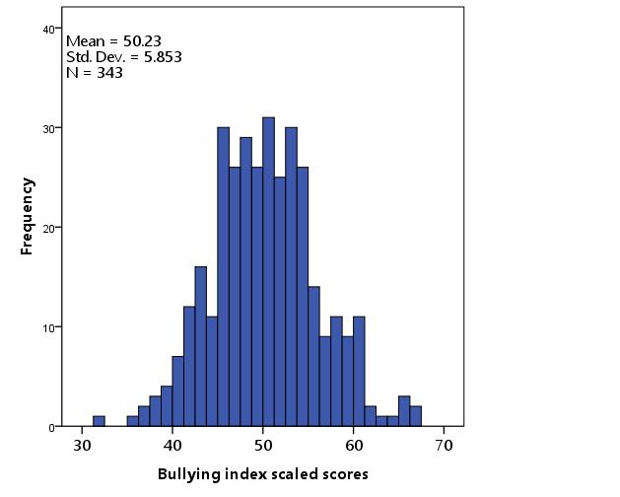

Table 8 shows the distributional properties of districts’ bullying climate scores for each of the four grades. Bullying scores vary the least in high school, with the largest variation in grade 5. Within each grade, districts were characterized into three district safety categories: least safe, typical, or most safe; the cutoffs used to classify districts into the three district safety categories are shown in Table 8.

Table 8: Distribution of bullying scaled scores by grade1

|  |  |  |  |  |  |  |  |
| --- | --- | --- | --- | --- | --- | --- | --- |
| Grade | Number of districts | Mean | Standard Deviation | Minimum | Maximum | Least safe2  cutoff | Most safe2 cutoff |
| Grade 4 | 236 | 57 | 5.6 | 42 | 67 | 51.4 | 62.6 |
| Grade 5 | 250 | 54 | 5.8 | 33 | 66 | 48.2 | 59.8 |
| Grade 8 | 264 | 44 | 5.4 | 30 | 62 | 38.6 | 49.4 |
| Grade10 | 253 | 45 | 4.6 | 30 | 59 | 40.4 | 49.6 |

1Districts are only included if the districts met the minimum reliability, N and % representation (see p. 5); 2Least safe districts’ bullying scores fall 1 or more standard deviations below the mean; most safe districts scores fall 1 or more standard deviations above the mean.

Tables 9 through 12 provide the average score for the least safe, typical, and most safe districts for each grade, respectively. The average bullying scaled scores of students in the least safe districts range from a low of 35 in grade 8 to a high of 48 in grade 4; in comparison, in the most safe districts, the average bullying scaled scores range from a low of 51 in grade 8 to a high of 64 in grade 4. To more easily assess the magnitude of the bullying scaled scores differences across all four grades, the average bullying scores for those districts that fall into the three district safety categories (i.e., least safe, typical, and most safe) were transformed into z-scores. Of the four grades, students in grade 8 in the least safe districts rate their climate, on average, three-quarters of a standard deviation below the state mean (a 27-percentile difference); of all students in the state, 8th grade students in the least safe districts experience the harshest bullying environments. In the next section, students’ item-level responses that separate the three district groups (least safe, typical, and most safe) in each grade are discussed.

Finding 4: Students in the least safe districts report experiencing or observing more bullying behaviors and are less likely to report that adults or students will step in to prevent bullying.

Figures 3 through 6 compare the probability of the average student responding in the most favorable item response category for each district safety group (least safe, typical, and most safe). For bullying protective factor items, a response of, *“always true”* is the most affirmative response; for bullying behavior items, a response of, *“never true”* is the most positive response. Across all four grades, students in the most safe districts experience less bullying than students in the typical or least safe districts. Overall, students in the most safe districts report they are 1.3 to 2.6 times *less likely* to experience or observe bullying within their schools when compared to students within the least safe districts. These students have, on average, a higher probability of responding, “never true” to all the bullying behavior items. For example, in grade 4, students in the most safe districts are, on average, nearly 2 times *more likely* to respond, “never true” to BUL 12 (In my school, older students scare or pick on younger students) than students in the least safe districts (Figure 3). Similarly, in grade 5, students in the most safe districts, on average, are 2.2 times *more likely* to respond, “never true” to BUL2 (I have been punched or shoved by other students more than once in the school or in the playground.) than students in the least safe districts (Figure 4). One of the largest disparities between the most safe and least safe districts was in response to BUL13 (In my school, groups of students tease or pick on one student.). Eighth grade students in the most safe districts were, on average, 2.6 times *more likely* to respond, “never true” to this item than students in the least safe districts (Figure 5).

In addition, across all grades, students in the least safe districts have a higher probability of reporting (1.3 to 2.4 times) that adults and students in their schools are less likely to intervene to prevent bullying. For example, in grade 5, students in the least safe districts are, on average, 1.6 times *less likely* to respond, “always true” to BUL8 (Teachers don’t let students tease each other) compared to students in the most safe districts (Figure 4). In grade 10 (Figure 6), students in the least safe districts are, on average, 2.2 times *less likely* to respond, “always true” to BUL4 (Students at school try to stop bullying when they see it happening) than students in the most safe districts.

Figure 3: 4th grade student responses by district safety category

|  |  |  |  |
| --- | --- | --- | --- |
| Table9: Students’ average bullying score within each performance category | | | |
| District Safety Category | Number of Students (Districts) | Grade-level Index Mean (S.D.) | State Average  z-score2 |
| Least safe1 | 4,984 (35) | 48 (17.7) | -.09 |
| Typical | 39,157 (170) | 57 (19.1) | .36 |
| Most safe | 6,538 (31) | 64 (19.5) | .71 |
| All | 50,679 (236) | 52 (19.3) | .36 |

1Least safe district: average score is 1 or more standard deviations (S.D.) below the grade-level mean. 2z-score: number of standard deviation units above or below the state mean.

Figure 4: 5th grade student responses by district safety category

Tl

|  |  |  |  |
| --- | --- | --- | --- |
| Table10: Students’ average bullying score within each performance category | | | |
| District Safety Category | Number of Students (Districts) | Grade-level Index Mean (S.D.) | State Average  z-score2 |
| Least safe1 | 7,345 (45) | 46 (17.5) | -.23 |
| Typical | 39,925 (166) | 55 (19.3) | .23 |
| Most safe | 7,414 (39) | 62 (19.9) | .59 |
| All | 54,684 (250) | 54 (19.6) | .22 |

1Least safe district: average score is 1 or more standard deviations (S.D.) below the grade-level mean. 2z-score: number of standard deviation units above or below the state mean.

Figure 5: 8th grade student responses by district safety category

|  |  |  |  |
| --- | --- | --- | --- |
| Table11: Students’ average bullying score within each performance category | | | |
| District Safety Category | Number of Students (Districts) | Grade-level Index Mean (S.D.) | State Average  z-score2 |
| Least safe1 | 4,880 (40) | 35 (15.2) | -.75 |
| Typical | 45,391 (179) | 43 (17.4) | -.36 |
| Most safe | 7,340 (45) | 51 (18.6) | .06 |
| All | 57,611 (264) | 43 (17.7) | -.34 |

1Least safe district: average score is 1 or more standard deviations (S.D.) below the grade-level mean. 2z-score: number of standard deviation units above or below the state mean.

Figure 6: 10th Grade student responses by district performance category

|  |  |  |  |
| --- | --- | --- | --- |
| Table12: Students’ average bullying score within each performance category | | | |
| District Safety Category | Number of Students (Districts) | Grade-level Index Mean (S.D.) | State Average  z-score2 |
| Least safe1 | 6,427 (39) | 38 (15.6) | -.62 |
| Typical | 39,667 (178) | 44 (17.1) | -.31 |
| Most safe | 5,369 (36) | 52 (18.7) | .07 |
| All | 51,463 (253) | 44 (17.4) | .-.31 |

1Least safe district: average score is 1 or more standard deviations (S.D.) below the grade-level mean. 2z-score: number of standard deviation units above or below the state mean.

Bullying is one of nine domains of school climate measured by the VOCAL survey. The next section expands the profiles of the least safe and most safe districts by examining what students in these two district safety categories report about the other domains of school climate. It examines the conditions within school environments that might help to explain the difference between the least safe and most safe bullying districts.

Finding 5: Students in the most safe districts report more positive relationships and a greater sense of physical safety than students in the least safe districts.

“Students need a sense of physical and psychological safety for learning to occur” (Darling-Hammond & Cook-Harvey, 2018, p15). Students learn best when they feel physically and emotionally safe in the school environment. When schools do not have behavioral rules, norms and structures in place to support students’ physical safety, students are more likely to experience or feel threatened by violence in their schools and bullying can go unchecked (Swearer, Espelage, Vaillancourt, & Hymel, 2010; Thapa, Cohen, Guffey, & Higgins, 2013). In all four grades, students in the least safe districts report feeling less physically safe (PSF); the PSF effect size is comparable to or even larger than the bullying effect size (Figure 7).

Trust and respect among and between staff, teachers, and students are fundamental to supporting students’ healthy development, sense of belonging, and feelings of safety in their schools (Darling-Hammond & Cook-Harvey, 2018). Figure 7 shows group differences in relationship (REL) scores for each grade. Students in the most safe districts report more positive relationships than students in the least safe districts. For instance, on the item, “Students respect one another”, students in the most safe districts were 1.5 times (younger grades) to over 2.0 times (older grades) more likely to respond, “always true” to this item than students in the least safe districts (data not shown). Overall, the difference in their reported perceptions of the quality of the relationships is greater than a third of a standard deviation (12-percentile). Students in the most safe districts also feel adults are more respectful and accepting of diversity (CLC). For example, they were 1.5 to 1.8 times more likely to respond, “always true” to the item, “Adults working at this school treat all students respectfully, regardless of a student’s race, culture, family income, religion, sex, or sexual orientation” (younger students responded to: “Adults working at this school treat all students with respect).

Figure 7: Difference in climate scores between least safe and most safe districts1,2

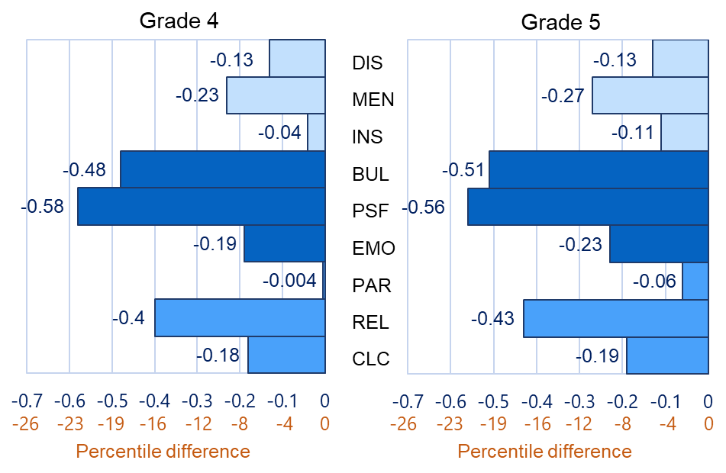

This caption helps readers understand which domains are associated with the three dimensions of school climate. The three dimensions of school climate are: Engagement, Safety, and Environment; domains are color coded depending on which dimension they belong to. The bullying domain belongs to the safety dimension.

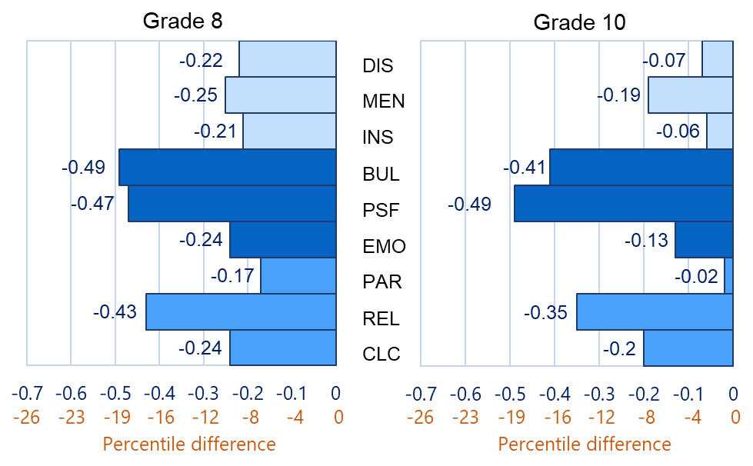

1Student-level differences are in standard deviation units.

2Engagement domains: CLC: Cultural and Linguistic Competence; REL: Relationships; PAR: Participation;

2Safety domains: EMO: Emotional Safety; PSF: Physical Safety; BUL: Bullying;

2Environment domains: INS: Instructional Environment; MEN: Mental-health Environment; DIS: Discipline Environment

When students do not feel a sense of belonging in their schools, it can increase students’ stress and anxiety which in turn impacts their learning and sense of safety (Darling-Hammond & Cook-Harvey, 2018). Students in the least safe districts report feeling less emotionally secure (EMO) and rate their school mental health (MEN) resources as less effective than students in the most safe districts. On average, the difference between students’ reports of emotional safety and the effectiveness of mental health resources are roughly 0.2 SDUs (8 percentiles, moderate) in all grades. Heightened stress and anxiety (as measured by reports of emotional safety) could make students in the least safe districts more susceptible to bullying.

Punitive discipline and a lack of a developmental, normed approach to discipline can heighten aggression and bullying behaviors in schools and lead to increased student stress and anxiety (Darling-Hammond & Cook-Harvey, 2018). Students in the least safe districts report less positive discipline environments than students in the most safe districts. This difference is largest in grade 8 and is equivalent to a fifth of a standard deviation (8 percentiles, moderate). The grade 8 difference is 1.7 to 3.1 times larger than the disparities found in the other three grades. This finding may reflect the lack of a developmental approach to discipline in middle schools where students typically seek more autonomy and social acceptance (Voight & Hanson, 2017). When relationships, emotional supports, and social acceptance do not reflect the developmental needs of students, more aggressive behaviors, bullying, and disciplinary issues are more likely to occur (Booth, & Gerard, 2014; Gage, Larson, Sugai & Chafouleas, 2016). This hypothesis about the relationship between higher bullying rates and less developmentally appropriate disciplinary strategies could help explain why grade 8 students in the least safe bullying districts experience and report less restorative discipline environments. In general, students in less safe districts also report feeling more physically and emotionally insecure, and view relationships as less caring, respectful and accepting of diversity. The overall school climate in these least safe districts is less positive and may contribute to the conditions that allow bullying to be both more prevalent and more tolerated.

*Students in the most safe districts are more likely to view adult on student relationships as more caring and respectful.*

Finding 6: On average, the least safe districts have lower ELA and math MCAS scaled scores and student growth percentiles, and less favorable levels of attendance and disciplinary actions than the most safe districts.

Achievement, attendance, and discipline data were compared for students in the least safe districts to those in the most safe districts. Figure 8 shows the standardized difference (SDUs) between the two groups’ ELA and mathematics MCAS mean scores, and for the means of four non-academic indicators. Appendices B3 (grade 4 and 5) and B4 (grade 8 and 10) provide further descriptive statistics for each comparison shown in Figure 8.

On average, students in the least safe districts scored between two-thirds of a standard deviation to four-fifths of a standard deviation lower on the 2019 ELA (labelled escaleds in Figure 8) and mathematics (mscaleds) MCAS than did students in the most safe districts. For example, students in the least safe districts scored, on average, 494 on the grade 5 ELA MCAS test; this compares to an average of 506 for students in the most safe districts (Appendix B3). Students in the least safe districts also experience lower levels of academic growth for both ELA (esgp) and mathematics (msgp) with average growth percentile differences ranging from 0.12 SDUs (ELA, grade 5) to 0.4 SDUs (mathematics, grade 10). For instance, grade 8 students in the least safe districts had an average mathematics student growth percentile of 47 compared to an average percentile of 51 for students in the most safe district (Appendix B4).

The scaled score differences in ELA (escaleds) and mathematics (mscaleds) between students in the least safe districts and those in the most safe districts are on the same order of magnitude as the difference in average student bullying climate perception scores. In grade 4, for example, the bullying score difference between students in the least safe districts and the most safe districts is equivalent to 0.8 SDUs; similarly, the difference in ELA and mathematics scaled scores for students in the least safe districts and the most safe districts are 0.78 and 0.75 SDUs, respectively.

Students attending the least safe districts have, on average, less favorable outcomes on four non-academic indicators than students in the most safe districts. Figure 8 shows that students in the least safe districts have higher levels of in-school suspensions (ISS), out-of-school suspensions (OSS), and higher discipline rates (DcpR) overall.

Figure 8: Standardized difference in student attendance and discipline rates in the least safe and most safe districts1

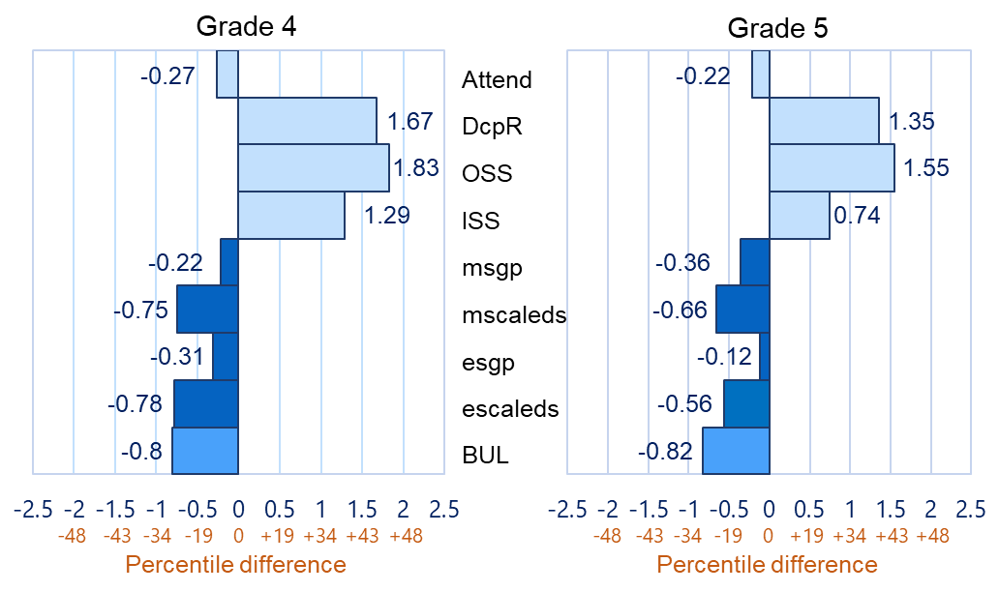

This caption shows the colors associated with the bullying score, the four academic indicators and the four non-academic indicators in Figure 8.

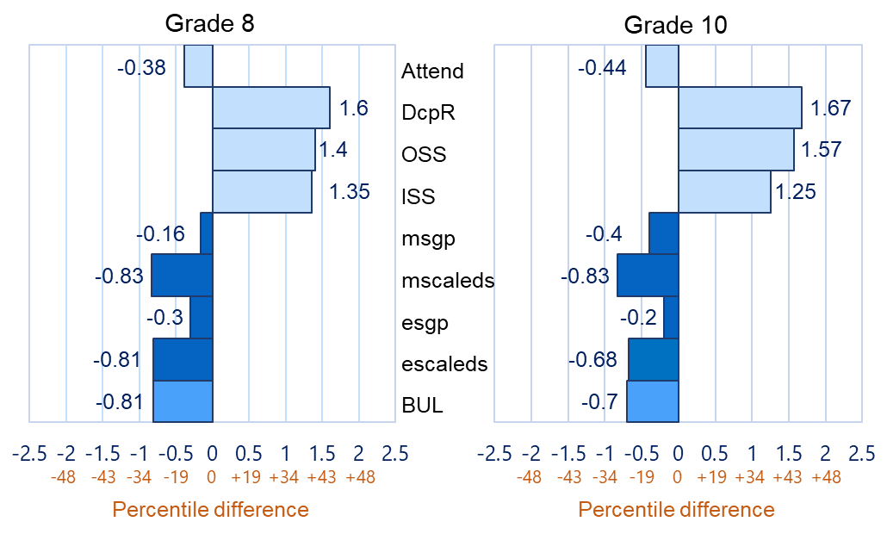

1 BUL: Bullying index scaled score; escaleds: ELA MCAS scaled score; esgp: ELA student growth percentile; mscaleds: mathematics MCAS scaled score; msgp: mathematics student growth percentile; ISS: in-school suspension; OSS: out-school suspension; DcpR: Disciplinary rates: Attend: Attendance.

For example, in grade 4, the average percent of ISS and OSS in the least safe districts is 3.7% and 5.7%, respectively; these rates decrease to 1.1% and 1.2% for students in the most safe districts (Appendix B3). Similarly, the average rate of disciplinary actions (DcpR) in grade 4 is also higher in the least safe districts (7.3%) than in the most safe districts (2.0%). These grade 4 differences for ISS, OSS, and disciplinary actions between the least safe and most safe districts are equivalent to 1.29, 1.83, and 1.67 SDUs, respectively (Figure 8). The results between least and most safe districts replicate across the four grades with all but one effect greater than a standard deviation in size (large effects). Huang and Cornell (2018) report that higher rates of student engagement in bullying is associated with higher rates of suspensions in schools; Gastic (2008), Ramirez et al., (2012) and Gage, Larson, Sugai, and Chafouleas (2016) found that bullying victims and perpetrators were more likely to experience more suspensions or other types of disciplinary actions than students with no involvement in bullying. The differences in the rates of suspensions between students in the least safe and most safe districts suggest that a greater level of tolerance for bullying may contribute to higher suspension rates in the least safe districts. Gregory, Cornell and Fan (2011) noted that teacher-student relationships that are caring, supportive, and respectful help reduce suspension rates in schools. Students in the least safe districts view teacher-student relationships as less caring and supportive than students in the most safe districts and feel less emotionally secure (see Finding 5). The poorer quality of teacher-student relationships in the least safe districts could exacerbate and contribute to the disparities in bullying and the resulting disciplinary actions and foster a school climate where discipline is more punitive rather than restorative.

*Students in the least safe bullying districts have, on average, higher rates of suspensions and perform less well on the state’s MCAS tests compared to students in the most safe districts.*

Students in the least safe districts also have, on average, lower attendance (Attend) than students in the most safe schools (Figure 8). The attendance difference between least safe and most safe districts ranged from 0.22 SDUs in grade 5 (roughly a 1%-point difference) to 0.44 SDUs (2%-point difference) in grade 10. Railsback (2004), in interviews of chronically absent students, found that teachers’ lack of respect and support, and students’ concerns for their safety were major factors that contributed to student absenteeism.

This brief cannot disentangle cause from effect, but the findings of this report taken together with the research cited imply that a lack of caring relationships and a low sense of physical and emotional security of students in the least safe districts may create conditions to exacerbate bullying and, as a result, trigger lower student attendance, and higher rates of student suspensions and disciplinary actions. The next set of findings examine the relationship between the type of district (urban or charter) and the geographical location of districts and the average district bullying climate scores.

Finding 7: Students attending urban districts report feeling less safe than students enrolled in non-urban districts.

Twenty-three of twenty-four urban districts are represented in the VOCAL survey and these students account for between 21% (grade 10) and 31% (grade 4) of the study’s sample (Appendix B1; B2). Figure 9 shows the bullying index scaled scores broken out by urbanicity and grade.

Figure 9: Bullying index scaled scores by urbanicity and grade

The gap between urban and non-urban students is largest in grade 4: this 5-point gap is equivalent to 0.26 SDUs (~10 percentile difference; moderate effect). The gap narrows to 2 to 3 points in the two older grades; the effect size of these gaps is 0.13 and 0.15 for grade 8 and grade 10, respectively (~ 5 percentiles, i.e., small effects). Despite these disparities, urbanicity was not significantly associated with the least safe district safety category. In grades 5, 8, and 10, all urban districts were associated with the “typical” district safety category. In grade 4, urban districts were distributed across the three district safety categories in proportion to their representation in the state.

Finding 8: On average, in 3 of the 4 grades, charter district students report feeling less safe compared to students in non-charter districts. Among students in charter districts, urban charter students report feeling the least safe.

Charter students represent between 4.2% (grade 4) to 7.2% (grade 8) of the study sample (see Appendices B1 and B2). Figure 10 compares the average bullying climate scaled scores by charter status broken out by grade.

Figure 10: Students’ bullying index scaled scores by charter status and grade

In three of the four grades, students in charter districts view their schools as less safe than students in non-charter districts; by the time students reach high school, charter and non-charter district students have comparable views of the bullying environment. The 7-point and 6-point gaps in grades 4 and 5 are equivalent to .33 and .31 SDUs, respectively (i.e., moderate effects); these gaps represent a 12 to 14 percentile difference. The 2-point difference between charter and non-charter students in grade 8 is small (0.08 SDUs; ~4-percentile) but still statistically significant.

Charter district status is significantly associated with the least safe district category, indicating comparatively harsher bullying climates in charter districts compared to non-charter districts. The significant association of charter school status with the least safe district category occurs despite 10th grade charter and non-charter students holding comparable views of bullying. In grades 4 and 5, 15% to 18% of all districts in the state fall within the least safe district category but almost 50% of charter school districts are in this category. In grades 8 and 10, roughly 15% of all districts in the state fall within the least safe district category while 22% and 28% of charter school districts fall in this category, respectively.

*In grades 4 and 5, 15% to 18% of all districts in the state fall within the least safe district safety category but almost 50% of charter school districts are within this category.*

A further breakdown of charter districts was performed. Students’ bullying responses in charter districts located in urban areas was compared to charter students’ responses in non-urban locales. The average bullying index scaled scores for charter districts broken out by urbanicity and grade is shown in Figure 11. Across all four grades, students in urban charters feel less safe than students in non-urban charters. The larger 7‑point gap in grade 4 is of moderate size (i.e., 0.33 SDUs, 14 percentiles); the smallest gap of 3 points in grade 5 is equivalent to a 0.16 effect size (i.e., 6-percentiles; small);. Appendices B1 and B2 provide further descriptive statistics for Figure 11. Replication of the results across the four grades supports the interpretation that urban charter students, on average, feel less safe than non-urban charter students. Overall, charter students feel less safe than non-charter students.

Figure 11: Charter students’ bullying climate scores by urbanicity and grade

Finding 9: Students in western Massachusetts report feeling less safe, on average, compared to students in other regions of the state.

Districts were categorized into five regions using DESE’s five regional student advisory council regions. For each grade, western Massachusetts students represent approximately 14% of students in this study (Appendix B1; B2). Figure 12 shows the average bullying climate scaled scores by region and grade. On average, western Massachusetts students score 2 to 4 points lower than their peers. The largest point difference represents a fifth of a standard deviation or an 8-percentile gap (i.e., moderate effect). The score difference between western Massachusetts and the other four regions of the state replicates in all four grades; replication supports the validity of the finding.

*In grades 8 and 10, roughly 15% of all districts in the state fall within the least safe district safety category but they account for 30% (G8) and 37% (G10) of districts within western Massachusetts, respectively.*

Districts in western Massachusetts are significantly associated with the least safe district category (i.e., districts scoring 1 or more standard deviations below the grade-level mean). In grades 4 and 5, 15% to 18% of all districts in the state fall within the least safe district category but they make up 25% to 31% of districts within western Massachusetts, respectively.

Figure 12: Bullying index scaled scores by region and grade

In grades 8 and 10, roughly15% of all districts in the state fall within the least safe district category but they account for 30% and 37% of districts within western Massachusetts, respectively. The similarity of these associations across all four grades provides further evidence that students in western Massachusetts feel less safe when compared to their peers in other geographic regions.

**Key Findings by Race: Black - White Students**

This section explores whether and how black students differ in their bullying climate perceptions when compared to white students and looks at factors that might help explain any differences observed. It also examines the relationship between black-white bullying climate gaps and black-white achievement gaps.

Finding 10: On average, in each of the four grades measured, black students feel less safe compared to white students. The gaps between black and white student perceptions of bullying narrow somewhat by the time students reach middle and high school but they remain statistically significant.

Black students are evenly distributed across the four grades and represent 8.6% of all students in the sample; black students make up 9.2% of students in Massachusetts. White students represent, on average, 58% of students in the state and 61% of students in this study. The proportion of white students in the state ranges from 57% in grade 4 to 60% in grades 8 and 10. In this study, the share of white students ranges from 57% in grade 5 to 65% in grade 10 (Appendices B1 and B2). Figure 13 shows that black students report feeling less safe in their schools than do white students.

Figure 13: Black and white student bullying climate gap1

1Higher bullying climate score corresponds to a more favorable bullying climate

The 7 and 8-point black-white gaps (henceforth gap) in grades 4 and 5 represent just over a third of a standard deviation (i.e., 14 percentiles; moderate effect), respectively. These gaps reduce to 3 to 4 points in grade 8 and grade 10, respectively; these gaps represent roughly a tenth (i.e., 4 percentiles; small) to a fifth (i.e., 8 percentiles; moderate,) of a standard deviation, respectively and are statistically significant.

Finding 11: The black-white student achievement gap in grades 8 and 10 is 3.3 to 4.5 times larger than the black-white student bullying gap, but near equivalent in grades 4 and 5.

Racial academic achievement gaps are a perennial issue in Massachusetts. In 2017, Massachusetts was 31 out of 50 states in terms of educational equity by race. For example, on the 2017 National Assessment of Educational Progress, fewer than a third of black students in grade 4 were proficient in reading; this compares to 60 percent of white students (Rennie Center, 2018). The student achievement gap comparison helps benchmark the magnitude of the student bullying climate gaps. Figure 14 compares the size of the bullying climate gap to the student achievement gap by grade; these differences are expressed in standard deviation units (SDUs).

Figure 14: Comparison of black-white student achievement and bullying climate gaps

In contrast to the bullying climate gap (see figure 13), the achievement gap does not narrow in the older grades. As a result, the achievement gap is 1.4 and 1.7 times the climate gap in grades 5 and 4, respectively; it increases to 3.3 and 4.5 times the climate gap in grades 10 and 8, respectively. The next set of analyses examines if there is a relationship between racial achievement gaps and racial bullying gaps at the district level. Voight, Hanson, O’Malley, and Adekayne (2015) found that, in middle schools, larger black-white gaps in safety were associated with larger black-white gaps in achievement.

Finding 12: Districts with larger black-white bullying gaps have larger district gaps in ELA MCAS growth scores.

For the analyses discussed for Finding 12 and those discussed in Finding 13, 14, and 15, results from all grades were combined to calculate the average district z-scores for bullying climate perceptions. 172 districts met the minimum reporting requirements for these analyses (see p.5). Figure 15 shows the relationship between district black‑white ELA MCAS student growth percentile (esgp) gaps and district bullying climate gaps.

Figure 15: Relationship between district ELA MCAS student growth percentile (esgp) racial gaps and district bullying racial gaps

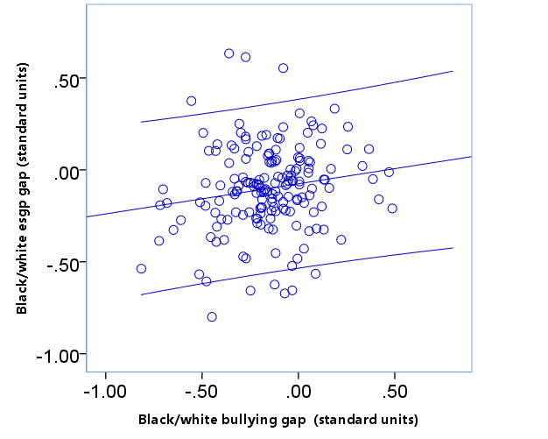

District ELA student growth percentile gaps and bullying climate gaps are positively correlated; the correlation of 0.16 is small but statistically significant (*p* < 0.05). Districts with larger MCAS ELA student growth percentile achievement gaps also have larger bullying climate gaps. Districts’ bullying climate gaps are not significantly related to districts’ ELA or mathematics MCAS scaled score gaps, or with districts’ mathematics student growth percentile gaps. Although the racial bullying climate gaps are smaller in magnitude than the racial achievement gaps, they are still concerning. Research has shown that students who are bullied have, on average, lower academic achievement (Nakamoto & Schwartz, 2010); a higher level of bullying experienced by black students could contribute to their lower academic achievement. The next sections examine what conditions within districts’ school environments may contribute to the black-white differences observed.

Finding 13: Districts with overall safer school environments have smaller black-white district bullying gaps.

Figure 16 shows the relationship between average district-level bullying scores and the size of the district-level black-white bullying gap. The small negative correlation (-0.24) is statistically significant (*p* < 0.01). Districts with higher bullying scores, or more positive bullying climates, have, on average, smaller black-white bullying gaps.

Figure 16: Relationship between average district-level bullying scores and the size of the district-level black-white bullying gap.

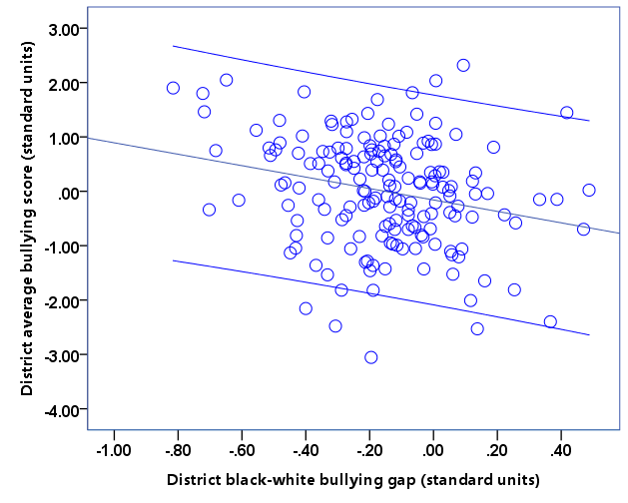

Notably, in some of the least safe districts (those with low average bullying scores), black students feel safer than their white peers (positive gap). These data indicate the importance of assessing how different groups of students view the safety of their environment and how students in the same settings may have different perceptions and experiences of bullying depending upon their race. “Microclimates” based on students’ race may exist within schools and districts (Voight, Hanson, O’Malley, & Adekanye, 2015).

Finding 14: The largest gaps between black and white students’ bullying perceptions are primarily in predominantly white, non-urban districts.

Figure 17 shows the relationship between the size of the bullying climate race gap in districts and the percentage of black students within districts. The equity line is located at zero on the y-axis of the graph; there is no difference in bullying climate perceptions between black and white students for districts on this line. Most districts fall below the equity line indicating that in these districts black students feel less safe than white students. As noted earlier, there are some districts where black students feel safer than white students (districts above equity line).

Figure 17: District bullying climate race gap by percentage of black students

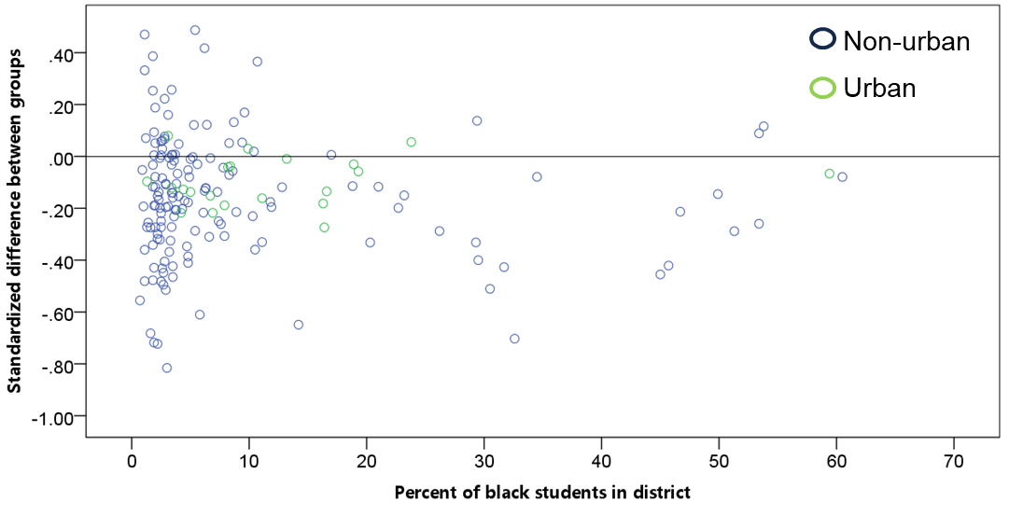

On average, the bullying gap is significantly larger in non-urban districts (in blue) than in urban districts (in green). The average gap for the 151 non-urban districts was ‑0.15 SDUs; in the 21 urban districts the gap was ‑0.10 SDUs. Figure 17 also highlights the relationship between the percentage of black students in districts and the size of districts’ bullying climate gaps. The largest bullying climate gaps are in non-urban districts (in blue) that are predominantly white.

Finding 15: Black students report their schools as less respectful, less accepting of diversity, and less physically and emotionally secure than white students.

This section compares black and white student responses to the other domains of school climate as they might help explain the difference observed between black and white students’ bullying perceptions. The average bullying climate difference between black and white students across all four grades is equivalent to a quarter of a standard deviation or a 10-percentile difference (Figure 18).

A large difference between the two student groups is evident in students’ physical safety (PSF) perceptions; black students feel less physically secure than white students. The effect size of the PSF difference is equivalent to roughly a third of a standard deviation (a 14-percentile gap). Beyond these two safety domains, black and white students differ in their perception of the quality of the relationships in their schools. Relationships (REL) between staff, teachers, and students are viewed as less caring and respectful by black students when compared to white students. Figure 18 also shows that black students, more so than white students, feel diversity (CLC) is less valued and respected in their schools (‑0.15 SDUs; 6 percentile gap).

The school climate domains of bullying, physical safety, and relationships were key differentiators when least safe districts were compared to the most safe districts (Finding 5). Similar to the district findings, students’ sense of emotional security (EMO: ‑0.11 SDUs, 4‑percentile) and views on the effectiveness of the mental health resources in their schools (MEN: -0.12 SDUs, 5 percentile gap) separate black and white student perceptions. Black students feel less emotionally secure and view school mental health resources more negatively.

Black students feel more meaningfully engaged in their classrooms (PAR: +.15 SDUs) and view their instructional environments as more supportive of learning (INS: +0.11 SDUs) than do white students. Voight, Hanson, O’Malley, and Adekayne (2015) found similar black-white gaps in relationships and safety among middle schoolers; however, the results here do not conform to their finding that black students feel less engaged than white students. More research is required to determine if efforts to improve black students’ sense of safety, the quality of their teacher and peer relationships, and the degree of their connection and acceptance within their schools could advance their academic achievement.

Figure 18: Difference in climate scores between black and white students (all grades)1,2

This caption helps readers understand which school climate domains are associated with the three dimensions of school climate. The three dimensions are: Engagement, Safety, and Environment. Each dimension is color coded separately. Bullying belongs to the safety dimension.

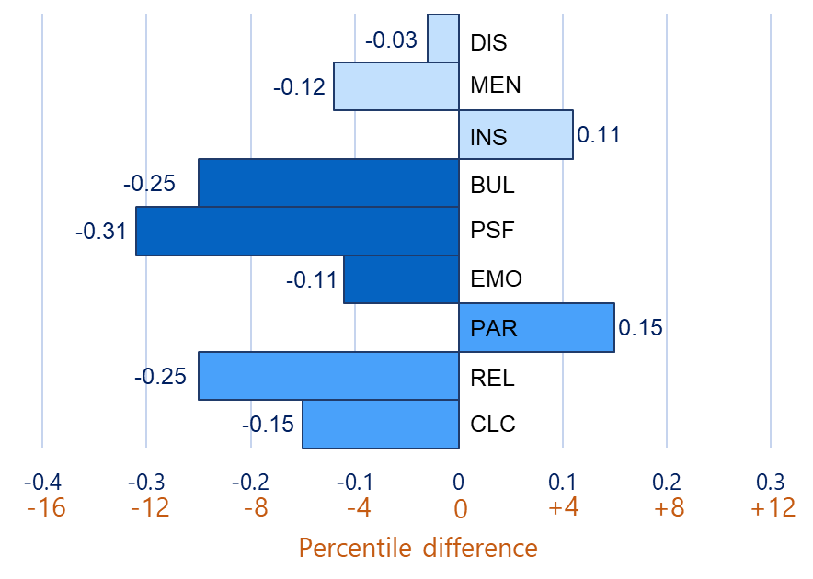

1Student-level differences are in standard deviation units.2 Engagement domains: CLC: Cultural and Linguistic Competence; REL: Relationships; PAR: Participation; Safety domains: EMO: Emotional Safety; PSF: Physical Safety; BUL: Bullying; Environment domains: INS: Instructional Environment; MEN: Mental-health Environment; DIS: Discipline Environment

Darling-Hammond and Cook-Harvey (2018) view strong teacher-student relationships as the most important element of school climate needed to support student learning and academic achievement; “when teachers view students’ experiences as an asset and intentionally bring students’ voices into the classroom, they create an “identity-safe” and engaging atmosphere for learning to take place” (p21). For black students, identity-safe classrooms are likely needed to support these relationships and their academic success. Studies such as Darling-Hammond and Cook-Harvey’s and the data from this study suggest that if black students feel safer and more respected, their susceptibility to bullying victimization may lessen and the black-white bullying climate gap could narrow. More respectful and identity-safe classrooms could possibly also help promote black students’ academic achievement.

Summary

This brief focused on Massachusetts students’ perceptions of their district and school bullying climates. Some students feel less safe than others and significant variation in bullying climate perceptions is apparent between students enrolled in different districts. Younger students report safer school environments than older students. Middle and high school environments appear to provide students with less protection from bullying than elementary school environments.

Irrespective of grade, when the least safe districts are compared to the most safe districts, differences in VOCAL student reports may help explain why bullying is more problematic in the least safe districts. In contrast to students in the most safe districts, students in the least safe districts report feeling less physically and emotionally secure and view teacher and peer relationships as less respectful and caring. The school environments within these least safe districts are more conducive to bullying. District characteristics can also help explain the variation in district bullying climate scores. Students in charter and/or urban districts, and students in western Massachusetts report feeling less safe in their schools.

Students’ sense of safety is correlated with their academic achievement, attendance, and disciplinary experiences. When students personally feel safer or when they are in districts where, on average, students report safer school environments, student achievement is higher, and students demonstrate better attendance and are less likely to experience disciplinary action such as suspensions or expulsions.

Black students feel less safe in school than white students in Massachusetts (though to a lesser degree in middle and high school). The largest gaps between black and white students’ reports of bullying in school are in predominantly white, non-urban districts where the low proportion of black students likely makes it harder for them to connect with and have a sense of belonging to their predominantly white peers, teachers, and schools. Improving relations between black students and their school communities may help strengthen the bond black students have to their schools and reduce the likelihood of them experiencing bullying. This brief provides some evidence that there is a relationship between the black-white bullying gap and the black-white achievement gap, though this analysis explored only correlations and did not include methods that would allow for causal interpretations. Correlations between black-white achievement gaps and bullying gaps were only significant for the MCAS ELA student growth percentile analysis. More research is needed to examine whether narrowing black-white bullying gaps could also help reduce black-white achievement gaps in Massachusetts.

Limitations of study.

The reliability of the bullying scale was such that it only supported analyzing aggregate data at the district level and not at the school level. Given that the bullying data resulted from a school climate survey administered to students, it would have been ideal to report findings at the school level. Because developers of the VOCAL survey did not want to burden students with an overly long survey, not all bullying behavior items appeared on each grade-level survey and the total number of bullying items was capped to ensure a balanced school climate survey in each grade. As a result, the reliability of the bullying scale was only sufficient to perform analyses at the district-level for each grade. The relatively low reliability also impacted the analyses between black and white students as it was only possible to perform some of the student group analyses by aggregating the data across all four grades.

References

Beran, T. N., Hughes, G. and Lupart. (2008). A model of achievement and bullying: analyses of the Canadian National Longitudinal Study of Children and Youth Data. *Educational Research, 50* (1), 25 –39.

Booth, M. Z. and Gerard, J. M. (2014) Adolescents’ stage-environment fit in middle and high school: The relationship between students’ perceptions of their schools and themselves. *Youth & Society, 46* (6), 735 – 755.

Darling-Hammond, L., and Cook-Harvey, C. M. (2018). *Educating the whole child: Improving school climate to support student success.* Palo Alto, CA: Learning Policy Institute.

Dunne, M., Sabetes, R., Bosumtwi-Sam, C., and Owusu, A. (2013). Peer relations, violence, and school attendance: Analyses of bullying in senior high schools in Ghana. *Journal of Developmental Studies, 49* (2), 285 –300.

Gage, N. A., Larson, A., Sugai, G., and Chafouleas, S. M. (2016). Student perceptions of school climate as predictors of office discipline referrals. *American Educational Research Journal,* 33 (3), 492 – 515.

Gastic, B. (2008). School truancy and the disciplinary problems of bullying victims. *Educational Review, 60* (4), 391 – 404.

Gregory, A., Cornell, D., and Fan, X. (2011). The relationship of school structure and support to suspension rates for black and white high school students. *American Educational Research Journal*, 48 (4), 904 – 934.

Huang, F. L., and Cornell, D. (2018). Relationship between school climate and out-of-school suspensions. *Children and Youth Services Review, 94*, 378 – 389.

Kraft, M. (2019). *Interpreting Effect Sizes of Education Interventions.* (EdWorkingPaper: 19-10). Retrieved from Annenberg Institute at Brown University: <http://www.edworkingpapers.com/ai19-10>.

Kutsyuruba, B., Kinger, D. and Hussain, A. (2015). Relationships among school climate, school safety, and student achievement and well-being: A review of the literature. *Review of Education, 3* (2), 103 – 135.

Lacey, A. and Cornell, D. (2013). The impact of teasing and bullying on schoolwide academic performance. *Journal of Applied School Psychology, 29* (3), 262 – 283.

Morrow, M. T., Hubbard, J. A., and Swift, L. E. (2014). Relations among multiple types of peer victimization, reactivity to peer victimization, and academic achievement in fifth grade. *Merrill-Palmer Quarterly, 60* (3), 302 – 327.

Mundy, L.K. et. al. (2017). Peer victimization and academic performance in primary school children. *Academic Pediatrics, 17* (8), 830 – 836.

Nakamoto, J. and Schwartz, D. (2010). Is peer victimization associated with academic achievement? *Social Development, 19* (2), 221 – 242.

Oliveira, F. R., Almeida de Menezes, T., Irffi, G. and Oliveira, G. R. (2018). Bullying effect on student’s performance. *Economia*, 19, 57 – 73.

Rasch, G. (1960). *Probabilistic models for some intelligence and attainment tests*. Copenhagen: Danish Institute for Educational Research. (Expanded edition, 1980. Chicago: University of Chicago Press).

Ramirez, M. et. al. (2012). Youth violence across multiple dimensions: A study of violence, absenteeism, and suspension among middle school student children. *Journal of Pediatrics, 161* (3), 542 – 546.

Railsback, J. (2004). *Increasing Student Attendance: Strategies from Research and Practice.* Northwest Regional Educational Laboratory, Portland, OR. Retrieved from http://educationnorthwest.org/ webfm_send/302.

Rennie Center for Education Research. Condition of Education in the Commonwealth. Winter, 2019. Retrieved from: <https://www.renniecenter.org/sites/default/files/2019-01/2019%20Condition%20of%20Education%20Action%20Guide_Student%20Voice.pdf>.

Swearer Napolitano, S. M., Espelage, D. L., Vaillancourt, T., Hymel, S. (2010). What can be done about school bullying? Linking research to education practice. *Educational Researcher, 39* (1), 38 – 47.

Thapa, A., Cohen, J., Guffey, S. and D’Alessandro, A. H. (2013). A review of school climate research. *Review of Educational Research, 83* (3), 357 – 385.

Voight, A., Hanson, T., O’Malley, M., and Adekanye, L. (2015). The racial school climate gap: Within-school disparities in students’ experiences of safety, support and connectedness. American Journal of Community Psychology, 56 (3–4), 252 – 267

Voight, A., and Hanson, T. (2017). How are middle school climate and academic performance related across schools and over time? (REL 2017–212). Regional Educational Laboratory West, Retrieved from: <http://ies.ed.gov./ncee/edlabls>.

Waasdorp, T. E., Pas, E. T., Zablotsky, B., and Bradshaw, C. P. (2017). Ten-year trends in bullying and related attitudes among 4th-to 12th-graders. *Pediatrics, 139* (6): e20162615.

Wright, B. D., & Masters, G. N. (1982). Rating scale analysis. Chicago: MESA Press

Appendix A

The View of Climate and Learning (VOCAL) conceptual framework**1**

|  |  |  |
| --- | --- | --- |
| **Dimension** | **Domain (label)** | **Definition** |
| Engagement  (ENG) | Cultural and Linguistic Competency (CLC) | The extent students feel adults/students value diversity, manage dynamics of differences, and avoid stereotypes. |
| Engagement  (ENG) | Relationships (REL) | The extent students feel there is a social connection and respect between staff/teachers and students, and between students and their peers. |
| Engagement  (ENG) | Participation (PAR) | The extent students feel engaged intellectually, emotionally, and behaviorally in the classroom, and the extent that students or their parents are engaged in school life. |
|  |  |  |
| Safety  (SAF) | Emotional Safety (EMO) | The extent students feel a bond to the school, and the extent adults/students support the emotional needs of students. |
| Safety  (SAF) | Physical Safety (PSF) | The extent that students feel physically safe within the school environment. |
| Safety  (SAF) | Bullying/Cyber-bullying (BUL) | The extent that students report different types of bullying behaviors occurring in the school and the extent that school/staff/students try to counteract bullying. |
|  |  |  |
| Environment  (ENV) | Instructional (INS) | The extent that students feel the instructional environment is collaborative, relevant, challenging and supportive of learning. |
| Environment  (ENV) | Mental Health (MEN) | The extent that students have access to support systems that effectively support their social, emotional, and mental-health well-being. |
| Environment  (ENV) | Discipline (DIS) | The extent that discipline is fair, applied consistently and evenly, and a shared responsibility among staff, teachers, and students. |

1Based on the USED’s conceptual framework (USED, 2019)

Appendix B1: Grades 4 and 5 bullying climate figures (Fig.) descriptive statistics

|  |  |  |  |  |  |
| --- | --- | --- | --- | --- | --- |
| Fig. | Factor | Grade 4  Mean (s.d.)1 | Grade 4  Pct.2 Med.3 | Grade 5  Mean (s.d.)1 | Grade 5  Pct.2 Med.3 |
| 1 | Number | 55,569 | 78%2 | 59,159 | 81%2 |
| Bullying score | 57.7 (19.5) | 56.43 | 55.0 (19.8) | 53.13 |
| School climate score | 61.7 (18.5) | 62.73 | 56.8 (18.7) | 57.13 |
| 9 | Number | 17,186 | 30.9%2 | 16,963 | 28.7%2 |
| Urban | 54.0 (19.1) | 51.93 | 51.6 (19.1) | 48.53 |
| Number | 38,383 | 69.1%2 | 42,196 | 71.3%2 |
| Non-urban | 59.3 (19.4) | 56.43 | 56.3 (19.9) | 53.13 |
| 10 | Number | 2,359 | 4.2%2 | 3,339 | 5.6%2 |
| Charter | 51.4 (18.8) | 47.93 | 49.1 (19.3) | 48.53 |
| Number | 53,210 | 95.8%2 | 55,820 | 94.4%2 |
| Non-Charter | 57.9 (19.5) | 56.43 | 55.3 (19.8) | 53.23 |
| 11 | Number | 1921 | 3.5%2 | 2746 | 4.6%2 |
| Urban charter | 50.2 (18.4) | 47.93 | 48.6 (19.3) | 48.53 |
| Number | 438 | 0.8%2 | 593 | 1.0%2 |
| Non-urban charter | 56.6 (19.6) | 56.43 | 51.7 (19.0) | 48.53 |
| 12 | Number | 10,200 | 18.4% | 10,771 | 18.2% |
| Northeast Region | 58.4 (19.5) | 56.43 | 54.7 (19.8) | 53.13 |
| Number | 15,972 | 28.7% | 16,891 | 28.6% |
| Southeast Region | 58.4 (19.7) | 56.43 | 55.8 (19.9) | 53.13 |
| Number | 10,059 | 18.1% | 10,636 | 18.0% |
| Greater Boston | 57.1 (19.5) | 56.43 | 55.2 (19.5) | 53.13 |
| Number | 11,679 | 21.0% | 12,539 | 21.2% |
| Central Mass. | 58.5 (19.2) | 56.43 | 55.6 (19.7) | 53.13 |
| Number | 7,659 | 13.8% | 8,322 | 14.1% |
| Western Mass. | 54.7 (19.0) | 51.93 | 52.1 (19.8) | 48.53 |
| 13 | Number | 4,875 | 8.8%2 | 5,125 | 8.7%2 |
| Black students | 52.2 (18.8) | 47.93 | 49.7 (19.0) | 48.53 |
| Number | 32,494 | 58.5%2 | 35,126 | 59.4%2 |
| White students | 59.5 (19.5) | 56.43 | 56.6 (19.9) | 53.13 |

1s.d: Standard deviation: 2Pct: Percent represented in sample; 3Med: Median

Appendix B1 cont.: Grades 4 and 5 bullying climate figures descriptive statistics

|  |  |  |  |
| --- | --- | --- | --- |
| Figure | Factor | Grade 4  Mean (s.d.)1 | Grade 5  Mean (s.d.)1 |
| 14  Bullying scaled score | Number | 4,875 | 5,125 |
| Black students | 52.2 (18.8) | 49.7 (19.0) |
| Number | 32,494 | 35,126 |
| White students | 59.5 (19.5) | 56.6 (19.9) |
| 14  ELA  MCAS scaled score  (escaleds) | Number | 4,782 | 5,034 |
| Black student | 493 (20.0) | 493 (20.5) |
| Number | 32,322 | 34,921 |
| White students | 505 (20.1) | 504 (19.4) |
| 14 Mathematics  MCAS scaled score  (mscaleds) | Number | 4,805 | 5,072 |
| Black students | 488 (21.3) | 490 (19.4) |
| Number | 32,418 | 35,010 |
| White students | 502 (21.0) | 501 (19.2) |

Appendix B2: Grades 8 and 10 bullying climate figures (Fig.) descriptive statistics

|  |  |  |  |  |  |
| --- | --- | --- | --- | --- | --- |
| Fig. | Factor | Grade 8  Mean (s.d.)1 | Grade 8  Pct.2 Med.3 | Grade 10  Mean (s.d.)1 | Grade 10  Pct.2 Med.3 |
| 1 | Number | 58,729 | 81%2 | 52,825 | 73%2 |
| Bullying score | 43.5 (17.8) | 42.53 | 44.2 (17.5) | 41.03 |
| School climate score | 43.3 (17.1) | 42.73 | 43.7 (17.5) | 42.33 |
| 9 | Number | 15,231 | 25.9%2 | 11,076 | 21.0%2 |
| Urban | 41.7 (17.1) | 39.03 | 41.8 (17.4) | 41.03 |
| Number | 43,498 | 74.1%2 | 41,749 | 79.0%2 |
| Non-urban | 44.1 (18.1) | 42.53 | 44.8 (17.4) | 44.93 |
| 10 | Number | 4,228 | 7.2%2 | 2,842 | 5.4%2 |
| Charter | 42.1 (17.6) | 42.53 | 45.1 (19.1) | 44.93 |
| Number | 54,501 | 92.8%2 | 49,983 | 94.6%2 |
| Non-Charter | 43.6 (17.9) | 42.53 | 44.1 (17.4) | 41.03 |
| 11 | Number | 3006 | 5.1%2 | 1862 | 3.5%2 |
| Urban charter | 40.8 (17.3) | 39.03 | 43.3 (18.4) | 41.03 |
| Number | 1222 | 2.1%2 | 973 | 1.8%2 |
| Non-urban charter | 45.4 (17.7) | 42.53 | 48.3 (19.8) | 44.93 |
| 12 | Number | 10,830 | 18.4%2 | 10,732 | 20.3%2 |
| Northeast | 44.5 (17.8) | 42.53 | 45.0 (17.5) | 44.93 |
| Number | 17,612 | 30.0%2 | 15,318 | 29.0%2 |
| Southeast | 43.5 (18.1) | 42.53 | 43.8 (17.3) | 41.03 |
| Number | 9,675 | 16.5%2 | 8,749 | 16.6%2 |
| Greater Boston | 44.8 (17.7) | 42.53 | 45.9 (17.8) | 44.93 |
| Number | 12,429 | 21.2%2 | 10,747 | 20.3%2 |
| Central Mass. | 43.4 (17.7) | 42.53 | 44.1 (17.4) | 41.03 |
| Number | 8,183 | 13.9%2 | 7,279 | 13.8%2 |
| Western Mass. | 40.9 (17.4) | 39.03 | 42.0 (17.7) | 41.03 |
| 13 | Number | 5,147 | 8.8%2 | 4,254 | 8.1%2 |
| Black students | 41.2 (16.8) | 39.03 | 40.7 (17.5) | 37.33 |
| Number | 36,549 | 62.2%2 | 34,470 | 65.3%2 |
| White students | 43.8 (18.1) | 42.53 | 45.1 (17.4) | 44.93 |

1s.d: Standard deviation: 2Pct: Percent represented in sample; Med: Median

Appendix B2 cont.: Grades 8 and 10 bullying climate figures descriptive statistics

|  |  |  |  |
| --- | --- | --- | --- |
| Figure | Factor | Grade 8  Mean (s.d.)1 | Grade 10  Mean (s.d.)1 |
| 14  Bullying scaled score | Number | 5,147 | 4,254 |
| Black students | 41.2 (16.8) | 40.7 (17.5) |
| Number | 36,549 | 34,470 |
| White students | 43.8 (18.1) | 45.1 (17.4) |
| 14  ELA  MCAS scaled score  (escaleds) | Number | 5,042 | 4,102 |
| Black student | 489 (22.8) | 496 (21.4) |
| Number | 36,367 | 34,151 |
| White students | 503 (22.7) | 511 (20.9) |
| 14  Mathematics  MCAS scaled score  (mscaleds) | Number | 5,085 | 4,214 |
| Black students | 488 (20.4) | 493 (21.1) |
| Number | 36,457 | 34,426 |
| White students | 502 (21.0) | 509 (20.8) |

Appendix B3: Grades 4 and 5 least safe and most safe district descriptive statistics

|  |  |  |  |  |  |
| --- | --- | --- | --- | --- | --- |
| Fig. | Achievement data | Grade 4 | | Grade 5 | |
| Least safe  Mean (s.d.)1 | Most safe  Mean (s.d.)1 | Least safe  Mean (s.d.)1 | Most safe |
| 8 | Number of students | 4,984 | 6,538 | 7,345 | 7,414 |
| Bullying score | 48 (17.7) | 64 (19.5) | 46 (17.5) | 62 (19.9) |
| Number of students | 4,867 | 6,490 | 7,213 | 7,373 |
| ELA MCAS  scaled score (escaleds) | 491 (20.3) | 509 (20.1) | 494 (21.2) | 506 (19.6) |
| Number of students | 4,608 | 6,254 | 6,844 | 7,145 |
| ELA esgp | 44 (28.2) | 53 (28.8) | 48 (29.3) | 51 (28.5) |
| Number of students | 4,894 | 6,524 | 7,262 | 7,389 |
| Mathematics MCAS scaled score (mscaleds) | 488 (22.4) | 505 (20.5) | 489 (20.0) | 504 (19.3) |
| Number of students | 4,621 | 6,262 | 6,854 | 7,150 |
| Mathematics msgp | 45 (28.5) | 51 (28.1) | 42 (28.6) | 52 (28.0) |
| Fig. | Non-academic data | Least safe  Mean (s.d.)1 | Most safe  Mean (s.d.)1 | Least safe  Mean (s.d.)1 | Most safe  Mean (s.d.)1 |
| 8 | Number of students | 4,983 | 6,533 | 7,345 | 7,414 |
| Percent attendance1 | 95% (4.6) | 96% (3.3) | 95% (4.5) | 96% (3.4) |
| Number of students | 4,703 | 6,379 | 7,256 | 6,887 |
| Percent In-school suspension (ISS)2 | 3.7% (2.4) | 1.1% (1.2) | 2.5% (1.7) | 1.0% (1.1) |
| Number of students | 4,703 | 6,379 | 7,256 | 6,887 |
| Percent Out-school suspension (OSS)3 | 5.7% (2.6) | 1.2% (0.7) | 5.0% (1.4) | 1.4% (1.0) |
| Number of students | 4,984 | 6,538 | 7,345 | 7,414 |
| Disciplinary Rate4 | 7.3% (3.5) | 2.0% (1.3) | 6.3% (3.2) | 2.0% (1.4) |

1Attendance rate: Indicates the average percentage of days in attendance for students enrolled in study; 2In-School Suspension Rate: The percentage of enrolled students in study who received one or more in-school suspensions. 3Out-of-School Suspension Rate: The percentage of enrolled students in study who received one or more out-of-school suspensions;4Discipline rate: the number of disciplinary incidents divided by school enrollment for study participants

Appendix B4: Grades 8 and 10 least safe and most safe district descriptive statistics

|  |  |  |  |  |  |
| --- | --- | --- | --- | --- | --- |
| Fig. | Achievement data | Grade 8 | | Grade10 | |
| Least safe  Mean (s.d.)1 | Most safe  Mean (s.d.)1 | Least safe  Mean (s.d.)1 | Most safe  Mean (s.d.)1 |
| 8 | Number of students | 4,880 | 7,340 | 6,427 | 5,369 |
| Bullying score | 35 (15.2) | 51 (18.6) | 38 (15.6) | 52 (18.7) |
| Number of students | 4,843 | 7,304 | 6,238 | 5,332 |
| ELA MCAS  scaled score (escaleds) | 493 (22.8) | 511 (22.0) | 500 (22.8) | 515 (20.3) |
| Number of students | 4,659 | 7,086 | 5,407 | 4,945 |
| ELA esgp | 45 (28.7) | 54 (28.2) | 48 (28.4) | 53 (27.9) |
| Number of students | 4,850 | 7,330 | 6,372 | 5,366 |
| Mathematics MCAS scaled score (mscaleds) | 492 (20.6) | 511 (22.6) | 496 (22.2) | 514 (20.8) |
| Number of students | 4,667 | 7,101 | 5,432 | 4,959 |
| Mathematics msgp | 47 (29.0) | 51 (28.4) | 45 (28.5) | 56 (27.8) |
| Fig. | Non-academic data | Least safe  Mean (s.d.)1 | Most safe  Mean (s.d.)1 | Least safe  Mean (s.d.)1 | Most safe  Mean (s.d.)1 |
| 8 | Number of students | 4,879 | 7,340 | 6,427 | 5,367 |
| Percent attendance1 | 94% (5.8) | 96% (3.9) | 94% (6.8) | 96% (5.0) |
| Number of students | 4,860 | 7,017 | 6,427 | 4,801 |
| Percent In-school suspension (ISS)2 | 3.8% (2.5) | 1.1% (3.0) | 3.7% (2.7) | 1.2% (1.2) |
| Number of students | 4,860 | 7,017 | 6,427 | 4,801 |
| Percent Out-school suspension (OSS)3 | 4.7% (2.8) | 1.3% (1.4) | 5.2% (2.6) | 1.4% (1.4) |
| Number of students | 4,880 | 7,340 | 9,427 | 5,369 |
| Disciplinary Rate4 | 7.1% (3.4) | 2.1% (3.3) | 7.5% (3.1) | 2.2% (1.8) |

1Attendance rate: Indicates the average percentage of days in attendance for students enrolled in study; 2In-School Suspension Rate: The percentage of enrolled students in study who received one or more in-school suspensions. 3Out-of-School Suspension Rate: The percentage of enrolled students in study who received one or more out-of-school suspensions;4Discipline rate: the number of disciplinary incidents divided by school enrollment for study participants

Acknowledgements

DESE would like to thank Laura Schaub and Dava Davainis of the State Library of Massachusetts for their assistance in providing research articles for this brief.

1. Both MCAS and bullying scaled scores are transformed into z-scores to allow for comparison.
2. Person Separation Reliability is a statistical measure that ranges from 0 (not reliable) to 1 (reliable). Measures with high reliability are accurate, reproducible, and consistent across multiple rounds of surveys on the same population.
3. A z-score is a measure of how many standard deviations below or above the mean a score is.