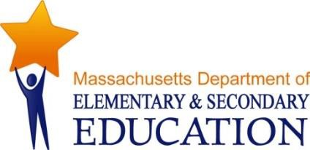

Job Opportunity Announcement:
Three (3) Student & Family Support
Contract Employee Positions

The Massachusetts Department of Elementary and Secondary Education (DESE) is seeking to hire three high-performing individuals who are ready to support the goal of the Massachusetts public K-12 and adult education system to prepare all students for success in life. DESE is committed to a diverse workforce and we strongly encourage candidates from diverse racial, ethnic, and cultural backgrounds to apply.

DESE’s Office of Student and Family Support (SFS) works in partnership with educators, schools, students, families, and other agencies and organizations across the Commonwealth to advance the Department's mission. Our programs and initiatives aim to ensure access to high quality and student-centered pre-K-grade 12 education and strengths-based, holistic supports and enrichment. We seek to add one contracted staff member to each of following SFS teams to support schools, districts, and programs with grant administration, capacity-building, and technical assistance (TA).

- The Behavioral and Mental Health (BH/MH) team works to ensure that schools and districts build internal capacity to meet the social emotional and behavioral and mental health needs of their students, as well as develop their capacity to build partnerships with community-based providers.
- The BH/MH contracted program specialist will work with the team to support schools and districts, including grantees of related programs and those receiving support through the Department’s Statewide Systems of Support, with coaching/TA on building and implementing multi-tiered systems of support for behavioral and mental health and social and emotional learning (SEL).

- The Educational Stability (ES) team works to ensure that children and youth who are homeless, in foster care, migrant, or in military families have full access to a consistent public education.
- The ES contracted program specialist will help to coordinate related grant program(s), including developing and posting RFP(s), managing grant reviews and awards processes, monitoring and providing training and TA to grantees and other interested districts.

- The 21st Century Community Learning Centers (CCLC) team works to strengthen student learning by implementing innovative, interactive, relevant, and engaging teaching and learning strategies during the school year and summer that meets the specific academic, SEL, and developmental needs of students.
- The 21st CCLC contracted program specialist will assist in efforts to build the capacity of grantees to implement high quality, academically enriching programming that occurs either as part of a longer school day (ELT) or during out-of-school time (OST).

We are looking for individuals who demonstrate the following abilities and skills:
- Collaborate and communicate well with a diverse range of internal and external partners and stakeholders;
- Proactively support and uphold core commitments to equity and racial equity, diversity, and inclusion;
- Effectively manage multiple priorities in a high-expectations environment;
- Practice a self-reflection, continuous improvement, and problem solving mindset;
- Flexibly respond to changing job requirements and priorities; and
- Learn and build on the varying cultural and community backgrounds of students, families, school districts and other community members through awareness of one’s own cultural identity and views about difference.

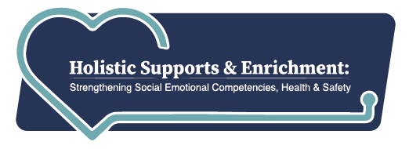
We plan to post these job opportunities on or close to Friday, February 4, 2022 (select DESE using the Organization filter) and will prioritize applications received
in the first 14 days after posting.
Note: These positions are based in Malden. Agency employees are currently operating
within a hybrid model through August 2022, telecommuting up to three days per week.

