RETHINKING DISCIPLINE PHASE II, COHORT I
ACTION PLAN TEMPLATE

Submission Instructions – June 2024

Participants of the Rethinking Discipline Initiative Cohort are required to submit action plans to the Massachusetts Department of Elementary and Secondary Education (DESE). This document includes the first part of the action plan requirement for the cohort – addressing action plan steps for late summer/early fall 2024, based on the steps detailed in this reflection document. In the fall of 2024, we will reconvene Rethinking Discipline participants to request status updates on the challenge listed below as well as action plan next steps (subsequent action plan components for School Year 2024-2025, informed by the experiences and lessons gleaned from this late summer/early fall efforts).

We anticipate providing networking and additional learning supports the upcoming year, as well as the following summer-fall 2025, as schools and districts look to sustain and scale up practices with successful impact and promise. We will send dates and details once confirmed, and please continue to share requests and feedback with us along the way.

SUBMISSION INSTRUCTIONS

Utilizing the table beginning on page 2 in this document, complete all sections and respond to all questions.

Submission Details: Due Date: The Rethinking Discipline Action Plan is due no later than Tuesday June 18, 2024.

Submit the Action Plans to Stacy Cabral at Stacy.Cabral@mass.gov. The Department plans to review and approve action plans this summer. Please note, the reviewer will follow up with the identified contact for the action plan with any clarifying questions, if needed.

ACTION PLAN TEMPLATE

Utilize the principles of improvement science, summarized in the image of the slide below, to brainstorm change initiatives to address an equity challenge in your school/district. We are asking you provide information associated with one equity-focused change idea related to bigger picture goals for your school/district that you will test out this summer/fall and then learn from and scale up or modify based on the experience. As a reminder, we will connect with you later this summer/fall to hear updates and ask for the next steps (a part II to your action plan), informed by this first test of change (part I of your action plan), and we will ask for updated action plans roughly each quarter during calendar year 2025 (with details to be confirmed later this summer/fall).

Please provide information about steps in this equity challenge as requested in IIa and then complete the action plan information in IIb below. Please revisit this reflection document for more details on how to approach this plan.
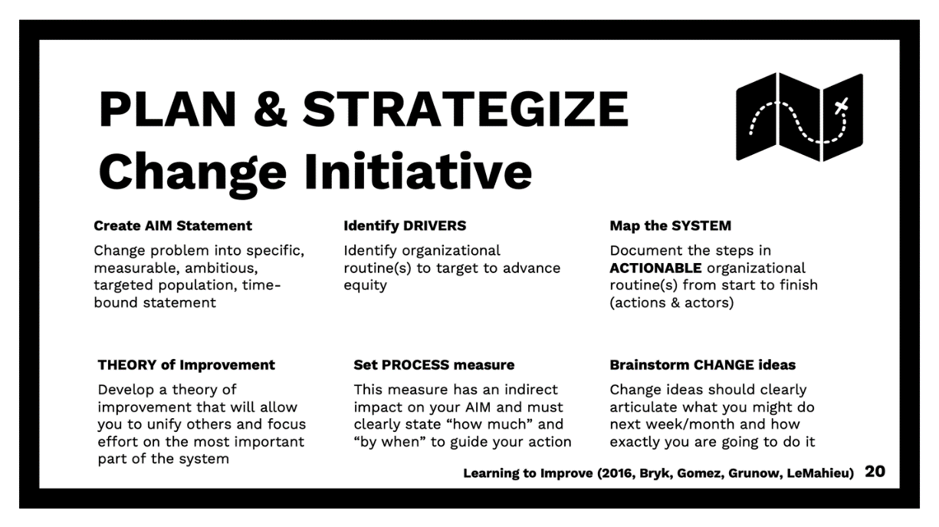

IIa. SIX STEPS
Informed by the learning series offered by DESE and the Equity Imperative this winter/spring (8:30-10:00 a.m. ET on 2/8, 3/7, 4/4, and 5/30/24), use the space below to outline each of the six steps. Please revisit this reflection document for more details on how to approach this plan.
NOTE: See Example at the end of the reflection document (starting at the bottom of p.10), as well as the slides from the 5/30/2024 session (available upon request from Stacy Cabral) for illustrative examples of possible organizational routines/Drivers and process measures related to an AIM statement. The resource is offered to be of assistance in generated ideas. Please create ones that are applicable specifically to your school/district. If you need additional assistance, please feel free to email Stacy Cabral at Stacy.Cabral@mass.gov.

AIM STATEMENT:

ONE DRIVER:

SYSTEM MAP SHOWS:

THEORY OF IMPROVEMENT:

PROCESS MEASURE:

ONE CHANGE IDEA:

See next page for IIb. Action Plan Late Summer/Early Fall

IIb. ACTION PLAN – LATE SUMMER/EARLY FALL
Use the space below to map out your change idea into an action plan (with landscape layout). Note that this action plan is meant to test out your change idea above, and can be for a 4-8 week time period in late summer/early fall (though if you wish to include a longer period of time you can). We will then ask for a next steps version of this action plan for late fall through early winter 2024, and then one for late winter through spring 2025, and then ways you plan to sustain and continue to scale up effective practices in fall 2025. Each subsequent part is expected to build upon and incorporate lessons gleaned from prior ones (e.g., where modifications are needed, where efforts can be scaled up, where a deeper or new direction will be helpful, etc.).

Steps  Every change initiative has multiple steps. Each row should have one step articulated in this column. | Who  Indicate who will be responsible for each step in this column. | Due Date  Decide the due date for each step, and document that in this column. | Measurement  Not every step will have a measurable effect, however, for those that do, indicate how you plan to measure the impact of your action in this column. | Status Updates and Implications for Next Steps  This column is to fill in as you proceed with these action plan steps, to indicate what is completed, what challenges or barriers were faced, what implications can factor into subsequent plans, etc.

