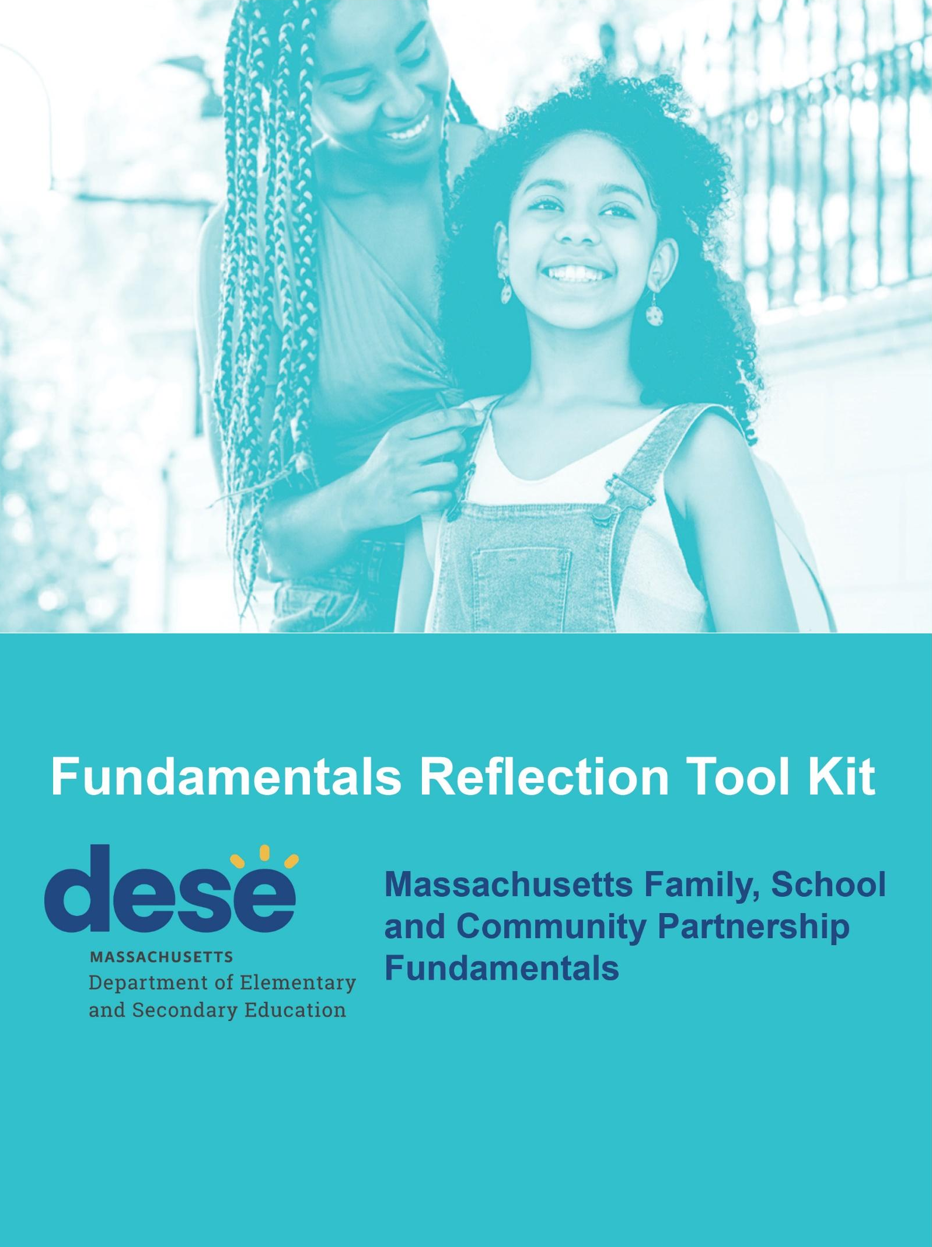

Contents
About the Tool Kit 2
Step 1: Get Your Mindset 3
Activity: Family Partnership Over the Decades Brainstorm 4
Activity: Your Family Engagement “Stuff List” 7
Step 2: Reflect on Where You Are 9
Activity: Leadership Check In | Understanding Leader Interests and Priorities 10
Activity: MA DESE Family, School, and Community Partnership Fundamentals Reflection 11
Step 3: Listen to Stakeholders 18
Activity: Student, Family and Staff Focus Groups and Quick Polls 19
Activity: Digesting Stakeholder Feedback 24
Activity (Optional): Additional Stakeholder Feedback 26
Step 4: Identify Partnership Deepening Priorities 27
Activity: Identifying Next Level Family School Partnership Priorities 28
Activity: Leadership Check In | Recommended Family Partnership Priorities 32
Step 5: Co-Create and Take Action Together 33
Activity: Strategy Exploration and Planning 34
Activity: Implementation Readiness Recommendations 38
Activity: Leadership Check In | Final Recommendations and Implementation Support 40
Acknowledgements 41

About the Tool Kit

This tool kit complements the Better Together: Massachusetts Family, School, and Community Partnership Fundamentals online training module for educators. It is designed to provide a thoughtful, structured process district and school teams can use to reflect on family partnership, get feedback from stakeholders, and identify family school partnership priorities.

The kit includes team meeting agendas, activities and other materials you can use to support the five-step reflection process (approximately 20 hours of reflection activities including stakeholder focus groups):
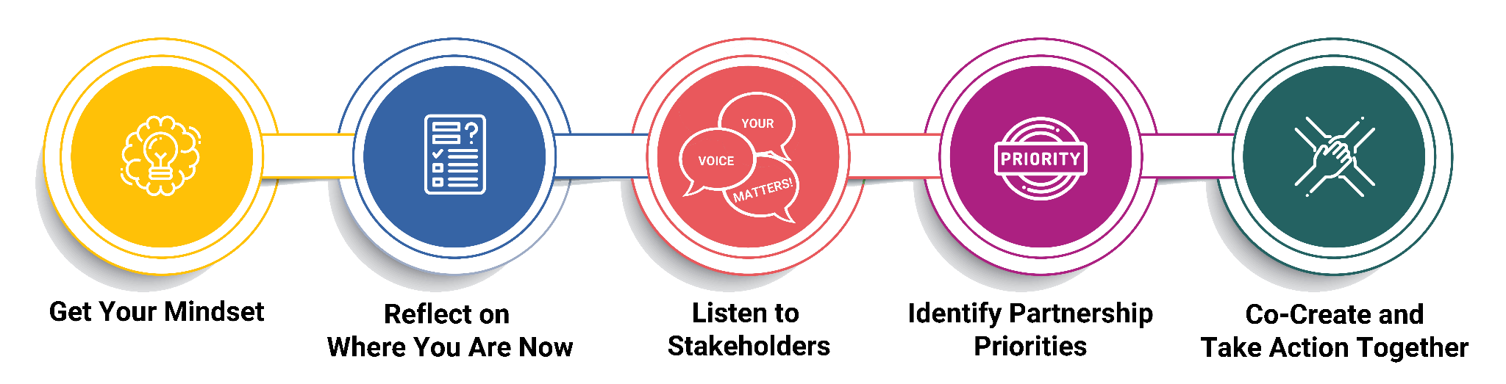

Step 1: Get Your Mindset

Activity: Family Partnership Over the Decades Brainstorm

Goals
- Explore family school partnership trends and strategies over the past three decades.
- Think about the shift from “parent involvement” to “family partnership”.

Materials
- Family Partnership Over the Decades Brainstorm Tool
- From Parent Involvement to Family Partnership Handout
- MA DESE Better Together Online Training Module: Getting Your Mindset section

Time
- 30-45 minutes

Instructions

- Set up a shared document version of the Decades brainstorm tool to support collaborative brainstorming. You can use flip chart paper on the wall or a big whiteboard with columns for each time period.
- Ask team members to think about each time period:
  - What do you remember/know about family school partnership in this period? What was going on?

Team members may have multiple or different perspectives for a time period – that of child/student, parent, educator, what you saw represented in movies/TV, changes in the policy environment, etc.

- Ask team members to post a few examples about each decade they remember. You can also have team members divide into pairs or trios to brainstorm for a specific decade.

- Give team members a few minutes to review the examples shared, then debrief the activity together:
- What do you see? What jumps out at you in each decade or overall as you look across the decades?

If different team members brainstormed a specific decade, ask them to summarize their perspectives on the decade. Do they see any trend(s) related to family engagement for that decade?
- Review the “From Parent Involvement to Family Partnership” handout (also available in the online Better Together training module). Discuss as a team.
- What do you think? Have you experienced any kind of shift?
- Where would you put your district/school on the continuum?

Additional Resources
- History of Parent Involvement in American Schools – A Historical Perspective

Getting Your Mindset: Family Partnership Over the Decades Brainstorm Tool

Think about the time period. What do you remember/know about family engagement for this period? What was going on? (if you were in school, working in a school, if you were a parent, representation in movies/tv, policy context, etc.).

1990 - 1999 | 2000 - 2009 | 2010 - 2019 | 2020 Pandemic and Emerging from the Pandemic Period

Getting Your Mindset: Moving from Parent Involvement to Family Partnership

Parent Involvement Mindset | Family Engagement Mindset | Family Partnership Mindset
We invite parents to things and hope they come:  - Parent conferences  - Health fairs  - Fun nights  - Heritage festivals  - Occasional workshops  - PTA  We provide a lot of information (one-way communication)  We do things to and for families.  Parent meetings are short. More in-depth meetings are reactive or used as a consequence.  We don’t provide much educator support or only do “one-off” professional development. | We start engaging in more mutually beneficial ways:  - Home visits  - Parent universities and cafes  - Occasional parent or school culture surveys  - Parent leadership training  We start linking to community partners.  Professional development for educators is more systematic.  Family engagement indicators are included in evaluation, certification or licensure (but may not be emphasized). | We treat our partnership with families as an essential ingredient of instruction and student support (mixed in, not sprinkled on top).  We have an asset-based view of families.  Families are our equal partners and co-designers. We empower and share power.  Communication is two-way. We listen as much (more than!) we talk.  We collect student, family, and staff input regularly and we all use it.  We create the conditions and systems staff and families need to work together successfully.  We build capacity in both educators and families (dual capacity).  We customize strategies for different families. We don’t use one-size-fits-all approaches.

Activity: Your Family Engagement “Stuff List”

Goal
- Reflect on the work (“stuff”) you do now to engage with and collaborate with families.

Materials
- Your Family Engagement “Stuff List” Brainstorm Tool

Time
- 30-45 minutes

Instructions

- Set up a shared document version of the Stuff List brainstorm tool to support collaborative brainstorming. You can also break the team into 2-3 smaller groups and give each group a piece of flip chart paper and markers.
- Ask team members to brainstorm all of the family engagement “stuff” your district or school is doing - everything they can think of in 5 minutes – and post it to the Stuff List.
  - What are all of the activities, projects, initiatives, programs, events, people or organizations, etc. that have something to do with family/caregiver engagement?

- Give the team a few minutes to review the Stuff List. If you had smaller groups do the brainstorm, ask someone from each group to read each group as quickly as they can.
- As a team, discuss your Stuff List reactions and observations:
  - What kinds of “stuff” do you see?
  - What family partnership strategies or priorities does your “stuff” reflect?
  - How is your “stuff” connected? How are these things working together to improve outcomes for students?
  - How is your stuff working? Is it getting the results you need?

- Summarize your team’s main takeaways and capture them in your team notes – key points or thoughts you want to be sure to remember as you continue the reflection process.

Your Family/Caregiver Engagement “Stuff List” Brainstorm

Take 5 minutes to list all of the projects, initiatives, programs, events, organizations, and individuals that have something to do with family engagement in your district/school.

Our Elementary “Stuff” | Our Middle School “Stuff” | Our High School “Stuff”
Our District Wide “Stuff” (done for all grades)

Step 2: Reflect on Where You Are

Activity: Leadership Check In | Understanding Leader Interests and Priorities

Goal
- Understand your superintendent’s interests and priorities so that your team can begin to listen for and think about ways strong family partnership can help support key district priorities.

Materials
- None

Time
- 30-45 minutes

Instructions

- Schedule an initial check-in meeting with your superintendent or principal to discuss the reflection process and district/school priorities.
- At the meeting, start by quickly reviewing the reflection process: team members involved, steps and what the team will work on. You might also share some of the themes starting to emerge from team discussions so far.
- Next, ask your superintendent/principal to share their most pressing priorities for the district: What is most on their mind? What do they lie awake thinking about or wishing?
The priorities your leader shares may or may not be explicitly related to family school partnership. You are gathering information about leader priorities that your team will consider, along with family, student and staff feedback, to inform your recommendations for next level family partnership work.
- If time allows, you can ask your leader other questions:
- Do you have anything specific you want our team to think about related to family school partnership – any interests, priorities, goals related specifically to family partnership?
- Is there anything you want to highlight about the district’s family school partnership work; for example, a strength, opportunity or gap?
- Does our district/school partner with any groups focused on family engagement (community or parent groups, organizations, etc.)

- Schedule a follow-up meeting with your leader for later in the reflection process when you are ready to share stakeholder feedback and your team’s recommendations for next level family partnership work.

Activity: MA DESE Family, School, and Community Partnership Fundamentals Reflection

Goals
- Use the Massachusetts Family, School and Community Fundamentals to understand what strong family school partnership can look like.
- Reflect on the five Fundamentals and discuss your district/school’s current strengths, gaps, and opportunities.

Materials
- Massachusetts Family, School and Community Fundamentals
- Team Fundamentals Reflection Note Catcher – Strengths, Gaps and Opportunities

Time
- Individual Homework: 30-45 minutes
- Team Reflection Meeting: 90-120 minutes (1-2 meetings)

Instructions

- As preparation for this team reflection activity ask each team member to independently review the Massachusetts Family, School, and Community Fundamentals.

- After reviewing the Fundamentals, ask team members to go back through the tool and jot down notes on what they think are your district or school’s strengths, opportunities and gaps for each Fundamental for each Fundamental:
- Positive Relationships
- Family Well-Being
- Pathways for Partnership
- Child/Youth Development
- Staff Capacity
You can also ask team members to work in pairs or trios to review and reflect on the five fundamentals.

- Create a shared document version of the Team Fundamentals Reflection Note Catcher you can use to capture notes when you meet as a team.

- Meet as a team. Discuss the Fundamentals and collaboratively assess family school partnership strengths, gaps and opportunities. To the extent possible, reach consensus on your team’s Fundamentals self-assessment findings.

Here is a suggested agenda for your meeting:

Welcome and Reconnecting (5 mins)
The Fundamentals Reflection Assignment (5 mins)
Spend a few minutes talking about the experience of doing the assignment and how team members approached it.
- Did you find it easy or challenging?
- Any other thoughts or things you want the team to know before we start unpacking what you found?
Identifying Strengths, Gaps and Opportunities (75-90 minutes, you may need 2 meetings)
Facilitate a discussion with the team to assess each Fundamental.

With the team, determine your strategy for assessing each Fundamental. For example:
- You could work on them in order and allocate a certain amount of time for each (15-20 minutes) or review all quickly at a high level, then circle back for a deeper discussion.
- You could have the team pick the order and why
- You could have the team identify Fundamentals that need more or less discussion (an area of strength vs. an area for growth)
- If all team members filled out the note catcher in advance or you ask them to post to a flip chart or white board in advance, you could divide the team up to analyze each fundamental and report back what they find to the full group.

Use the Team Fundamentals Reflection Note Catcher to record the major takeaways from the team discussion: important strengths, gaps or opportunities for each Fundamental and any different or diverging perspectives your team wants to keep on the radar.

Wrap Up (5 mins)
Summarize key takeaways and themes from the team’s Fundamentals self-assessment, then ask the team to take stock of where they landed:
- Overall, does our analysis feel complete? Is there something you’re still chewing on or wondering about?
- Is there any opportunity/priority that came up during the discussion that feels especially important – it really resonates for us and feels very important for our family partnership work going forward?
- Were there any areas you didn’t feel you could assess - you need other input?

Encourage the team to talk with other colleagues and people in their spheres of influence after the meeting about key findings from the meeting. What strengths, gaps, and opportunities do they see?

Team Fundamentals Reflection Note Catcher

Use the complete, more detailed Massachusetts Family, School, Community Partnership Fundamentals self-assessment tool as a reference to help you understand each Fundamental and indicator and what a strong family school partnership approach might look like.

For each Fundamental, identify the strengths, gaps, and possible opportunities you see.

Fundamental 1: Building Positive Relationships (BPR)

Indicators:
- Intentionally create a respectful, welcoming, inclusive, safe environment for all stakeholders.
- Intentionally build and sustain trusting relationships with all families.
- Use multiple, reciprocal, and balanced communication paths.
- Survey families, students and community members to identify issues and concerns.
- Identify possible cultural brokers from diverse communities, school or district employees, or existing family or community leaders.
Possible Strengths | Possible Gaps | Possible Opportunities

Fundamental 2: Promoting Family Well-Being (PFWB)

Indicators:
- Partner with community groups in ways meaningful to families to strengthen family well-being and support student success.
- Employ multiple strategies to connect families with resources to enhance family well-being.
- Turn the district/school into a hub of community life or leverage an existing centralized location for that purpose.
- Ensure accessible programming by identifying and addressing barriers families experience in participation, including access to technology.
Possible Strengths | Possible Gaps | Possible Opportunities

Fundamental 3: Promoting Pathways for Partnerships with Families (PPPF)

Indicators:
- Engage with families to enhance their understanding of how the school and district operates, as well as the rights and responsibilities of families under federal and state laws.
- Share power and decision making while providing families opportunities to be effective advocates for their children and to engage in civic advocacy for student achievement.
- Engage with families to enhance their understanding about resources to support student achievement leading to college and career readiness.
- Partner with families in identifying and planning engagement activities to ensure smooth transitions for families and students, including transitions into post-secondary education and employment opportunities.
- Offer families multiple opportunities for practicing leadership roles based on families’ own definitions of engagement and leadership.
- Support families’ civic engagement efforts.
Possible Strengths | Possible Gaps | Possible Opportunities

Fundamental 4: Supporting Child and Youth Development, Learning, Health, and Well-being (DLHW)
Indicators:
- Link student work to learning standards which lead to college and career readiness for all students.
- Use standardized test results and other data to inform decision-making about increasing student achievement.
- Identify collaborative development and learning opportunities among families, schools/the district and community organizations, including out-of-school time learning.
- Ensure that all stakeholders have a voice in all decisions that affect the learning and well- being of children and youth.
Possible Strengths | Possible Gaps | Possible Opportunities

Fundamental 5: Building Capacity of the Staff (BCS)
Indicators:
- Encourage and establish a culture that promotes the importance of all staff in building trusting relationships with all families.
- Prioritize family engagement as a part of district/school professional development (PD) and align coaching plans for all staff with culturally responsive family engagement practices
- Establish partnerships and on-going communications with community and cultural organizations, including health and human services
- Collect information, data and feedback from all families in an on-going way, share this information with staff and families and use it to collaboratively plan diverse opportunities for capacity building
Possible Strengths | Possible Gaps | Possible Opportunities

Step 3: Listen to Stakeholders

Activity: Student, Family and Staff Focus Groups and Quick Polls

Goal
- Get perspectives from diverse family members, students, and staff on what’s working with family school partnership and what could improve.

Materials
- Sample Focus Group Flyer
- Sample Focus Group Agenda
- Sample Focus Group Quick Poll Questions

Time
- Preparation: 2 hours
- Focus Group Meetings: 4-5 hours; 60 minutes per group
  - 1 student focus group: 8-10 students representing grades 5-12
  - 1 educator group: 8-10 school staff including teachers and other staff who work directly students and families
  - At least 2 family groups: 8-10 family members per group; one focus group conducted in English and at least one other in another language

Instructions

- Meet as a team to plan your focus group strategy and assign team member responsibilities.
  - Are there families, students and staff you might not typically hear from whose voices you want to be sure you hear?
  - Will you conduct focus groups in person, online or some combination? If in person, where might family members feel comfortable gathering (for example, somewhere in the community rather than the school)?
  - How will you recruit focus groups participants? Who will help with outreach to families who might not be comfortable with, or respond to, a general invitation message? What information do they need in advance (see the sample focus group flyer)?
  - Do you need family/caregiver consent for students to participate?
  - Who will facilitate each focus group (including bilingual facilitation or interpretation support)?

Focus group planning tips:
  - Over-recruit! If you want 8-10 participants, recruit 15-18 in case schedules or circumstances change.
  - For outreach, think about who has the best, most direct and trusted connection to the family members, students or staff you want to include – ask for their help.
  - Have 2 people facilitate the focus group so that you can capture good notes.
  - Be thoughtful about who facilitates each focus group. In general, your reflection process team members should not participate in them unless they are absolutely needed as facilitators and trusted by participants. Your goal is to provide a safe space for focus group participants to speak their minds.
  - Do not record the meeting. Most focus group participants will feel more comfortable this way and might be afraid to say no if you ask to record.

- Conduct your focus groups (see sample agenda).
  - Be sure to capture basic information about focus group participants as part of introductions; for example, number of children in the school system, years teaching, diversity, language, etc.
  - You might also want to take a quick poll at the start of the focus group to warm people up, get “baseline” perspectives, and provide a little bit of data you can compare across stakeholder groups. The sample Quick Poll handout shows the types of questions you can ask.
  - Make sure facilitators take good notes on key themes and ideas and can provide a summary for the team that doesn’t include personally identifiable information (it’s very important to maintain focus group participant anonymity).

Sample Family School Partnership Focus Group Flyer

This sample flyer is also available in Spanish and Portuguese.

Students thrive when families and caregivers and school staff value each other and work together. The COVID-19 pandemic and events of 2020-2021 have shown how incredibly important this is!

How well do you think schools and families are working together? What have you learned, particularly in recent years during and as we emerge from the pandemic period? What do you think we can do better?

We want to hear all about it!
We are hosting focus groups with families/caregivers, students, and school staff. We would love to have you participate.
- Join from anywhere. All focus groups will be hosted online as Zoom meetings.
- Parent/Caregiver Focus Group will be offered in English and a second language chosen by each district.
- Focus groups will be facilitated by [add name/role/organization].
- All information you share in a focus group is confidential. We want to know what you really think!

What We’ll Talk About | Focus Group Questions

For Families/Caregivers
- What makes you feel welcome in your child’s school? What would help you feel connected and valued?
- What do you think schools and families/caregivers should talk about, do, or work on together?
- What’s working for you in your partnership with the schools now? What’s challenging?
- What information or training would you want from the school to help you support your child’s learning and development?
- What differences have you experienced in your relationship and interactions with your child’s school over the past few years, during and as we emerged from the pandemic? Are there things your child’s teacher or school did that you would like to see continue?

For Teachers and School Staff
- What does strong family-school partnership look and sound like - in the classroom, in meetings, across the school, and at home?
- What’s working for you in your partnership with families now? What’s challenging?
- Tell us a little bit about the culture in your school/district when it comes to working collaboratively with families and whether you think families feel welcome in schools, supported, and heard.
- During the pandemic period and as we emerge, what have you learned about school and family partnership? Are there any changes or innovations you made that you think are worth saving?

For Students
- How do your family members interact with your teacher(s) and other school staff? What do you see them doing or talking about together? (school events, meetings about you, other kinds of meetings)
- Talk about what you think your family member’s experience is like when they visit school or talk to school staff by phone or in an online meeting.
- What do you think school staff and your family members should talk about or do together? How do you think they should work together to support you?
- Tell us if there’s anything you like or don’t like about the school's interactions with your family and what you would like to see changed if you don’t like it.

Sample Family School Partnership Focus Group Agenda

Preparation
- Set up Quick Poll questions in advance. Best if done online.
- Confirm with all participants the day before the focus group.

Materials
- Focus Group Flyer with Questions

Agenda

Welcome, Why We’re Here, and Introductions (5 minutes)
- Thank participants and explain the purpose of the focus group (collect their thoughts on family school partnership, what’s working and what could improve)
- Explain how the focus group will work. After introductions, the facilitator will ask questions and take notes on key themes which will be shared with the district/school family partnership reflection process team – input they can use to make recommendations for strengthening family-school partnership.
- Ensure anything shared is confidential: names or any detail that personally identifies a participant (or their child) will not be used. You really want to know what they think even if it’s hard to hear.
- Ask if there are any questions.

Introductions (5-10 minutes)
- Ask each participant to introduce themselves. They can use their last name or not.
  - Families can share: first name, how many children they have, ages, and how many are in district schools, how many years they have lived in your community (some family/caregivers may share more about their child, e.g., receives SPED services, etc.).
  - Students can share: first name, school, and grade
  - Staff can share: first name, role, school, number of years teaching or working in the district/school

Quick Poll (5 minutes)(see sample Quick Poll Questions)
- Explain that you would like to have participants take a quick poll to get warmed up.
- Share the poll link or handout.
- Thank people for doing the poll and let people know the discussion you are about to facilitate will build on the poll questions.

Focus Group Discussion
- Facilitate a discussion about each focus group question.
Before you move to the next question, check in with participants who haven’t responded to see if they would like to add something. You can also use the “around the table/room” method to hear from everyone or “thumbs up/thumbs down” method to see if other participants feel the same way or differently about something
- Pause now and then to synthesize or summarize what you are hearing.

Wrap Up
- Summarize key themes from the discussion.
- Ask if participants have any final thoughts before you close. You can also use the “of all the things we discussed, which feels most important” or “if you had one minute with the principal/superintendent” method to get a sense of priority themes/ideas.

Sample Focus Group Quick Poll Questions

The Quick Poll has each stakeholder group answer the same questions so that you can compare across groups.

Use a friendly 1-5 scale rating system; for example, smiley face or stars rating system.

Family Member Version
- I feel teachers and families/caregivers are working together well as partners to support students.
- I have the relationship I want to have with my child's school.
- My voice, ideas, and input are valued in my school.

Student Version
- I feel teachers and families/caregivers are working together well as partners to support students.
- My parents/family has the relationship I want them to have with my school/teachers.
- My voice, ideas, and input are valued in my school.

School Staff Version
- I feel teachers and families/caregivers are working together well as partners to support students.
- I have the relationship I want to have with the families of our students.
- My voice, ideas, and input related to family engagement are valued in my school/district.

Activity: Digesting Stakeholder Feedback

Goals
- Reflect as a team on the feedback you received in family, student and staff focus groups.
- Begin to lift up ideas for priority family partnership work that reflects stakeholder and district leadership interests.

Materials
- Summary of key themes and quick poll results from each focus group - all anonymous (do not include any information that would in any way personally identify a focus group participant). Here is an example of what you could share with your team during the debrief meeting - you will likely want something like this to share with district/school leadership later. You could also have focus group facilitators come to the meeting ready to share high level themes.

Time
- 90 minutes

Instructions
- Schedule your team meeting. Typically, team leads do not share focus group findings in advance so that you can walk through them together as a team.
- At the meeting, go through your focus group methods, findings from each focus group, and key themes from your own team discussions/reflections.

Here is a sample agenda for your team debrief meeting:

Welcome and Focus Group Overview (5 minutes)
Share your agenda and goals for the meeting. Explain your focus group process and methods: who you recruited, why and what you wanted to learn.

Most teams use an “express bus” strategy: Go through all of the findings quickly (no stops…), then spend time as a team discussing reactions and possible implications. You can suggest team members jot down notes during the findings review.
You can also explain that the focus groups and the quick poll you did during the groups are just two methods for hearing stakeholder voice. They are not the be all and end all; however, they are rich sources of feedback and input. As the team reviews findings, they can be listening for voices that may not be represented (yet!).

Quick Poll Results (5 minutes)
Go through the Quick Poll results quickly. Explain that the poll is a “dipstick” strategy. Only participants in the focus group completed the poll so 1-2 people can shift the results. However, the poll is still a really helpful tool for getting some “baseline” data – a sense where are people as they come into the focus group – and to compare across stakeholder groups.
As you review the results for each poll question, highlight what’s “above the line” (total % of people who gave a positive response) and how this is the same or different across stakeholder groups.

Stakeholder Focus Group Themes (15 minutes)
Review key themes from each stakeholder group or have the focus group facilitator summarize them.

Reactions, Observations and Possible Family School Partnership Implications (50 minutes)
Spend most of the remaining meeting time digesting and reflecting on what you heard. If needed, circle back to a particular focus group to take a closer look at themes.
Prompts:
- What jumps out at you? What reactions do you have, given what you heard? What themes really resonate with you and why?
- Where are we hearing similar feedback across groups? Where are we hearing differences?
- How does the feedback we got from families, students and staff relate to or align with district/school priorities our superintendent/principal/leadership wants us to consider?
- Are there voices or perspectives we’re not hearing (yet)?

If time allows, you can allocate some dedicated time to discuss possible implications for family school partnership work (where should you go next and why) – some of these will come up naturally any way as the team discusses findings. However, don’t feel pressure to leave the meeting with implications fully outlined. The main goal for this meeting is to fully digest and synthesize stakeholder feedback.

Next Steps & Wrap Up (10 minutes)
Summarize key points and ask team members to share any final thoughts on meeting discussions. Explain that the team now has a lot of input (superintendent priorities, team reflection activities including the Fundamentals self-assessment, focus group feedback). Going forward, the team will start to shift from reflecting/listening to prioritizing and planning with the goal of making recommendations about next level/next stage family school partnership strategies.

Before moving on, you may also also want to do a few “data dive” meetings with stakeholders to discuss the findings, or a specific finding, and possible implications.

Resources
- Data Driven Dialogue Protocol - University of Chicago
- 5 Steps for a Thin Slice Data Dive - Edutopia (geared for teachers but a generally helpful method)

Activity (Optional): Additional Stakeholder Feedback

Goal
- Identify or collect and consider other feedback from families, students and staff; for example, survey or focus group data, which could provide additional insight into which aspects of family school partnership are working and which could improve.

Materials
- Will vary by district

Time
- 1-3 hours

Instructions
Check to see if your district or individual schools have recent survey or focus group data from family members (ideally also students and staff!).

If so, review the data with your team. You might then identify particular data points (data dives) you could discuss with small, informal stakeholder groups. For example, you might convene a group of family members or students to share their perspectives on 3-4 key questions in the survey – focus on quality rather than quantity!

Step 4: Identify Partnership Deepening Priorities

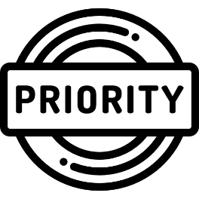

Activity: Identifying Next Level Family School Partnership Priorities

Goal
- Given stakeholder feedback, superintendent/leader priorities, and your team’s reflection activity discussions, identify your top priorities for impactful next level/next stage family school partnership work.

Materials
- Family School Partnership Priorities Exercise Note Catcher
- Definition of Consensus
- High Impact Family School Partnership Strategies – Priority Matrix

Time
- Preparation: 30 minutes
- Team Meeting: 90 minutes

Instructions

Create a shared document version of the Family School Partnership Priorities Note Catcher.

As preparation for the team meeting: ask team members to review key reflection process themes (leader priorities, stakeholder feedback, team Fundamentals self-assessment). This is very important! You want team members to ground themselves in what they have learned and heard during the reflection process.

Invite each team member to identify what they see as the “top 3 priorities” for family school partnership work going forward and post them to the note catcher before the meeting (Part 1 of the note catcher).

- At the team meeting, review and discuss possible priorities team members posted. Work as a team to reach consensus on 1-3 recommended priorities.

Be sure the priorities you identify reflect the input and feedback you received from leadership, family, students and staff. You don’t want more “stuff” (remember the stuff list?)! You want to work strategically to strengthen family school partnership in ways that impact students.

- Schedule another team meeting if needed to finalize family school partnership recommendations.

- Stakeholder feedback loop: Ask team members to discuss the team’s proposed/recommended priorities with stakeholders, as a reality check and way to get family, student and staff voice and nurture buy-in.

Here is a sample agenda for your Priorities meeting.

Welcome and Reconnecting (5 minutes)
Reconnect and share the meeting goal and agenda.
Reviewing Team Member Priority Ideas (20 minutes)
Give the team time to review and discuss the priority ideas team members posted to the Priorities note catcher (individual perspectives on possible priorities). Your goal at this stage of the discussion is to understand the ideas team members have shared.
- If you have time, ask each team member to share their top 3 ideas. Otherwise, ask team members to read through the note catcher.
- Check to see if team members want to ask any quick clarifying questions about an idea.
- Ask if anyone would like to share their ideas.
- Ask probing questions about ideas posted. For example, ask a team member to elaborate on an idea, explain why they feel it is important, or explain how a priority they posted aligns with leader interests and/or stakeholder feedback.
- Save a few minutes to ask if team members want to take any priority ideas off the list or add new ideas based on the discussion so far.

Identifying Your Team’s Top Priorities (60 minutes)
Work as a team to identify consensus priorities: 2-3 priorities team members agree represent strong next level/next stage family partnership work. They can really get behind them and recommend them to leadership.
- Share the definition of consensus.
- Look for instances where two or more team members had the same or similar priority idea.
- You can also ask team members to go back over the priorities ideas list and put an *, X, or other symbol next to their new top 3, now they have seen other team member ideas.
- Use stakeholder input or feedback as a lens. Which priorities, if you take them on, address something really important you heard from family, student, staff, or leader interests?
- Use the Priorities Matrix as another lens to think about impact vs. effort for priorities you are considering. Do you see some “thin edge of the wedge” work or other strategically smart place to start?
- Consider your readiness: Which priorities do you feel best positioned to support now (initial work) and which need more stage-setting or foundation-building (longer term)?
- Use a consensus decision-making method; for example, fist to five, to assess team member enthusiasm about a priority idea.
- Resist the temptation to roll individual team member priority ideas into one bigger idea, just to achieve consensus. For example, team members shared better parent/teacher conferences, annual family and student survey, and better website and social media engagement strategy as possible priorities. You could reasonably make a case to combine all three into one “Communication” priority. This can result in a big, vague category rather than a priority and you often lose important ideas. If you want to consolidate, make sure to push for clarity and specificity: what is the priority work you want to do/achieve.
- From time to time, summarize where the team is: where have you reached consensus, where you haven’t, and what would help team members decide (more thinking or discussion, more information, talking to someone, etc.)
- It’s totally okay if your team doesn’t reach consensus on 2-3 possible priorities in one meeting. Schedule a follow-up prioritization meeting time as needed.

Next Steps and Wrap Up (5 minutes)
Summarize any decisions made. Check in to see how the team feels overall: how comfortable do they feel with their priority recommendations so far? Comfortable enough to discuss them with leadership? If not, what else does the team need in order to feel comfortable (another team meeting, additional information related to a priority, input from someone, etc.). Outline any next steps or follow-up assignments for the team or team members.

Family School Partnership Priorities Exercise Note Catcher

Part 1: Summarizing the Learning (10-15 minutes)
As a team, review the findings from reflection activities:
- What you heard about district priorities
- What your team learned by reflecting on the Massachusetts Family, School and Community Partnership Fundamentals
- What you heard from stakeholders

Key Learning

Part 2: Individual Reflection - 5 minutes
Take a few moments to reflect on what you have talked about in team meetings and heard from stakeholders and leadership. Individually, write down the top 3 priorities you see as critical for deepening and strengthening family-school partnership in your district.

Post the priorities you feel are most critical in a collaborative document or list them on a flip chart for other team members to see.

Team Member | What You Hear as the Top 3 Priorities
(add more rows as needed)

Part 3: Building Team Consensus
Next, review the definition of Consensus and, with your team, discuss team member priority ideas and reach consensus on your TEAM’s top three (3) priorities (it’s okay if you don’t identify three – quality and clarity over quantity!)

Team Top 3 Priorities
1
2
3

Definition of “Consensus”
The outcome of a problem-solving meeting or negotiation where all participants agree - and can agree publicly - that they can at least live with the decision(s) to be implemented. Participants further agree not to sabotage or undermine the decision(s). Generally, everyone will not have all of their interests met, but everyone will generally have some of their important interests met. The outcome is perceived by all as reasonable and worth achieving.

- To achieve consensus, everyone in the group must actively participate.
- To participate fully and freely, all group members must have a common base of information and keep up to date on the progress of the group.
- A norm must be created in which everyone will feel comfortable to state his or her views and to disagree.
- Silence is not agreement. It means there are still thoughts or questions to discuss.
- A disagreement should be respected. It can clarify unidentified problems and serve as a catalyst for improving the decision.
- When someone objects or disagrees, the goal of the group is to discover the unmet need that has produced the objection and to find a way to meet that need in a revised agreement, rather than suppress the objection.

Priority Matrix
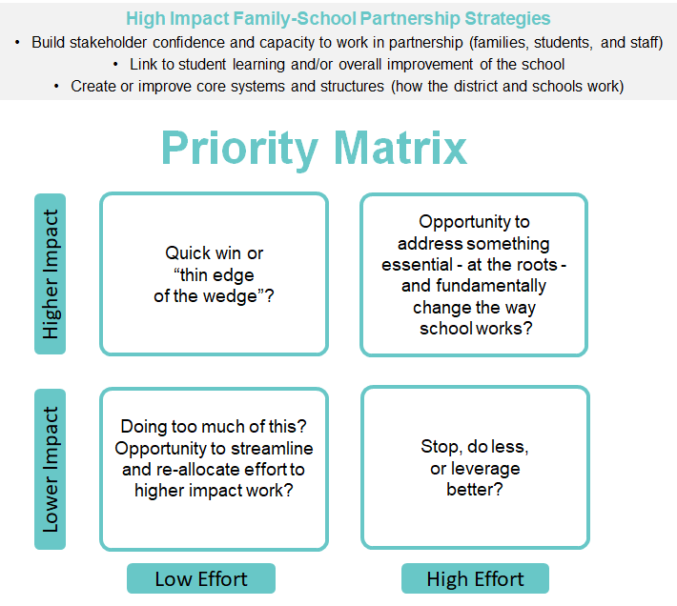

Activity: Leadership Check In | Recommended Family Partnership Priorities

Goals
- Share key findings from the reflection process and recommended family partnership priorities with your superintendent/principal and other district leadership.
- Secure the leadership support the team needs in order to move forward to strategy exploration and planning.

Materials
- Summary of key themes and findings from the reflection process (see Digesting Stakeholder Feedback example)

Time
- Preparation: 30-45 minutes
- Meeting: 45-60 minutes

Instructions

Confirm your meeting time, purpose, and agenda with your superintendent or principal (ideally you scheduled this when you first met, at the start of the reflection process).
- Meet as a team to review your team’s findings, next level family partnership priorities recommendations, and overall strategy for the meeting (who will play what role, questions you can anticipate, etc.).
- Be sure you can articulate your recommended priorities clearly: what do you want to focus on, why, and why is the current context and timing right or ripe for focusing on the priority/ies?
- This check-in with leaders focuses on getting affirmation and buy-in about “what” you want to work on and why. The discussion may drift into questions about “how” you want to work on it. You may want to come in with a few strategy or practice examples to illustrate; however, your team still has more work to do exploring “how” strategies and will have a third check-in with leaders to review them.

- At the meeting, succinctly share key findings and priority recommendations and discuss them with leadership.
- Do the priorities resonate with leadership? Does something you are recommending rise to the top for them?
- How will focusing on them address or help address important district or school priorities? (it’s always good to be explicit about how work you propose supports what leader interests and things they already want to accomplish!)
- Does your leader/leadership have anything in particular they want you to think about or pay attention to as you move forward to explore specific strategies and practices (resource implications or opportunities, staff implications, connections to other initiatives, etc.)?

After the meeting, debrief as a team to identify implications for strategy planning.

Step 5: Co-Create and Take Action Together

Activity: Strategy Exploration and Planning

Goals
- Discuss strategies you can use to address next level family partnership priorities.
- Assess the potential impact of the strategy, alignment with reflection process findings, and the potential implications for staff and families (dual capacity lens).

Materials
- MA DESE Online Training Module: Better Together-Massachusetts Family, School and Community Fundamentals (look at the Practice Spotlights and Additional Fundamentals Resources sections)
- Family School Partnership Strategy Planning Tool

Time
- Preparation: 4-6 hours; different team members can be given research assignments
- Meetings: 2-3 meetings; 60-90 minutes each

Instructions
- Ask team members to work independently or in pairs to research strategies/practices districts have used to address the next level family partnership priorities you identified.
- Be sure to start with strategies you may already have in place (remember your stuff list and five Fundamentals reflection findings). Who can you speak with to learn more and get staff and family perspectives?
- Start moving forward as partners! Think about family members, staff or students you could engage at this learning stage.
- Use the Better Together online training module to explore practice resources.
- Reach out to colleagues in other districts.
- Explore online resources related to family school partnership; for example, Edutopia’s Family Engagement area.

- Hold a team “strategy learning” meeting. Ask team members to share their strategy research and assessment of it:
- What is the strategy or practice?
- Is it something the team should consider? Why? (what makes it a good fit for next level family partnership priorities)
- How does the strategy relate to what your district or school may already do (what assets or opportunities could you leverage)?
- What roles would/could educators and families play in designing and implementing the strategy?
- Are there any other important considerations the team should know?

After team members have shared their research, open it up for discussion:
- Did hearing about the strategies spark additional strategy ideas?
- Is there anything else the team wants to learn about or look into (other strategies, more information about how a district or school did something, etc.)?

Remember: At this stage, keep the focus on learning, not deciding.

- Next, hold your “strategy planning” meeting(s). For each next level family school partnership priority, identify what you want to accomplish and your primary strategies. Use the Strategy Planning Tool to guide your discussion and capture key information.

Family School Partnership Strategy Planning Tool

Use this tool to help you identify core strategies you want to use to accomplish your next level family school partnership priorities. This tool is designed to support high level strategizing (it’s not a detailed action plan).

Tips:
- It’s better to focus on quality implementation rather than to take on too much at once; for example, it’s okay to focus on 1-2 priorities only. Be bold and strategic.
- Check yourself as you work. Do your priorities and strategies connect directly back to what you learned during your family school partnership reflection process? How?
- Get input from stakeholders, especially family members. Let them help you co-design strategies and plans.
- Think about things you could stop doing, streamline, or leverage more effectively.
- Include strategies for embedding your family school partnership priorities and strategies into things people pay attention to: school improvement plans, leadership team and other meeting agendas, roles and responsibilities, budget/budget process, professional development plans, etc.

Family School Partnership Priority 1: [add your first priority here]
Goal(s) / Impact You Want: Which aspect of how your school or district works do you want to improve or change and why? (policies, structures, roles, practices, protocols, etc.)?

Connection to District Priorities: How will your work on this priority reinforce efforts on other key district priorities and vice versa?

Strategies  What strategic work will you undertake to accomplish this priority? | Strategy Lead  Who will lead, drive and monitor work on this strategy? | Timeframe  When will work on the strategy begin? What are the main implementation stages or phases?
Challenges You Anticipate and How You Could Minimize or Mitigate Them

Critical Support Needed
Do you need leadership support, practice ideas/models, resources, or other support in order to plan and implement your work on this priority effectively?

Family School Partnership Priority 2: [if you have a second priority, add it here]
Goal(s) / Impact You Want: Which aspect of how your school or district works do you want to improve or change and why? (policies, structures, roles, practices, protocols, etc.)?

Connection to District Priorities: How will your work on this priority reinforce efforts on other key district priorities and vice versa?

Strategies  What strategic work will you undertake to accomplish this priority? | Strategy Lead  Who will lead, drive and monitor work on this strategy? | Timeframe  When will work on the strategy begin? What are the main implementation stages or phases?
Challenges You Anticipate and How You Could Minimize or Mitigate Them

Critical Support Needed
Do you need leadership support, practice ideas/models, resources, or other support in order to plan and implement your work on this priority effectively?

Family School Partnership Priority 3: [add your third priority here]
Goal(s) / Impact You Want: Which aspect of how your school or district works do you want to improve or change and why? (policies, structures, roles, practices, protocols, etc.)?

Connection to District Priorities: How will your work on this priority reinforce efforts on other key district priorities and vice versa?

Strategies  What strategic work will you undertake to accomplish this priority? | Strategy Lead  Who will lead, drive and monitor work on this strategy? | Timeframe  When will work on the strategy begin? What are the main implementation stages or phases?
Challenges You Anticipate and How You Could Minimize or Mitigate Them

Critical Support Needed
Do you need leadership support, practice ideas/models, resources, or other support in order to plan and implement your work on this priority effectively?

Activity: Implementation Readiness Recommendations

Goals
- Identify how you will organize for implementation and assess your current level of implementation readiness.

Materials
- Strategy Planning Tool used earlier to discuss priorities and key strategies

Time
- 90 minutes

Instructions

As a team, review the priorities and strategies you identified. How ready do you feel to begin working on them? Discuss important leadership, planning and implementation functions and take notes on your team’s recommendations.

Leadership
- How will you organize to lead work on your priorities? Who will meet on a regular basis to review progress and drive the vision and work forward? How often / when should they meet?
- How will you keep leaders engaged in and actively championing the work? (think about leadership broadly, e.g., district leadership, staff with influence, and family leaders)
- How will you begin to communicate priorities to educators and families?

Recommendations

Planning
- Which priorities and strategies need additional planning? Who will lead this, when and how?
- How will you get family and educator input or – even better - involve educators and family members as co-designers?

Recommendations

Implementation
- What do the leads you identified for each priority and/or strategy need in order to effectively lead their piece of the work (information, time, connections, etc.)?
- Do staff and family members have the capacity they need to help with implementation? Is there information or training that would help lay a good foundation for implementation?
- How will you know if implementation is going well?

Recommendations

Activity: Leadership Check In | Final Recommendations and Implementation Support

Goals
- Share final reflection process recommendations with your superintendent/principal and other district leadership.
- Secure the leadership support the team needs in order to move forward on additional planning and implementation.

Materials
- Concise summary of family school partnership priorities, proposed strategies, and implementation readiness recommendations.

Time
- 45-60 minutes

Instructions
- Confirm your meeting time, purpose, and agenda with your superintendent or principal (ideally you scheduled this at the start of the reflection process). If needed, meet in advance as a team to review your recommendations and plan your approach to the meeting (who will play what role, questions you can anticipate, etc.).
- Consider summarizing your key family school partnership priorities and strategies in a simple, user-friendly overview (one pager) that you can share later with educators and families. You can use an initial draft in your meeting with leadership.
- Meet with the superintendent/principal. Share your team’s recommendations. Get leader reactions and dig into details where needed.
- Overall, do the priorities and proposed strategies sound on target? (clear, address leader and family interests, bold but feasible)
- Do any strategies or pieces of work feel particularly important? (higher priority)
- Does anything raise concerns or questions, things the team may need to discuss more?
- How ready does your leader feel the district/school is to move forward on each priority area? In addition to the team’s implementation readiness recommendations, is there anything that would help create strong conditions for implementation?

Be sure to end the meeting with a discussion about what happens next. This the final step of the reflection process: your team has completed its mission! Is there anything else your leader wants you to do before the shift to implementation? How will your leader launch/empower the team responsible for implementation?

- As a team, debrief the meeting. Thank the team and outline next steps. If your team is disbanding, talk about ways they can continue to support the work. If your team will morph into the team that will lead implementation, set your new meeting schedule and talk about your plan for engaging and orienting new members.

Acknowledgements

We would like to thank the following for their help creating and refining the materials in this Family Partnership Fundamentals Reflection Process tool kit:

- School & Main Institute
- Patricia Spradley, Former Chief of Family and Community Engagement, Springfield Public Schools; School & Main Institute Faculty and Coach
- Districts and schools that completed the Fundamentals Reflection Process in 2020-2022: Abby Kelly Foster Charter School, Chelsea Public Schools, Community Charter School of Cambridge, Douglas Public Schools, Everett Public Schools, Haverhill Public Schools, Medford Public Schools, Milford Public Schools, Randolph High School, Southeastern Regional Vocational Technical High School, Swampscott Public Schools, and Woburn Public Schools

This tool kit complements the Better Together: Family, School and Community Partnership Fundamentals online training module from Massachusetts Department of Elementary and Secondary Education.

