Staircase Problem Handout 3.3

Below are three staircases made up of square blocks.
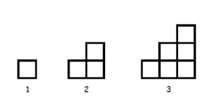

- Draw or build the next two staircases in this pattern.

- What patterns do you notice?

- How many blocks are in staircase 10? How do you know for sure?

- How many blocks are in staircase 50? How do you know for sure?

- How many blocks are in staircase 100? How do you know for sure?

- Write a rule for knowing the number of blocks in any staircase. Explain why your rule works.

