In Protocols 1, 2 & 3, you worked to develop a shared team understanding for several foundational pieces to the accessibility framework:
In Protocol 1, you addressed the team members’ beliefs and assumptions about math instruction for students with disabilities.
In Protocol 2, you gained familiarity with 6 areas of demand and difficulty that have an impact on mathematics learning and discussed the use of an IEP as a useful instructional resource;
In Protocol 3, you worked toward developing a common vision of what a “rigorous mathematics experience for all students” will look like under the new frameworks;
In Protocol 4, you were introduced to a framework for making mathematics accessible to a student with particular disabilities;
In Protocol 5, you extended this framework to considering a group of students with diverse learning needs.
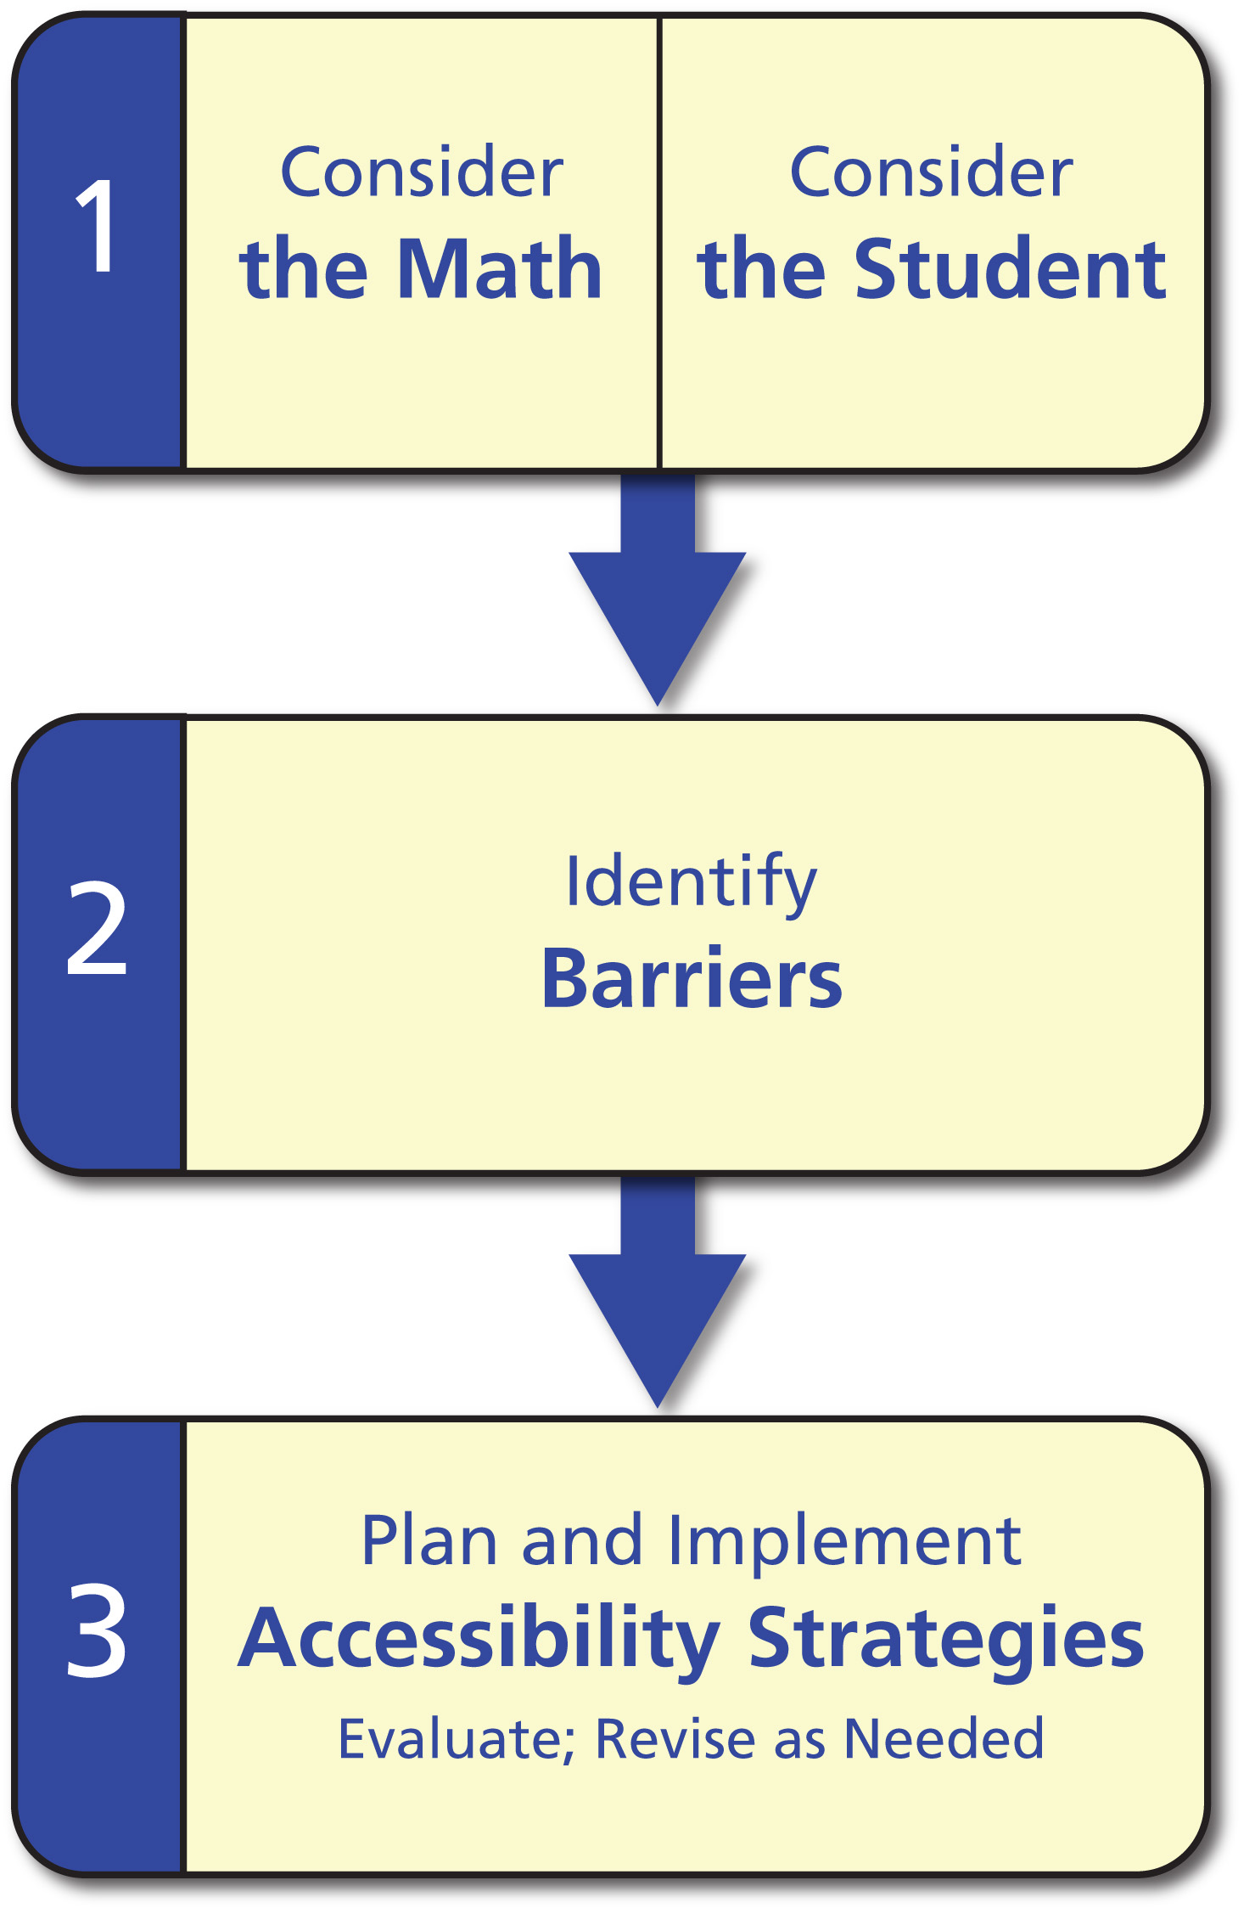
Imagine you are trying to describe the accessibility framework to a colleague. What’s the one paragraph version you would say to your colleague? (Think about what feels most critical to you for someone to understand as they put all this information together?)

What are your thoughts about next steps for sharing this work with your colleagues?

