Jasper feels overwhelmed when there is a lot of text on a page because he has difficulty with reading comprehension, particularly when there are a lot of math vocabulary terms. He often gets confused by the wording of directions, and thus is unsure of what he is being asked to do. He is embarrassed to ask for help in class because the other students all seem to catch on right away. Jasper is more comfortable when things are presented visually. Often he draws pictures as a way to figure out the solutions to problems.
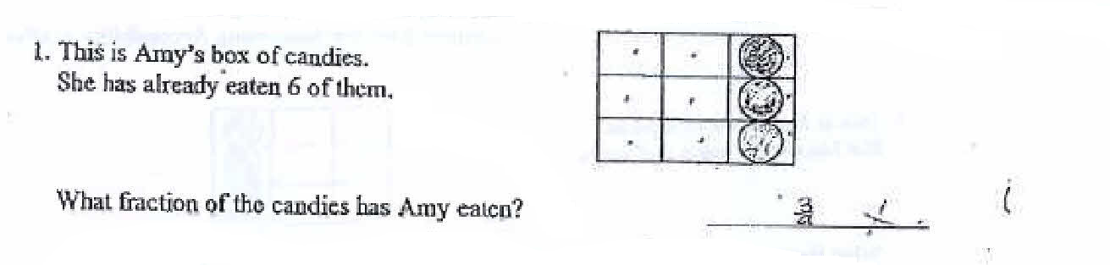
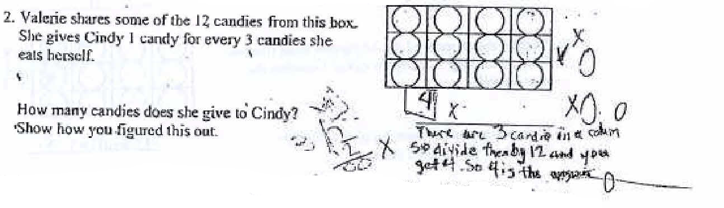
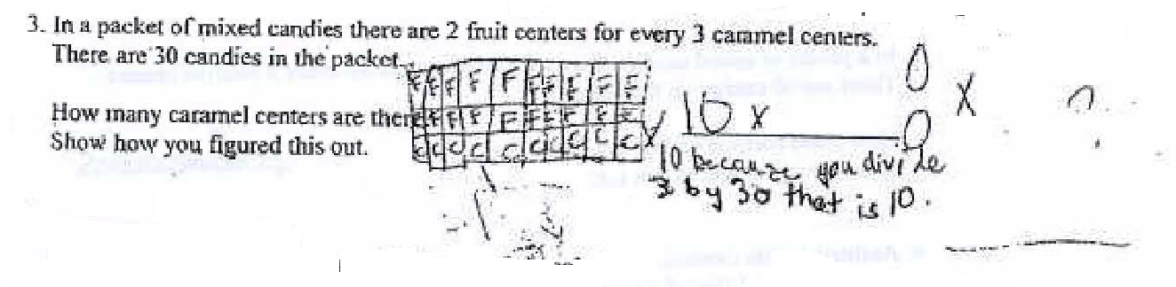
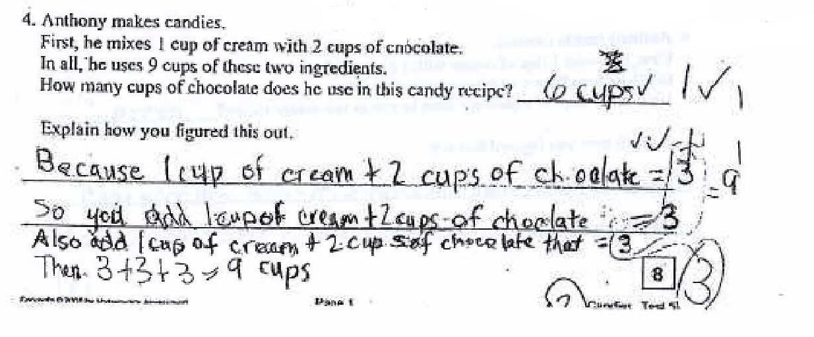
Anwyn is able to focus on math tasks and often comes up with novel solutions. However, she is rigid in her thinking, finds it very difficult to explain her work, and seldom checks what she has done. She has little patience with geometric tasks and visual representations. She rarely pays attention to verbal directions, wanders about the class at every opportunity, constantly looks out the window and delights in creating subtle distractions for other students.
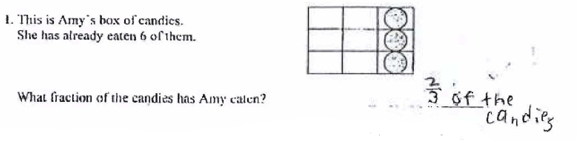
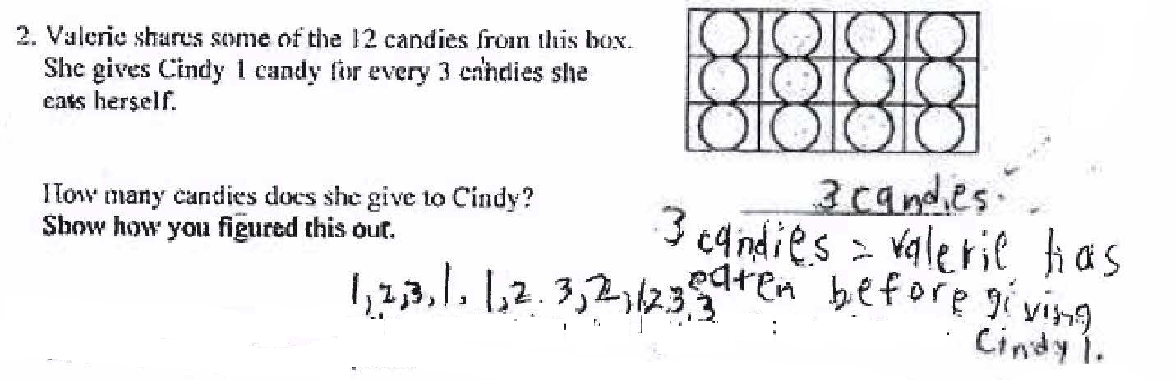
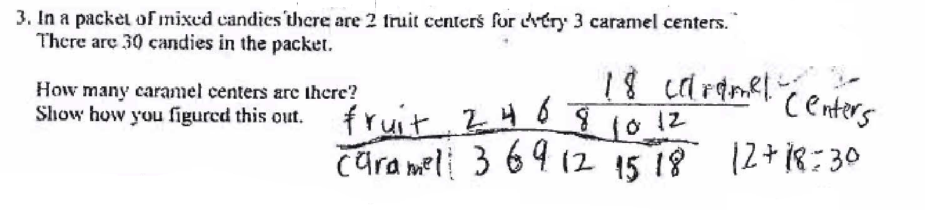
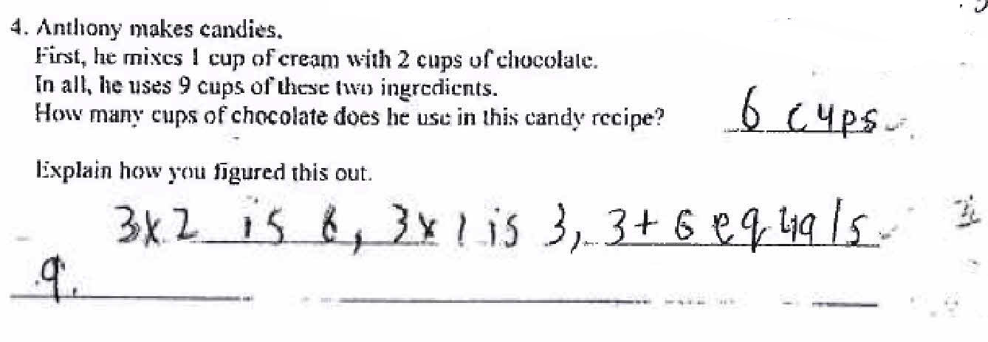
Mira is easily distracted and seems to tune in and out during math class. During class discussions, she doesn’t pay attention to other students’ explanations but she likes to talk about her own ideas. She says some things that are on target while others seem to be coming from “left field.” When she is solving math problems, she shows similar inconsistencies. Sometimes she comes up with good strategies for approaching problems but she has difficulty changing directions if the strategy doesn’t work. She also tends to rush through math problems, leaving out parts and making careless errors.

