|  |  |
| --- | --- |
| MTSS Logo | MTSS RESOURCE    MTSS & SPECIAL EDUCATION |

**6 GUIDING PRINCIPLES OF IDEA**

Free Appropriate Public Education — IDEA guarantees that each child with a disability, eligible for special education, will be entitled to a free appropriate public education (FAPE).

* Free requires that the education of each child with a disability must be provided at public expense and at no cost to the child’s parents.
* Appropriate means that each child with a disability is entitled to an education that is “appropriate” for his or her needs.
* Public refers to the public school system. The public school system must educate students with disabilities, respond to their individual needs, and help them plan for their future.
* Education - IDEA is an education act that guarantees that eligible children with disabilities will receive a public education that includes special education and related services as directed by the child's Individualized Education Program (IEP).

**Appropriate Evaluation** — IDEA requires that each child suspected of having a disability receive an appropriate evaluation. An appropriate evaluation provides information to be used to determine the child’s eligibility for special education and related services and the educational needs of the child.

**Individualized Education Program (IEP)** — In order to ensure that students with disabilities receive an appropriate and individualized education, IDEA requires that, after drawing upon current evaluation information, the IEP team develop a written document, the IEP, designed to meet the unique educational needs of each student with disabilities.

**Least Restrictive Environment (LRE)** — IDEA guarantees that a child with a disability will receive a free appropriate public education in the least restrictive environment (LRE) appropriate. This principle reflects IDEA’s strong preference for educating students with disabilities in general education classes with the access to general education curriculum. Placement in the general education classroom is the first placement option the IEP team must consider.

Parent and Student Participation in Decision Making — This principle reinforces the belief that the education of children with disabilities is made more effective by strengthening the role of parents in the special education process. IDEA requires that parents (and students, as appropriate) participate in each step of the special education process. Students must be invited to participate in IEP meetings where transition services are to be discussed.

**Procedural Safeguards** — Procedural safeguards are a set of activities whose purpose is to ensure that:

* The rights of children with disabilities and their parents are protected.
* All information needed to make decisions about the provision of a free appropriate public education to the student is provided to parents of children with disabilities and to the student when appropriate.
* Procedures (mediation and due process) are in place to resolve disagreements between parties.

Want to Extend Your Learning? Quizlet on 6 Guiding Principles of IDEA. 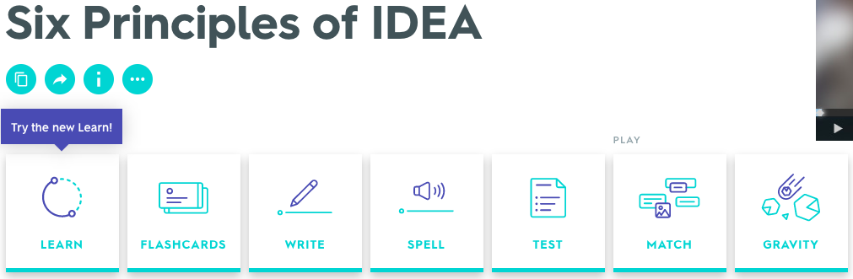

https://quizlet.com/45728212/six-principles-of-idea-flash-cards

ACTIVITY

**OPTION 1: Explore Connections Between IDEA and MTSS**

1. Conceptualize the MTSS Framework. Consider the following drivers articulated in the [Blueprint (Section 4, pgs 11-20):](http://www.doe.mass.edu/sfss/mtss/blueprint.pdf)

* Leadership Drivers
* Competency Drivers
* Implementation Drivers

2. Review the IDEA Guiding Principles

3. Where might the IDEA guiding principles fit into the MTSS framework?

For example, consider the following data suggestions from the MTSS Blueprint and discuss how they may support the IEP development process.

* Teachers use and analyze a variety of student-specific data to assess the effectiveness of their instructional strategies and practices and modify instruction to meet their students’ needs as identified.
* Administrators and teachers use a variety of ongoing assessments (formative, benchmark, and summative) to frequently and continually assess instructional effectiveness and to identify students’ individual academic needs (e.g., content or standard-specific academic needs) in order to provide student-specific interventions, enrichment, and supports.
* The school engages in ongoing monitoring of the impact of tiered interventions and adjusts school’s structures and resources (e.g., time, staff, schedules) to provide interventions to students throughout the year.

ACTIVITY

**OPTION 2: How Can Inclusive Practice Support the Effective Implementation of IDEA?**

Universal design for learning (UDL) is a framework that reduces barriers in instruction, proactively provides appropriate accommodations and supports, and allows for high-achievement expectations for all students, regardless of their unique mix of strengths and weaknesses, by providing options and choices for students to personalize their learning. UDL is an educational framework based on research in cognitive neuroscience that guides the development of flexible

learning environments that can accommodate learner variability. The nine (9) [UDL Guidelines](http://udlguidelines.cast.org/) are a tool used in the implementation of UDL. Guideline 6, specifically, is focused supporting executive function and learning by providing provide scaffolding and strategies that will optimize student success.

1. Review Guideline 6 of the UDL Framework: Provide options for [Executive Functions](http://udlguidelines.cast.org/action-expression/executive-functions/executive-functions)

##### [Guide appropriate goal-setting (checkpoint 6.1)](http://udlguidelines.cast.org/action-expression/executive-functions/goal-setting/goal-setting)

##### [Support planning and strategy development (checkpoint 6.2)](http://udlguidelines.cast.org/action-expression/executive-functions/strategy-development/strategy-development)

##### [Facilitate managing information and resources (checkpoint 6.3)](http://udlguidelines.cast.org/action-expression/executive-functions/information-resources/information-resources)

##### [Enhance capacity for monitoring progress (checkpoint 6.4)](http://udlguidelines.cast.org/action-expression/executive-functions/monitoring-progress/monitoring-progress)

2. Consider the Individualized Education Program (IEP) guideline — In order to ensure that students with disabilities receive an appropriate and individualized education, IDEA requires that, after drawing upon current evaluation information, the IEP team develop a written document, the IEP, designed to meet the unique educational needs of each student with disabilities.

3. How might effective implementation of Guideline 6 of UDL help prepare robust IEPs to support IDEA?