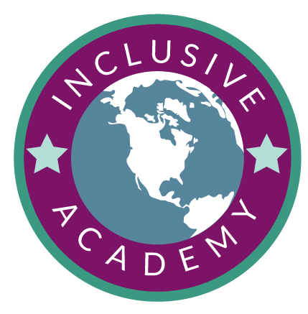 | UDL Interview Questions for Candidates
Professional development is a great way to support staff with UDL implementation and overtime, Inclusive Practice scales within a building and significantly impacts student outcomes. The improvement cycle, however, is cycial, as every year experienced educators retire and new teachers are onboarding and supported through Induction Programs. So, even when you’re scaling UDL and Inclusive Practice as a school, you will likely always have teachers who are in the Explore phase. One important consideration is hiring practices and looking for teachers who are likely to align to the UDL Framework and the believe that students need different options and choices to meet their greatest potential. Consider the questions below and how they align to the UDL Guidelines. What would answers tell you about these candidates?
Curriculum and Teaching
- How would you use technology to enhance your instruction and provide students with multiple ways to access information or express their understanding?
- If you were hired for this position, what would you do to familiarize yourself with the curriculum/school?
- How do you go about preparing for a lesson/unit to ensure that the needs of all students are met through options and choices?
- If I were to walk into your classroom, what would I see? Describe the environment and how the lesson would be designed.
- At the end of the school year, what are the most important things that your students will know and be able to do?
- Tell us about assessments you use to inform instruction and how you utilize the results of these assessments in your practice.
- How do you engage reluctant learners in rigorous, meaningful learning experiences?

- In our district, we believe that when students don't learn, it's because teaching, curriculum and the school are disabled. How do you feel about that statement?
- How would you use student feedback to improve your instruction and ensure that you are developing authentic choices and options to improve their learning?
- How important is it to provide students with options and choices about how they will learn and share what they know through assessments?
Family and Community Engagement
- How will you handle home/school communication to ensure that you develop meaningful communication with all families, regardless of variability?
- How would you communicate with a student’s family if they were struggling academically or behaviorally in your classroom?
Professional Responsibility
- Tell us about yourself and something that you have done that you are proud of as an educator.
- We encourage and promote collaboration and professionalism in our school. Give us an example from your experiences of how you have worked effectively as part of a team to foster collaboration and community. What can we expect from you as you join ours?
- What plans do you have for your own future professional development?
- What have you read recently that informs your practice?
- Tell us about two different lessons – one that you expected would go well, and it did; and another you expected to go well, and it didn’t. What did you learn from these experiences?

