Student Opportunity Act Plan: SY 2021-2023
Pioneer Valley Performing Arts Charter School

→ Commitment 1: Focusing on Student Subgroups

Which student groups will require focused support to ensure all students achieve at high levels in school and are successfully prepared for life?

PVPA has identiﬁed the following subgroups of students due to their opportunity and achievement gaps:

Latinx students Black students
Economically Disadvantaged Students Students with Disabilities

These four subgroups have been selected based on the following data:

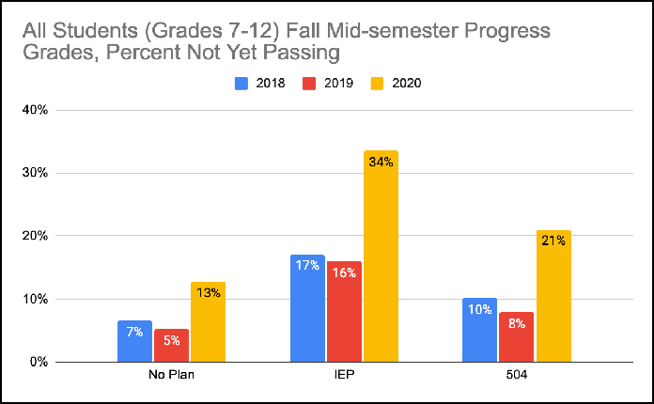
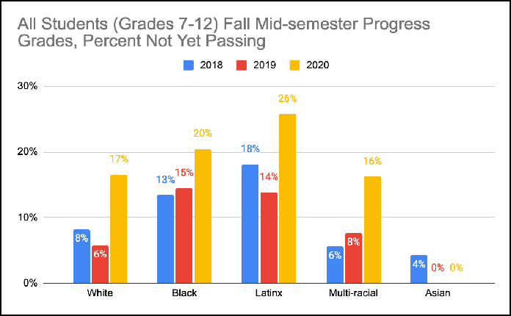
Progress Course Grades Fall 2018-2020
- Quarter 1 progress grades for all arts and academics courses

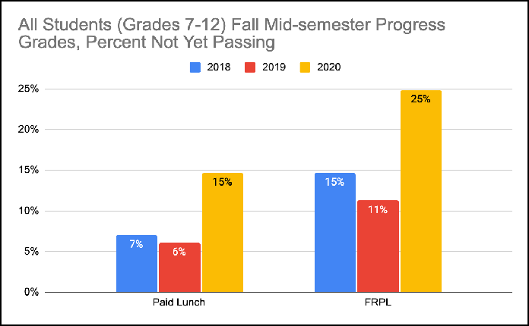
- Fall 2020 grades reﬂect remote learning context, and COVID-19 pandemic

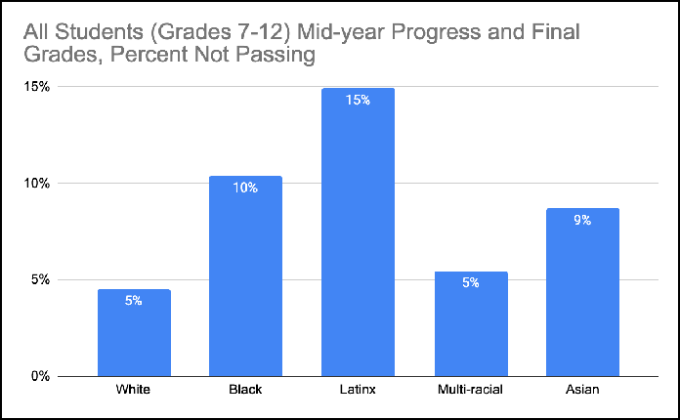
Final and Progress Course Grades January 2020

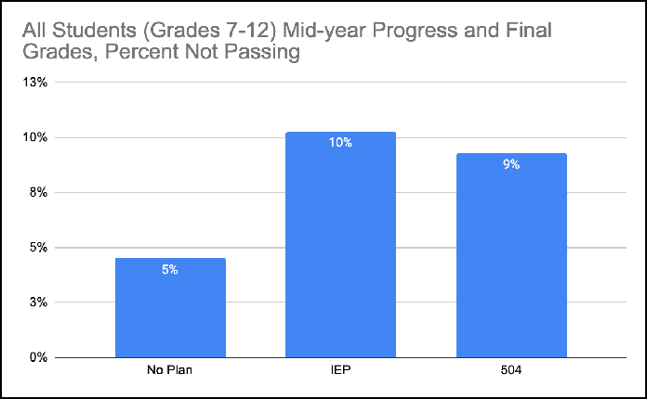

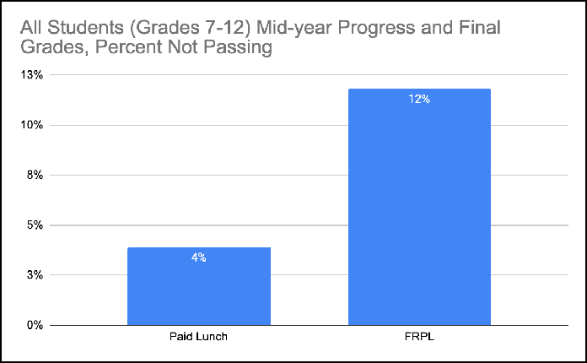
- Arts and academics courses

- Final grades for one-semester-long courses

- Mid-year progress grades for full-year courses

→ Commitment 2: Using Evidence-Based Programs to Close Gaps

What evidence-based programs will your charter school adopt, deepen, or continue to best support the closure of achievement and opportunity gaps? What resources will be allocated to these programs?

Diversifying the educator/administrator workforce through recruitment and retention
As seen in the graph below, our current workforce does not mirror our student population.
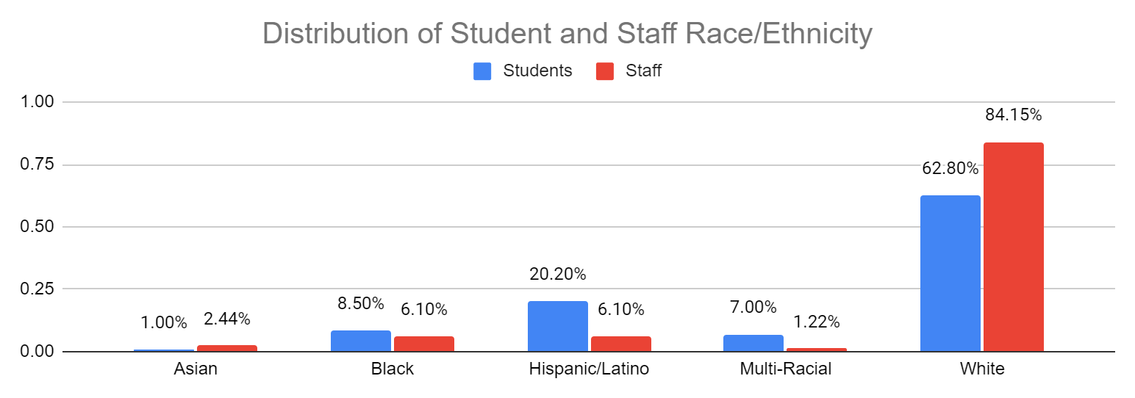

PVPA is committed to continuing to hire staﬀ of color on a proactive basis. A growing body of educational research demonstrates the importance and need to develop inclusive school environments for students and staﬀ to support the retention of a diverse teacher workforce. PVPA is implementing these initiatives through our new collective bargaining relationships and admin reorganization.

- · Shared or collective decision-making
- Opportunities for growth and development such as mentorship programs and access to professional development
- Cultivation of relationships with students and families to strengthen the school community

Increased staﬃng to expand student access to arts, athletics, and enrichment and strategic scheduling to enable common planning time for teachers

PVPA will increase common planning time in order to provide high quality professional development to faculty, foster collaboration between special education and regular education teachers, and develop stronger shared instructional practices to meet the needs of diverse learners. Currently teachers have 75 minutes of collaborative time each week as a whole staﬀ. In addition, Middle School teachers have a common prep block once per week. We will add a weekly common prep block for the 9th and 10th grade teams. Administrators will give input on agendas, facilitation, and speciﬁc discussion topics. This will support teachers in building relationships, establishing routines, and developing a productive work cycle that results in positive student outcomes.

Common planning time will be used for the following activities:

    - Professional development in Universal Design for Learning, including studying CAST materials
    - Professional development in culturally responsive pedagogy and anti-racist education
    - Developing shared research-based strategies for meeting the needs of diverse learners

In addition, PVPA will hire at least one designated substitute teacher to provide release time to individual teachers to meet with academic support teachers, paraprofessionals, our English Language Education Coordinator, counselors, and/or other specialists.

PVPA wishes to change its schedule in order to focus more intensive eﬀorts on high need students. Speciﬁcally our change in schedule will create/expand:

- Expand our successful middle school advisory program into the high school
- Create more time for individual support for high need students
- Increase teacher collaborative time to facilitate intensive focus on high need students.

We will accomplish this through our strategic partnership with our teachers’ union. After signing our ﬁrst contract in the fall, 2020, we will now launch our Labor -Management Committee with the school’s ﬁrst agenda item being the Master Schedule.

Collaborative relationships between teachers’ union leaders and school administrators can lead to meaningful change in the lives of our highest need students.

Evidence-based program #1: Diversifying PVPA Workforce

FY21 budget item | Amount | Foundation Category1
anti-racism training for admin and board | 10,000 | Professional Development
Recruitment & Retention Activities | 15,000 | Professional Development
Evidence-based program identiﬁed by the Department: |  | Diversifying workforce
SOA program categories: |  | D and H

Evidence-based program #2: Increased staﬃng to expand student access to arts, athletics, and enrichment and strategic scheduling to enable common planning time for teachers

FY21 budget item | Amount | Foundation Category
Schedule change - teacher salaries | 125,000/year | Classroom Teachers and Specialists
Additional FTE - Support Staﬀ | 28,000 | Other Teaching Services
Advisory Program Development | 5,000 | Other Teaching Services
Evidence-based program identiﬁed by the Department: |  | Increased Staﬃng and Strategic Scheduling
SOA program categories: |  | B and D

→ Commitment 3: Monitoring Success with Outcome Metrics and Targets
What metrics will your charter school use to monitor success in reducing disparities in achievement among student subgroups? Select from the list of Department metrics or provide your own.

1) Department outcome metrics:
✓
Extended engagement rate (five-year cohort graduation rate plus the percentage of students from the cohort who are still enrolled)
✓
Chronic absenteeism (percentage of students missing 10 percent or more of
their days in membership)
- First semester college matriculation
rate
- Custom metrics (must include targets as well):

  - In-house analysis achievement data based on student grades

→ Commitment 4: Engaging All Families

1

How will your charter school ensure that all families, particularly those representing the student subgroups most in need of support, have the opportunity to meaningfully engage with the charter school regarding their students’ needs?

Pioneer Valley Performing Arts Charter Public School is committed to informing our community engagement to ﬁt the needs of all students, with a special focus on the success of students of Color, of low socioeconomic backgrounds, English learners, and with disabilities. We pursue this work by cultivating an equitable education system, which is one where our staﬀ and faculty are informed by diversity and inclusion practice in all facets of our operations. Through this work, we have been able to engage in close partnerships with our students and families which has sown the seed for healthy community dialogue and advocacy around individual subgroup needs. Largely, realizing that equity does not necessarily mean creating equal conditions for all, rather allocating resources and supports to remove barriers and create opportunity.

With this, after recognizing that the remote nature of schooling was our expected reality for the foreseeable future, the PVPA PTO was revitalized in July 2020 with the intention of strengthening student support systems both at school and at home. We acknowledged the need to create a space for caregivers to come together, connect with staﬀ and faculty, and voice their concerns/thoughts about their children’s education. The PTO has been a fully remote group which has increased access to families across the community to participate without needing to travel. We continue to work to reduce barriers of participation; all families are encouraged to participate in ways big and small, there is little necessary commitment for caregivers to join the group, and we strive to center the monthly meetings around creating lines of connection between families and diﬀerent collectives of the PVPA staﬀ.

The mission of the Special Education Parent Advisory Council, known as SEPAC, is to provide education and information to parents and guardians on special education issues and services and to act as an advisory council to the PVPA Student Services and Academic Support departments. SEPAC works with parents to advocate for the rights of their students and continuously push for accessibility and proper resources both in and out of the classroom. The English Language Programs Coordinator works with Spanish speaking students and families to oﬀer additional academic support, translation services, and act as an advocate for those families in ensuring they are fully and equitably informed about their child’s education. PVPA works to critically evaluate the needs of our students as they evolve over time and invest in developing relationships between all parties to address concerns as they arise.

Certiﬁcations:

✔ By checking here, I certify that our charter school has engaged stakeholders in our community in accordance with the Student Opportunity Act
Please summarize your stakeholder engagement process, including speciﬁc groups that were engaged:

The senior Admin team developed a plan that would align with the goals currently being worked on by the Strategic Action Plan Committee. The plan was shared at the January PTO meeting where parents were given the opportunity to discuss the plan and to reach out to members of the senior admin team with additional questions.

The plan was shared with the Board of Trustees at the February 9, 2021 meeting. Our Board of Trustees consists of students, staﬀ, parents and community members so this is the most representative body to gather input from our stakeholders.

✔ By checking here, I certify that the Pioneer Valley Performing Arts Charter Public School’s Board of Trustees voted on our Student Opportunity Act Plan.
Date of vote: February 9, 2021 Outcome of vote: Approved

