Instructions for Completing FY26 SOA Plan Progress Reports in GEM$

Contents
Quick Start Instructions 1
Assign SOA Roles in GEM$ 2
How to locate your FY26 SOA Plan Progress Report in GEM$ 2
How to begin entering data in your FY26 SOA Plan Progress Report 4
The FY26 SOA Plan Progress Report submission form in GEM$ 5
Key Evidence-based Programs in District’s SOA Plan 5
Section 1: Summary of Progress to Date (Academic Year 2025-2026) 6
Section 2: Key Changes to Your Plan and Next Steps in Implementation 8
Section 3: Engaging Families/Caregivers and Other Stakeholders 9
How to submit your SOA Plan 11
How to print your FY26 SOA Plan Progress Report 13

Quick Start Instructions
- Log into GEM$ using your email and password
- Select Application Supplement from the menu
- Set Fiscal Year to 2026
- Select SOA Plan Progress Report from list of application supplements
- Change Status from Not Started to Application Supplement Started
- Select a section of FY26 SOA Plan Progress Report to begin entering information into template
- Remember to save your work at regular intervals!

Assign SOA Roles in GEM$
Make certain your User Access Administrator assigns at least one person the LEA SOA Plan Writer role in the Grants for Education Management System (GEM$). There are two only GEM$ roles involved in completing and approving FY25 SOA Plan Progress Reports:
  - LEA SOA Plan Writer
  - LEA Superintendent/Chief Executive (likely already assigned)

- LEA SOA Plan Writer: The LEA SOA Plan Writer enters data into the FY26 SOA Plan Progress Report (which is an Application Supplement) in GEM$.
  - More than one person may be assigned this role.
  - The LEA SOA Plan Writer is the only role with permissions to enter data into the application supplement.
  - Superintendents must be assigned the LEA SOA Plan Writer role, in addition to the LEA Superintendent/Chief Executive role, in order to directly edit/enter information in the template.

- LEA Superintendent/Chief Executive: The superintendent or her/his designee either 1) returns the report to the LEA SOA Plan Writer(s) if edits are required or 2) approves the FY25 SOA Plan Progress Report. When the LEA Superintendent/Chief Executive approves the progress report in GEM$, DESE will receive an email indicating that it has been submitted for review.

How to locate your FY26 SOA Plan Progress Report in GEM$
- Sign into GEM$ using your email address and password: https://mass.egrantsmanagement.com/
- Click Application Supplement in the left-hand navigation panel (circled in green).
- Once the Application Supplements page opens, make certain the Fiscal Year is set to 2026 (circled in green)
- Click on the link for the FY26 SOA Plan Progress Report (circled in green).

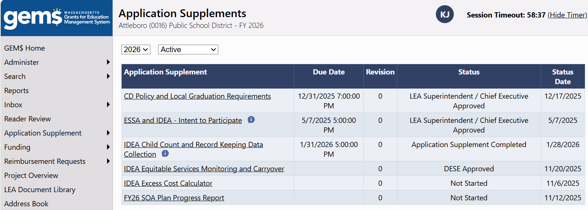

- The FY26 SOA Plan Progress Report Submission Sections page that appears below will open. The four sections of the FY26 SOA Plan Progress Report that districts will complete are listed here. From this page you can navigate to any section of the progress report by clicking on the section name. You may complete the sections in any order.
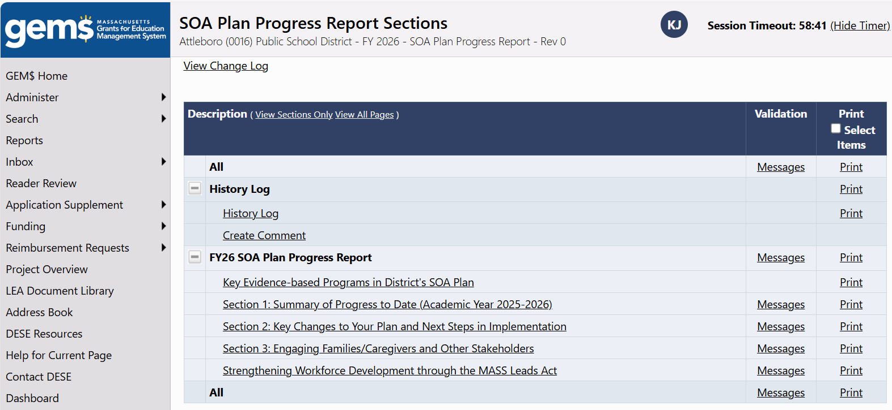

How to begin entering data in your FY26 SOA Plan Progress Report
- When you first open the application supplement, your Status, circled in red in the screen shot below, indicates Not Started.
- To begin typing in your progress report, you need to start the application supplement by moving your cursor to the Change Status To line, circled in green, and clicking on Application Supplement Started.
Note: If you forget to complete this step, you will be able to see the instructions and items in the template, but the data entry screens will not open.
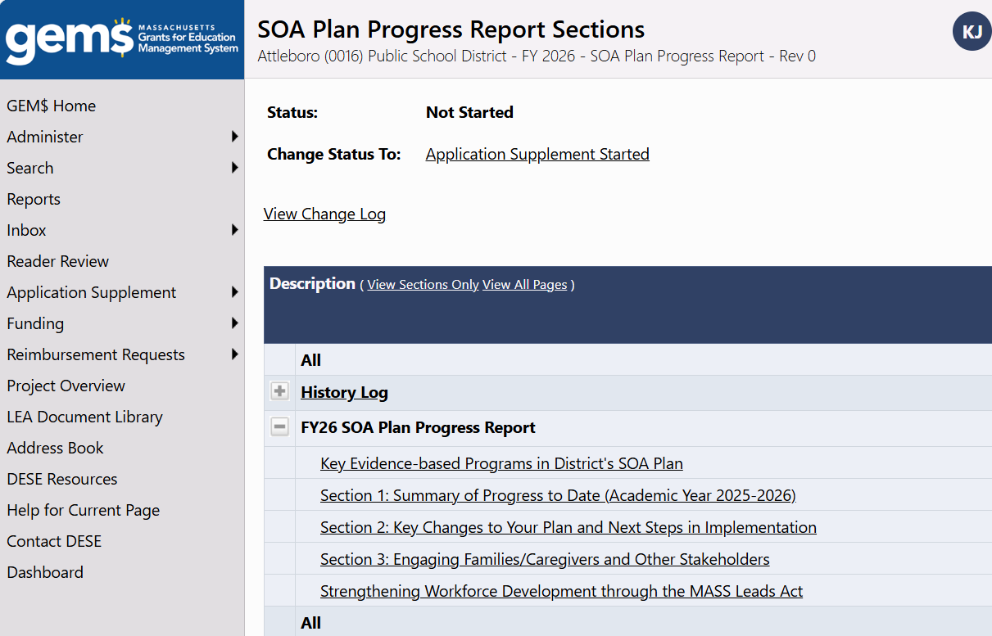

- A Status Change Confirmation pop-up will appear. Click Confirm to change your status to Application Supplement Started. Once you have done that, your status will be updated on the FY2 SOA Plan Progress Report Sections page. You may begin entering data into your plan by clicking on the Section you wish to begin working on.

The FY26 SOA Plan Progress Report submission form in GEM$
- Screenshots of each section appear below.
  - Most sections are relatively intuitive and straightforward to complete in GEM$.

- General tips for completing each section.
  - Narrative response questions allow for a variety of formatting options, as you can see in the text box below.
  - It is possible to copy and paste text from other word processing applications into GEM$.
  - You can also copy and paste screen shots into GEM$ if you have visuals you would like to include.
  - Required questions are marked with an asterisk (*).

Key Evidence-based Programs in District’s SOA Plan

This year GEM$ will auto-populate this section with a list of the evidence-based programs detailed in Section 5 of your district’s SOA Plan. The district in the example below is prioritizing the implementation of the three evidence-based programs (EBP) listed.
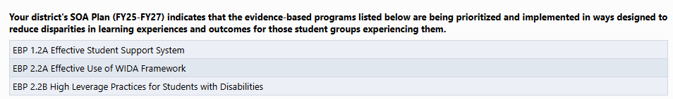

Section 1: Summary of Progress to Date (Academic Year 2025-2026)
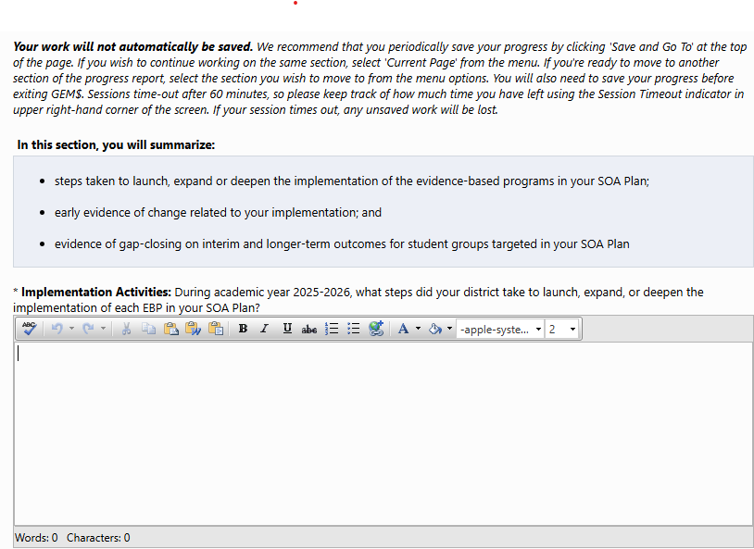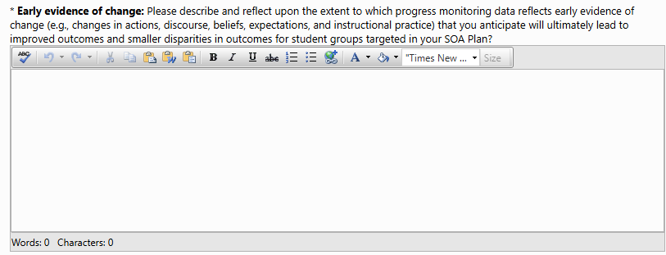

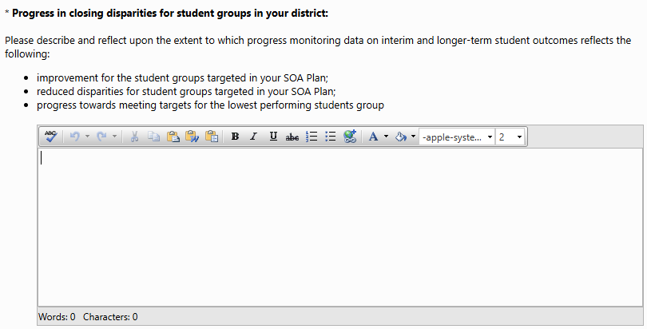

Section 2: Key Changes to Your Plan and Next Steps in Implementation

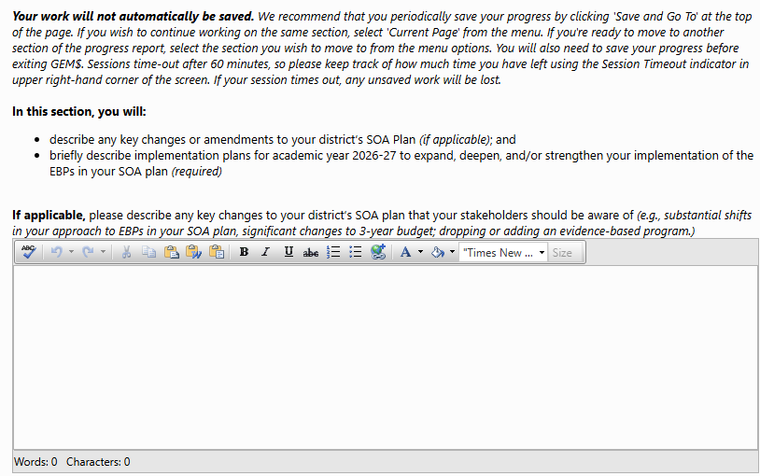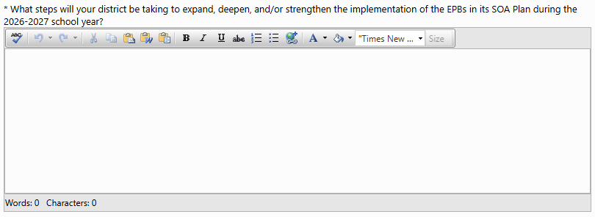

Section 3: Engaging Families/Caregivers and Other Stakeholders

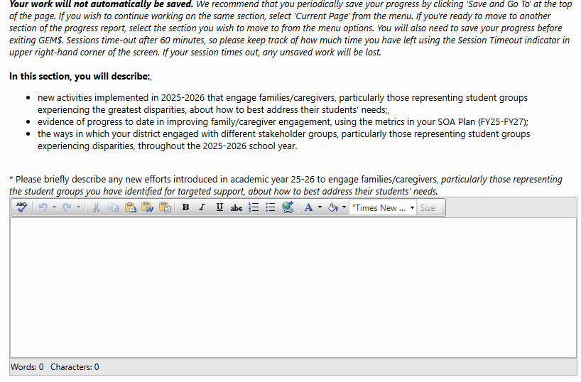

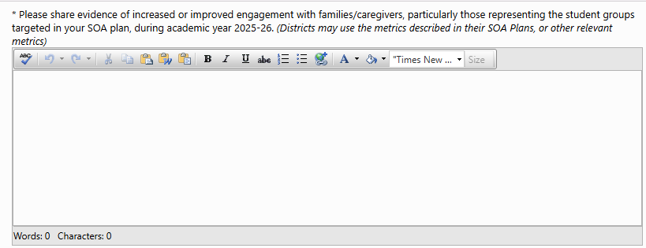

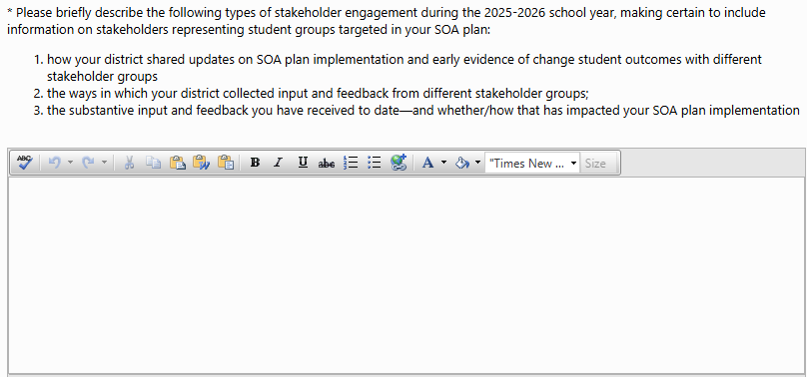

How to submit your SOA Plan

Instructions for LEA SOA Plan Writer(s)
Once the progress report is fully entered into GEM$, the next step in the GEM$ ‘workflow’ is to send the report to the LEA Superintendent/Chief Officer for review by changing the Status of the report from Application Supplement Started to Application Supplement Completed. (NOTE: Superintendents who double as LEA SOA Plan Writers will need to follow these steps—essentially sending the report to themselves for approval.)

- Check for validation errors on the FY26 SOA Plan Progress Report Sections.

  - If the Validation Column (outlined in green) is blank, you can change the status to Application Supplement Completed.
  - If the word Messages appears in the column, the section(s) has a validation error. All validation errors must be resolved before GEM$ will permit the status to be updated to be moved to Application Supplement Completed.

No Validation Errors | Validation Errors
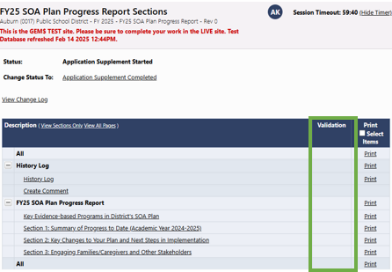 | 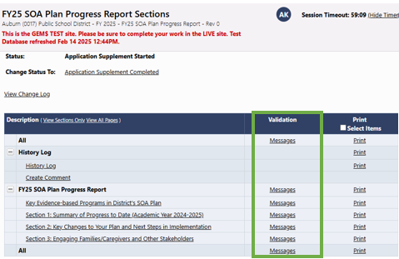

- Click on Messages for a description of any error(s). If multiple sections have errors, clicking on Messages in either of the All rows will open a Validation Messages table that describes errors for each section. Clicking on Review (circled in green in screenshot on p11) will take you to the section of the report that requires attention.

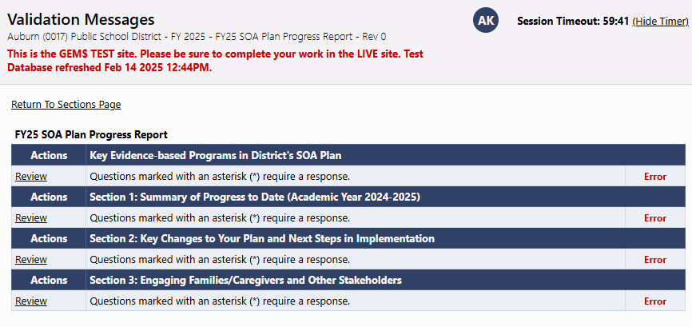

  - When all validation errors (Messages) have been eliminated (green box) and the SOA Plan is ready for the LEA Superintendent/Chief Executive’s review and approval, return to the Student Opportunity Act (SOA) Plan Submission Sections

- Update the Status from Application Supplement Started to Application Supplement Completed by clicking Application Supplement Completed on the Change Status To: line (green circle) and confirm that you want to update the status. Once the status is updated, GEM$ automatically generates an email that goes to the LEA Superintendent/Chief Executive letting them know that the application supplement is complete.

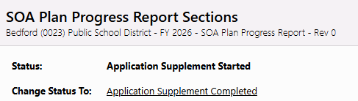

- No further edits can be made once the Status has been updated to Application Supplement Completed. If additional edits are required, the LEA Superintendent/Chief Executive will need to change the Status to LEA Superintendent/Chief Executive Returned – Edits Needed. This will generate an email for the LEA SOA Plan Writer(s) and restores access to the data entry template.

Instructions for LEA Superintendent/Chief Executive
The LEA Superintendent/Chief Executive, will receive a No Reply email from GEM$ indicating that the LEA SOA Plan Writer has completed the FY25 SOA Plan Progress Report Application Supplement. This is the superintendents’ cue to review the plan and either approve it, or return it to the LEA SOA Plan Writer for edits. (REMINDER: the LEA Superintendent/Chief Executive role does not have permissions to make direct edits to the progress report.

- To do that, navigate to the FY26 SOA Plan Progress Report Sections page and update the Status from Application Supplement Completed to either LEA Superintendent/Chief Executive Approved or LEA Superintendent/Chief Executive Returned – Edits Needed by clicking on the appropriate link on the Change Status To: line.
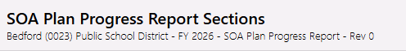
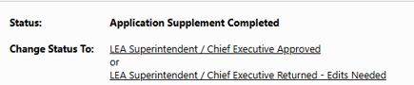

  - Changing the Status to LEA Superintendent/Chief Executive Returned – Edits Needed generates an email to the LEA SOA Plan Writer(s) that signals the progress report needs and permits them to make edits to the data entry screens.
  - Changing the Status to LEA Superintendent/Chief Executive Approved generates a GEM$ email to DESE letting us know the progress report is submitted and ready for review.

How to print your FY26 SOA Plan Progress Report

- FY26 SOA Plan Progress Reports can be printed at any time from the FY26 SOA Plan Progress Report Sections page by clicking on Print. You can print either the entire report, or individual sections.
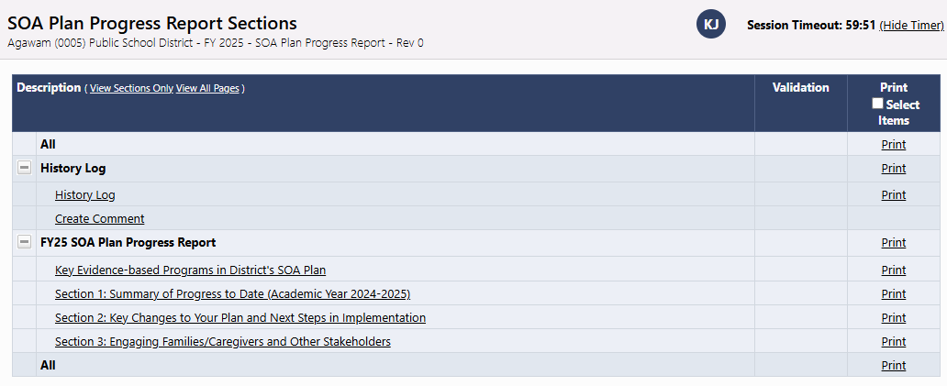
- You also have the option of printing your choice of sections in a single document. Check the box in the Print Selected Items column on the far right. A set of boxes will appear next to each section. Place a checkmark next to the section(s) you would like to print. (In the example below, Sections 1 and 2 would be printed as a single document.) You can either click on the word Print in the column header or click the Print Selected Items box at the bottom of the table to print the selected sections.

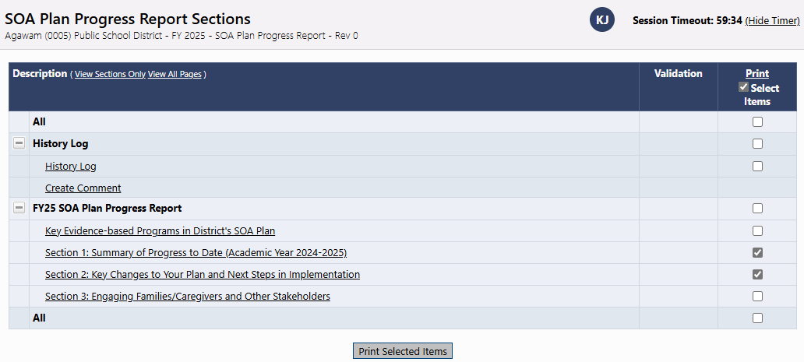

- Once you select print, a Print Request page will open. Your browser must be set to accept pop-ups.
  - Give your document a name and type it in the Document Name field
  - Enter your Email Address
  - Click the Print button

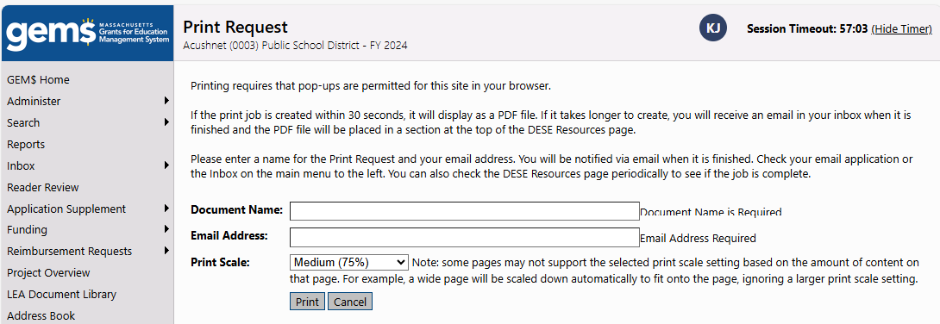

  - A message will appear letting you know that GEM$ is preparing your progress report for printing.
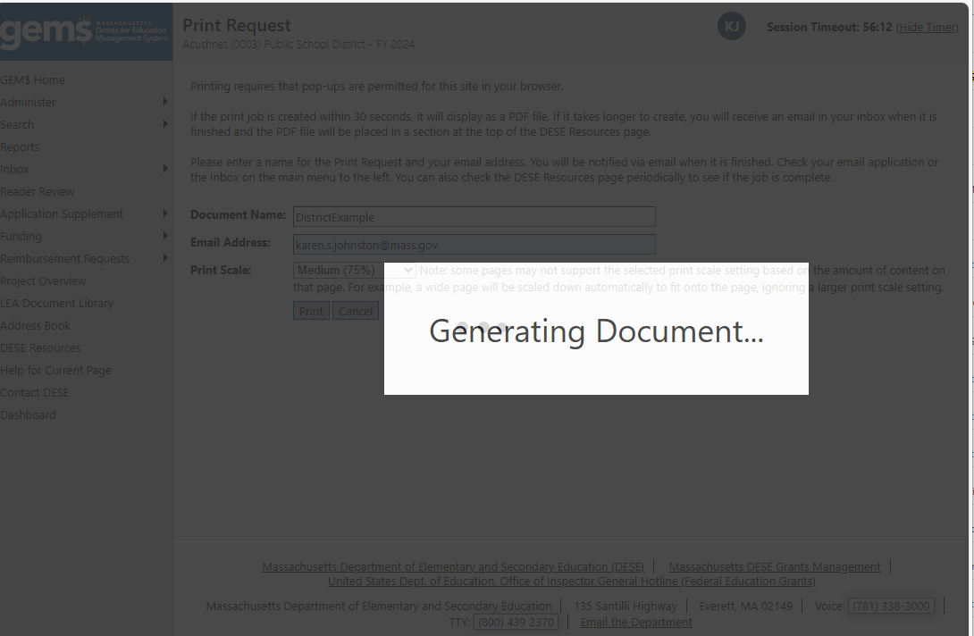

Your report will either:
- Open on your screen in a pdf format (e.g., in Acrobat Reader). You can either print from the screen or download and save the file to print later.
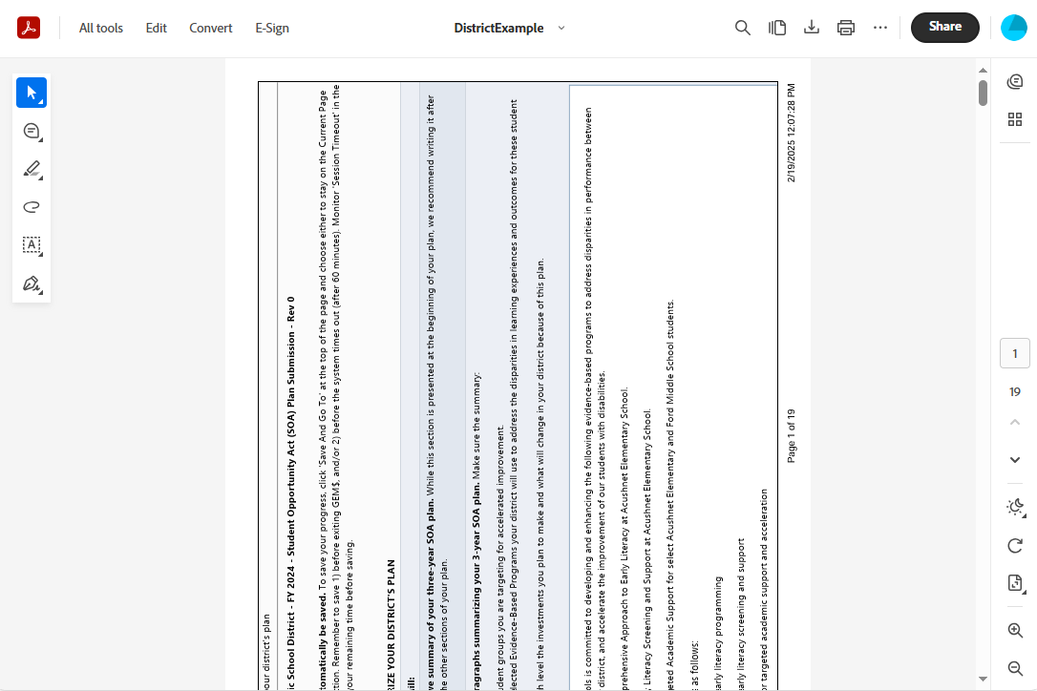

- If it takes GEM$ longer than 30 seconds to prepare the report, the system (GEM$NoReply@eGrantsManagement.com) will instead send an email to the address you provided with the subject line GEM$ - PDF Generated
