Data Advisory Commission
Annual Report for 2022
Chapter 132, Section 17 of the Acts of 2019
December 2022

Massachusetts Department of Elementary and Secondary Education
75 Pleasant Street, Malden, MA 02148-4906
Phone 781-338-3000 TTY: N.E.T. Relay 800-439-2370
www.doe.mass.edu

This document was prepared by the Massachusetts Department of Elementary and Secondary Education (DESE)

Board of Elementary and Secondary Education Members

Ms. Katherine Craven, Chair, Brookline
Mr. Matt Hills, Vice Chair, Newton
Ms. Tricia Canavan, South Hadley
Ms. Darlene Lombos, Boston
Ms. Farzana Mohamed, Newton
Mr. Michael Moriarty, Holyoke
Mr. James Peyser, Secretary of Education, Milton
Mr. Eric Plankey, Westford, Student Member
Mr. Paymon Rouhanifard, Brookline
Ms. Mary Ann Stewart, Lexington

Dr. Martin West, Newton

Jeffrey C. Riley, Commissioner
Secretary to the Board

The Massachusetts Department of Elementary and Secondary Education, an affirmative action employer, is committed to ensuring that all of its programs and facilities are accessible to all members of the public.
We do not discriminate on the basis of age, color, disability, national origin, race, religion, sex, gender identity, or sexual orientation.
Inquiries regarding the Department’s compliance with Title IX and other civil rights laws may be directed to the
Human Resources Director, 75 Pleasant St., Malden, MA 02148-4906. Phone: 781-338-6105.

© 2022 Massachusetts Department of Elementary and Secondary Education
Permission is hereby granted to copy any or all parts of this document for non-commercial educational purposes. Please credit the “Massachusetts Department of Elementary and Secondary Education.”

This document printed on recycled paper

Massachusetts Department of Elementary and Secondary Education
75 Pleasant Street, Malden, MA 02148-4906
Phone 781-338-3000 TTY: N.E.T. Relay 800-439-2370
www.doe.mass.edu

Table of contents
Legislative charge 4
Data Advisory Commission Membership 5
Data Advisory Commission – 2022 Overview of Deliberations 5
March 2022 5
June 2022 7
December 2022 7
Appendix A – 2021 Data Advisory Commission Annual Report 8
Data Advisory Commission – 2021 Overview 8
Data Advisory Commission Focus Areas and Recommendations from 2021 Deliberations 8
Appendix B – 2020 Data Advisory Commission Annual Report 10
Charge 1: Establishing a data collection and reporting system to: (A) track funding allocated for low-income students and students identified as English learners pursuant to chapter 71A and ensure spending is targeted to the intended populations; and (B) allow for access to school-level expenditures and data across all districts to inform the public and policy-makers of high impact, cost-effective school-level interventions and investments 10
Charge 2: Strengthening the department’s capacity to analyze and report staffing, scheduling and financial data in ways that support strategic resource allocation decisions at the district and school levels, including a review of national best practice models that ensure greater financial transparency 12
Charge 3: Strengthening district capacity to use state, district and school-level data to inform strategic resource allocation and implementation decisions 13
Charge 4: Streamlining data reporting, eliminating duplicative reporting requirements and improving data quality 14

Legislative charge
The Department of Elementary and Secondary Education (DESE) respectfully submits this Report to the Legislature: Data Advisory Commission Annual Report: 2022 pursuant to the statutory requirement in chapter 132 of the acts of 2019:

Section 17.(a) There shall be a data advisory commission to promote the improved use of state, district and school-level data to inform effective resource allocations at the district and school levels.
The data advisory commission shall assist the department in identifying, analyzing and making recommendations on high-impact, cost-effective data strategies for assessing student needs and addressing persistent disparities in achievement, including, but not limited to:
(i) establishing a data collection and reporting system to: (A) track funding allocated for low-income students and students identified as English learners pursuant to chapter 71A and ensure spending is targeted to the intended populations; and (B) allow for access to school-level expenditures and data across all districts to inform the public and policy-makers of high impact, cost-effective school-level interventions and investments;
(ii) strengthening the department’s capacity to analyze and report staffing, scheduling and financial data in ways that support strategic resource allocation decisions at the district and school levels, including a review of national best practice models that ensure greater financial transparency;
(iii) strengthening district capacity to use state, district and school-level data to inform strategic resource allocation and implementation decisions; and
(iv) streamlining data reporting, eliminating duplicative reporting requirements and improving data quality.
(b) The data advisory commission shall consist of: the commissioner of elementary and secondary education, who shall serve as chair; the secretary of education, or a designee; 1 member to be appointed by each of the following organizations, all of whom shall have demonstrated knowledge, experience and interest in data collection and analysis for the purpose of improving student performance: the Massachusetts Association of School Committees, Inc.; the Massachusetts Association of School Superintendents, Inc.; the Massachusetts School Administrators Association, Incorporated; the Massachusetts Association of School Business Officials, Inc.; the Massachusetts Association of Vocational Administrators, Inc.; the Massachusetts Association of Regional Schools, Inc.; and the Massachusetts Business Alliance for Education, Inc.; and 4 members to be appointed by the commissioner, 1 of whom shall be a teacher in a district of not less than 15,000 students who has experience in an underperforming or chronically underperforming school that has utilized data to successfully improve student performance, 1 of whom shall be a parent of a student currently enrolled at a kindergarten, elementary school, middle school or junior high school or high school in the commonwealth and 2 of whom shall have professional experience and knowledge in the area of data collection, quality and usage in establishing education policy and improving student outcomes.
(c) The data advisory commission shall report annually, not later than December 1, on its progress to the board of elementary and secondary education; provided, however, that the report shall be made publicly available on the department’s website.

Data Advisory Commission Membership
- Matthew Deninger, Chief Strategy and Research Officer, Designee of the Commissioner of Elementary and Secondary Education, Chair
- Ann Reale, Undersecretary of Education, Massachusetts Executive Office of Education (EOE), Designee of the Secretary of Education
- Steve Sharek, Massachusetts Association of Vocational Administrators (MAVA)
- Deborah Boyd, Massachusetts Association of Regional Schools (MARS)
- Joe Esposito, Massachusetts Business Alliance for Education (MBAE)
- Mercy Nunez, Parent, New Bedford Public Schools
- Mary Bourque, Massachusetts Association of School Superintendents (MASS)
- Aldo Petronio, Massachusetts Association of School Business Officials (MASBO)
- Paul Schlichtman, Massachusetts Association of School Committees (MASC)
- Matt Mattos, Massachusetts School Administrators Association (MSAA)
- Teacher, to be determined
- At-large, to be determined
- At-large, to be determined

Data Advisory Commission – 2022 Overview of Deliberations
The Data Advisory Commission met three times during 2022. Consistent with its legislative charge, the group continued its overview of current ongoing data-related strategies and initiatives at the Department of Elementary and Secondary Education (hereafter “DESE”).

March 2022
In March, the Commission looked at updates from the six focus areas it established in 2021:
- Optimize data collection, specifically regarding districts’ reporting of student information, in coordination with other state agencies, and specific to district use of incremental increases in Chapter 70 funding via the state Student Opportunity Act, in concert with the federal COVID relief funds for districts through ESSER I, II, and III. (§17(a)(i))

Specifically in the area of data collection optimization, the Commission discussed the future plans of the Student Opportunity Act planning process, including the amendment process and any data that would be collected as part of the process in order to inform policy. The Commission also heard from DESE federal grants staff about ESSER fund data collection, and the progress districts have made on spending and drawing down funds. Lastly, in this area, DESE announced to the Commission that it would be procuring and implementing a new grants system, and that it will ask the Commission in future meetings to advise on the implementation of the system.

- Optimize and align performance indicators, specifically regarding districts’ performance targets per the state Student Opportunity Act, and any federal requirements as part of ESSER I, II, and III to help determine if funding is achieving its intended purpose. (§17(a)(ii))

The Commission heard from the Student Opportunity Act team about the SOA target-setting process that districts went through, how districts would be held accountable to those targets, and the alignment between those targets and the state and federal accountability system.

- Improve data matching to better understand workforce/wage outcomes for students. (§17(a)(iii))

DESE previewed and discussed a college and career readiness dashboard that will be made public in 2022. The Commission also learned that DESE had made progress on an updated data sharing agreement with the Department of Unemployment Assistance in order to be able to match and report on wage data.

- Strengthen the end-of-the-year financial data collection to improve usability of financial information, through improved coding and enhanced data exports. (§17(a)(i) thru (iv))

DESE reported that the End of Year report improvements are currently on hold as it focuses efforts on a new Circuit Breaker system, which is in dire need of technical improvement.

- Commission an independent researcher to study whether state funds are targeted to and are reaching intended population of students, whether cost-effective interventions are being implemented, and whether the funds are achieving their intended purpose. (§17(a)(i))

DESE reaffirmed its commitment to commission a study when there is enough spending data available to produce findings.

- Support greater use of existing data analytics tools that provide data for all stakeholder groups, including but not limited to families, school personnel, district personnel, and policymakers, and work with all stakeholder groups to improve the availability and usability of state-supported data and data analytics tools. (§17(a)(ii))

DESE reported to the Commission about the state of its efforts to increase use of analytic tools, and reiterated that new, innovative tools were on the horizon and would be presented at later meetings.

June 2022
In June, the Commission concentrated on three of its focus areas in depth, discussing the SOA plan data analysis, the planned spending analysis of the ESSER programs, and the college and career readiness dashboard.

For the SOA plan data analysis, the Commission learned that, as of June 2022, 95% of plans had been received. Using these received plans as the universe:
- 42% of districts indicated they’re using SOA dollars to implement high-quality, aligned curriculum
- 41% of districts indicated they’re using SOA dollars to implement inclusion/co-teaching
- 40% of districts indicated they’re using SOA dollars to implement SEL and mental health – especially since the pandemic
- 35% of districts indicated they’re using SOA dollars to implement research based early literacy
- 24% of districts indicated they’re using SOA dollars to implement culturally responsive teaching – new this year
- 16% of districts indicated they’re using SOA dollars to implement acceleration academies

For the presentation on planned ESSER spending by category, the Commission learned that:
- ESSER I funds were largely spent on technology, COVID response (like pre-vaccine activities), and other academic and operational needs (buses, keeping folks employed, etc.)
- ESSER II and III, however, is funding to help districts emerge stronger from the pandemic, and therefore planned spending is geared toward addressing unfinished learning, curriculum improvements, extra supports for specialized populations (ELs, SWD), and facilities and air quality improvements.

The prototype of the College and Career Readiness Dashboard was presented to the Commission. This dashboard presents a high level overview of statewide data related to student outcomes after high school, and each report has a “key takeaways” section that describes some of the trends in the data. Furthermore, each dashboard is interactive, and allows users to dig into and slice data by various variables (student groups, etc.).

December 2022
For its last meeting in December, the Commission saw two newly launched public/live versions of major reports: the College and Career Readiness Dashboard, and the Wage Outcomes report. DESE demonstrated both reports, and the Commission provided constructive feedback on both.

The Commission also received an update and a brief demonstration of the new grants management system that DESE is currently building in partnership with a vendor and discussed particular data points as they relate to budgeted information, and how DESE planned to link and integrate this new system with DESE’s other data systems.

Appendix A – 2021 Data Advisory Commission Annual Report

Data Advisory Commission – 2021 Overview
The Data Advisory Commission met three times during 2021. Consistent with its legislative charge, the group continued its overview of current ongoing data-related strategies and initiatives at the Department of Elementary and Secondary Education (hereafter “DESE”).

In the spring, the Commission looked at DESE’s State Longitudinal Data System, or “SLDS”. The SLDS project aims to strengthen data links across state agencies to follow students from early childhood through the workforce and to make this data more widely available and more usable by researchers, policymakers, and the public. The project will bring different state agencies together into a central hub, develop a shared research agenda, and establish a data governance structure to codify how this data is used and protect student privacy. The project is intended to encourage shared ownership for progress on state goals; make data more useful to all stakeholders; increase access to the data; and make reporting and data use more efficient, effective, and transparent.

Also in the spring, the Commission was briefed on the federal COVID stimulus funds (ESSERs I, II, and III), which total $2.8 billion over 3.5 years. The Commission discussed the kinds of information they would want to learn from the use of these funds, such as spending categories and evaluations of student outcomes stemming from the funding.

In the fall, the Commission dug into the kinds of financial data DESE has, and its strengths and limitations. For instance, the state has data both on what districts plan to spend, as well as what districts actually spent. However, the former is always subject to change, and the latter is often collected long after accounting books have closed and therefore can only provide a snapshot of what happened. The Commission then looked at a few examples of these data, including the Student Opportunity Act funding and how districts plan to use it (planned spending) and the improvements DESE is making to its End of Year Reporting system (actual spending).

After having analyzed various DESE data systems and sources, the Commission established focus areas and recommendations for the coming years to guide the state toward further improvements in the realm of data collection, analysis, reporting, streamlining, and proper use, in order to fulfill its legislative charge. The details of these focus areas and recommendations are below.

Data Advisory Commission Focus Areas and Recommendations from 2021 Deliberations
The Commission prioritized the following as areas and recommendations they will devote their attention to moving forward (Reference is to charge addressed in SOA Chap 132, Section 17(a)):
- Optimize data collection, specifically regarding districts’ reporting of student information, in coordination with other state agencies, and specific to district use of incremental increases in Chapter 70 funding via the state Student Opportunity Act, in concert with the federal COVID relief funds for districts through ESSER I, II, and III. (§17(a)(i))
- Optimize and align performance indicators, specifically regarding districts’ performance targets per the state Student Opportunity Act, and any federal requirements as part of ESSER I, II, and III to help determine if funding is achieving its intended purpose. (§17(a)(ii))
- Improve data matching to better understand workforce/wage outcomes for students. (§17(a)(iii))
- Strengthen the end-of-the-year financial data collection to improve usability of financial information, through improved coding and enhanced data exports. (§17(a)(i) thru (iv))
- Commission an independent researcher to study whether state funds are targeted to and are reaching intended population of students, whether cost-effective interventions are being implemented, and whether the funds are achieving their intended purpose. (§17(a)(i))
- Support greater use of existing data analytics tools that provide data for all stakeholder groups, including but not limited to families, school personnel, district personnel, and policymakers, and work with all stakeholder groups to improve the availability and usability of state-supported data and data analytics tools. (§17(a)(ii))

Appendix B – 2020 Data Advisory Commission Annual Report

Charge 1: Establishing a data collection and reporting system to: (A) track funding allocated for low-income students and students identified as English learners pursuant to chapter 71A and ensure spending is targeted to the intended populations; and (B) allow for access to school-level expenditures and data across all districts to inform the public and policy-makers of high impact, cost-effective school-level interventions and investments

The Department of Elementary and Secondary Education (hereafter “DESE”), has developed systems that track our various funding streams and sources, as well as reporting tools that enable DESE to publish critical information on investments in the K-12 education space.

All districts in Massachusetts keep detailed financial records and adhere to strict reporting requirements as part of a controlled fiscal environment. DESE collects information at various points throughout the fiscal year from districts, processes the data, and reports on that data in a public manner. It is through the various public reports that DESE produces that one can start tracking the extent to which state funding is making its way to intended student populations.

Starting in 2019, DESE began tracking and reporting on school-level expenditure data, which also happens to be a requirement of the federal Every Student Succeeds Act. DESE produces a few reports for a variety of audiences. For legislators, state officials, and district administrative officials interested in tracking spending down to the school level, the annual Per Pupil Expenditures by School report is intended to give viewers a picture of school-level expenditures both within a particular district that the user may select, as well as across all school districts in the Commonwealth.

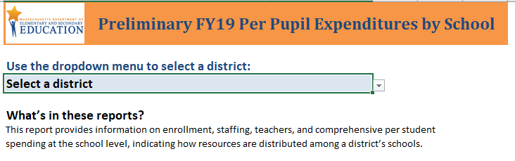
Geared more toward a parent or teacher audience, school-level expenditures are now included in the annual School/District Report Cards that DESE publishes and that school districts distribute to all public school parents. This report provides basic data that allows users to compare a school’s spending to the average spending on schools within their district and to the average spending on schools across the state.
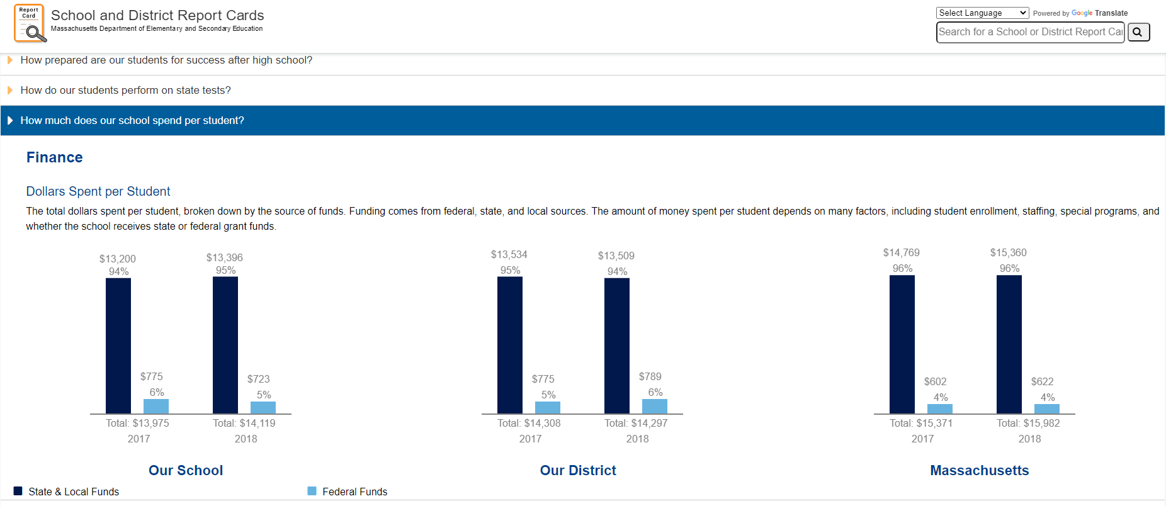

It is important to note here that school-level expenditure data does not come without caveats. It is often difficult, if not impossible, to determine high-impact or cost-effective interventions and strategies at the school level due to the wide range of strategies that districts and schools employ and the fidelity of implementation for each strategy. Furthermore, some districts may consider their interventions or programs to be district-level endeavors that are delivered to their schools (and therefore expenditures reported as district-level costs), while others may consider similar interventions as school-level programs (and therefore they report those expenditures as school-level costs). Disentangling district-level approaches and expenditures from school-level approaches and expenditures is not easy, as neither approach is “right” or “wrong.” However, over time and on an ongoing basis, DESE will continue to promote consistency in reporting across districts, so that between-district and intra-district comparisons about school-level expenditures can be made with more validity.

Despite these challenges, the DESE data collections and the reports that come from them allow questions to be asked about school-level spending and conversations to be started about whether resources reach intended audiences. To that end, DESE commissioned an independent study in 2019 to understand the very question asked in this charge: are resources in Massachusetts reaching the intended student populations?

The December 2019 report, written by education researchers Kristen Blagg and Victoria Lee at the Urban Institute, makes several claims about school-level funding in Massachusetts and the extent to which it reaches high-need student populations:
- Schools vary substantially in how much they spend per pupil. Most schools spend between $12,000 and $18,000 per pupil, though some schools, especially vocational high schools, spend substantially more.
- Recent national evidence, based on district spending data, shows that education expenditures matter for student outcomes.
- Studies of school-level spending indicate that, on average, schools with higher shares of high-need students tend to spend as much as, or slightly more than, schools with lower shares of high-need students.
- Massachusetts allocates state education aid to districts based on student needs, community wealth, and local labor costs. Although the formula allocates more state money to districts with students with greater need, districts can use local funds to spend more than what is required.
- Across the state, high schools tend to spend more per pupil than elementary and middle schools.
- To fairly compare schools with different kinds of student needs requires looking at all three high-need subgroups (economically disadvantaged pupils, pupils with disabilities, and English learners) simultaneously.
- Within districts, schools with higher shares of economically disadvantaged pupils, pupils with disabilities, and English learners spend more per pupil.
- Across the state, schools with higher shares of economically disadvantaged students spend less per pupil, unless we account for local labor costs.

Because the report relies on data in 2017 and 2018, prior to the passage of the Student Opportunity Act and the pandemic, it represents an important baseline measure that Massachusetts can use to track the effectiveness of the Act.

This study, along with the many reports DESE produces, increases transparency and public accountability for the use of education dollars. DESE will continue to update and improve this information on an ongoing basis, so that the most up-to-date data will be available to a variety of audiences.

Charge 2: Strengthening the department’s capacity to analyze and report staffing, scheduling and financial data in ways that support strategic resource allocation decisions at the district and school levels, including a review of national best practice models that ensure greater financial transparency

Since 2016, DESE has been producing an innovative suite of reports that analyze staffing, scheduling, and financial data in ways that allow users to make more informed resource allocation decisions. Dubbed “RADAR,” (Resource Allocation and District Action Reports), the reports aim to provide state and district-level data about how districts use their people, time, and money resources in a visually accessible way. They are intended to support districts in making effective strategic decisions as they develop plans and budgets.

Users can select their district, and then select up to 10 comparison districts, allowing them to see how they are allocating resources relative to those selected districts, as well as compared to state averages. The reports enable users to visualize district and state trends over 5 years, investigate various staffing levels, per pupil spending levels, special education services, and more.

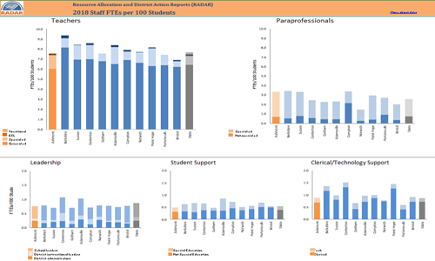

RADAR represents one of the most accessible and user-friendly ways for stakeholders to look at and share district data, and use it to make strategic resource allocation decisions.
To date, DESE has not yet begun a review of national best practice models of financial transparency.

Charge 3: Strengthening district capacity to use state, district and school-level data to inform strategic resource allocation and implementation decisions

DESE maintains strong relationships with district administrators, providing both ad hoc support and ongoing resource allocation planning and implementation support. DESE offers a wide variety of opportunities to connect with districts in all manner of settings, from webinars to conference presentations (often heavily subscribed and receiving positive responses from attendees) to specialized communities of practice focused on resource allocation. DESE has also created case studies of the resource allocation work done by districts that are available online and circulated among DESE staff in relevant program areas. These case studies provide a glimpse into internal processes districts use in making resource allocation decisions and even tracking return on investment.

In addition, a long-planned connection was made between Planning for Success, the Department’s online resource for district strategic planning, and resource allocation, including using RADAR and other DESE tools. Several options for including resource allocation work in the planning process were developed and have been integrated into Planning for Success materials. As districts use these strategic planning tools for their future planning needs, each will be able to make strategic resource allocation a main component.

While these initiatives and activities have been helpful, DESE finds that its capacity to support districts in making resource allocation decisions rarely meets demand. Reaching all stakeholders who need and could benefit from this support is an ongoing challenge for DESE.

Charge 4: Streamlining data reporting, eliminating duplicative reporting requirements and improving data quality

DESE is constantly working to streamline reporting, eliminate duplicative requirements, and improve the quality of our data. A key focus of Commissioner Riley is to reduce administrative burdens on districts to the extent possible and streamline reporting requirements. This work is ongoing. DESE understands that the more current and accurate the data, the more meaningful it is for districts, policymakers, and other interested parties. To promote strategic planning and thoughtful allocation of resources, DESE will continue to streamline data collection and reporting, promote data accuracy and quality, and provide timely updates of resource allocation tools.

