Student Opportunity Act Plans

Frequently Asked Questions

Contents

**1.** **Does my district need to develop a Student Opportunity Act (SOA) Plan?** 2

**2.** **Is our SOA Plan supposed to describe how we are spending any additional Chapter 70 funds our district receives?** 2

**3.** **What’s the difference between SOA Plans and District Improvement Plans?** 2

**4.** **Are we expected to begin SOA Planning from scratch?** 3

**5.** **Can our FY24 SOA Plan focus on the same evidence-based programs (EBPs) that were in our original SOA Plan?** 3

**6.** **How do I move forward with our district’s plan in the absence of updated targets for the lowest-performing student group? And how do I use them once they are available?** 4

**7.** **Does our SOA Plan need to be approved by our School Committee prior to the April 1, 2024 due date?** 5

**8.** **Where do I find the SOA Application Supplement in GEM$?** 5

**9.** **I have located our SOA Application Supplement in GEM$, but it won’t let me enter data into the template. What do I do now?** 5

**10.** **Are there word count limits in the GEM$ SOA Application Supplement?** 6

**11.** **How much of our district’s annual increase in Chapter 70 aid is attributable to additional state investments and the revised Chapter 70 funding formula (versus changes due to enrollment and inflation)?** 7

Student Opportunity Act Plans

Frequently Asked Questions

## **Does my district need to develop a Student Opportunity Act (SOA) Plan?**

**Yes.** *Every three years, every district and charter school in the Commonwealth is required to develop and submit a Student Opportunity Act Plan.*

The requirement to develop an SOA plan ***is not*** related to whether --or how much--a district receives in additional Chapter 70 funds as a consequence of: 1) the state’s increased investments in education being phased in through FY27, and 2) the revised Chapter 70 funding formula that was introduced in the SOA legislation.

## **Is our SOA Plan supposed to describe how we are spending any additional Chapter 70 funds our district receives?**

**No.** *The additional Chapter 70 funds that some districts receive are not grant funds and SOA Plans are not simply a vehicle for describing how a district is spending any additional Chapter 70 funding it receives.*

* The misconception that plans should focus narrowly on how any additional Chapter 70 funds they receive in that fiscal year are being utilized is one that has been difficult to fully dispel.  Many districts, in fact, receive the per pupil minimum in Chapter 70 funding or only relatively small increases in Chapter 70 funding from year to year. And yet, the legislation requires that all districts submit a three-year SOA plan.
* It is only once your district identifies the key EBPs it will focus on in your SOA Plan that you will briefly describe for each EBP: 1) the implementation steps your district will take, and 2) the resources (from any source) you anticipate allocating over the next three fiscal years to support high quality implementation.

## **What’s the difference between SOA Plans and District Improvement Plans?**

**The District Improvement Plan (DIP**) serves as a comprehensive plan that describes the full set of strategies that a district will implement to support all students in their district.

By contrast, the **SOA Plan** addresses a subset of a district’s overall initiatives, focusing on evidence-based programs and strategies that will improve the educational experiences and outcomes of students, **including English learners, students with disabilities, and low-income students.** To that end, your district’s SOA plan should spotlight critical, actionable evidence-based programs and strategies that are focused on rapidly improving outcomes for student groups experiencing disparities, whether you are enhancing ongoing efforts or introducing a small number of new initiatives.

## **Are we expected to begin SOA Planning from scratch?**

**The short answer: It depends.** We know that districts develop multiple plans for all kinds of purposes in addition to district improvement plans andSOA plans *(e.g., federal Title grants, MTSS academies, other competitive grants and professional development opportunities).* These frequently entail similar processes *(e.g., disaggregated data analysis, stakeholder engagement, selection of evidence-based practices).*

* Previous stakeholder engagement and input processes, data analyses, and plans can serve as an important launching point for your SOA Plan.
* Closely review SOA guidance to make certain your previous work addresses plan requirements.

***Please read the*** [***FY24 SOA Plan guidance materials***](https://www.doe.mass.edu/soa/fy2024-guidance.docx) ***carefully, to ensure that you are fulfilling the requirements and expectations for SOA Plans.*** Even if you have engaged in data analyses and stakeholder engagement for other plans and projects, you may very well find that you need to take additional steps for your SOA Plan.

You may find that you need to:

* Further disaggregate data by student group to uncover disparities in learning experiences and outcomes
* Explore instructional, perspectives, and systems-level data as you consider underlying factors under district control that are contributing to those disparities;
* Reach out to additional stakeholders representing student groups experiencing the greatest disparities *(e.g., students, parents/caregivers, community organizations)* to solicit additional input *(e.g., through focus groups, surveys addressing perspectives on culture, climate, and learning)*

In the longer term, DESE wants to support districts to increasingly develop systemic approaches to:

* engage in high quality data analysis and root cause analysis;
* establish ongoing strategies to meaningfully engage stakeholders throughout visioning, planning, and implementation processes that can be leveraged for multiple plans and grants;
* ensure that systemic processes support alignment of multiple plans and grants;
* monitor the progress of implementation and outcomes.

## **Can our FY24 SOA Plan focus on the same evidence-based programs (EBPs) that were in our original SOA Plan?**

**If** your updated disaggregated data analysis and analysis of underlying factors contributing to disparities for student groups supports a continuing focus on the same EBP(s), then it is certainly appropriate to continue focusing on them.

If you plan to continue with one or more of the same EBPs, in your EBP narrative, be sure to briefly address:

* any progress/improvement in addressing disparities when implementing your original SOA Plan;
* any new strategies you will focus on as you continue implementation;
* specific implementation supports that will be provided to targeted student groups.

## **How do I move forward with our district’s plan in the absence of updated targets for the lowest-performing student group? And how do I use them once they are available?**

Until updated targets are available, we recommend referencing the [2023 Accountability Targets](https://view.officeapps.live.com/op/view.aspx?src=https%3A%2F%2Fwww.doe.mass.edu%2Faccountability%2Flists-tools%2Faccountability-targets.xlsx&wdOrigin=BROWSELINK) , which include 2024-2027 increments.

***That said, the good news is that you don’t technically need the targets in order to develop your SOA Plan.***

Here is some additional context for **Section 3: Setting Ambitious 3-Year Achievement Targets**.

* The Student Opportunity Act requires DESE to set and report on ambitious 3-year targets for improving student achievement for student groups statewide.
  + DESE has chosen to use MCAS ELA and Math for the lowest performing student group to track progress in gap-closing.
  + Why this group*?  By definition, this group includes the students who currently have the lowest academic performance, and therefore need the most significant levels of support to reduce the disparities between their performance and that of their peers.   This group typically includes substantial proportions of a districts’ high needs population, as well as other student groups.* This makes it a good proxy for assessing the progress of multiple student groups and streamlines the analysis and reporting process.
* The SOA Legislation also calls for districts to establish achievement targets that are consistent with those established by DESE.
  + Section 3 of the *FY24 SOA template* directs districts to check a box acknowledging that they will also be using the 3-year targets that DESE sets for its lowest performing student group.
  + In addition to the required lowest performing student group targets, your district has the option of setting additional targets if it wishes to do so.

If your district does not wish to set additional targets, the only thing you need to do in Section 3 is check the box next to “Pleases confirm that your district will use DESE’s three-year targets for increasing performance for the “Lowest Performing Students” group in ELA and math. (see screen shot below.)

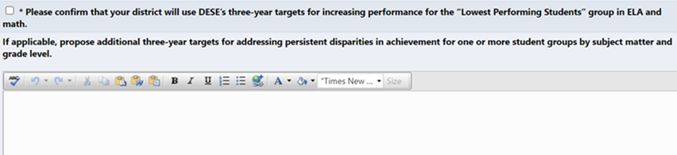

## **Does our SOA Plan need to be approved by our School Committee prior to the April 1, 2024 due date?**

**Yes.** Please check your school committee calendar now to ensure that the school committee vote takes place before the April 1 deadline!

## **Where do I find the SOA Application Supplement in GEM$?**

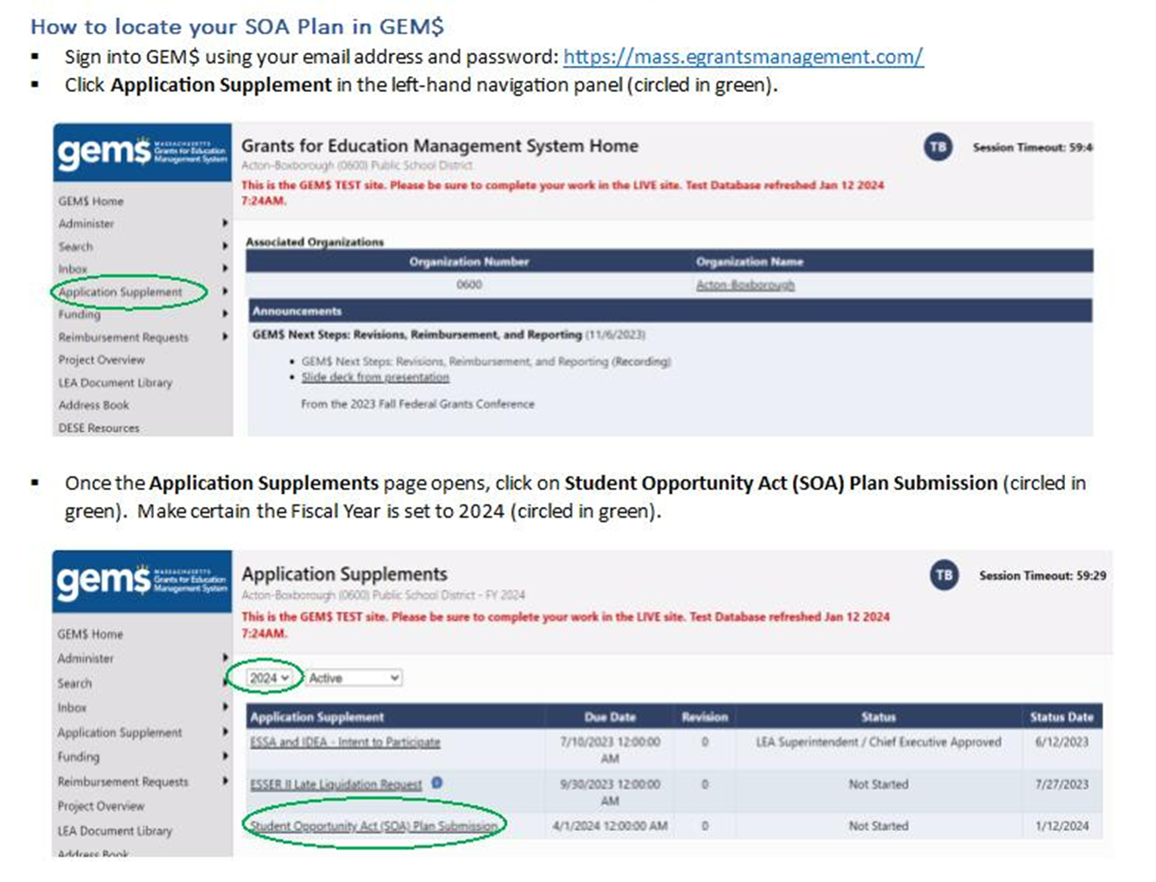

## **I have located our SOA Application Supplement in GEM$, but it won’t let me enter data into the template. What do I do now?**

Make sure to change your Status to *Application Supplement Started* on the SOA Plan Submission Sections page.

When you first get into the application supplement it looks like the area circled in green below.  You need to go to the **Change Status To** line and click on *Application Supplement Started*.  Once you do that, the **Status line** should update to read Status:  *Application Supplement Started*.   Once you change the status, you should be able to open the individual sections of the template to enter data.

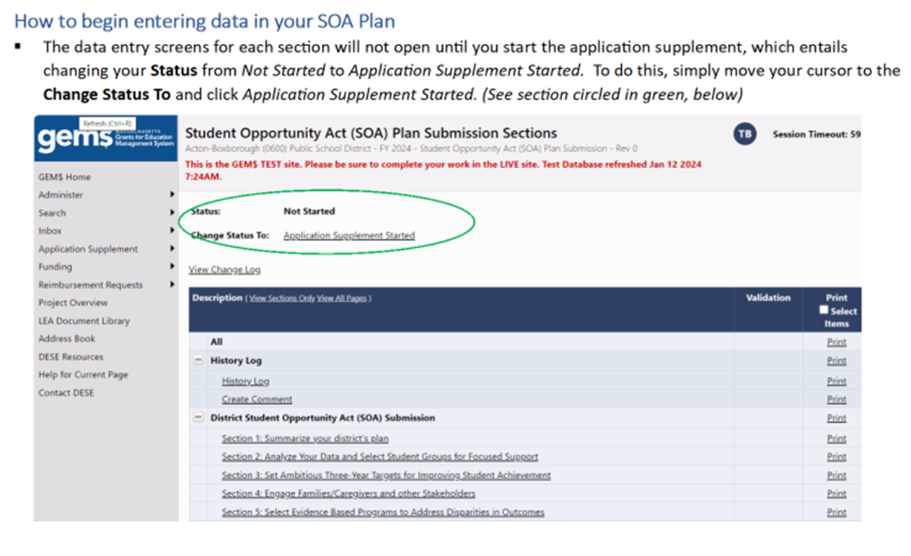

## **Are there word count limits in the GEM$ SOA Application Supplement?**

*We encourage districts to keep their local stakeholders in mind as they shape their overall plan summary and narrative responses, and provide responses that are succinct, clear, and easy-to-digest.* Most open-ended items have *a word count limit of 5,000*, which translates to roughly 1 ½ pages of single-spaced text.   If you take a look at the FY24 [SOA Plan Examples](https://www.doe.mass.edu/soa/soa-plan-examples.docx) on our website, you will see that most responses to individual items fall well within 1 ½ pages.

That said, word count limits are higher for the response items listed below, to provide districts wishing to offer more expansive responses the flexibility to do so.

* **Items with no word count limit**

1. ***Section 1:   Summarize your district’s plan.*** This section consists of a single open-ended narrative response item.
2. ***Section 5:  Select Evidence Based Programs to Address Disparities in Outcomes.*** The first narrative question for each EBP included in your SOA Plan *(i.e., Provide a short description of what your district has in place now related to this EBP and what you anticipate will be in place by the conclusion of the plan's implementation (by June 2027).*

* **Items with a word count limit of 10,000**

1. **The two narrative items in Section 2: Analyze your data and select student groups for focused support:**
   * In conducting your data analysis, where did you observe the most significant disparities in student learning experiences and outcomes? On which measures and or which student groups?
   * What does your deeper analysis suggest are the best ways to address these disparities across student groups?
2. **The following two narrative items in Section 4 Engage Families/Caregivers and other Stakeholders:**
   * Describe the approaches your district uses to regularly engage with families/caregivers. In your response, please be sure to address what steps you will be taking to meaningfully engage with families/caregivers of student groups you are targeting for accelerated improvement as this plan is implemented.
   * Describe the ways in which you engaged different stakeholder groups in the development of your three-year SOA Plan. How have you integrated the perspectives of those groups into the three-year plan? How will you continue to engage stakeholders throughout the implementation of your plan?

## **How much of our district’s annual increase in Chapter 70 aid is attributable to additional state investments and the revised Chapter 70 funding formula (versus changes due to enrollment and inflation)?**

**Important Reminder:** The additional Chapter 70 funds that some districts receive are not grants funds and SOA Plans are not simply a vehicle for describing how a district is spending any additional Chapter 70 funding it receives*. (**See FAQ 2**)*

That said, we know many districts find it useful to distinguish additional resources attributable to the increased investments in education that are being phased in through FY2027 and new Chapter 70 funding formula from changes attributable to enrollment changes and inflation.

Here is how to estimate SOA-related increases in any given year:

1. Open your district’s Chapter 70 Summary for the fiscal year of interest. ([Preliminary FY25 Chapter 70 Aid are used in example below](https://view.officeapps.live.com/op/view.aspx?src=https%3A%2F%2Fwww.doe.mass.edu%2Ffinance%2Fchapter70%2Ffy2025%2Fp-spreadsheet.xlsm&wdOrigin=BROWSELINK).)
2. On the Index tab, select your district from the dropdown menu and then click on Summary:

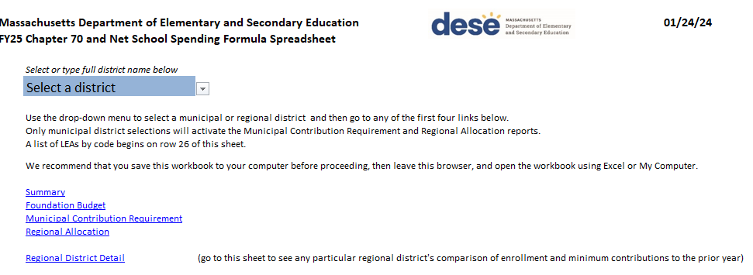

1. Subtract your district’s **Minimum Aid Adjustment** (item 9)[1] from the **FY25 Chapter 70 Aid** (item 13). The difference is the estimated increase in FY25 Chapter 70 funds that can be attributed to FY25 increases in Chapter 70 investments and the new Chapter 70 funding formula. (See example below).

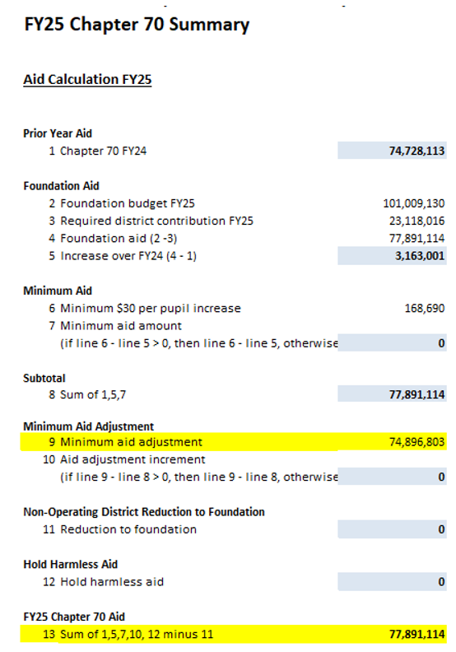

**Note:** Figures are from the Governor’s FY25 proposed budget. Amounts will not be final until the budget is approved and signed into law later this year.

This district is receiving approximately $2,994,311 in SOA- related increases in Chapter 70 funding in FY25 *(i.e., $77,891,114 - $74,896,803 = $2,994,311)*

1. The Minimum Aid Adjustment shows how much aid your district would receive if changes introduced in the SOA legislation were *paused* for a year.