Step-by-step visual representation on how to use the IDEA Equitable Services Annual Child Count Application:

Step 1:
Access the Security Port using your local credentials. Then, go to the “IDEA Equitable Services Annual Child Count” Application and select your district from the drop-down menu.

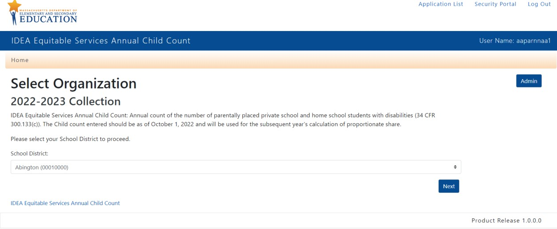

Step 2: Complete the fields as indicated in the screenshot below.
- IDEA Section 611 (Fund Code 240) Child Count ages 3-21
- IDEA Section 619 (Fund Code 262) Child Count ages 3-5

Reminders:
- Count all students in each category who are determined to be eligible for special education services, regardless of whether a student receives services.
- Students are counted even if a parent declines services.
- Only students whose parent(s) do not consent to an initial evaluation or reevaluations are not "eligible" and not counted.
- All students remain eligible for 3 years following identification.
- Stand-alone private preschools or childcare centers are not included.
- Preschool-aged (3-5) children are considered to be parentally-placed private school students if they are enrolled in a private school that meets the definition of an elementary school and should be counted.
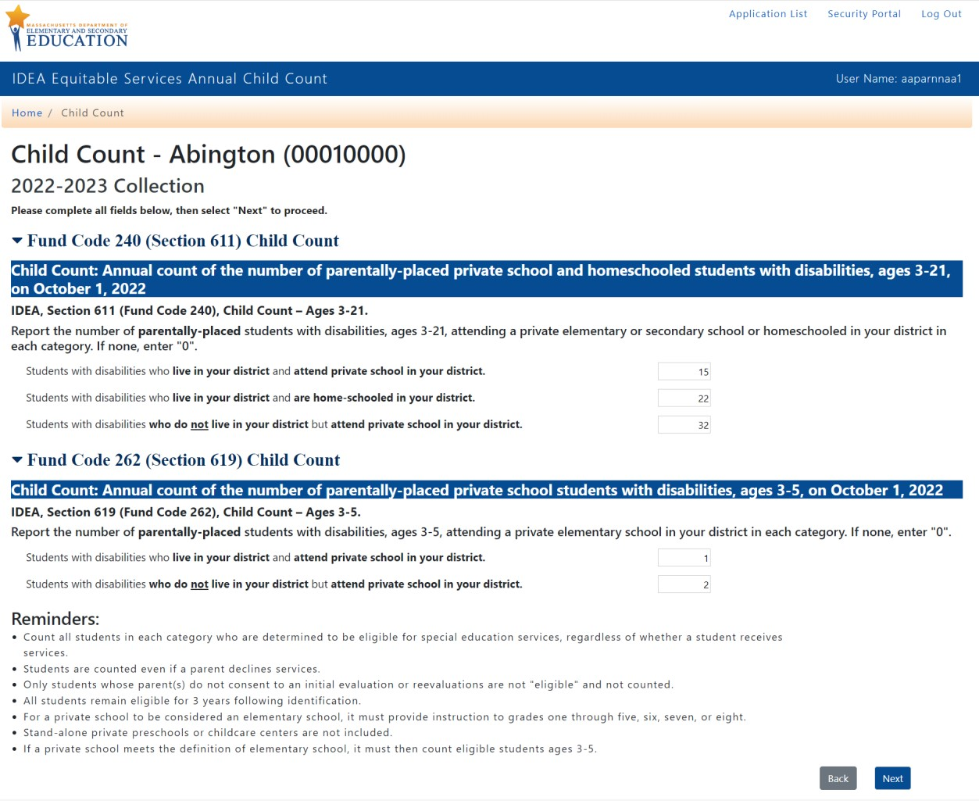

Step 3: Certify
In this step, you will review and certify the data submitted. By clicking the “Certify” button, you will certify that the district authorizes you to provide and certify the information. Furthermore, you will certify that the child count numbers provided are complete and accurate as of October 1 and have been obtained in compliance with IDEA regulations. By certifying, you further agree to provide documentation supporting the child count(s) and record-keeping data provided if requested by the DESE.
