Massachusetts Individualized Education Program (IEP) Technical Guide
Contents
Introduction 1
Effective Student and Parent Engagement 1
IEP Form Components 2
Student and Parent Concerns 2
Student and Team Vision 2
Student Profile 4
English Learners 4
Assistive Technology 6
Present Levels of Academic Achievement and Functional Performance 6
Academics 6
Behavioral/Social/Emotional 8
Communication 8
Additional Areas 9
Postsecondary Transition Planning 10
Community and Interagency Connections 11
Transfer of Rights to Student 12
Decision-Making Options for Student 12
Transition to Adult Service Agency or Agencies-688 Referral 13
Accommodations and Modifications 14
Accommodations for Presentation of Instruction 16
Accommodations for Responses 17
Timing and Scheduling Accommodations 17
Setting and Environmental Accommodations 18
Content Modifications 18
Instructional Modifications 19
Output Modifications 20
Assessments 21
State or Districtwide Assessments 21
Alternate Assessments 21
Measurable Annual Goals 22
Short-Term Objectives and/or Benchmarks 23
Schedule of Progress Reporting 24
Participation in the General Education Setting 24
Service Delivery 26
Consultation 26
Direct Service in the General Education Classroom 26
Direct Services in Other Settings 27
Transportation Services 28
Schedule Modification 28
Service Delivery for Extended School Year Services 30
Extended School Year Transportation Services 30
Additional Information 30
Response Section 31

Introduction
The Massachusetts Department of Elementary and Secondary Education (Department) recently made updates to the Individualized Education Program (IEP) form. These changes are intended to strengthen the IEP process and improve the educational outcomes and experiences of students with disabilities in the Commonwealth. The IEP Improvement Project is intended to provide schools, districts, and families with more than newly designed and updated forms. It is also intended to provide opportunities for families, schools, and districts to work together to build better systems that more effectively support students with disabilities. To do this, the Department encourages IEP Teams to come to a shared understanding that the completed IEP will capture the IEP Team’s determination of individualized instruction, services, and supports for each student with an identified disability.
The updated IEP is a tool to help improve outcomes for students with disabilities by building on individual student strengths. Additionally, the language used in the updated IEP is intended to be easily accessible to students and their families. The updated IEP also reflects the requirement that students with disabilities are placed in the least restrictive environment consistent with their needs. The updated IEP also seeks to strengthen the transition planning process to better prepare students for independence in adult life, including post-secondary education and employment.
The purpose of this Technical Guide is to help IEP Teams write IEPs that provide students with disabilities with the special education and related services to which they are entitled under federal and state laws and regulations. This Technical Guide is intended to lead the reader through the updated IEP form and should be used in conjunction with other guidance, technical assistance, and tools available on the Department’s IEP Improvement webpage.

Effective Student and Parent Engagement
Throughout this document, the Department has included some helpful points on how to proactively engage families in the IEP process. It is important to consider that some families may be unfamiliar with the public education system in the United States, and face language and cultural barriers that make the IEP process especially unfamiliar. The school district’s proactive support and engagement of families throughout the IEP process is especially important to promote meaningful participation and student success. For example, schools may schedule a meeting or conversation with the parent and student in advance of the IEP Team meeting so that the family and school staff can exchange information, improve communication, and discuss the IEP Team process. Such conversations may occur over the phone, video call, or in-person. School districts should use appropriate and competent interpreters during meetings with families that have limited proficiency in English and written documents should be translated in the primary language of the home, if such primary language is other than English. Some students may need support preparing for the IEP Team meeting and may find it particularly helpful to have an opportunity to connect with a trusted teacher, paraprofessional, or related service provider before it.

IEP Form Components

Student and Parent Concerns
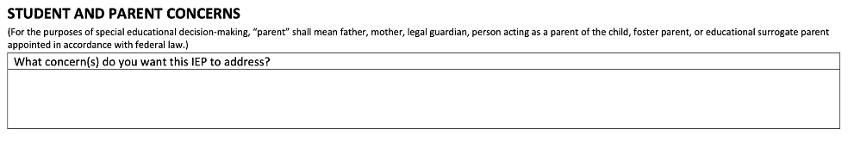
This section is intended to help the IEP Team focus its discussion on the student’s concerns and needs, as well as the concerns of their parents. Schools and districts should consider conferring with students and parents prior to the IEP meeting and reminding them that the meeting will begin with their concerns. The IEP Team should consider areas of concern that may impact the student’s progress in education. Examples of topics to consider when completing this section include, but are not limited to academic skills, social skills, behavioral needs, independent functioning, and daily living skills. For students engaged in post-secondary transition planning, the IEP Team should prompt students and parents to share concerns that relate to the student’s post-secondary success.

Student and Team Vision
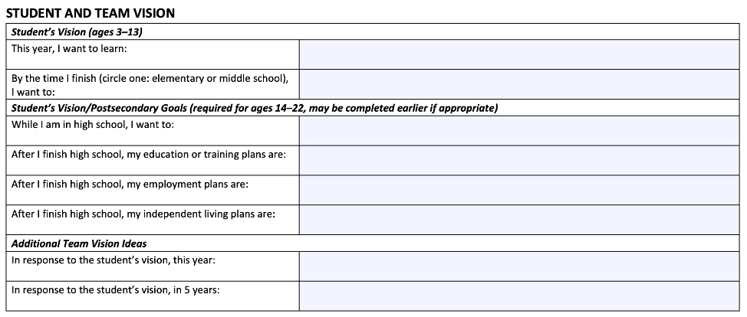
The Student and Team Vision section of the IEP contains two components:
- The Student’s Vision statement, differentiated by age level (3-13 and 14-22), and
- Additional Team Vision Ideas.
Some key points relating to this section of the IEP form:
- Students may need assistance developing their vision statement prior to the IEP Team meeting. Such assistance may be provided by a trusted teacher, related service provider, school counselor, paraprofessional, etc.
- Students who are 13 but will turn 14 during the new IEP period should respond to the questions for students aged 14-22.
- For students aged 14-22, the “Student's Vision/Post-Secondary Goals” section is a first step toward transition planning. More transition planning information appears later in the IEP.
- The “Student’s Vision” section will vary by student, as each student is unique. The vision expressed by the student should be used to guide the rest of the IEP process. Effective relationship building with students and family engagement outside of and during the IEP Team meeting may provide the IEP Team with an understanding of the family and cultural contexts from which the student vision has emerged.
Student and Parent Vision Considerations
Before the IEP Team meeting, consider:
- Providing the student and parent with the vision questions.
- Sharing projects, drawings, or writings with other members of the IEP Team that the student has created about their personal vision.
- If there is a staff person in an advisory role that has relevant information, obtain such information as needed.
- If there is information in the guidance or cumulative records (for example, parent or student surveys) that may contribute to the discussion.
During the IEP Team meeting, consider:
- The student’s participation in any interest inventories, career exploration, or discussions about career and technical education through the guidance office if appropriate.
- Parent input on discussions the family has had about the student’s life after high school if appropriate.
After the IEP Team meeting, consider:
- Following up with the student for additional information or clarification if needed.
The “Additional Team Vision Ideas” section is for the IEP Team members (other than the student) to respond to the student’s vision. Please give special consideration to parental input when completing this section.

Student Profile
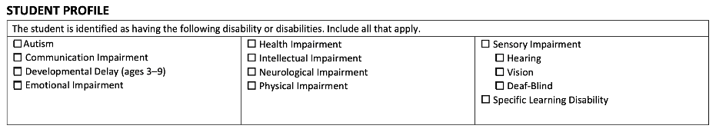
The Student Profile section is used to identify all disabilities determined through the special education eligibility process. It is important to note that a student’s disability determination on an IEP may not always align with medical or other diagnostic evaluations. If relevant, more information about the student’s disability can be included when describing the impact of the student’s disability in other sections of the IEP. For example, the IEP Team might identify a student as having a specific learning disability in their Student Profile and further explain that the student has dyslexia, dysgraphia, or dyscalculia in later sections of the IEP.

English Learners
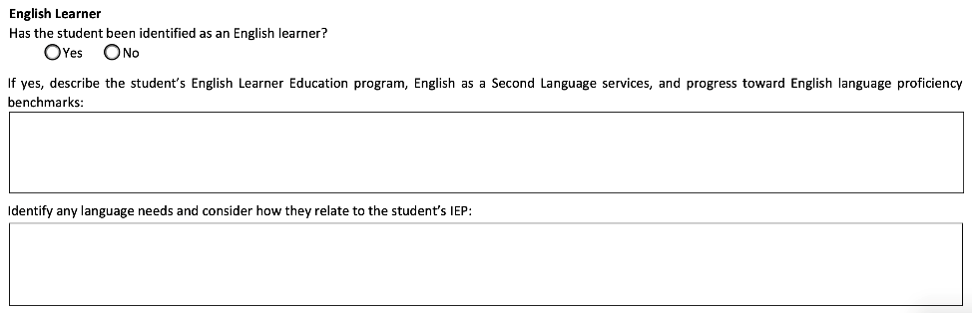
If the student with a disability has also been identified as an English learner (EL), the IEP Team should mark “Yes” in this section and answer the subsequent questions.
When an EL has a disability, the Individuals with Disabilities Education Act (IDEA) requires that the IEP Team consider the student’s language needs as they relate to the IEP. It is therefore essential for the IEP Team to include those with the knowledge of the student’s language needs. Specifically, it is important that the IEP Team include “professionals with training, and preferably expertise, in second language acquisition and an understanding of how to differentiate between the student’s limited English proficiency and the student’s disability.”
English Learner Considerations
Before the IEP Team meeting, consider:
- Collecting information about the student’s English Learner Education program, English as a Second Language (ESL) services, and progress towards English language proficiency benchmarks.
- Reviewing the student’s latest EL assessment data.
During the IEP Team meeting, consider:
- Having a copy of the English Learner Toolkit- Tool #2 Considering the Influence of Language Differences and Disability on Learning Behaviors, as a reference for the IEP Team’s discussion, as needed.
- Discussing consultation time between the ESL teacher, the special education teacher, or others, as needed.
After the IEP Team meeting, consider:
- Scheduling regular planning meetings so that the student’s services remain well coordinated.
ESL teachers and others familiar with the student’s language development often bring to the IEP Team knowledge of:
- The impact of the student’s disability on the process of language acquisition;
- How the student’s disability-related needs will be met in their English Learner Education program, such as Sheltered English Immersion, Dual Language Education, or Transitional Bilingual Education;
- How the student may be able to use language supports to enhance learning and demonstrate understanding of content;
- How the EL’s language needs relate to the IEP;
- Strategies for teaching ELs in ways that are linguistically and culturally relevant;
- The student’s progress toward English language proficiency.
The above information helps provide a basis for understanding the student’s needs as an EL with a disability and how these needs will be addressed in the IEP.
The Department encourages districts and schools to develop procedures and practices for communication and collaboration between special education and EL education staff regarding support and services for ELs with disabilities. For example, the IEP Team may determine the need for consultation between the ESL teacher and the special education teacher to address the student’s language access, disability related needs, and monitor progress.
The U.S. Department of Education has created a resource to assist in this general area: “Tool #3: Developing an IEP for an English Learner with a Disability” from the EL Tool Kit, providing a checklist for developing IEPs for ELs.

Assistive Technology
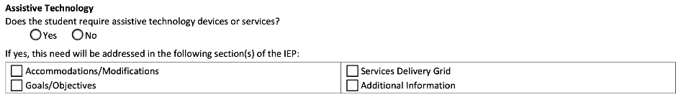
In this section, the IEP Team must indicate if the student requires assistive technology devices or services. If yes, please identify which sections of the IEP will be used to address the student’s assistive technology needs.

Present Levels of Academic Achievement and Functional Performance

Academics
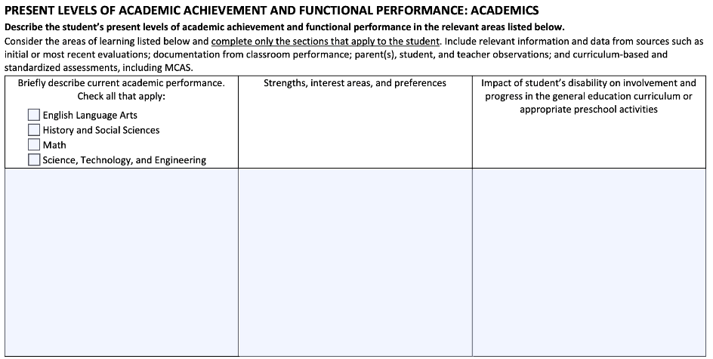
The Present Levels of Academic Achievement and Functional Performance (“Present Levels”) section of the IEP has four components: 1. Academics, 2. Behavioral/Social/Emotional, 3. Communication, and 4. Additional Areas.
Some key points:
- Use clear, easy to understand, language.
- When including information from evaluations, the IEP Team may include the key conclusions from those evaluations rather than repeating extensive details that can be easily found by reading those evaluations separately from this IEP.
- Discuss Present Levels holistically, rather than limiting conversation on a particular topic to specific individuals. For example, the middle school English teacher may not be the only person on the IEP Team who understands the student’s literacy progress. The student’s parents, history teacher, school psychologist, special education teacher, etc. all might have ideas to share about the student’s literacy progress.
- Include the student’s strengths, interests, and preferences in relation to the relevant Present Levels.
- The IEP Team should comment on each component that is relevant to the student. If a component or components are not relevant to the student, write “Not applicable.”
Present Levels Considerations
Before the IEP Team meeting, consider:
- Gathering data and information about the student's current performance and preparing information that is most timely and relevant for the IEP Team meeting.
- Asking the student about where they are having difficulties in school to help inform the IEP Team discussions.
During the IEP Team meeting, consider:
- Discussing skills that are necessary across curricular areas which may inform the IEP Team as to the impact of the disability on involvement and progress.
- Asking the student about what they see as their strengths, interests, and preferences.
After the IEP Team meeting, consider:
- As appropriate, sharing the student’s strengths, interest areas, and preferences to assist them the student’s teachers in planning and building on the student’s strengths.

Autism Specific Questions
State law requires IEP Teams to consider and address the following areas for all students who have a disability on the autism spectrum:
- the verbal and nonverbal communication needs of the child;
- the need to develop social interaction skills and proficiencies;
- the skills and proficiencies needed to avoid and respond to bullying, harassment or teasing;
- the needs resulting from the child's unusual responses to sensory experiences;
- the needs resulting from resistance to environmental change or change in daily routines;
- the needs resulting from engagement in repetitive activities and stereotyped movements;
- the need for any positive behavioral interventions, strategies, and supports to address any behavioral difficulties resulting from autism spectrum disorder; and other needs resulting from the child's disability that impact progress in the general curriculum, including social and emotional development.

Behavioral/Social/Emotional
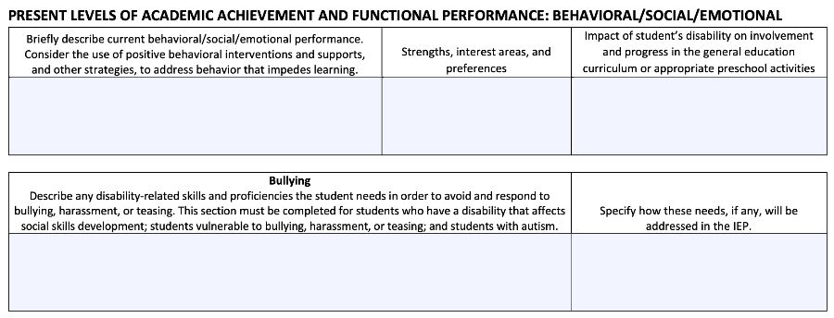
Under this section, IEP Teams should consider the use of positive behavioral interventions and supports, and other strategies to address the student's behavior that impedes their learning or that of others as appropriate and necessary.
Students with disabilities face increased rates of bullying, harassment, and teasing, whether as the target or the aggressor. To help students be prepared and make good choices during these challenging situations, the IEP Team should consider skills necessary for students to address bullying.

Communication
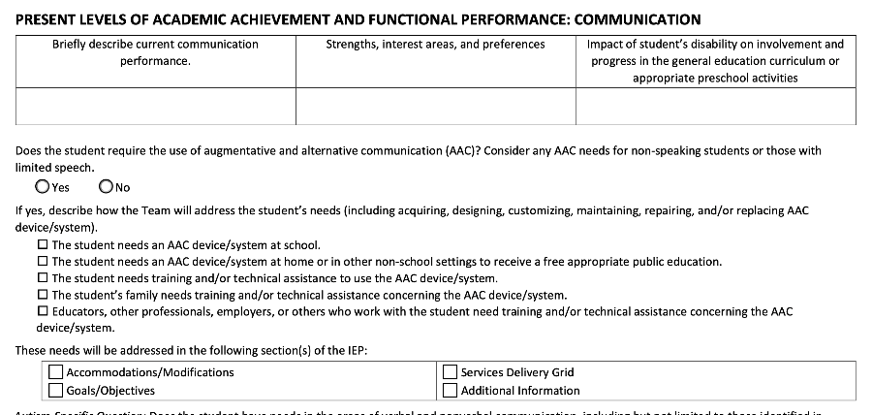
Describing the Present Levels for Communication involves gathering comprehensive information about the student’s abilities, strengths, areas of need, and the impact of their disability.
If the student requires Augmentative and Alternative Communication (AAC) devices/systems, it is important to specify the student’s present levels of performance in navigating communication devices, selecting appropriate symbols or words, and effectively conveying their messages across school, home, and community settings if appropriate. The IEP Team should discuss and document whether and how the student’s needs will be addressed through accommodations and modifications, goals and objectives, services, and/or additional information discussed later in the IEP.

Additional Areas
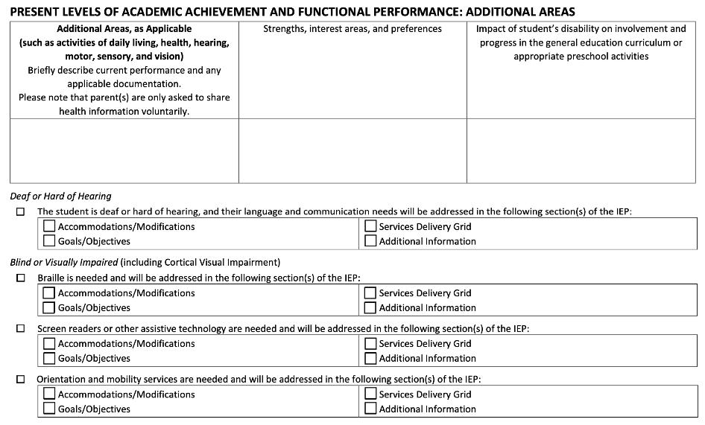
When examining the Present Levels, consider additional areas that might be relevant to the student’s disability, such as activities of daily living, health, hearing, motor, sensory and vision.
Deaf/Hard of Hearing
For students who are Deaf or hard of hearing, the IEP must indicate which section of the IEP will address their language and communication needs. The IEP Team must consider the student’s language and communication needs, opportunities for direct communication with peers and professional personnel in the student’s language and communication mode, academic level, and full range of needs, including opportunities for direct instruction in the student’s language and communication mode.
Blind/Visually Impaired
In the case of a child who is blind or visually impaired, the IEP Team must determine how it will provide for instruction in Braille and the use of Braille unless the IEP Team determines, after an evaluation of the child's reading and writing skills, needs, and appropriate reading and writing media (including an evaluation of the child's future needs for instruction in Braille or the use of Braille), that instruction in Braille or the use of Braille is not appropriate for the child.

Postsecondary Transition Planning
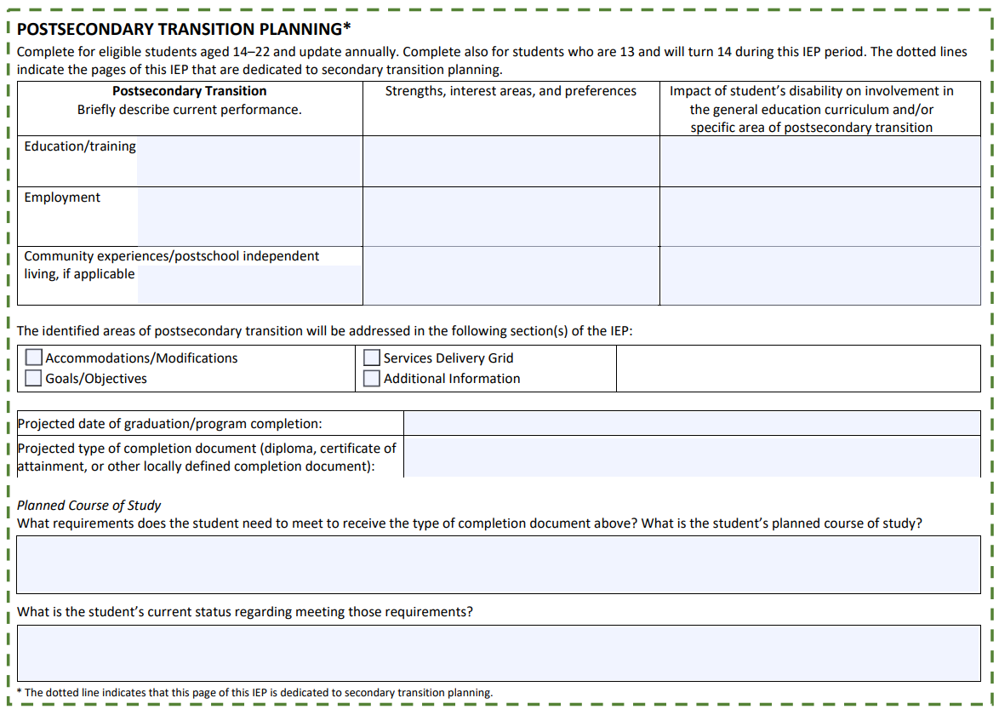
Postsecondary Transition Planning Considerations
Before the IEP Team meeting, consider:
- Providing the parent with information about the difference between earning a diploma and a certificate of completion, if applicable.
- Providing the student’s guidance counselor with questions about the student’s planned course of study, credits earned and needed etc.
- Gathering data from a work coach or other adults who have involvement in the student’s employment and community experiences.
- Asking the student about their strengths, interest areas, and preferences.
During the IEP Team meeting, consider:
- Orienting the IEP Team to the student vision completed at the beginning of the meeting.
- Orienting the IEP Team to the present levels of achievement section for relevant information about strengths, interest areas, and preferences for transition planning.
- Discussing any interest inventories, career readiness, etc. that the student completed with the school counseling office.
IEP postsecondary transition planning is designed to help students with disabilities successfully transition from high school to postsecondary education, vocational training, employment, and independent living. The goal of the planning process is to provide support and accommodations for a smooth transition, and to help students achieve their educational and career goals. Because postsecondary transition can now be found in the IEP form, rather than in a separate document, the Department asks that schools and districts take a close look at this section for important information.

Community and Interagency Connections
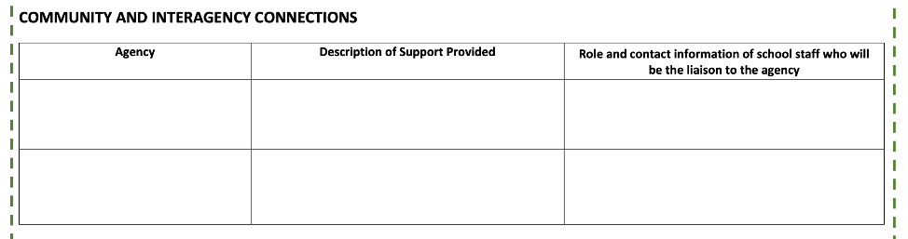
This section documents the agencies and community organizations the student is working with as part of their transition from secondary school. The purpose of this section is to promote coordination and communication between the school and the community or agency providers. If this section does not apply to the student, please write, ”Not applicable.” Otherwise, provide the name of the agency or organization, and give a brief description of the support provided and the roles and contact information of school staff who will serve as liaisons to the agency or organization.

Transfer of Rights to Student
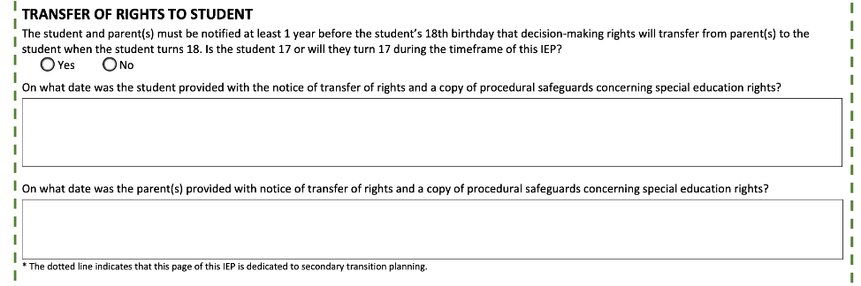
Transfer of rights to a student in special education refers to the process by which certain rights and responsibilities under IDEA transfer from the parents to the student once they reach the age of majority or become legally emancipated. The age of majority is 18 in Massachusetts.
No later than one year before the student reaches the age of 18, the school district must provide notice to the parents or guardians and the student that the rights will transfer to the student. This notice typically includes information about the transfer of rights, a description of the rights that will transfer, and information about the procedures and options available to the student. IEP Teams should use this section to document if and when the transfer of rights notice was provided to the student and parent(s).

Decision-Making Options for Student
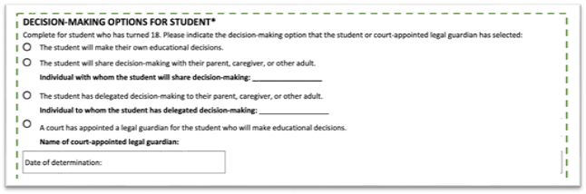
IEP Teams should use this section to document which option the student or student’s legal guardian selected. If no option has been selected, leave this section blank.

Transition to Adult Service Agency or Agencies-688 Referral
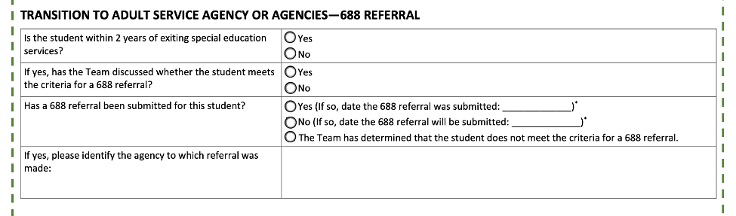
In Massachusetts, 688 referral refers to the process of transitioning qualifying students with disabilities from the K-12 educational system to an adult services agency.
To complete this section, IEP Teams should:
- Determine if the student is within two years of exiting special education services.
  - At what age will the student exit from special education services? Will the student be within two years of that date during this IEP period? If so, select yes. If not, select no.
- Determine if the student meets the criteria for a 688 referral. More information about the 688 referral process including eligibility criteria can be found on the Department’s Chapter 688 webpage.
- Document when the 688 referral was or will be made or, alternatively, select the option stating that the IEP Team has determined that the student does not meet the criteria for a 688 referral.
- Finally, if a 688 referral has been submitted, identify the agency to which the referral was made.

Accommodations and Modifications
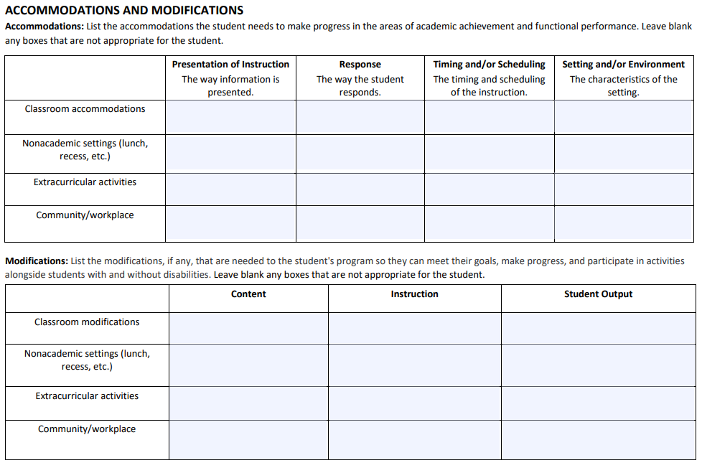
IEP accommodations and modifications are two kinds of supports that may be provided for students with disabilities through their IEP. In general, the key differences are:
 | Accommodations | Modifications
General Purpose | - Provide access to the general education curriculum by addressing barriers or challenges.  - Level the playing field so students can fully participate in educational activities. | - Make changes to curriculum, instruction and/or assessment directly tailored to individual needs.  - Alter what is being taught or assessed to match the student's abilities and learning goals.
Typical Nature of Changes | - Content and standards of the curriculum are not changed.  - The ways in which educators present information and the ways in which students demonstrate their knowledge or skills are adjusted to allow for access to curriculum and instruction. | - The curriculum is adapted to focus on key concepts.  - Content is simplified.  - Complexity of assignments or tasks is reduced.
Examples | - Providing extra time on tests.  - Using assistive technology.  - Providing visual prompts and instructions. | - Using alternative assignments.  - Direct, explicit, multi-sensory instruction.  - In language arts, providing modified materials at a different reading level.
Both accommodations and modifications are individualized based on the student's specific needs resulting from their identified disabilit(ies).

Accommodations Considerations
Before the IEP Team meeting, consider:
- Providing definitions of accommodations to all IEP Team members.
- Observing the student in different settings to gather data on the types of accommodations that might be necessary.
- Compiling recommendations from current assessments, both formal and informal, and preparing to share them with the IEP Team.
- Providing IEP Team members with examples of the different types of accommodations (presentation, response, timing/scheduling, and setting/environment).
During the IEP Team meeting, consider:
- Asking the parent and student about accommodations the student might be accessing outside of school and discussing any implications for the new IEP.
- Reviewing the data collected about the effectiveness of the accommodations the student may be currently receiving.
After the IEP Team meeting, consider:
- Collecting relevant data to determine the effectiveness of accommodations.

Accommodations for Presentation of Instruction
When providing accommodations for presentation of instruction, the goal is to provide access to the materials and content being shared so that students with disabilities can effectively participate in the learning experience. Here are some common accommodations:
- Providing alternative presentation formats such as a PowerPoint rather than a verbal presentation or replacing or supplementing the standard class presentation with posters or other visual aids.
- Providing visual supports can be beneficial for students with disabilities such as attention deficits or visual impairments. Visual organizers or outlines can help to structure the presentation. Visual aids such as diagrams, charts, or pictures, can enhance student understanding. Providing written instructions or key points on the board or in handouts may clarify the instructor’s expectations.
- Providing additional communication supports for students with disabilities such as speech or language impairments. These include the use of speech-generating devices, communication apps, or other assistive technology; providing a communication partner or facilitator; or using alternative means of communication such as sign language or written responses.
- Pairing students with disabilities with a peer mentor or allowing them to co-present with a partner can provide additional support and alleviate anxiety.

Accommodations for Responses
The aim in providing these accommodations is to support students with disabilities in effectively communicating their knowledge and ideas. Here are some common accommodations:
- Providing alternative response formats that can accommodate students with different learning styles or communication needs. These might include allowing oral rather than written responses; the use of speech-to-text software, word prediction tools, or other assistive technology; or using visual aids or graphic organizers to structure written responses.
- Simplifying language prompts for students with language or processing difficulties, which can enhance their understanding and ability to respond. Consider using clear and concise language in instructions and questions, breaking down complex tasks or questions into smaller, more manageable parts, and providing visual cues or examples to help students understand what is being asked.
- Allowing students who have motor or coordination challenges to use a scribe (someone who writes down their dictated responses) or providing them with typing assistance to support their ability to effectively convey their thoughts.
- Breaking assignments or tasks into smaller sections (chunking) or allowing for partial completion can help students with attention or executive functioning difficulties.
- Pairing students with disabilities with a peer mentor or allowing them to work collaboratively with a partner can provide valuable support and assistance during response activities.

Timing and Scheduling Accommodations
These accommodations are designed to address the specific needs of students with disabilities regarding the pace, duration, and organization of their learning activities. Here are some common timing and scheduling accommodations:
- Providing students with additional time before or after class to prepare, gather thoughts, or organize their materials.
- Offering flexibility in scheduling can accommodate students who may need breaks, rest periods, or have specific times of the day when they are more alert and focused. Such accommodations might include allowing short breaks during long activities or tests; providing the option to complete tasks or assignments at different times of the day; adjusting the pacing of instruction, or breaking down complex tasks into smaller, manageable segments.
- Providing transition support (additional time and assistance) for students moving between activities, classes, or locations. Accommodations may include providing visual schedules or timers to help students anticipate and prepare for transitions; allowing extra time for transitioning between classes or activities; or assigning a peer buddy or support staff to assist with transitions.
- Providing frequent breaks (sensory, movement, or rest) for students with attention or sensory processing difficulties to manage their energy levels and maintain focus.

Setting and Environmental Accommodations
These accommodations aim to create an inclusive and accessible environment that promotes learning and participation. Here are some common setting or environment accommodations:
- Providing access to adaptive furniture such as adjustable desks or sensory seating options.
- Reducing background noise or providing auditory supports for students with auditory processing difficulties or sensitivities, which can enhance their learning experience. The former might include providing noise-canceling headphones or earplugs and the latter may include providing closed captioning or transcripts for audiovisual materials. Students who require a low-stimulus environment may benefit from a soundproof or quiet area.
- Providing visual supports can assist students with communication or attention difficulties. These include but are not limited to preferential seating, displaying visual schedules or routines to provide structure and predictability, using visual cues or aids such as visual organizers, charts, or diagrams to reinforce concepts, or providing visual prompts or reminders for classroom expectations or procedures.
- Providing access to assistive technology can help students engage with the learning environment effectively. This might include using screen readers, speech-to-text software, or text-to-speech tools; using specialized keyboards, or other adaptive devices; or, for students with speech or language impairments, providing access to augmentative and alternative communication (AAC) devices/systems.
- Providing social supports to foster a positive and inclusive social environment. These include but are not limited to facilitating peer interactions through structured activities or buddy systems, grouping with positive peer role models during social interactions, or providing visual cues for social cues and expectations.
- Providing sensory support accommodations to students with sensory sensitivities and integration challenges. This may include allowing sensory breaks, providing tools such as fidgets or sensory toys, creating a sensory-friendly environment by adjusting lighting, temperature, or visual stimuli.

Modifications
Modification Considerations
Before the IEP Team meeting, consider:
- Gathering input from the student, if appropriate, about any modifications that have been helpful.
- Gathering work samples that show impact of any current modifications.
During the IEP Team meeting, consider:
- Sharing work samples that illustrate the impact of any current modifications the student is receiving (if any).
- Discussing the skills the student needs and how that relates to potential modifications being considered.
After the IEP Team meeting, consider:
- Collecting data to determine the success of modifications used.

Content Modifications
Modifying the curriculum or instructional materials to match the student’s abilities and learning needs is sometimes necessary for the student to progress effectively in the general education program. Some examples of content modifications include:
- Modifying the language used in instructional materials or assignments to make them more accessible. This might involve using shorter sentences and simpler vocabulary; breaking down complex concepts into smaller, more manageable parts; or providing visual aids or concrete examples.
- Adjusting the reading level of materials to match the student's reading ability can help with comprehension and engagement. This might involve providing simplified or adapted versions of texts at the student’s reading level, offering audio versions of texts, using text-to-speech software, or providing additional explanations, summaries, or visual supports to accompany texts.
- Modifying assignments can help students demonstrate their knowledge and skills at a level that aligns with their abilities. This might include adjusting the length or complexity of assignments, reducing the number of tasks or questions, or permitting alternative modes of expression, such as verbal or visual responses.
- Focusing the curriculum on essential skills and concepts helps students prioritize meaningful and relevant content. This might involve streamlining the curriculum to prioritize key learning objectives, providing additional practice and reinforcement for foundational skills, or customizing the curriculum to align with the student's individual goals and interests. Collaboration with ESL and other relevant staff may be helpful when modifying the curriculum for English learners with disabilities.

Instructional Modifications
Some examples of IEP instructional modifications include:
- Providing differentiated instruction to meet the unique needs of each student to support their learning and engagement. This might involve providing varying levels of challenge or complexity based on individual needs and abilities, offering different learning pathways or materials to accommodate different learning styles, or adapting instructional methods to suit students’ individual strengths and preferences.
- Providing instructional support and structure (scaffolded instruction) can help students build upon their existing knowledge and skills. This might involve breaking down complex tasks or assignments into smaller, manageable steps, providing explicit instruction and guided practice before independent work, or offering prompts, cues, or templates to assist with organization or problem-solving.
- Providing direct and explicit instruction can support students’ understanding of concepts and procedures. This might involve breaking down complex information into smaller, more digestible chunks; using modeling, think-alouds, guided practice, or other explicit teaching strategies; or providing step-by-step instructions and explanations to promote comprehension.
- Incorporating multi-sensory components into instruction can benefit students with diverse learning styles and sensory processing needs. This might involve using hands-on manipulatives or materials to reinforce concepts, providing visual aids (charts, diagrams, graphic organizers), or incorporating movement or kinesthetic activities to enhance engagement and understanding.
- Modifying or using alternative instructional materials can address different learning needs. This might involve providing materials in alternate formats (e.g., audio, visual), incorporating text-to-speech software, speech recognition tools or other assistive technology or using real-life examples or concrete materials to make concepts more tangible.

Output Modifications
Student output modifications involve adapting or adjusting the expectations for how students demonstrate their knowledge and skills. They are designed to help students with disabilities in effectively expressing their learning in ways that suit their individual needs and abilities. Here are some examples:
- Allowing students to use alternate response formats to address different learning styles and communication needs. This might involve allowing oral instead of written responses, the use of speech-to-text software, word prediction tools or other assistive technology, or the use of visual aids or graphic organizers.
- Providing partial completion options can support students who struggle with task initiation or completing assignments independently. This might involve allowing students to complete only a portion of the assignment or task, breaking tasks into smaller segments, providing the student with completed sections to build upon, or providing starter sentences or prompts to assist with written responses.
- Modifying assessments can enable students to demonstrate their knowledge and skills to the best of their abilities. This might involve using alternate assessment formats (e.g., oral presentations, projects, portfolios), or adjusting the number or complexity of assessment questions.
- Offering alternate assignments can provide students with different options to showcase their understanding. This might include providing choices for assignments that align with the student's strengths and interests, or offering alternative modes of expression, such as creating a visual presentation instead of writing a report.

Assessments

State or Districtwide Assessments
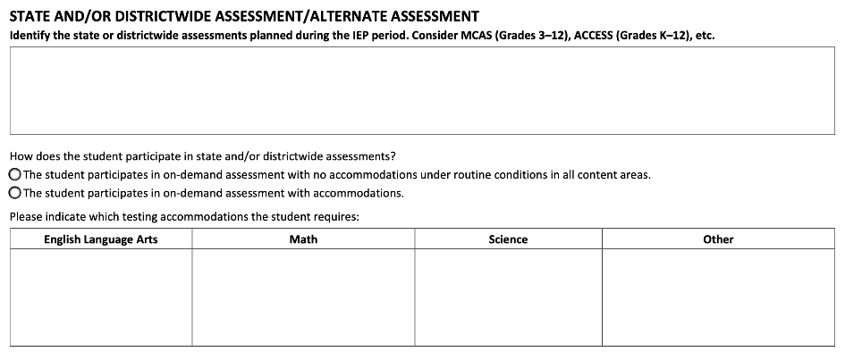
In Massachusetts, the statewide assessment is the MCAS, which begins in third grade. Other state or districtwide assessments refer to standardized assessments administered to students, including those eligible for special education, to measure their academic achievement and progress.
Students with disabilities may be eligible for accommodations during state or districtwide assessments to provide a fair testing environment including extended time, breaks, and use of assistive technology.

Alternate Assessments
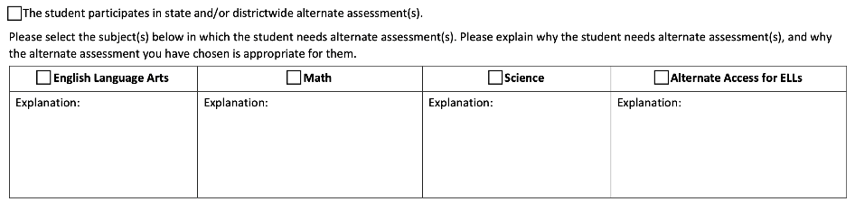
Some students with disabilities may face challenges accessing and demonstrating their knowledge on standard state or districtwide assessments even with accommodations. In some instances, alternate assessments may be used to provide a more appropriate evaluation of their skills and progress. A small number of students with the most significant cognitive disabilities who are unable to take the standard tests even with accommodations may be eligible to participate in alternate assessments, such as the MCAS Alternate Assessment (MCAS-Alt). MCAS-Alt consists of a portfolio of specific materials assembled annually by the teacher and student. Materials for the portfolio may include work samples, instructional data, videotapes, and other supporting information. The determination of which students may be eligible to participate in the alternate assessments must be made on a case-by-case basis. More information about the MCAS-Alt, including eligibility criteria can be found on the Department’s MCAS Alternate Assessment webpage. As indicated on the IEP form, the IEP Team must explain why the student needs the specific alternate assessments and why the alternate assessment is appropriate for the student.
In considering whether the MCAS-Alt should be used with the student, it is important for the parent and/or the student to be informed of how participation in the MCAS-Alt may delay or otherwise affect the student from completing the requirements for a regular high school diploma. Specifically, the MCAS-Alt assesses learning standards that are below the expectations needed to obtain a regular high school diploma in Massachusetts.

Measurable Annual Goals
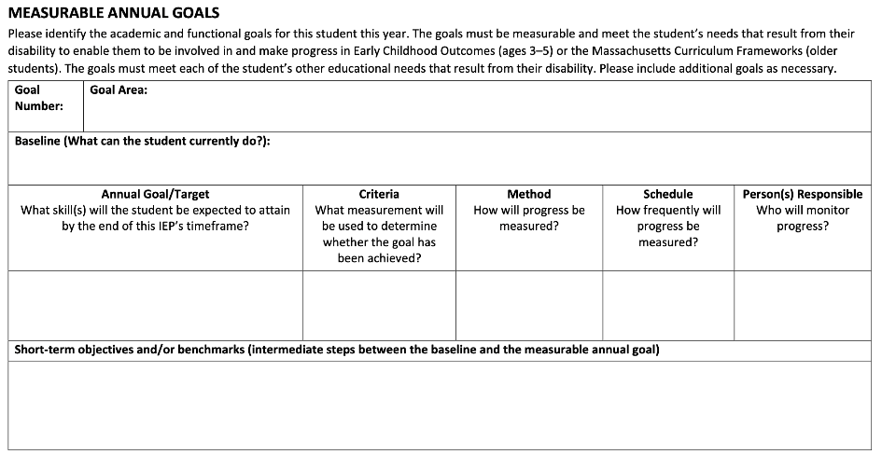
Developing measurable annual goals is a critical step in the IEP process. When developing measurable annual goals, IEP Teams should consider a variety of information, including the information in the Student and Team Vision and Present Levels sections of the IEP. Parental input is critical in developing measurable, effective, and meaningful goals. IEP Teams should also consider the extent to which measurable annual goals can help the student increase learning and participation in the least restrictive environment.
The IEP form requires the IEP Team to describe the student’s baseline in the selected goal area, identify an annual goal/target, the measurement that will be used to determine whether the goal has been achieved, the method for measuring progress, the schedule of progress monitoring, and the person responsible for monitoring the student’s progress as to the specific goal.
Here is a further description of those components:
- The baseline refers to the student's current level of performance or skill in the targeted area. It serves as a starting point for measuring progress toward the annual goal and is determined through assessments, observations, or other data collection methods.
- A measurable annual goal/target is a specific objective that the student is expected to achieve within a year. It focuses on an area of need identified through assessment and other data. The goal should be specific, measurable, and relevant.
- The criteria for success specify the expected level of achievement or proficiency the student must reach to demonstrate that they have met their goal. These criteria establish clear benchmarks to evaluate progress and can be defined in terms of specific performance levels, percentages, scores, or other measurable indicators.
- The method of measurement outlines how progress toward the goal will be assessed and documented. Assessment tools, tests, observations, work samples, and other data collection methods can provide reliable and valid information measuring the student's progress.
- The schedule for progress monitoring determines how frequently progress will be assessed and reported. It identifies specific checkpoints throughout the year when data will be collected and analyzed to determine the student's progress toward the annual goal. Progress monitoring may occur quarterly, semi-annually, or at other specified intervals.
- The person responsible for monitoring and reporting progress toward the annual goal is identified in the Goal section. This may be a special education teacher, general education teacher, a related service provider, or another designated professional. The person responsible verifies that data are collected, progress is tracked, and reports are shared with the IEP Team, including the parents. Names of specific staff members should not be included in this section as they may change during the IEP period, but IEP Teams should identify the person responsible by title or role.

Short-Term Objectives and/or Benchmarks
If the current performance levels and baseline information are the starting points and the goals are the end points, then the objectives and benchmarks should be thought of as the steps between the starting and end points. Objectives break skills within the annual goal into discrete components, and benchmarks describe the amount of progress a student is expected to make within a specified segment of the IEP period. Benchmarks establish expected performance levels that allow for regular checks of progress that coincide with progress-reporting periods. Both lay out sequential, logical steps towards reaching the annual measurable goal. Depending upon the needs of the student and the makeup of the goal, the IEP Team may break down the goal into objectives, benchmarks, or a combination of the two.

Schedule of Progress Reporting
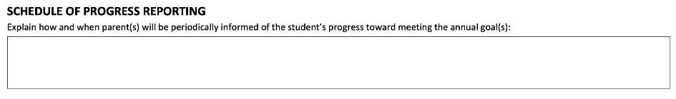
Written progress reports are a component of ongoing communication between school districts and parents and must be submitted to parents of eligible students at least as often as report cards or progress reports are issued for students without disabilities. Progress reports must answer the following two questions for each goal:
- What is the student’s progress toward the annual goal?
- Is the progress sufficient to enable the student to achieve the annual goal by the end of the IEP period?
IEP Team members should respond to these questions by taking the following steps when writing their progress reports:
- Specify what the student has been working on.
- List what the student has achieved.
- Indicate any challenges to progress.
- Project whether the student will reach the annual goal if progress continues at its current pace.
When writing these reports, school personnel should use language that is generally understandable and avoid using educational jargon. If the student is at risk for not meeting their annual goal(s), IEP Team members must consider why progress is not being made, and, if appropriate, reconvene an IEP Team meeting. The IEP Team will then discuss the lack of expected progress and responsively revise the IEP.

Participation in the General Education Setting
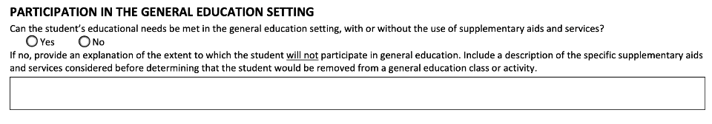
To the maximum extent appropriate, students with disabilities must be educated with students without disabilities, and special classes, separate schooling, or other removal of students with disabilities from the regular educational environment should only occur if the nature or severity of the disability is such that education in regular classes with the use of supplementary aides and services cannot be achieved satisfactorily.
Participation in the General Education Considerations
Before the IEP Team meeting, consider:
- Sharing examples of any supplementary aids and services that were used to support the student in the general education environment.
- Share the student’s current schedule with the IEP Team members so that they can consider the student’s current participation in the general education setting.
- Sharing the most current research around inclusionary practices along with examples of students benefitting from being in general education with appropriate aids and or services.
During the IEP Team meeting, consider:
- Orienting the IEP Team members to the significant importance of this section to facilitate authentic IEP Team discussion.
When making decisions about participation in the general education setting for an eligible student, several important points should be considered:
- Individualized Approach: The extent to which the student can participate in the general education setting must be determined considering the individual student’s strengths, abilities, and needs. IEP Teams should avoid making blanket assumptions or decisions based solely on a student's disability category (e.g., assuming that the student should be placed in a substantially separate classroom because they are identified as having an intellectual impairment).
- Collaboration and Team Decision-Making: The least restrictive environment (LRE) determination involves collaboration among the student's IEP Team, including parents, general and special education teachers, related service providers, administrators, and student support providers. The collective expertise and input from IEP Team members are crucial in making informed decisions.
- Academic and Social Considerations: Consider the student's academic abilities, learning and social-emotional needs. Can the general education classroom adequately address the student’s educational goals and needs? Can accommodations, supplementary aides, services, modifications, or other supports be provided to facilitate the student’s meaningful participation and progress in the general education classroom?
- Support Services and Accommodations: Determine the level and type of supplementary aides, services, supports, accommodations, and modifications required for the student to participate and progress in the general education setting. This may include additional teacher and other professional support, specially designed instruction, assistive technology, modifications to assignments, or related services such as speech and occupational therapies.
- Social Integration and Peer Interaction: Consider the importance of social integration and peer interaction for the student's overall development. Will the general education classroom provide opportunities for meaningful interactions with peers without disabilities and promote social inclusion?

Service Delivery
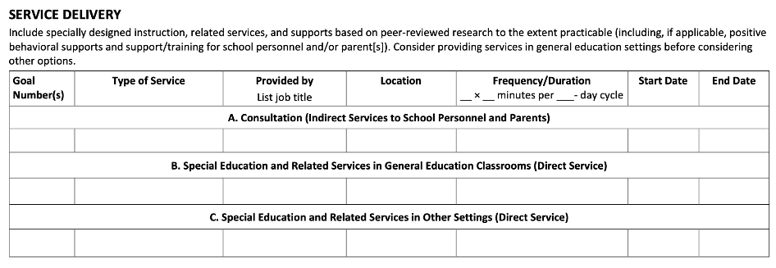

Consultation
The consultation model in special education service delivery typically involves collaboration between special education professionals, general education teachers, related services providers, parents/guardians, and other stakeholders to meet the needs and IEP goals of students with disabilities. Here are some common components of the consultation model:
- Observations and Assessments: Classroom observations and assessments help gather additional information about the student's learning environment and progress.
- Problem-Solving and Action Planning: The consulting service provider engages in problem-solving discussions with general education teachers, parents/guardians, and other relevant stakeholders to develop action plans and interventions, as needed.
- Recommendations and Support Strategies: The consulting service provider offers IEP Team members recommendations and support strategies to address the student's needs.
- Training and Professional Development: The consultation model often includes training, classroom modeling, and professional development to enhance understanding and implementation of components of the IEP.

Direct Service in the General Education Classroom
Direct service in the general education classroom refers to the provision of specially designed instruction, services, or support delivered by staff members such as special education teachers, related service providers, etc. directly to students with disabilities within the general education setting. Here are some key points about direct services:
- Specially Designed Instruction: Direct services often encompass specially designed instruction tailored to address students' unique learning needs and challenges. This may involve strategies, techniques, or interventions designed to promote academic, social-emotional, or behavioral progress. Special education professionals may provide direct instruction in specific subjects, such as reading, math, or writing, using evidence-based practices and instructional methodologies.
- Related Services: In addition to specially designed instruction, direct services can also include related services delivered by professionals such as speech-language pathologists, occupational and physical therapists, or counselors. These services support students in areas such as communication, motor skills, social-emotional development, and behavior management, contributing to their overall educational progress.
- Progress Monitoring: Special and general education professionals regularly monitor students' progress during direct services. They collect data, assess learning outcomes, and adjust instructional strategies as needed to promote student growth and achievement. Progress monitoring helps track individual student progress and inform decision-making regarding instructional adjustments or intervention strategies.

Direct Services in Other Settings
In addition to direct services provided in general education classrooms, special education and related services can also be delivered in other settings outside of the general education environment.
- Special Education Services in Other Settings: Students with disabilities sometimes require specially designed instruction and/or related services provided in settings outside of the general education classroom in smaller groups or individually. Special education professionals provide direct services in these settings, focusing on targeted skill development, remediation, previewing or reinforcement of academic concepts, or otherwise meeting the student’s unique needs outside of the general education classroom.
- Related Services in Other Settings: Related services may be provided in designated therapy rooms or specialized spaces so that they can be provided more explicitly and intensively. Therapists work directly with students to address their specific goals, improve skills, and support their overall development.
- Home-Based Services: In certain situations, special education and related services can be delivered directly in a student's home. This may occur when a student is unable to attend school due to medical reasons or when specific services, such as homebound instruction or therapy, are required. Special education professionals or therapists visit the student's home to provide direct services tailored to the student’s individual needs.
- Community-Based Instruction: Community-based instruction involves providing direct services in real-life settings outside of the school, such as community centers, vocational training sites, or workplaces. Students receive instruction and support in practical skills related to independent living, socialization, vocational training, and community integration.

Transportation Services
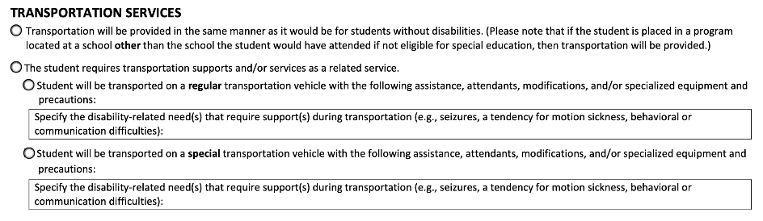
Many students with disabilities will get to school in the same manner as students without disabilities (see the first checkbox under Transportation Services section). This could range from walking to school to riding the regular school bus in the same manner as other students. In Massachusetts, this is ordinarily referred to as “regular transportation.”
Some students with disabilities may need transportation as a related service (see the second checkbox under Transportation Services section). In Massachusetts, this is ordinarily referred to as “special transportation.” As a related service, transportation can include travel to and from school and between schools, travel in and around school buildings, and specialized equipment (such as special or adapted buses, lifts, and ramps).

Schedule Modification
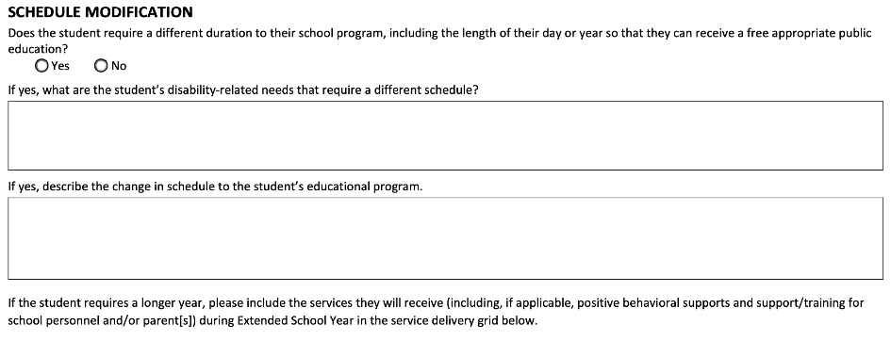
An eligible student may need a different duration to their school program, including the length of their day, year, or other schedule modifications to meet their individual needs. These modifications can be necessary for students who may require shorter or longer instructional periods, breaks, or a reduced or extended school day. Here are some common types of schedule modifications for students with disabilities:
- Extended School Year (ESY): ESY is a way in which the duration of the school year might be changed for some eligible students. The IEP Team makes the decision about a student's need for ESY. ESY may be identified if the student has demonstrated or is likely to demonstrate substantial regression in learning skills and/or substantial difficulty in relearning such skills if an extended program is not provided. This decision is ordinarily based on data collected from various sources (e.g., progress reports, report cards, teacher observations, test scores). Each student's needs for ESY must be considered individually. For more information, please see this Question and Answer Guide.
- Extended Day: The daily duration of the student's program is ordinarily equal to that of the regular school day, unless the IEP Team states that a different duration is necessary to provide a free appropriate public education to the student. Some students may require an extended school day to receive additional instructional time, related services, or other supports to make effective progress towards their educational goals, provide remediation, or accommodate the student's individual learning pace.
- Staggered Schedules: Staggered schedules involve adjusting the start or end times of specific classes, subjects, or activities within the school day. This modification can be helpful for students who benefit from a more flexible or individualized approach to their daily routine. For example, staggering schedules can allow for personalized attention, therapy sessions, or other services without disrupting the student’s overall schedule.
- Shortened Day: Some eligible students may benefit from a shortened school day due to factors such as fatigue, attention span, or medical needs. The specific hours or periods of the day that are shortened should be determined based on the student's unique needs. Since a shortened day results in reduced access to an education for the student, it is important that the IEP Teams carefully consider any such decision, including alternatives that may provide increased access to an education for the student.
When implementing schedule modifications, it is essential to involve the student's IEP Team. The IEP Team collaborates to determine the specific modifications needed, documents them in the student's IEP, and monitors the schedule adjustments.

Service Delivery for Extended School Year Services
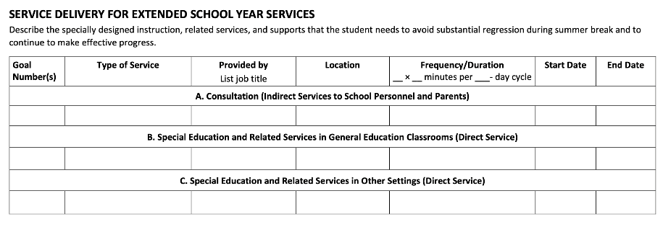
If the IEP Team determines that an eligible student needs ESY services, this section of the IEP details the specific special education services that the eligible student will receive during ESY, including when, where, how often, and for how long.

Extended School Year Transportation Services
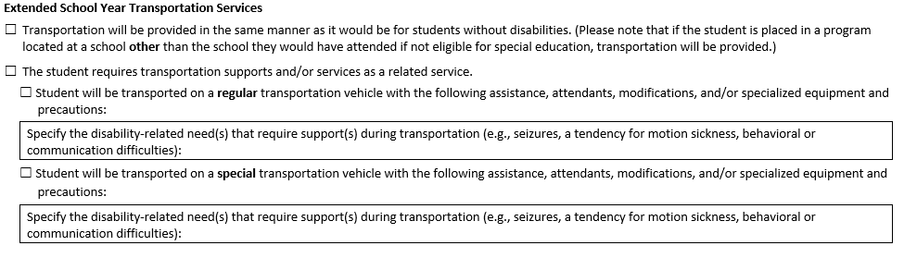
After determining that a student with disabilities is eligible for ESY services, the IEP Team must carefully consider and document any transportation services needed by the eligible student for ESY.

Additional Information
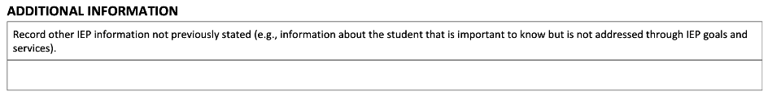
In this section, the IEP Team may capture other relevant information and details that may inform the student’s educational experience, support the student’s well-being, and IEP goals.

Response Section
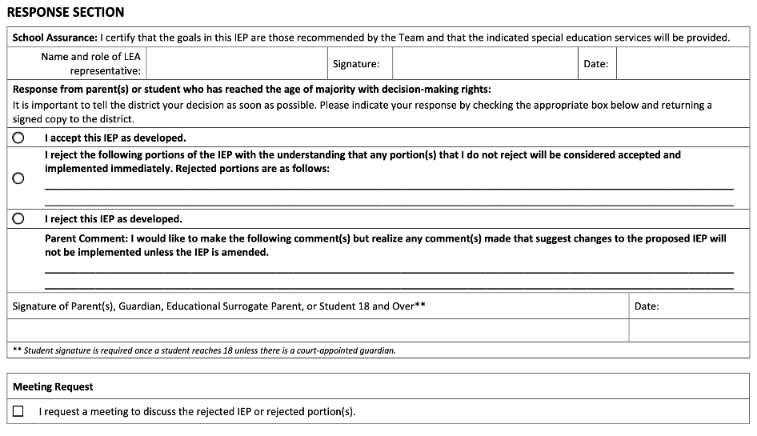
Immediately following the development of the IEP, and within 45 school working days after receipt of the parent's written consent to an initial evaluation or reevaluation, the district must provide the parents with two copies of the proposed IEP and proposed placement along with the required notice, except that the proposal of placement may be delayed according to the provisions of 603 CMR 28.06(2)(e) in a limited number of cases.
No later than 30 days after receipt of the proposed IEP and proposed placement, the parents will accept or reject the IEP in whole or in part; request a meeting to discuss the rejected portions of the IEP or the overall adequacy of the IEP; or if mutually agreed upon, accept an amended proposal; and accept or reject the proposed placement.
Upon parental response to the proposed IEP and proposed placement, the school district shall implement all accepted elements of the IEP without delay.

See 1/7/2015 Dear Colleague Letter, English Learner Students and Limited English Proficient Parents at 26-27 (available at https://www2.ed.gov/about/offices/list/ocr/letters/colleague-el-201501.pdf).
Available at https://www2.ed.gov/about/offices/list/oela/english-learner-toolkit/chap6.pdf p. 11.
Available at https://ncela.ed.gov/sites/default/files/legacy/files/english_learner_toolkit/OELA_2017_ELsToolkit_508C.pdf.

