Massachusetts Department of
Elementary and Secondary Education (MA DESE)

State Systemic Improvement Plan (SSIP)
Phase III, Year 4 Report

FFY 2018
Submitted April 1, 2020

Table of Contents
Acronyms and Abbreviations 1
A. Summary of Phase III Year 4 2
1. Massachusetts Theory of Action and SiMR 3
2. Summary of Improvement Strategies 6
3. Evidence-Based Practices Implemented to Date 8
4. Evaluation Activities, Measures, and Outcomes 9
5. Highlights of Changes to Implementation and Improvement Strategies 13
B. Progress in Implementing the SSIP 14
1. Description of the State’s SSIP Implementation Progress 14
2. Stakeholder Involvement in SSIP Implementation 23
C. Data on Implementation and Outcomes 26
1. How the State Monitored and Measured Outputs to Assess Effectiveness 26
2. How the State has Demonstrated Progress and Made Modifications to the SSIP 33
3. Stakeholder Involvement in the SSIP Evaluation 35
D. Data Quality Issues 36
1. Data Limitations, Implications, and Plans for Improving Data Quality 36
E. Progress in Achieving Intended Improvements 39
1. Assessment of Progress toward Achieving Intended Improvements 39
F. Plans for Next Year 61
1. Additional Activities to be Implemented Next Year 61
2. Planned Evaluation Activities Including Data Collection, Measures, Expected Outcomes 64
3. Anticipated Barriers and Solutions 66
4. State’s Need for Additional Support/TA 66
APPENDIX 67

Tables and Figures
TABLES
Table 1. Indicator 7, Outcome Area A: Social Emotional Skills - Reported Data and Targets 5
Table 2. MA SSIP Evaluation Plan 27
Table 3. Data Collection Plan 30
Table 4. Data Limitations, Implications, and Plans for Improvement 37
Table 5. Year 4 Statewide Professional Development Events and Supports for Practitioners and Coaches 40
Table 6. EC-PBS/Pyramid Participation among Districts, Schools, and Classrooms: 2017 to 2020 47
Table 7. Mid-Year Leadership Team Survey: Greatest Challenges to Implementation 52
Table 8. Teachers’ Self-Rating of Key Practices Before the Initiative and Now (n=44) 55
Table 9. SPP Indicator 7 Data: Summary Statement 2 (Statewide) 58
Table 10. SPP Indicator 7 Data: Summary Statement 1 (Statewide) 58
Table 11. SSIP Implementation: February 2020 – Spring 2021 62
Table 12. SSIP Evaluation Plan: March 2020 – February 2021 64
Table 13. Anticipated Barriers and Solutions 66

FIGURES
Figure 1. MA SSIP Theory of Action 4
Figure 2. EC-BoQ Results - Program-wide Implementation of EBPs: Overall Scores by Cohort 8
Figure 3. TPOT Results - Classroom Implementation of EBPs: Overall Scores by Cohort 9
Figure 4. Massachusetts EC-PBS/Pyramid Model Sequence and Supports 16
Figure 5. Interagency Initiatives to Support EC-PBS/Pyramid Model 17
Figure 6. Statewide Progress Aligned with EC-PBS/Pyramid Training and Implementation (February 2019 – February 2020) 20
Figure 7. Participant Pre/Post Ratings of Learning Objectives (Overall mean ratings) 42
Figure 8. Types of Support Provided by External Coaches 43
Figure 9. Parent Engagement Activities (n=77) 44
Figure 10. Progress on FFY 2018 Areas of Focus over the Past Year (n=77) 46
Figure 11. EC-BoQ v2.0 Results over Time by Cohort: By Critical Elements and Overall 48
Figure 12. District Progress toward Establishing Key Components of EC-PBS/Pyramid (n=77) 51
Figure 13. Aggregate TPOT Results Across the Key Practices and Overall (n=68) 54
Figure 14. Perceived Benefits of Pyramid Model Classrooms 57
Figure 15. Statewide and Pyramid Model FFY 2018 Results across Child Outcomes 59

Acronyms and Abbreviations
BIRs Behavior Incident Report System
COS Child Outcomes Summary
CSEFEL Center on the Social and Emotional Foundations for Early Learning
EC-BoQ Early Childhood PBS Benchmarks of Quality
ECE Early Childhood Education
EC-PBS Early Childhood - Positive Behavior Supports
ECSE Early Childhood Special Education
FCSN Federation for Children with Special Needs
IEP Individualized Education Program
MA DESE Massachusetts Department of Elementary and Secondary Education
MA EEC Massachusetts Department of Early Education and Care
PBC Practice Based Coaching
PMC Pyramid Model Consortium
PTR-YC Prevent, Teach, Reinforce - Young Children
PTR-F Prevent, Teach, Reinforce for Families
SEAP Special Education Advisory Panel
SiMR State-identified Measurable Result
SLT State Leadership Team
SSIP State Systemic Improvement Plan
TOA Theory of Action
TPOT Teaching Pyramid Observation Tool

A. Summary of Phase III Year 4
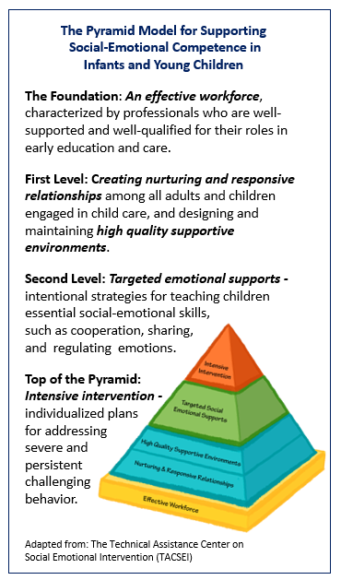
The Massachusetts State Systemic Improvement Plan (SSIP) is devoted to improved social emotional outcomes for preschool children with Individual Education Programs (IEPs). In collaboration with key stakeholders, the Massachusetts Department of Elementary and Secondary Education (MA DESE) selected the implementation of Early Childhood Positive Behavior Supports through Pyramid Model strategies (EC-PBS/Pyramid Model) as its evidence-based practice (EBP) to achieve this goal and to help prepare all children for success.
The Pyramid Model is a research-based, tiered intervention framework that begins with an effective workforce as its foundation. The first level refers to the creation of nurturing and responsive relationships among all adults and children engaged in child care, and providing high quality supportive environments for children (see box at right). The second level refers to targeted emotional supports – more intentional strategies for teaching social emotional skills to children. Finally, the top of the pyramid refers to intensive intervention – individualized plans for children with severe, persistent challenging behavior.
MA DESE and state agency partners continued to expand the SSIP over the past year to support the scale up and implementation of EC-PBS/Pyramid Model with fidelity to a greater number of sites, and to provide additional opportunities for all statewide personnel to strengthen Early Childhood Special Education (ECSE).
Among its state agency partnerships, MA DESE continues its collaboration with the Massachusetts Department of Early Education and Care (MA EEC) on core components of the SSIP, and on related initiatives with the shared goal of providing cohesive services for children and stronger networks for families. Collectively, these agencies are now supporting the development of 95 EC-PBS/Pyramid Model implementation sites across the Commonwealth – “sites” include school districts, early childhood education programs (ECEs), and three community-wide efforts.
During FFY 2018, MA DESE expanded its direct support for school districts implementing EC-PBS/Pyramid strategies from 26 to 31 districts. This includes 19 districts that have been engaged for three or more years (Cohorts 1 and 2), six districts that joined early in the 2018-19 school year (Cohort 3), and six that joined early in the 2019-20 school year (Cohort 4). It is worth noting that one of the Cohort 4 districts is working toward a community-wide approach to implementation (referenced above). Taken together, work toward implementation across the 31 districts extends to 50 schools and 290 classrooms, representing a 49% increase in classrooms over last year. During Year 4, there has been a continued emphasis toward scale up to additional sites, the expansion of the model to support collaborative implementation approaches including regional training events provided by external coaches, and consideration of sustainability for districts that have been engaged in Pyramid Model implementation for several years. The SSIP evaluation plan is principally designed around assessing progress for these 31 districts, as reflected in the evaluation findings in Section E.
MA DESE continues to collaborate with national experts from the Pyramid Model Consortium (PMC) to support implementation and scale-up of EC-PBS/Pyramid strategies in these districts and community-based sites, and to continue to build statewide infrastructure. PMC staff, in coordination with state personnel, design and provide training geared toward building capacity among practitioners, internal (school-based) coaches, behavioral specialists, and other educators for implementing the model with fidelity. MA DESE also continues to fund eight external coaches with experience in EC-PBS/Pyramid Model and early childhood education, to support each district in their implementation efforts. Each district has one external coach, while most coaches serve more than one district. PMC also facilitates the SSIP external coaches’ monthly professional learning community (PLC) meetings to support coaches in their work with districts toward implementation fidelity.
This year, external coaches participated in training events related to Trauma Informed Care, recognizing implicit bias and fostering culturally responsive practices, and assessing child outcomes via the Child Outcomes Summary (COS) process. As in prior years, MA DESE, MA EEC, PMC, and external coaches collaborated on the design and delivery of statewide leadership team meetings driven by data, evaluation findings, and stakeholder feedback; external coaches also provide local and regional trainings for participating sites.
MA DESE continues to collaborate with other state agencies to broaden the scope and reach of Pyramid Model adoption through several related statewide initiatives. These initiatives include community-based EC-PBS/Pyramid implementation sites sponsored by MA EEC as described above, other related statewide training opportunities and learning forums (i.e., MA EEC Trauma Informed Care initiative, the Annual Pyramid Model Summit), and parent involvement activities conducted by the Federation for Children with Special Needs (FCSN), among others. During FFY 2018, the Massachusetts Pyramid Model State Leadership Team (SLT) was reinstated following a review phase, and new stakeholder groups became engaged in statewide planning and feedback. Finally, MA DESE continues to build the foundation for this infrastructure through an array of department initiatives related to positive social emotional outcomes for all students.
MA DESE and its partners continue to collaborate with an external evaluator to assess implementation and outcomes, to provide timely information to assist in program improvement, and to assist in communicating results to stakeholders for discussion and feedback.

1. Massachusetts Theory of Action and SiMR
MA SSIP Theory of Action
The MA SSIP Theory of Action (TOA) continues to serve as the blueprint for implementing the SSIP, assessing progress, and determining next steps. The TOA, shown in Figure 1 below, is based on a system of collaboration and support that flows from the state level (interagency initiatives, MA DESE ECSE initiatives), to programs, classrooms, and children. Family engagement is a focus throughout, as well as an ongoing process of inquiry and improvement. Figure 6 on page 19 provides a graphic summary of statewide SSIP progress as it aligns with this TOA, and progress toward the SSIP is discussed in the context of the TOA throughout this report. Section C presents the comprehensive SSIP evaluation plan as it aligns with the Theory of Action.
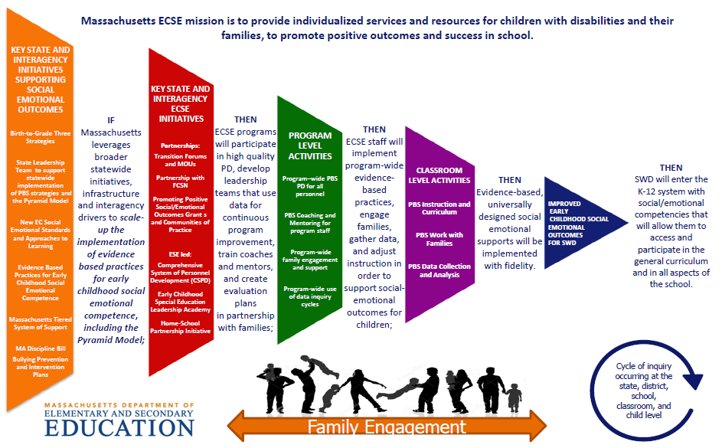
Figure 1. MA SSIP Theory of Action

SiMR Targets and Results
To assess progress toward its State-identified Measurable Result (SiMR) of improved child outcomes for children with IEP’s, as aligned with the Theory of Action, MA DESE uses statewide results for Indicator 7: Preschool Outcomes; Outcome A: Percent of preschool children aged 3 through 5 with IEPs who demonstrate improved positive social-emotional skills (including social relationships). To address Indicator 7, child level data are collected via the Child Outcomes Summary (COS) process. Results are then analyzed to address two Summary Statements.
- Summary Statement 1: Of those preschool children who entered the preschool program below age expectations in Outcome A, the percent who substantially increased their rate of growth by the time they turned 6 years of age or exited the program.
- Summary Statement 2: The percent of preschool children who were functioning within age expectations in Outcome A by the time they turned 6 years of age or exited the program.

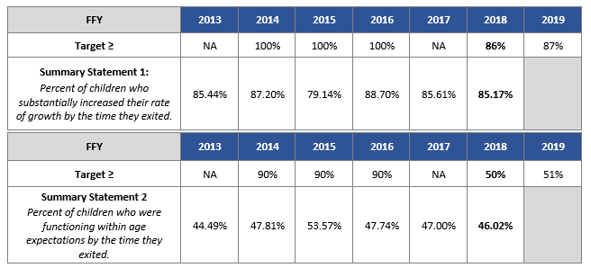
Table 1. Indicator 7, Outcome Area A: Social Emotional Skills
Reported Data and Targets

Table 1 above shows statewide SiMR results for FFY 2018 in comparison to the five prior years. As shown, for Summary Statement 1, outcomes for Massachusetts preschool children with disabilities have fluctuated to some extent since the original baseline measure in FFY 2013 but have largely remained consistent over time. For Summary Statement 2, results have generally increased since the original baseline. It is important to note that the data submitted for FFY 2018 represent 1,045 children, a 61% increase in the number of usable records over FFY 2017 (n=651), and a 163% increase over FFY 2016 (n=398). As such, MA DESE is moving toward greater reliability for this measure and given the increase in N, suggests that the outcomes have improved for more children. This increase reflects MA DESE’s continued focus on supporting districts in collecting and reporting Child Outcomes data for Indicator 7. The state is currently developing plans and systems for statewide reporting on an annual basis.
During the most recent reporting period (FFY 2017 to FFY 2018) results were essentially unchanged (85.61% to 85.17%) for Outcome A, Summary Statement 1. Results for Summary Statement 2 over the same time period decreased slightly (47.00% to 46.02%). In each case, the proportional year-to-year difference was not found to be statistically significant.
Based on the revised targets set last year for FFY 2018, the state fell short of its goal of achieving 86% for Summary Statement 1, and 50% for Summary Statement 2. As described later in this report (Section C2a), MA DESE is engaged in several activities to continue to increase districts’ capacity for collecting and reporting valid and reliable Child Outcomes data for Indicator 7, and for increased use of the data for program improvement at the local level. External coaches are also participating in training to build capacity for supporting districts to collect, analyze, and use their data.
Finally, it is important to note that Child Outcomes data for Indicator 7 for the 31 SSIP districts receiving intensive supports from MA DESE were analyzed as a subset of the statewide data. This year, results aggregated across the 20 districts with usable data suggest performance on both Summary Statements that is greater than overall statewide averages – 89.1% for Summary Statement 1, and 46.6% for Summary Statement 2. These results are discussed in Section E.

2. Summary of Improvement Strategies
Principal Activities for Implementation of Evidence-Based Practices
The principal activities to foster adoption of EC-PBS/Pyramid Strategies that began in spring 2015 continue to be expanded across the state, district, school, and community levels, as aligned with the MA SSIP Theory of Action. Key activities are briefly described below. Additional details and progress measures related to these activities are presented in Section E.
Key State and ECSE Initiatives:
- Building state infrastructure through continued collaboration with national experts to prepare and support district leadership teams for implementing the EBPs of the EC-PBS/Pyramid Model. Activities include the design and provision of high-quality professional development in Pyramid Model practices, fidelity measures and tools, and implementation strategies (TPOT, PBC, PTR-YC, and others).
- Expanded professional development opportunities to further support the Pyramid Model framework and effective EC-PBS strategies, based on stakeholder needs and ECSE priority areas: Trauma Informed Care, inclusion strategies, family engagement strategies and family training (Positive Solutions for Families), connections between early literacy and the Pyramid Model, ensuring equity, using Behavior Incident Report systems (BIRs), and others.
- Ongoing training and supports for external coaches provided by MA DESE and national experts to further build capacity among the coach cadre for supporting districts in the areas of need identified by key stakeholders, through fidelity measures and survey feedback.
- Expansion of principal activities and program resources to additional school districts and several community-based teams to support adoption of EC-PBS/Pyramid strategies. Includes leadership team statewide training to launch the new cohort of districts, and access to all activities described above.
District/Program Level Activities:
- Formation of district leadership teams among the six Cohort 4 districts that joined the initiative in the 2019-20 school year. Like Cohorts 1 through 3, these leadership teams plan and guide EC-PBS/Pyramid Model implementation in their districts and schools, with ongoing support from external coaches, supported by fidelity tools.
- Continued participation of district leadership teams and district/school personnel across the menu of professional development opportunities based on staff PD readiness/needs. All cohorts.
- Individualized external coaching supports for participating districts to help guide implementation plans, and progress toward program-wide adoption and sustainability.
- Provision of family engagement activities and training opportunities through Positive Solutions for Families (offered by FCSN), supported by external coaches.
School/Classroom Level Activities:
- Practitioner Training: External coaches continue to provide local and regional trainings in EC-PBS/Pyramid Model practices to participating districts. As noted above, PMC hosts statewide trainings across foundational Pyramid Model implementation strategies and tools: TPOT, PTR-YC, PTR-F, and others.
- District-Based Internal Coach Training: Internal (classroom-based) coaches are offered a two-day Practice Based Coaching (PBC) training event to help prepare them for working with teachers to implement EC-PBS/Pyramid strategies with fidelity, as well as PBC in a Group training, and virtual monthly “Community of Practice” (COP) events, to provide further guidance for PBC among school staff.
- Fidelity Measures for Classroom Implementation – TPOT: Internal coaches, often with the support of external coaches, are scaling up their use of the TPOT to observe teachers implementing EC-PBS/Pyramid strategies in the classroom, and to plan ongoing support for teachers to support fidelity.
The principal activities are also reflective of the EC-PBS/Pyramid work being supported by MA EEC across an additional 64 implementation sites, situated in community-based early childhood education (ECE) programs (two of these sites are employing a community-based approach). The MA EEC Pyramid Model initiative is also being spearheaded by PMC, and most of the activities described below are now being offered across these two contexts: in school districts, and in ECE programs. As such, most of the statewide training opportunities and coach support events are available to personnel across both initiatives, ideally leading to greater integration of the work and more opportunities for collaboration. The external coaches are also common to both projects.
As described throughout this report, Massachusetts continues to work toward a community-wide model of infrastructure and supports for implementation to ensure improved outcomes for all students entering the K-12 system, regardless of their entry point into early childhood education. This year, these plans have been advanced as three of the implementation “sites”, across the MA DESE and MA EEC initiatives, are formally being approached as community-wide (i.e., city-wide) efforts.
Interagency Initiatives and Broader Statewide Infrastructure
MA DESE is engaged in numerous statewide initiatives and activities related to the implementation of the EC-PBS/Pyramid Model more broadly across Massachusetts, as well as initiatives designed to strengthen Early Childhood Special Education across the Commonwealth. Key activities are listed below, and are described in Section B.
EC-PBS/Pyramid Initiatives Related to the TOA
- Massachusetts PBS Pyramid Model State Leadership Team (SLT)
- MA EEC EC-PBS/Pyramid Model Training Initiative
- EC-PBS/Pyramid Model Summit
- MA EEC Trauma Informed Care Initiative
- On-site Professional Development for Inclusion Strategies
- Positive Solutions for Families
- National Center for Pyramid Model Innovations (NCPMI) Program Coach Technical Assistance Project
Broader Statewide Infrastructure Related to the TOA
Early Childhood Special Education Initiatives:
- Preschool Development Grant Birth-Five (PDG B-5) Planning
- Building Inclusive Communities in Preschool (BIC) Initiative
- Early Childhood Leadership Institute
- Early Childhood Transition Forums
- Early Literacy and ECSE
- Early Learning Network Regional Meetings
Department of Elementary and Secondary Education Initiatives:
- 2019 Special Education Professional Development Series
- Early Childhood Special Education Discretionary Federal Program Improvement (298) Grant
- Early Reading
- Family Engagement Consortium
- Promoting Racial Equity and Dismantling Racism
- Social and Emotional Learning

3. Evidence-Based Practices Implemented to Date
District/Program Level
Implementation of EC-PBS through Pyramid Strategies is built upon evidence-based practices, namely the Pyramid Model framework, to support the social and emotional development of preschool students. With respect to implementation of EBPs at the program level, the EC-PBS Program-wide Benchmarks of Quality (EC-BoQ) tool has been used as an ongoing self-assessment and planning tool for district leadership teams, and as a measure of progress over time at the state level. Participating district teams have consistently shown progress over time on this measure.
Last year, an updated version, the EC-BoQ v2.0, was introduced to district leadership teams during statewide meetings in the fall, and built into team planning during the school year. The new version incorporates quality indicators for culturally responsive practices to help ensure equity within programs, as well as other updates. The EC-BoQ has 41 total benchmarks across 7 Critical Elements (the self-assessment items are provided in the Appendix for reference). Data collected since FFY 2017 (Figure 2) indicate progress toward implementation over time for all Cohorts, 1 through 3. Cohort 4 data represent a baseline measure. The percentages in the figure represent the total score on the self-assessment across the 41 total benchmarks.
Among the 31 participating districts, BoQ results were available for 28 districts. Figure 2 includes “matched” results (i.e., from two points in time) for n=7, n=5, and n=6 districts across Cohorts 1, 2, and 3 respectively, and baseline data for all 6 Cohort 4 districts. Additional details of the BoQ results are provided in Section E.
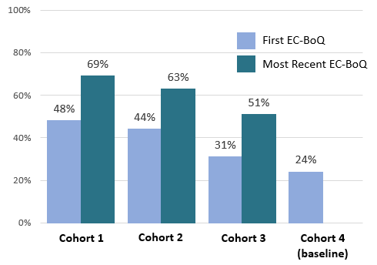
Figure 2. EC-BoQ Results - Program-wide Implementation of EBPs:
Overall Scores by Cohort

Classroom Level
At the classroom level, progress toward implementation of EBPs is assessed using the Teaching Pyramid Observation Tool (TPOT), a research-based measure of Pyramid Model implementation fidelity. The TPOT is a measure of 114 practices across 14 Key Practice Areas. As of FFY 2017, processes have been in place that allow external coaches to report de-identified TPOT results for teachers within their support districts. The TPOT coding system allows for assessing the number of unique districts and teachers represented in the data, and for identifying the SSIP cohort for each teacher. The coding system also allows for tracking individual teachers over time.
TPOT data have been received at the state level for 68 teachers across 15 of the 31 districts (n= 37, 15, and 16 teachers from Cohorts 1 through 3 respectively). On average, results suggest that these teachers are moving toward fidelity (i.e., 80%, as measured by research and Pyramid Model experts) on many of the key practices. It is important to note that based on the n-sizes, these results represent just a portion of participating teachers, and are not representative of all teachers. Overall scores are shown in Figure 3; additional details about the assessment and the results are provided in Section E.
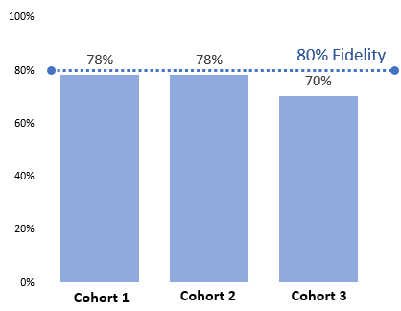
Figure 3. TPOT Results - Classroom Implementation of EBPs:
Overall Scores by Cohort

4. Evaluation Activities, Measures, and Outcomes
During Phase II, MA DESE worked closely with internal partners and key stakeholders to develop an evaluation plan for the SSIP that is well-aligned with its Theory of Action. At the outset of Phase III, the plan was refined with input from key stakeholders. Each year, the plan is reviewed and refined with MA DESE and its partners, in coordination with the evaluator, to allow for updates as the project has evolved.
The external evaluator collaborates with project personnel to implement this plan through refining data collection tools, designing new instruments and data collection processes, managing data collection and supporting stakeholders, and analyzing and summarizing data for formative updates and for the annual report.
The evaluation questions address both implementation and outcomes, and can be summarized as follows:
- To what extent is SSIP implementation carried out as planned?
(i.e., Delivery of high-quality professional development events, provision of external coach supports and guidance, integration with related initiatives to support Pyramid Model, district-level planning and implementation, classroom implementation of EC-PBS/Pyramid strategies.)
- To what extent have intended outcomes been achieved?
(i.e., Increased coach and practitioner knowledge and skills, increased district capacity to implement, fidelity of implementation at the classroom level, increased numbers of classrooms implementing, perceived benefits for children and families, and improved child outcomes as aligned with the SiMR/Indicator 7.)
The data collection activities to support the evaluation are listed below. A full description of each data source, its purpose, and relevance within the overall evaluation plan is provided in Section C. Data on Implementation and Outcomes.
- Extant review of project documentation
- Statewide Training Evaluation Feedback Forms
- Monthly External Coach Logs
- EC-PBS Program-wide Benchmarks of Quality Assessment v2.0
- Mid-year Leadership Team Survey
- Pyramid Model Teacher Survey
- External Coach Survey
- Teaching Pyramid Observation Tool (TPOT)
- Child Outcomes (Indicator 7A data) measured via the Child Outcomes Summary (COS) process
Evaluation Findings
With respect to outcomes for the SSIP districts in the fourth year of Phase III, Key Findings prepared by the external evaluator are shown below. Section E of this report presents the findings and supporting data in detail. Findings are categorized according to the MA SSIP Theory of Action, followed by a brief summary and considerations for going forward.
KEY FINDING: SSIP project leaders, in collaboration with national experts, continued to deliver high-quality statewide training events, leadership team meetings, and supports for external coaches to advance the implementation of the EC-PBS/Pyramid in Massachusetts schools. Most training events were offered to personnel across the larger Pyramid Model community (beyond school district programs), for continued statewide capacity-building.
KEY Finding: Statewide training events to support EC-PBS/Pyramid Model strategies continue to be high-quality, relevant, and useful for participants. Participants across all events reported considerable growth on the learning objectives, including the events new to the project this year (i.e., BIRs and Inclusion).
KEY Finding: External coaches continue to provide individualized support to districts, most frequently through site visits. Support is most often focused on supporting leadership teams, and also extends to building capacity for internal coaching and TPOT administration, data decision making, and Practices training. Over the past year, supports increased in alignment with SSIP priority areas, including internal coaching, data decision making, and behavior systems. External coach support is highly valued by district teams and is greatly contributing to progress toward implementation.
KEY Finding: MA DESE provides several avenues of support to districts for their work with families, and for increasing family engagement. This includes partnering with the state’s Parent Training and Information Center (PTI), and external coaches’ work with districts to support Positive Solutions for Families. District leadership teams are moving toward greater family engagement through train-the-trainer sessions, and by promoting varied family activities and training opportunities.
key Finding: MA DESE continues to integrate the work of the SSIP across interagency initiatives related to early childhood special education, moving toward a community-wide vision. MA DESE collaborates with MA EEC and the State Leadership Team on multiple initiatives that support implementation of the Pyramid Model framework, equity, and inclusion across school district and community contexts. During FFY 2018, several events were devoted to Trauma Informed Care (TIC) through the lens of the Pyramid Model.
key finding: MA DESE, its partners, and external coaches supported district leadership teams in making progress toward improvements intended for FFY 2018. Leadership team members reported progress in the following areas: building internal coach capacity to support teachers, advancing teachers’ fidelity of implementation in the classroom, and using data for program planning. Progress was also reported in understanding culturally responsive practices to address equity, and increasing family engagement, which was the greatest area of progress.
KEY Finding: The MA DESE initiative continues to expand, as the numbers of districts, schools, and classrooms working toward implementation have all increased over the past year. There are currently 50 schools and 290 classrooms that have adopted EC-PBS/Pyramid, representing a 49% increase in classrooms over last year.
KEY Finding: District results over time on the EC-BoQ v2.0 across Cohorts 1, 2, and 3 suggest that participation in the initiative continues to contribute to the development of systems to support program-wide implementation. On average, each cohort reported growth on all Critical Elements over the past year.
KEY FINDING: Cohorts 1, 2, and 3 reported considerable growth on the EC-BoQ in: Staff Buy-in, PD and Staff Support Plans, and Monitoring Implementation and Outcomes. Cohorts 1 and 2, in particular, noted strong growth in Family Engagement, while Cohorts 2 and 3 noted strong growth in Establishing Program-Wide Expectations. All cohorts strengthened their Leadership Team processes. The greatest area for further development continues to be Monitoring Implementation and Outcomes.
KEY Finding: On the whole, participating districts across all cohorts need additional support and guidance to fully establish key components of program-wide implementation, and to move toward maintaining these components beyond external coach support.
KEY Finding: The primary challenge to implementation is common across all cohorts – lack of time and/or availably of classroom-based coaching. This is consistent with prior years, though the challenge has reportedly decreased to some extent. Other top challenges include developing internal coach capacity, and access to substitutes for training.
KEY Finding: To expand implementation, district leadership team members identified several types of assistance that would be helpful. The greatest needs are consistent with last year, and include guidance on how to build internal coach capacity, guidance on building in TPOT processes for teachers, and district-based Pyramid Model practices training for teachers and other staff.
KEY FINDING: Based on TPOT scores representing approximately one-quarter of implementing teachers, personnel are demonstrating implementation fidelity (80%) on many of the key practices, and moving toward fidelity on this measure overall.
KEY FINDING: Comparable to last year’s findings, teacher self-ratings in key practices associated with Pyramid Model implementation from a modest proportion of teachers indicated confidence in their own growth toward fidelity over time. The reported gains were statistically significant.
KEY Finding: Many school and district personnel indicate that as a result of EC-PBS/Pyramid strategies, children are demonstrating improved social emotional competencies. Some personnel have also noticed academic benefits, and decreased rates of suspension. This finding is consistent with last year, and perceived gains have increased over time.
KEY Finding: The statewide six-year trend in the percentage of preschool children with disabilities functioning within age expectations by the time they turned 6 or exited the program has increased modestly over time. The highest result was in FFY 2015. The percentage decreased slightly over the past year, while the proportional difference year-to-year was not found to be significant.
KEY Finding: The statewide six-year trend for the percentage of students with disabilities who substantially increased their rate of growth by the time they turned 6 or exited the program has shown some year-to-year fluctuation. However, results over the past two years have been comparable to FFY 2013 (original baseline) and have remained essentially unchanged from FFY 2017 to 2018.
KEY Finding: In FFY 2018, children with IEPs in Pyramid Model districts, as a subset of the statewide Child Outcomes dataset, performed at or above statewide averages on Child Outcomes across two outcome areas: Social-Emotional Skills (including Social Relationships), and Actions to Meet Needs across both Summary Statements.
Evaluation Summary
Evaluation findings continue to show the full range of planned MA SSIP activities being carried out according to the state’s plan, and in alignment to the MA SSIP Theory of Action. This includes broad statewide infrastructure initiatives across agencies, and within MA ECSE to support preschool children with disabilities. FFY 2018 findings also suggest progress within the Pyramid Model school districts as aligned with the EC-BoQ, as a measure of program-wide implementation. On the whole, school district leadership teams are working with their external coaches to strengthen implementation within-district, and to expand to additional schools and classrooms. Results on classroom-level fidelity measures from a sample of teachers point to progress toward fidelity of implementation in the classroom, for these individuals.
With respect to benefits for children, project stakeholders continue to report that time spent in Pyramid Model classrooms has contributed to greater social emotional development, stronger academic potential, and reduced rates of suspension. Additionally, a sample of children with IEPs across 20 Pyramid Model districts, when viewed in the context of overall statewide results, are showing relative levels of performance beyond the larger statewide group. Overall, evaluation findings point to several ideas for consideration by stakeholders going forward, listed below. These ideas are discussed in more detail in Section E, and incorporated into MA DESE’s plans for next year in Section F.
Implementation Roadmap: Creation of guidelines or roadmaps, within the context of an Implementation Science framework, would be useful to help advance districts closer to “full implementation”.
Planning to Sustain Pyramid Model Implementation: Districts would benefit from additional information about how to plan for sustaining the Pyramid Model, beyond full implementation and the eventual fade-out of support from an external coach.
Monitoring Implementation and Outcomes: Additional guidelines and supports for districts related to using the data sources identified as part of the Pyramid Model implementation and decision-making system (i.e., EC-BoQ, TPOT, BIRs, Child Outcomes) will be important.
Internal Coaching: Continued focus on alternative solutions, such as PBC in a Group, the Internal Coach Community of Practice, and perhaps building internal coach teams, will be important going forward.
Implementation Fidelity: Increased use of the TPOT is warranted to continue to move teachers toward fidelity.
5. Highlights of Changes to Implementation and Improvement Strategies
Over the past year, MA DESE continued to build upon last year’s work by making several improvements to its SSIP implementation strategy. These changes have been based on a process of continuous improvement in which evaluation data and feedback are reviewed and discussed with key stakeholders on an ongoing basis to help strengthen the initiative. A full description of each is presented in Section C.
- Eliminating Implicit Bias, Ensuring Equitable Access: External coach and state team webinar series devoted to implicit bias, and half-day follow up training to continue the conversation.
- Supporting Leadership Teams to Use Data, Planning for Sustainability
  - Behavior Incident Report System (BIRs): Two-day training on the BIRs to provided early care and education programs and classrooms with a system to collect and analyze behavior incidents in their program
  - Assessing Child Outcomes and Using Data: Multi-day training provided by ECTA for external coaches to support districts’ collection and use of child outcomes data (COS process)
  - Planning for Sustaining Pyramid Model Implementation: Early work toward an action planning tool for external coach and leadership team collaboration
- Building Internal Coach Capacity – Activities include statewide trainings in Practice Based Coaching in a Group, an alternative approach to coaching; and internal coach Community of Practice virtual meetings, designed for coaches to collaborate with their peers and national experts as they work toward implementation fidelity.
- Regional Meetings to Support Community Connections: Regional meetings for leadership teams/program staff, facilitated by external coaches (collaboration of district and ECE sites) to develop community collaborations toward implementation. Regional trainings are also intended to mitigate some logistical challenges to attending statewide events, and to allow for small-group discussions that are most valued by training attendees.
- Promoting Use of Evaluation Findings: Distribution of Annual Summary Report and Discussion Guide to assist discussion and use of SSIP findings at all levels. Plans for “data issue” of eNewsletter with FFY 2018 summary of statewide findings.

B. Progress in Implementing the SSIP

1. Description of the State’s SSIP Implementation Progress
- Description of extent to which the State has carried out its planned activities with fidelity; accomplishments and milestones; and adherence to intended timeline, and
- Intended outputs that have been accomplished as a result of the activities
This section is organized around three major areas of SSIP activities:
First, Principal Activities for Implementation of Evidence-Based Practices – These are the primary implementation activities currently underway with 31 school districts. This section includes a summary of accomplishments and adherence to the timeline set out for this year. These activities are indicated in the green and red bars of the MA SSIP Theory of Action (TOA).
Second, EC-PBS/Pyramid Interagency Initiatives Related to the TOA – This section highlights interagency collaboration and activities underway to support and expand the use of EC-PBS/Pyramid Model strategies statewide. These activities are indicated in the red and orange bars of the TOA.
And third, Broader Statewide Infrastructure Related to the TOA – This section includes other state-level inter- and intra-agency initiatives designed to strengthen early childhood special education across the Commonwealth. These SSIP activities are also indicated in the red and orange bars of the TOA.
Principal Activities for Implementation of Evidence-Based Practices
There are presently 31 school districts participating in the initiative, receiving direct support from MA DESE and its partners. This number is up from 26 last year and includes 19 districts that have been engaged for three or more years (Cohorts 1 and 2), six districts that joined early in the 2018-19 school year (Cohort 3), and six that joined early in the 2019-20 school year (Cohort 4). It is worth noting that one of the Cohort 4 districts is working toward a community-wide approach to implementation.
Across the 31 districts there are 50 schools, 290 classrooms, and 270 lead teachers working toward implementation of the EC-PBS/Pyramid Model. This represents a 16% and 49% increase in schools and classrooms, respectively. The principal activities that are being carried out with these districts are described below, with a focus on updates since last year.
With respect to the timeline established for this year, the vast majority of coaching, training, and support activities have been carried out as planned. One exception was the statewide BIR training, which was shifted from October 2019 to January 2020.
Key State and ECSE Initiatives:
- Building state infrastructure through collaboration with national experts to prepare and support district leadership teams for implementing the EBPs of the EC-PBS/Pyramid Model. Activities include the design and provision of high-quality professional development in Pyramid Model practices, fidelity measures and tools, and implementation strategies, including: Leadership Team meetings/trainings; Practice Based Coaching (PBC); Teaching Pyramid Observation Tool (TPOT) Reliability and refresher training; Prevent, Teach, Reinforce, for Young Children (PTR-YC); Prevent, Teach, Reinforce, for Families (PTR-F); and others.
Also, this year, PMC is refining its four-part Leadership webinar series intended for school and district leaders to identify fiscal and operational components needed to build and sustain successful Practice Based Coaching to support the Pyramid Model. External coaches will provide support for leadership teams when using the webinar series.
- Expanded professional development opportunities to further support the Pyramid Model framework and effective EC-PBS strategies, based on stakeholder needs and ECSE priority areas: Trauma Informed Care, inclusion strategies, family engagement strategies and family training (Positive Solutions for Families), connections between early literacy and the Pyramid Model, ensuring equity, using Behavior Incident Report systems, and others.
- Ongoing training and supports for external coaches provided by ECSE and national experts to further build capacity among the coach cadre for supporting districts in areas of need identified by key stakeholders. Activities include monthly external coach professional learning community meetings, and training events related to using data for program improvement including Child Outcomes Summary (COS) Process data, examining implicit bias to address disproportionality, and others.
- Expansion of principal activities and program resources to additional school districts and several community-based teams to support adoption of EC-PBS/Pyramid strategies. Includes leadership team statewide training to launch cohort of new districts, and access to all activities described above.
District/Program Level Activities:
- Formation of district leadership teams among the six Cohort 4 districts that joined the initiative in the 2019-20 school year. Like Cohorts 1 through 3, these leadership teams plan and guide EC-PBS/Pyramid Model implementation in their districts and schools, with ongoing support from external coaches. Implementation plans are developed in accord with district self-assessment using the EC-PBS Program-wide Benchmarks of Quality tool.
- Continued participation of district leadership teams and district/school personnel across the menu of professional development opportunities based on staff PD readiness/needs. All cohorts.
- Individualized external coaching supports for participating districts to help guide implementation plans and progress toward program-wide adoption and sustainability. Includes on-site work with leadership teams, internal (classroom-based) coaches, teaching staff, behavior support specialists, and others.
- Provision of family engagement activities and training opportunities through Positive Solutions for Families (offered by FCSN), supported by external coaches.
School/Classroom Level Activities:
- Training Practitioners: External coaches continue to provide local and regional trainings in EC-PBS/Pyramid Model practices to participating districts. As noted above, PMC hosts statewide trainings across foundational Pyramid Model implementation strategies and tools: TPOT, PTR-YC, PTR-F, and others. Additionally, online training in Pyramid Model practices is available through the PMC website via the ePyramid Modules. Training opportunities have been expanded directly through the SSIP (e.g., leadership training series mentioned above), and well as through events sponsored by MA EEC (e.g., events related to trauma informed care, culturally responsive practices, and connections between early literacy and the Pyramid Model).
- Training District-Based Internal Coaches: Internal (classroom-based) coaches are offered a two-day Practice Based Coaching (PBC) training event to help prepare them for working with teachers to implement EC-PBS/Pyramid strategies with fidelity, as well as PBC in a Group training. The PBC Group model is intended to help alleviate the time constraints and challenges around coaching capacity at the school level. PMC also offers virtual monthly meeting with internal coaches, “Community of Practice” (COP) events, to provide further guidance for PBC among school-based staff. To date, the COP events have been modestly attended, but will continue to be offered and promoted going forward.
- Fidelity Measures for Classroom Implementation – TPOT: Internal coaches, often with the support of external coaches, are scaling up their use of the TPOT to observe teachers implementing EC-PBS/Pyramid strategies in the classroom, and to plan ongoing support for teachers to support fidelity. Internal coach capacity and TPOT use have increased during FFY 2018 and continue to be priority areas of focus for the SSIP to ensure sustainability.
Sequence of Trainings and Supports
Figure 4 below was created by PMC as a guide for project participants, which shows the design and role of leadership teams, and the sequence of trainings and supports for EC-PBS/Pyramid Model implementation at the local level. The data sources identified for programs to monitor their progress, including implementation fidelity and child outcome progress measures, are also indicated. Ultimately, the goal of the SSIP at the state and local levels is geared toward classroom implementation of EC-PBS through Pyramid strategies, with a focus on fidelity to the model.
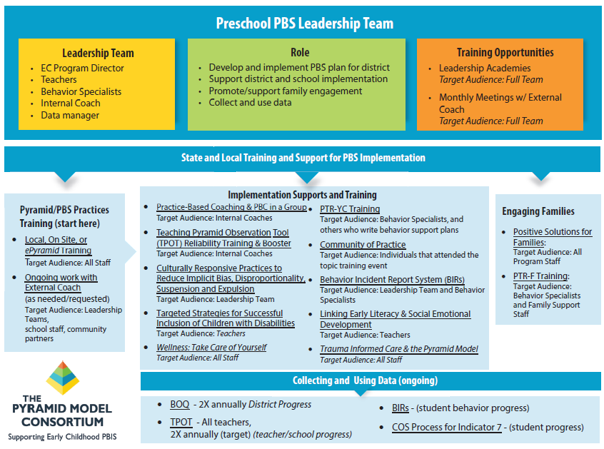
Figure 4. Massachusetts EC-PBS/Pyramid Model Sequence and Supports
EC-PBS/Pyramid Interagency Initiatives Related to the TOA
MA DESE continues to leverage and extend a range of statewide activities to promote and support the EC-PBS/Pyramid Model in Massachusetts. Of particular note, MA DESE and MA EEC are currently collaborating across several new and continuing initiatives to support the Pyramid Model framework and child development more generally across both district- and community-based programs. Additionally, the PBS/Pyramid Model Statewide Leadership Team (SLT), which had been meeting monthly through spring 2018, went through a process of review and restructuring in an effort to align the multiple initiatives that are underway. The SLT was re-launched in spring 2019, with the addition of new members and agency representation.
MA DESE also continues to build infrastructure through an array of department initiatives related to positive social emotional outcomes for all students, with and without disabilities. These initiatives, coupled with the EC-PBS/Pyramid Model, provide various entry points for local school districts and community-based early childhood education programs to promote improved outcomes for children with disabilities. The current status of each initiative is described in this section.
Figure 5 shows several key interagency initiatives devoted to improving early childhood special education through the EC-PBS/Pyramid inclusive of the MA DESE work with 31 districts. As shown in the figure, between the MA DESE and MA EEC EC-PBS/Pyramid initiatives, there are 95 “implementation sites”, as well as a variety of other activities contributing to a community-wide vision of the Pyramid Model framework and related content being offered statewide.
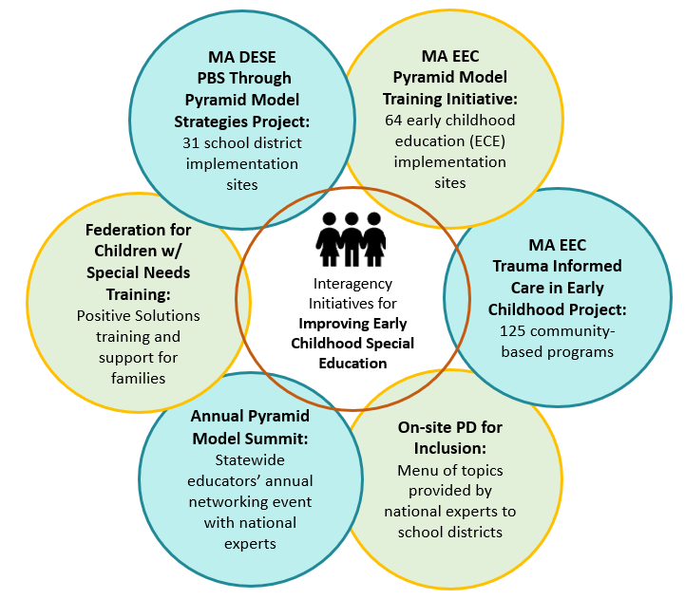
Figure 5. Interagency Initiatives to Support EC-PBS/Pyramid Model

Massachusetts PBS/Pyramid Model State Leadership Team (SLT)
After a recalibration process during FFY 2017, the Massachusetts Pyramid Model SLT was relaunched in FFY 2018, and new agencies and team members were added to expand stakeholder representation. The team is currently represented by MA DESE, MA EEC, MA Part C Early Intervention staff, the Head Start TA Network, Early Childhood Infant Health, an external coach for EC-PBS/Pyramid, and leadership team members from both an MA DESE public school district, and an early childhood education program implementing the EC-PBS/Pyramid Model. Among this year’s activities, the group completed the State Leadership Team Benchmarks of Quality tool to assess progress toward statewide implementation. The SLT also reviewed statewide evaluation findings derived from the MA DESE and MA EEC evaluation projects over the past year, with a focus on the commonalities and lessons learned across projects. Work continues on developing and expanding the statewide interagency initiatives devoted to EC-PBS Pyramid Model.
MA EEC EC-PBS/Pyramid Model Training Initiative
MA EEC is working with the Pyramid Model Consortium to continue to provide EC-PBS/Pyramid Model training and external coach supports to 41 early education and care (ECE) programs across Massachusetts, and to support scale-up of Pyramid Model implementation. The 41 participating ECE programs include two Demonstration sites established by the SLT in 2017, 18 ECE programs that began the initiative in spring 2018, and 21 ECE programs that launched in December 2018. In FFY 2018, 21 additional ECE programs joined the initiative sponsored by MA EEC StrongStart. The MA EEC initiative is similar to the SSIP in its principal activities, which include the provision of statewide trainings, regional Pyramid Model practices trainings, and individualized external coach supports for each program. As mentioned above, this project further supports SSIP in that SSIP district and school personnel have access to trainings where space permits, and external coaches common to both projects are helping to help build connections for the EC-PBS/Pyramid Model between community programs and public schools.
MA EC-PBS/Pyramid Model Summit
The SLT organizes an annual EC-PBS/Pyramid Model Summit to foster education and networking among practitioners across the state. Since the last report, the April 2019 Summit was conducted, devoted to Trauma Informed Care and the Pyramid Model, to continue building upon themes presented in the regional Pyramid Model Learning Communities during December 2018 and January 2019. There were 163 attendees representing all five regions of the state. The 8th annual summit was scheduled for April 2020, with themes connected to statewide goals for Pyramid Model this year: Addressing Equity and Intergenerational Trauma through Pyramid Model. Among the events planned for the day, external coaches and leadership team members were planning a formal poster session to share their successes in Pyramid Model implementation. However, due to caution around social gatherings related to COVID-19, the event was recently cancelled.
MA EEC Trauma Informed Care Initiative
MA EEC and the Pyramid Model Consortium provided a unique opportunity for 125 programs to learn more about Trauma Informed Care. Due to the complexity of how trauma impacts children, it is important for early educators to integrate a trauma-informed approach to their work with children and families. Five regional trainings were provided for programs to receive resources and information that can be used to support the early care and education workforce to:
- Recognize the signs and symptoms of trauma
- Understand how trauma impacts children’s learning and development
- Consider what you can do to support children and families when trauma occurs
Positive Solutions for Families
Positive Solutions for Families is an evidence-based training series that has been developed to provide families and caregivers information and strategies to promote children’s social and emotional skills using positive approaches. Positive Solutions can be used independent of any district adopted program or as a companion to the Positive Behavioral Support: Pyramid Model.
MA DESE works with external coaches and the Federation for Children with Special Needs (FCSN) to provide Positive Solutions: Train the Trainer opportunities for professionals interested in implementing Positive Solutions for Families in their schools and districts. As one example of FCSN’s work, a program working with children who are deaf and hard of hearing completed the Positive Solutions Train the Trainer curriculum with the FCSN this past year. As part of this training, program educators discussed the need for modifications necessary to meet the specific needs of the children and their families. The program presented the Positive Solutions modules and worked with families to assist them in implementing strategies. Other programs participating in the Pyramid Model project are engaging families in a variety of ways. Several district leadership teams have included family members on their district leadership team. Yet another program has invited parents to an “evening of learning” where families were able to review information from the backpack series related to Positive Solutions and customize the strategies to meet the needs of their child and family.
On-site Professional Development for Inclusion Strategies
Training and technical assistance were offered by the Pyramid Model Consortium for all DESE districts to support high quality inclusion practices. Topics included:
- Why is Inclusion Important?
- Creating a Foundation of a High-Quality Early Childhood Setting
- Classroom Environment, Classroom Schedule, Adult Roles and Responsibilities, Building Relationships & Promoting Child Participation
- General Classroom Modifications that Support Inclusion
- Routines within Routines within Routines (Routines3), Using Naturalistic and Embedded Instruction, Visual Supports
- Building Individualized Supports into Classroom Activities and Routines
- Using Reinforcement, Individual Schedules, Alternative and Augmentative Communication
- The Power of Peers: Using Peer-Mediated Intervention
- What are the key social skills to teach?, Teaching peer-mediated intervention in the classroom, Using embedded and naturalistic instruction to support social learning
- Data-Based Decision-Making
- Writing functional IEP Objectives for the inclusive classroom, Linking instruction and data collection in the classroom, Prompting Hierarchies, Collecting data and making data-based decisions
NCPMI Program Coach Technical Assistance Project
In FFY 2018, three Massachusetts external coaches were selected to participate in a national-level technical assistance opportunity provided by the National Center for Pyramid Model Interventions (NCPMI). As part of this experience, the coaches collaborated with national experts and program coaches representing other states toward Pyramid Model implementation. Among other activities, coaches identified their own coaching strengths and goals for their state-level work. Coaches were introduced to the NCPMI program coaching log and data analysis tool for assessing their own progress working with programs and districts.
Figure 6 below provides a summary of these activities as they align with the TOA elements and progress across each element. Note, this graphic is meant only as a “snapshot” of project activities and should be viewed in the larger context of the details and findings presented throughout this report.

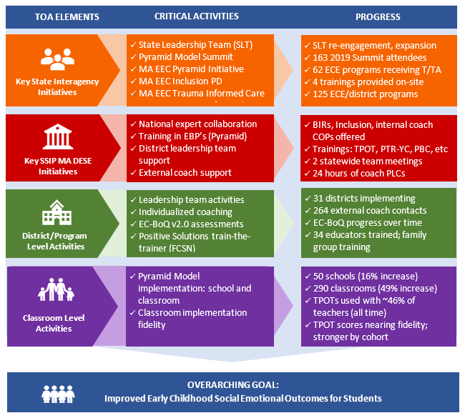
Figure 6. Statewide Progress Aligned with EC-PBS/Pyramid Training and Implementation
(February 2019 – February 2020)
Broader Statewide Infrastructure Related to the TOA
This section includes other state-level inter- and intra-agency initiatives designed to strengthen early childhood special education across the Commonwealth.
Preschool Development Grant Birth-Five (PDG B-5) Planning Grant
The PDG B-5 planning grant is a joint project between the Massachusetts Executive Office of Education (MA EOE) – which includes MA EEC, MA DESE, and the Children’s Trust (MA CT) – and the Massachusetts Executive Office of Health and Human Services (MA EOHHS) which includes the Department of Public Health (MA DPH). The grant supports collaboration and coordination among agencies to create a unified data system for sharing information about children birth to age five (B-5) across all programs, and to deliver information and resources to families and educators more effectively across the Commonwealth. By identifying and addressing gaps in services and efficiencies in coordination, Massachusetts will use this opportunity to ensure that the B-5 mixed delivery system prepares young children for success in the K-12 system while supporting parents in their role as their child’s first teacher.
Key activities include:
- Conducting a comprehensive needs assessment
- Producing an action-oriented strategic plan
- Improving parent choice and knowledge through an online parent portal, and through more effective implementation of screening using the Ages and Stages Questionnaire (ASQ)
- Expanding and coordinating training for all staff working with children by creating a Massachusetts’ Early Childhood Multi-Tiered System of Support that is currently in development
- Developing an integrated data system that will enable us to analyze and track child services and outcomes longitudinally, from home visiting to early intervention to early education, through K-12 education, and into post-secondary.
Building Inclusive Communities in Early Childhood (BIC) Initiative
MA DESE and MA EEC continue to engage the mixed delivery system to develop action plans and build community work around inclusion through working with national experts to build local capacity for inclusive practices. This year there are a total of 10 school district teams. Six teams are from the first cohort and there are four school districts teams in the second cohort.
A kick-off for the BIC conference was held on October 21, 2019. The participants represented the mixed delivery system (public schools, early care and education programs, early intervention, head start and Preschool Expansion Grantees). There was also representation from the Departments of Early Education and Care and Elementary and Secondary Education. The keynote speakers presented on the following topic: “Inclusive Early Childhood Education: Equity and Excellence for All”. The conference was well attended and out of the 99 individuals who registered 91 participated in the BIC conference.
During the year the cohorts will engage with the same national presenters from last year in PLCs and they will be required to develop action plans. A second Building Inclusive Community (BIC) conference will be held on March 27, 2020. Drs. Richard Villa and Jacqueline Thousand will lead the conference and the teams will present on their work.
The PLCs hosted by the two national presenters will focus on goals and activities identified by the teams on the following variables:
- promoting a vision of early childhood inclusive education
- professional development to build capacity of educators, community partners, and families
- incentives to support people during the change process
- resource allocation and/or reallocation
- action planning – Where do they want to be a year from today? What are the specific activities and people responsible for guiding your community to get there?
In addition to these initiatives, there are numerous Early Childhood Special Education initiatives underway which are ongoing this year:
Early Childhood Leadership Institute
The Massachusetts Early Childhood Leadership Institute (MA ECLI) is a yearlong program for special educator and early childhood leaders at the school and district level across the state. The Institute focuses on building leadership capacity in areas such as implicit bias and racism, data analysis and program improvement, literacy, social emotional learning and leadership, and others.
Early Childhood Transition Forums
DESE worked with EEC and DPH to develop and hold EC Transition Forums across the state. The Forums were part of DESE’s Early Learning Networking meetings. The DPH’s Regional Consultation Programs (RCP) staff provided the opportunity for Early Intervention (EI) programs, Community Early Education programs and Education programs to hear about regulations and best practices in early childhood transitions from EI to Part B Special Education.
In FFY 2019, the RCPs will host EC Transition Forums in each of the six regions across the state. At these forums, EI programs, school districts and community early care and education programs will have time to work together to review current policies and procedures, best practices in early childhood transitions and to make changes to support effective strategies by using the Technical Assistance Advisory, developed in partnership with DPH, for seamless transition practices for children and families.
Early Literacy and ECSE
Since FFY 2017, MA EEC has collaborated with MA DESE’s early literacy and ECSE teams to connect early literacy across the agencies and in public school districts and child care settings specifically for ECSE programs to connect social/emotional development with early literacy skills. During FFY 2018, the Pyramid Model Consortium offered a full-day training session to Pyramid Model implementation sites across both MA DESE and MA EEC devoted to connecting social emotional development with early literacy. The training session included ideas for supporting infants, toddlers, and preschoolers in these practices.
Early Learning Network Regional Meetings
In collaboration with staff from the Family and Community Engagement team at MA EEC, MA DESE co-hosted bi-annual, regional early learning network meetings for professional development and networking on early learning topics.
2019 Special Education Professional Development Series
- Early Identification and Supports for Young Children with Autism
- Partnering with Families of Young Children with Disabilities Transitioning into Public PreK or K
- Promoting Positive, Healthy Early Childhood Education with Deaf and Hard of Hearing Children: Parent Engagement and Support, Best Practices, and Effective Approaches
Early Childhood Special Education Discretionary Federal Program Improvement (298) Grant
The Early Childhood Special Education Discretionary Federal Program Improvement Grant is a discretionary grant provided by MA DESE intended to further early childhood special education (ECSE) practices in SSIP districts. All SSIP districts implementing the Pyramid Model are eligible to apply for grant money. The funding from this grant allows these districts to improve educator effectiveness and family engagement, while also working to strengthen their curriculum, instruction, and assessment. Districts who receive this grant money must focus the funding in one of two priority areas:
- instruction to increase children's educational outcomes, and
- systems to engage effectively with families.
For FY 2019, 25 SSIP districts applied for and each received $7000 to implement a range of programs and systems to support family engagement, the implementation of Pyramid Model Strategies (PBS/Pyramid) and evidence-based practices for teaching students with disabilities in early childhood classrooms. To support the work of the SSIP districts, MA DESE has:
- Increased 298 grant funding from $3,000 per district in FY 2018 to $7,000 per district in FY 2019
- Collaborated with district leadership teams in the planning of how to use funding
- Based on district leadership team feedback, increased assistance in developing plans for the use of funds that best align with the districts’ implementation of the Pyramid Model
Early Reading
In FY 2019, MA DESE kicked off the CURATE (Curriculum Ratings by Teachers) project. MA DESE is convening panels of teachers to review the available evidence on curriculum materials and make user-friendly reports available to educators to support them in making well-informed decisions about curriculum. In FY 2019, panels are reviewing and will be releasing reports on preK-2 Literacy curricula. In FY 2020, after those reports are available, we will have the opportunity to support strong curriculum decision-making in districts by publicizing those reports, conducting trainings, supporting districts with curriculum review and selection processes, and convening Networks of educators who use or are adopting the positively reviewed curricula.
Family Engagement Consortium
With support from Council of Chief State School Officers (CCSSO), members from MA DESE, MA EEC, and MA DPH began meeting in September 2017 to plan for the development of the prenatal through young adulthood family engagement framework. The Massachusetts Family Engagement Coalition included a diverse group of local, regional, and state agency representatives; over 500 members including families and youth. The goals of the Coalition include the evaluation of the awareness of family engagement and the development of a roadmap for health, human services, and education programs and personnel to effectively engage children, youth, and families.
Promoting Racial Equity and Dismantling Racism
MA DESE is leading efforts to eliminate explicit and implicit bias and disproportionality in special education identification, placement, and removals for children of color. This multifaceted initiative includes work for MA DESE personnel as well as with MA DESE districts and schools. MA DESE has contracted with PMC to bring the Pyramid Equity Project (PEP) to Massachusetts. The PEP will be tailored to the Massachusetts landscape to increase the use of data tools, materials, and procedures to explicitly address implicit bias, implement culturally responsive practices, and use data systems to understand potential discipline equity issues through the implementation of the Pyramid Model for Promoting the Social Emotional Competence of Infants and Young Children. A three-pronged approach will be supported with SSIP districts in Massachusetts who are implementing EC-PBS thorough Pyramid Model Practices: 1) enhancing the professional development offerings to the workforce in the SSIP districts, 2) working with the external coaches to increase their skills in utilizing the Pyramid Model Equity Coaching Guide, and 3) supporting the collection and use of data to help SSIP districts and program-wide leadership teams address implicit bias and disproportionality in their schools.
Social and Emotional Learning
With funding from MA EEC’s Race to the Top/Early Learning Challenge Grant, staff from MA DESE and MA EEC worked with a selected vendor to develop Preschool and Kindergarten Social and Emotional Learning standards as well as Approaches to Play and Learning Standards.

2. Stakeholder Involvement in SSIP Implementation
This section of the report addresses both:
(a) How stakeholders have been informed of the ongoing implementation of the SSIP, and
(b) How stakeholders have been involved in decision-making regarding ongoing implementation
The MA SSIP provides multiple opportunities for key stakeholders at the state, district, program/classroom, and community levels to learn about the SSIP including the project philosophy and goals, the provision of project training events and embedded supports, and the availability of resources to support and extend implementation. Stakeholders also participate in decision-making about the direction of the project by rating the quality and relevance of professional development events, providing updates on progress, articulating needs at the local level for moving forward with implementation, and by making suggestions about needed changes or improvements. As described below, the stakeholder groups include the State Leadership Team, Special Education Advisory Panel, external coaches, district leadership teams, district and school staff, and students and families.
Key aspects of the feedback structures include sharing information and gathering feedback via state-level leadership and steering committee meetings with stakeholders, and by providing mechanisms for frequent feedback both formally and informally from participants within the SSIP districts and from the external coaches who support them. New feedback and communication tools established in FFY 2017 remained in place during FFY 2018, namely, the External Coach Survey, the Teacher Survey, and a monthly eNewsletter.
State PBS/Pyramid Model Leadership Team
Massachusetts is one of 32 states that has a statewide, cross-sector Pyramid Model Leadership Team. MA DESE plays an active role on the on the Leadership Team to both support the broader Implementation of Pyramid Model across the state, as well as to solicit feedback that helps to refine implementation efforts and to identify opportunities for collaboration within MA DESE sites. As describe above, the team currently includes representatives across various MA agencies, and representation from implementation sites.
Special Education Advisory Panel (The Panel) and Special Education Steering Committee
The Panel (formerly the Special Education Advisory Council), established under state law, is comprised of members appointed by the Commissioner on behalf of the MA Board of Education; over half of the voting members are individuals with a disability or a parent of a child with a disability. The Panel also has representation from the state’s Parent Training and Information (PTI) Center through the Federation for Children with Special Needs. The Special Education Steering Committee is composed of members of the Panel plus representatives of advocacy organizations, other state agencies, and statewide partners in special education, consistent with the requirements for advisory bodies established in the Individuals with Disabilities Education Act (IDEA). These groups continue to be valued stakeholders, as MA DESE seeks out opportunities to discuss and share information about the department’s vision and direction for strengthening early childhood initiatives. During FFY 2017, MA DESE collaborated with the Panel on resetting targets for Child Outcomes reporting for Indicator 7. These targets were reviewed with the Panel in December 2019.
External Coach Feedback
External coaches have a key role in supporting district and school personnel in moving toward implementation of EC-PBS through Pyramid strategies. Since these individuals make direct contact with district teams on a regular basis, they are in the best position to determine some of the ways the initiative might be improved at the local level, and to understand challenges to implementation. MA DESE maintains ongoing communication primarily through monthly PLCs, as well as by email and phone. These monthly meetings allow all MA coaches to provide updates of district progress, discuss challenges, and request additional information or supports from state leaders. Coaches also complete a Monthly External Coach Log to capture information about each instance of technical assistance they provide to districts. State leaders receive monthly updates about each district compiled from the logs, and links to real-time summary reports are available for reviewing district- and state-level data in real time.
In both FFYs 2017 and 2018, an External Coach Survey was distributed to coaches prior to the new school year to gather feedback about the project’s leadership and communication structures, to identify coaches’ professional development needs for the coming year, and to solicit input on how to address some of the common challenges toward implementation identified by the district teams. During a fall 2019 kick-off meeting, MA DESE and MA EEC project leaders, PMC, external coaches, and the external evaluator discussed the survey results, as well as evaluation findings from FFY 2017, and made decisions about the focus and direction of the project in the 2019 school year.
District Leadership Team Feedback
MA DESE visits a sample of EC-PBS/Pyramid school districts each year to observe activities, and to learn from administrators and staff about the progress being made. Leadership teams also have an opportunity each year to provide feedback through the Mid-Year Leadership Team Survey. The survey allows teams team members to describe their progress toward implementation of the EC-PBS/Pyramid Model, the facilitating factors, ongoing challenges, and requests for ongoing support from both external coaches and MA DESE. Additional questions about project sustainability were included in this year’s survey for Cohorts 1 - 3. The survey also addresses stakeholder perceptions of the project’s impact on teacher/staff knowledge and skills, and benefits for children and families. Last year’s survey responses with all open-ended comments were shared with project leaders for discussion, and reflected in annual reports including the Discussion Guide. This year’s survey was conducted in January – February 2020, and results will be shared with project leaders in the coming months to continue to identify next steps for the initiative. Selected results from the survey are presented in Section E.
Teacher Feedback
Lead teachers from Cohorts 1 - 3 who are engaged in implementation were asked to complete the most recent Pyramid Model Teacher Survey in January 2020. The survey addresses progress toward implementation, challenges and needs for expansion, and overall feedback about the initiative. The survey also includes a self-assessment of key practices aligned with the TPOT (retrospective pre/post), and perceptions of project benefits. Last year’s survey responses with all open-ended comments were shared with project leaders for discussion, and reflected in annual reports including the Discussion Guide. This year’s survey was conducted in January – February 2020, and results will be shared with project leaders in the coming months to continue to identify next steps for the initiative. Selected results from the survey are presented in Section E.
Training Participant Feedback
MA DESE and the PMC continue to collect evaluation feedback from participants at each training and at statewide meetings for leadership teams and external coaches. The feedback forms allow MA DESE, the PMC, and external coaches to gauge the general quality of the sessions, usefulness of the information, and ideas for strengthening the events going forward. A retrospective pre/post item related to the training-specific objectives is used to gauge the extent to which participants are making gains on the learning objectives. Results, including district participation at each event, are summarized and shared with training facilitators, project leaders, external coaches, and MA EEC personnel. Participants’ suggestions are reviewed and considered for future sessions.
Other Communication Structures
MA DESE produces a monthly eNewsletter which is distributed via email to the EC-PBS/Pyramid community. These newsletters provide project updates, highlight EC-PBS/Pyramid district implementation activities, provide information about external coaches’ expertise and work with districts, and provide information about upcoming Pyramid Model training opportunities.

C. Data on Implementation and Outcomes

1. How the State Monitored and Measured Outputs to Assess Effectiveness
The evaluation plan developed during Phase II has largely been carried out as planned during Phase III, with several refinements each year. Since FFY 2017, two evaluation questions have been added, along with intended outcomes and data sources:
- To what extent is MA DESE making the intended improvements to the workforce development structure as identified through the evaluation and outlined in its annual reports? (Question EQ1c—updated each year to reflect the annual goals)
- To what extent do district and school personnel perceive benefits of implementing EC-PBS/Pyramid strategies for children? (Question EQ4a)
The external evaluator continues to collaborate with project personnel and stakeholders to carry out this plan by refining data collection tools, designing new instruments and data reporting processes, managing data collection and supporting stakeholders in that effort, and analyzing and summarizing data for formative updates and annual reports.
This past year, several instruments were modified to best meet the project needs, and to ensure economy of data reporting and formative review by key stakeholders. For example:
- The Mid-Year Leadership Team Survey was revised to include additional questions about sustaining implementation beyond external coach supports, and the survey was also shortened.
- The External Coach Contact Record was translated into a Monthly Coach Log, allowing coaches to report their work with districts on a monthly basis rather than after each contact. Additionally,
  - the log was shortened, and now mirrors the MA EEC coach log for continuity of data collection across these Pyramid Model efforts,
  - new questions about progress toward implementation were added, based on stakeholder feedback at the summer 2019 External Coach Retreat – summary results are shared periodically to assess effectiveness of the group as a whole, and
  - a brief monthly summary report is produced from the log updates for each district, to assist state-level leaders in a quick view into the status of each district.
Perhaps most importantly, DESE and its stakeholders continued to work on expanding Child Outcomes (via the COS) data collection and use. This past year, the amount of data reported statewide, and by SSIP districts specifically, increased substantially. Linkages of the data to demographic data will also allow for assessing the results by subgroup, to understand whether outcomes differ for children by gender, race/ethnicity, primary disability category, and other factors. As described in this report, external coaches have been engaged in a multi-part training series to help build statewide capacity for collecting high-quality data (refining the COS process), reporting data to the state, and using the data locally to gauge progress toward the outcomes for children with IEPs.
(a) How the evaluation measures align with the Theory of Action
The SSIP Theory of Action articulates the following activities at the state level with respect to infrastructure for principal activities, as well as ongoing interagency collaboration to support the SSIP. The next level of activities engages districts/programs, followed by classrooms and students. Across these four levels, the plan incorporates key questions to help focus the evaluation, as well as appropriate short, intermediate, and long term outcomes to assess progress and impact of the SSIP. Data collection instruments have been selected or developed, and processes for collecting data at regular intervals have been put into place. These tools and processes are reviewed and updated annually. Table 2 shows the SSIP evaluation plan, including key questions at each level of the Theory of Action, as well as the intended outcomes and data sources.
Table 2. MA SSIP Evaluation Plan
Evaluation Questions | Intended Outcomes | Data Sources
State Interagency Initiatives
State Level Infrastructure
EQ1a  In what ways is MA DESE using the SSIP, including statewide implementation of EC-PBS through Pyramid strategies, to build state-level capacity to support improved social emotional outcomes for young children with disabilities? | S1. Short Term and Intermediate  In order to build state capacity, MA DESE will…  - provide statewide and regional training on EC-PBS through Pyramid strategies to district administrators and educators, including Leadership Team Academies, Practices Trainings, and Coaches’ Trainings. Participants will become familiar with the tenets of PBS and PBS through Pyramid strategies and classroom and program-wide implementation.  - leverage the cadre of PBS external coaches to support districts and communities  - collaborate with community and social services agencies to provide additional training and support to families. | - Extant project documents (e.g., state and district meeting notes, inter-agency meeting minutes, external coach meeting notes)  - Statewide training and meeting data (i.e., internal project records and sign-in sheets)  - Statewide training and meeting evaluation feedback forms  - Monthly Coach Log
EQ1b  To what extent is implementation of EC-PBS through Pyramid strategies in MA integrated with other early childhood and/or MA DESE initiatives at the community/local and state levels? | S2. Intermediate  MA DESE will…  - engage in ongoing collaboration with colleagues in Part C and K-12 PBIS initiatives to build community liaison and data sharing to promote effective transitions and improve social emotional outcomes.  - engage in ongoing collaboration to continue to identify strategies and actions to promote local level integration of PBS. | - Extant project documents (e.g., state and district meeting notes, inter-agency meeting minutes, external coach meeting notes, inter-agency planning and evaluation documents)
EQ1c  To what extent is MA DESE making the intended improvements to the workforce development structure as identified through the evaluation and outlined in its annual reports? | S3. Short Term and Intermediate  (In 2019-20) MA DESE will…  - Build internal coach capacity  - Support teams in data use toward sustainability  - Provide training and build skills related to implicit bias, equity | - Statewide training data/documentation  - Extant project documents  - Mid-Year Leadership Team Survey
Program/District Infrastructure
EQ2a  Is the state-level plan resulting in the number of districts, schools, and classrooms participating in EC-PBS through Pyramid strategies growing over time? | S4. Long Term  MA DESE will provide adequate training and support in EC-PBS/Pyramid Model strategies so that participating districts build capacity to expand the number of schools and classrooms participating. The number of participating districts will also expand each year to the extent that the state has resources to sustain support for additional sites. | - EC-PBS/Pyramid Implementation Profile (replaced the PBS/Pyramid Model Implementation Database)  - Mid-year Leadership Team Survey
Program/District Infrastructure
EQ2b  To what extent are districts developing systems to support and sustain program-wide EC-PBS through Pyramid strategies? (Assess facilitating factors, challenges, and ongoing needs.) | D2. Intermediate  The participating districts have established a system-wide approach to implementing and sustaining EC-PBS/Pyramid strategies as aligned with the Early Childhood Program-Wide PBS Benchmarks of Quality (i.e., established leadership teams, gained staff buy-in, designed and implemented staff support plans, established family involvement, monitor progress, etc.). | - Monthly Coach Log  - EC-BoQ v2.0 assessments  - Mid-year Leadership Team Survey
Classroom Level
EQ3a  To what extent are teachers implementing EC-PBS through Pyramid strategies in their classrooms? | D3. Intermediate  Teachers will be able to implement EC-PBS through Pyramid strategies with fidelity to improve the social/emotional development of young children with disabilities. | - Mid-year Leadership Team Survey  - Pyramid Model Teacher Survey  - De-identified teacher TPOT results
EQ3b  Does the fidelity of classroom implementation improve over time? | D4. Long Term  Teachers will demonstrate improved implementation fidelity over time.
Student Level
EQ4a  To what extent do district and school personnel perceive benefits of implementing EC-PBS/Pyramid strategies for children? | C1. Long Term  Children of teachers implementing EC-PBS/Pyramid strategies will demonstrate improved social/emotional competencies and other academic benefits. | - Mid-year Leadership Team Survey  - Pyramid Model Teacher Survey
EQ4b  Is the number of children in MA, aged 3-5, with disabilities, exiting from preschool with age-expected social emotional functioning increasing? | C2. Long Term  Children with disabilities, aged 3-5, will exit preschool with social/emotional competencies that will allow them to access and participate in the general curriculum and in all aspects of the school. | - Indicator 7 data - Child Outcomes Summary (COS): Summary Statement 2  Collected by SSIP districts annually
EQ4c  Is the number of children in MA, aged 3-5, with disabilities, exiting from preschool with greater than expected growth in their social emotional functioning increasing? |  | - Indicator 7 data - Child Outcomes Summary (COS): Summary Statement 1  Collected by SSIP districts annually

(b) Data sources for each key measure
Data are collected by MA DESE, external coaches, and the external evaluator according to this plan. As in prior years, external coaches were provided with Data Collection Guidelines that specify each data collection activity for which they are responsible, links to online reporting tools, and due dates. Across the data sources, results are made available by the evaluator for review by project leaders and stakeholders. The data sources, purpose of each, and response rates where applicable, are summarized below.
Extant Project Documents – Project documentation (i.e., interagency meeting minutes, external coach PLC meeting notes, training participation data, etc.) is reviewed to determine progress toward project goals.
Training Feedback Forms – Feedback forms are designed to assess the quality and usefulness of the training sessions, progress on learning objectives, and to solicit suggestions for improvements going forward. The forms include a retrospective pre/post item associated with the learning objectives for each event to gauge participant learning.
Monthly External Coach Log – External coaches complete this online form each month for each school district they support. The log tracks the mode of contact (e.g., site visit, phone call, email, etc.), the type of support provided, duration, and district progress toward EC-PBS/Pyramid Model implementation across five key areas. These areas include effective Leadership Team, internal coach fulfilling role, using Tier 3 strategies effectively, utilizing data at all levels, and family engagement. From March 2019 to February 2020, a total of 264 external coach contacts across 30 districts were recorded in the database. Sixty-four of these contacts were with the new group of six Cohort 4 districts during the 2019-20 school year.
EC-PBS Benchmarks of Quality (EC-BoQ v2.0) – The EC-BoQ v2.0 is used by district leadership teams, often in coordination with external coaches, to assess program-wide EC-PBS/Pyramid Model Implementation across seven critical elements. Teams are guided to use the measure at least twice each school year, but the timing of the EC-BoQ is ultimately up to district staff. The new version introduced to the project in FFY 2017 incorporates benchmarks associated with culturally responsive practices to ensure equity. For this report, data were available for 28 of 31 districts, for a 90% overall representation. “Matched” results from at least two points in time were available for 18 of the 25 Cohort 1 - 3 districts (72% representation). Baseline results were also available for all 6 Cohort 4 districts (100%), who began the project in fall 2019.
Mid-year Leadership Team Survey – The annual survey captures district teams’ assessment of progress toward implementation, the contribution of external coaches, challenges, needs for support from MA DESE and external coaches moving forward, and progress toward sustainability. The survey also addresses perceived benefits of the initiative for staff, and for children and families. The online survey link was distributed to approximately 147 team members across 31 districts in January 2020. Responses were received from 96 team members across 28 districts for response rates of 65% (team members) and 90% (districts).
Pyramid Model Teacher Survey – The survey addresses progress toward implementation at the classroom level, challenges and needs for moving forward, and overall feedback about the initiative. The survey also includes a self-assessment of key practices aligned with the TPOT, and perceived benefits of EC-PBS/Pyramid for children and families. The online survey link was shared with Cohort 1 - 3 leadership teams for distribution to all lead teachers participating. The estimated number of lead teachers is 247 across the 25 Cohort 1 - 3 districts. Responses were received from 44 teachers across 13 districts for response rates of 18% (teachers) and 52% (districts).
EC-PBS/Pyramid Implementation Profile (PIP) – The online form captures the total numbers of schools and classrooms with preschool programs in each district, as well as the numbers of schools, classrooms, and teachers implementing the EC-PBS/Pyramid Model. This year’s form also captured the number of teachers who had received TPOTs as of February 2020, and the number of teachers to ever have had a TPOT – these items helped determine the extent to which the fidelity measure is being used.
Teaching Pyramid Observation Tool (TPOT) – The TPOT is a measure of implementation fidelity in the classroom, and consists of a two-hour classroom observation and subsequent interview with a teacher to assess implementation of EC-PBS/Pyramid Model practices. To date, baseline data have been received for 68 teachers across 15 districts. The data represent teachers from Cohorts 1 through 3. These numbers represent 60% of the possible 25 Cohort 1 - 3 districts, and 28% of Cohort 1 - 3 lead teachers (based on 247 teachers implementing as indicated in the Pyramid Implementation Profile). A second TPOT score was received for eight teachers, with representation from Cohorts 1 - 3.
Child Outcomes Summary (COS) Process data (Indicator 7) – Child Outcomes Summary (COS) process data are reported annually for monitoring progress toward child outcomes statewide, and among SSIP districts. For the statewide analysis, usable records (i.e., records that contained complete entry and exit data, after at least 6 months of services) were received for 1,045 children across 133 districts. For the 24 SSIP districts participating at the time data were reported for FFY 2018, usable records were received for 384 children across 20 districts. This represents a 123% increase in the number of child records representing SSIP districts.
(c) Description of baseline data for key measures
District EC-PBS Benchmarks of Quality v2.0
With the shift to the updated EC-PBS BoQ version 2.0 in FFY 2017, new baselines were established for this measure for Cohorts 1 and 2. For Cohorts 3 and 4, “true” baselines have also been established (as both cohorts began using this version in their first year). The BoQ is comprised of 7 Critical Elements across 41 indicators. In terms of baseline results, districts review all indicators using a three-point scale where 0 = not in place, 1 = partially in place, and 2 = in place. The overall means for Cohorts 1, 2, 3, and 4 were 1.08, .89, .63, and .48, respectively. Comparison data for Cohorts 1 - 3, for districts with data from at least two points in time, are provided in Section E; all cohorts reported growth over time.
Teaching Pyramid Observation Tool (TPOT)
TPOT results from at least one point in time have been collected from 68 teachers across 15 districts (Cohorts 1 - 3). The first TPOT score submitted for each teacher is considered the baseline, and will serve as the basis for comparison going forward. The aggregate baseline score was 75%. Scores ranged from 31% to 96%.
Indicator 7: Child Outcomes
Data for Indicator 7 across SSIP districts are presented in Section E, as are statewide results over the past six years. The baseline for this measure was reset based on FFY 2017 results, with approval from OSEP. As such, the FFY 2017 results of 85.61% and 47.00% for Summary Statements 1 and 2 respectively became the new baseline.
(d) Data Collection Procedures and Associated Timelines
The data collection procedures described above are carried out per the schedule shown in Table 3.
Table 3. Data Collection Plan
Data Sources | Process | Timeline
Extant Project Documents: MA DESE and SLT meeting notes | Meeting minutes prepared following each meeting | Ongoing
Statewide Training Data  (i.e., schedules, sign-in sheets) | Collected by project leaders and/or training facilitators at each meeting | Ongoing
Statewide Training/Meeting Feedback Forms | Completed by participants at conclusion of each statewide training or meeting; collected by external coaches | Ongoing
EC-PBS Benchmarks of Quality (EC-BoQ) Assessment v2.0 | Completed by leadership teams and external coaches at leadership meetings; results uploaded to evaluation database by external coaches | Bi-Annually
Monthly External Coach Logs | Online form completed by external coaches to document substantive contacts districts, current status | Monthly
External Coach Survey | All external coaches invited to complete online survey annually | Annually
Mid-year Leadership Team Survey | All leadership team members invited to complete online survey | Annually
Pyramid Model Teacher Survey | All teachers invited (via leadership teams) to complete online survey | Annually
EC-PBS/Pyramid Implementation Profile (PIP) | Online form completed by external coaches in consultation with district leaders | Annually
Teaching Pyramid Observation Tool (TPOT) | Conducted at the local level for teachers implementing EC-PBS/Pyramid Model; de-identified results uploaded to evaluation database by external coaches | Annually / Bi-Annually (as available)
Child Outcomes Summary (COS) Process data (Indicator 7) | As of FFY 2016, districts began collecting data for Indicator 7 for new students in classrooms implementing the PBS/Pyramid Model. Data collection process managed by MA DESE and supported by evaluator | Annually in spring

(e) Sampling Procedures
Sampling procedures are not being been used in the collection of evaluation data. All data used to assess progress toward implementation and to assess outcomes are conducted with all participants as appropriate, including training evaluation forms, surveys, fidelity measures, and documentation of technical assistance provided by external coaches. Child Outcomes data (Indicator 7) are currently collected statewide using the state’s OSEP approved cohort model, as well as for SSIP districts annually.
(f) Planned data comparisons
Several data comparisons are included in this report including analysis of results/responses over time, retrospective pre vs. post measures, and comparison of progress across cohorts. These comparisons include the following:
- Analysis of Results/Responses over Time: Child Outcomes data are reported for students statewide (using the state’s cohort model; see FFY 2014 SPP/APR page 43) and compared over time. Results are presented for FFY 2013 – FFY 2018. SSIP districts also report data annually; results are not comparable year-to-year at this stage, due to small n’s reporting each year. SSIP district data for FFY 2018, as a subset of statewide data, is shown in comparison to overall statewide results for context. Additionally, several of the Mid-Year Leadership Team Survey items are compared to last year for context, and to assess year to year developments.
- Retrospective Pre vs. Post Measures: Feedback Forms for statewide events allow for assessments of participant gains on the session-specific learning objectives. Retrospective pre/post measures are also used in the in the Pyramid Model Teacher Survey allowing for a comparison of teachers’ self-ratings of key practices aligned the TPOT before the initiative, and currently.
- Progress across Cohorts: The EC-BoQ v2.0 was put in place in FFY 2017 (replacing the original version). Data from FFY 2017 and FFY 2018 are compared to assess progress over time for Cohorts 1 - 3. Selected survey items are also compared across cohorts to identify differences in the challenges and needs associated with implementation.
(g) How data management and data analysis procedures allow for assessment of progress toward achieving intended improvements
MA DESE put in place several data collection procedures during Phase II that allowed an assessment of progress early in the project, and that continue to be refined and expanded throughout Phase III. Findings can be found in Section E. For example:
- Monthly External Coach Logs allow for an ongoing assessment of implementation activities in district, as well as perceived progress toward sustainability. Monthly status updates, and links to online summary reports by district and statewide are available to project leaders for assessing progress and targeting support for external coaches.
- The External Coach Survey conducted in summer 2019 allowed coaches to share feedback and suggestions about district needs for scaling up implementation, moving toward sustainability, addressing some of the most persistent challenges (i.e., internal coach capacity), and identifying some of their own professional development needs for the coming year. Data were analyzed and summarized in time for a fall kick-off meeting with project leaders and stakeholders, and decisions were made about the focus for the coming year. During this meeting the team also reviewed the FFY 2017 SSIP report findings to help inform the discussion.
- The Mid-year Leadership Team Survey results allow MA DESE to address the needs of district leadership teams with respect to the content and format of future training sessions, and by supporting external coaches for responding to district needs. Items related to perceived benefits for children and families provide insight into progress toward improved outcomes.
- The Pyramid Model Teacher Survey results allow MA DESE to better understand progress at the classroom level, and to consider additional supports for district teams, internal and external coaches, and for school staff to move implementation forward. Items related to teachers’ skills in key practice areas, and perceived benefits children and families, provide insight into progress toward improved outcomes.
- Training Evaluation Feedback Forms distributed at the conclusion of each training session and statewide meeting allow MA DESE and PMC to modify training as needed to meet the needs of participants. This feedback is typically summarized after each event and shared with the EC-PBS/Pyramid Leadership Team and external coaches for timely review. New self-assessment items related to event learning objectives have been helpful in gauging the effectiveness of each session. Participant feedback continues to inform refinements to the content, logistics, and format of the sessions.
- Child Outcomes data (Indicator 7) review allows MA DESE to monitor progress toward child outcomes. Efforts to increase data collection and use by SSIP districts continues to be supported by MA DESE, and was the focus of the spring 2019 statewide Leadership Team Meeting. Feedback received both during this event, and survey data described above, pointed to the need for external coach training related to the COS Process; several events were conducted with coaches in FFY 2018 as described in this report, and will continue in the coming year.
The external evaluator manages all online data collection tools, with the exception of SmartForms provided by MA DESE for collecting Child Outcomes data. The evaluator provides aggregate summaries of data to MA DESE project leaders and stakeholders for review and decision-making, and MA DESE project leaders continue to share and discuss data with project stakeholders. As described above, there have been several opportunities for presenting results to stakeholders for discussion this past year. New in FFY 2018, the Annual Summary Report and Discussion Guide was created to encourage greater discussion and use of the evaluation findings at all levels: state, district, and school. All data sources also serve to inform the annual SSIP report and help guide plans for the coming year.

2. How the State has Demonstrated Progress and Made Modifications to the SSIP
(a) How the State has reviewed key data that provide evidence regarding progress toward achieving intended improvements to infrastructure and the SiMR, and
(b) How data support changes that have been made to implementation and improvement strategies
Over the past year, MA DESE and stakeholders continued to review data related to progress toward implementation, including feedback and data related to broad infrastructure improvements, progress on fidelity measures and program-wide implementation efforts in EC-PBS/Pyramid districts, and outcomes data to assess progress toward the SiMR. MA ECSE priority areas (i.e., Eliminating Implicit Bias to Ensure Equity in Education, Inclusion for Students with Disabilities) also continue to inform the broader landscape of planned SSIP activities. Key data sources, evidence toward progress, and resulting changes and improvements are described in this section.
Implementation – EBPs and Child Outcomes: As outlined in the MA TOA, ensuring high-quality implementation of EC-PBS/Pyramid Model strategies, along with external coaching and guidance, will contribute to improvements in infrastructure, and in the SiMR. The SSIP evaluation plan employs a comprehensive approach to assessing progress across these elements and identifying progress toward outcomes (Section E). A brief description is provided here, along with a description of the changes to improvement strategies made this past year.
- At the program level, the EC-BoQ is the key data source pointing to progress at the district level, which has steadily shown growth over time across cohorts. With respect to changes, areas of growth continue to include district capacity for Monitoring Implementation and Outcomes (using data), and Family Engagement strategies. While both areas have shown progress this past year, MA DESE continues to provide additional supports in these areas (described below). Relatedly, state leaders are considering the best way forward in helping district develop plans for sustaining Pyramid Model implementation beyond support from external coaches.
- At the classroom level, teacher TPOT scores are also reviewed in the aggregate, as are the percentages of TPOTs being used by district. TPOT data are not yet representative of the statewide effort, but for the 25% of teachers represented, evidence suggests movement toward fidelity (80%) on this measure overall. Internal coach capacity has been one of the key challenges for districts, which directly impacts capacity for using the TPOT. MA DESE and partners continue to support districts to increase internal coaching, as describe below.
- At the child level, SiMR results for the children with IEPs statewide have remained stable over the past year, while the Pyramid Model districts as a subset of the statewide sample suggest stronger performance across two of the three outcome measures (Social-Emotional Skills, and Actions to Meet Needs) across both Summary Statements. These results, combined with consistent survey trends from more than 100 stakeholders across two years, suggest progress toward improved outcomes for students and progress toward the SSIP vision. In terms of changes, MA DESE is aware through evaluation findings and conversations with stakeholders that district leadership teams need additional support for data collection and use, including child outcome measures. These changes are describe below, specifically regarding the COS process data, and Behavior Incident Report Systems (BIRs).
Promoting Racial Equity and Dismantling Racism: MA ECSE has set a priority to eliminate explicit and implicit bias and disproportionality in special education.
- As part of this work in FFY 2018, external coaches and state leaders participated in a webinar series over four sessions, facilitated by national experts. The objective was to begin to build capacity among this leadership group to begin to identify and understand implicit bias in their own experience, to prepare for facilitating discussions with district teams and personnel.
- In fall 2019, external coaches participated in a half-day session to build on that learning, and reviewed the Pyramid Model Equity Coaching Guide (available through NCPMI).
- In the coming year, this work will continue, and evaluation data will be collected from external coaches to assess progress toward capacity building.
Supporting Leadership Teams to Use Data, Planning for Sustainability: As described above, evaluation findings over the past several years, through the EC-BoQ, surveys, and feedback from stakeholders, have pointed to the need for bolstering district/school personnel capacity for collecting, understanding, and using data related to child outcomes. Enhancements this year included the following:
- Behavior Incident Report System (BIRs): Two-day training on the BIRs to provide early care and education programs and classrooms with a system to collect and analyze behavior incidents in their programs.
- Assessing Child Outcomes and Using Data: Multi-day training was provided by ECTA for external coaches to support districts’ collection and use of child outcomes data (COS process). This training series addressed the “why” of Child Outcomes data, the “how” of the COS Process, details of the trajectory of progress resulting from these data, data interpretation, and early discussion of data quality. MA DESE and its partners will continue to develop and extend this training series to include using data at the local level to better understand program progress. Topics will include:
  - the COS process and Indicator 7 data collection,
  - integration of Child Outcomes data into the IEP process and early childhood instruction for students with disabilities, and
  - effective and functional data collection and analysis.
- Planning for Sustaining Pyramid Model Implementation: MA DESE and its partners are in early discussions of an action planning tool for external coach and leadership team collaboration. The objective would be to help teams (those with more experience) to identify readiness by using data and creating “action plans” for moving beyond external support.
Building Internal Coach Capacity: Activities include statewide trainings in Practice Based Coaching in a Group, an alternative approach to coaching; and internal coach Community of Practice virtual meetings, designed for coaches to collaborate with their peers and national experts as they work toward implementation fidelity. Information from PMC suggests that COP participation has been very modest; increasing participation among internal coaches will be a continued focus area.
Regional Meetings to Support Community Connections: Regional meetings for leadership teams/program staff, have been facilitated by external coaches (collaboration of district and ECE sites) to develop community collaborations toward implementation. Regional trainings are also intended to mitigate some logistical challenges to attending statewide events (as reported on Leadership Team Surveys), and to allow for small-group discussions that are most valued by training attendees (as reported on Event Feedback Forms).
Promoting Use of Evaluation Findings: To continue to support sharing and discussion of the statewide SSIP efforts and evaluation findings at all levels, MA DESE distributed the FFY 2017 Annual Summary Report and Discussion Guide to external coaches and leadership teams in summer 2019. There are plans for a “data issue” of the MA DESE eNewsletter with FFY 2018 summary of statewide findings.
(c) Evidence of change to baseline data for key measures
Data related to baselines and progress over time are presented in Section E.
(d) How data are informing next steps in the SSIP implementation
With respect to next steps, MA DESE is looking closely at the implementation status and needs of each district based on feedback and information provided by participants and external coaches, as well as through visits and informal communications with district personnel. Indicator 7 data, survey results, extant data, and qualitative data are expressly driving the plan for future implementation (see Section F). MA DESE envisions the following areas of focus going forward:
- Continued emphasis:
  - Eliminating implicit bias and ensuring equitable access through continued PLCs and analyzing data (BIR)
  - Promoting authentic Family Engagement
  - Supporting implementation fidelity (building internal capacity, supporting TPOT use and reporting). Supporting Leadership Teams to use data and plan for sustainability. Data sources include: BIR, EC-BoQ, Child Outcomes via COS process (Indicator 7), TPOT
- New emphasis:
  - Supporting districts to analyze local level data, especially child level outcomes
  - Increasing training opportunities for coaches and local staff to collect, analyze and use Child Outcomes Summary process and data
(e) How data support planned modifications to intended outcomes (including the SiMR)
There are no planned modifications to intended outcomes at this time.

3. Stakeholder Involvement in the SSIP Evaluation
Stakeholder involvement in the SSIP evaluation has included ongoing input and feedback from participants at the state, district/program, school, and classroom levels. Much of this information has been shared in Section B (2) of this report, with respect to how stakeholders have been informed about the SSIP, and the ways in which they have provided input toward implementation and evaluation. The following list includes examples of the ways in which stakeholders have been directly involved in the evaluation this year.
- How stakeholders have been informed of the ongoing evaluation of the SSIP
- Direct communication from the evaluation team to SSIP district leadership teams through informational emails about the evaluation including sharing the 2019 Annual Summary Report and Discussion Guide. Ongoing support for data collection (i.e., online surveys, Child Outcomes data)
- Data collection procedures and purpose of evaluation have been shared during site visits with districts
- Direct communication with external coaches is ongoing via monthly PLCs, Data Collection Guidelines, ongoing email and phone support, and sharing findings throughout the year
- Information about the evaluation purpose, timeline, and methods have been shared at leadership team meetings; the SSIP statewide infographic has been updated and shared with coaches and teams
- An infographic for the MA EEC Pyramid Model Initiative in 2019 was shared with shared with all MA external coaches
- Provided evaluation updates and data analysis at MA PBS/Pyramid State Leadership Team meetings, Networking meetings, and EC Leadership meetings
- Evaluation purpose and plan has been shared with the Special Education Steering Committee; the same information has been shared with the Special Education Advisory Panel, including discussion of Indicator 7 targets
- Evaluation purpose and plan has been shared at ECSE leadership team meetings, and with EC-PBS Leadership Team (MA DESE, MA EEC, PMC, and evaluator)
- Ongoing communication with MA DPH and MA EEC regarding SSIP evaluation as part of alignment with MA Part C SSIP
- How stakeholders have had a voice and been involved in decision-making regarding the ongoing evaluation of the SSIP
MA DESE continues to solicit feedback from SSIP participants, as well as from the larger statewide stakeholder group, about the direction of the project. With respect to data collection tools specifically, MA DESE works to refine and improve each tool to ensure its relevance and alignment with project goals with the input of stakeholders as appropriate. For example, external coaches contributed to the redesign on the Monthly External Coach Log to help streamline data collection, to better address sustainability, and to ensure its utility for coaches as well as for the evaluation. Coaches have also contributed to refining data collection processes, such as for reporting TPOT results. Beyond these examples, decisions about the ongoing evaluation are primarily made by project leaders in coordination with the external evaluator. This past year, all data collection tools were shortened where possible, to best meet stakeholders’ needs and time challenges. Throughout the evaluation, feedback about project effectiveness and future direction of the initiative are solicited from stakeholders. Feedback mechanisms include the following:
- Statewide Leadership Team Meeting Feedback Forms
- Training Evaluation Forms distributed to all participants at statewide events - TPOT, PTR-YC, PTR-F, PBC, PBC in a Group, BIRs, Inclusion Strategies for Children with Disabilities, and others
- Mid-year Leadership Team Surveys
- Pyramid Model Teacher Surveys
- Informal feedback from implementation sites via communication with MA DESE, PMC staff, and external coaches
- Monthly External Coach Logs
- External Coach Surveys
- MA DESE ECSE Leadership Team meetings and informal communications (feedback solicited from other MA DESE offices)
- Ongoing work with MA EEC and MA DPH on alignment with Part C SSIP via the Interagency Coordinating Council (ICC)
- Feedback from the Federation for Children with Special Needs (FCSN) via the SLT and stakeholder meetings

D. Data Quality Issues

1. Data Limitations, Implications, and Plans for Improving Data Quality
This section addresses:
- Limitations related to the quality or quantity of the data used to report progress or results
- Implications for assessing progress or results, and
- Plans for improving data quality
In FFY 2016, MA DESE conducted an initial review of the project’s data limitations, implications for assessing progress, and plans for improving data quality by using the IDEA Data Center (IDC) Working Principles of High-Quality IDEA Data framework as a lens for review. The full review was updated in the FFY 2017 SSIP report (pages 36-37), and updated this year, as presented in Table 4. The data elements for being considered include Training Feedback Forms, Monthly Coach Logs, Mid-Year Leadership Team Survey, Teacher Survey, EC-BoQ assessment, TPOT, and Child Outcomes data (Indicator 7).
Table 4. Data Limitations, Implications, and Plans for Improvement
IDC Principles of  Data Quality | Summary of Preliminary Review and Updates:  Limitations, implications, and improvement plans
Timely  Current per a specific period of time | There are no particular limitations with respect to timeliness of data that allow for an assessment of SSIP activities during the annual reporting period. Some data are collected more frequently than others as appropriate (e.g., Training Feedback Forms, Monthly Coach Logs) to allow for assessment of progress during the year, and for adjusting the approach to implementation.
Accurate  Consistent across time, methods, and locations (reliable) and represent what they intend to measure (valid) | Indicator 7: Ensuring the validity of data collected via the Child Outcomes Summary process continues to be a focus for MA DESE. The implication of data that are not valid is an inaccurate assessment of child outcomes. To help ensure validity, MA DESE continues to offer supports, including on-line modules and technical assistance guidance such as FAQs, SmartForms, and support from external coaches.  TPOT: TPOT data reported for the statewide evaluation have been derived from an observation and interview with a TPOT reliable rater (as indicated by external coaches when data were submitted). To continue to ensure accuracy within the TPOT process, external coaches continue to work with internal coaches to serve as co-raters, and to help ensure reliability across TPOT administrations. Ongoing TPOT trainings and booster sessions (new in FFY 2018) has helped to increase the number of raters prepared at the local level.
Complete  Represent the expected population and subgroups  Complete  Represent the expected population and subgroups (continued) | TPOT: Ideally, participating teachers are expected to participate in TPOT assessments twice annually (beginning and end of year). At this time, we have some indication of the percentage of teachers who had TPOTs so far across Cohorts 1 through 3 bases on the PIP data, which is 45%. And, an estimated 22% have had (or have scheduled) a TPOT so far this school year Based on these estimates, it is still the case that TPOTs are not being conducted as often as anticipated by project leaders.  One known challenge is the preparedness/availably of internal coaches to administer TPOTs. It is also possible that local contract issues are impacting the ability of coaches to conduct TPOTs. As mentioned throughout this report, efforts continue to focus on supporting increased internal coach capacity, and by extension, local capacity for collecting this fidelity measure at regular intervals.  The implications of incomplete data include lack of feedback for teachers at the local level for their classroom practice (for those who do not receive TPOTs), limited information for coaches to identify the areas of support teachers need most, and inability of state level personnel to obtain an accurate sense of fidelity across participating districts.  Child Outcomes (Indicator 7): For the past three years, MA DESE requested that all participating districts provide Child Outcomes data collected via the COS Process annually for all classrooms implementing EC-PBS/Pyramid. For FFY 2018, data were reported by 23 of the 24 districts implementing at that time. After data cleaning, matched entry and exit ratings were available for 384 children across 20 districts. This represents a 123% percent increase in usable records from SSIP districts compared to the prior year. MA DESE has been actively supporting districts, training external coaches, and developing policy changes to further increase data collection.  Going forward, MA DESE will continue to support all districts in reporting annually. In addition, there are still considerations to be confronted by the SSIP team and stakeholders such as how the state can best support the collection, use, and reporting of high-quality data via the Child Outcomes Summary to inform Indicator 7. Addressing these limitations will include continuing to offer other resources including FAQs, SmartForms, and support from external coaches. Indicator 7 data collection, reporting, and use was the topic of the spring 2019 Statewide Leadership Team Meeting, and external coaches have participated in a multi-day training to build capacity among support personnel.  Pyramid Model Teacher Survey: The Teacher Survey was added in FFY 2017 as an avenue for feedback from practitioners, providing valuable insight into implementation at the local level. This year, Cohort 1 - 3 districts were invited to participate; teachers surveys were received from 52% of these districts. New survey distribution strategies, such as a Teacher Survey flyer for communication at the local level, may help increase response rates and therefore the completeness of data for this measure.
Secure  Collected and stored with consideration to maintaining confidentiality; electronic and physical protections | MA DESE takes great strides to ensure data security. Oversight and policy direction for all IT activities, including data security, is provided by the Commonwealth’s Executive Office of Technology Services and Security (MA EOTSS), headed by the Commonwealth Chief Information Officer. MA DESE activities must conform to the Commonwealth’s Technical Security Policies and Practices, which in turn are based on ISO-27000 and NIST industry standards. More information is available on the EOTSS website.
Accessible  Readily available in format that are understandable, user-friendly, and practical | TPOT: TPOT accessibility was addressed in FFY 2017 with a new process for external coaches to submit de-identified data, clear guidelines for the data collection process and timelines, and continued assurances of confidentiality and protections for teachers in the process.
Usable  Support decision-making for sound management, strong governance, and improvement of child outcomes | No apparent limitations. Data analyses are being conducted as planned for decision-making, assessing progress, and determining next steps.

E. Progress in Achieving Intended Improvements

1. Assessment of Progress toward Achieving Intended Improvements
This section of the report addresses MA DESE’s progress toward achieving the intended improvements of the SSIP at the state, district, and school/classroom levels to support EC-PBS through Pyramid strategies, specifically within the 31 school districts directly involved in evaluation activities. The findings address the key questions as described in Section C as aligned with the MA SSIP Theory of Action, with an emphasis on documenting progress over time. Fidelity measures are also highlighted with respect to progress toward implementation and outcomes at both the district and classroom levels.
(a) Infrastructure changes that support SSIP initiatives
Evaluation Question 1a: In what ways is MA DESE using the SSIP, including statewide implementation of EC-PBS/Pyramid strategies, to build state-level capacity to support improved social emotional outcomes for young children with disabilities?
(Findings in this section align with Intended Outcomes S1a., b., and c. from the Evaluation Plan.)
KeY Finding: SSIP project leaders, in collaboration with national experts, continued to deliver high-quality statewide training events, leadership team meetings, and supports for external coaches to advance the implementation of the EC-PBS/Pyramid in Massachusetts schools. Most training events were offered to personnel across the larger Pyramid Model community (beyond school district programs), for continued statewide capacity-building.
- Statewide Pyramid Model Trainings: MA state leaders from DESE and EEC, in collaboration with its partner the Pyramid Model Consortium (PMC), successfully carried out the statewide training sessions to support the use of EBP’s that were planned for this year. Statewide trainings included Practice Based Coaching (PBC); TPOT Reliability training; PBC in a Group; Prevent, Teach, Reinforce for Young Children (PRT-YC); PTR for Families (PTR-F); using the Behavior Incident Report System (BIRs); and others (see Table 5).
- Statewide Leadership Team Meetings: Two statewide Leadership Team meetings were conducted during the current reporting period – spring 2019 (End of Year) and fall 2019 Leadership Launch for Cohort 4 districts. The fall 2019 meeting was devoted to Child Outcomes data collected via the COS process (Indicator 7), as was a targeted focus of the SSIP over the past year. Between the statewide trainings and Leadership Team Meetings, there have been 582 documented attendees (with duplicates) across these events.
- External Coach Supports: SSIP project leaders also continue to work toward building capacity through ongoing external coach PLCs, monthly virtual meetings with PMC, MA DESE and MA EEC staff, and the external evaluator. Beginning this school year, these meetings have been expanded to include all MA external coaches (19 in all) across the 95 district and ECE implementation sites. This blending of the PLCs is intended to further streamline the coaching process, supports, and communication about statewide efforts toward Pyramid Model implementation. External coaches also took part in several professional development events this year, including a participatory webinar series devoted to recognizing Implicit Bias, and two days of on-site meetings devoted to Child Outcomes data collected via the COS Process.
Pyramid Model professional development events, statewide meetings, and other support activities conducted from February 2019 through February 2020 are shown in Table 5. As indicated, the number of participating districts varied by event. District attendance was highest at the recent Behavior Incident Reporting System (BIRs) training in January 2020, attended by 13 districts, follow by the End of Year Leadership Team Meeting in March 2019 devoted to Child Outcomes (11 districts). Both events represented “new” topics for these teams, as opposed to several other events that district personnel may have had access to in prior years. Regarding the levels of district participation, external coaches continue to work individually with their teams to identify the most important events for them to attend. Time constraints, the need for substitutes to cover staff, and training logistics can present challenges to attendance.
Finally, while Section E of this report is largely focused on progress among the 31 participating districts, personnel across both the MA DESE and MA EEC EC-PBS/Pyramid initiatives now have access to most of the professional development events offered by PMC as the work becomes further integrated across the public school and community contexts. These integrated events are noted in the table below.
Table 5. Year 4 Statewide Development Events and Supports for Practitioners and Coaches
(February 2019 - February 2020)
Date | Activities | Audience | Outputs/Attendees
DESE and National Expert Support for External Coaches, Internal Coaches, and Implementing Sites
Ongoing | Communication with Pyramid Model Consortium staff | NA | Ongoing communication and planning; on-site trainings
Ongoing | External Coach support contacts provided to districts (in-person, phone, email) | District Leadership Teams, Internal Coaches, school staff | 264 district contacts logged by external coaches
Ongoing (monthly) | External Coaches Professional Learning Community (PLC) | External Coaches | 24 hours of meeting time with coaches
Summer 2019 | Five-part Implicit Bias webinar series | External Coaches | External coach participation
Oct. 2019, Feb. 2020 | Child Outcomes Summary (COS) Process training series (ECTA) | External Coaches | External coach participation
Ongoing (monthly) | Internal Coaches’ Community of Practice (COP) Virtual Convening | Internal Coaches | Internal coach participation (modest)
Ongoing | Site visits by MA DESE and EEC staff to participating districts | District Leadership Teams, External Coaches, Teachers | Visits to 5 districts
Statewide Professional Development Events
2/25 – 2/26/19 | *Practice Based Coaching (PBC) | Administrators, teachers, external and internal coaches | 19 attendees  4 districts, 6 ECE programs
3/12/19 | End of Year Leadership Team Meeting (DESE all cohorts) | District leadership teams, External Coaches | 31 attendees  11 districts
3/21 – 2/22/19 | *TPOT Reliability Training | Internal Coaches, External Coaches | 30 attendees  3 districts, 5 ECE programs
3/28/19 | * Prevent, Teach, Reinforce – Young Children (PTR-YC) | Behavior Specialists and External Coaches | 29 attendees  6 districts, 5 ECE programs
4/10/19 | **Annual Summit | Coaches, mental health consultants, teachers, early interventionists, etc. | 163 statewide attendees  9 districts, 10 ECE programs
5/30/19 | * Prevent, Teach, Reinforce – Young Children (PTR-YC) | Behavior Specialists and External Coaches | 33 attendees  5 districts, 4 ECE programs
9/23 – 9/24/19 | Cohort 4 School District Leadership Launch | Leadership Teams, External Coaches | 31 attendees  7 districts (all Cohort 4 represented)
10/28 – 10/29/19 | * Practice Based Coaching (PBC) | Administrators, teachers, external and internal coaches | 24 attendees  4 districts, 8 ECE programs
10/29 – 10/30/19 | *Practice Based Coaching in a Group | Internal and External Coaches | 16 attendees  2 districts, 7 ECE programs
Statewide Professional Development Events
11/12 – 11/13/19 | *TPOT Reliability Training | Internal Coaches, External Coaches | 38 attendees  4 districts, 13 ECE programs
11/14/19 | *TPOT Booster | Internal Coaches, External Coaches | 8 attendees  3 districts, 3 ECE programs
1/13/20 | * Prevent, Teach, Reinforce – Young Children (PTR-YC) | Behavior Specialists and External Coaches, other staff | 50 attendees  10 districts, 16 ECE programs
1/14/20 | * Prevent, Teach, Reinforce for Families (PTR-F) | Behavior Specialists and External Coaches, other staff | 47 attendees  7 districts, 6 ECE programs
1/27 – 1/28-20 | * Behavior Incident Report System (BIRs) | Leadership Teams, Behavior Specialists, External Coaches | 17 attendees  13 districts, 1 ECE program
2/11/20 | * Targeted Strategies for Successful Inclusion of Students with Disabilities | Leadership Teams, Behavior Specialists, Teachers, External Coaches | 46 attendees  8 districts, 9 ECE programs
582 Total attendees
(with duplicates)
*Integrated event with MA EEC EC-PBS/Pyramid Initiative Early Childhood Education sites
**Statewide Pyramid Model event
KeY Finding: Statewide training events to support EC-PBS/Pyramid Model strategies continue to be high-quality, relevant, and useful for participants. Participants across all events reported considerable growth on the learning objectives, including the events new to the project this year (i.e., BIRs and Inclusion).
Training Feedback Forms are collected at all statewide and regional events. The forms address progress toward each event’s learning objectives, the quality and usefulness of the sessions, and suggestions for improvements going forward. Findings across several statewide events are provided in this section. Throughout the year, feedback data from each event, including district participation, are summarized and shared with event facilitators and project leaders for review. To gauge participant knowledge gains after each statewide event, participants self-assess their learning using a retrospective-pre/post item. Each event has three or four specific learning objectives for which participants rate their knowledge of the material prior to the event, and then after the event. A five-point scale is used for the ratings: 1 = no knowledge, and 5 = full knowledge.
Figure 7 shows the overall pre and post means of participants’ self-reported gains for nine statewide events conducted between February 2019 and February 2020. As shown, participants reported learning gains for every session. Participants of the PBC in a Group training event reported the greatest gains, where overall mean ratings increased from 1.61 (pre) to 4.41 (post). The TPOT training event resulted in mean ratings of 1.74 (pre) and 4.48 (post), followed by Practice Based Coaching means of 1.94 (pre) and 4.45 (post).
The gains for the BIRs training, which was being offered for the first time, were 2.12 (pre) and 4.41 (post). The overall mean ratings after training each event or statewide leadership meeting were 4 or higher on the five -point scale, suggesting that participants came away with a solid understanding of the Pyramid Model concepts and strategies by the conclusion of each event. While not shown in the figure, participants also reported gains on each learning objective for every session.
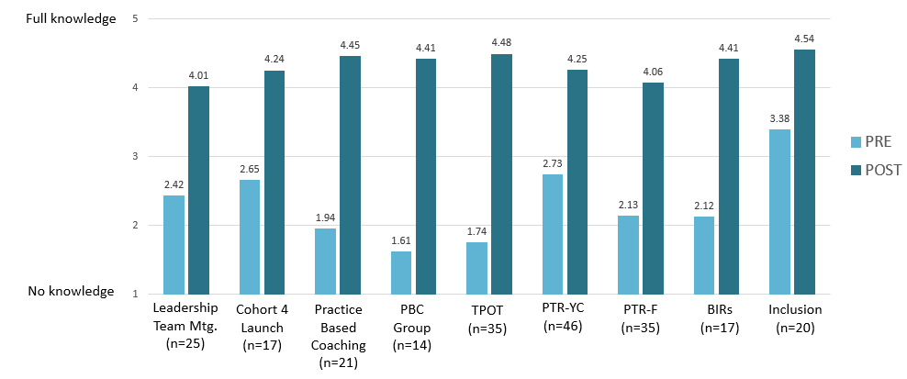
Figure 7. Participant Pre/Post Ratings of Learning Objectives
(Overall mean ratings)
In addition to the pre/post ratings to assess progress toward learning objective, and other feedback items, participants use a five-point rating scale to assess overall even quality: 1 = poor, 2 = fair, 3 = good, 4 = very good, and 5 = excellent. Mean ratings of the statewide events shown above ranged from 3.86 to 4.93 (these means are not shown in the figure). With respect to the overall quality of the SSIP statewide trainings, leadership team meetings, and regional events, the vast majority of respondents reported that the delivery of the material was effective, and that the information was relevant and useful to their professional practice. These results are on par with prior years of the project.
KeY Finding: External coaches continue to provide individualized support to districts, most frequently through site visits. Support is most often focused on supporting leadership teams, and also extends to building capacity for internal coaching and TPOT administration, data decision making, and Practices training. Over the past year, supports increased in alignment with SSIP priority areas, including internal coaching, data decision making, and behavior systems. External coach support is highly valued by district teams and is greatly contributing to progress toward implementation.
External Coach Contact Records, and newly updated Monthly External Coach Logs provided insight into the types of support that coaches are providing to their districts to help advance implementation. From March 2019 to February 2020, a total of 264 external coach contacts across 30 districts were recorded in the database. Sixty-four of these contacts were with the new group of six Cohort 4 districts during the 2019-2020 school year. Coaches most often met with district and school staff in-person during site visits (77% of contacts), followed by training events, and phone calls and email contacts.
Figure 8 below shows the types of support typically provided by external coaches this school year, in comparison to last year. As shown, the focus on SSIP priority areas for FFY 2018, namely internal coaching, TPOT support, data decision making, and behavior systems, all increased in comparison to last year. The only area of an apparent decrease was in the provision of Practices training. The personnel with whom internal coaches most often interacted were leadership team members (77% of contacts), program administrators (63%), internal coaches and classroom teachers (each 43%), and behavior specialists (23%)
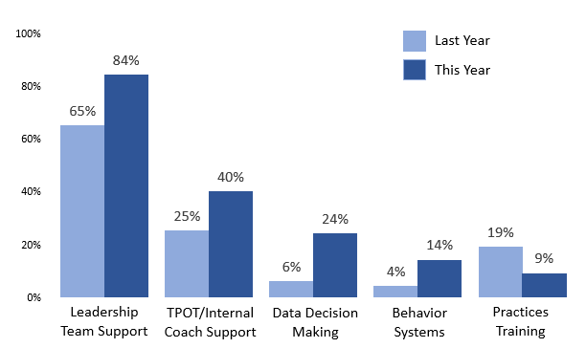
Figure 8. Types of Support Provided by External Coaches
(Question Allowed “check all that apply”)

With respect to the contribution that external coaches make to district progress, survey responses from leadership team members across all cohorts indicated high levels of satisfaction with coaching, with respect to coaches’ professionalism, knowledge of Pyramid Model content and strategies, and their understanding of districts’ unique needs. Several quotes from team members:
“Without the support of our external coach we would not have moved forward on any of the initiatives. Our coach is professional, supportive, and encouraging in our work towards implementing the Pyramid Model.”
“Our coach keeps in touch with us and is quick to offer possible solutions as roadblocks to implementation arise.”
“Our coach was instrumental in helping us get the whole school up and running with PBS during a challenging district realignment. Without her support we would not be as far along as we are now!”
“At this point, we don’t rely heavily on our external coach, we are almost self-sufficient, but it is helpful when we ask questions. The external coach role has been significant in implementation in our program.”
In terms of what district leadership team members need from external coach going forward, they most frequently indicated:
- Internal coach support (observing teachers, assisting with PD, TPOT support)
- Data-based decision making (support for data coordinator, leadership team, internal coach, etc.)
- Family group training (providing information, co-presenting Positive Solutions)
KeY Finding: MA DESE provides several avenues of support to districts for their work with families, and for increasing family engagement. This includes partnering with the state’s Parent Training and Information Center (PTI), and external coaches’ work with districts to support Positive Solutions for Families. District leadership teams are moving toward greater family engagement through train-the-trainer sessions, and by promoting varied family activities and training opportunities.
Based on information provided by project leaders and extant documents, the state’s Parent Training and Information (PTI) Center, which is part of the Federation for Children with Special Needs (FCSN), has conducted several Positive Solutions train-the-trainer sessions for educators across the state. Since the time of the last report:
- FCSN provided Positive Solutions train-the-trainer sessions to 34 educators during sessions conducted during May and June 2019.
- FCSN provided family training over a four-session series in March and April 2019 for one of the Pyramid Model implementation sites. A sample of evaluation forms from those events indicated very positive feedback about the quality of the events, and the relevance and usefulness of the information for families. MA DESE has been collaborating with FCSN on a follow-up survey for participating family members.
Information reported by district team members (Cohorts 1 - 3) on the Mid-Year Leadership Team Survey suggests additional Positive Solutions training opportunities have been provided for staff, and families are being engaged with Pyramid Model strategies in a variety of ways.
As shown in Figure 9, 41% of survey respondents reported that their schools or districts took part in Positive Solutions for Families training (compared to 22% reported last year by these same cohorts). In terms of other supports for family engagement, 42% reported having a family member on their team. And, 70% reported that their districts/schools have hosted family training or other activities this past year. Some examples are provided in the text box.
parent engagement activities
“Parent workshops on challenging behaviors for the ‘anxious’ child. [We] also provide two parent classes that go for 8 and 12 weeks with free childcare and dinner included.”
“We offer monthly parent meetings with a short presentation on a parenting topic, followed by parent discussion.”
“PBS family night. Giving parents information about routines and visuals. Provided visual schedules for parents to take home regarding mourning routines and nighttime routines. Discussed the importance of social emotional literacy with a list of books.”
“We are currently delivering Positive Solutions curriculum and area awaiting a training for the trainers to be scheduled.”
“We invite families in for parenting workshops, we present PBS to families, we have family engagement literacy events with families.”
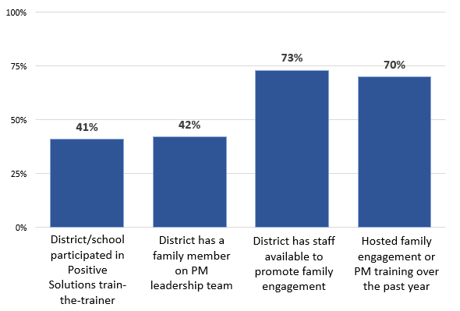
Figure 9. Parent Engagement Activities (n=77)

Evaluation Question 1b: To what extent is the implementation of EC-PBS through Pyramid strategies in MA integrated with other early childhood and/or MA DESE initiatives at the community/local and state levels?
(Findings in this section align with Intended Outcomes S2a. and b.)
KeY Finding: MA DESE continues to integrate the work of the SSIP across interagency initiatives related to early childhood special education, moving toward a community-wide vision. MA DESE collaborates with MA EEC and the SLT on multiple initiatives that support implementation of the Pyramid Model framework, equity, and inclusion across school district and community contexts. During FFY 2018, several events were devoted to Trauma Informed Care (TIC) through the lens of the Pyramid Model.
As evidenced though EC-PBS Leadership Team meeting notes, project documentation, and MA EEC evaluation data, a variety of interagency initiatives are underway to expand the reach of EC-PBS through Pyramid strategies in the state, and to move toward a more cohesive community-wide structure and philosophy.
Some of the key initiatives and indicators of progress from FFY 2018 include the following:
MA EEC EC-PBS/Pyramid Model Training Initiative: The MA EEC initiative continues to expand, now comprised of 62 ECE programs: 20 Cohort 1 programs that began implementation in spring 2018, 21 Cohort 2 programs that launched in winter 2018, and 21 Cohort 3 programs launched in fall 2019. Leadership teams have been formed at the ECE programs, and personnel have access to many of the same statewide training events as their MA DESE district counterparts.
- ECE programs receive external coaching and are also supported by PMC. There are currently 19 coaches, 8 of whom are also supporting the 31 MA DESE school districts. Evaluation measures and data collection procedures have been streamlined across these initiatives to allow for a statewide look at progress going forward; a compilation of evaluation findings across these initiatives (DESE and EEC) was shared with the MA SLT this year for review and discussion.
- Additionally, toward the end of the grant period during May and June 2019, external coaches offered a series of regional training events for the ECE program teams. Coaches serving each region teamed up to deliver the three-hour sessions, which were designed for program staff to discuss content and strategies aligned with Pyramid Model implementation, to network and learn from each other, and to work on action plans that would address the summer months and beyond. The sessions were intended for teachers, center directors and other administrators, mental health staff, program coaches, and other interested staff.
Participant feedback forms indicated that the meetings were very well-received, as the smaller group format has allowed for greater discussion and collaboration. Regional/local meeting locations have also been appreciated. External coaches are currently planning another round of regional events for May and June 2020.
Pyramid Model Learning Communities (PMLCs) - The Massachusetts Pyramid Model Learning Communities (PMLCs) are regional training and networking events that have been offered throughout the state since 2016. These events are conducted by experienced local facilitators across the five regions of the state multiple times during the year. The events are designed to introduce new personnel to the Pyramid Model, as well as to support and help expand implementation efforts among those with more experience.
- During FFY 2018, two rounds of regional sessions were offered in which PMLCs were held in each of the five regions – one round of sessions in December-February, and another second round in spring 2019.
- The theme of the events was Trauma Informed Care (TIC) and the Pyramid Model with a focus on recognizing the signs and symptoms of trauma, understanding its effects on learning and development, and strategies to support children and families when trauma occurs. These topics were presented through the lens of the Pyramid Model framework.
Ultimately, the work of the PMLCs has shifted toward a community-based model of support to help promote systems-change within early childhood education. This year, that work began in two communities, where cross-sector teams within each city came together with a facilitator to self-assess progress using a Community-wide Benchmarks of Quality tool and to create action plans. A national trainer was brought in by the Pyramid Model Consortium to assist in creating those plans. Other communities/districts are expressing interest in this approach, and the feasibility of the community-wide model will be further explored by the State Leadership Team (SLT).
7th Annual EC-PBS/Pyramid Model Summit - The SLT also organizes an annual EC-PBS/Pyramid Model Summit to foster education and networking among practitioners across the state.
- In FFY 2018, the 7th Annual Summit was also devoted to Trauma Informed Care and the Pyramid Model, to continue building upon themes presented in the regional PMLCs. There were 163 attendees at this year’s Summit. Feedback from the event was positive overall and was shared with the SLT for planning future events.
- Planning for the 2020 Summit has been underway, with a focus on Addressing Equity and Intergenerational Trauma through Pyramid Model.
Evaluation Question 1c: To what extent is MA DESE making the intended improvements to the workforce development structure as identified through the evaluation and outlined in its annual reports?
(Findings in this section align with Intended Outcomes S3a. and b.)
KeY Finding: MA DESE, its partners, and external coaches supported district leadership teams in making progress toward improvements intended for FFY 2018. Leadership team members reported progress in the following areas: building internal coach capacity to support teachers, advancing teachers’ fidelity of implementation in the classroom, and using data for program planning. Progress was also reported in understanding culturally responsive practices to address equity, and increasing family engagement, which was the greatest area of progress.
Based on last year’s evaluation findings and project feedback, MA DESE, and its partners identified several improvements to be put in place during FFY 2018. While progress toward some of these components are addressed in the EC-BoQ results and other sections of this report, leadership team members were asked to reflect specifically on progress across these areas over the past year. Combined responses for Cohort 1 - 3 team members on the Leadership Team Survey are shown in Figure 10. Approximately two-thirds of survey respondents noted having made progress toward increasing internal coach capacity (67%), and relatedly, increased implementation fidelity in the classroom (i.e., TPOT) (63%). Progress in parent engagement was reportedly the greatest area of growth – 75% reported progress, and nearly half of those respondents indicated the progress was significant. The other MA DESE areas of focus for FFY 2018 were also noted for progress by half of survey respondents, including using data for program planning, and broadening staff understanding of culturally responsive practices to ensure equity.
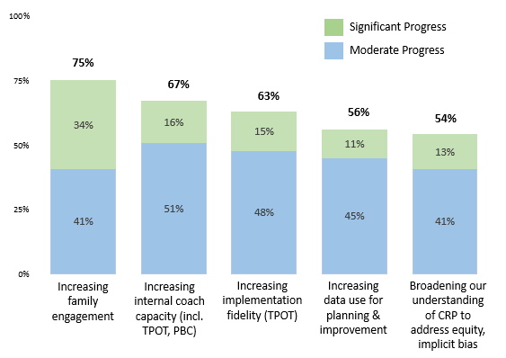
Figure 10. Progress on FFY 2018 Areas of Focus over the Past Year (n=77)
(b) Evidence that SSIP’s evidence-based practices are being carried out with fidelity and having desired effects
Evaluation Question 2a: Is the state-level plan resulting in the number of schools and classrooms participating in EC-PBS through Pyramid strategies sample growing over time?
(Findings in this section align with Intended Outcome S4.)
KeY Finding: The MA DESE initiative continues to expand, as the numbers of districts, schools, and classrooms working toward implementation have all increased over the past year. There are currently 50 schools and 290 classrooms that have adopted EC-PBS/Pyramid, representing a 49% increase in classrooms over last year.
Table 6 below shows the progress in the expansion of the initiative over the past four years as documented by external coaches in coordination with district personnel and reported in the EC-PBS/Pyramid Implementation Profile database. There are currently 50 schools and 290 classrooms working toward implementation across the 31 participating districts. This represents increases of 16% and 49% over last year’s numbers of schools and classrooms respectively. This year, participating classrooms include 242 PreK, 30 Kindergarten, 16 First Grade, and 2 Second Grade classrooms. The percentage of preschools within the participating districts has reached 32%. Among the 463 preschool classrooms in these districts, 52% (242) are reportedly working toward EC-PBS/Pyramid implementation.
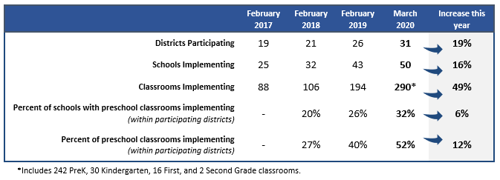
Table 6. EC-PBS/Pyramid Participation among Districts, Schools, and Classrooms: 2017 to 2020

Evaluation Question 2b: To what extent are districts developing systems to support and sustain program-wide EC-PBS through Pyramid strategies?
(Findings in this section align with Intended Outcome D2.)
KeY Finding: District results over time on the EC-BoQ v2.0 across Cohorts 1, 2, and 3 suggest that participation in the initiative continues to contribute to the development of systems to support program-wide implementation. On average, each cohort reported growth on all Critical Elements over the past year.
District leadership teams are guided to use the EC-BoQ at least two times annually to assess their progress toward EC-PBS/Pyramid Model implementation at the district/program level, and to inform their action/implementation plans. This work is often done with support from external coaches, as indicated in coach log reports. Results on the EC-BoQ have consistently shown district-level progress over time. In FFY 2017, the project shifted to using the revised EC-BoQ v2.0, which incorporates quality indicators for culturally responsive practices, as well as other updates. As such, this year’s EC-BoQ data represent growth over time from FFY 2017 to FFY 2018. The EC-BoQ v2.0 includes ratings of 41 benchmarks across seven critical elements, each rated on a scale of 0-2, where 0 = not in place, 1 = partially in place, and 2 = in place.
The results in Figure 11 show each cohort’s first use of the BOQ v2.0, and the most recent (Time 1 and Time 2). The figure includes districts with data from at least two points in time – Cohort 1 (n=7 districts), Cohort 2 (n=5), and Cohort 3 (n=6). It is important to note that each cohort had a different level of experience when completing this version of the BoQ for the first time in FFY 2017, as reflected in their “Time 1” results. That is, for Cohorts 1 and 2, their “first” BoQ was not a true baseline, as they had been engaged in the project for several years. Results are discussed below the figure.
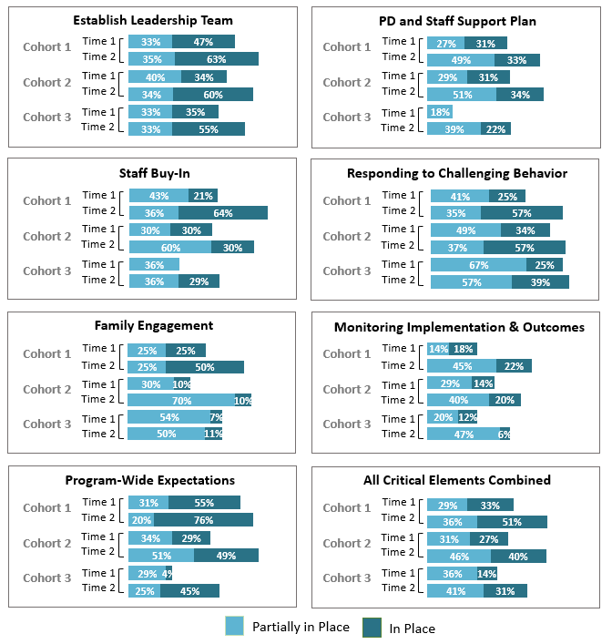
Figure 11. EC-BoQ v2.0 Results over Time by Cohort: By Critical Elements and Overall

As shown, all cohorts reported progress toward program-wide implementation over the past year. And, districts who have been participating longer are more likely to have reported that the seven Critical Elements are “in place”. Specifically, Cohort 1 reported 51% of all indicators to be “in place” on their most recent BoQ, compared to 33% in FFY 2017. Cohort 2 reported 40% in place, compared to 27% the prior year. Cohort 3, for which the first BoQ would represent a true baseline, reported 31% in place, compared to 14% the prior year. While not shown in the figure above, Cohort 4 baseline results (n=6 districts) indicated 11% of the benchmarks in place at start-up. In reviewing the results, it is important to note that some Cohort 1, 2, and 3 districts have added new schools into the initiative this year. As such, the EC-BoQ ratings may reflect fewer elements in place as the new schools are gaining traction.
Another way to view the BoQ results is in the overall scores, that is, the total percentage of points documented on the self-assessment tool out of the possible 82 points (41 indicators, each with a possible score of 2 to indicate “in place”). The average overall scores on the most recent BoQ, and the range of scores for each cohort, are shown below. The range of scores within each cohort points to the variability of program-wide implementation district to district.
- Cohort 1: 69% overall. Score range of 52% to 84%
- Cohort 2: 63% overall. Score range of 60% to 66%
- Cohort 3: 51% overall. score range of 29% to 62%
- Cohort 4: 24% overall. Score range of 17% to 44% (baseline year).
KeY Finding: Cohorts 1, 2, and 3 reported considerable growth on the EC-BoQ in: Staff Buy-in, PD and Staff Support Plans, and Monitoring Implementation and Outcomes. Cohorts 1 and 2 in particular noted strong growth in Family Engagement, while Cohorts 2 and 3 noted strong growth in Establishing Program-Wide Expectations. All cohorts strengthened their Leadership Team processes. The greatest area for further development continues to be Monitoring Implementation and Outcomes.
As shown in Figure 11 above there were some areas of program-wide implementation that were advanced more than others over the past year. Similar themes emerged from team members’ comments on the Leadership Team Survey.
- For many Cohort 1-3 survey respondents, their “biggest success” has been the development of a Common Language/Approach and establishing Program Wide Expectations. Some described the benefits for children and staff that have resulted from these accomplishments.
Cohorts 1 and 2
“We have developed a common language that is consistently being used throughout the building. We have created a matrix that explicitly states expected behavior throughout all areas of the school.”
“Established common language, classroom practices, signage…all staff onboard and committed, students and families engaged in common language and practices.”
“Classrooms are speaking the same language in regards to expectations and rules. We have increased parent engagement.”
“We have created rules/expectations and have posters for each area of our program with the rules/expectations. We have also run parent trainings which have been successful. The children are demonstrating the expectations and behaviors have seemed to decrease.”
Cohort 3
“Having a ‘uniform’ approach/framework addressing SEL that is implemented throughout our entire school by staff (consistent/same use of the following throughout the building: language, picture icons, schedule icons, positive behavior systems, expectations)... school wide implementation of the ‘Pyramid Corner’ in our monthly classroom newsletters followed up by the Backpack Series handout (that corresponds to the same topic) sent home to entire school mid-month.”
“For the school it is a nice way for all teachers to be on the same page about what procedures we are using to effectively handle children’s behavior, and building a positive environment for children to learn.”
“Unified language, goals, expectations across rooms and teachers.”

- Additionally, a number of Leadership Team members from Cohort 1 and 2 cited Family Engagement activities as their “biggest success”.
Cohorts 1 and 2
“The portion of the Pyramid Model that I’m participating in is with the community families with young children. This consists of Parent/Caretakers Positive Solutions workshop series. Parents/Caregivers feedback: very positive to have the opportunity to become familiar with the Pyramid Model and supporting each other.”
“The increase in family engagement has been wonderful. Also, the use of our school-wide expectations is very helpful to keep different classrooms consistent.”
“We’ve provided two parent trainings that were well attended!”

- For Cohorts 3 and 4 Leadership Team members, Professional Development was often associated with their “biggest success”, as these districts are in earlier stages of implementation. Cohort 4 team members most often mentioned progress toward establishing their Leadership Teams, and generating Staff Buy-In.
Cohorts 3 and 4
“Our biggest successes have been providing high quality training to ALL staff, implementing the use of Behavior Incident Report and providing Team Coaching with all teachers.”
“The professional development from the Pyramid Model has been well received in the district. I look forward to continuing the pyramid model work.”
“This year, we have been able to have a professional development day to introduce the Pyramid Model to the entire staff. We have determined program wide expectations. We were awarded a grant of $10,000 to support implementation and have begun a pilot curriculum in two classrooms.”
“I think doing the 5:1 ratio for deposits has made a huge difference school wide. We have also started watching the e-modules as a staff.”
“The collaboration of the leadership team and the initial trials in two classrooms. Watching the program embrace the Pyramid Model and our expectations.”

KeY Finding: On the whole, participating districts across all cohorts need additional support and guidance to fully establish key components of program-wide implementation, and to move toward maintaining these components beyond external coach support.
Since Year 1 of the initiative, evaluation findings indicate steady progress by district teams toward program-wide implementation of EC-PBS/Pyramid Strategies, as well as perceived benefits for children and families. The SSIP has also steadily expanded into additional schools and classrooms – since Year 1, the number of participating classrooms has more than tripled. A combination of factors has reportedly contributed to this progress, including high-quality professional development opportunities, support from state leaders, dedicated external coach supports, and ongoing efforts by district and school personnel.
To gauge the extent to which participating districts are moving toward realizing some of the necessary components of program-wide implementation, as well as whether they could be maintained beyond external coach support, Cohort 1 - 3 team members were asked to consider their teams’ progress to date. As shown in Figure 12, survey respondents perceive that these particular component areas will require further development and support to be deemed fully “in place”, and to continue beyond external coach support.
- As shown, these survey respondents were most likely to report having leadership teams that meet regularly. A third or more of each cohort reports this is sustainable beyond external coach support.
- As would be anticipated, internal coaches in place to support teachers (including use of PBC and TPOTs) is occurring to a moderate extent. Cohort 3 respondents were most likely to report strengths in this area. As noted throughout this report, progress has been made this past year on increasing internal coach capacity.
- While all cohorts have reported some progress over the past year on using data effectively for assessing and guiding progress at the program, classroom, and child-levels, less than half of Cohort 1 and 2 respondents reported this aspect of implementation to be “in place”, and less than a third of Cohort 3 respondents.
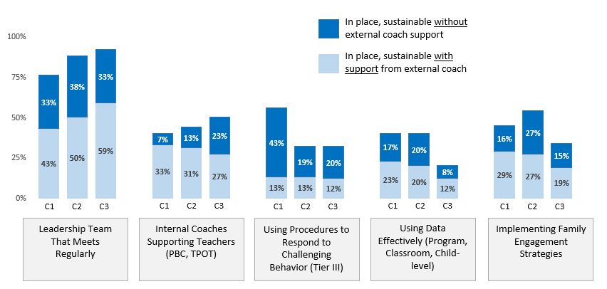
Figure 12. District Progress toward Establishing Key Components
of EC-PBS/Pyramid (n=77)
KeY Finding: The primary challenge to implementation is common across all cohorts – lack of time and/or availably of classroom-based coaching. This is consistent with prior years, though the challenge has reportedly decreased to some extent. Other top challenges include developing internal coach capacity, and access to substitutes for training.
Table 7 below shows the greatest challenges reported by leadership team members; the top challenges are shaded for each cohort. Last year’s survey results from Cohorts 1 and 2 are shown for comparison. Results are grouped by Cohorts 1 and 2 combined, and Cohorts 3 and 4 combined, as results were comparable across these cohorts (exceptions are noted in the table).
As indicated, lack of time/availability for classroom coaching remained the greatest challenge, although progress appears to have been made when compared to last year among Cohorts 1 and 2 (62% this year, compared to 80% last year). It is interesting to note that 46% of respondents from Cohorts 3 and 4 indicated the same.
Districts also continue to confront challenges building internal coach capacity – Cohort 1 and 2 respondents were more likely to indicate this challenge than Cohorts 3 and 4.

Table 7. Mid-Year Leadership Team Survey:
Greatest Challenges to Implementation
Greatest Challenges to Implementation | Cohorts 1 & 2 (n=50) | Cohorts 3 & 4 (n=46) | Last Year - Cohorts 1 & 2 ( n=40)
Lack of time/availability for classroom-based coaching | 62% | 46% | 80%
Developing internal coaching capacity to support teachers | 54% | 28% | 58%
Difficulty attending statewide training opportunities | 36% | 19%* | 28%
Lack of substitutes to allow teachers to attend training | 36% | 37% | 53%
Insufficient funding | 32% | 24% | 35%
Finding time for the leadership team to meet and plan | 26% | 26% | 38%
Time to implement the Pyramid Model in the classroom | 18% | 41% | 33%
Lack of support and buy-in from teachers | 18% | 26% | 10%
Aligning this initiative with school-age PBIS initiatives | 18% | 11% | 5%
Lack of support from district leaders for this initiative | 12% | 23%* | 15%
*Cohort 3 only; 0% indicated by Cohort 4 respondents.
Survey comments from leadership team members provided detail about challenges. For all cohorts, time and resources were described as the greatest challenges to implementation.
Many team members identified competing initiatives, substitute teachers, and contractual issues as additional factors that compound these challenges. There were also several mentions of social emotional learning not being a district priority, and or lack of alignment of SEL strategies across the district.
“It is difficult to find time to implement practice based internal coaching…there are many competing initiatives from the district and teacher and paraprofessional contract restraints.”
“TIME, Resources, and inability to free up staff during paid contractual day.”
“With such a large group of teachers, and coaches that are also teachers, the time for coaching is challenging.”
“There are lots of programs in our district. Our coach is trying hard to demonstrate that the goals are the same for the other programs and we can support each other.”
“Our program is experiencing change as we expand, and trying to stay focused on important initiatives can be overwhelmed sometimes by administrative needed.”
“Staff is having a difficult time buying in because of its similarities to PBIS, in which this school did significant work with a coach over the past few years.”
“District’s contract negotiations with paraprofessionals has stalled. This has interfered with out plans to provide professional development.”

For some team members, the challenge of time and resources is amplified by the overall demands of implementing a comprehensive model.
“I feel there are so many components to the Pyramid Model and there is not enough time to get to everything. I would like more assistance with some of the areas we are not getting to. These would include including families in problem behaviors, PTR-YC, etc.”
“Staff need time for planning and writing goals; no time in the daily schedule to thoroughly plan and prepare in depth.”
“Our leadership team is small but effective. Time is the biggest challenge for all of us. There is never enough time to actually sit and plan and discuss thoughtfully other than the planned monthly meetings with our external coach…”
“I believe the staff is overwhelmed with the student needs and lack of support by the administration.”

KeY Finding: To expand implementation, district leadership team members identified several types of assistance that would be helpful. The greatest needs are consistent with last year and include guidance on how to build internal coach capacity, guidance on building in TPOT processes for teachers, and district-based Pyramid Model practices training for teachers and other staff.
As reported on the leadership team survey, the most common areas of need going forward, across cohorts, include:
- Internal Coaching: Guidance on scaling up internal coach capacity, and relatedly, guidance on how to build in a process for using TPOT with teachers.
- Practices Training: District-based and regional Pyramid Model practices training for teachers and other staff, including additional access to the ePyramid Modules for self-paced learning.
- Program-wide Expansion: Guidance on how to deepen or expand the Pyramid model within the district.
- Monitoring Progress: Guidance on using data to monitor progress.
Survey comments provided additional details. For all three cohorts, the greatest needs were described as continued professional development, support for internal coaching, and information to help increase administrator support. Ongoing external coach support was mentioned often. Many of the suggestions were directly aligned with challenges shared in the previous section. Other more specific suggestions included:
- Annual Planning: A year-long plan for professional development with training dates and meeting dates.
- Administrator and Budget Commitment: Commitment by district administration; addition to the district budget (“would not be possible without 298 grant”).
- Resources to Support Internal Coaching: Funding for substitutes to free-up time for regularly schedule coaching; stipends and reserved time for internal coaches to work with teachers; release time for internal coaches to observe classrooms and meet with teachers.
- Classroom Materials: Time to develop classroom materials to support social emotional learning; more prepared materials available; social emotional curriculum.
(c) Outcomes regarding progress toward short-term and long-term objectives that are necessary steps toward achieving the SiMR
Evaluation Question 3a: Are teachers implementing EC-PBS through Pyramid strategies in their schools?
(Findings in this section align with Intended Outcome D3.)
KeY Finding: Based on TPOT scores representing approximately one-quarter of implementing teachers, personnel are demonstrating implementation fidelity (80%) on many of the key practices and moving toward fidelity on this measure overall.
As of this year, TPOT scores have been received for 68 teachers across 15 districts. TPOTs were reportedly conducted by “TPOT reliable raters” in all cases. Figure 13 shows average ratings in the 14 Key Practices (comprised of 114 indicators in total across the practices) and overall. A score of 80% is considered implementation fidelity.
As shown, these teachers were observed to be strongest in engaging in supportive conversations with children, transitions between activities, and providing directions. On average, teachers have the most room for growth in teaching behavior expectations, teaching social skills and emotional competencies, and teaching problem solving. Results are also consistent across cohorts, and indicate progress over time (i.e., higher scores, generally, for more experienced teachers). Finally, a review of individual teacher scores indicated the following percentages of teachers at fidelity (80%) on the overall TPOT: For Cohort 1, 54% of teachers reached fidelity; for Cohort 2, 40% of teachers reached fidelity; for Cohort 38% of teachers reached fidelity.
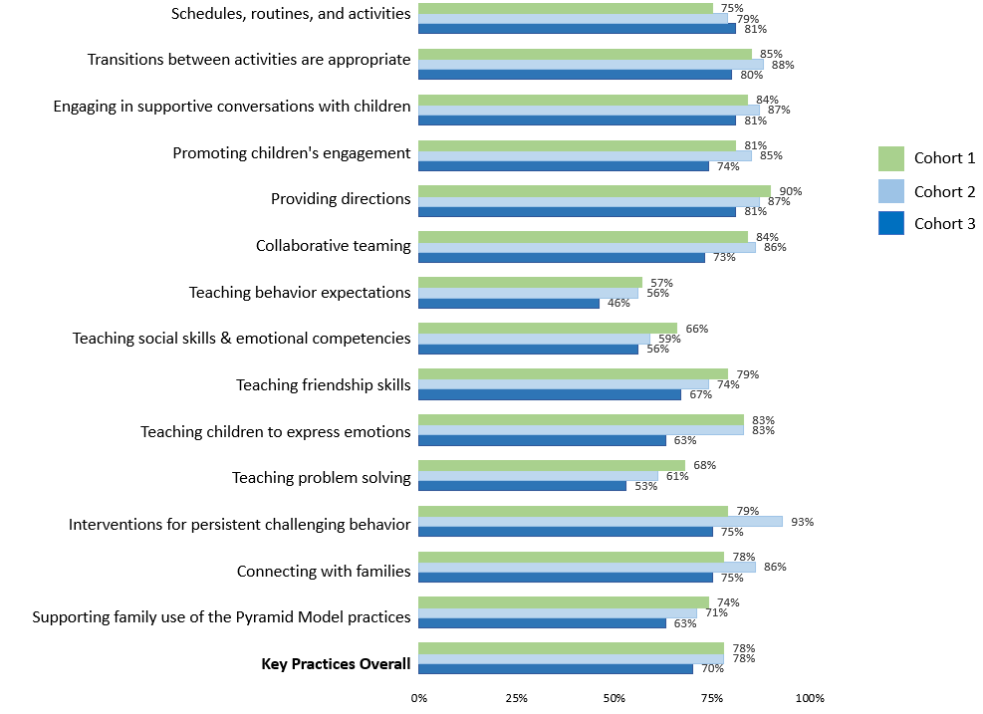
Figure 13. Aggregate TPOT Results Across the Key Practices and Overall (n=68 teachers)
It is important to note that TPOT use across participating districts remains modest. Data collected on the Pyramid Implementation Profile in March 2020 suggest that approximately 46% of teachers have received at least one TPOT since beginning the initiative. Specifically, among the estimated 242 teachers (of preschool classrooms), 112 have taken part in a TPOT. Additionally, among the 242 teachers, 54 have had a TPOT this year (or have one scheduled). TPOT use also varies by district. As discussed elsewhere in this report, persistent challenges related to building internal coach capacity and other time constraints are likely contributors to the modest use of the TPOT as a decision-making tool.

Evaluation Question 3b: Does the fidelity of classroom implementation improve over time?
(Findings in this section align with Intended Outcome D3.)
KeY Finding: Comparable to last year’s findings, teacher self-ratings in key practices associated with Pyramid Model implementation from a modest proportion of teachers indicated confidence in their own growth toward fidelity over time. The reported gains were statistically significant.
Currently, the availability of TPOT data being collected and shared at the state level (collected via observation and interview) are not sufficient to assess the fidelity of implementation over time using that measure. This year, TPOT scores from two points in time were available for 8 teachers. For this small group of teachers, overall scores averaged 82% on the first TPOT, and 89% on the second TPOT, indicating fidelity overall, and growth over time.
The Pyramid Model Teacher Survey for Cohort 1 – 3 teachers included a self-rating of 11 areas associated with the TPOT Key Practices scale. Teachers used a scale from 0 to 5, where 5 indicated “implementation fidelity” to rate each skill area before the initiative, and now (January 2020). As shown in Table 8, teachers indicated confidence in their growth since they began the Pyramid Model Initiative. These results represent the 44 teachers who responded to the survey (approximately 18% of total teachers working toward implementation from these cohorts); they do not represent participating teachers more generally. The largest self-reported areas of growth were supporting family use of Pyramid Model practices, teaching children to express emotions, and teaching social skills and emotional competencies.
Table 8. Teachers’ Self-Rating of Key Practices Before the Initiative and Now (n=44)
Key Practices Aligned with TPOT | BEFORE | NOW | Gain
 | Overall Mean |  | 0.78
 | 3.51 | 4.29
Effective use of schedules, routines, and activities | 4.00 | 4.66 | 0.66
Engaging in supportive conversations with children | 3.77 | 4.50 | 0.73
Promoting children’s engagement | 3.86 | 4.48 | 0.61
Teaching behavior expectations | 3.77 | 4.60 | 0.84
Teaching social skills and emotional competencies | 3.51 | 4.42 | 0.91
Teaching friendship skills | 3.56 | 4.32 | 0.77
Teaching children to express emotions | 3.45 | 4.45 | 1.00
Teaching problem solving | 3.34 | 4.30 | 0.95
Interventions for children with persistent challenging behavior | 3.66 | 4.25 | 0.59
Connecting with families | 3.56 | 4.02 | 0.47
Supporting family use of the Pyramid Model practices | 2.12 | 3.17 | 1.05
*Reported gains in all key practice areas were statistically significant at p<.0001 based on paired sample t-tests. Effect sizes calculated using Cohen’s D ranged from .74 to 1.18, which is considered a large effect (i.e., educationally meaningful).
On the Pyramid Model Teacher Survey, respondents also described some of their greatest successes implementing Pyramid Model strategies, which align with these findings.
- Most teachers reported increased positive student behaviors as their “biggest success” in implementing Pyramid Model strategies in their classroom. Examples included children’s ability to learn more complex emotions, decreased challenging behaviors, and noticing students being more kind and patient with each other since introducing many of the strategies.
- Teachers also described how specific Pyramid Model strategies have contributed to their “biggest success”. Examples included teaching behavior expectations, using visual supports, songs, positive role modeling/modeling supportive conversations, and positive praise for expected behaviors.
With respect to challenges to implementation, teachers most often identified lack of time to implement Pyramid Model in the classroom (46%), and lack of time/availability for classroom based coaching (41%). These challenges are consistent with last year. Some teachers also indicated difficulty attending regional or local training opportunities (18%).
Finally, teachers described some of the additional supports they need to keep moving forward success
Time for Coaching and Collaboration
“Classroom-based coaching and observations in other classrooms would be most helpful to keep moving forward successfully with implementation.”
“Increased coach training opportunities for both teachers and paras.”
“It has been difficult to do my role as classroom teacher and internal coach, not enough time in the day.”
“It would be very helpful to have time to meet with the classroom paras to discuss/collaborate on the implementation of Pyramid Model strategies.”
“Time built into our schedule to reinforce the social thinking lessons with activities and role modeling.”
“More time to collaborate with colleagues about how each class is implementing Pyramid Model.”
“I would love to observe other teachers in their classrooms in real time.”
Resources to Support Implementation
“Materials already prepped—ready to go! No more printing, laminating, cutting, etc.”
“More funded supplies.”
“Mental health support – counselors, social workers, for ongoing proactive therapies and also for triage.”
“…all teachers get the TPOT workbook that the coaches get that truly describes what they are looking for when they observe.”

vide quarterly progress meetings with parents; back to school night in September, four Positive Solutions training sessions with families; monthly Coffee and Conversation with parents; winter student performance; Listening Walk at the Zoo”
“We are currently delivering Positive Solutions curriculum and area awaiting a training for the trainers to be scheduled.”
“We invite families in for parenting workshops, we present PBS to families, we have family engagement literacy events with families.”
-District Leadership Team Members
-

(d) Measurable improvements in the SiMR in relation to targets
Evaluation Question 4a: To what extent do district and school personnel perceive benefits of implementing EC-PBS/Pyramid strategies for children?
(Findings in this section align with Intended Outcome C1.)
KeY Finding: Many school and district personnel indicate that as a result of EC-PBS/Pyramid strategies, children are demonstrating improved social emotional competencies. A moderate proportion of personnel have also noticed academic benefits, and decreased rates of suspension and expulsion. This finding is consistent with last year, and perceived gains have increased over time.
Leadership team members across Cohorts 1 through 3 were asked to rate the extent to which the Pyramid Model initiative has led to benefits for children and families. Figure 14 shows the percent of respondents that selected to a “moderate” or “great extent” among both groups.
As shown, a large majority of respondents across cohorts (78% of Cohorts 1 and 2, 69% of Cohort 3) report that children are demonstrating improved social emotional competencies, the main goal of the SSIP. Compared to responses from Cohorts 1 and 2 last year, this is up from 65%. Across these cohorts, more than half of respondents also noted decreased rates of suspension (64%, 58%), as well as children making greater cognitive and academic progress (52%, 54%). Again, compared to last year, these percentages for Cohorts 1 and 2 are up from 36%.
All cohorts also believe that there have been benefits related to families – more than half believe that relationships with the school have been strengthened, and that families have gained new skills to support their children in social emotional development. Once again, these estimates have increased since last year for Cohorts 1 and 2. Taken together, these perceptions over time seem to suggest that more time engaged in this initiative translates to more widespread benefits for children.
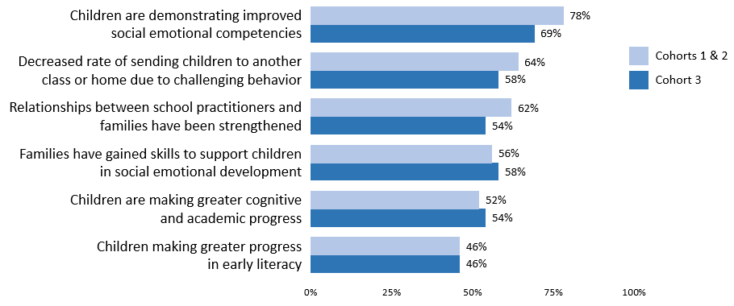
Figure 14. Perceived Benefits of Pyramid Model Classrooms:
Percent of Leadership Team Members Selecting to a “moderate” or “great extent”
Evaluation Question 4b: Is the number of children in MA, aged 3-5, with disabilities, exiting from preschools with age-expected social emotional functioning increasing?
teacher voices
Benefits of Participation…
“Children are better able to recognize and understand emotions of self and others. Children work harder to earn rewards for positive behaviors.”
“[Students are] better able to express feelings appropriately.”
“Students’ relationships have benefitted the most because they are learning quality skills and understand the classroom expectations.”
“Receptiveness to use ‘break space’ when needed. Understanding that mistakes make us better learners. Students assisting others with challenges and a feeling of inclusiveness in the classroom.”
“My pre-kindergarten students have really begun to create an inclusive, and kind environment for each other.”
“The greatest benefits of participation for children has been that they are being explicitly taught and given time to practice and be reinforced for using effective behavioral strategies in the areas of social skills and positive self-regulation.”
“The way the students can express their own feelings and try to solve problems using different strategies.”
“Children are more independent.”
(Note: Key Findings in this section align with Intended Outcome C2.)
KeY Finding: The statewide six-year trend in the percentage of preschool children with disabilities functioning within age expectations by the time they turned 6 or exited the program has increased modestly over time. The highest result was in FFY 2015. The percentage decreased slightly over the past year, while the proportional difference year-to-year was not found to be significant.
The State Identified Measurable Result (SiMR) for the MA SSIP is the improvement of social emotional outcomes for young children with disabilities, aged 3-5. The first way in which MA DESE is measuring achievement of the SiMR is by assessing over time the percent of preschool children functioning within age expectations in positive social-emotional skills by the time they turn 6 years of age or exit the program. These data are collected via the Child Outcomes Summary (COS) process designed by the Early Childhood Outcomes Center as a way for states to summarize data on children’s movement toward age expectations in specific outcome areas. The full Child Outcomes statewide dataset for FFY 2018 included 133 districts, with data for 1,045 individual children. There was a range of 1 to 64 children per district. It is worth noting that the number of usable records for FFY 2018 represents a 61% increase over last year. As shown in Table 9, the state’s SiMR (for Outcome A, Summary Statement 2) decreased slightly over the past year from 47% in FFY 2017 to 46.02% in FFY 2018. However, the proportional year-to-year difference was not found to be statistically significant. The analysis of proportional difference is based on the overall results on the measure and the number of students represented in the calculation each year.
Table 9. SPP Indicator 7 Data: Summary Statement 2 (Statewide)
SiMR Data | FFY 2013 | FFY 2014 | FFY 2015 | FFY 2016 | FFY 2017 | FFY 2018
 | n=472 | n=479 | n=420 | n=398 | n=651 | n=1045
Summary Statement 2:  Percent of children who were functioning within age expectations by the time they exited. | 44.49% | 47.81% | 53.57% | 47.74% | 47.00% | 46.02
Target | -- | 90% | 90% | 90% | (new baseline) | 50%
Note: Summary Statement 2 is calculated by: # of preschool children reported in progress category (d) plus # of preschool children reported in progress category (e) divided by [the total # of preschool children reported in progress categories (a) + (b) + (c) + (d) + (e)] times 100.
Evaluation Question 4c: Is the number of children in MA, aged 3-5, with disabilities, exiting from preschool with greater than expected growth in their social emotional functioning increasing?
KeY Finding: The statewide six-year trend for the percentage of students with disabilities who substantially increased their rate of growth by the time they turned 6 or exited the program has shown some year-to-year fluctuations. However, results over the past two years have been comparable to FFY 2013 (original baseline) and have remained essentially unchanged from FFY 2017 to 2018.
The second way MA DESE is measuring achievement of the SiMR is by assessing over time the percent of preschool children who entered the preschool program below age expectations in positive social emotional skills who substantially increased their rate of growth by the time they turned 6 years of age or exited the program, as measured by the Child Outcomes Summary. As shown in Table 10, the percentage decreased by less than one percentage point from FFY 2017 to FFY 2018, from 85.61 to 85.17%.
Table 10. SPP Indicator 7 Data: Summary Statement 1 (Statewide)
SiMR Data | FFY 2013 | FFY 2014 | FFY 2015 | FFY 2016 | FFY 2017 | FFY 2018
 | n=419 | n=422 | n=350 | n=398 | n=651 | n=1045
Summary Statement 1:  Percent of children who substantially increased their rate of growth by the time they exited. | 85.44% | 87.20% | 79.14% | 88.70% | 85.61% | 85.17%
Target | -- | 100% | 100% | 100% | (new baseline) | 86%
Note: Summary Statement 1 is calculated by: # of preschool children reported in progress category (c) plus # of preschool children reported in category (d) divided by [# of preschool children reported in progress category (a) plus # of preschool children reported in progress category (b) plus # of preschool children reported in progress category (c) plus # of preschool children reported in progress category (d)] times 100.
KeY Finding: In FFY 2018, children with IEPs in Pyramid Model districts, as a subset of the statewide Child Outcomes dataset, performed at or above statewide averages on Child Outcomes across two outcome areas: Social-Emotional Skills (including Social Relationships), and Actions to Meet Needs across both Summary Statements.
As of FFY 2016, Pyramid Model districts have been required to submit Child Outcome data collect via the COS Process annually. This is a change from prior years when Pyramid Model districts, like all other districts in the state, followed a cohort cycle of reporting every four years according to Massachusetts’ OSEP approved sampling plan. The objective of the shift was to begin monitoring progress and trends in child outcomes for these districts specifically, in addition to monitoring statewide progress on Indicator 7A. It is important to note that this information will not be sufficient to examine the impact of SSIP activities on student outcomes but is instead intended as a form of progress monitoring within the districts directly receiving Pyramid Model training and supports. With this plan in place, a partial set of data have been collected from SSIP districts over the past three years. For FFY 2016, 83 usable student records were received from 12 Cohort 1 districts. For FFY 2017, 172 usable records were received from 16 Cohort 1 and 2 districts. For FFY 2018, 384 usable records were received from 20 Cohort 1 – 3 districts. To date, there are insufficient data to assess trends over time for these districts, given the small number of matched districts year-to-year, and the relatively small number of children represented within many of the district datasets.
In Figure 15 below, aggregate Pyramid Model district results are shown in relation to overall statewide results to serve as a frame of reference. These districts make up 34% of the statewide dataset for FFY 2018. As shown in Figure 15, the percentage of children with IEPs ages 3-5 in Pyramid Model districts who substantially increased their rate of growth (Summary Statement 1) was higher in each of the three OSEP outcome areas, in relation to overall statewide averages. The percent of children functioning within age expectations by the time they exited the program (Summary Statement 2) was comparable or above statewide averages for Social-Emotional Skills (including Social Relationships) and Actions to Meet Needs; results were slightly lower for Knowledge and Skills.
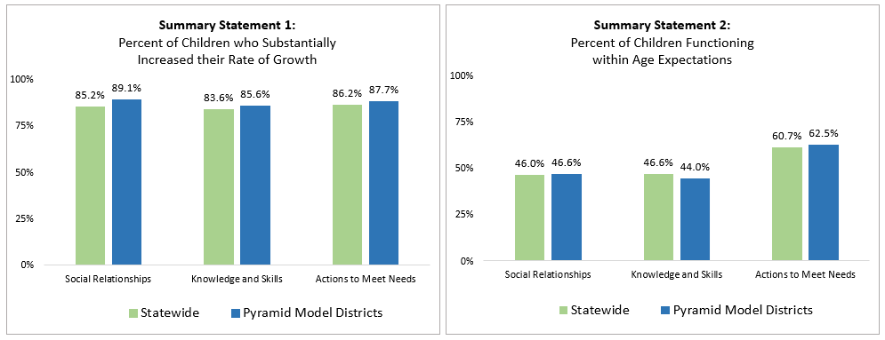
Figure 15. Statewide and Pyramid Model FFY 2018 Results across Child Outcomes

(e) Evaluation Summary and Considerations Going Forward
Evaluation findings continue to show the full range of planned MA SSIP activities being carried out according to the state’s plan, and in alignment to the MA SSIP Theory of Action. This includes broad statewide infrastructure initiatives across agencies, and within MA ECSE to support preschool children with disabilities. Data suggest that these systems are expanding annually, and greater coordination across agencies via combined efforts by project partners, stakeholders, and the SLT, is being achieved. In particular, MA DESE and MA EEC continue to streamline efforts to promote and support EC-PBS/Pyramid Strategies across school district and ECE program settings, with some early efforts toward building community-wide sites in three locations.
FFY 2018 findings also suggest progress within the Pyramid Model school districts as aligned with the EC-BoQ, as a measure of program-wide implementation. While progress has been made, the greatest areas for growth continue to be Monitoring Implementation and Outcomes (using data), and Family Engagement. On the whole, school district leadership teams are working with their external coaches to strengthen implementation within-district, and to expand to additional schools and classrooms. As in prior years, the number of participating schools and classrooms has increased. Results on classroom-level fidelity measures from a sample of teachers point to progress toward fidelity of implementation in the classroom, for these individuals.
With respect to benefits for children, project stakeholders continue to report that time spent in Pyramid Model classrooms has contributed to greater social emotional development, stronger academic potential, and reduced rates of suspension. Additionally, a sample of children with IEPs across 20 Pyramid Model districts, when viewed in the context of overall statewide results, are showing relative levels of performance beyond the larger statewide group. Larger datasets and results over time will help better identify trends in these data. Based on the evaluation, below are several ideas for stakeholder consideration.
Implementation Roadmap: To continue to build on the foundation being established, creating guidelines or roadmaps, within the context of an Implementation Science framework, would be useful to help advance districts closer to “full implementation”. The objective would be to operationalize the vision for where districts need to be, before they can consider sustainability. The roadmap would help set a path and suggested timeline, including plans for external coaches’ gradual release of responsibility (fade-out).
Planning to Sustain Pyramid Model Implementation: Evaluation findings suggest that districts need additional information about how to plan for sustaining the Pyramid Model, beyond full implementation and the eventual fade-out of support from an external coach. Relatedly, as external coaches work with districts to address plans, they too would benefit from common guidelines on what the process may “look like” for districts (i.e., timelines, readiness checklists/action plans, specific strategies), as well as ideas from other states that have done so effectively.
Monitoring Implementation and Outcomes: Building upon work underway this past year, additional guidelines and supports for districts related to using the data sources identified as part of the Pyramid Model implementation and decision-making system (i.e., EC-BoQ, TPOT, BIRs, Child Outcomes) will be important.
Internal Coaching: District capacity for internal coaching continues to present a challenge. Stakeholders have shared some of the specific realities they face, including competing priorities and lack of time and resources for the role. Continued focus on alternative solutions, such as PBC in a Group, the Internal Coach Community of Practice, and perhaps building internal coach teams, will be important going forward.
Implementation Fidelity: Relatedly, this year’s data suggest that TPOTs are being used to a modest extent, and in some districts, not at all. Increased use of the TPOT is warranted to continue to move teachers toward fidelity. Recognizing that EC-PBS Pyramid Model implementation is district-driven, project leaders should also consider conveying a stronger message to leadership teams about the recommended frequency and use of TPOTs for local PD planning and coaching activities.

F. Plans for Next Year

1. Additional Activities to be Implemented Next Year (with timeline)
After a thorough review of the current implementation data, MA DESE has identified a number of strengths and areas for continued growth which will drive the activities for next year (see Table 11 for timelines). Adjustments to data collection, use, and reporting are also planned. Each of these areas is described below.
- Activities that will be continued with little or minor adjustments:
- Actively engage with state and district stakeholders
- Strengthen state infrastructure, including intra- and inter-agency collaboration
- Build capacity of external coaches and support their work with district leadership teams and staff
- Encourage additional family engagement and evaluation of Positive Solutions
- Provide individualized training for teachers and coaches regionally or in districts
- Continue to provide discretionary grant funds to support costs associates with training and implementation, including stipends, substitutes, supplies, and materials
- Continue MA DESE visits to sites to each implementing school at least once per year, and more frequently as needed
- Activities that address areas for continued growth:
MA DESE is committed to supporting schools and districts to provide equal access and high-quality early childhood special education for children with disabilities. MA DESE and its partners will continue to analyze the infrastructure and available resources for most effectively expanding and sustaining the EC-PBS/Pyramid foundation that has been established. This includes supporting the ongoing scale up and work toward fidelity to new schools within implementing districts, as well as assessing the extent to which resources allow for new districts to begin training and coaching activities toward adopting the model. In all cases, the focus will remain on moving toward implementation fidelity and sustainability where implementation is underway. After an analysis of the data provided by the external evaluator, MA DESE, along with stakeholders, will commit to the following areas of focus moving forward by:
- Committing to professional development and coaching supports to promote implementation fidelity in schools and districts, which includes increased use of TPOT and continued focus on building capacity for internal coaching.
- Supporting initiatives to address significant disproportionality in the identification, placement and removals of children of color, implicit bias and ensure equitable access, including:
  - Providing districts with online data collection tools to analyze Behavior Incident Reports (BIRs) for district personnel to analyze both corrections and praise for children
  - Launching the Pyramid Equity Project in Massachusetts to support district personnel to identify and address implicit bias.
- Expanding opportunities for authentic family engagement.
- Supporting Leadership Teams to use data and plan for sustainability by:
  - Creating data-based Action Plans based on the analysis and synthesize of data, including BIR, BoQ, indicator 7, and TPOT data
  - Supporting Practice-Based Coaching
  - Building capacity for supporting challenging behaviors and writing effective behavior intervention plans
  - Promoting acquisition of early literacy and numeracy skills
- Data Collection, Use, and Reporting
- Support increased data reporting and analysis of Child Outcomes data collected via the COS process by providing additional training for COS collection, data-based decision making, and using COS data.
- Continue to increase training for data-based decision making (state, district, classroom, and child level) using COS data and other local level district data
- Continue to review statewide evaluation data collection tools to ensure data utility; refine as needed, and continue alignment with MA EEC Pyramid Model initiatives for assessing statewide progress
- Continue to build in processes for stakeholder review and processing of data for decision-making
- Continue to reinforce and streamline systems for data collection for the SSIP evaluation
- Continue state-level guidance for reporting de-identified TPOT data; support districts to increase reporting rates
Table 11. SSIP Implementation: February 2020 – Spring 2021
Date | Activities | Audience
Ongoing and Continuing | Communication with Pyramid Model Consortium staff | N/A
Ongoing and Continuing | Monthly External Coach Logs completed as monthly to document substantive contacts with districts | N/A
Ongoing and Continuing | Site visits by MA DESE staff to participating districts, including intensive support for Indicator 7 data collection | District leadership teams, external coaches, teachers
Ongoing and Continuing | Monthly Professional Learning Community (PLC) meetings | External coaches
Ongoing and Continuing | State-level Leadership Team Meetings | MA DESE, MA EEC, and MA DPH staff
May/June | Regional Leadership Team Meetings | District leadership teams and external coaches
Spring 2020 | Targeted Inclusion Strategy Events | Upon request – teachers, internal coaches, behavior specialists, and external coaches
3/23 – 3/24/20 | TPOT (Teacher Pyramid Observation Tool) Training | Internal coaches and external coaches
5/5/20 | Linking Social-Emotional and Early Literacy | Teachers, internal coaches, behavior specialists, and external coaches
5/6/20 | Positive Solutions for Families | Teachers, internal coaches, behavior specialists, and external coaches
6/2/20 | Prevent, Teach, Reinforce – Young Children (PTR-YC) | Teachers, internal coaches, behavior specialists, and external coaches
Ongoing and Continuing | Coaches’ Community of Practice:  - in-depth data-based decision making (using indicator 7)  - fidelity measures  - integration of literacy and numeracy instruction  - support for family engagement | External coaches
Ongoing and Continuing | Positive Solutions train-the-trainer w/MA EEC and FCSN | Teachers, internal coaches, behavior specialists, and external coaches
Monthly | Coaches’ Community of Practice - PBC | Internal coaches
FY 2021
Summer-Monthly | Trauma Informed Care – Family Engagement | Monthly Peer Learning Group
Summer/Early Fall | New staff “ramp up” | District leadership teams, internal coaches, and teachers
Monthly | Coaches’ Community of Practice | Internal coaches
Fall | Beginning of the Year Leadership Meeting, to include:  - BoQ  - implementation planning  - data-based decision making  - support for family engagement  - Behavior Incident Reports – Equity/Disproportionality data | District leadership teams and external coaches
Summer/Fall | Practices Training | Teachers, paraprofessionals, other staff
Fall | Embedding Equity Guide into Practice Based Coaching | Internal coaches and external coaches
 | Positive Solutions Train-the-trainer | Teachers, internal coaches, behavior specialists, and external coaches
 | TPOT (Teacher Pyramid Observation Tool) Training | Internal coaches and external coaches
 | Prevent Teach, Reinforce – Young Children (PTR-YC) | Teachers, internal coaches, behavior specialists, and external coaches
 | Practice Based Coaching (PBC) | Teachers, internal coaches, behavior specialists, and external coaches
Fall/Winter | Practice Based Coaching in a Group | Teachers, internal coaches, behavior specialists, and external coaches
Winter/Spring | Practices Training | Teachers, paraprofessionals, other staff
 | Positive Solutions Train-the-trainer | Teachers, internal coaches, behavior specialists, and external coaches
 | TPOT (Teacher Pyramid Observation Tool) Training | Internal coaches and external coaches
 | Prevent Teach, Reinforce – Young Children (PTR-YC) | Teachers, internal coaches, behavior specialists, and external coaches
 | Prevent Teach, Reinforce – Families (PTR-F) | Teachers, internal coaches, behavior specialists, and external coaches
 | TPITOS | External coaches, internal coaches
 | Linking Social-Emotional and Early Literacy | Teachers, internal coaches, behavior specialists, and external coaches
 | Regional Leadership Team Meetings | District leadership teams and external coaches

2. Planned Evaluation Activities Including Data Collection, Measures, Expected Outcomes
The evaluation approach for the coming year will be consistent with the plan presented in Section C of this report. In the coming year, MA DESE will continue to collaborate with stakeholders to monitor and refine this plan including the key questions, intended outcomes, and data collection processes. In particular, the external evaluator will work with MA DESE, project partners, and key stakeholders to identify indicators, data sources, and data collection processes for assessing child outcomes associated with the EC-PBS Pyramid/strategies initiative.
In coordination with the external evaluator, MA DESE will continue to fine-tune data collection tools and procedures to ensure high response rates, and a continued focus on valid and reliable data across all measures. The IDC Framework for High-Quality Data, as referenced in Section D, will continue to serve as a guide. MA DESE will continue to review all data as they become available to continue its cycle of inquiry for continuous improvement. Table 12 shows the evaluation plan for the coming year including key questions and an abbreviated list of intended outcomes, as well as data sources and timelines.
Table 12. SSIP Evaluation Plan: March 2020 – February 2021
Evaluation Questions | Intended Outcomes | Data Sources | Anticipated Timeline
State Level Infrastructure
EQ1a  In what ways is MA DESE using the SSIP, including statewide implementation of EC-PBS through Pyramid strategies, to build state-level capacity to support improved social emotional outcomes for young children with disabilities? | S1. Short Term and Intermediate  In order to build state capacity, MA DESE will…  - Provide statewide and regional training on PBS through Pyramid strategies  - leverage the cadre of PBS external coaches to support districts and communities;  - collaborate with community and social services agencies to provide additional training and support to families. | - Extant project documents  - Statewide training and meeting data, feedback forms  - External Coach Log; External Coach Survey | - All ongoing throughout the year  - Fall 2020
EQ1b  To what extent is implementation of EC-PBS through Pyramid strategies in MA integrated with other early childhood and/or MA DESE initiatives at the community/local and state levels? | S2. Intermediate  MA DESE will…  - engage in ongoing collaboration with colleagues in Part C and K-12 PBIS initiatives  - engage in ongoing collaboration to continue to promote local level integration of PBS. | - Extant project documents | - Ongoing
EQ1c  To what extent is MA DESE making the intended improvements to the workforce development structure as identified through the evaluation and outlined in its annual reports? | S3. Short Term and Intermediate  (In 2020-21) MA DESE will…  - Provide training and build skills related to implicit bias, equity  - Build capacity to use data, especially child level outcome data | - Extant project documents  - Statewide training data  - Mid-Year Leadership Survey | - Ongoing  - December 2020
Program/District Infrastructure
EQ2a  Is the state-level plan resulting in the number of districts, schools, and classrooms participating in PBS through Pyramid strategies growing over time? | S4. Long Term  MA DESE will provide adequate training and support in EC-PBS/Pyramid Model strategies so that participating districts build capacity to expand implementation. | - EC-PBS/Pyramid Implementation Profile  - Mid-Year Leadership Survey | - February 2021  - December 2020
EQ2b  To what extent are districts developing systems to support and sustain program-wide EC-PBS through Pyramid strategies? | D2. Intermediate  The participating districts have established a system-wide approach to implementing and sustaining PBS/Pyramid strategies as aligned with the EC-BoQ | - EC-BoQ v2.0 assessments  - Mid-year Leadership Team Survey | - Fall and spring  - December 2020
Classroom Level
EQ3a  To what extent are teachers implementing EC-PBS through Pyramid strategies in their classrooms? | D3. Intermediate  Teachers will be able to implement PBS through Pyramid strategies with fidelity to improve the social/emotional development of young children with disabilities. | - Mid-year Leadership Team Survey  - Pyramid Model Teacher Survey  - TPOT results | - December 2020
EQ3b  Does the fidelity of classroom implementation improve over time? | D4. Long Term  Teachers will demonstrate improved implementation fidelity over time. |  | - February 2021
Student Level
EQ4a  To what extent do district and school personnel perceive benefits of implementing EC-PBS/Pyramid strategies for children? | C1. Long Term  Students of teachers implementing EC-PBS/Pyramid strategies will demonstrate improved social/emotional competencies and other academic benefits. | - Mid-year Leadership Team Survey  - Pyramid Model Teacher Survey | - December 2020
EQ4b (NEW QUESTION)
To what extent are student benefits reflected in classroom/school level assessment/performance data?
EQ4b  Is the number of children in MA, aged 3-5, with disabilities, exiting from preschool with age-expected social emotional functioning increasing? | C2. Long Term  Children with disabilities, aged 3-5, will exit preschool with social/emotional competencies that will allow them to access and participate in the general curriculum and in all aspects of the school. | - Indicator 7 data | - Annually in spring
EQ4c
Is the number of children in MA, aged 3-5, with disabilities, exiting from preschool with greater than expected growth in their social emotional functioning increasing?

3. Anticipated Barriers and Solutions
MA DESE has planned for the following contingencies in implementing the next steps of the MA SSIP, shown in Table 13.
Table 13. Anticipated Barriers and Solutions
Anticipated Barrier | Solution
Greater requests from districts to join the cohort than current state infrastructure can accommodate. | - Create model districts and support leadership teams to become mentors  - Through support of national TA centers, train highly effective external coaches to build “in-state” experts.
Attrition of trained local staff (ongoing concern). | - Provide new staff “ramp up” training and support at the beginning of the school year.  - Provide Massachusetts educators with access to the ePyramid Modules through its Learning Management System in the coming year will help address training needs.
State model does not adequately account for diverse local level needs. | - Stakeholders engage in continuous feedback loop and data analysis to address diverse community needs and provide responsive, individualized supports for district staff and families.
External coaches and local staff are not using COS data and other child level outcomes data to make meaningful decisions and integrating IEP goals | - MA DESE is working with Early Childhood Technical Assistance center (ECTA) and PMC to increase training and build capacity for external coaches; coaches will then become trainers for SSIP districts.  - MA DESE is in process of hiring vendor to develop statewide guidance documents, online resources, including modules, related to COS and other child level data.

4. State’s Need for Additional Support/TA
MA DESE relies on the technical assistance and support from OSEP directly and from OSEP-funded TA centers, including, the IDEA Data Center (IDC), the National Center for Systemic Improvement (NCSI), the Early Childhood Technical Assistance Center (ECTA). MA DESE participated in a variety of individualized, targeted, and universal TA, most notably, support from the IDC to reset targets for Indicator 7.
MA DESE has been accepted for an intensive TA opportunity with the National Center for Pyramid Model Innovations (NCPMI) to build internal state expertise in the Pyramid model and engage in high leverage coaching activities. Further support beyond what has been provided is not needed.

APPENDIX
- Early Childhood Program-Wide PBS Benchmarks of Quality (version 2.0) Critical Elements and Quality Indicators
- Massachusetts Early Childhood Special Education – EC-PBS eNewsletter, June 2019 (evaluation edition)

Early childhood program-wide benchmarks of quality
Critical elements and quality indicators
Adapted from: Early Childhood Program-Wide PBS Benchmarks of Quality, version 2.0, Lise Fox,
Mary Louise Hemmeter, Susan Jack, and Denise Perez Binder (2017)
establish leadership team
- Team has broad representation that includes at a minimum a teacher, administrator, a member who will provide coaching to teachers, a member with expertise in behavior support and a family member. Other team members might include a teaching assistant, related service specialists, a community member, and other program personnel.
- Team has administrative support. Administrator attends meetings and trainings, is active in problem-solving to ensure the success of the initiative, and is visibly supportive of the adoption of the model.
- Team has regular meetings. Team meetings are scheduled at least 1x per month for a minimum of 1 hour. Team member attendance is consistent.
- Team has established a clear mission/purpose. The team purpose or mission statement is written. Team members are able to clearly communicate the purpose of the leadership team.
- Program has a child discipline policy statement that includes the promotion of social and emotional skills, use of positive guidance and prevention approaches, and eliminates the use of suspension and expulsion.
- Team develops an implementation plan that includes all critical elements. A written implementation plan guides the work of the team. The team reviews the plan and updates their progress at each meeting. Action steps are identified to ensure achievement of the goals.
- Team reviews and revises the plan at least annually.
Staff buy-in
- A staff poll is conducted in which at least 80% of staff indicate they are aware of and supportive of the need for a program wide effort for (a)addressing children’s social emotional competence and challenging behavior, (b) using culturally responsive practices, and (c) addressing implicit bias.
- Staff input and feedback is obtained throughout the process – coffee break with the director, focus group, suggestion box. Leadership team provides update on the process and data on the outcomes to program staff on a regular basis.
Family engagement
- Family input is solicited as part of the planning and decision-making process. Families are informed of the initiative and asked to provide feedback on program- wide adoption and mechanisms for promoting family involvement in the initiative (e.g., suggestions box, focus group).
- There are multiple mechanisms for sharing the program wide plan with families including narrative documents, conferences, and parent meetings to ensure that all families are informed of the initiative.
- Family involvement in the initiative is supported through a variety of mechanisms including home teaching suggestions, information on supporting social development, and the outcomes of the initiative. Information is shared through a variety of formats (e.g., meetings, home visit discussions, newsletters in multiple languages, open house, websites, family friendly handouts, workshops, rollout events, access to staff with bilingual capacity).
- Families are involved in planning for individual children in a meaningful and proactive way. Families are encouraged to team with program staff in the development of individualized plans of support for children including the development of strategies that may be used in the home and community.
program-wide expectations
- 2-5 positively stated program-wide expectations are developed.
- Expectations are written in a way that applies to both children and staff. When expectations are discussed, the application of expectations to program staff and children is acknowledged.
- Expectations are developmentally appropriate and linked to concrete rules for behavior within activities or settings.
- Program staff and families are involved in the identification of the program-wide expectations that address needs, cultural norms and values of the program and community
- Expectations are shared with families and staff assist families in the translation of the expectations to rules in the home.
- Expectations are posted in classrooms and in common areas in ways that are meaningful to children, staff and families.
- Strategies for acknowledging children’s use of the expectations are developmentally appropriate and used by all program staff including administrative and support staff (e.g., clerical, bus drivers, kitchen staff).
Professional development and staff support plan
- A plan for providing ongoing support, training, and coaching in each classroom on the Pyramid Model including culturally responsive practices and implicit bias is developed and implemented.
- Practice-based coaching is used to assist classroom staff with implementing the Pyramid Model practices to fidelity.
- Staff responsible for facilitating behavior support processes are identified and trained.
- A needs assessment and/or observation tool is used to determine training needs on Pyramid Model practices.
- All teachers have an individualized professional development or action plan related to implementing Pyramid Model and culturally responsive practices with fidelity
- A process for training new staff in Pyramid Model and culturally responsive practices is developed.
- Incentives and strategies for acknowledging staff effort in the implementation of Pyramid Model practices are implemented.
Procedures for responding to challenGing behavior
- Teachers have received training related to potential bias when responding to behavior challenges and have strategies to reflect on their responses to individual children
- Program staff respond to children’s problem behavior appropriately using evidence- based approaches that are positive, sensitive to family values, culture and home language, and provide the child with guidance about the desired appropriate behavior and program-wide expectations.
- A process for responding to crisis situations related to problem behavior is developed. Teachers can identify how to request assistance when needed. A plan for addressing the child’s individual behavior support needs is initiated following requests for crisis assistance.
- Teachers have opportunities to problem solve with colleagues and family members around problem behavior. Teachers are encouraged to gain support in developing ideas for addressing problem behavior within the classroom (e.g., peer-support, classroom mentor meeting, brainstorming session).
- A team-based process for addressing individual children with persistent challenging behavior is developed. Teachers can identify the steps for initiating the team-based process including fostering the participation of the family in the process.
- An individual or individuals with behavioral expertise are identified for coaching staff and families throughout the process of developing and implementing individualized intensive interventions for children in need of behavior support plans.
- Strategies for partnering with families when there are problem behavior concerns are identified. Teachers have strategies for initiating parent contact and partnering with the family to develop strategies to promote appropriate behavior.
monitoring implementation and outcomes
- Data are collected, summarized with visual displays, and reviewed by the leadership team on a regular basis.
- The program leadership team monitors implementation fidelity of the components of program-wide implementation and uses data for decision making about their implementation goals.
- The program measures implementation fidelity of the use of Pyramid Model practices by classroom teachers and uses data on implementation fidelity to make decisions about professional development and coaching support.
- The program collects data on behavior incidents and program actions in response to behavior and uses those data to address child and teacher support needs.
- Behavior incident and monthly program action data are analyzed on a regular basis to identify potential issues related to disciplinary action bias.
- Program-level data are summarized and shared with program staff and families on a regular basis.
- Data are used for ongoing monitoring, problem solving, ensuring child response to intervention, and program improvement.
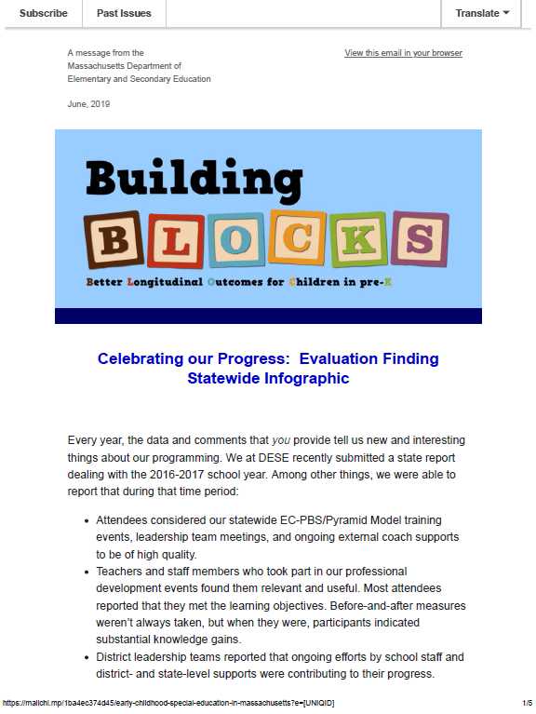

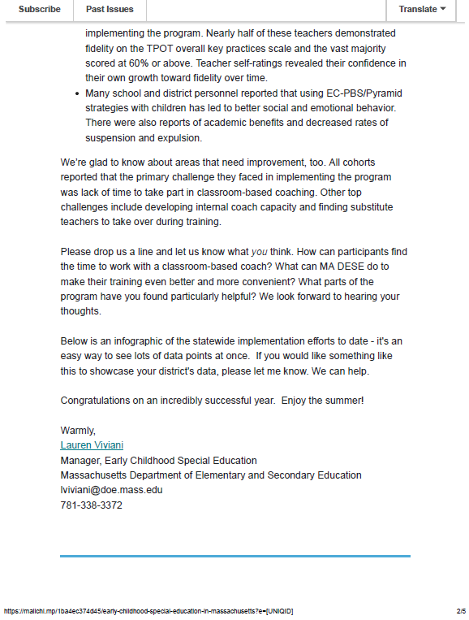

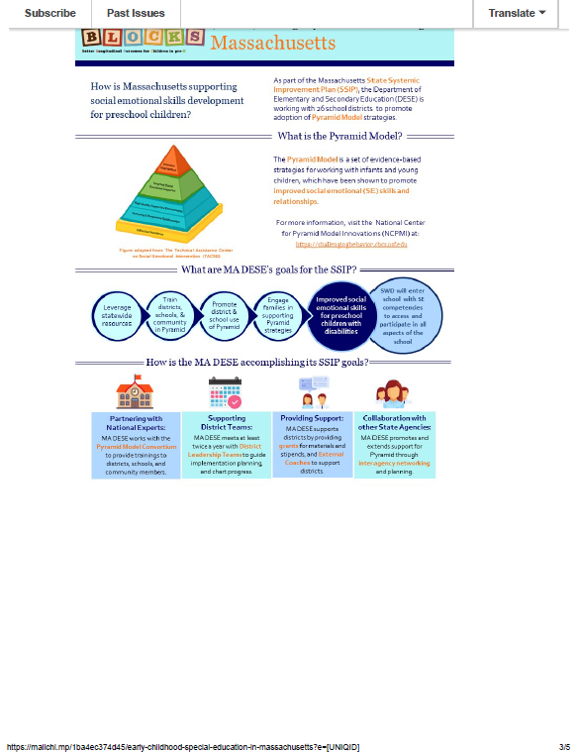

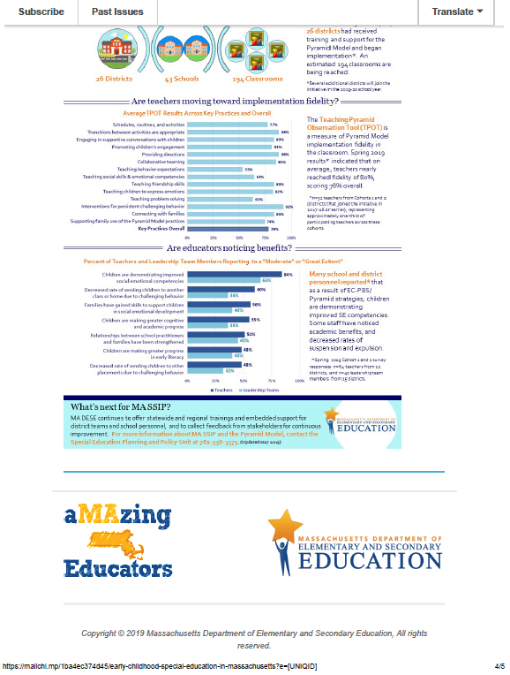

Further detailed information about summary statement calculations, data collection samples, methods, and tools can be found in MA DESE’s FFY 2018 Part B State Performance Plan (SPP)/Annual Performance Report (APR).
Early Childhood Program-wide PBS Benchmarks of Quality (2010), Lise Fox, Mary Louise Hemmeter, and Susan Jack.
Early Childhood Program-wide PBS Benchmarks of Quality, version 2.0 (2017), Lise Fox, Mary Louise Hemmeter, Susan Jack, and Denise Perez Binder.
Teaching Pyramid Observation Tool (TPOT) for Preschool Classrooms (2014), Lise Fox, Mary Louise Hemmeter, and Patricia Snyder.
Updates for one district were not available for FFY 2018, therefore district counts are based on prior information.

