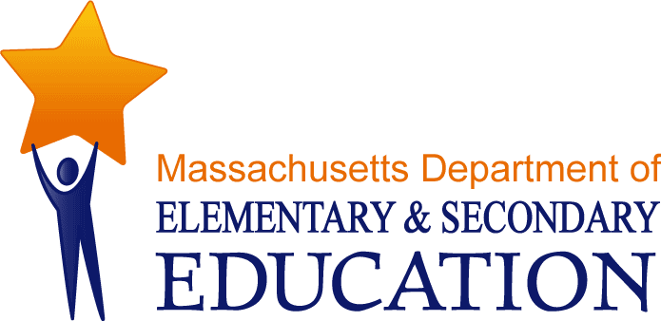

Guidelines:
For the Specialized Assessment of Students with Visual Impairments

July 2012

Appendix D: Resources

Massachusetts Organizations/Resources/Educational Programs
Carroll Center for the Blind*
The Carroll Center for the Blind provides direct and consultative services to children and adults throughout the state. The Center also serves as an information resource.
The Massachusetts Accessible Instructional Materials Library -AIM Library
The Massachusetts Accessible Instructional Materials Library (AIM Library), formerly called the Vision Resource Library (VRL), acquires, maintains and distributes specialized instructional materials, as well as coordinates textbooks in Braille and large print, to assist school districts and educators in Massachusetts to provide students with visual impairments an appropriate education and equal access to the general curriculum.
Massachusetts Commission for the Blind (MCB)
The MCB is primarily an adult vocational rehabilitation agency, but some technical assistance is available to high school students and consultation to families and schools. No direct services are provided, but MCB can be an information resource.
New England Center for Deafblind (NEC)
The NEC provides technical assistance to children and families in Connecticut, Maine, Massachusetts and New Hampshire. No direct services are provided, but consultation, training and referral services are available.
Northeast Regional Center for Vision Education (NERCVE)
Northeast Regional Center for Vision Education (NERCVE) is an established center within the Institute for Community Inclusion that is academically affiliated with the University of Massachusetts Boston, Graduate College of Education. UMass Boston is New England's only academic center for preparing Teachers of Students with Visual Impairments and Orientation and Mobility Specialists, two key specialties that assist people with visual impairments achieve their goals of high quality education, employment, and independent travel.
Perkins School for the Blind*
Direct and consultative services to children from birth through age 22 throughout the state. The Perkins School for the Blind also serves as an information resource.

*Educational Program
National Organizations/Resources
Academy for Certification of Vision Rehabilitation and Education Professionals (ACVREP)
A national professional organization which administers testing and awards national certification to certified orientation and mobility specialists, certified vision rehabilitation therapists and certified low vision therapists.
American Foundation for the Blind (AFB)
The American Foundation for the Blind (AFB) is a national nonprofit agency that expands possibilities for people with vision loss.
The National Braille Press (NBP)
The National Braille Press is a nonprofit Braille printing and publishing house. NBP has an extensive catalog of books and a children's book club.
National Center to Improve Practice in Special Education Through Technology, Media and Materials (NCIP)
This website provides a list of resources, general information, practices, products, organizations and publications that support users with visual impairments. These resources were compiled during NCIP's period of funding, 1992-1998. If you have any questions about a resource, please use the contact information listed for the resource. NCIP encourages the reproduction and distribution of these materials as long as the contents are not altered in any way, and credit is given to NCIP.
The National Federation of the Blind
With more than 50,000 members, the National Federation of the Blind is the largest and most influential membership organization of blind people in the United States. The NFB improves blind people’s lives through advocacy, education, research, technology, and programs encouraging independence and self-confidence.
National Instructional Materials Accessibility Standard (NIMAS)
The Individuals with Disabilities Education Act of 2004 (IDEA) is the main federal program authorizing state and local aid for special education and related services for children with disabilities. One significant improvement in the 2004 legislation was the addition of sections defining the provision of textbooks and instructional materials in accessible formats for students with vision impairments or print disabilities. NIMAS will guide the production and electronic distribution of curricular materials in accessible, student-ready versions, including Braille and digital talking books.
National Organization of Parents of Blind Children (NOPBC)
The National Organization of Parents of Blind Children (NOPBC) is a national membership organization of parents and friends of children with blindness reaching out to each other to give vital support, encouragement, and information.
Functional Vision Assessment Resources

Assessment and Instructional Resources provided by Texas School for Blind and Visually Impaired: http://www.tsbvi.edu/Education/IAER-ASS.html#_1_16

Ross, Karen S. (1987) Family Consultation Competencies for Educators of the Visually Impaired. Dissertation.

Sanford L. & Nurnett, R. (n.d.). Functional vision assessment for preschool or students with multiple impairments. Unpublished Protocol. Hermitage, TN: Consultants for the Visually Impaired.

A searchable data base from Perkins: These online resources related to Functional Vision Assessments have been carefully evaluated.
http://www.perkins.org/resources/scout/vision-and-blindness/functional-vision-assessmen.html

Learning Media Assessment Resources

Learning Media Assessment of Students with Visual Impairments: A Resource Guide for Teachers, Alan J. Koenig and M. Cay Holbrook (1995)

Perkins School for the Blind webpage on The Learning Media Assessment with links to additional resources: http://www.perkins.org/clearinghouse/literacy/lma.html

Braille/Print Literacy Issues and the Learning Media Assessment
By Eva Lavigne and Ann Adkins, TSBVI Outreach. http://www.tsbvi.edu/Outreach/seehear/spring03/literacy.htm

Assistive Technology Assessment Resources

Additional information on Assistive Technology and the National Instructional Materials Accessibility Standard (NIMAS) can be found on the Massachusetts Department of Elementary and Secondary Education website at: http://www.doe.mass.edu/edtech/assistive/

Principles of Assistive Technology for Students with Visual Impairments: http://www.tsbvi.edu/technology/principles.htm

Technology Assessment Checklist for Students with Visual Impairments: http://www.tsbvi.edu/technology/tech-assess-checklist.htm

Association of Massachusetts Educators of Students with Visually Impairments:
http://www.amesvi.org/id7.html

Orientation and Mobility Assessment Resources

A list of (links to) orientation and mobility assessment tools:
http://www.tsbvi.edu/recc/om.htm

A searchable data base from Perkins: These online resources related to orientation and mobility have been carefully evaluated.
http://www.perkins.org/resources/scout/orientation-and-mobility/resources-for-specialists.html

Resources for Orientation & Mobility Specialists:
http://orientationandmobility.org/index.html

Association of Massachusetts Educators of Students with Visually Impairments:
http://www.amesvi.org/id6.html

Expanded Core Curriculum Resources

American Foundation for the Blind (AFB):
http://www.afb.org/Section.asp?SectionID=44&TopicID=189&SubTopicID=4

National Agenda for the Education of Children and Youth with Visual Impairments, Including those with Multiple Disabilities. (Hosted by Texas School for the Blind and Visually Impaired):
http://www.tsbvi.edu/agenda/wi-ecc.htm

Iowa Expanded Core Curriculum (ECC) Resource Guide, Iowa Department of Education:
http://www.iowa.gov/educate/index.php?option=com_content&view=article&id=576:blindness-and-visual-impairment&catid=539:programs-a-services&Itemid=1610

