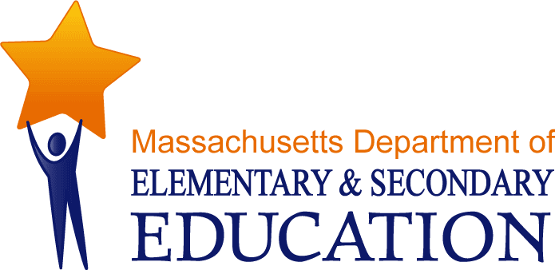
Guidelines:
For the Specialized Assessment of Students with Visual Impairments

July 2012

The Impact of Vision Loss on Learning
Communication and learning styles are significantly affected by vision loss, whether these losses or impairments are lifelong, intermittent, or increase over time. Since most assessments are developed for students who see, it is critical that professionals trained in the education of students with visual impairments select and administer specialized assessments for these students that determine:

- the strategies and modalities for learning and communication;

- the appropriate media for literacy development and access to the general education curriculum, which may include print, Braille, tactile communication systems, and/or picture systems; and

- the areas of need relative to orientation and mobility, social skills, daily living skills, career education, visual efficiency, assistive technology, and compensatory skills as appropriate.

Most students with visual impairments are educated in inclusive settings and receive instruction from general education teachers. The students may also receive services from special education teachers and/or related service providers. Although licensed in their specific disciplines, the training programs for these professionals generally provide limited knowledge of and experience with the evaluation and education of students with visual impairments.

Fully understanding the sensory capacity, learning profiles, and communication styles of students with visual impairments will provide evaluators the information they need to select, administer, and/or adapt the most appropriate assessments for a student. This knowledge will also assist teachers, therapists, school administrators and other school personnel to understand how a visual impairment affects a student’s ability to function across all settings in the school environment. Understanding the following “hidden” characteristics of a vision loss will enable non-vision specialists to facilitate meaningful inclusion and participation of students with visual impairments.

Students with visual impairments:

- Have limited ability to learn incidentally. This affects how they form concepts and develop schema or frameworks for understanding new ideas and vocabulary that provide essential foundation skills for comprehension and abstract reasoning. Learning social skills, play skills and adaptive living skills are likewise affected. Interpreting non-verbal, social interactions especially body language, understanding another person’s point of view, and working in cooperative learning groups are markedly enhanced by “seeing” other’s responses to these interactive activities. Mastering these skills may require explicit instruction for students with visual loss. Limited incidental learning also affects performance on standardized assessments, especially cognitive and achievement tests, where questions are based on assumptions about the kinds of information that should be known by certain chronological ages. Tests that have not been standardized on students with visual impairments may underestimate students’ true abilities and the results should be interpreted with caution.

- Use their other senses differently from their teachers, therapists and peers with vision. This has far-reaching implications for both the methodology and the content of instruction. Teachers typically teach using “visual” vocabulary and strategies to describe how things look (colors, shapes, outlines), where they exist in the environment (in the small drawer above the atlas), how they are ordered (first, last, etc.) in order for students to code information into visual images that will help them take in, store and recall information. Students with visual impairments rely on their other senses to do this. Teachers need to understand this in order to adapt their instruction and use other sensory information to explain concepts and directions, such as how something smells, or feels, or tastes. In this manner, teachers can incorporate the learning style of the student with visual impairment into their directions, the class discussions, and student performance expectations.

- Differ from one another and from day to day. Two students with the same levels of vision and cognition may “see” differently due to the etiology of their vision loss and/or environmental factors related to the nature of the task they are viewing, such as the lighting or the visual complexity of the task. Moreover, the same student may “see” differently from day to day because of internal, personal factors including fatigue, motivation, attention, and other considerations.

Vision education specialists are experts in understanding and applying this information to assist in the design and implementation of appropriate services for specific students with vision loss to ensure their access to the general education curriculum and successful participation in a general education environment, regardless of the educational setting where services are provided. They are also experts in providing consultation and technical assistance to school personnel around understanding how these characteristics of vision loss affect students in non-academic areas of the school and community.

