Synopsis of high-quality task:

Your school is building a new playground. The principal is asking for your help to design a play space that children will really enjoy. Mrs. Mills decides to have a contest to see whose idea will become the actual play space for the school. You are going to enter your design! You will be given a piece of graph paper that represents 17 yards by 22 yards. You are expected to present a two-dimensional model of your playground that is not drawn to scale.
- What is the total area of the playground you will design? Demonstrate your understanding using a visual representation, numbers and words.

- Within the area, you will need to create three rectangular areas within your play space: a playground, a picnic area, and a field to play sports in. What is the area of each space? Demonstrate your understanding using a visual representation of each section on your graph paper, numbers and words. Label each section on your graph paper in a clear, organized way.

- Mrs. Mills also expects the playground to be safe for children, so you need to provide measurements for the purchase of fence. The requirement is that there is fencing around each rectangular section you have designed as well as the entire play space itself.

- Mrs. Mills only has a budget of $4,000 to purchase fencing. Each yard of fence costs $3 a foot. How much will it cost to purchase the fencing needed for your play space? Would Mrs. Mills be able to use your design why or why not? Use pictures, numbers and words to justify your response.

Anticipated student time spent on task: 120. It may be wise to separate the task into two 60-minute sessions.

Student task structure(s): Individual work/partner work/group work

Math Content Standards and Practices:

4.OA.A.3 Solve multistep word problems posed with whole numbers and having whole number answers using the four operations, including problems in which remainders must be interpreted. Represent these problems using equations with a letter standing for the unknown quantity. Assess the reasonableness of the answer using mental computations and estimation strategies including rounding.
4.NBT.A.3 Use place value understanding to round multi-digit whole numbers to any place value
4.NBT.B.4 Fluently add and subtract multi-digit whole numbers using the standard algorithm.
4.NBT.B.5 Multiply a whole number of up to four digits by a one-digit whole number, and multiply two-digit numbers, using strategies based on place value and the properties of operations. Illustrate and explain the calculations by using equations, rectangular arrays, and or area models.
4.MD.A.2 Use four the four operations to solve word problems involving distances, intervals of time, liquid volumes, masses of objects and money, including problems involving simple fractions or decimals, and problems that require expressing measurements given in a larger unit in terms of a smaller unit. Represent measurement quantities using diagrams such as a number line diagrams that feature a measurement scale.
4.MD.A.3 Apply the area and perimeter formulas for rectangles in real world and mathematical problems.

SMP 1 Make sense of problems and persevere in solving them.
SMP 2 Reason abstractly and quantitatively.
SMP 4 Model with mathematics.
SMP 8 Look for and express regularity in repeated reasoning.

Prior Knowledge:

3.OA.A.1 Interpret products of whole numbers as the total number of objects in each group
3.0A.A.3 Use multiplication and division within 100 to solve word problems in situations involving equal groups, arrays, and measurement quantities e.g. by using drawings and equations with a symbol for the unknown number to represent the problem.
3.OA.D.8 Solve two step word problems, using the four operations. Represent these problems using equations with a letter standing for the unknown quantity. Assess the reasonableness of answers using mental computation and estimation strategies including rounding.
3.NBT.A.1 Use place value understanding to round whole numbers to the nearest 10 or 100.
3.NBT.A.2 Fluently add and subtract within 1000 using strategies and algorithms based on place value properties of operations, and/or the relationship between addition and subtraction.
3.MD.C.5 Recognize area as an attribute of a plane figure and understand concepts of area measurement.
3.MD.C.5.a A square with side length 1 unit, called a “unit square,” is said to have “one square unit” of area, and can be used to measure area.
3.MD.C.5.b A plane figure which can be covered without games or overlaps by n unit squares is said to have an area of n square units.
3.MD.C.6 Measure areas by counting unit squares (square cm, square m, square in, square ft, and improvised units).
3.MD.C.7 Relate area to the operations of multiplication and addition.
3.MD.C.7.a Find the area of a rectangle with whole number side lengths, and show that the area is the same as would be found by multiplying the side lengths.
3.MD.C.7.b Multiply side lengths to find areas of rectangles with whole-number side lengths in the context of solving real world and mathematical problems, and represent the whole number products as rectangular areas in mathematical reasoning.
3.MD.D.8 Recognize perimeter as an attribute of plane figures and distinguish between linear and area measures. Solve real world and mathematical problems involving perimeters of polygons, including finding the perimeter given the side lengths, finding an unknown side length, and exhibiting rectangles with the same area and different perimeters.
2.MD.C.8 Solve world problems involving dollar bills, quarters, dimes, nickels, and pennies (up to $10), using $ and ¢ symbols appropriately and whole dollar amounts.

Connections to the real-world:

Children connect to the idea of play spaces and playgrounds. Most children have had experience with playgrounds in one form or another through schools, after school, weekends with families, or even in books or in television where children watch others play on their favorite sitcoms. This performance tasks gives children an opportunity to be the designers of their own playground. Hopefully though this performance task, students will discover math in a world outside of school. Children will open their eyes to math all around them. This also connects designing to architecture, planning and cost of projects. Through this task, students will work through planning, designing and considering the cost of their design. Learning to be thoughtful through this process of problem solving is a vital tool to be successful in the world today.

Mastery Goals:

Learning Objective:
Students will be able to design a play space while demonstrating their understanding of area and perimeter.
Students will be able to convert a larger measurement to a smaller measurement.
Students will be able to assess the reasonableness of their solutions using estimation.

Language Objective:
Students will provide a written response to the following question: “Would Mrs. Mills be able to use your design why or why not? Use pictures, numbers and words to justify your response.”

Students who work in partnerships/groups: Students will discuss a plan for their two-dimensional play space. Students will discuss the meaning of the problem, possible solutions and plan a pathway to the completion of the task.

Students will use appropriate vocabulary such as area, perimeter, measurement, estimation and reasonableness in their discussions and justifications with their classmates.

Teacher instructions
Instructional Tips/Strategies/Suggestions:
- This task is scheduled to take 120 minutes individually, in partners or in small groups.
- Students should be given a set time to plan. Students should be given a draft graph paper to use as a planning tool for their final draft.
- Students will need to have access to graph paper that is 17 by 22 squares.
- Some students may struggle with the abstractness of the graph paper. As a modification, students should have access to manipulatives (place value blocks “ones” work well, also known as centimeter cubes.) This may aid in bridging the conceptual understanding of area and perimeter and the abstract two-dimensional map. This may help students who struggle with spatial reasoning plan out their play space.
- Sentence stems and vocabulary word banks may be added to the task to support those just acquiring English, or have an educational plan (see below)
- Students will need to have an understanding of what the phrase “Not drawn to scale” means. This may be a bit abstract for some students and may need a pausing point. Students do see this phrase on standardized tests, and it may be worthwhile taking the time to explain it.
- Students will have the openness to be able to make the size of their play sections as small or as large as will the graph paper will allow. However, students will need to think about the reasonableness of the size of the area they are choosing. For example, a soccer field would not be reasonable if it the area was 12 square feet in total so that they could have an enormous playground section. Students will need to think about the reasonableness of each area as they are planning.
- It is important to note that the measurement of each square is in yards, however, the measurement of the fence given is in feet. There is a conversion that children need to do (I would not point that out to students, but allow for self-discovery).
- Student responses to the problems will vary. The task is designed for students to have different solutions.
- Included is a reference sheet and student sheets that only have one problem on each page. This is so that you can modify the problems you want them to solve. It also gives students more work space.
- If you are choosing to use this as an independent task or as a partnership/group task, the following guiding questions can be used to support the productive struggle of the student:
  - What do you know? What are you trying to find out?
  - How much area have you used so far? How much do you have left?
  - What might help you?
  - Have you tried to draw out/create a model of what you are thinking?
  - Have you labeled the measurements?

Day 1:
  - Introduce the Performance Task to all students: 10 Minutes
    - Access or build prior knowledge: What experiences do you already have with area? Perimeter? What understanding do you already have in using area and perimeter?
How many of you have ever played at a playground? What does a playground usually have in it? Have you ever noticed a fence around the area where you play? Brainstorm information together on a chart to use as a reference as students are working on the performance task.
    - Building vocabulary: Post words from the word bank with visuals (provided below)
      - Be aware of Tier 2 vocabulary words that students may need clarification on such as: fence, dimensional, requirements, budget and purchase. Review, post and discuss meaning as you administer the task.
  - Students work independently to begin to brainstorm and plan: 10 Minutes
  - This may be a time to bring the class together to discuss the task. 15 Minutes
    - What have you discovered so far? What are you sure of? What are you struggling with?
  - Then, work time to continue to plan and solve either independently, with partners or within their small groups. (Suggested time: 60 minutes)
    - Circulate, offering support and clarification as needed. If you see a majority of students struggling with the same concept, this would be an opportunity to share out the problem and work out possible solutions together. This is a great opportunity to think about SMP 1: Making sense of problems and persevering in solving them
    - By the end of this time, students should have a completed labeled two-dimensional map. Students should also have the performance task complete with equations, and clearly labeled solutions.
  - (Optional) Day 1 Debrief: 10 Minutes: This is where students would share out their mathematical thinking thus far.
    - How have you used your math knowledge or understanding today? Use precise math vocabulary in your discussion.
I have used my math knowledge about __________ to help me today to___________.

    - What did you discover about today?
I have figured out that ______________ by ______________.

*You may choose to spread this out over a two-day period, if so, a suggestion would be to extend the independent/ partner work during day one. Then, on day two take the time for discussion and sharing out of the variety of solutions.
- Share: Students have an opportunity to showcase their solutions. (Teacher note: Collect the work from the previous day. Notice the variety of possible solutions and choose three that will be presented to the class. Perhaps, the first would be the most common, then the second is more sophisticated and lastly is the one that demonstrates the highest level of sophistication.
    - How are these solutions similar? How are they different?
    - Is the information accurate? How do you know? Justify your response with evidence
    - How does this problem change the way you look at math in the real world?

Instructional Materials/Resources/Tools:
Graph paper (multiple copies per student/partner/small group)
Colored tiles
Colored pencils
Performance Task worksheet for each student
Rubric for each student

Accessibility and Supports:

Potential sentence starters:
The area of the__________ is___________________.
The perimeter of the _________ is _______________.
The total cost of the fence is ____________________.
Mrs. Mills will be able to use my design because ________________________.
Mrs. Mills will not be able to use my design because _____________________.

Materials:
Use of colored tiles (to help support students who struggle with spatial reasoning or need support to bridge their understanding from conceptual to the abstract two dimensional blueprint of their play space.)

Key academic vocabulary:
Area:
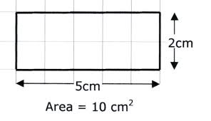
Perimeter:
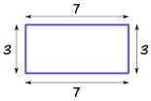

Measurement, square yards, square feet, design, justify, demonstrate, fence, dimensional, requirements, budget, purchase

Reference Sheet:

Area:
Perimeter:

Fence
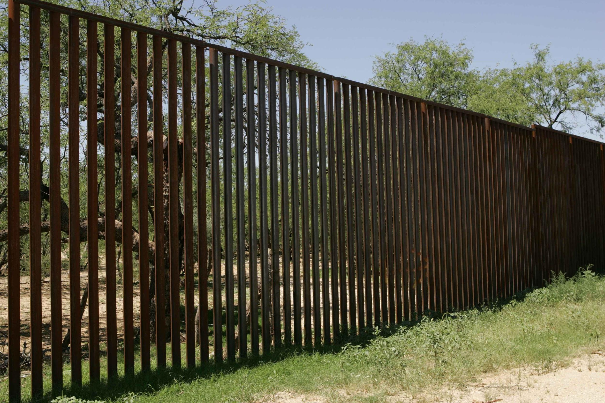

Requirements: you need to do/have
Budget: How much money you have to spend
Purchase: buy

Measurement
- yards
- feet
Design: create or make
Justify
Demonstrate
Dimensional

Name: _____________________________ Date: __________
Performance Task: Grade 4

Your school is building a new playground. The principal is asking for your help to design a playground that children will really enjoy. Mrs. Mills decides to have a contest to see whose idea will become the actual play area for the school. You are going to enter your design! You will be given a piece of graph paper that represents 17 yards by 22 yards. You are expected to present a two-dimensional model of your playground that is not drawn to scale.
A. What is the total area of the play space you will design? Demonstrate your understanding using a visual representation, numbers and words.

B. Within the area, you will need to create three rectangular areas within your play space: a playground, a picnic area, and a field to play sports in. What is the area of each space? Demonstrate your understanding using a visual representation of each section on your graph paper, numbers and words. Label each section on your graph paper in a clear, organized way.

C. Principal Mills also expects the playground to be safe for children, so you need to provide measurements for the purchase of fence. The requirement is that there is fencing around each rectangular section you have designed as well as the entire play space itself. How many yards of fencing will your playground need in order to make sure it meets the requirements?

D. Mrs. Mills only has a budget of $4,000 to purchase fencing. Each yard of fence costs $3 a
foot. About how much will it cost to purchase the fencing needed for your play space? Would Mrs.
Mills be able to use your design why or why not? Use pictures, numbers and words to justify your
response.
Name: _____________________________ Date: __________
Performance Task Modified: Grade 4

Your school is building a new playground. The principal is asking for your help to design a playground that children will really enjoy. Mrs. Mills decides to have a contest to see whose idea will become the actual playground for the school. You are going to enter your design! You will be given a piece of graph paper that represents 17 yards by 22 yards. You are expected to present a two dimensional model of your playground that is not drawn to scale.

A. What is the total area of the play space you will design? Demonstrate your understanding using a visual representation, numbers and words.

The total area of the play space is __________________.

B. Within the area, you will need to create three rectangular areas within your playground: a swingset, slide area, a picnic area, and a field to play sports in. What is the area of each space? Demonstrate your understanding using a visual representation of each section on your graph paper, numbers and words. Label each section on your graph paper in a clear, organized way.

C. Principal Mills also expects the playground to be safe for children, so you need to provide measurements for the purchase of fence. The requirement is that there is fencing around each rectangular section you have designed as well as the entire playground itself. How much fence will you need for the swing set section, the picnic section, the field and the entire playground itself?

Swing Set and Slide: ___________ Field: __________________ Picnic Place: ____________

Whole Playground: ____________

D. Mrs. Mills only has a budget of $4,000 to purchase fencing. Each yard of fence costs $3 a
foot. About how much will it cost to purchase the fencing needed for your play space? Would Mrs.
Mills be able to use your design why or why not? Use pictures, numbers and words to justify your
response.

The total cost of the fence is ____________________.
Mrs. Mills will be able to use my design because ________________________.
Mrs. Mills will not be able to use my design because _____________________.

Word Bank
Area | Perimeter | Measurement Justify  Square yards Demonstrate  Square feet  Design

Performance Task Rubric

Category | 3 | 2 | 1
Mathematical Concepts | Shows a complete understanding of the mathematical concepts and addresses all components using clear and effective strategies. | Shows some understanding of the mathematical concepts and addresses some of the components using strategies. | Shows limited or not understanding of the problem and uses inaccurate strategies to complete the task.
Explanation | Student can clearly and effectively explain their reasoning for the area and perimeter. Student used mathematical vocabulary to expressing their ideas. | Student can provide an explanation, but may need prompting questions from the teacher to guide them. The student shows some use of appropriate mathematical vocabulary and representation. | Student provides little to no explanation of their reasoning and uses little to no mathematical vocabulary to show their knowledge as it relates to the real world problem.
Accuracy | Students work is thorough and reveals no errors. | Students work in thorough and reveals little errors. | Little work is shown and/or contains several inaccuracies.

Sample Student Work:

