Synopsis of high-quality task: Launch Fundraiser:

Students are asked to determine the length of time it would take to travel from one part of town to another by riding in a parent’s car, and then by walking after the car breaks down. Students are given the distance needed to travel in meters and kilometers, the time at which they need to arrive at their destination, and the distance between the starting and ending points where the car broke down.

This would take place in the first quarter of the school year, where students are learning to add and subtract multiple units of length in meters and kilometers. This can be a task in the middle of a metric conversion unit, or can be used as a mini-assessment at the end of a metric conversion unit.

Anticipated student time spent on task: 60-90 minutes

Student task structure: Group work

Math Content Standards and Practices:

4.NBT.B.4 Fluently add and subtract multi-digit whole numbers using the standard algorithm.
4.MD.A.2 Use the four operations to solve word problems involving distances, intervals of time, liquid volumes, masses of objects, and money, including problems involving simple fractions or decimals, and problems that require expressing measurements given in a larger unit in terms of a smaller unit.

SMP1 Make sense of problems and persevere in solving them.
SMP2 Reason abstractly and quantitatively.
SMP5 Use appropriate tools strategically.

Prior Knowledge:

3.NBT.A.2 Addition and subtraction of numbers in the thousands.
4.MD.A.1 Conversion between meters and kilometers.

Connections to the real-world:

Students are asked to determine the length of time it would take to travel from one part of town to another by riding in a parent’s car, and then by walking after the car breaks down. Students can relate to having an interruption in traveling and figuring out what they need to do to get to where they want to go.
Mastery Goals:

Learning Objective:
Students will be able to use distance in meters and a given walking speed to determine the amount of time it takes to travel. Students will convert from kilometers to meters.

Language Objective:
Students will be able to state and justify the evidence they used to solve the problem.

Teacher instructions

Instructional Tips/Strategies/Suggestions:
- Students can work in pairs or small groups on this task. Heterogeneous groups are recommended.
- Introduce the task whole-group and use the slide with the story on it to encourage a discussion about what they need to know in order to answer the questions: Will we make it to Launch on time to kick off the fundraiser? What time will we get to Launch? Once the class has generated a list of information they need to know, show them the next slide with that information on it. Then provide them with a handout of the slides.
- There is a bonus question: If we wanted to walk the entire way, at what time would we have needed to leave the Boys and Girls Club? This question allows students to play around with rates and is a bit above and beyond the scope of standard 4.NBT.B.4, but will allow students to stretch their thinking a little.

Instructional Materials/Resources/Tools:
Student handouts:
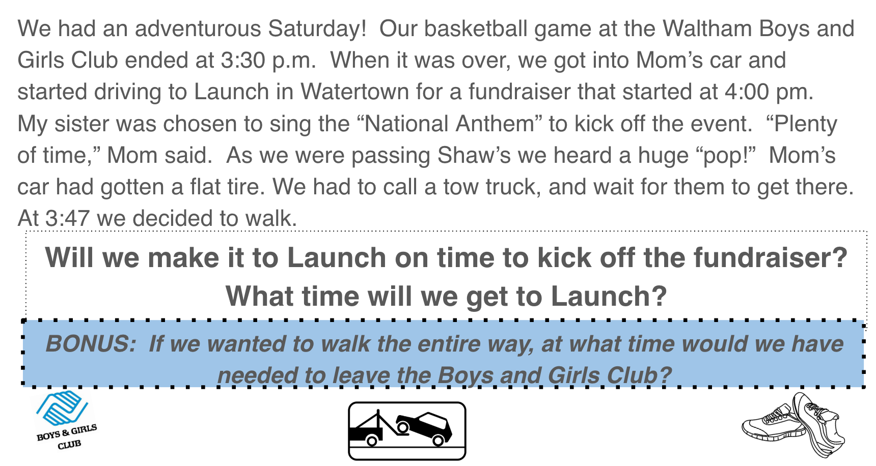
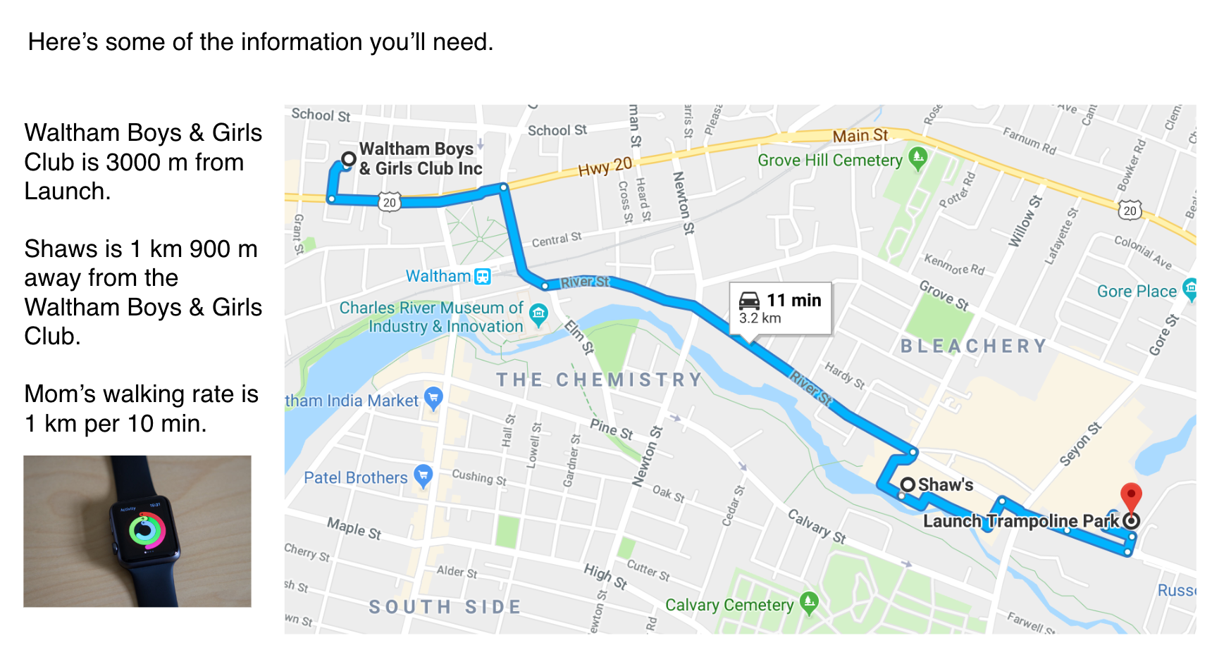

Accessibility and Supports:

Potential sentence starters:
- We will (or will not) make it to Launch on time to kick off the fundraiser.
- We will get to Launch by ________ p.m.
- If we wanted to walk the entire way, we would have needed to leave the Boys and Girls Club by (time).
- We know this is true because ___________.
- A strategy I used was ____________.
- I agree/disagree with _________. My strategy was different, and I did ________.

Key academic vocabulary: Kilometer, Meter, Walking rate, Kilometer per minute, Fundraiser, National Anthem

Sample Student Work

