Synopsis of high-quality task:

Students will make decisions for how to spend money to buy gear for a softball team, given a budget, the cost of individual items and number of people on the team.

Anticipated student time spent on task: 50 minutes

Student task structure(s): Individual and partner work

Task Source: created in-district

Math Content Standards and Practices:

Operations and Algebraic Thinking
4.OA.A Use the four operations with whole numbers to solve problems.

Number and Operations in Base Ten
4.NBT.B Use place value understanding and properties of operations to perform multi-digit arithmetic on whole numbers less than or equal to 1,000,000.

SMP.1 Make sense of problems and persevere in solving them.
SMP.2 Reason abstractly and quantitatively.
SMP.3 Model with mathematics.
SMP.6 Attend to precision.

Prior Knowledge:
Operations and Algebraic Thinking
3.OA.A Represent and solve problems involving multiplication, and division.
3.OA.D Solve problems involving the four operations, and identify and explain patterns in arithmetic.

Number and Operations in Base Ten
3.NBT.A Use place value understanding and properties of operations to perform multi-digit arithmetic.

Connections to the real-world:
- Sports teams and Sports gear
- Purchasing equipment for a team
- Working with a budget

Mastery Goals:

Content Objective:
Students will be able to reason and apply whole number computation skills to propose a solution to a problem.

Language Objective:
Students will be able to justify their conclusions and communicate them to others.

Teacher instructions
Instructional Tips/Strategies/Suggestions:

Read the problem once as a class, then allow time for students to read the problem a second time to themselves. Students should mark-up the problem as they read it themselves. (10 min)

Assign students to begin solving the problem independently. (15 min)

Allow students to share their thinking with partners then finish/revise/improve their solutions. (15 min)

During this time, monitor students to identify potential students to share their approach.

Debrief by inviting selected students to share their different solutions. (10 min)

Instructional Materials:

- Directions are embedded in task
- Provide blank paper, lined paper, or grid paper.
- Scoring rubric

 | Above and Beyond | On Target | Almost There | Not Yet
Problem Solving | The response  accurately  describes two  ways to spend the money. | The response  accurately  describes one  way to spend the money. | The response  describes how  to spend the money, but is  only partially  complete or accurate. | A response is  offered, but it  is not complete  or accurate.
Communication | Appropriate  strategies for  both ways are  shown/  explained step-by-  step. The  final answers  are written  clearly. | Appropriate  strategies for  one way are  shown/  explained step-by-  step. The  final answer is  written clearly. | Appropriate  strategies are  partially shown  or explained.  The final  answer may  not be written  clearly. | Appropriate  strategies are  not shown or  explained. The  final answer is  not written  clearly.

Accessibility and Supports:

Potential sentence starters:

One way that Coach Hurter could spend the money is…
Coach Hurter could buy…
The total cost for the __________ would be __________

Key academic vocabulary:

Budget
Purchase
Spend
Describe
Justify

Student Worksheet

Name: _____________________________

Ryan’s Sports Store

Coach Hurter wants to buy items for the softball team. There are 10 players on her team, and she has a budget of $800. She is going to purchase the items from Ryan’s Sports Store.

Describe one or two different ways that Coach Hurter could spend all (or nearly all) of her budget on items for her players. Justify your decisions.

Ryan’s Sports Store
Jacket | $40
Sweatshirt | $22
Hat | $5
T-shirt | $10
Sweatpants | $18
Duffel Bag | $35

Sample Student Work: Example 1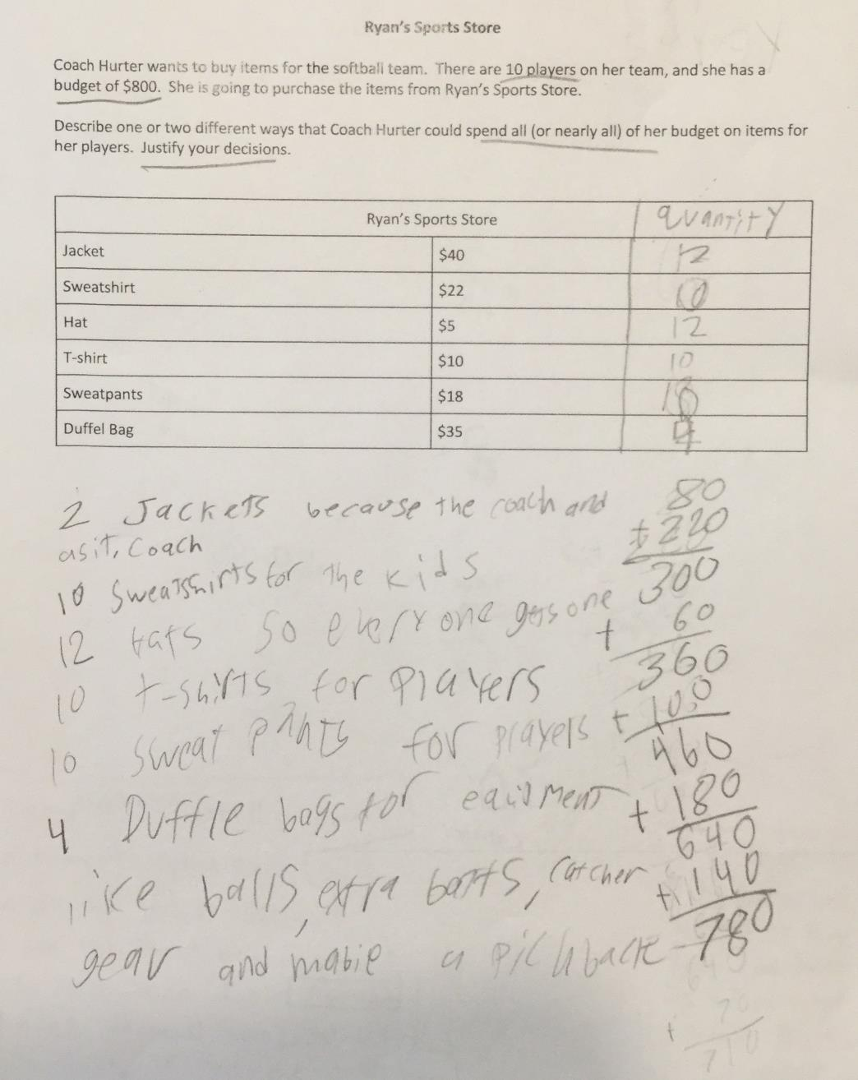

Student work: Example 2
