Task-level Phenomena: Students observe the reaction of chemicals interacting over time.

Synopsis of high-quality task:
Students explore and experience two different types of heat transfers. Students observe a chemical reaction, use the data they collect to graph a representative model, and generate questions to facilitate a discussion. Students use a notice and wonder chart to generate ideas and guide their thinking. Finally, students draw an initial model of endothermic and exothermic reactions. This task can be used as an initial introduction to chemical reactions.

Anticipated student time spent on task: One 60-minute class

Type of Task (check one):
____ 1. Investigation/experimentation/design challenge
_X__ 2. Data representation, analysis, and interpretation
____ 3. Explanation

Student task structure(s): small group, individual work
STE Standards and Science and Engineering Practices:

STE Standard:
6.MS-PS1-6. Plan and conduct an experiment involving exothermic and endothermic chemical reactions to measure and describe the release or absorption of thermal energy.
Clarification Statements:
- Emphasis is on describing transfer of energy to and from the environment.
- Examples of chemical reactions could include dissolving ammonium chloride or calcium chloride.

Science Practice:
- Analyze and interpret data.

Prior Knowledge:
Previous Standard from Strand Map:

4-PS3-2. Make observations to show that energy can be transferred from place to place by sound, light, heat, and electric currents.
Clarification Statement:
- Evidence of energy being transferred can include vibrations felt a small distance from a source, a solar-powered toy that moves when placed in direct light, warming a metal object on one end and observing the other end getting warm, and a wire carrying electric energy from a battery to light a bulb.
Previous Topics:
- Kinetic energy and heat transfer.
- Graphing skills: how to graph data.

Connections to the real-world:
Endothermic and exothermic chemical reactions occur commonly in our daily lives, both in nature such as burning, photosynthesis, and freezing, and manufactured products like hand warmers and cold packs.
Mastery Goals:
Learning Objective:

- Collect and analyze data (measurement of temperatures) from experiments using endothermic and exothermic chemical reactions.
- Generate a list of questions based on the analysis of data collected.

Performance Objective:

- Make observations and collect data about chemical reactions.
- Create a graph of observed temperature changes in both endothermic and exothermic chemical reactions.

Language Objective:

- Analyze and discuss data orally in small group and whole group.
- Interpret peer ideas and construct written explanations.
- Speak, using academic and content relevant vocabulary.

Teacher instructions
Instructional Tips/Strategies/Suggestions:

Part 1: Exothermic and endothermic introduction lab (10 min)
- In partners, students measure temperature changes that occur as chemical compounds dissolve in water. They collect data for 5 minutes, measuring at 1-minute increments, with a thermometer.
- Students follow the procedure outlined below:
  - Add 100 mL of room temperature water to each of the 400 mL beakers.
  - Place the temperature probe into the water. Take down your start point.
  - Add the 5 grams of potassium chloride and 5 grams of calcium chloride to separate containers.
  - Collect temperatures over 30-second intervals for a total of 3 minutes.
  - Clean up and disposal of materials

Part 2: Graphing (10 min)
- Students develop a graph of their data using they collected. The graph should include labels of the X and Y axis.
- Each student will create their own graph on the student handout.

Part 3: Notice and wonder (10 min)
- Students use the prompts (what did you notice and what to you wonder) to reflect on their observations and data.
- Students should discuss their observations and questions with each other. Use the Think-Pair-Share strategy to give all students a chance to share their ideas.

Part 4: Clean up (5 min)
- Ask students to clean up their area, keeping in mind safety within the lab classroom.

Part 5: Whole-class discussion (10 min)
- Each pair will share what they noticed and wondered and record on their ideas on board. Be sure to include all information. Elicit their initial understandings. As vocabulary words are introduced by students, make sure to define the word for all students and create a word wall.
- Ask students to generate questions about what other types of investigations they could do as class to learn more about chemical reactions. Record the list on the board. Note: Use these ideas in future lessons.

Part 6: Endothermic and exothermic initial model (15 min)
- Have students draw an initial model that describes the difference between endo and exothermic reactions, including how they interact with one another. Encourage students to use specific terminology, including seconds, degrees, etc. in their drawings.

Next steps:
- In the next class, have students share out their models in pairs and then create a class consensus model that combines all of their ideas that are agreed upon as a class.

Instructional Materials/Resources/Tools:
Advance Prep:
- Prepare sets of materials or lab stations in advance to help ensure that students easily complete the lab.
- Allow 2 L of distilled water to sit overnight at room temperature.

Safety Information:
- Rubber apron to protect clothing
- Safety glasses
- Report any spills to teacher
- Do not taste, eat, or drink any of the materials used in the lab
- Wash your hands before leaving the laboratory
Materials: (For each Group)
- 2- 400-mL beaker
- 2- 100-mL beaker
- Stirring spoon
- Temperature probe
- Distilled water
- 5.0g calcium chloride (CaCl2)
- 5.0g potassium chloride (KCl)

Teaching Tips:
- Potassium chloride absorbs heat from its surroundings when it dissolves in water. Therefore, this is the Endothermic process. The dissolution of calcium chloride is an exothermic process.
- This lab is designed for students to notice and wonder what is occurring to introduce the concept of chemical reactions/physical properties.
- Review with students heat transfer prior to lab.
- Review with student’s convection in association with heat prior to lab.

Extensions:
- Have students research to find out how calcium chloride is used when outdoor temperatures drop below freezing.
- Have students make a list of everyday activities that use endothermic and exothermic processes.
- Have students research to find out about cold packs and heat packs. The different materials used, methods of packaging, and the shelf life.

Task Source:
- #ProjectPhenomena. Energy changes during chemical reactions. https://sites.google.com/site/sciencephenomena/
- The Ambassador would like to recognize science teachers from North Brookfield Public Schools for their contributions to the development of this task.

Accessibility and Supports:
Review graphing skills
- Labeling graph
- Plotting points on a graph

Student Work Sample:

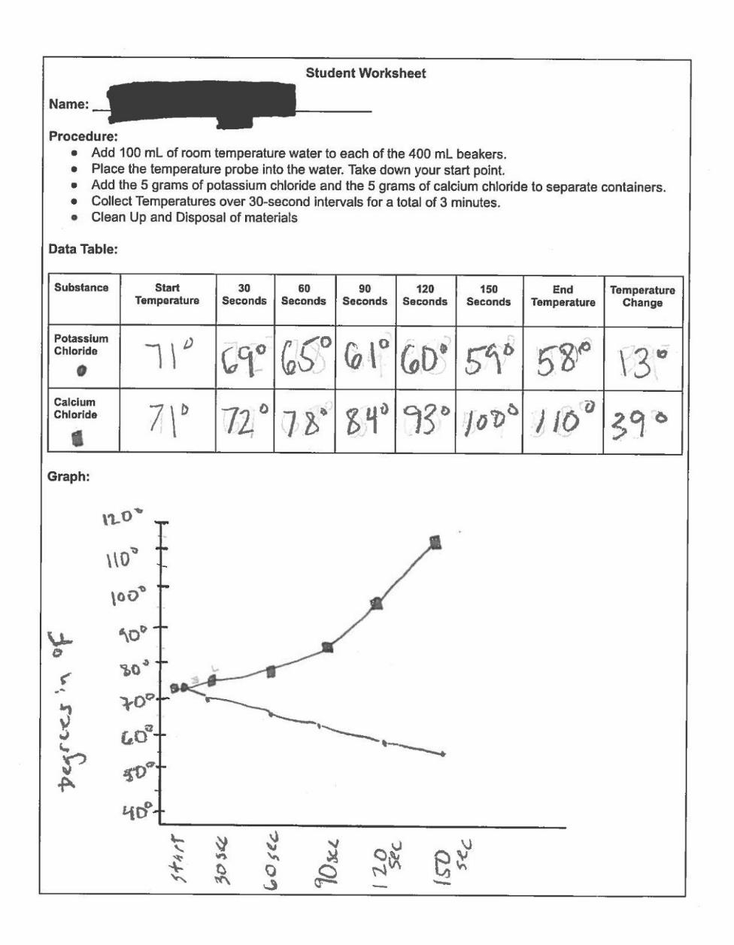
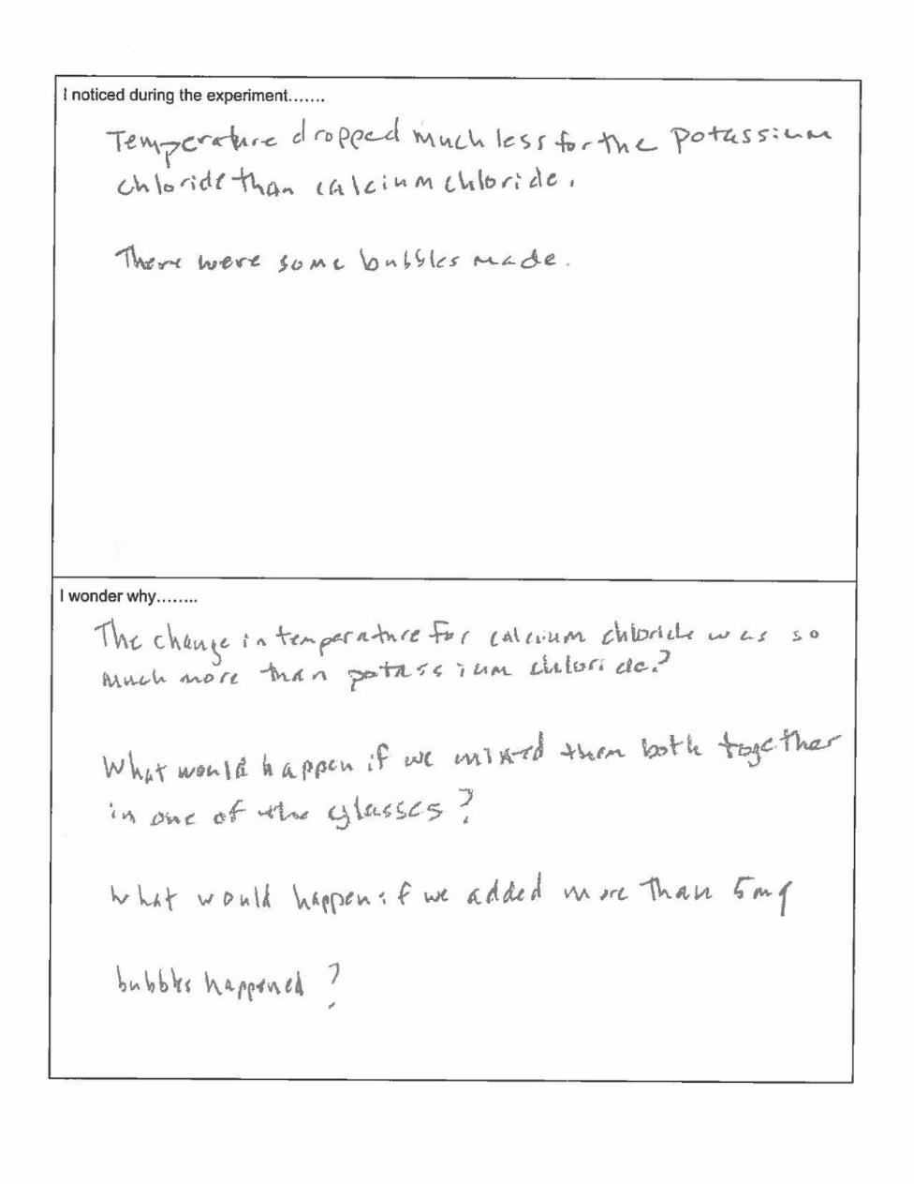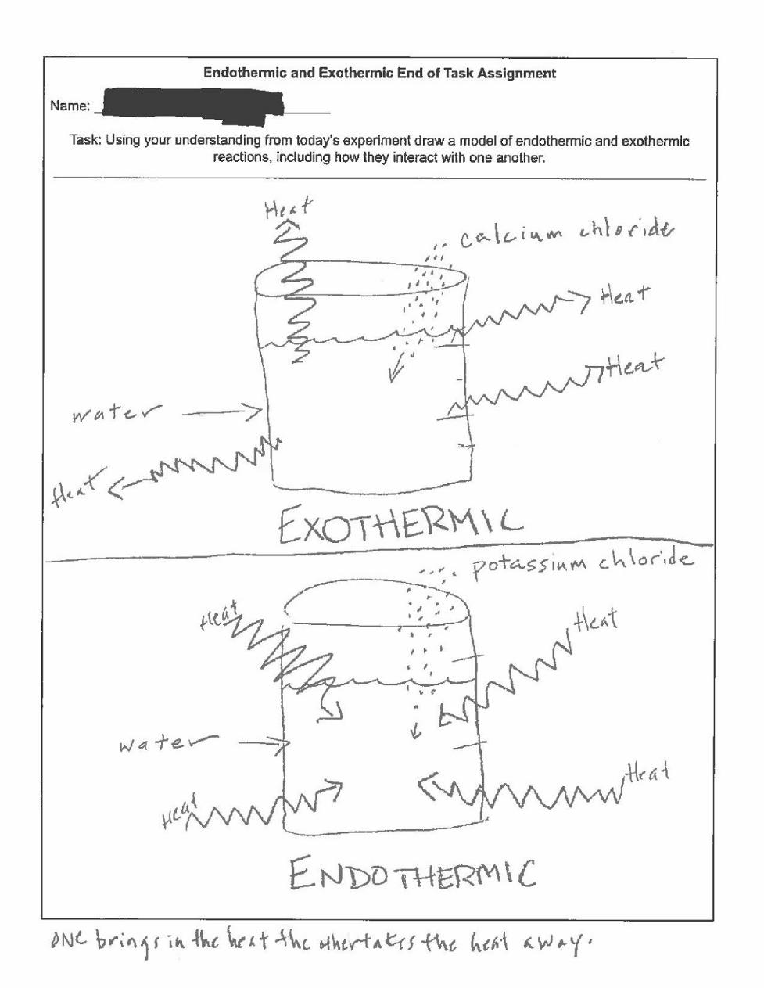

Student Worksheet

Name: __________________________________________________________________

Procedure:
- Add 100 mL of room temperature water to each of the 400 mL beakers.
- Place the temperature probe into the water. Take down your start point.
- Add the 5 grams of potassium chloride and 5 grams of calcium chloride to separate containers.
- Collect Temperatures over 30-second intervals for a total of 3 minutes.
- Clean Up and Disposal of materials

Data Table:

Substance | Start Temp | 30 Secs | 60 Secs | 90 Secs | 120 Secs | 150 Secs | End Temp | Temperature Change
Potassium Chloride
Calcium Chloride

Graph:
I noticed during the experiment…….

I wonder why……..

Endothermic and Exothermic Initial Model

Name: ____________________________________________________________________

Task: Using your understanding from today’s experiment draw a model of endothermic and exothermic reactions, including how they interact with one another.

