Synopsis of high-quality task:

Students will create a one-day school schedule for a 6-hour day (or 360 minutes) that consists of at least 8 periods. The schedule needs to fit the parameters of specific class times per day. They need to explain how their schedule meets the parameters provided and why the school should adopt their schedule.

Anticipated student time spent on task: Two 52-minute class periods

Student task structure(s): Partner work or small group work (2-4 students)

Math Content Standards and Practices:

6.RP.A.3.c Find a percent of a quantity as a rate per 100 (e.g., 30% of a quantity means 30/100 times the quantity); solve problems involving finding the whole, given a part and the percent.

SMP 1 Make sense of problems and persevere in solving them.
SMP 3 Construct viable arguments and critique the reasoning of others.
SMP 4 Model with mathematics.

Prior Knowledge:

5.NBT.A.1 Recognize that in a multi-digit number, a digit in one place represents 10 times as much as it represents in the place to its right and 1/10 of what it represents in the place to its left.
5.NBT.A.4 Use place value understanding to round decimals to any place.
5.NF.B.3 Interpret a fraction as division of the numerator by the denominator (a/b = a ÷ b). Solve word problems involving division of whole numbers leading to answers in the form of fractions or mixed numbers, e.g., by using visual fraction models or equations to represent the problem. For example, interpret 3/4 as the result of dividing 3 by 4, noting that 3/4 multiplied by 4 equals 3, and that when 3 wholes are shared equally among 4 people each person has a share of size 3/4. If 9 people want to share a 50-pound sack of rice equally by weight, how many pounds of rice should each person get? Between what two whole numbers does your answer lie?

Connections to the real-world:

Creation of a schedule and creating a pie chart that displays percent and time spent per subject area throughout the day. Students will have to defend how their schedule meets the parameters and is the best option for the school to adopt.

Mastery Goals:

Learning Objective:
Students will be able to utilize proportional relationships to determine the amount the time spent per class/subject throughout their day. They will use ratios to create proportions in order to determine the percentage of their school day spent for each class/subject.
Students will be able to reflect and brainstorm with their classmates utilizing strategies and terminology.
Students will be able to utilize graphic organizers to map out their schedule and create their proposal to justify what/when classes should occur in our school schedule.

Language Objective:
Students will be able to verbally explain the schedule they created and justify their reasoning.

Teacher instructions:
Day 1:
- Students will work with partners/small groups
- Hand out Page 1 to groups and read the task aloud
- Allot students 15 minutes to fill out their first two columns on page 1
- Allot students 30-45 minutes to complete the %’s column on page 1 (provide students with page 2 for work set up).
Day 2:
- Students will calculate their totals (pages 1, 2) to ensure accuracy.
- Students will then create a circle graph (page 3) that displays percent and time spent per subject area throughout the day with the use of a straight edge.
- Students will complete their proposal to justify their schedule changes (page 4).

Instructional Materials/Resources/Tools:
Include:
- Pages 1, 2, and 3 (copy of each per group)
- Ruler (per group)
- Scoring rubric – Focus on including the standards-content and practices for performance criteria. Less focus should be on presentation style, design, etc. unless it is tied directly to an ELA standard.
Accessibility and Supports:

Provide students with a checklist of steps for determining percentages and equivalent fractions.

Prompts:
- What are you solving for?
- How do you set up a percent proportion for number of minutes? How many minutes is each period out of?
- How can you make your numbers easier to tackle?
- Once your proportion is set up, what can you do to solve? (Cross Products)
- How many degrees in a circle? How many minutes in a school day? How many degrees per minute?

Key academic vocabulary: proportion, ratio, simplified fraction; is = part; of = whole (total); percent (understand that it is out of 100)

Page 1
Designing Our Schedule

You and your classmates have been selected to redesign our daily schedule for one day. You have a lot of choices and options, but your schedule must follow these rules:
- The school day must consist of a full 6 hours (or _____________ minutes).
- ELA and Math must be the same amount of time in your daily schedule.
- Social Studies and Science must be included in your daily schedule.
- Specials must be longer than your lunch period.
- You must have a minimum of 8 periods. (Feel free to add in additional classes you would like to suggest we should have. For example: advisory, foreign language, extra gym class, recess, etc.)
As you work on your ideal schedule, consider when certain classes should occur during the 6-hour day and if specific classes should be longer than others. It is better to have specific classes in the morning or at the end of the day? Should specials be longer or shorter than math class? Use the percent proportion model to determine the percentage of the day each period will be. Show your work using page 2. After you have your completed schedule, you will create a circle graph to represent the amount of time spent on each area of your school day schedule. You will also submit a proposal to the principal of the school. Your task is to justify that your schedule meets the listed rules above and is the best choice for our school schedule to be switched to.

OUR NEW CLASS SCHEDULE
 | CLASS NAME | # of minutes | % out 100
Period 1
Period 2
Period 3
Period 4
Period 5
Period 6
Period 7
Period 8
TOTALS:

Work Space Page 2
 | CLASS NAME | # of minutes | % out 100  is %  ________ = _________  of 100
Period 1

Period 2

Period 3
Period 4
Period 5
Period 6
Period 7

Period 8
TOTALS:
Page 3
Directions: Using the circle graph below, identify each class periods degrees, percent and class name.

Name of Schedule
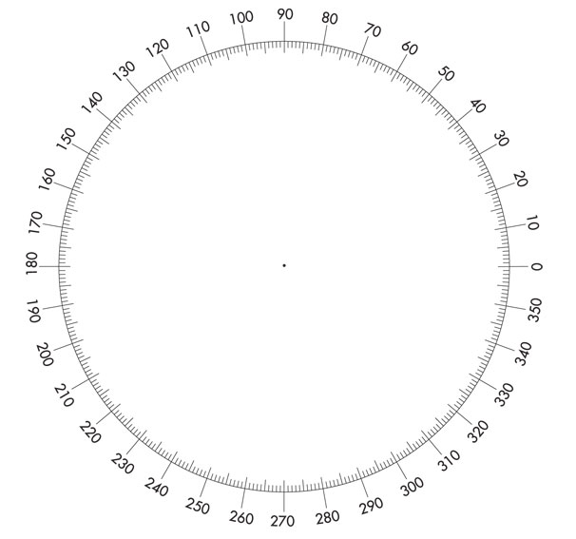
KEY:

Schedule Proposal Page 4
Did you include the following classes?
- ELA - Specials
- Math - Lunch
- Science - At least two extra class
- Social Studies
Double Check: Do all your minutes total 6 hours and/or 360 minutes? Show your calculations here. | Double Check: Do all your percentages equal 100%? Show your calculations here.
What makes your schedule different from the current schedule?

Why should the principal adopt your schedule?

Sample Student Work:

