Engineering Design Process:
Redesign a Cafeteria to Make it Wheelchair Accessible
Grade 6
Task-level Problem:
The cafeteria space is not designed for a wheelchair to easily move around.

Synopsis of high-quality task:
There is a new student coming to school next week that requires the use of a wheelchair to move around. Students work in groups to design and create a 2-dimensional scaled drawing (floor plan) of a cafeteria space that needs to be made handicapped accessible through application of the Engineering Design Process. The final student artifact must meet specific criteria and constraints.

Anticipated student time spent on task: 2, 60-minute classes

Type of Task (check one):
__X_ 1. Investigation/experimentation/design challenge
____ 2. Data representation, analysis, and interpretation
____ 3. Explanation

Student task structure(s): Students will work in pairs or groups of four
STE Standards and Science and Engineering Practices:

STE Standard:
6.MS-ETS1-5(MA) Create visual representations of solutions to a design problem. Accurately interpret and apply scale and proportion to visual representations. Clarification Statement: Examples of visual representations can include sketches, scaled drawings, and orthographic projections. Examples of scale can include ¼”=1.0” and 1cm=1m.

Science and Engineering Practice:
- Using mathematics and computational thinking
Prior Knowledge:
Previous Standards from Strand Map:
3.3-5-ETS1-4(MA) Gather information using various informational resources on possible solutions to a design problem. Present different representations of a design solution.

6.MS-ETS1-1 Define the criteria and constraints of a design problem with sufficient precision to ensure a successful solution. Include potential impacts on people and the natural environment that may limit possible
solutions.
Previous Topics:
- The Engineering Design Process
- Scale representation
- Scale measurement

Connections to the real-world:
Although a student themselves may not be handicapped they may know someone who is or may have experienced a short-term injury that would have made it difficult for them to access and move about various spaces. The Americans with Disabilities Act (ADA), signed into law on July 26, 1990, by President George H.W. Bush, makes it mandatory for all public spaces to be handicapped accessible. Public schools serve a diverse population of students; all who require access to various areas of the building.

Mastery and Language Goals:

Learning Objective:
- Apply the Engineering Design Process and mathematical computations to design a solution based on criteria and constraints by creating scale models of a cafeteria space.

Performance Objectives:
- Design a solution based on criteria and constraints.
- Create a scale model.

Language Objectives:
- Engage effectively in small group and teacher-led discussions with diverse partners.
- Present outcomes, orally and in writing, with pertinent descriptions, details, and examples.
- Use scientific terminology when writing and speaking.

Teacher Instructions
Instructional Tips/Strategies/Suggestions:
Note: Students in our school keep laboratory notebooks where they record all steps of the Scientific Process or the Engineering Design Process (EDP) when planning and carrying out investigations or when solving problems. Here, the “Do Now” and any note-taking during the video is written in their binders. All planning and steps in the Engineering Design Process are recorded in their lab notebooks. Students work through one or multiple steps at a time and are assigned “checkpoints” where students share what they have written with the teacher and the teacher either approves their work or responds by asking probing questions to assist students in correcting their own errors or filling in missing information.

Day 1
- Do Now: (Written on board) Why is teamwork important when solving a design problem?
First students write down thoughts independently. Next, students turn and discuss with team. Then, students share out ideas and teacher records on chart paper. Record initial ideas in one color and then revisit the same question at the conclusion of the task and record new ideas in another color.

- Teacher reviews ideas from Do Now chart before introducing task.

- Review What is Engineering? Using video clip: https://www.youtube.com/watch?v=bipTWWHya8A

- Discuss importance of teamwork in solving a design problem.

- Introduce task:
  - Project picture of student in wheelchair on board alongside pictures of current cafeteria space
  - Teacher presents background information to students: There is a new student coming to school next week that requires the use of a wheelchair to move around. Currently our cafeteria space is not designed for a wheelchair to easily move around. Your job as engineers is to design a solution so that the new student can easily access the cafeteria.

- Project or post the headings Problem, Criteria, and Constraints on the board (without the answers displayed). Underneath, write the word “**Checkpoint**” with asterisks so that students know what they need to complete prior to checking-in with the teacher. Read or have a student read each step aloud. Discuss/review the definition or meaning of Problem, Criteria, and Constraints for clarification.

- Students then work in groups of four to use the background information and the provided photos to write the Problem, Criteria and Constraints and then check-in when they finish. If work is correct, students return to their groups and move onto the next steps. If not, teacher responds by questioning the students to help them correct mistakes or add missing information. (See TEACHER EXAMPLE)

- Students then continue on to Research and Materials and check-in when finished. Students will list what information or dimensions they need and the teacher can then provide the actual dimensions or you may choose to take your class on a “field trip” to the cafeteria to make those measurements themselves:
  - average wheelchair dimensions (1m X 1m)
  - actual dimensions of the cafeteria tables (1.5m x 4m)
  - cafeteria space/room dimensions (40m x 72m)
  - locations of windows, doors, etc.

Day 2:
- Begin class with a quick reflection of what students accomplished during day 1. As a class discuss, “What did you find to be the most challenging part of the Engineering Design Process (EDP) yesterday? What did you learn from that struggle(s)? What might you do differently next time?” “Can we add anything to our team work chart?”

- Distribute copies of the Rubric. Teacher displays/projects the rubric and reviews requirements and expectations. Answer any student questions and offer clarification where needed.

- Design: Distribute copies of Cafeteria Design Problem worksheet to each student. Review the directions on the handout (below) and explain that students will use these directions as well as their materials to create their solution(s) to the problem -- the floor plan. Students arrange their tables on the template (referencing the criteria and constraints and when complete they will check-in. Teacher asks probing questions like: “Is there adequate space for the wheelchair to maneuver between each table?” or “Can the wheelchair move between table and wall?” etc.)

- Communicate, Explain and Share: Students will share solution/designs for the problem. Students will be responsible for passing in a completed solution (template with tables appropriately placed) and completing 2 questions on the student handout. Although not part of the assessment score, students will be encouraged to share solutions with class. Also refer back to the teamwork ideas and create a final list.

*** TEACHER EXAMPLE ***
Do not provide to students! This is an example of what you should look for as students check-in.

Problem:
There is a new student coming to school next week that requires the use of a wheelchair to move around. Currently our cafeteria space is not designed for a wheelchair to easy move around. Your job as engineers is to design a solution so that the new student can easily access the cafeteria.

Criteria:
- Cafeteria dimensions (40m X 72m)
- 10 cafeteria tables (1.5m X 4m) must be used
- 1 of those 10 tables must be designated as “Peanut-Free” (Note: This was added after the pilot so it is not present in the student sample)
- Enough space for the wheelchair (1m x 1m) to easily maneuver the space

Constraints:
- Doorways cannot be blocked by any objects
- All four sides of each table needs to be accessible by the wheelchair

Research:
- Average wheelchair dimensions (1m X 1m)
- Actual dimensions of the cafeteria tables (1.5m x 4m)
- Cafeteria space/room dimensions (40m x 72m)
- Locations of windows, doors, etc.
- Scale: 1 square = 50 centimeters

Materials:
- 1 Piece of Cafeteria Graph Paper Template (Scale for graph paper: 1 square = 50 centimeters)
- 1 Piece of Blank Graph Paper
- 1 Wheelchair Template (2cm X 2cm)
- 1 Centimeter ruler
- 1 Pencil
- 1 Pair of scissors
- Tape or glue
- Calculator (if needed)

Design/Test: (See student sample)

Communicate, Explain and Share: (See student sample)

Instructional Materials/Resources/Tools:

- Centimeter rulers (1 per student)
- Pencils (1 per student)
- Scissors (1 per pair/group)
- Tape or glue (1 per pair/group)
- Calculators (if needed)
- Student Lab Notebooks (or lined paper)
- Chart paper & markers
- 1 Wheelchair Template (2cm X 2cm; 1 per pair/group)
- Copies of Blank Graph Paper (1 per pair/group; Note: scale for graph paper: 1 square = 50 centimeters)
- Copies of Cafeteria Graph Paper Template (1 per group)
  - Note: When photocopying the graph paper template make one copy first and check that the machine does not change the scale of the squares. When we copied extras of the graph paper template to use with a second class (the graph paper used in the pilot was made on a photocopier at a different building), our machine altered the floor plan to “fit” the paper which resulted in some students in the second class receiving squares that were smaller and did not correctly fit the cut outs of the tables.
- Copies of Cafeteria Design Problem (1 per student)
- Copies of the Scoring Rubric (1 per group)
- Copies of The Engineering Design Process Handout (Optional)
- Projector
- Internet connection to view video (linked above)

Example of Wheelchair Picture Examples of Cafeteria Pictures

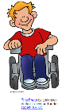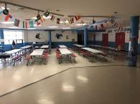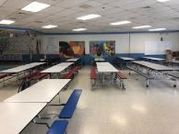
Example of Graph Paper Example of Cafeteria Graph Paper Template

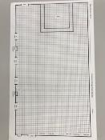
Accessibility and Supports:

Key academic vocabulary:
Tier 2 - design, model, scale, wheelchair, calculate, arrangement, template, navigate
Tier 3 - engineer, handicapped, criteria, constraint, dimensions, accessible

Supplementary materials and/or Supports:
- Partner ELs and special education students with regular education students or peer models for both language and content
- Provide a handout/visual with the Engineering Design Process Handout (Protocol) sequenced and defined (see materials below).
- Possible sentence starters (for ELs and special education students) to use with questions on handout such as “Completing this design problem has changed my thinking because ____________” and, “Some challenges I had to overcome during this assignment were _________________ . “

Task Source:
The Ambassador would like to recognize Michelle LaRocque and Tomeka Kinsey from Lawrence Public Schools for their contributions to the development of this task.

Original task created by; Portions of the task sourced from the following:
- Video: “What is Engineering?” created by The University of Newcastle (UON), Australia https://www.youtube.com/watch?v=bipTWWHya8A
- Engineering Design Process is from the 2016 Massachusetts Science and Technology/Engineering Curriculum Framework, p. 100 http://www.doe.mass.edu/frameworks/scitech/2016-04.pdf
Sample Student Work:

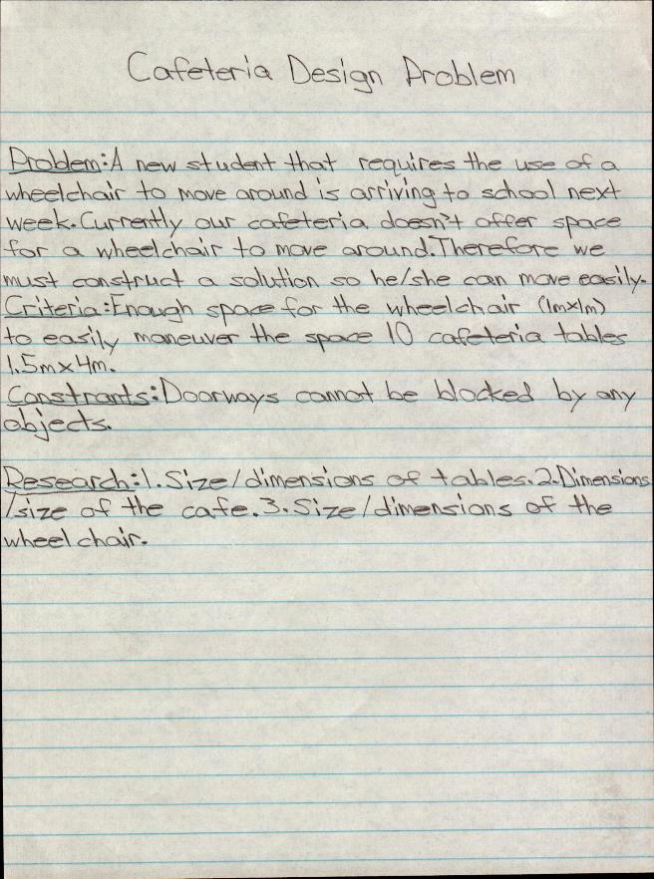
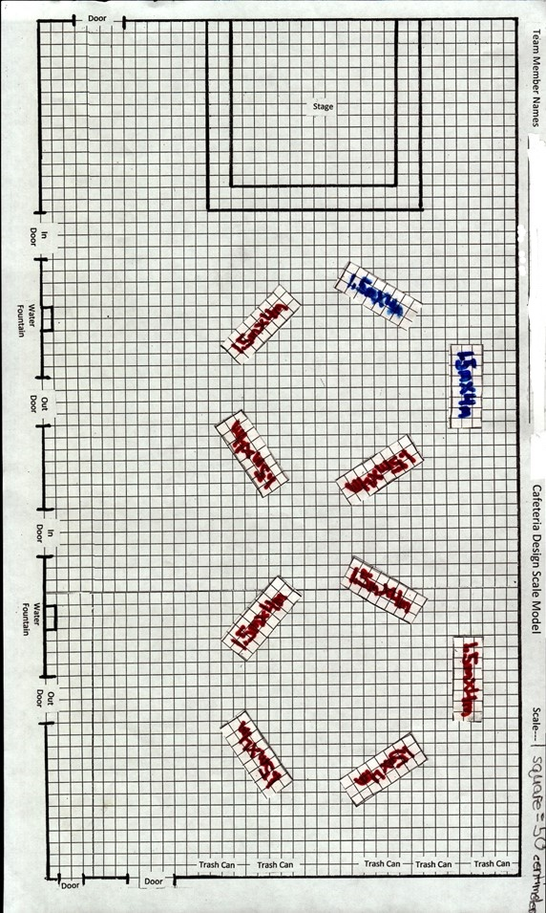
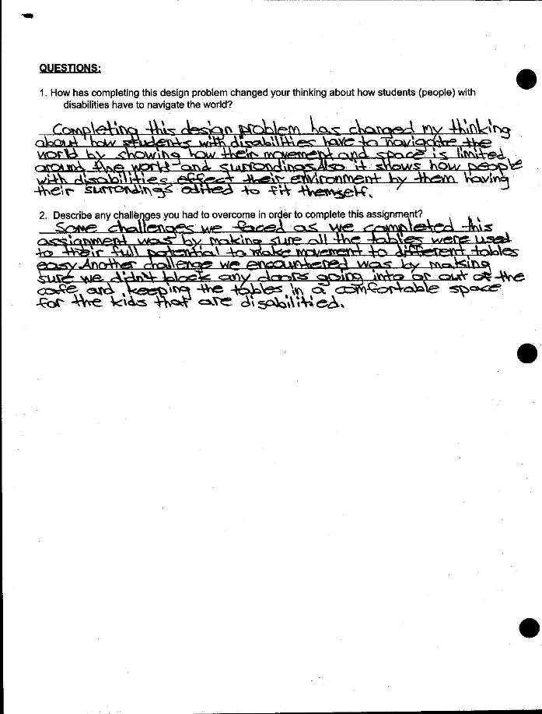

Name ______________________________ Class ______________________

CAFETERIA DESIGN PROBLEM

Directions:

- Use the blank piece of the graph paper you were given to create 10 cafeteria tables that are 1.5m X 4m. The scale you are using is 1 square = 50 centimeters. (Note: to offer a greater challenge to students, provide the scale as well as the real dimensions of each table and ask students to calculate measurement for the scaled table)

- Once you have your tables drawn, write the dimension on each table, then use scissors to cut them out.

- Use the cafeteria template (the second piece of graph paper) to place the 10 tables in an arrangement that would make the cafeteria accessible for the student and their wheelchair and meet the criteria and constraints.
- Cut out one of the wheelchair templates to check accessibility (on bottom of sheet).

- Once your model is finished, tape or glue the cut out tables to the graph paper or trace the tables on the graph paper.

- Answer the questions.

U

Cut out the wheelchair template below to use with your scale model (Hint-review wheelchair criteria!)

Answer the following questions.
- How has completing this design problem changed your thinking about how students (people) with disabilities have to navigate the world?

______________________________________________________________________________________________________________________________________________________________________________________________________________________________________________________________________________________________________________________________________________________________________________________________________________________________________________________________________________________________________________________________

2. Describe any challenges you had to overcome in order to complete this assignment?

___________________________________________________________________________________________________________________________________________________________________________________________________________________________________________________________________________________________________________________________________________________________________________________________________________________________________________________________________________________________________________________________________________________________________________________________________________________

CAFETERIA DESIGN SCALE MODEL RUBRIC SCORESHEET

Team Member Names: _________________, __________________, __________________, ___________________

Criteria | Exceeding Expectations  4 Points | Meeting  Expectations  3 Points | Partially Meeting Expectations  2 Points | Not Meeting  Expectations  1 Point
Model  Tables | Model includes all tables drawn to scale and labeled with dimensions. | Model includes most drawn to scale and labeled with dimensions. | Model includes some tables drawn to scale and labeled with dimensions. | Model is missing most tables drawn to scale and labeled with dimensions.
Model  Accessibility | All tables have been placed to allow for wheelchair accessibility. | Most tables have been placed to allow for wheelchair accessibility. | Some tables have been placed to allow for wheelchair accessibility. | Most tables are not placed to allow for wheelchair accessibility.
Model  Safety | All doorways are not blocked. | Most doorways are not blocked. | Some doorways are not blocked. | Most doorways are blocked.
Team Work | All team members used time efficiently and all members contributed for the duration of the activity | Most team members used time efficiently and contributed for the duration of the activity | Not all team members used time efficiently and contributed for the duration of the activity while others did not | Team did not use time efficiently and/or contribute for the duration of the activity
Questions | Questions are answered completely and with thoughtfulness. | Questions are answered completely and with some thoughtfulness. | Questions are not answered completely but demonstrate some thoughtfulness. | Questions are not answered completely and demonstrate no thoughtfulness.

Score: ________

Comments:__________________________________________________________________________________________
___________________________________________________________________________________________________
___________________________________________________________________________________________________
___________________________________________________________________________________________
Engineering Design Process Handout
