Synopsis of high-quality task: Vegetable Garden

Students use multiplication and division of mixed numbers to find the area of a rectangular vegetable garden. They then use the area to determine how many different kinds of vegetables they can plant if each vegetable takes up a given size of the garden. Students need to divide the area of the garden by the area of each plot of vegetables.

This could be an entry-point into division of fractions, as it shows division as creating equal groups. Students not yet familiar with the standard algorithm still have an entrance to the problem.

Anticipated student time spent on task: 1 hour

Student task structure: Partner work

Math Content Standards and Practices:

6.NS.A.1 Interpret and compute quotients of fractions, and solve word problems involving division of fractions by fractions, e.g., by using visual fraction models and equations to represent the problem.

SMP1 Make sense of problems, and persevere in solving them.
SMP2 Reason abstractly and quantitatively.
SMP4 Model with mathematics.

Prior Knowledge:

5.NF.B. Apply and extend previous understandings of multiplication and division to multiply and divide fractions.

Connections to the real-world:

Students who garden or have family members that garden will connect to this problem. Some schools have vegetable gardens that are designed by students.

Mastery Goals:

Learning Objective:
Students will be able to interpret and compute quotients of fractions and solve word problems involving division of fractions by fractions, e.g., by using visual fraction models and equations to represent the problem.

Language Objective:
Students will explain how they solved the division problem using words and drawings.

Teacher instructions

Instructional Tips/Strategies/Suggestions:
Partner students in homogeneous groupings.

To launch the task, ask students about their prior experiences with gardening.
Then ask students what they notice and wonder about the scale drawing.
Review key vocabulary as needed.
Students then work with partners to complete the tasks. There are two versions of the problem: one that requires creating 1/4ths and one that requires creating 1/6th, and the 1/6th version is more challenging and harder to create in the visual model.

Students may use color or shading for the Key to their drawing. Watch for how students interpret the divisor in the shape of the vegetable plots (do they make them $1\frac{1}{4}$ft by 1 ft, or 5 ft by$\frac{1}{4}$feet, for example), and when students share their results, select students who have done them differently.

Once students complete their designs and work have students take turns sharing their designs with the class.

Instructional Materials/Resources/Tools:

Include:
- Use the slides that go with this task to guide the implementation of the task.
- Materials: Colored Pencils and a document camera.

Accessibility and Supports:

Sentence starters:

I found the area of my garden by ...
I can plant _______ vegetables in my garden. I found this answer by ...

Key academic vocabulary: Area, square feet

Middle School Garden -Scale Drawing

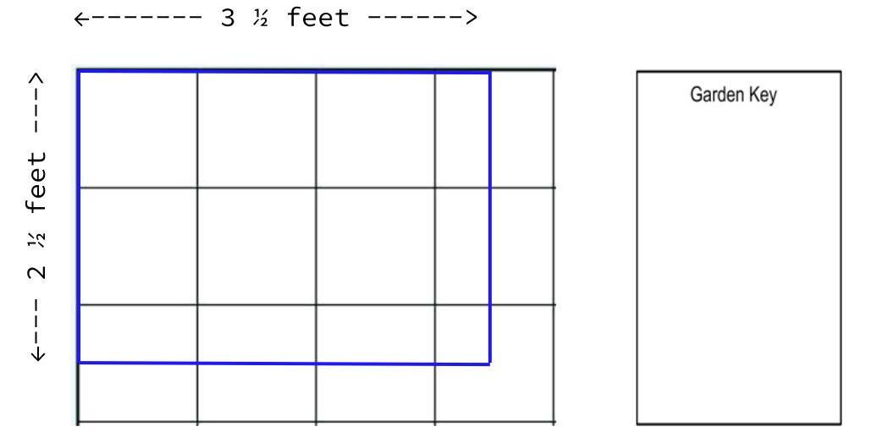

What do you notice? | What do you wonder?

Question #1- What is the area of the garden?

- Solve using the visual model:

b) Solve using a math equation:

Answer the question in a complete sentence:
________________________________________________________________________________

Question #2 - How many students can plant in this garden bed?
- Each student will get $1\frac{1}{4}square feet$of planting space.
- Each student will choose one type of vegetable to plant in their area.

- Draw a possible garden design that shows the number of planting spaces in this garden bed. Create a garden key to show which vegetables you have chosen for each planting space.

_______students can plant in this garden bed. I found my answer by _________________________________
________________________________________________________________________________________________________________________________________________________________________________________________________________________________________________________________________________________________________________________________________________________________________
c) Write and solve a division equation that represents this problem:

Extra Garden Models

Variation B:
The students at a Middle School are creating a second school garden.

How many students can plant in this garden bed?
- Each student will get $2\frac{1}{2}square feet$of planting space.
- Each student will choose one type of vegetable to plant in their area.

Draw a possible garden design that shows the number of planting spaces in this garden bed. Create a garden key to show which vegetables you have chosen for each planting space.

$$Garden Dimensions: 4\frac{1}{2} feet by 3\frac{1}{3} feet$$

Garden Key

a)
_______students can plant in this garden bed. I found my answer by _________________________________
______________________________________________________________________________________________________________________________________________________________________________________________________________________________________________________________________________

b) Write and solve a division equation that represents this problem:

Extra Garden Templates:
Garden #2

Garden Key

Garden Key
d
Sample Student Work