Task-level phenomenon:
Cranberries, like most plants, depend on pollinators to flourish. If pollinators start to die off or become unavailable because hives are not located near the crops, the plants will die.

Synopsis of high-quality task:
Students explore the crisis facing the bee populations, and how this affects human agriculture, specifically the Massachusetts cranberry industry. Over the course of four classes, students become environmental experts advising cranberry growers. They learn about colony collapse disorder, the importance of bees and other pollinators, and the science of cranberry bogs. The task is a group project in which students develop a model of their own cranberry bog, along with a written explanation that addresses the physical features of the bog and placement of the hives, as well as a student-developed list of problems that their design will need to address.

Anticipated student time spent on task: 4-5 class periods (approximately 4-5 hours)

Type of Task (check one):
____ 1. Investigation/experimentation/design challenge
____ 2. Data representation, analysis, and interpretation
__ X_3. Explanation

Student task structure(s): Group work
STE Standards and Science and Engineering Practices:

7.MS-LS2-5. Evaluate competing design solutions for protecting an ecosystem. Discuss benefits and limitations of each design.*
Clarification Statements:
- Examples of design solutions could include water, land, and species protection and the prevention of soil erosion.
- Examples of design solution constraints could include scientific, economic, and social considerations.

Science and Engineering Practice:
- Constructing Explanations and Designing Solutions

Prior Knowledge:
Previous Standard from Strand Map:

7.MS-LS2-6(MA). Explain how changes to the biodiversity of an ecosystem—the variety of species found in the ecosystem—may limit the availability of resources humans use.
Clarification Statement:
- Examples of resources can include food, energy, medicine, and clean water.

7.MS-ETS1-2. Evaluate competing solutions to a given design problem using a decision matrix to determine
how well each meets the criteria and constraints of the problem. Use a model of each solution to evaluate
how variations in one or more design features, including size, shape, weight, or cost, may affect the function
or effectiveness of the solution.*

Connections to the real-world:

Cranberries are a large part of the economy of Massachusetts. Students may have some background knowledge on the importance of proper farming and agricultural practices. Bees are important pollinators of the cranberry crop and they are now being shipped in from other parts of the country to pollinate the bogs. Colony collapse disorder, one of the reasons of bee colony health, is a problem that is currently being investigated by the Environmental Protection Agency and the Department of Agriculture, will be researched. This is a pressing issue regarding the food supplies of the nation.

Mastery and Language Goals:

Learning Objective:
- Students obtain information and evidence to describe the need to protect ecosystems locally.
- Students identify factors that affect cranberry bog ecosystems.

Performance Objective:
- Students construct explanations that predict patterns of relationships between changes in the components of an ecosystem.
- Students construct an argument supported by physical evidence that explains how changes to physical or biological components of an ecosystem affect organisms and populations.
- Students will design a model of a cranberry bog and access any issues that their design may develop.

Language Objective:
- Students will be able to listen, speak and explain, in writing how the changes to physical or biological components of a bog ecosystem affect organisms and populations.
- Students will work in small groups to orally present relevant findings and conclusions from their final cranberry bog design obtained from their research.

Teacher Instructions:
Day 1 – Gathering Evidence
Part 1 (20 minutes):
- Students make observations and generate questions about bees in their notebooks. Suggested images: https://upload.wikimedia.org/wikipedia/commons/thumb/c/c5/Honeybee-cooling_cropped.jpg/1200px-Honeybee-cooling_cropped.jpg
- Students share their observations and questions in small groups compile list of observations and questions.
- Class discussion. Each group shares out their lists to whole class. Record lists on the board. Additional prompts if not student generated; What do the bees look like? What are the bees doing? Do the bees in the foreground look different than the background?
Part 2 (20 minutes)
- Handout graphic organizer and article. Keep the bee image on the projector screen prior to passing out article.
- Students read NewsEla article “Overview of the Bee Blight” link: https://newsela.com/read/overview-bee-blight/id/20875/
- Students work in small groups to discuss article. Students use the article to gather evidence about bees.
Part 3 (10 minutes)
- Whole group discussion about how the article relates back to their earlier observations.
- Students generate a list of possible next steps to learn more about and record on board. If running out of time can assign for homework.

Day 2- Gathering Evidence
Part 1 (20 minutes):
- Students watch a video, “Cranberries and How Do They Grow” (https://www.youtube.com/watch?v=XZPXQ7nw_9Y) and make observations and generate questions about cranberry bogs in their notebooks.
- Students share their observations and questions in small groups compile list of observations and questions.
- Class discussion. Each group shares out their lists to whole class. Record lists on the board. Additional prompts if not student generated; Discuss What do you see? What is the person doing? What time of year is it?
Part 2 (20 minutes)
- Handout graphic organizer and article. Break the article up so each student in a group of 4 reads one part and completes the chart.
- Students read the article “How Cranberries Grow”, https://www.cranberries.org/how-cranberries-grow
- Students work in small groups to discuss article. Students use the article to gather evidence about cranberry bogs. Discuss needs of the cranberry plants. Soil layers and requirements, location of the plants and how they grow, water needs, habitat interactions, pollination
Part 3 (10 minutes)
- Whole group discussion about how the article relates back to their earlier observations.
- Students generate a list of possible next steps to learn more about and record on board. If running out of time can assign for homework.

Day 3 and 4 Designing a Cranberry Bog
- Students refer back to their evidence collected to brainstorm in small groups. How are bees and bogs connected to each other?
- Record ideas on board.
- Provide students with their design Challenge: Student description - You are an environmental expert contracted to advise a new cranberry grower in Massachusetts on what is needed for a successful cranberry bog. Currently there are 14,000 acres in Massachusetts used to produce cranberries bringing in about $60,000,000 in 2017. A location for the cranberry bog has been found. Use the information that your collected from the readings to draw a plan for the bog. You must use graph paper. Include your scale showing how many acres your bog is and include at least 3 other physical features that will be necessary for the success of the new cranberry grower.
- Break students into small groups and give a piece of graph paper (8” by 11”) on which they will make their design.
- Group directions: The groups must then produce a design for a cranberry bog operation in that area. In their design, they must address all of the concerns that the class came up with during the previous day. Accompanying their design will be a 1-page written description of their bog, addressing the specific problems mentioned by the class, as well as any other concerns brought up within the group.
- Provide students with additional background information if needed or scaffold in information as needed. Suggestions:
  - designing a bog activity sheet
  - provide a variety of images of local cranberry bogs and how they are organized (Duxbury, Wareham, Nantucket)
  - brainstorm potential issues that need to be considered when planning the bog (space, water, tree cover, pollination, soil composition and erosion, pesticides, logistics, etc.
Day 5- Communicating Ideas
- Student groups present their ideas to the group in a gallery walk format.
- Individual/pairs of students review projects and add sticky notes with feedback onto the projects. Provide sentence starters or questions for them. Suggested protocol: https://learninginhand.com/blog/feedbackchat
- Student groups review their feedback and make revisions.
Instructional Materials/Resources/Tools:

- Student computer access or printed copies of
  - Bee Blight reading and graphic organizer (Day 1)
  - How Cranberries Grow reading and worksheet (Day 2)
  - Designing a Bog activity sheet optional (Day 3)
  - Bogs and the Bees performance task directions for each group (Day 3)
- Rubric
- Projector with connection to teacher computer
- Graph Paper (Day 3-4)

Task Source:
The Ambassador would like to recognize Dighton-Rehoboth science teachers for their contributions to the development of this task.
Accessibility and Supports:

- Differing Lexile levels of Bee Blight article (available on NEWSELA site)
- Designing a bog activity sheet can be used as a scaffold to support students to organize their information.

Performance Task Rubric

Sample Student Work: see below
Provide a few examples of student work at varying levels.
High Quality
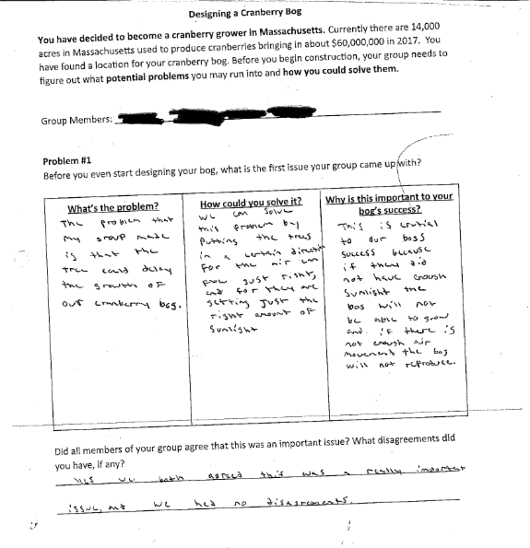

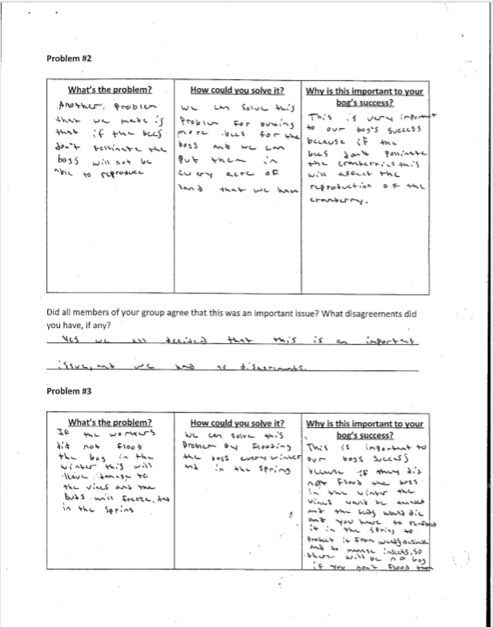
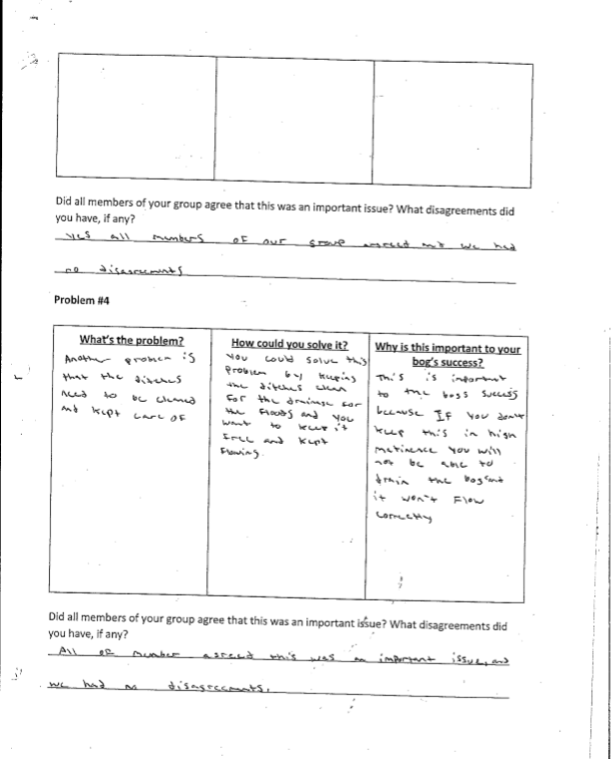
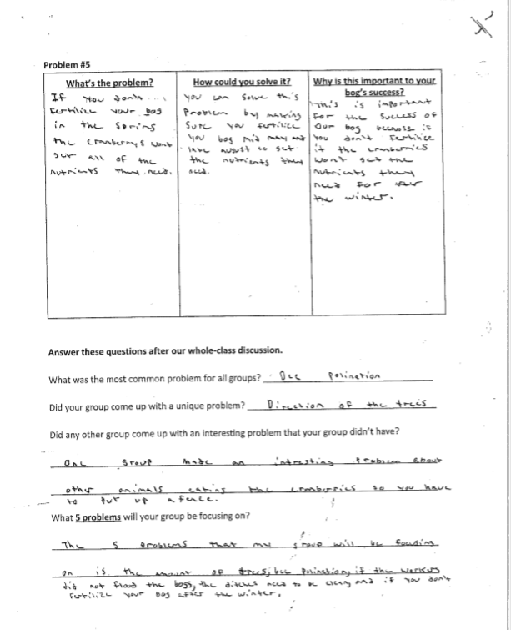
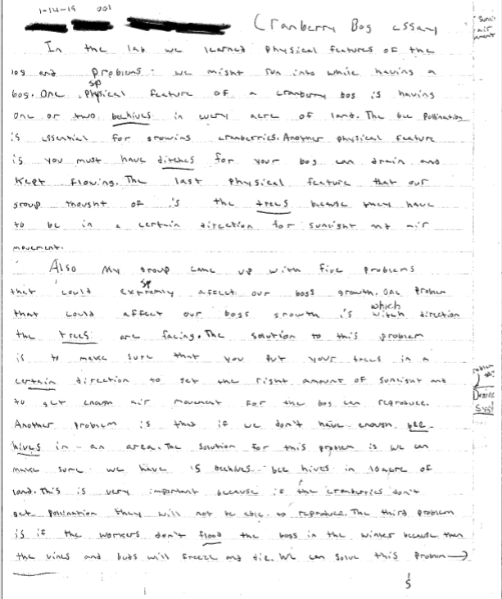
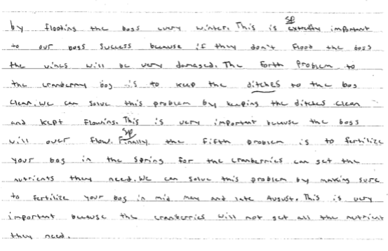
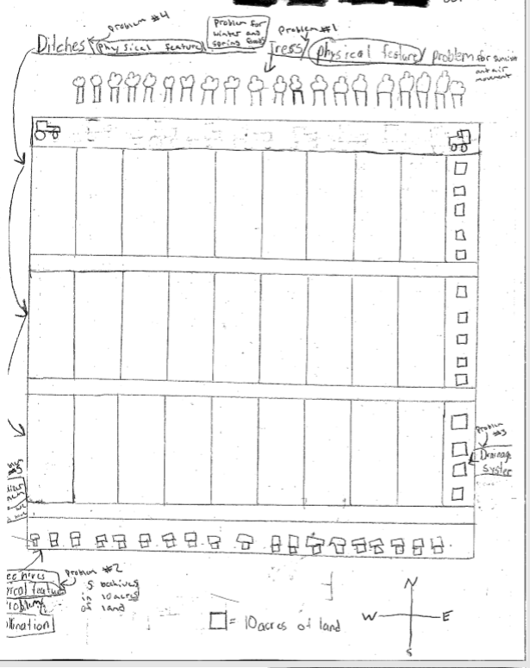
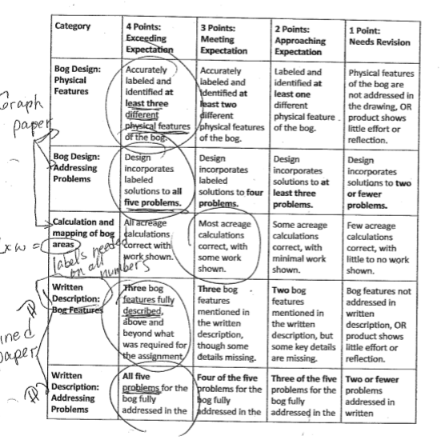
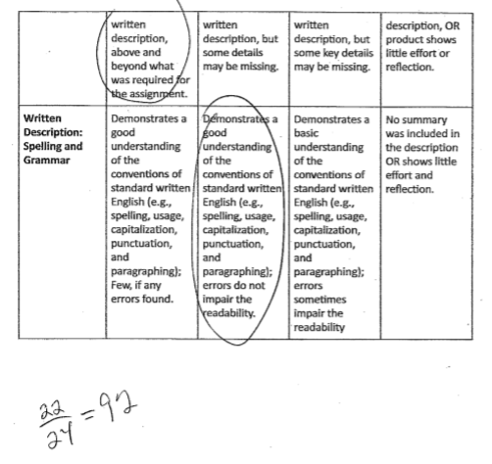

Medium quality:
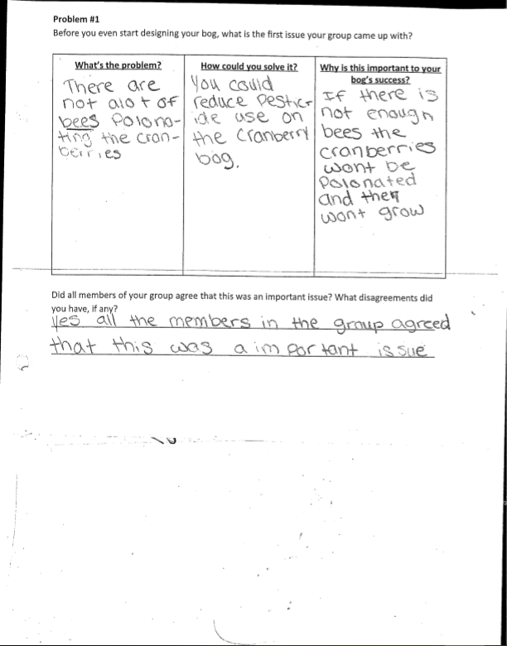
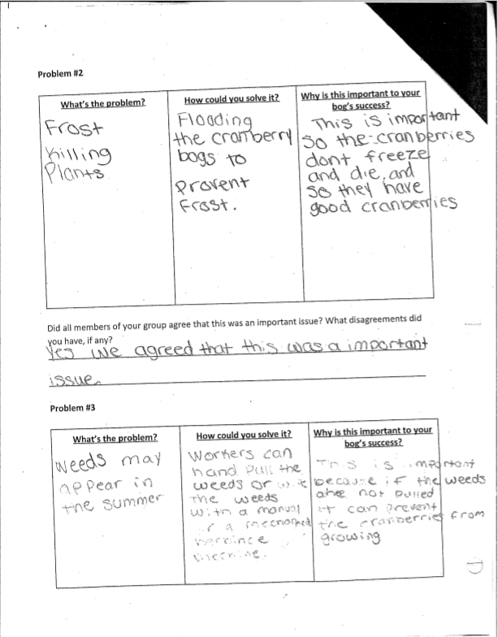
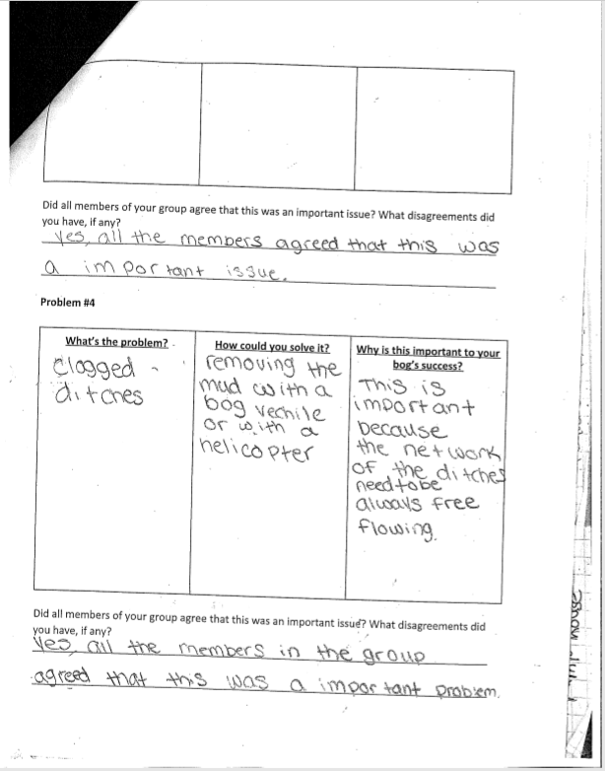
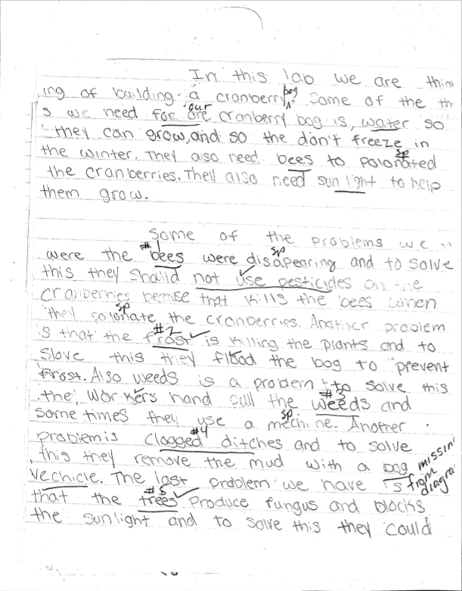
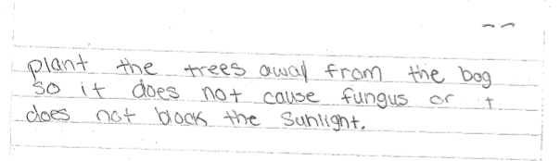
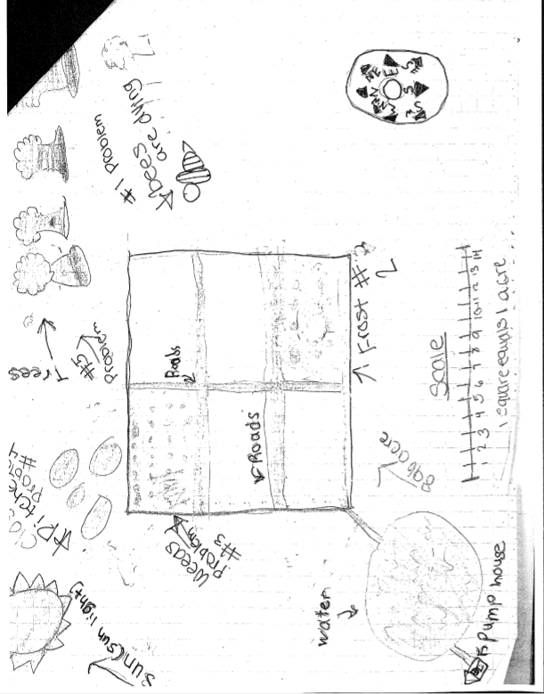
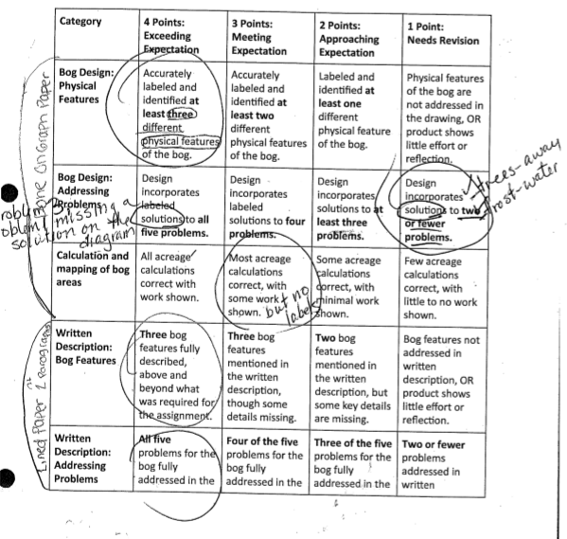
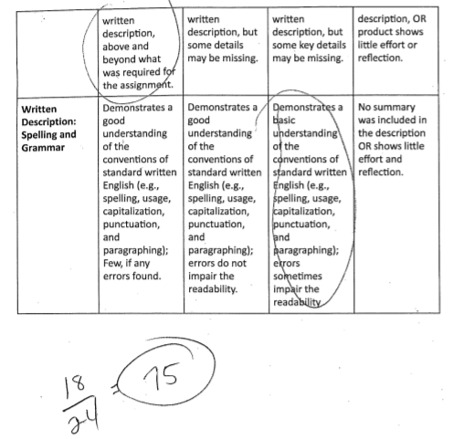

Low quality:
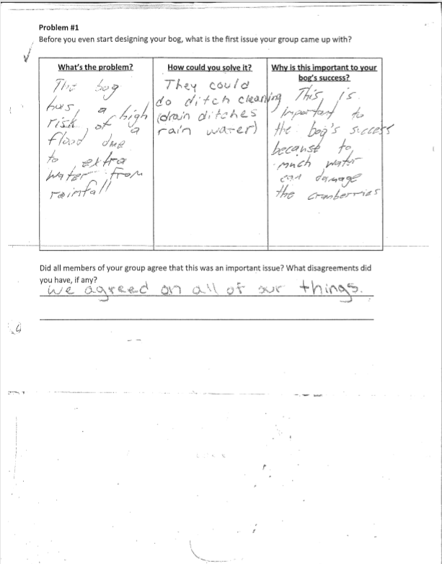
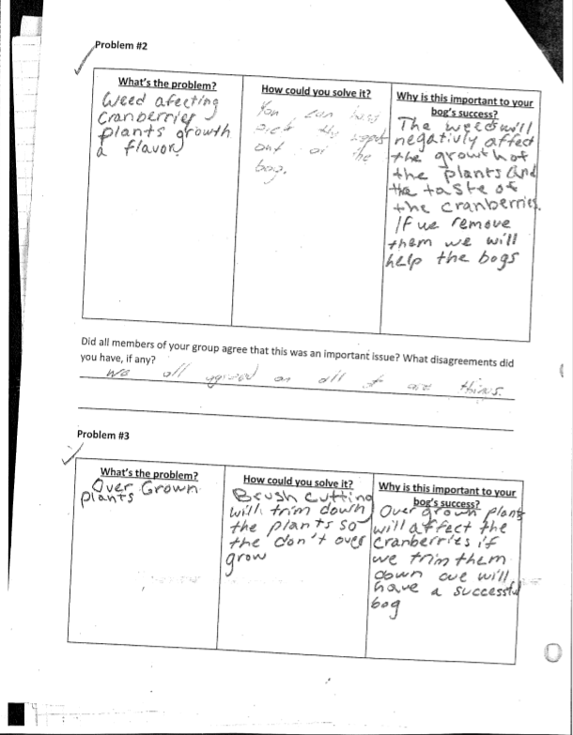
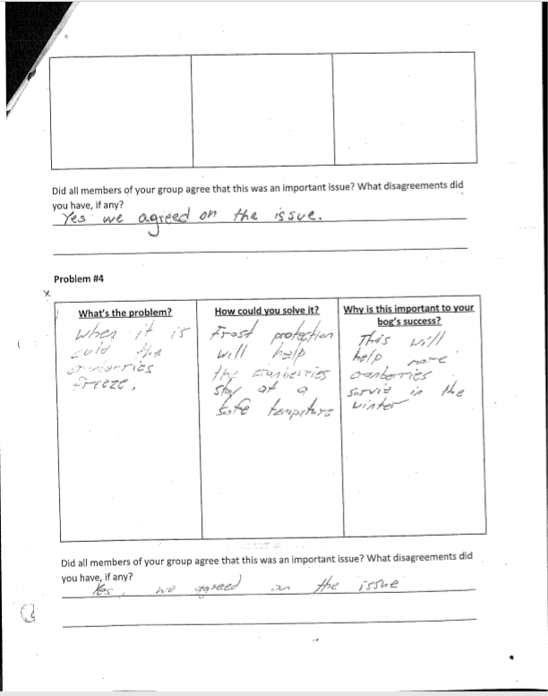
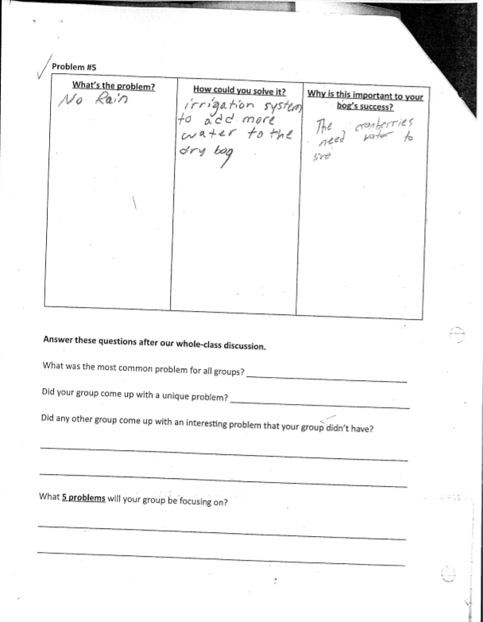
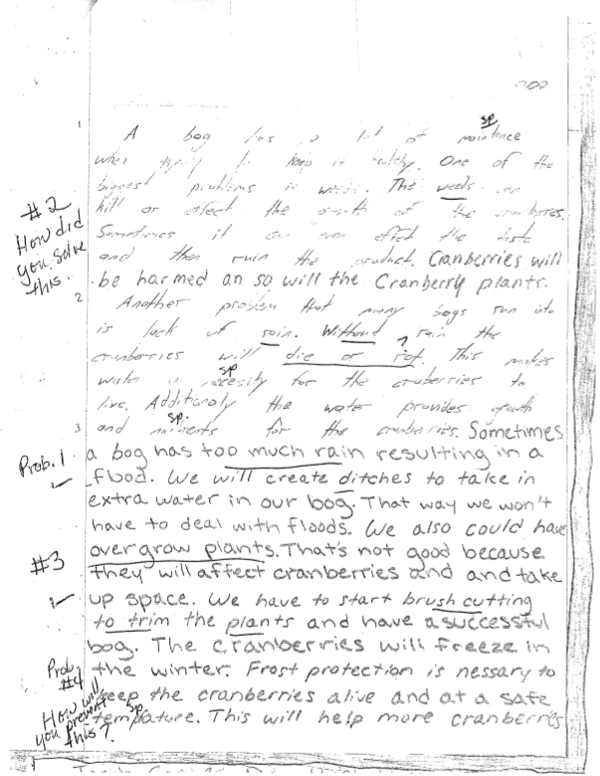
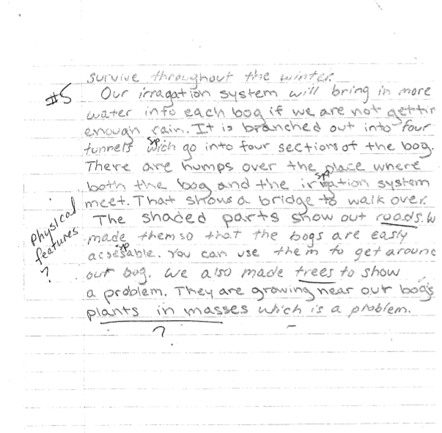
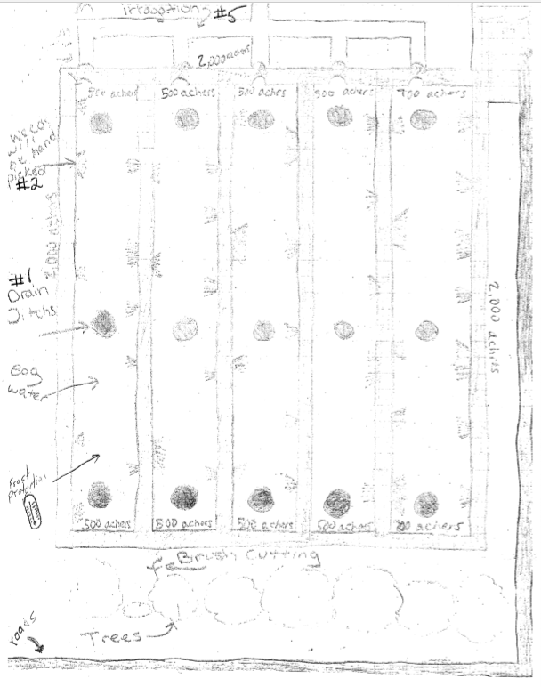
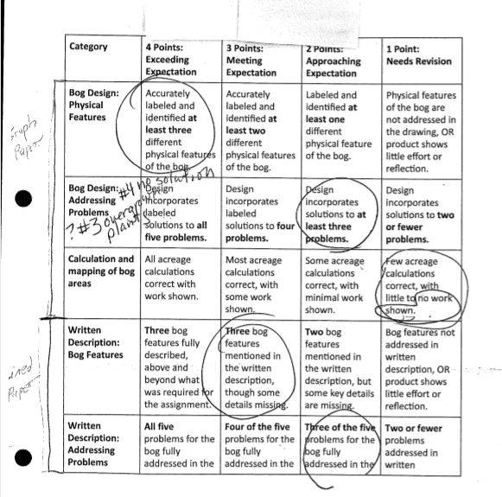
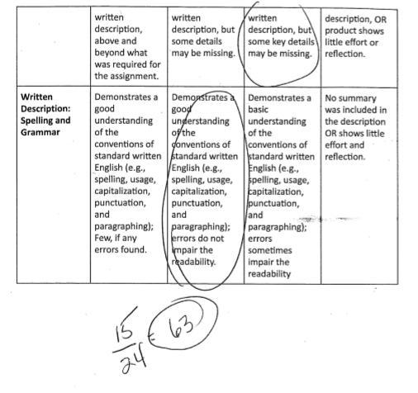

Student Worksheet
Bee Blight
Article: Overview of the Bee Blight”

Graphic Organizer

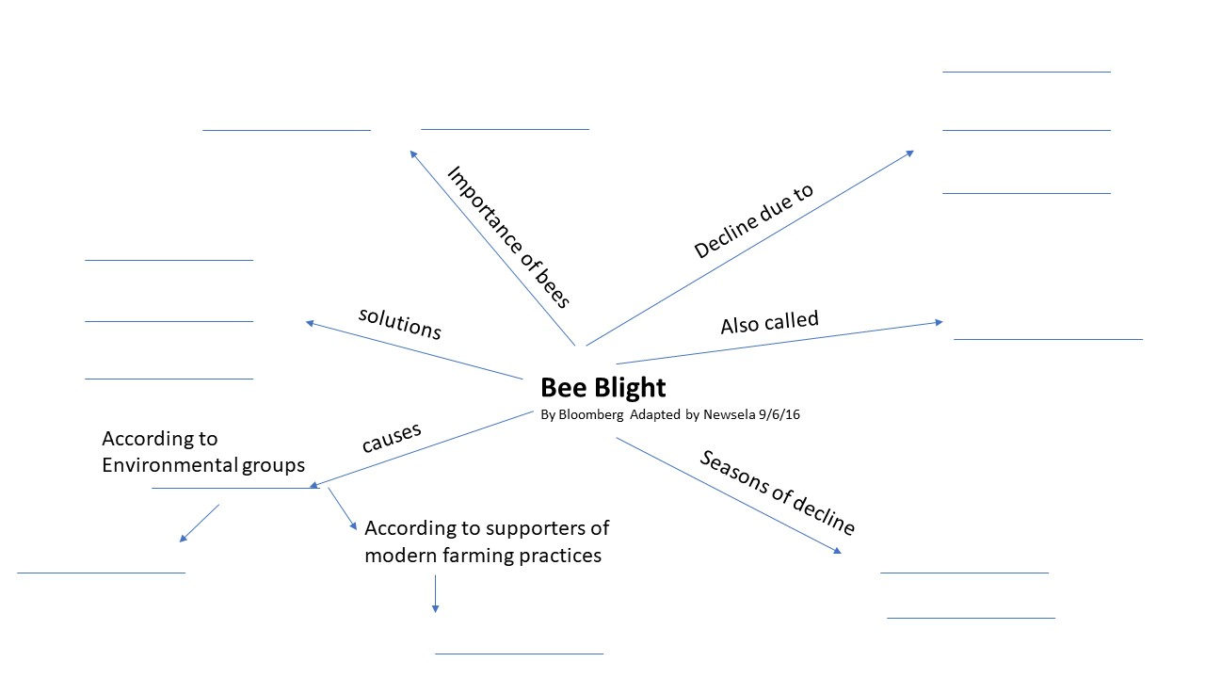

Bee Blight Suggested Answers

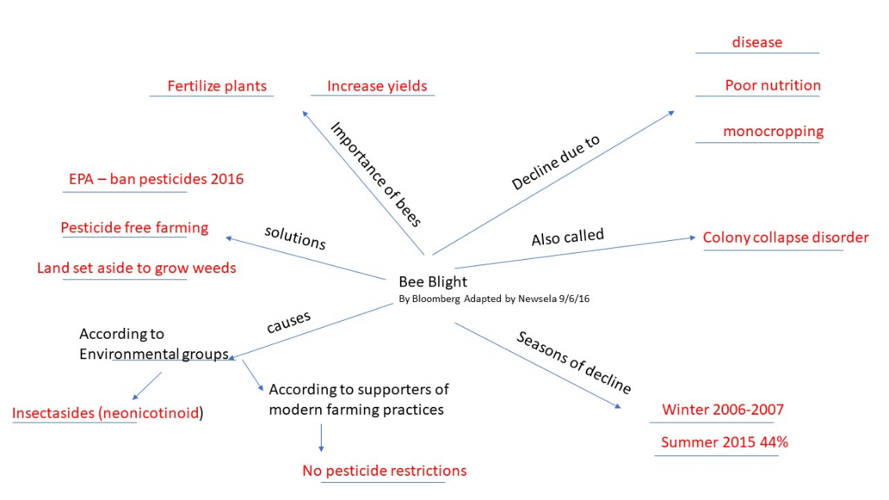

Student Worksheet

Group Names: ______________________________________________________________________
How Cranberries Grow
Needs of a bog- Winter | Reason

Needs of a bog - Spring | Reason

Needs of a bog- Summer | Reason

Needs of a bog- Harvest | Reason

Suggested Answers
How Cranberries Grow
Needs of a bog: - Winter | Reason
Winter Flood | Protects vines and buds from winter injury
Sanding | Stimulate growth, improve drainage, control weeds
Brush cutting and tree clearing | promote air movement which helps reduce frost risk and fungal growth.  eliminate weeds, diseases and insects and pesticide use for those

Needs of a bog: - Spring | Reason
Removal of winter flood  Spring Flooding  Ditch cleaning | allows vines to slowly come out of dormancy  manage insects, weeds, and disease  helps with flooding and draining
Frost protection | protect bud and shoots
Fertilizing | small doses of nutrient supplements
Weed management | allows growth of vines
Construction and management of Cranberry bogs | making old bogs level, replacing low producing vines, removing weeds like briar, poison ivy, or brambles, upgrade or replace irrigation systems, increase operation efficiency

Needs of a bog: - Summer | Reason
Irrigation | needed for growth, supplements rainfall
Weeding | allows proper growth
Bees | pollination
Integrated pest management-biological, cultural, and chemical methods | control pests
Pesticide application | control or prevent serious damage caused by insects or disease

Needs of a bog: - Harvest | Reason
Dry harvesting | comb the berries off vines for fresh fruit markets
Wet harvesting (flooding) | dislodge berries from vines for juices and processed foods
Frost protection | protects the ripening cranberries from freezing

Student Worksheet

Name: _________________________ Date: _______________ Class: _____________
Designing a Cranberry Bog
You have decided to become a cranberry grower in Massachusetts. Currently there are 14,000 acres in Massachusetts used to produce cranberries bringing in about $60,000,000 in 2017. You have found a location for your cranberry bog. Before you begin construction, your group needs to figure out what potential problems you may run into and how you could solve them.

Group Members: _______________________________________________________________

Problem #1
Before you even start designing your bog, what is the first issue your group came up with?

What’s the problem? | How could you solve it? | Why is this important to your bog’s success?

Did all members of your group agree that this was an important issue? What disagreements did you have, if any?
______________________________________________________________________________
______________________________________________________________________________

Problem #2

What’s the problem? | How could you solve it? | Why is this important to your bog’s success?
Did all members of your group agree that this was an important issue? What disagreements did you
have, if any?
______________________________________________________________________________
______________________________________________________________________________

Problem #3

What’s the problem? | How could you solve it? | Why is this important to your bog’s success?

Bog and the Bees Performance Task and Rubric
Student Name: Date: Class:

Task: You are an environmental expert contracted to advise a new cranberry grower in Massachusetts on what is needed for a successful cranberry bog. Currently there are 14,000 acres in Massachusetts used to produce cranberries bringing in about $60,000,000 in 2017. A location for the cranberry bog has been found. Use the information that your collected from the readings to draw a plan for the bog. You must use graph paper. Include your scale showing how many acres your bog is and include as least 3 other physical features that will be necessary for the success of the new cranberry grower.
Task Grading Sheet

Group Members:

Category | 4 Points:  Exceeding  Expectation | 3 Points:  Meeting Expectation | 2 Points:  Approaching Expectation | 1 Point:  Needs Revision
Bog Design:  Physical Features | Accurately labeled and identified at least three different physical features of the bog. | Accurately labeled and identified at least two different physical features of the bog. | Labeled and identified at least one different physical feature of the bog. | Physical features of the bog are not addressed in the drawing, OR product shows little effort or reflection.
Bog Design:  Addressing Problems | Design incorporates labeled solutions to all five problems. | Design incorporates labeled solutions to four problems. | Design incorporates solutions to at least three problems. | Design incorporates solutions to two or fewer problems.
Calculation and mapping of bog areas | All acreage calculations correct with work shown. | Most acreage calculations correct, with some work shown. | Some acreage calculations correct, with minimal work shown. | Few acreage calculations correct, with little to no work shown.
Written Description:  Bog Features | Three bog features fully described, above and beyond what was required for the assignment. | Three bog features mentioned in the written description, though some details missing. | Two bog features mentioned in the written description, but some key details are missing. | Bog features not addressed in written description, OR product shows little effort or reflection.
Written Description:  Addressing Problems | All five problems for the bog fully addressed in the written description, above and beyond what was required for the assignment. | Four of the five problems for the bog fully addressed in the written description, but some details may be missing. | Three of the five problems for the bog fully addressed in the written description, but some key details may be missing. | Two or fewer problems addressed in written description, OR product shows little effort or reflection.
Written Description:  Spelling and Grammar | Demonstrates a good understanding of the conventions of standard written English (e.g., spelling, usage, capitalization, punctuation, and paragraphing); Few, if any errors found. | Demonstrates a good understanding of the conventions of standard written English (e.g., spelling, usage, capitalization, punctuation, and paragraphing); errors do not impair the readability. | Demonstrates a basic understanding of the conventions of standard written English (e.g., spelling, usage, capitalization, punctuation, and paragraphing); errors sometimes impair the readability | No summary was included in the description OR shows little effort and reflection.
Individual  Behavior and  Responsibility | Student recorded 5 or more relevant and rigorous tasks signed by the group AND showed exemplary behavior, motivation, and leadership skills. | Student recorded 3-4 relevant and rigorous tasks signed by the group AND showed satisfactory behavior and leadership skills. | Student recorded 2 relevant and rigorous tasks signed by the group AND showed satisfactory behavior and/or motivation with minor teacher cues. | Student recorded 0-1 relevant and rigorous tasks signed by the group AND/OR showed unsatisfactory behavior or motivation throughout the assignment.

