Task-level phenomenon:
Students view a brief video of earthquakes, showing some damage and human reactions.
Synopsis of high-quality task:
This task begins with the phenomenon of a video of dramatic earthquakes. By the end, students produce a scientific explanation (Claim-Evidence-Reasoning) about the likelihood of earthquakes happening in various parts of the world.

Students start by plotting the locations of recent earthquakes, and then discuss possible reasons for why earthquakes happen in the very specific places that they do. Students will analyze the data and discover that earthquakes happen because the earth is broken into pieces. Students will then create models to try to explain what happens at the boundaries between tectonic plates. Finally, students construct an explanation using the CER format assessing the earthquake risk of six world cities in order to make a decision about the best place to live to avoid earthquakes.

This task would fit into a unit about plate tectonics, in conjunction with additional lessons.

Anticipated student time spent on task: 4-6 class sessions 55-minutes each

Type of Task (check one):
___ 1. Investigation/experimentation/design challenge
_X_ 2. Data representation, analysis, and interpretation
___ 3. Explanation

Student task structure(s): Individual work and group work
STE Standards and Science and Engineering Practices:

Standard:
7.MS-ESS3-2 Obtain and communicate information on how data from past geologic events are analyzed for patterns and used to forecast the location and likelihood of future catastrophic events.
Clarification Statements
- Geologic events include earthquakes, volcanic eruptions, flood, and landslides.
- Examples of data typically analyzed can include the locations, magnitudes, and frequencies of the natural hazards
State Assessment Boundary
- Active analysis of data or forecasting is not expected in the state assessment

Science and Engineering Practices:
- Analyzing and interpreting data
- Constructing explanations
- Developing and using models

Prior Knowledge:
Previous Standard from Strand Map:
4.ESS3-2 Evaluate different solutions to reduce the impacts of a natural event such as an earthquake, blizzard, or flood on humans.*
Clarification Statement:
- Examples of solutions could include an earthquake-resistant building or a constructed wetland to mitigate flooding.

Previous Topics:
- Latitude & Longitude - students MUST be able to plot points on a map using latitude and longitude. Teachers may need to add a day of practice before this task.
- Optional: Earth’s Layers and Plate Tectonics background. This task is designed to be flexible, but if your students have learned about these topics, you should make sure they are integrated into their explanations.

Connections to the real-world:
Students are asked to think about the relative risk of earthquakes in Boston, where they live now, and in other places in the world that they may have heard about, have family who live there, have visited or lived themselves, or may want to visit or live in the future. They also get to think about and begin to develop a mental model for what causes these very dramatic and engaging phenomena.

Mastery Goals:

Learning Objective:
- Analyze and interpret data of earthquake risk in various locations around the world
- Construct an explanation for where in the world earthquakes happen, and why they happen there

Performance Objective:
- Analyzing patterns in data by creating a map of where recent large earthquakes have occurred in the world and finding patterns in the locations
- Develop a physical model for what causes earthquakes
- Construct an evidence-based explanation about the relative risks for earthquakes in various places in the world

Language Objective:
- Write an explanation of the reasoning using the sentence starter “if…then…”.
- Discuss and describe models to develop ideas about what causes earthquakes.
- Write explanations using appropriate science vocabulary.

Teacher Instructions - Instructional Tips/Strategies/Suggestions:
If your students are missing background knowledge about latitude and longitude or earth’s structure, you may need to add a lesson.

PART ONE: Examining the Phenomenon & Analyzing Data (2 class sessions)
Activity 1A (15-20 mins): Phenomenon--Earthquake video
https://www.youtube.com/watch?v=FW-TkpvKPl0 (or similar video showing shaking and damage)
Show this to students and ask them to write down their notice and wonderings and then share them in small groups. Ask if any students have ever felt an earthquake (and encourage them to share their experiences).
Note: If you have students with trauma around earthquakes or natural disasters, check in with them beforehand and allow them to put their heads down or step into the hallway during the video. Give a disclaimer beforehand in case there are students with trauma you don’t know about.

Activity 1B (2 mins): Present task question (as a way of helping to focus student questioning)
Johana wants to move, but she isn’t sure where she wants to go. She is sure that she does not want to live in a city with frequent earthquakes. That is her main concern in making this decision.
Which cities should Johana take off of her list because of earthquakes? Why?

Activity 1C (15-20 mins): Questioning
Have students generate questions they have after viewing the video. Have them write 3-5 questions each on post-it notes and collect these questions on a “parking lot” poster for each group. Have student groups categorize similar questions into different themes. Guide them towards thinking about geographic locations where earthquakes happen, and how often they occur. It’s okay for students to voice misconceptions here--allow this to happen without correcting, as well as additional questions like “How do I stay safe during an earthquake?” For the last 5 minutes, let students look at other groups’ ideas, either by rotating through tables or as a gallery walk.

Break to teach latitude & longitude if needed.

Activity 1D (20-25 mins): Earthquake Plotting
Guiding Question (write or project on board):
- Are the earthquake locations random, or do you see patterns?
Provide students with a list of recent earthquake locations (the Incorporated Research Institutions for Seismology website has one that continuously updates; remember, you want a list of latitude and longitude, not pre-plotted points on a map) and a world map with lines of latitude and longitude (below). We suggest printing out a significantly overwhelming list (~8 pages double-sided) to lead students to discover how frequently earthquakes occur.

Give students 1-2 minutes to make observations about what this list shows them. Guide them to notice:
- Date and time are listed for each earthquake.
  - The earthquakes all happen in the last few days!!
- The locations are given in Latitude/Longitude form as well as a brief description
- Depth is listed (don’t worry about explaining what this means)

Ask students to plot 15-30 earthquakes each (depending on student skill levels), ensuring that most earthquakes in your packet will be plotted. Assign different pages to different students in each group. Students should each individually plot their assigned earthquakes, but they will help each other along the way. As students work, rotate from group to group, asking what patterns they notice. Students should notice that though they are plotting different points, similar patterns are developing.

If you can, project the same map on a large dry-erase board and ask many students to quickly plot their earthquakes, so that you have a map with dozens of data points. Recent Earthquake Locations from IRIS: https://ds.iris.edu/seismon/eventlist/index.phtml
(remember, you want a list of latitude and longitude, not pre-plotted points on a map!)

TEACHER NOTE: Ideally, students will plot enough locations to notice that the locations line up. They are not random. Later in the unit, you should teach about tectonic plates--these lines are the boundaries between plates.

Activity 1E (5 mins): Individual thinking
Students should work quietly and individually to record what they notice about the locations of the earthquakes.

Activity 1F (20-30 mins): Sense-making.
Guide a whole-class discussion where students share their findings from the plotting activity. Encourage them to find patterns in the locations. Show a video of earthquake locations from 2001-2015 (see link below). This video adds hundreds of data points of evidence; use strategically to support your class discussion.

https://www.youtube.com/watch?v=Ed0tGlfJHiY or a similar video plotting earthquakes around the world over several years.

Include “Turn & Talk” opportunities as needed using these prompts:
- What patterns do you notice?
- Why do you think the earthquake locations line up?
- What do you think the Earthquake “lines” tell you about the Earth?
- The Earth’s surface is sometimes compared to a cracked eggshell. Why?
- Think about what you know about the Earth’s layers. What clues might that give us?
- What do these lines tell us about the Earth?

Guide students to the conclusion that the Earth is broken into pieces. Name these pieces “tectonic plates.” The edges of each plate are called “plate boundaries.” Note: This piece could easily be an opening activity on day two.

PART TWO: Constructing a Model (1-2 class sessions)
.
Activity 2A (10-15 mins): Framing the Challenge
Review the ideas from part 1:
- Conclusion: Earthquakes naturally occur along lines.
- Hypothesis: Those lines break the Earth’s surface into pieces called tectonic plates.

Tell students: One way that scientists study things that are too big to observe is to build a model. Models are used to predict or explain phenomena. Ask students what models they have seen before and what can be learned from them. Then, tell students: Today we’re going to construct a model that shows what happens at plate boundaries.

Ask students to discuss in table groups:
- What does our model need to represent?
- What should the parts of the model be?
- How will we know if our models are useful?
  - Teacher note: vibrations in these models will represent earthquakes

Have students share their ideas. Record class answers on chart paper to display for the entire activity.

Activity 2B (5-10 mins): Explore Materials
Provide a wide variety of materials, possibly including kitchen sponges, towels, boxes, desks, blocks, textbooks, etc. Review your procedures for obtaining materials.

Tell students their first task is to figure out what materials work best for this model and be ready to explain why.

Students should have freedom to use different materials and be creative. Teacher should check in with each student group, but not push students in any particular direction. Ask questions, but not leading questions.

Activity 2C (10-20 mins): Constructing the Model
Students should work in groups or pairs to choose materials and build their models (this should take at least half the time). Students should record their work in the graphic organizer (see below).

Prepare explanation of your choice. Include self-eval of strengths and limitations of your model.

For students who finish early, ask:
- Do different types (directions) of motion create different effects?
- What kind of motion can make the biggest earthquake?
- Can you make a second model that shows something your first model doesn’t?

Activity 2D (15-20 mins): Present Models
Have each group demonstrate their model, explain their thinking to the class, and describe the strengths and limitations of their model. Ask the other students to evaluate the strengths and limitations of others’ models, as they are demonstrated.

By the end of the presentations, students should notice that
- any motion (convergent, divergent, transform) at plate boundaries can cause earthquakes, and
- there are many different successful models.

Optional Activity 2E (5-10 mins): Revise Models
Have students consider what they like best about other students’ models. Have them think about how they might improve their model now that they have seen other groups’ models.

Give groups an opportunity to return to their model, incorporating information and advice from other groups. Make sure that every group can demonstrate an earthquake using a model.

PART THREE: Constructing an Explanation (1-2 class sessions)
Activity 3A (20-30 mins): Writing (Claim-Evidence-Reasoning)

Prompt: Should Boston residents worry about major earthquakes? What about residents of Tokyo, Japan; Santo Domingo, Dominican Republic; Cairo, Egypt; Anchorage, Alaska; and Sydney, Australia? Remember to provide evidence from historical earthquakes and explain how your model of tectonic plates supports your claim.

You know your students best. Structure this writing task appropriately for your classroom. Make sure students use sufficient evidence, including the map of earthquake locations and the plate boundary model.

We recommend the following suggestions for kids who need additional support:
- Evidence must include:
  - Whether each city is near a plate boundary or not.
  - The names of the plate (or both plates if it's on a boundary) for each city.
- Reasoning must include BOTH:
  - How do we know where the plate boundaries are? Explain.
    - ***This piece connects directly to the standard and is important that students understand how scientists use real data to map the boundaries. Make sure they point out that the earthquakes form patterns and line up.***
  - How do the tectonic plates cause an earthquake to form at the boundaries? Talk about your model.
    - ***Students should show how they made sense of their model from class. Keep 1-2 models from class to demonstrate for students who struggle with this part.***
Additionally, if students need further reading to push their thinking, USGS has a website that directly explains what happens to cause earthquakes. This website will give students direct answers, so it should only be given to students who are completely stuck after all other interventions.
USGS Website: https://earthquake.usgs.gov/learn/kids/eqscience.php (included in appendix)

Instructional Materials/Resources/Tools:

Materials:
- kitchen sponges, towels, boxes, desks, blocks, textbooks, etc
- projector setup for videos

Links:
- Earthquake video
  - https://www.youtube.com/watch?v=FW-TkpvKPl0 or similar
- Incorporated Research Institutions for Seismology provides a list of recent earthquake locations
  - https://ds.iris.edu/seismon/eventlist/index.phtm l or search “IRIS earthquake locations list” and make sure you get the list and not the world map
- video of earthquake locations from 2001-2015
  - https://www.youtube.com/watch?v=Ed0tGlfJHiY or similar video plotting earthquakes over several years

Handouts:
- World map with latitude and longitude lines
- List of earthquake locations with latitude and longitude: This needs to be looked up close to the day the lesson is taught. We recommend searching for “IRIS recent earthquakes list”. You need a list of latitude and longitude, not on already plotted on a map!
- Earthquake Model Record
- Writing prompt and graphic organizer “Avoiding Earthquakes”

Task Sources:
- Teacher/Student Discourse Moves: National Science Foundation
  - http://stem4els.wceruw.org/resources/Student-and-Teacher-moves.pdf?
- Latitude-Longitude World Map: United Nations
  - https://www.un.org/Depts/Cartographic/map/profile/world.pdf
- BPS Science Explanation Rubric: developed by Boston Public Schools Science Department
- The Science of Earthquakes: USGS
  - http://earthquake.usgs.gov/learn/kids/eqscience.php

Accessibility and Supports:
key academic vocabulary:
- Tectonic plate
- Plate boundary
- Magnitude (not a focus, but they will hear it and need to know basically what it means)

ELLs will need additional supports for the argumentation piece of this task. Remember that students with ELD 1s and 2s get a lot out of being able to discuss and speak about their ideas before trying to write them down.

Other ideas for supporting writing:
The teacher might lead the class through the writing of an analysis paragraph for Boston, and then have students break into pairs or trios to write about another city. There could also be several types of graphic organizers offered, either general ones for writing CERs or more customized ones for this assignment, as needed.

Sample Student Work:

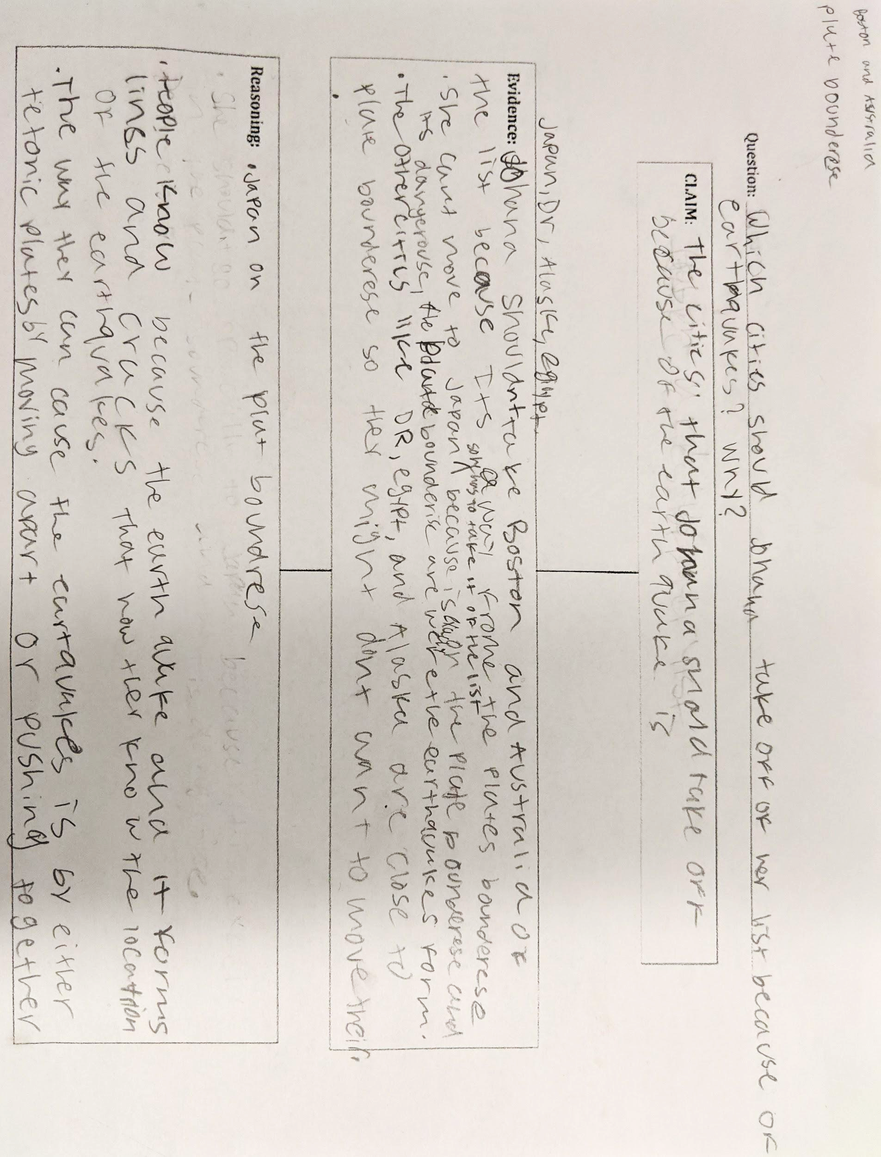

Sample Student A - Places Johana should not go to.
Johana should not move to japan because that's where most of the earthquakes is at. And she wants to move to a place where there is no earthquakes. And japan is where the plates are at and like she don’t wanna move around there it could destroy the city. Japan is on the eurasian plate. Another place she should move to is australia because it has a plate and there probably would not be a lot of earthquakes. And as it said she don’t wanna move to a place with earthquakes and her stuff can get messed up. Sydney, Australia is on the pacific plate and australian plate. A place i think she should move to is boston. Because it is a good place and there is not that much earthquakes the last big earthquake was 1755, but last year 2017 we had a earthquake but it was not big we are on the north american plate. another place that I think She should not move to is Dominican Republic cuz it is closer to earthquakes and it cuz like mess up all the things that's around her and she doesn't want to go nowhere where is there some earthquakes and I looked on the map and shows the Dominican Republic is like covered around earthquakes. She also should take of egypt because there is earthquakes around it and it is on the african and arabian plate. Last but not least she should not move to alaska because it is on the pacific north and american plate. So there is a good chance a earthquake will happen. Also where you can know where the boundaries are is where all the earthquakes that happened.
Earthquakes form when a rock underground suddenly brakes apart. Than it releases energy then causes the seismic waves to shake. When two rocks rub against each other and stick a little then it causes the ground to shake. When the rocks brake the earthquake occurs. Also when the earth's crust crash the a earthquake would form. Because the tectonic plates are moving and they rub against each other then the rocks underground brake.

Sample Student B - CER Essay
Boston,, USA and Sydney, Australia are two places johana can go to. They are close by some earthquakes but. Not on any plates or no earthquakes have hit it. Boston, USA and Sydney,Australia is on the edge of an island but is in a plate.
Boston, USA is #1 on the diagram I have and It's in the middle of where a lot of earthQuakes happen and that plate is called Eurasian plate. The tectonic plates movement makes earthquakes happen nearby. Sydney,Australia is in a tectonic plate which is called Australian plate but doesn't really get a lot of earthquakes. Most earthquakes that happen nearby are on the plate boundaries. Boston, USA basically in the middle of North American Plate, Sydney,Australia is in the center of the australian plate, Tokyo, Japan is North America Plate. Santo domingo, Dominican Republic is on the edge of the north american plate lastly Anchorage, Alaska is in the edge of the North American plate.
Earthquakes form from tectonic plates.Most earthquakes happen on the tectonic plates boundaries. This links back to the claim because boston, USA doesnt have alot of earthquakes, it could be nearby some but none have hit it. Tokyo, Japan is near a plate boundary where most earthquakes happen. Santo domingo, Dominican Republic cannot work too because it is on the line. Lastly #5 which is Anchorage, Alaska cannot work because it is near a line. Earthquakes are not random they happen like lines and those lines are the lines to the boundaries of a plate nearby.
We know where the boundaries are because most earthquakes happen on the black lines which are the boundaries another thing is that the tectonic plates cause earthquakes to happen because the tectonic plates move together.
Sample Student C - Where Johanna Should Live
Johanna should move to Boston or Sydney because they are in the middle of the North American plate and the Australian plate also they get earthquakes rarely. She should not move to the other four because Tokyo is on the boundaries of four tectonic plates Eurasian,North American, Pacific and Philippine plates. Santo Domingo is on the boundaries of the Caribbean. Cairo is near the boundaries of the Arabian, African plates. Anchorage is near the North american plate and Pacific Plate.
We know where the plate boundaries are because all the earthquakes that happens always happens repetitively in the same place which are the boundaries of the tectonic plates,we know where the tectonic plate edges are because when the tectonic plate boundaries collide together they create a vibration which is a earthquake. we know this because of all the earthquakes that happen always get dotted around the edges and surround the ring of fire. Tectonic plates form at the edges because both edges collide into each other and form a vibration which is a earthquake. If you get two sponges and place them beside each other then move them up and down against each other it creates a vibration which is the earthquakes.
This is why johanna should move to Boston or Sydney instead of Tokyo, Santo Domingo, Cairo and Anchorage.

Sample Student D – EARTHQUAKES Which Cities should Johana take off her list?

INTRODUCTION
Johana is wanting to move out of her state but she doesn’t know where to move. She knows she doesn’t want to move to a city or state that has frequent earthquakes. The two cities she can move to that for sure do not have many frequent earthquakes are Boston, MA, and Sydney, Australia.

THE 6 CITIES
The two cities Boston, and Sydney are better locations for Johana than the other four cities because they are in the middle of their plates. While the other four cities are on or near the boundary of their plate, Sydney is in the middle of the Australian plate, and Boston is in the middle of the North American plate. If you´re wondering why the other four cities have such frequent earthquakes, itś because they're surrounded by borders / boundaries. Also if the cities are surrounded by borders/boundaries, that area is most likely going to have a lot of earthquakes due to the cracking in between the 2 countries the border lines up with. Tokyo is near the boundary of the Philippine plate and the Eurasian plate. Cairo is near the boundary of the African and the Arabian plate. Dominican Republic is near the boundary of the North American plate and Caribbean plates. Also Alaska is near the boundary of the North American plate and the Pacific plate .

HOW IS IT HAPPENING?
The way an earthquake forms is when the tectonic plates are rubbing against each other and cause vibration to the earth. Also the tectonic plates don’t exactly have to be touching each other. The tectonic plates can even cause vibration to the earth by pulling away from each other causing a mini earthquake. The edges of a tectonic plate is very bumpy so it’s pretty easy for them to hit or rub against each other. Earthquakes happen at the edges of the tectonic plates due to their texture. That’s how we know that the four other cities, Tokyo, Australia, Alaska, and Dominican Republic have so many frequent earthquakes. They’re near the edge / boundary of their tectonic plate. We also know where the boundaries because that is where the edge of the tectonic plates are. Also on the edge of the tectonic plates / on the boundaries there is a pattern of where all of the earthquakes happen due to the texture of the boundaries. Therefore this is my Evidence and Reasoning as to why Johana should move to Boston or Sydney than the other four cities.

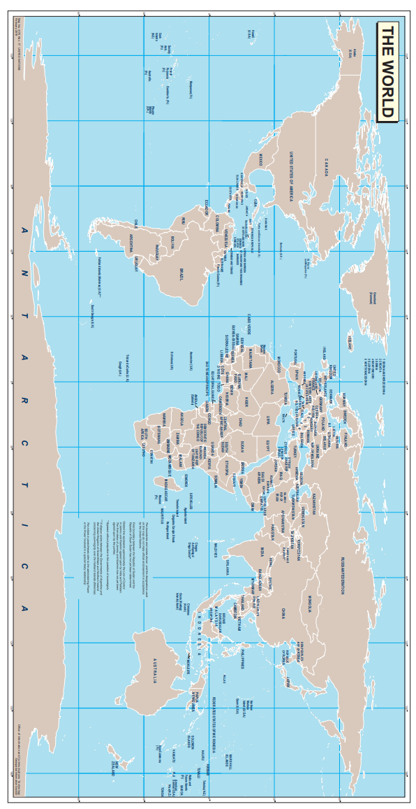
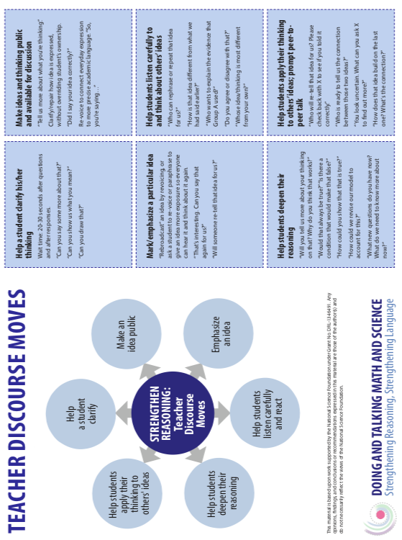
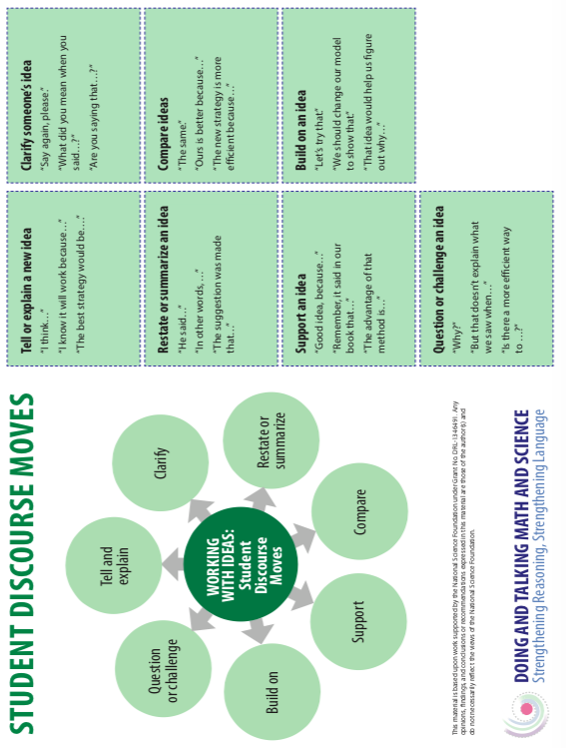
Name: ____________________________________________ Date: __________ Travel Group: ______

Earthquake Model Record

Draw your model / Dibuje su modelo | How does your model show that earthquakes happen at the boundaries of tectonic plates?  ¿Cómo puedes usar su modelo para demostrar que los terremotos ocurren en los borderes de los platos tectónicas?  _________________________________________  _________________________________________  _________________________________________  _________________________________________  _________________________________________  _________________________________________  _________________________________________  _________________________________________  _________________________________________  _________________________________________
What are the strengths of your model?  ¿Cuáles son las ventajas de su modelo?  _________________________________________  _________________________________________  _________________________________________  _________________________________________  _________________________________________  _________________________________________  _________________________________________  _________________________________________  _________________________________________ | What are the limitations of your model?  ¿Cuáles son las limitaciones de su modelo?  _________________________________________  _________________________________________  _________________________________________  _________________________________________  _________________________________________  _________________________________________  _________________________________________  _________________________________________  _________________________________________
Name: ____________________________________________ Date: __________ Travel Group: ______

Avoiding Earthquakes

Johana wants to move, but she isn’t sure where she wants to live. She is sure that she does not want to live in a city with frequent earthquakes. That is her main concern in making this decision. She is considering the following cities:

- Boston, US
- Tokyo, Japan
- Santo Domingo, Dominican Republic
- Cairo, Egypt
- Anchorage, Alaska
- Sydney, Australia

Which cities should Johana remove from her list because of earthquakes? Why?

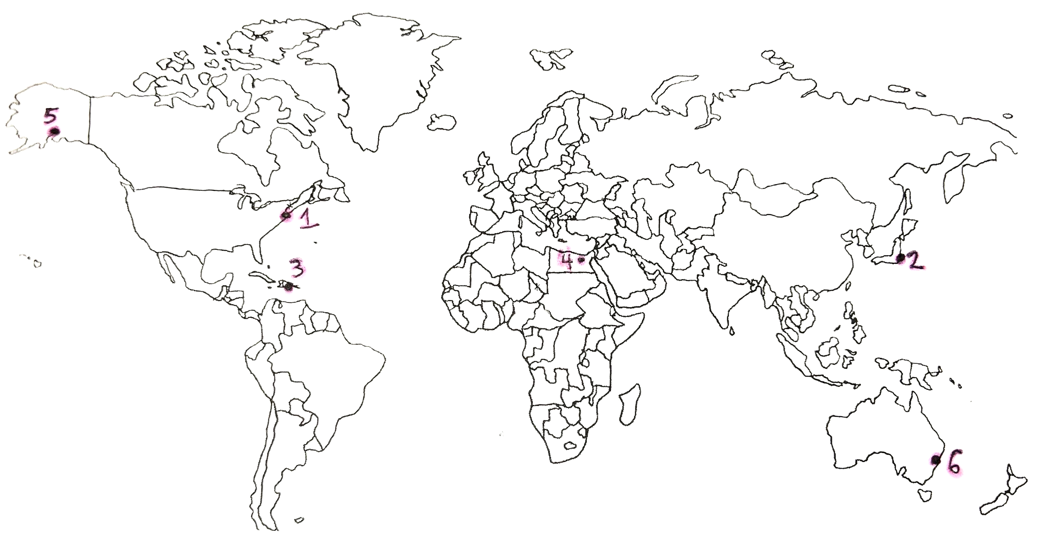
Remember to provide evidence from historical earthquakes, and explain how your model of tectonic plates supports your claim.

_________________________________________________________________________________________
_________________________________________________________________________________________
_________________________________________________________________________________________
_________________________________________________________________________________________
__________________________________________________________________________________________
__________________________________________________________________________________________
__________________________________________________________________________________________
__________________________________________________________________________________________
__________________________________________________________________________________________
__________________________________________________________________________________________
__________________________________________________________________________________________
__________________________________________________________________________________________
__________________________________________________________________________________________
__________________________________________________________________________________________
__________________________________________________________________________________________
__________________________________________________________________________________________
__________________________________________________________________________________________
__________________________________________________________________________________________
__________________________________________________________________________________________
__________________________________________________________________________________________
__________________________________________________________________________________________
__________________________________________________________________________________________
__________________________________________________________________________________________
__________________________________________________________________________________________
__________________________________________________________________________________________
