Task-level phenomenon:
Students will observe several phenomena related to static electricity and electric charge:
- Bucket with Styrofoam balls
- Cans and balloons
- PhET Computer simulation -John Travoltage (https://phet.colorado.edu/en/simulation/john-travoltage)
- PhET Computer simulation - Balloons and Static Electricity (https://phet.colorado.edu/en/simulation/balloons)
- Bag of Styrofoam snow and bat
- Hover plates

Synopsis of high-quality task:
Students experience phenomena related to static electricity and investigate different scenarios involving charged objects that will demonstrate repulsion and attraction. Lab stations are set up around the room though which groups of students circulate and investigate to observe different aspects of electric charge. Students figure out how static electric charges are produced and how the uneven distribution of charges affects object interaction.

Anticipated student time spent on task: 2 sessions, 45 minutes. Task can be modified for time depending on the number of lab stations set up. This could go a maximum of three days.

Type of Task (check one):
X 1. Investigation/experimentation/design challenge
____ 2. Data representation, analysis, and interpretation
____ 3. Explanation

Student task structure(s): Individual work/partner work/group work

STE Standards and Science and Engineering Practices:

7.MS-PS2-3. Analyze data to describe the effect of distance and magnitude of electric charge on the size of electric forces.
Clarification Statement:
- Includes both attractive and repulsive forces.
State Assessment Boundaries:
- State assessment will be limited to proportional reasoning.
- Calculations using Coulomb’s law or interactions of sub-atomic particles are not expected in
- state assessment.

7.MS-PS2-5. Use scientific evidence to argue that fields exist between objects with mass, between magnetic objects, and between electrically charged objects that exert force on each other even though the objects are not in contact.
Clarification Statement:
- Emphasis is on evidence that demonstrates the existence of fields, limited to gravitational,
electric, and magnetic fields.
State Assessment Boundary:
- Calculations of force are not expected in state assessment.

Science and Engineering Practice:
- Constructing explanations
Prior Knowledge:
Previous Standards from Strand Map:
3-PS2-3. Conduct an investigation to determine the nature of the forces between two magnets based on their orientations and distance relative to each other.
Clarification Statement:
- Focus should be on forces produced by magnetic objects that are easily manipulated.
Connections to the real-world:
A number of current technologies rely upon charged particles and their attraction or repulsion
- Ink and toner (copier/printer) - toner attracted to static electricity created on paper via a laser
- Dryer sheets to reduce static electricity - balancing out loose electrons with the positively-charged ions found in fabric softener
- Powder coat paint - charged powder attracted to oppositely charged substrate for application

Some naturally occurring phenomenon also rely on charged particle and their movement:
- Lightning created by differences in charges between clouds and ground
- Volcanic eruption and creation of lightning due to the movement of particles in the atmosphere

Mastery Goals:

Learning Objective:
- Produce and use electrical charges to demonstrate how objects interact based on their charges.

Performance Objective:
- Gather qualitative data to describe how objects interact based on particle interaction.

Language Objective:
- Orally ask clarification questions through peer-to-peer or teacher-student interaction
- Record ideas in a graphic organizer.
- Summarize in writing the cause of effect of each station.
Teacher Instructions:

Note: The classroom should be set up with the lab stations before class begins. The materials section contains all the lab station materials and how they need to be setup. Based on time, the teacher can choose up to six stations to work with. Doing all six stations will take 2x45 minute sessions.

Day 1:
Introduction - 5 min
Begin with opener (3-5 minutes) - Picture of woman with socks stuck to her (see in materials section). Have students write out in notes or journal what they think is occurring in the photo and why. Have a couple of students share ideas about the photo with the class, but at this time do not provide details about this process. Explain to students that they will revisit this photo at the end of this activity.

Student activity - 25 min
- Students move to stations in pairs (or threes). Each student should have enough of the data collection sheets (see materials) to complete each lab station. Although students will be working in groups, each student is responsible for completing their own individual sheet. Students should work cooperatively to complete each station activity. Consider assigning group members meaningful roles (such as examples included here https://www.humber.ca/centreforteachingandlearning/instructional-strategies/teaching-methods/classroom-strategies-designing-instruction/collaborative-learning/roles-and-responsibilities-for-group-members.html)
  - A typical amount of time for each station is 5 minutes. Putting a timer up on the projector helps to keep students aware of time left.
- During the activity the teacher circulates, making sure groups are answering questions, clarifying ideas, and providing redirection where necessary. Some things to look for while circulating:
  - Ensuring that all group members are participating in the kinesthetic part of the activity - manipulating the materials.
  - Students are using the material in the appropriate manner - setting up supplies and performing activity to get desired results.
  - Keeping them focused on the question - Why do you think this happened? Students should be discussing observations and connecting this to how static charge was created and on what objects certain charges would be found.
  - Making sure they are citing observations and evidence in their explanations. The CER (Claim Evidence Reasoning) model can be used here as a guide.
    - Claim - Hypotheses
    - Evidence - Observations
    - Reasoning - Explain why you think this happened

Class Discussion - 15 min
Bring students back from their stations into groups of 4-6 (two sets of pairs or threes). Ask students make a three column chart in their notebooks – Notice, Think, Wonder. Allow students 5 minutes to look through their station data and record what they notice about their data, why they think those noticings are happening, and questions they have about their experience. Have groups share their responses.
Ask groups to create a model together that shows how they think electric charges and static electricity cause the phenomena they observed in the stations.

Day 2 - Full period

Discussion - 10 min
Begin class by asking students to revisit their models from previous day. Lead a discussion about key features and ideas on what to include in their models.

Group Presentations of Models (4 groups @ ~3 minutes each = 12-15 minutes):
Each group will be assigned a lab station at random and will use their group model to explain how the phenomenon is occurring. Suggested phenomenon to use:
- Bucket with Styrofoam balls
- Cans and balloons
- Bag of Styrofoam snow and bat
- Hover plates
Have students explain their model, and how the model shows what is happening with the station’s phenomenon. Allow students to ask questions (including the presenting group) regarding the connections between the model and the phenomenon. If you have additional time, ask students at the end of the presentations to evaluate the strengths and limitations of the models they drew.

Summative activity - 20 minutes
With 20 minutes remaining, use the Balloons and Static Electricity post lab (see materials) to individually assess student understanding and connect the content with a real-world scenario.

With about 5-7 minutes left in the period, ask students to share what they thought for the first question about static charge in a dryer and how this is created. This is a good way to summarize the task using a real-world connection while engaging the class in a discussion.
- Students should discuss the movement of the clothes (rubbing against one another) and the transfer of charges. They should be able to connect this with clouds and lightning and the Styrofoam balls and bat from the lab as examples.
- Follow up by asking them how we deal with static charge on clothing in a dryer? The teacher is looking for them to identify dryer sheets or anti-static sprays. Some may also hit on touching something that is grounded (metal hitting the earth) to get rid of the excess charge. Continue by asking students if they can describe how the dryer sheet works inside the dryer to get rid of the charge. Answers may vary but should work towards the following:
    - Action of clothing in dryer results in a lot of excess negative charges (loose electrons). The dryer sheets contain a fabric softener that is positively charged and as it is released during the drying cycle it balances out the excess negative charges.

Instructional Materials/Resources/Tools:

- Women in socks photo
- Station setup material and instructions
- Station setup and student instructions - print these out, separate, and then place at the lab station with materials to help guide students during investigation
- Student data collection sheet one copy per student for each station setup.
- Balloons and Static Electricity post lab

Task Source:
The Ambassador would like to recognize the Silver Lake 7th Grade science teachers for their contributions to the development of this task.

Photo for introduction
“Static Cling”, by Patrick Johanneson, Flickr (https://www.flickr.com/photos/pj/63435128/in/photolist-2dZofk1-eC5TLi-jhsMtY-5pBG7m-ehFccS-fDmSj9-9heHaZ-fD5mNM-4eGNWr-7YQysM-fDmSE3-fDmR9E-7VE98N-G4Dqm-bi1BM2-aTxFfH-7ga1C2-5CfWZF-jSpCVZ-4RMB-58GTeN-2f5nKSZ-6B847-9jaRr1-frza2Z) , CC-BY-NC-SA 2.0

- PhET Computer simulation - John Travoltage (https://phet.colorado.edu/en/simulation/john-travoltage)
  - John Travoltage by Weiman, Reid, and Adams, University of Colorado, Boulder; PhET Interactive Simulations, licensed under CC BY 3.0 US
- PhET Computer simulation - Balloons and Static Electricity (https://phet.colorado.edu/en/simulation/balloons)
  - Balloons and Static Electricity by Reid and Adams, University of Colorado, Boulder; PhET Interactive Simulations, licensed under CC BY 3.0 US
- Balloons and Static Electricity post lab activity, by PhET Middle School Team, University of Colorado, Boulder, licensed under CC BY 4.0, modified for this activity.
Accessibility and Supports:
Activities that allows learners to practice the academic language in authentic contexts in partners or threes

The activity is designed with a number of different modalities in which the students interact with the core concepts. In this way students have opportunities to see the development and interaction of electric charge in different formats, each of which highlight the core ideas in the standards so that station activities will help to reinforce one another. Students also have opportunity to show understanding through writing and in illustrations and diagrams.

Summary activity at the end provides an opportunity to individually assess student understanding, provide students with feedback if necessary, and provide the teacher with a formative assessment tool.

Time for this activity varies depending on class size and number of stations set up. An alternative would be to have all the stations running, then at the end of the second day do the student presentations as a wrap up, and on a third day perform the assessment activity and class discussion about the dryer sheets.

Key academic vocabulary to highlight with students:
Students will be able to accurately describe static electricity. This includes the usage of words such as: protons, electrons, equilibrium, discharge, and transfer.
Sample Student Work: See Below
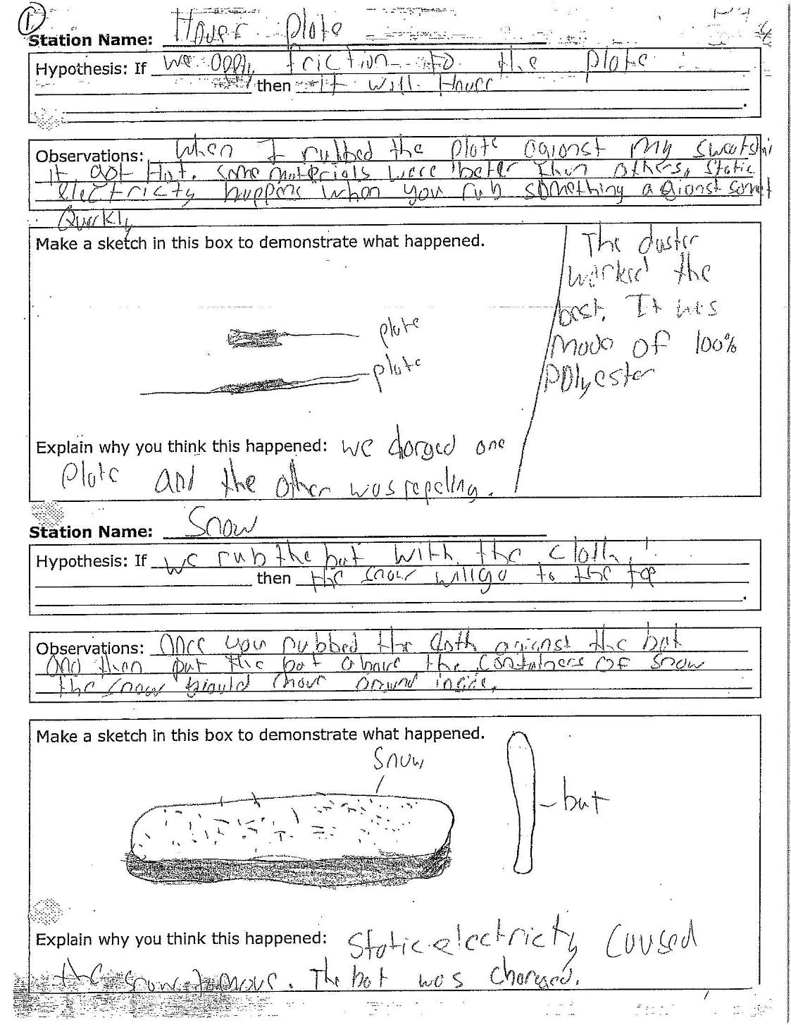
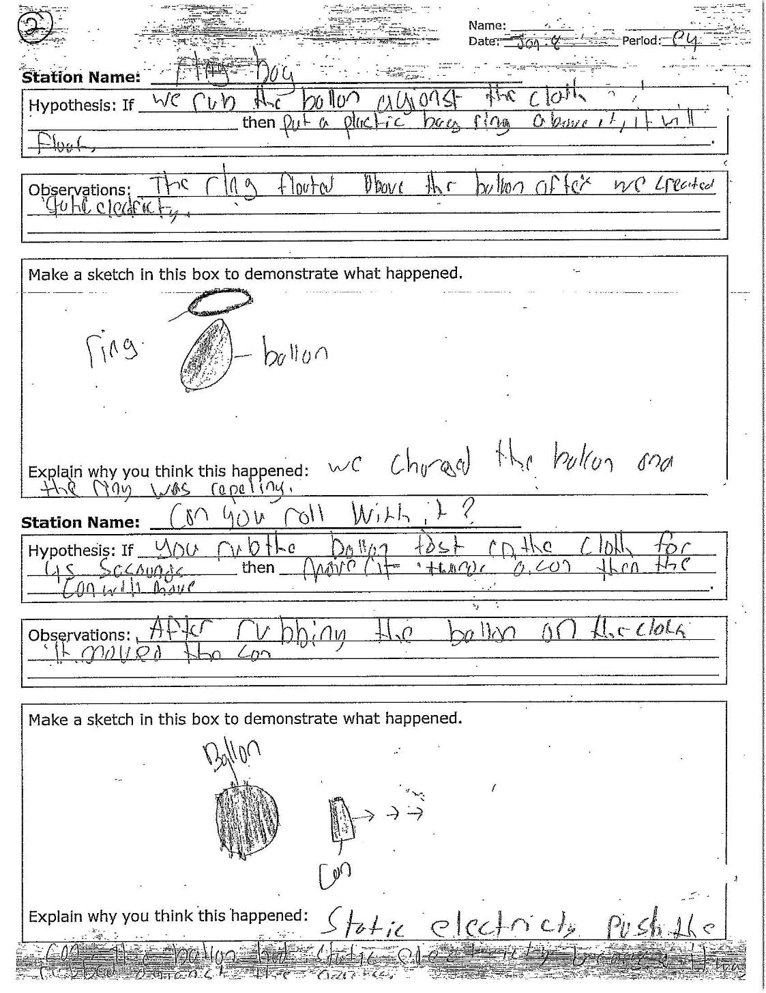
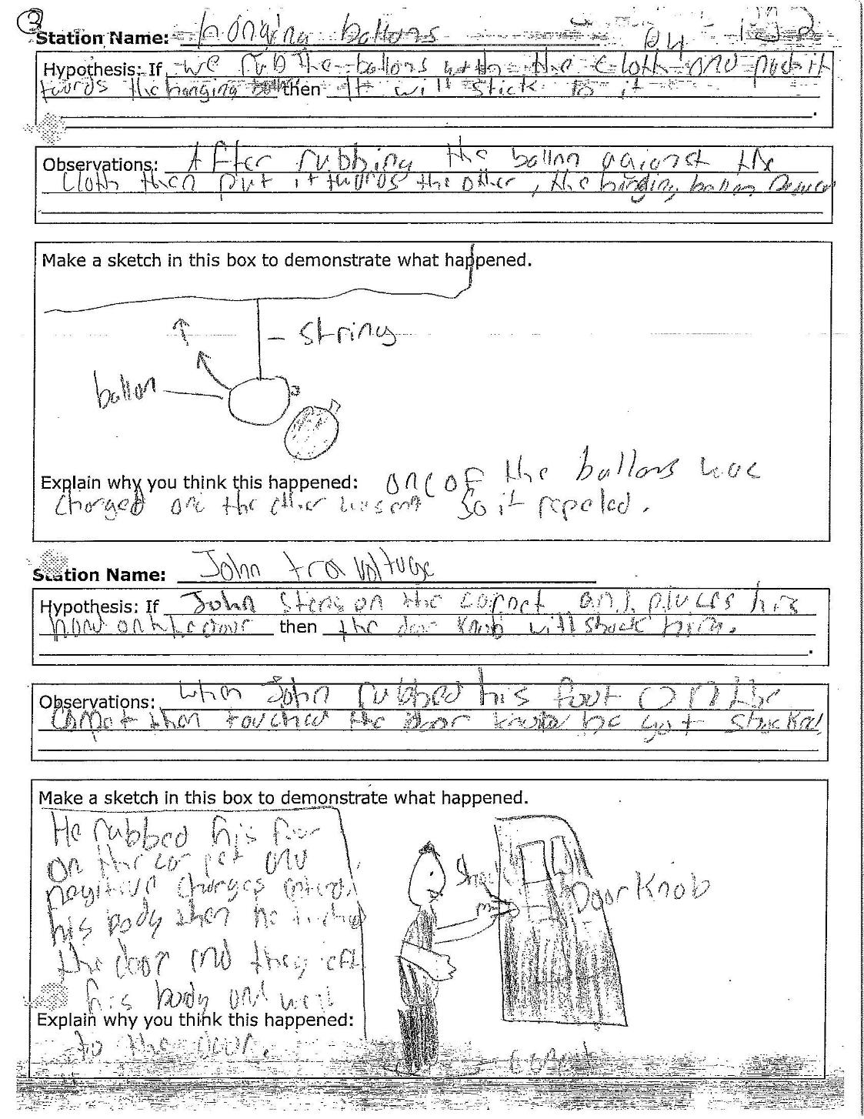
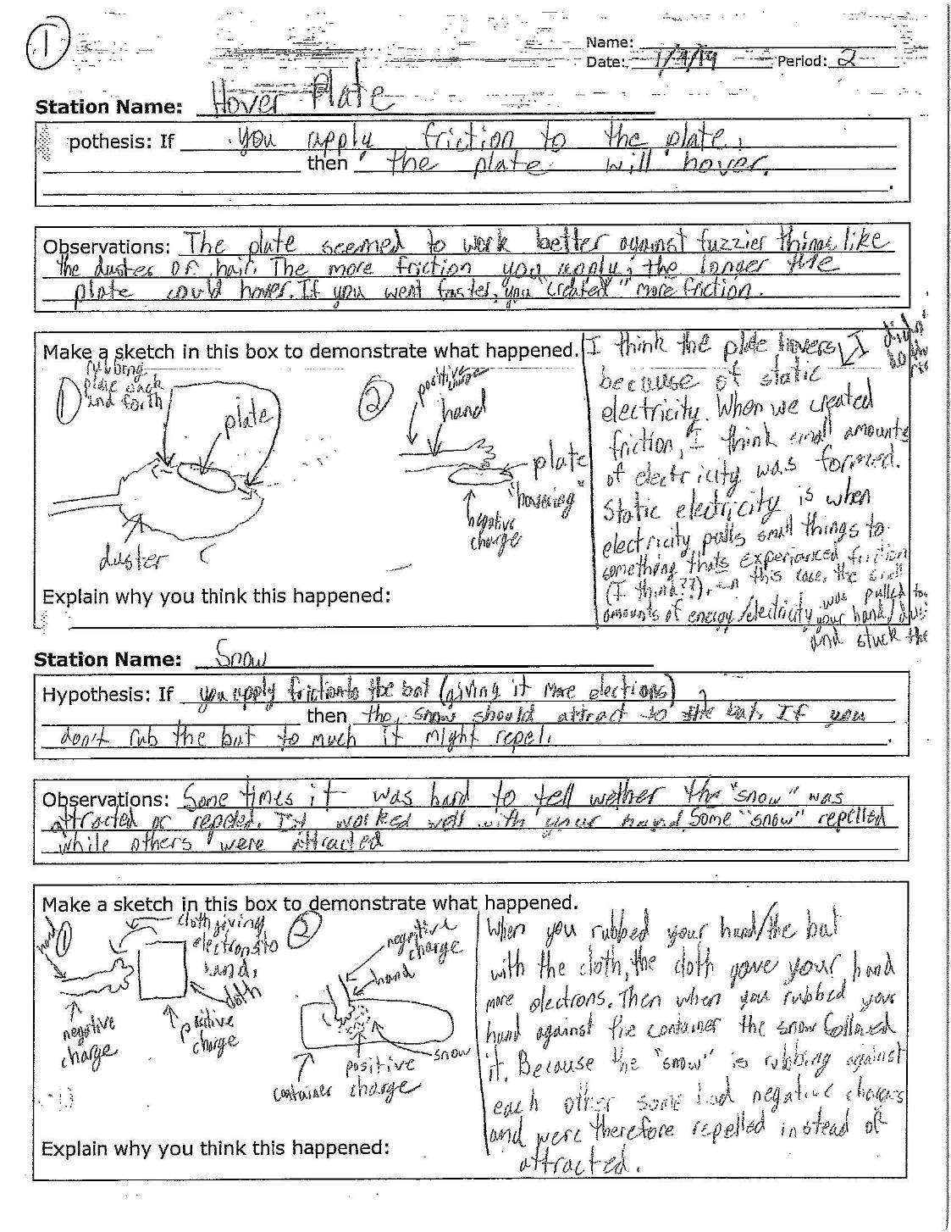
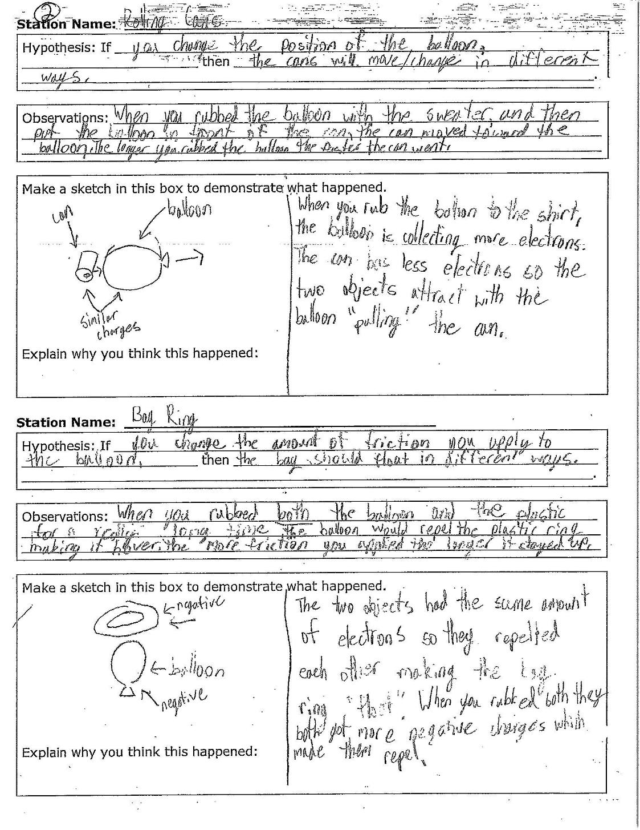
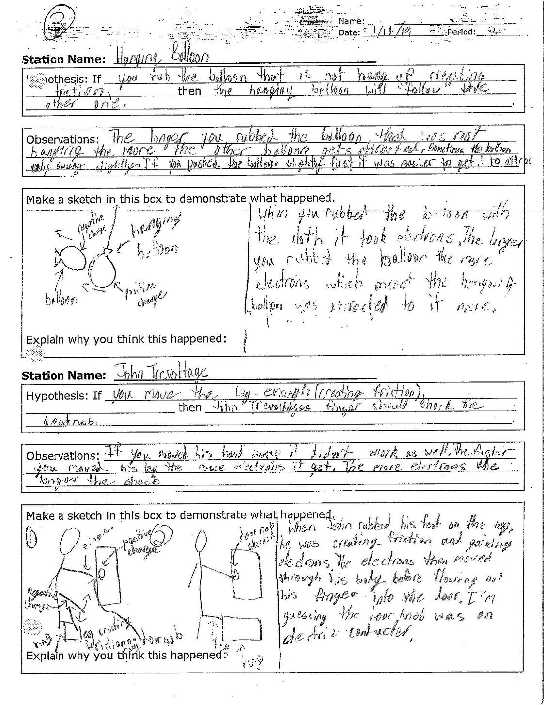
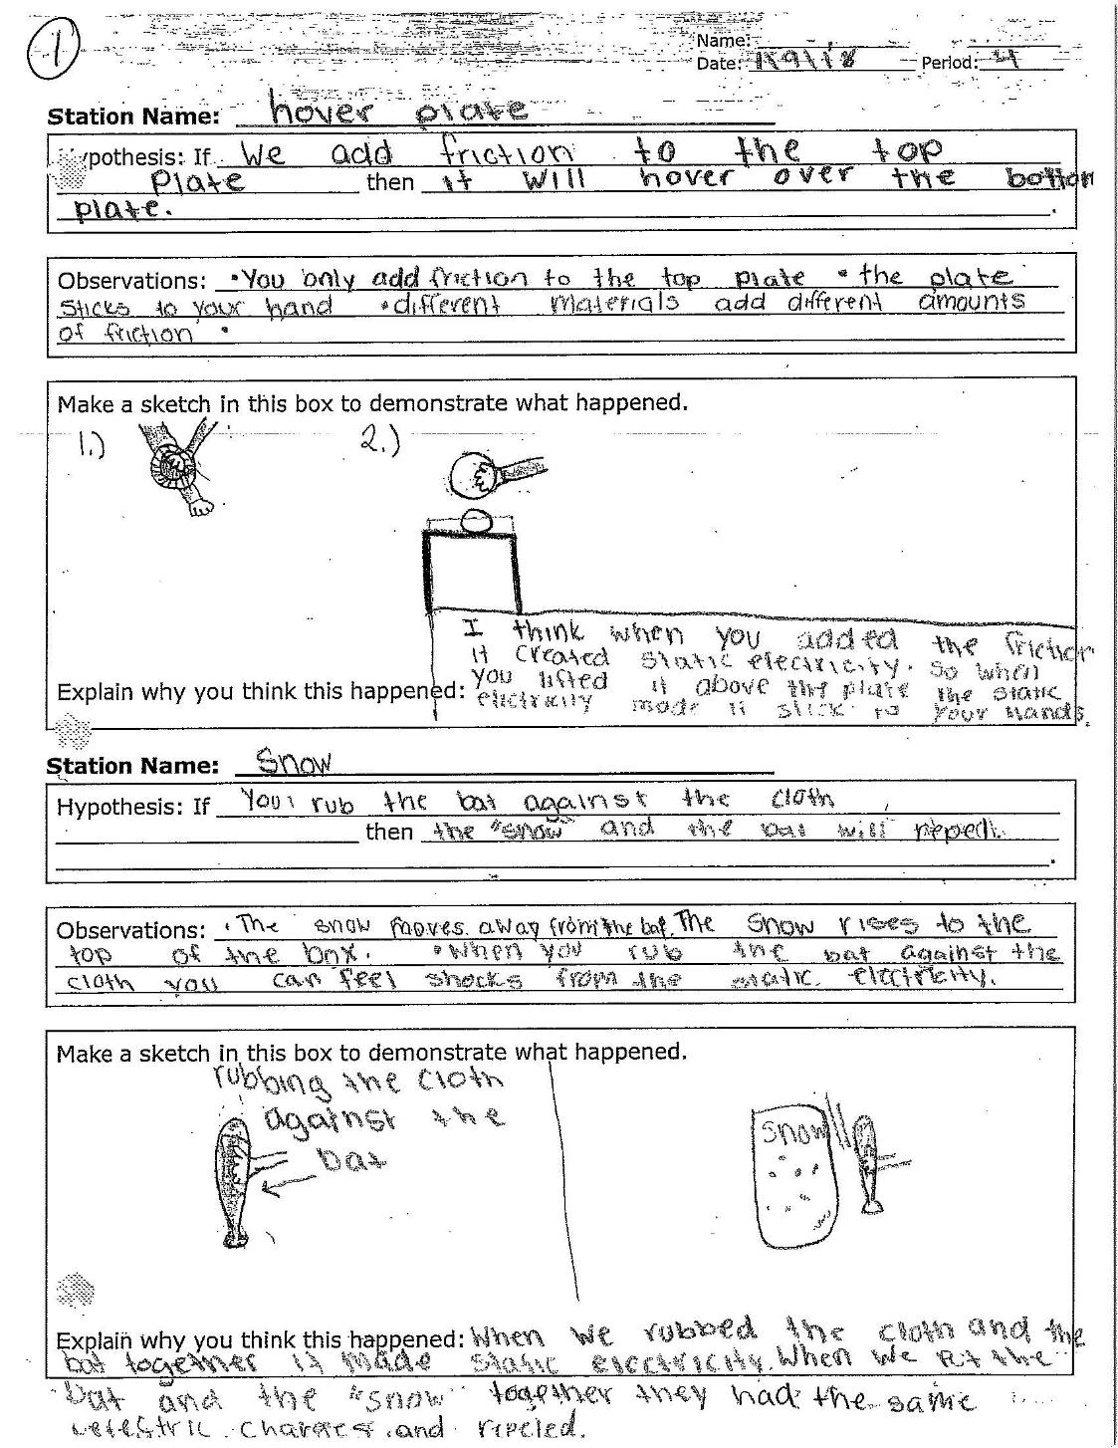
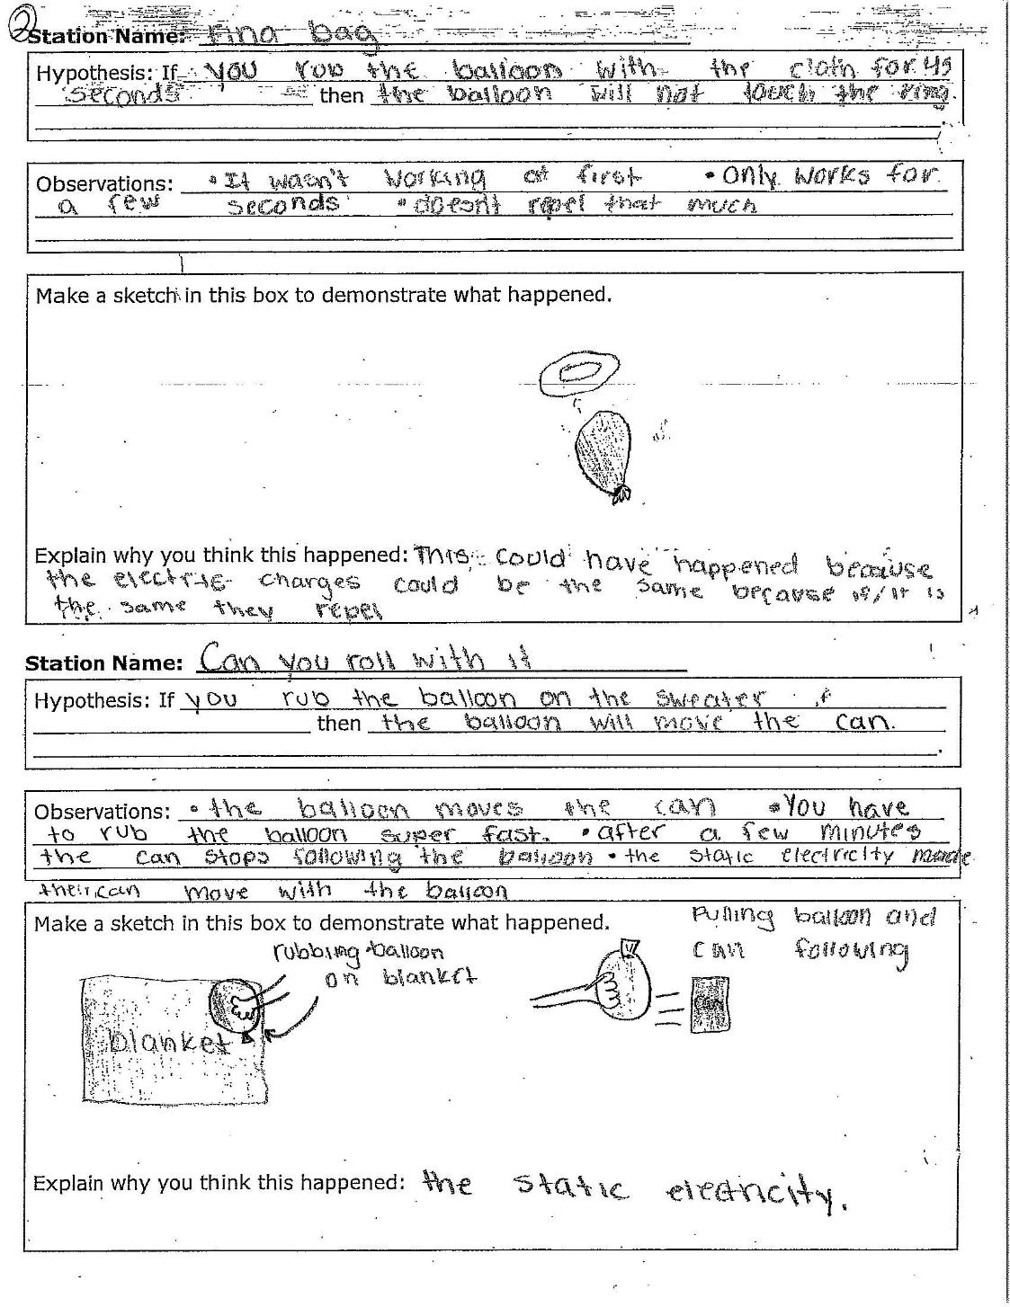
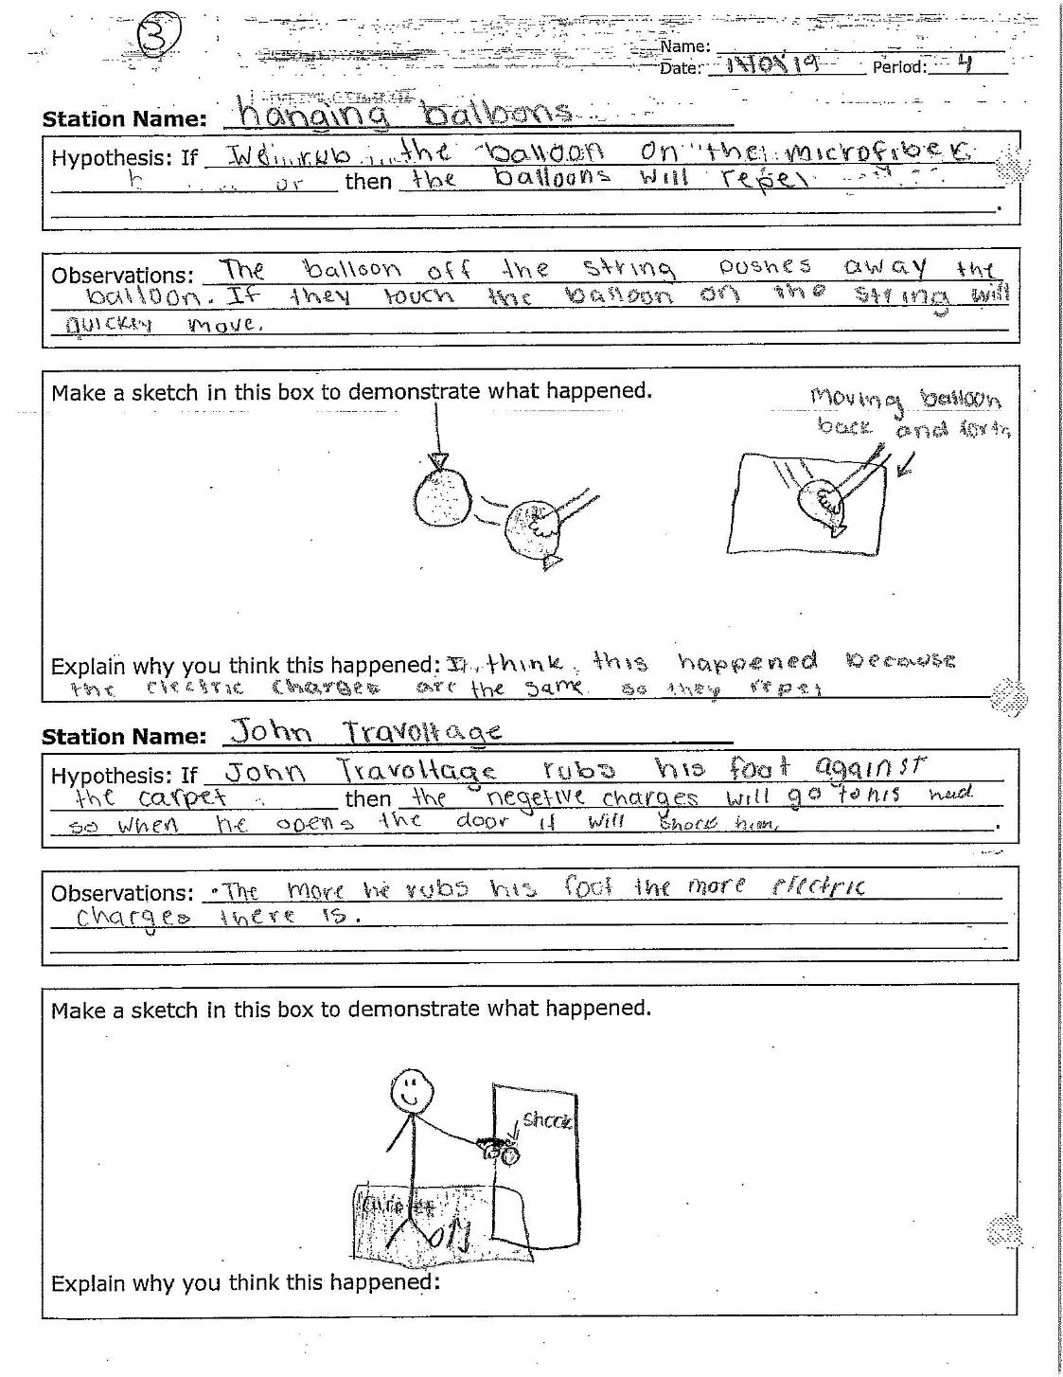

Electric Charge Station Material and Setup
Station #1
Can You Roll With It?
Materials:
- 1 Aluminum can (lay on table horizontally)
- 1 Flat table top
- 1 Inflated balloon
- 1 Microfiber cloth

Setup:
- Have the can on a table and balloon inflated ready for student experimentation. Students will add static charge to balloon and use it to “push” the can on the table

Station #2
Don’t Leave Me Hanging
Materials:
- 2 Inflated balloons
  - One is hanging from something attached via a string and can swing freely, the other is loose

Setup:
- One balloon is left loose on the table, the other is attached to a string and suspended from a stationary object (balloon should be free to move in all directions). Students will bring balloons near one another and observe interactions.

Station #3
Snow Comb? I thought you said Snow Cone.
Materials:
- 1 Hair comb
- 1 Microfiber cloth
- 1 Shallow pan/bowl
- Handful of small Styrofoam balls (2-3mm dia)
  - These are to be place in the shallow bowl

Setup:
- Have comb and cloth ready for experimentation. Bowl/pan should be filled with Styrofoam balls (enough to cover the bottom). Students will generate static charge on comb and use it to interact with Styrofoam balls to observe results.

Station #4
Can You Compute?
Material:
- Computer access at lab station for PhET activity
- PhET Computer simulation - Balloons and Static Electricity
  - https://phet.colorado.edu/en/simulation/balloons

Setup:
- Students will access the PhET activity and interact with it according to the student questions on their handout

Station #5
Staying Alive!
Material:
- Computer access at lab station for PhET activity
- PhET Computer simulation - John Travoltage
  - https://phet.colorado.edu/en/simulation/john-travoltage

Setup:
- Students will access the PhET activity and interact with it according to the student questions on their handout

Station #6
Flying Bag Ring
Material:
- 1 Microfiber cloth
- 1 Balloon, inflated
- 1 Plastic ring (about ¾ size of inflated balloon) - cut this ring, about 1” in width, from a plastic grocery like bag.

Setup:
- Have material at table ready for student investigation. Students will generate a static charge on the balloon and use it to “float” the plastic ring above the balloon

Electric Charge Station Student Instructions
Station #1
Can You Roll With It?
Materials:
- 1 Aluminum can
- 1 Flat table top
- 1 Inflated balloon
- 1 Microfiber cloth

Instructions:
- Place the can on its side on a flat smooth table
- Rub an inflated balloon back and forth on the microfiber cloth wicked fast for at least 45 seconds
- Bring the balloon close to the can without actually touching the can and start to move the balloon away from the can slowly
- Repeat

Station #2
Don’t Leave Me Hanging
Materials:
- 2 Inflated balloons

Instructions:
- Take the balloon that in not attached to the string and rub it against the microfiber cloth quickly and continuously for at least 45 seconds.
- Take the balloon you just rubbed on the microfiber cloth and slowly bring it towards the suspended balloon, then slowly move it away.
- Repeat

Station #3
Snow Comb? I thought you said Snow Cone.
Materials:
- 1 Hair comb
- 1 Microfiber cloth
- 1 Shallow pan/bowl
- Handful of small Styrofoam balls (2-3mm dia)

Instructions:
- Take the comb and rub it against the microfiber cloth quickly and continuously for at least 45 seconds.
- Slowly bring the tooth end of the comb you were rubbing close to the bowl of Styrofoam balls without touching the Styrofoam balls.

Station #4
Can You Compute?
Material:
- Computer access at lab station for PhET activity
- PhET Computer simulation Balloons and Static Electricity
- https://phet.colorado.edu/en/simulation/balloons

Instructions:
- Go to the PhET site and simulation listed above.
- Rest the balloon and make sure there is only one balloon selected
- Take the balloon and drag it to the right towards the wall.
- Now drag the balloon over the sweater on the left and pick up 3-6 negative particles
- Bring the balloon towards the wall
- Repeat, but this time pick up all the negative particles
- Now release the balloon in the middle of the screen where it originated

Station #5
Staying Alive!
Material:
- Computer access at lab station for PhET activity
- PhET Computer simulation - John Travoltage
  - https://phet.colorado.edu/en/simulation/john-travoltage

Instructions:
- Go to the PhET site and simulation listed above
- Grab John Travolta’s left arm and drag it towards the door handle
- Hold his hand there for a few seconds
- Drag his hand back so that he is touching this right shoulder
- Click on John’s left leg and swing it back and forth on the rug
- Click and drag his hand back to the door handle

Station #6
Flying Bag Ring
Material:
- 1 Microfiber cloth
- 1 Balloon, inflated
- 1 Plastic ring (about ¾ size of inflated balloon) - cut this ring, about 1” in width, from a plastic grocery like bag.

Instructions:
- Take the microfiber cloth and rub the balloon quickly and continuously for at least 45 seconds
- Use the microfiber cloth to rub the plastic bag ring
- Gently toss the bag ring in the air (try and get it to be parallel with the ground) and use the balloon to prevent the ring from touching the ground. The balloon should not touch the ring.

Name: ________________________
Date: ________________

Station Name: ___________________________________
Hypothesis: If________________________________________________________ ____________________________________________________________________ then_____________________________________________________________________________________________________________________________________

Observations: _______________________________________________________________________________________________________________________________________________________________________________________________________________

Make a sketch in this box to demonstrate what happened.

Explain why you think this happened:

Name: _____________________________
Static Charge

Post-Lab:

- When you pull clothes out of the dryer, sometimes they stick together.
What do you think might explain why they stick?

- How do you think dryer sheets might prevent the clothes from sticking together?

- The pictures below show positive and negative circles.
The negatives are stuck in place, but the positive is free to move:

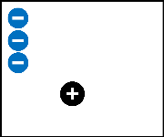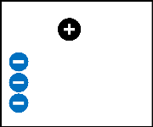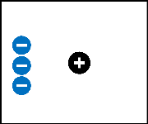
A B C

- For each picture above, draw arrows on the positive circle ( ) to show which way you think it will move.

- In which picture below, do you think the positive circle would go the fastest? (Circle your answer)

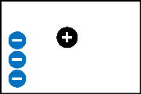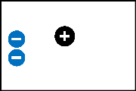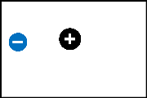
A B C

Why?
________________________________________________________________________________________________________________________________________________
________________________________________________________________________________________________________________________________________________

- In the pictures below, the middle positive “pucks” are free to move, and have some positive and negative circles stuck down on either side of them.

For each case (A, B, and C), do you think the middle positive “puck” will move or not move?
If the puck will move, draw an arrow on the “puck” to show which way you think it will move.
If the puck won’t move, write that down.

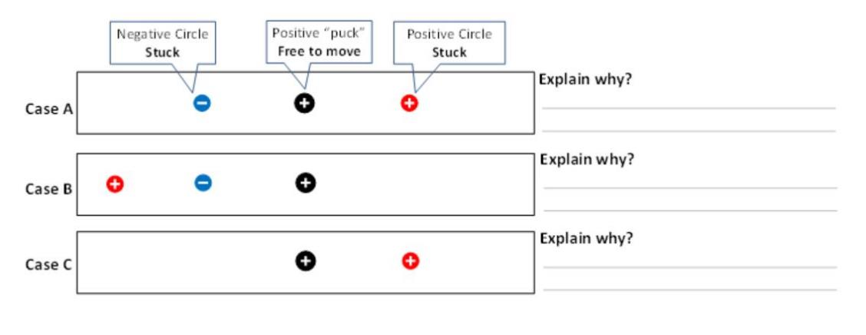

- Moving balloons?

In the picture below, the balloons on the left and middle are held in place. The right balloon is free to move.

Is it possible to add positives or negatives on the free balloon that would make it move
to the left ( 🡨 )? ___________

If so, then draw positives or negatives on the balloon that would make it move, and explain why you think it would work? ________________________________________________________________________ ________________________________________________________________________________________________________________________________________________
If it is not possible, explain why? ________________________________________________________________________
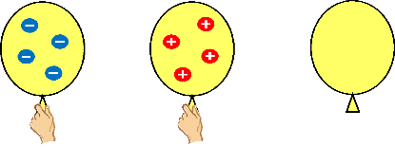
Picture for classroom introduction

Static Cling, by Patrick Johanneson, Flickr, CC-BY-NC-SA 2.0

