Task-level phenomena:
From 1965 through 2005 the water chemistry of the Merrimack River changed dramatically. Populations of Atlantic Shad and Bald Eagles also changed significantly during this time.

Synopsis of high-quality task:
In this performance task, students will analyze two data resources and find out that there has been an ongoing disturbance to the ecosystem along the Merrimack River which includes pollution, chemical waste and human waste. One particular organism of interest along the Merrimack River is the Bald Eagle, an endangered species, which has been known to nest within this ecosystem. Students will construct an explanation in the form of a Claim-Evidence- Reasoning (CER) composition.

Anticipated student time spent on task: 2 sessions, 55 minutes each (optional 3rd session extension)

Type of Task (check one):
____ 1. Investigation/experimentation/design challenge
__X_ 2. Data representation, analysis, and interpretation
____ 3. Explanation

Student task structure(s): group work

STE Standards and Science and Engineering Practices:
7.MS-LS2-4. Analyze data to provide evidence that disruptions (natural or human-made) to any physical or biological components of an ecosystem can lead to shifts in all its populations.
Clarification Statement:
- Focus should be on ecosystem characteristics varying over time, including disruptions such as hurricanes, floods, wildfires, oil spills, and construction.

Science and Engineering Practices
- Analyzing and Interpreting Data
- Constructing explanations

Prior Knowledge:
Previous Standards from Strand Map:
7.MS-LS2-1. Analyze and interpret data to provide evidence for the effects of periods of abundant and
scarce resources on the growth of organisms and the size of populations in an ecosystem.

Connections to the real-world:
- A swimmable, fishable river where residents of the community can actively use the river for such purposes, is an ongoing goal and mission of a variety of conservation groups including the Merrimack River Watershed Council, Mass Audubon, and U.S. Fish and Wildlife.
- The health of an ecosystem can be directly related to human impact via waste disposal. Efforts to clean up the Merrimack River of human waste (fecal coliform) and chemicals (nitrates and phosphates) have been seen to improve the quality of the river’s ecosystem.
- With healthy abiotic and biotic factors, a river’s ecosystems can thrive. Observations of this have been made and in particular Bald Eagle nesting and mating have seen an increase along the banks of the Merrimack River.

Mastery Goals:

Learning Objective:
- Gather and evaluate data to describe how disruptions (natural or human-made) to any physical or biological components of an ecosystem can lead to shifts in organism populations, particularly the Bald Eagle population along the banks of the Merrimack River.

Performance Objective:
- Construct an explanation, based on evidence, that disruptions (natural or human-made) to any physical or biological components of an ecosystem can lead to shifts in Atlantic Shad and Bald Eagle populations of the Merrimack River.

Language Objective:
- Use academic vocabulary as they discuss the data in small groups.
- Orally explain the data when presented in graph form.
- Construct a written explanation for why/how disruptions to any physical or biological components of an ecosystem can lead to shifts in organism population.

Teacher Instructions/Instructional Tips/Strategies/Suggestions:

Teacher Tips:
- Throughout this lesson, it is important for students to collaborate and for teachers to foster student engagement with prompting questions or collaboration and discussion. WIDA’s Doing & Talking Science (http://stem4els.wceruw.org/resources/Student-and-Teacher-moves.pdf) is a helpful resource.
- Timing is based on the needs of the students and should be facilitated by the teacher. Setting time parameters and having periodic class discussions between the parts of the CER will help maintain a rigorous pace.

Teacher Facilitation
Day 1:
Data Analysis
- Show the brief video of a Bald Eagle flying over the Merrimack River, https://www.youtube.com/watch?v=TpAcbAKRbPc. This video was published in 2012. At this time, sightings had become more frequent than decades ago.
- Distribute the Environmental Health of the Merrimack River and its Eagle Population handout and the Data Analysis worksheet to students (one for each student). Students will write down their interpretations on this in order for them to use it for a CER composition.
  - NOTE: The text in the Environmental Health of the Merrimack River and its Bald Eagle Population handout was modified after pilot testing. It had been determined that the original text contained too much information and was leading students.
- Students independently read the CER scenario.
- Students should complete the data analysis in small groups. Consider assigning group members meaningful roles (such as examples included here https://www.humber.ca/centreforteachingandlearning/instructional-strategies/teaching-methods/classroom-strategies-designing-instruction/collaborative-learning/roles-and-responsibilities-for-group-members.html)
- Some classes might need a guide on how to analyze graphs. You can make your own or it might be a good idea to do a sample analysis the day before as a class. Students may need prompting. The following questions are helpful:
  - Does this data resource have a title?
  - Does this resource have a legend or code?
  - How are the x-axis and y-axis labelled?
  - Is there more than one y-axis on a single graph? Why might this be the case?
  - How many lines are on the graph and are they labelled?
  - What is happening to the line or columns as you scan the graph from one side across to the other side?
  - Do you see any peaks, dips, or flat areas in the data? What do these mean?
  - Overall, what are the data points in the graph telling you?
  - Do you see any patterns or trends in the data?
  - Can you make any connections between two or more graphs that were provided?
  - Does the data show any relationship between human impact and climate change?
- The teacher should circulate around the room to listen to the students and their discussions. All students in each group should be collaborating and contributing. If students are struggling with their analysis, use some of the guiding questions outlined in item 4 above.
- Teachers should make sure students stay on task by reminding students of desired goal: to develop an explanation, based on analyzing data, for the change in population sizes of the Shad and Bald Eagle.
  - Have a student be the recorder and they can write down any information the group feel is important to help explain the data on both graphs.
- Students take time to look at the data and try to interpret in information themselves. Teachers should make sure that groups are discussing the different components of the graph, such as keys or legends, the titles of the axes, and what kind of information can they derive from the slope of the line(s).
- To support further social construction of knowledge, the teacher may want to have a brief whole class discussion of the data.
- After the class discussion, student groups brainstorm possible statements to serve as their CLAIM. Students draft a CLAIM before they proceed to the next portion of activity. Note: The teacher can provide a CLAIM, or options for a CLAIM, to students that need such support.

Day 2:
Completion of the CER
- After reviewing the data analysis scenario, data resources, and their drafted CLAIM students will use what they discovered from analyzing the graphs to start brainstorming and developing their written portion for the EVIDENCE piece of the CER.
- The teacher should check-in with groups and make sure students stay on task. The teacher should ask what the students found as evidence that support their CLAIM. This discussion can help get students to focus.
  - Note: The teacher can provide the SENTENCE STARTERS to students that need scaffolding or for ELL students. Furthermore, the CER composition template 2 may provide needed scaffolding for students.
- Students will use the CLAIM they decided on from the beginning of the activity and the EVIDENCE they collected from the data to help them develop a concrete REASONING response.
- Teacher should reinforce that a good REASONING written response will help tie together the EVIDENCE to the CLAIM.
- Teacher should remind students that in science, we always restate our CLAIM in our REASONING portion. Teacher should remind students of any previously taught SENTENCE STARTERS and where to locate them.
- Teacher will call students back to their seats and give a recap of the activity. A brief whole class discussion of students’ reasoning is appropriate to share best ideas and solidify their understanding.
- The teacher will post the graphs from the CER on the board so students can refer to the graphs when they explain their data and how it proves the stated CLAIM of the activity.

Day 3 (Optional):
Development of a public education poster or infographic
Note: This component was not included in the pilot testing of this activity, but rather added after analysis of pilot testing data as another way for students to make making of the learning experience.
- Students may produce a public education poster or infographic for the Annual Merrimack River Eagle Festival coordinated by Mass Audubon each February in Newburyport, MA.
- A simple web search of the festival’s title (Annual Merrimack River Eagle Festival) will bring you to the event page. This is an annual event and has been increasingly popular.

Instructional Materials/Resources/Tools:

Materials:
⦁ Student CER Worksheet (handout, 2 graphs included below)
Task Sources:

The Ambassador would like to recognize Ryan Jesionowski of Nettle Middle School in Haverhill for his contributions to this task.

- Bald Eagle in Flight Along the Merrimack River, published August 16, 2016, retrieved on June 19, 2019 from https://www.youtube.com/watch?v=0VNXSVceyvc
  - Youtube video in the public domain
- MRWC Committee members, et.al. (2014) Merrimack River Watershed Council Strategic Plan 2015-2020. Available at https://drive.google.com/open?id=1lx5nZ9HSBhmwptCzEXCnPBRmb2oRkgW8 or upon request from the MRWC.
- Mass Audubon, Joppa Flats Education Center, retrieved on June 19, 2019 from https://www.massaudubon.org/get-outdoors/wildlife-sanctuaries/joppa-flats/programs-classes-activities/go-birding/the-merrimack-river-eagle-festival

Accessibility and Supports:
- Two versions of CER composition template - one open format and the second is scaffolded by section for struggling writers
- Data analysis template for students to record interpretation of each data resource

Sample Student Work:
NOTE: The text in the Environmental Health of the Merrimack River and its Bald Eagle Population handout was modified after pilot testing. It had been determined that the original text contained too much information and was leading students too much. The original is included here in the student work.

Exemplars are posted below.

Student Exemplar #1 -

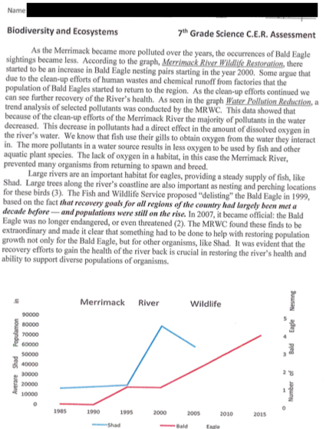

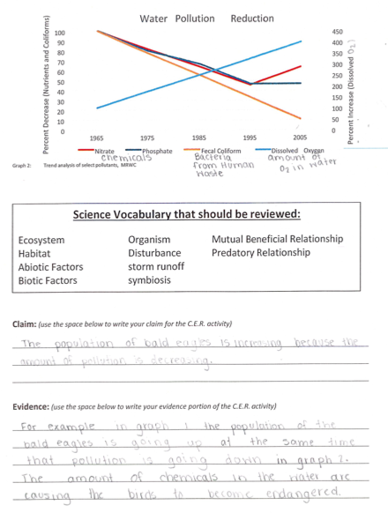

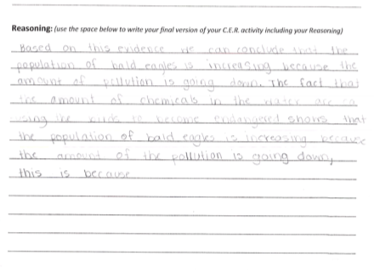

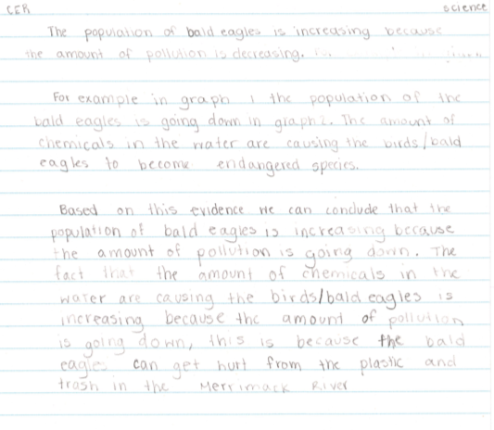

Name _______________________________________ Class Period ___ Date ______________

Environmental Health of the Merrimack River and its Bald Eagle Population

7th Grade Biodiversity and Ecosystems Unit C.E.R. Assessment

In the early 1900s, Bald Eagle sightings along the Merrimack River were common; however, by the mid-1900s that had changed. During that timeframe, the communities along the river also changed. The populations of people living in the area increased and along with development, also changed. Below are two data resources: Figure 1: Shad and Bald Eagle Populations from 1985, and Figure 2: Trend Analysis of Select Pollutants, MRWC. These graphs present measurements of two populations of living organisms and pollutants over time.

Your challenge is to analyze these two data resources and write an explanation that answers the scientific question: What is the relationship between the size of Shad and Bald Eagle populations AND water quality (as evidenced by pollutant data)?

Figure 1: Shad and Bald Eagle Populations from 1985

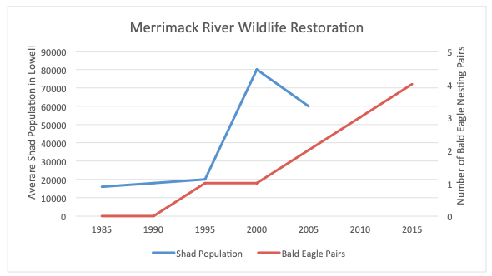

Figure 2: Trend Analysis of Select Pollutants, MRWC.

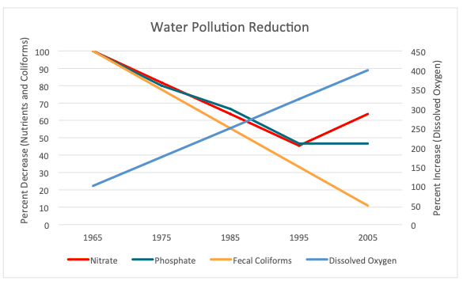

Data Analysis CER Writing Assessment:
Write a CER composition in which you provide Evidence and Reasoning to support a Claim about what you think is a potential explanation for the changes in Shad and Bald Eagle populations. Here are some questions which may prompt your thinking:

- Can you come to a conclusion about a cause the the change in the sizes of the populations?
- What other data do you think is useful to help you come to a conclusion about the population change?
- Use specific evidence from Figures 1 and 2 to support your claim.

Claim - Evidence - Reasoning (CER) Composition Template [version 1]

Provide an explanation that answers the scientific question: What is the relationship between the size of Shad and Bald Eagle populations AND water quality (as evidenced by pollutant data)?

Ensure that claims are supported by evidence, and that the reasoning between the claim and evidence is strong and clear. Finally, identify other sources of data that you would like to see in order to deepen your understanding of this topic.

Claim - Evidence - Reasoning (CER) Composition Template [version 2]

- Make a claim that answers the scientific question: What is a potential cause of changes in Shad and Bald Eagle populations?

- What evidence was used to write your claim? (Reference specific data from Figures 1 and 2 to support your claim.)

- Explain your reasoning and why the evidence supports your claim. Identify the factors in the data resources that may be contributing to the changes in population size and explain how they connect to your claim.

Name:____________________________________________________
Environmental Health of the Merrimack River and its Bald Eagle Population - Data Analysis

Use the spaces below to record your analysis of each of data resources 1 & 2.
Here are some questions to prompt your thinking:
- What is each data resource demonstrating over the given time span?
- What is happening to the lines from the left side of the graph to the right side?
- Do you see any peaks, dips, or flat areas in the data? What do these mean?
- Overall, what are the data points in the graph telling you?
- Do you see any patterns or trends in the data?
- Are there multiple lines on the graph? Are these lines somehow related to each other? Are the lines similar in appearance or different? Why do you think that is the case?
- $10,000 Question: How are the data in the two graphs connected? How does what is happening with the data in one graph relate to what is happening in the other graph?

Figure 1: Shad and Bald Eagle Populations from 1985

Figure 2: Trend Analysis of Select Pollutants.

