Synopsis of task:

Students will rescale the map of a local field. This task requires students to apply standard 7.G.A.1 and to think critically about the effect that changing from one scaling to another has on an image. Students will produce a new, rescaled map of Kelly Field in Milton, MA.

Anticipated student time spent on task: 30 minutes

Student task structure(s): Individual work with whole-group debriefing

Math Content Standards and Practices:

7.G.A.1. Solve problems involving scale drawings of geometric figures, such as computing actual lengths and areas from a scale drawing and reproducing a scale drawing at a different scale.

SMP 1 Make sense of problems and persevere in solving them.
SMP 2 Reason abstractly and quantitatively.
SMP 4 Model with mathematics.
SMP 6 Attend to precision.

Prior Knowledge:

6.RP.1 Understand the concept of a ratio including the distinctions between part:part and part:whole and the value of a ratio; part/part and part/whole. Use ratio language to describe a ratio relationship between two quantities.

Connections to the real-world:

Students use a screenshot from Google Maps, a familiar app to many. The task also uses a recognizable local landmark (Kelly Field is close to the middle school and home field for local sports teams. This task can be adapted to a different local field to make it more authentic for a variety of students).

Mastery Goals:
Learning Objective:
Students will be able to defend the conclusion that by making the scaling of a map smaller, the resulting map will be larger.

Language Objective:
Students will be able to write an explanation, using words and mathematical modeling on the student handout, for why a map becomes larger when the scaling is smaller. Students may be asked to explain their thinking after they work on the task.
Teacher instructions

Instructional Tips/Strategies/Suggestions:
Note: This task should be approached part by part so that students provide an initial explanation on Part A before doing any mathematical modeling.

- Begin as a whole group or small group and introduce the map. Read the information above the map on the student worksheet as a group.
- Have students independently complete Part A by studying the map and recording their ideas.
- Decide whether to have students complete Part B independently, in partners/small groups, or as a whole group lesson. This depends on students’ exposure to standard 7.G.A.1. Students can also attempt Part B independently and then debrief their efforts as a class.
- Debrief the task with a discussion of why the map appears larger when the scale is decreased. The teacher should project page 2 of the student handout and draw the rescaled map as part of the debriefing. Look for student reasoning that the map will appear larger because we require more bar-lengths to measure the dimensions of the park. For instance, 2 and a half bar lengths measured the bottom distance of the park (500 feet) when the bar represented 200 feet. With the bar now representing 150 feet, we require more bar lengths to measure the same distance.
Instructional Materials/Resources/Tools:

Student worksheet is attached. The student worksheet is 2 pages. Students should complete Part A and write an explanation on page 1 before moving to page 2 and completing the rescaling and Part C.

Each student will also need a ruler or other measurement marker.
Accessibility and Supports:

Potential sentence starters:
Part A: The map will appear smaller because…
Part A: The map will appear larger because…
Part C: My guess in Part A was correct because when I rescaled to 150 feet, _______________________ occurred.
Part C: My guess in Part A was not correct because when I rescaled to 150 feet, _______________________ occurred.
Key academic vocabulary: Scale, foot, feet, dimensions

Name __________________________________ Date _______________________

Rescaling Kelly Field

This is a screenshot of Kelly Field in Milton. Pierce Middle School is just off the map in the bottom right corner. The scale in the bottom right corner tell us that the length of the bar represents 200 feet on the map.
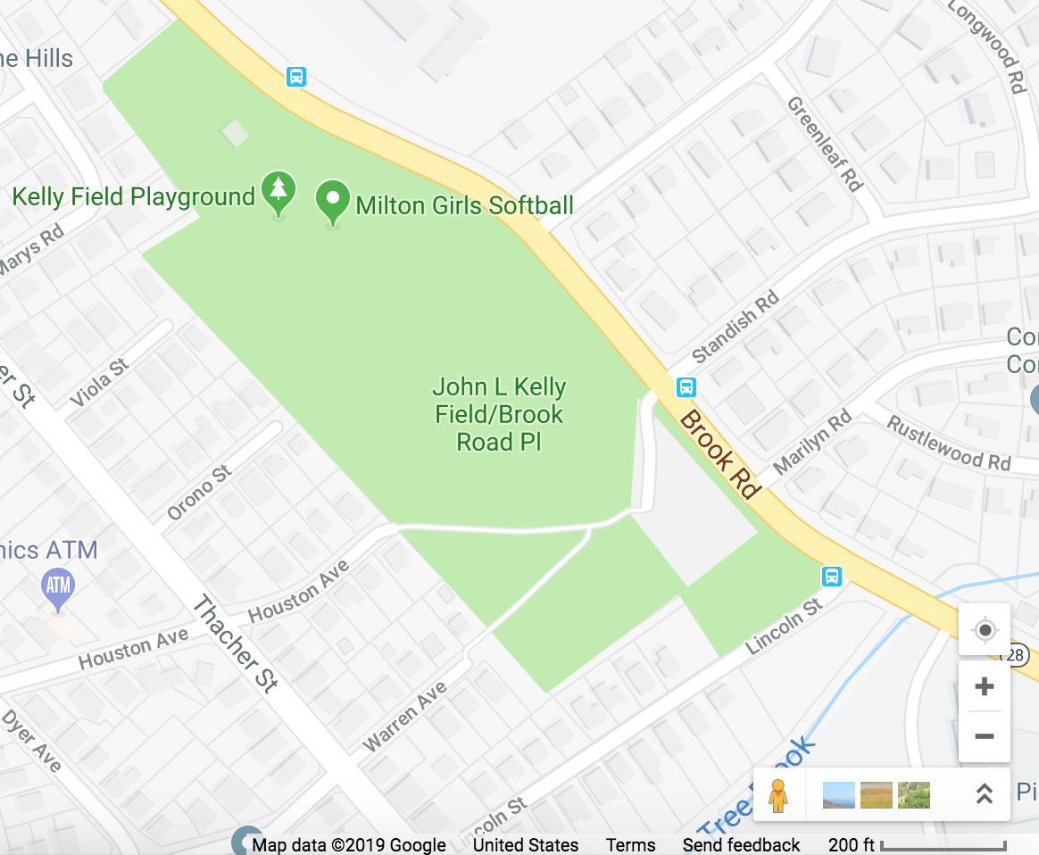

Part A: Clicking the zoom on this map will result in an image of Kelly Field where the exact same-size bar now represents 150 feet. Given this information, do you think the size of Kelly Field under the 150-foot scale will appear smaller or larger than it was under the 200-foot scale? ______________________________________

Explain why you think the map will appear smaller or larger. ________________________________________ ________________________________________________________________________________________

Part B: Use the table below to draw an accurate map of Kelly Field under this new 150-foot scale.
Screenshot with 200-foot scaling Screenshot with 150-foot scaling
Part C: Was your guess in Part A correct? Explain why the size of the map changed the way it did. ____________________________________________________________________________________________________________________________________________________________________________________________________________________________________________________________________________________

Student Work Samples - see following pages:
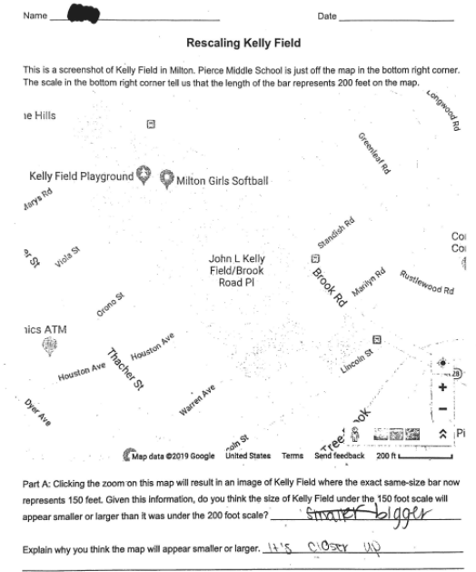
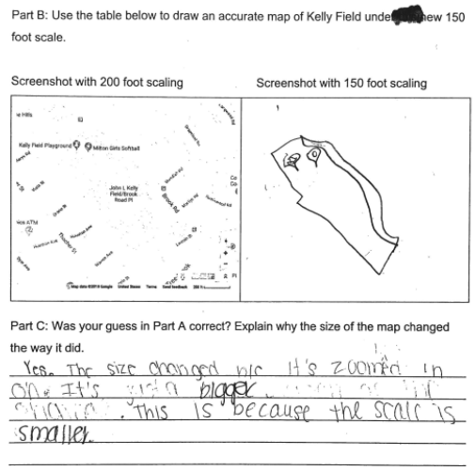
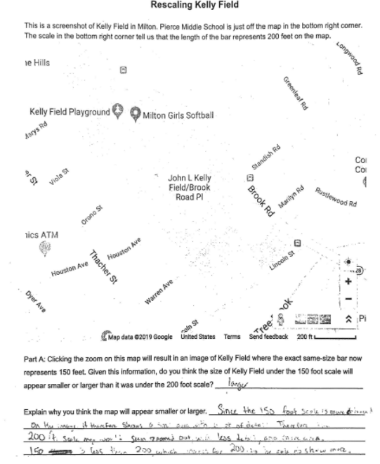
“Since the 150-foot scale is more enhanced on the image. It therefore shows a small area with a lot of detail. Therefore, the 200 ft scale map would seem zoomed out with less detail, and more area. 150 is less than 200, which makes for 200 to be able to show more.”
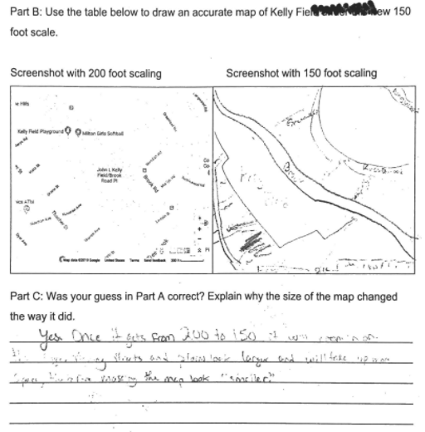
“Yes. Once it gets from 200 to 150 it will zoom in on the image, making streets and places look larger and will take up more space, therefore making the map look “smaller.””

