Task-level phenomenon:
An increase in the seal population on Cape Cod is bringing white sharks closer to the beaches frequented by people. Great white sharks and seals have a predator-prey relationship where the shark is the predator and the seals are the prey.

Synopsis of high-quality task:
These three lessons allow students to differentiate between types of symbiotic relationships such as competitive, predatory, parasitic, and mutually beneficial. First, students will view a collection of short videos introducing them to various symbiotic relationships among organisms in a marine environment. Students learn about these relationships through a series of short nonfiction readings. Next, students apply what they have learned to the different symbiotic “scenarios.” The final artifact of the task is to compose an evidence-based, open-response type writing using the Claim-Evidence-Reasoning model.

Anticipated student time spent on task: 3 classes, 55 mins each

Type of Task (check one):
____ 1. Investigation/experimentation/design challenge
____ 2. Data representation, analysis, and interpretation
__X_ 3. Explanation

Student task structure(s): group work

STE Standards and Science and Engineering Practices:

Standard:
7-MS-LS2-2 Describe how relationships among and between organisms in an ecosystem can be competitive, predatory, parasitic, and mutually beneficial and that these interactions are found across multiple ecosystems.

Science Practice:
- Constructing an explanation (for science).
Prior Knowledge:
Previous Standard from Strand Map:

2-LS2-3(MA) Develop and use models to compare how plants and animals depend on their surroundings and other living things to meet their needs in the places they live.
- Clarification Statement: Animals need food, water, air, shelter, favorable temperatures; plants need sufficient light, water, minerals, favorable temperatures, and animals or other mechanisms to disperse seeds.
Previous Topics:
- Food Webs
- Consumers vs. Producers vs. Decomposers
- Populations
- Ecosystems
- Biotic vs. abiotic

Connections to the real-world:
- All ecosystems rely on symbiotic relationships.
- There are many ecosystems that students are familiar with and can relate too such as temperate forest, rain forest, freshwater lakes, rivers, and oceans.
- An increase in the seal population on Cape Cod is bringing white sharks closer to the beaches frequented by people. Great white sharks and seals have a predatory relationship where the shark is the predator and the seals are the prey. Both of these populations are part of a larger marine ecosystem where relationships between organisms vary from symbiotic to competitive, parasitic or mutually beneficial. Students are aware of this recent change through the news, internet, and social media.

Mastery and Language Goals:

Learning Objective:
- Research through videos and readings, information about the different types of symbiotic relationships
- Construct an explanation based on evidence the different types of symbiotic relationships.

Performance Objective:
- Obtain information about the different types of symbiotic interactions
- Observe and analyze symbiotic interactions taking place
- Construct a response about symbiotic relationships taking place in a marine environment.

Language Objective:
- Discuss orally then in writing to explain the symbiotic relationships observed in an ocean ecosystem.

Teacher Instructions/Instructional Tips/Strategies/Suggestions:

Day 1:
- “What if There Were No Sharks?” Video https://www.youtube.com/watch?v=tAzxkDQFPe0&disable_polymer=true Teacher will ask students to write down their initial thoughts, observe what is happening in the video, and then revise or add to their initial response.

- Discuss video. Teacher will ask for volunteers and randomly select students to share out what the students saw in the video and what questions they have. Teacher will then ask students how can we find out more?

- National Geographic Videos (symbiotic relationships) “Fish Thieves”, “Caribbean Cleaners”, “Giving Fish a Bath,” and “Clownfish and Sea Anemones” along with Symbiotic Relationships Worksheet. Teacher will introduce how students will use the provided worksheet to take notes while viewing the videos. It may be helpful to model completion of the first row of the worksheet with a think-aloud following viewing of a small segment of the first video. Teacher may circulate around the room to monitor students completing activity as they watch the video clips. Pause the video when necessary to provide ample time for students to fill out the chart on the worksheet. When videos have concluded, post the worksheet in front of the class, discuss each situation, allow as many students to respond as possible. Students will self-grade ** [formative assessment]

- Post the CER Writing Prompt (Lemon shark). Teacher will discuss with the students the questions that are being asked, then ask students to complete open-response prompt individually, set a timer for 12 minutes to develop one paragraph.

- Wrap-up: Post the writing prompt again and have students volunteer to read their responses. Ask questions such as “How did you make that connection?” “How is this relationship similar to any from the videos?” “How did you decide which organism(s) is benefitting?” Collect student work and provide written feedback on open response writing similar to the oral questions. If short on time, have students submit their sheets as an exit ticket. Choose a few responses that represent the range of student abilities, read, and compile feedback to provide to the class as a whole during Day 2.

Day 2:
- Do Now: State an example of a predator and prey relationship in a marine environment. Ask students to complete the do now on lined paper or a now sheet, set timer for 3 minutes. Have students turn and talk to share their answers. Ask students to share out responses, ask probing questions like, “How do you know this is a predatory relationship?”

- Symbiotic readings with videos (cK-12 website link below) - Symbiotic Relationships, and Predation, Competition. Read the corresponding pages on each symbiotic relationship. If students have tablets or laptops, please have them open each cK-12 website on the device. If these technologies are not available print the readings. Teacher may choose to have students read individually, in groups or as a class. If individually/groups, teacher will circulate around the room and ask students, “What are the facts or details from each page?” If reading together, teacher may stop at any point to ask probing questions. After the reading, have students watch videos on each symbiotic relationship individually if using tablets or laptops, or as a class. A “7 Step Vocabulary” EL Strategy is included the Instructional Materials/Resources/Tools section below.

- Vocabulary practice using Symbiosis Vocabulary worksheet [definition, sample sentence, reference word] Students will complete activity using information from both the readings and videos. Teacher shall circulate around the room monitoring student progress, asking them to share how they developed their sample sentences, etc. Set timer for 15 min.

- Complete Symbiotic Interactions Matching Activity* [to be done in partners] During this time, teacher should check-in with each group as students explain how they picked the matching pairs they did. Encourage use of domain-specific vocabulary as students offer explanations. If there are errors ask, “Do you all agree?” “It seems to me that the word ________ is key. Do you remember hearing that or reading about it?”

- Wrap-up: Have students share out their sample sentences from the Symbiosis Vocabulary worksheet [informal assessment] Teacher will randomly select students to share out their sample sentences. Teacher will provide oral feedback on sentences.

Day 3:
- Do Now: Provide an example of parasitism from yesterday’s videos. Ask students to complete do now on lined paper or do now sheet, set timer for 3 min. Have students share out their responses.

- Post the CER Rubric on the screen and distribute to all students. Discuss CER Rubric with entire class. Teacher will explain how students will earn points for their response based on each component of the rubric.

- Post the *CER Writing Prompt in front of class. (Teacher distributes CER Chart [graphic organizer] and asks students to write prompt in topic section and then directs students to move onto the next section of the graphic organizer.)

- Have students complete CER Chart (graphic organizer) using their notes from the two previous days (While students begin, teacher returns student work with feedback to students. Teacher should circulate around room checking in with all students on their progress. Teacher can ask questions such as, “How did you decide on your claim? “Where is the evidence coming from?” and “How did you develop your reasoning?)

- Once students have a complete *CER Chart (graphic organizer), direct them to use their notes to compose a formal response to the prompt on the CER Writing Prompt sheet. (Teacher should circulate around the room to monitor the writing progress, reiterating to the students that they should be using their graphic organizers, using capital letters to begin sentences, use of proper punctuation, etc. Responses will be collected, graded via the rubric and returned to students with the scored rubric and written feedback.)

* Denotes academic support explained below

Instructional Materials/Resources/Tools:

Day 1:
- “What if There Were No Sharks?” Video: https://www.youtube.com/watch?v=tAzxkDQFPe0&disable_polymer=true
- National Geographic Videos (symbiotic relationships) “Fish Thieves,” “Caribbean Cleaners,” “Giving Fish a Bath,” and “Clownfish and Sea Anemones.” https://www.nationalgeographic.org/activity/ecological-relationships
- National Geographic Videos - Symbiotic Relationships Worksheet
- National Geographic Videos - CER Writing Prompt

Day 2:
- Symbiotic readings with videos:
Symbiotic Relationships https://www.ck12.org/c/biology/symbiosis/lesson/Symbiosis-BIO/?referrer=concept_details
Predation https://www.ck12.org/c/biology/predation/lesson/Predation-BIO/?referrer=concept_details
Competition https://www.ck12.org/c/biology/competition/lesson/Competition-BIO/?referrer=concept_details
- Symbiosis Vocabulary worksheet
- EL Support- 7-Step Model:
  - Teacher says the word
  - Students repeat the word 3 times
  - Teacher states the word in context from the text
  - Teacher provides the dictionary definition(s)
  - Teacher explains meaning with student-friendly definition(s)
  - Students engage in activities to develop word/concept knowledge
  - Teacher highlights grammar, spelling, polysemy, etc.
- Symbiotic Interactions Matching Activity

Day 3:
- CER Rubric
- CER Lab Conclusion Planning Sheet (graphic organizer)
- CER Writing Prompt

Task Source:
Portions of task sourced from the following:
Video: “What if There Were No Sharks?” CuriosityStream https://www.youtube.com/watch?v=tAzxkDQFPe0
Video: National Geographic Videos (symbiotic relationships) “Fish Thieves,” “Caribbean Cleaners,” “Giving Fish a Bath,” and “Clownfish and Sea Anemones.” https://www.nationalgeographic.org/activity/ecological-relationships/

Readings:
cK-12.org
- Symbiotic Relationships
https://www.ck12.org/c/biology/symbiosis/lesson/Symbiosis-BIO/?referrer=concept_details
- Predation
https://www.ck12.org/c/biology/predation/lesson/Predation-BIO/?referrer=concept_details
- Competition
https://www.ck12.org/c/biology/competition/lesson/Competition-BIO/?referrer=concept_details

CER Graphic Organizer: www.BiologyCorner.com

The Ambassador would like to recognize Mark DiFilippo & Paul Flanigan for their contributions to the development of this task.

Accessibility and Supports:
Include key academic vocabulary:
Tier 3 Vocabulary:
Competition, predation, symbiosis, commensalism, mutualism, parasitism

- Reading: Print the nonfiction text (readings) from cK-12.org; allow students to highlight and mark-up text

- Reading: Symbiotic Interactions Matching Activity are accompanied by images of each relationship/scenario which supports ELs and struggling readers and provides a visual to associate with the text

- Possible Extension for Accelerated Students: Ask them to add other examples (to the matching chart) of symbiotic relationships that fit into each of the three categories. If tablets or computers are available, provide time for students to search for accompanying images. You could also challenge students to make a matching activity for symbiotic relationships between organisms in another environment ex. desert, rainforest, etc.)

- Speaking: Provide students who require support with science sentence starters or sentence frames for discussion; give them a “heads-up” prior to calling on them to share aloud so that they can rehearse/practice their response

- Writing: Allow students to have additional time for writing, some students may need to type responses instead of writing, provide sentence starters or frames and word banks where needed. You may choose to pair students together to complete the CER Chart, but then have them unite their ideas into their final written response individually, or vice versa. You can also use student responses to do a peer-review of the writing.

Sample Student Work: Below
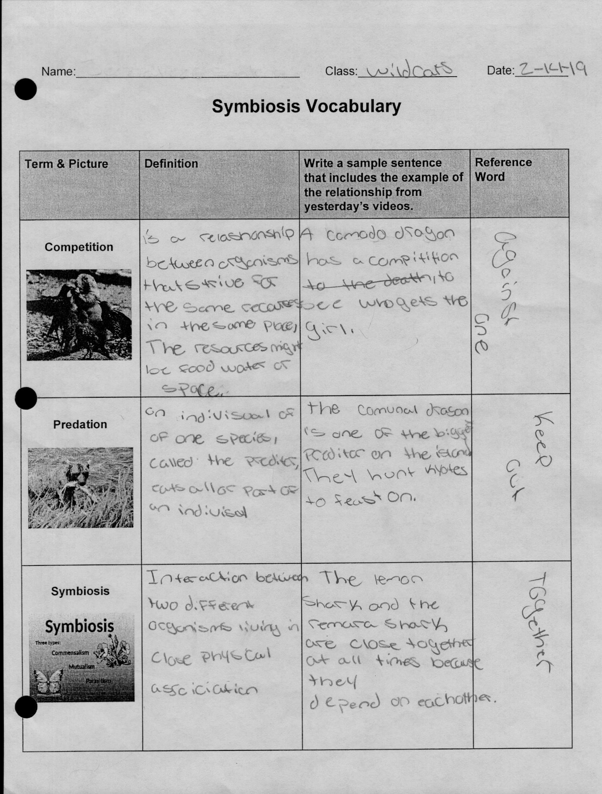
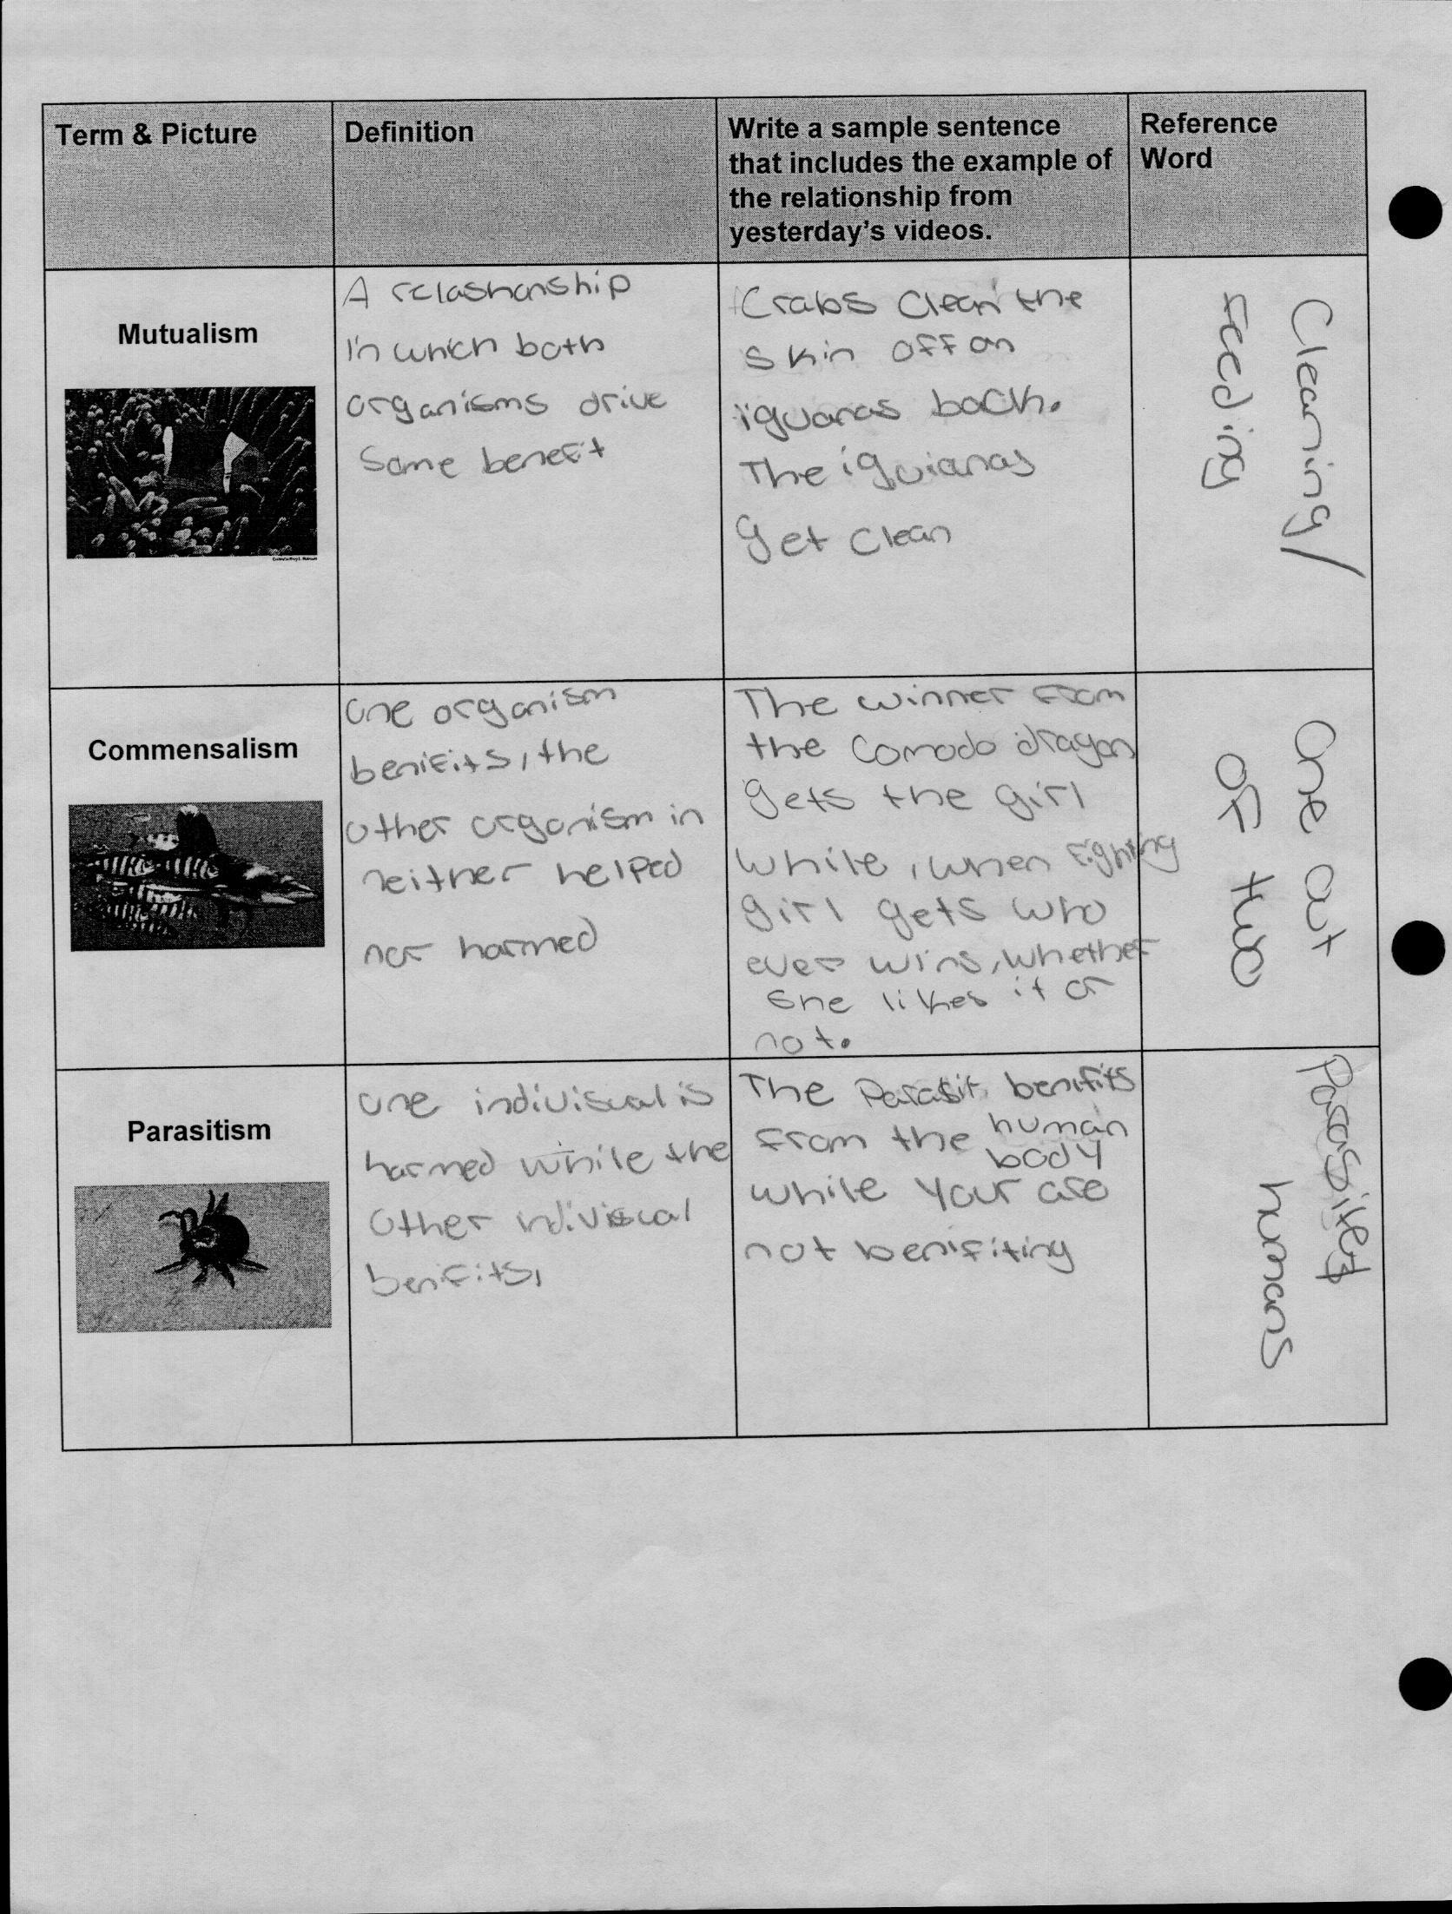
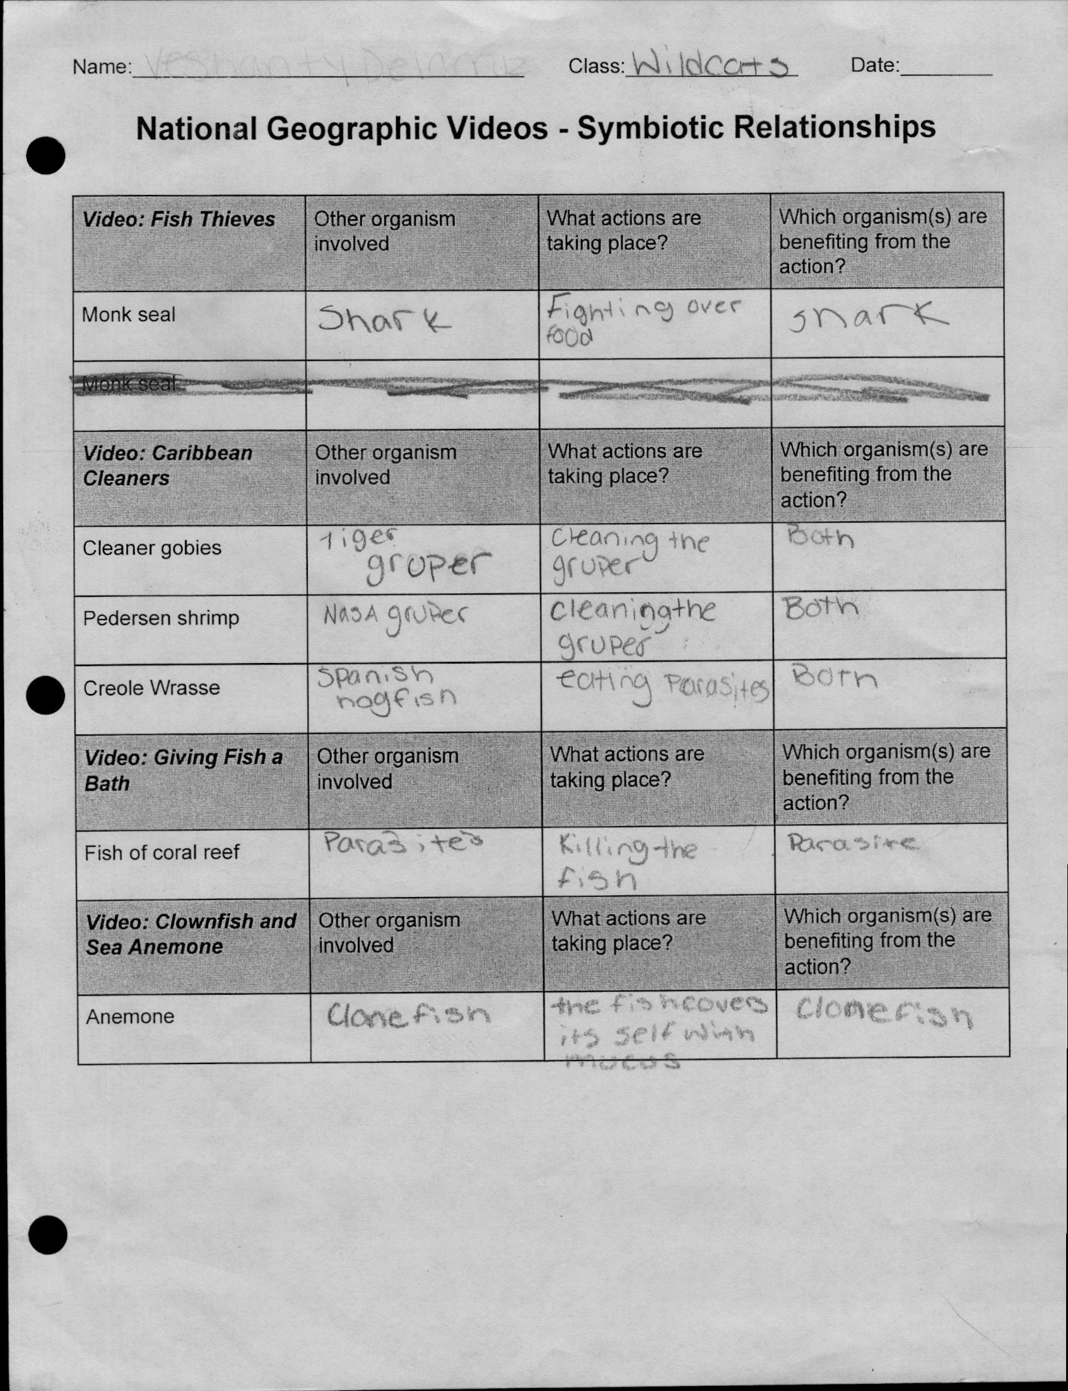
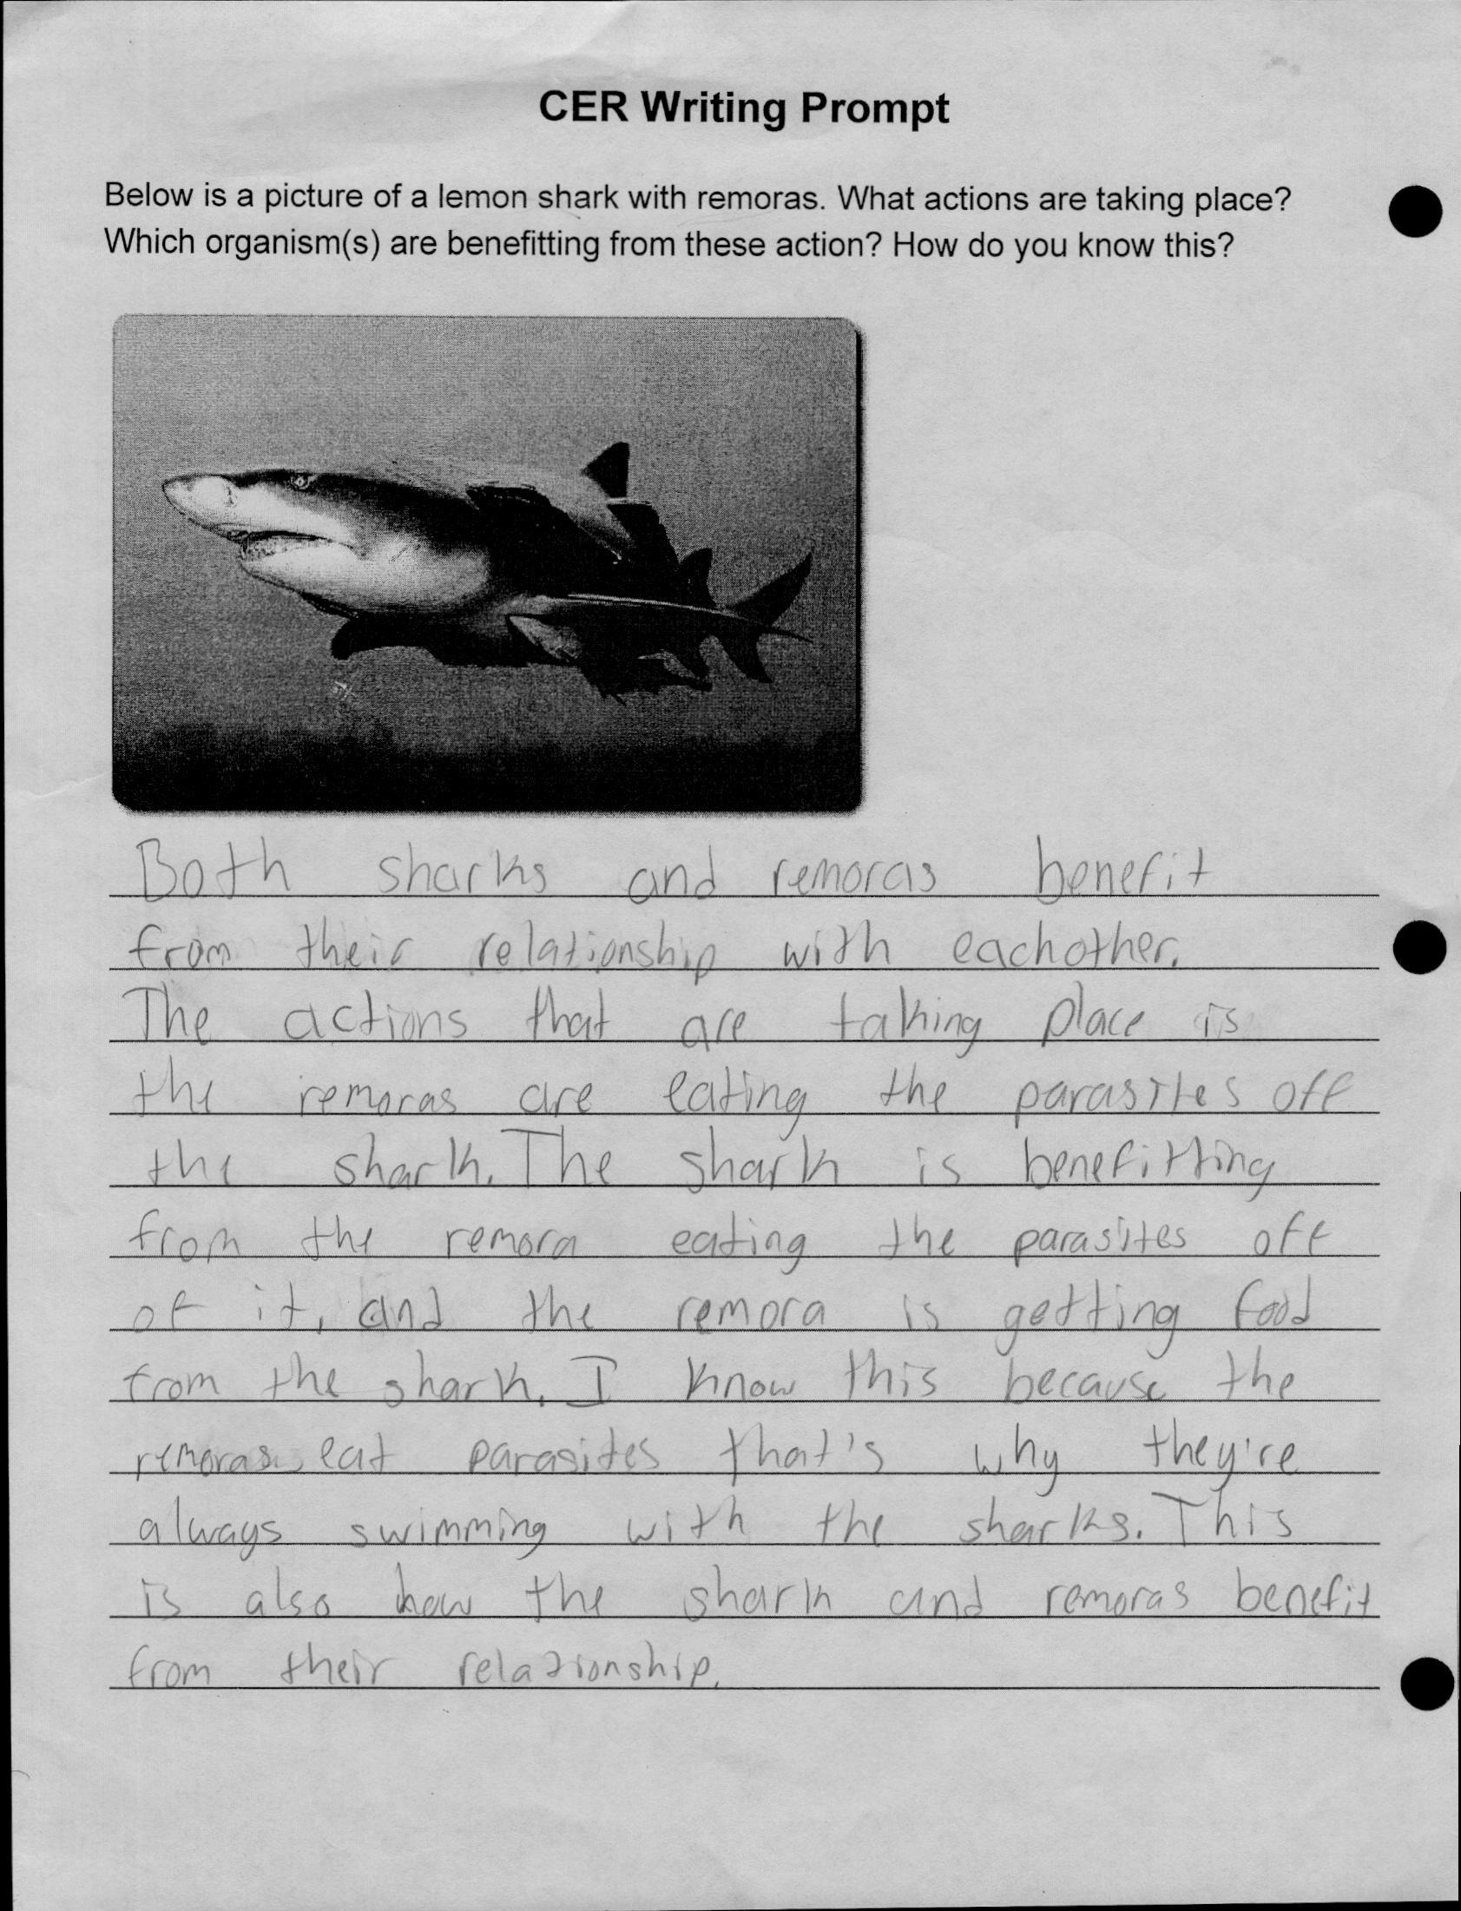
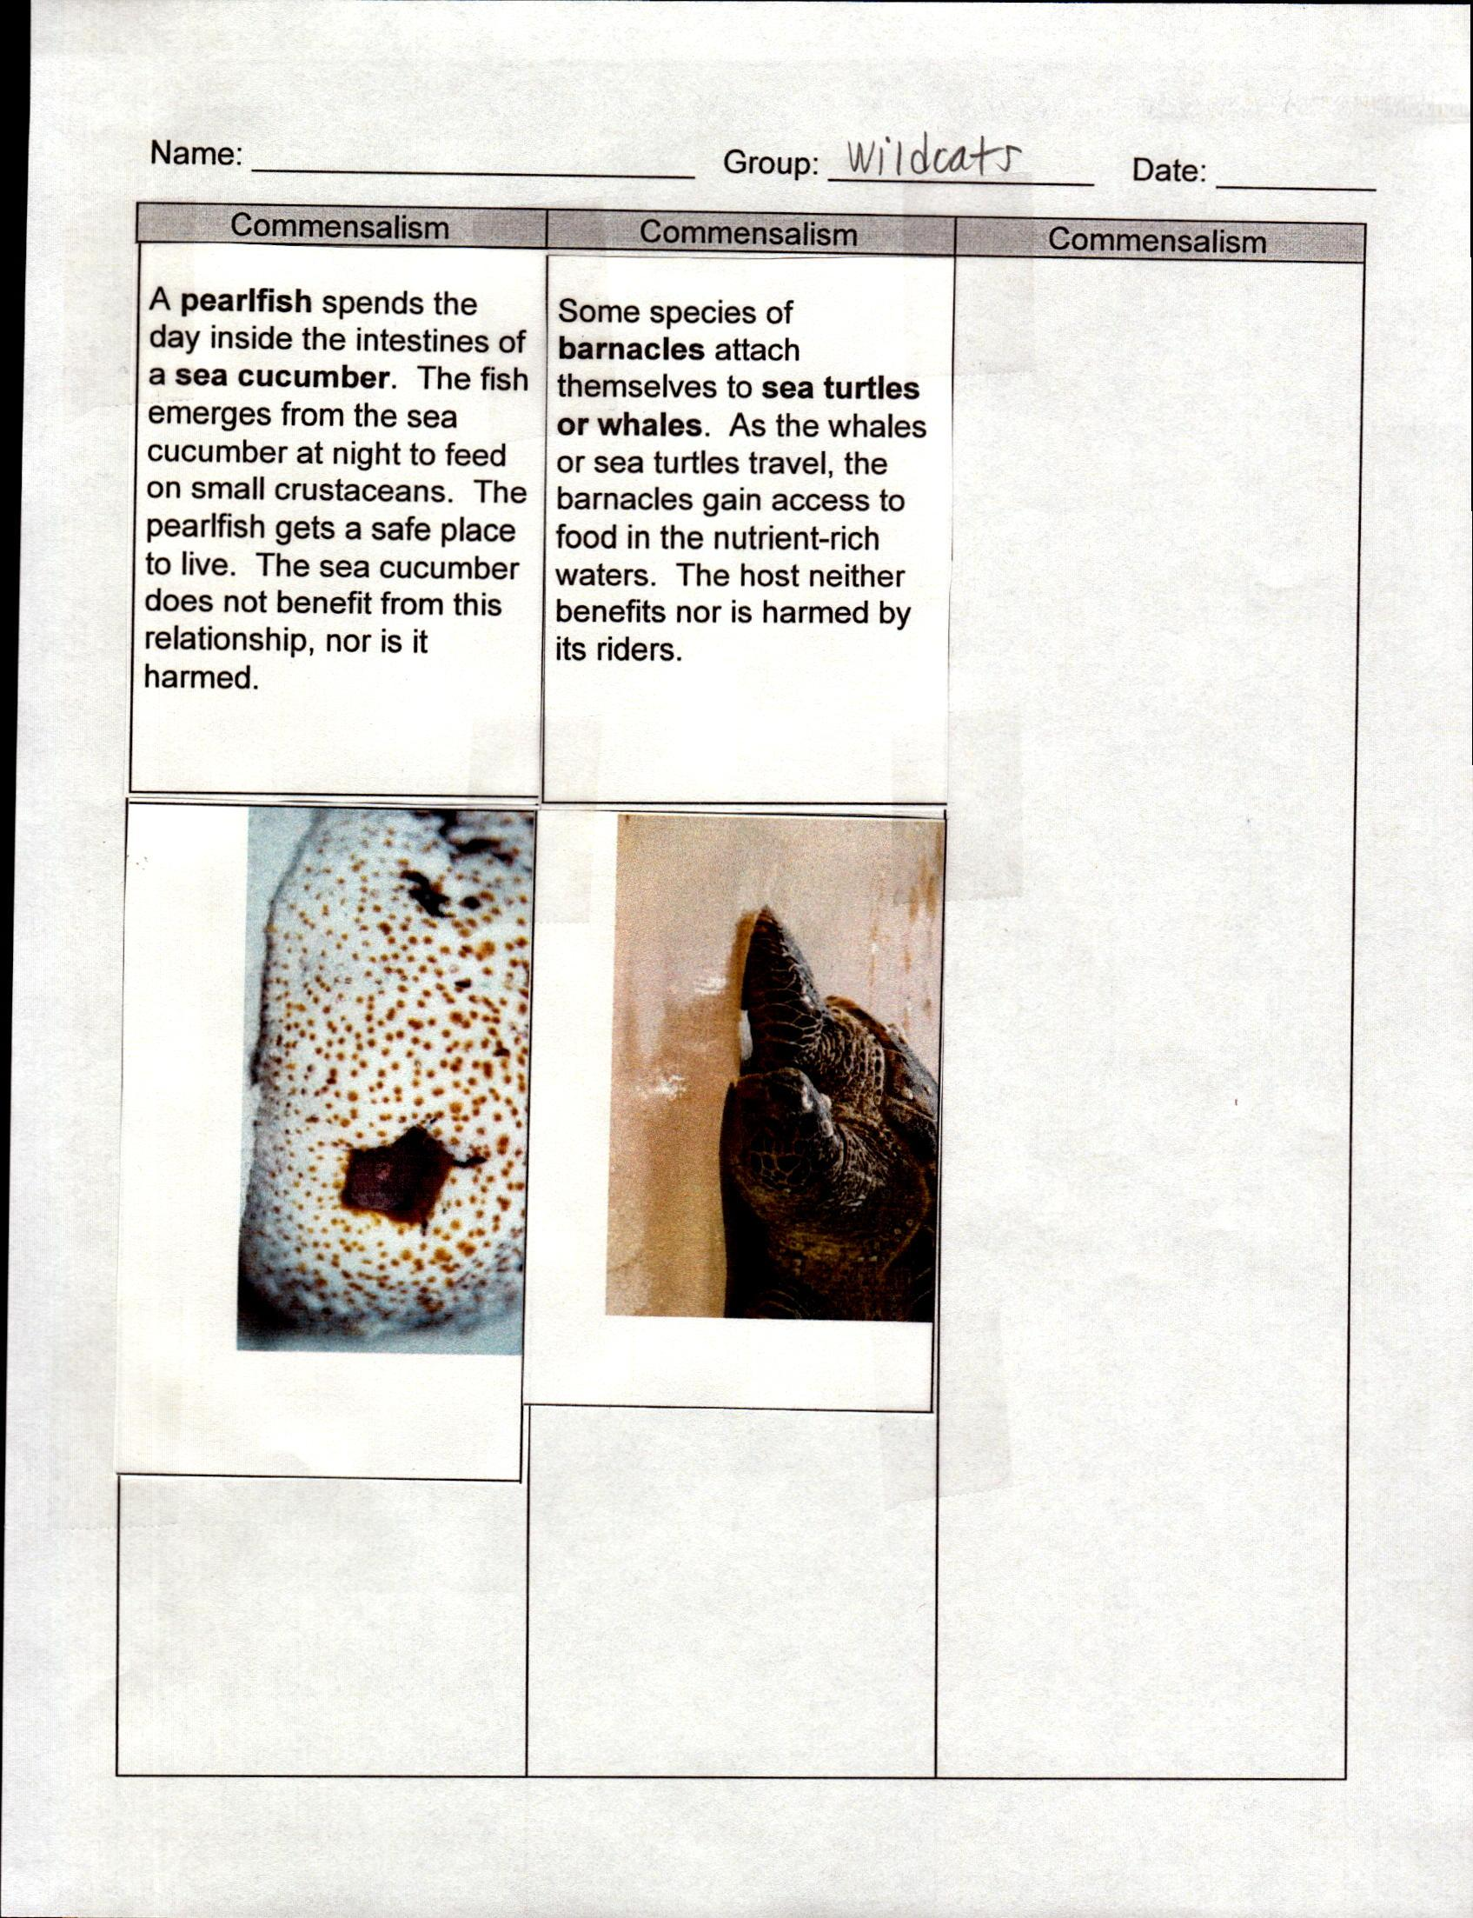
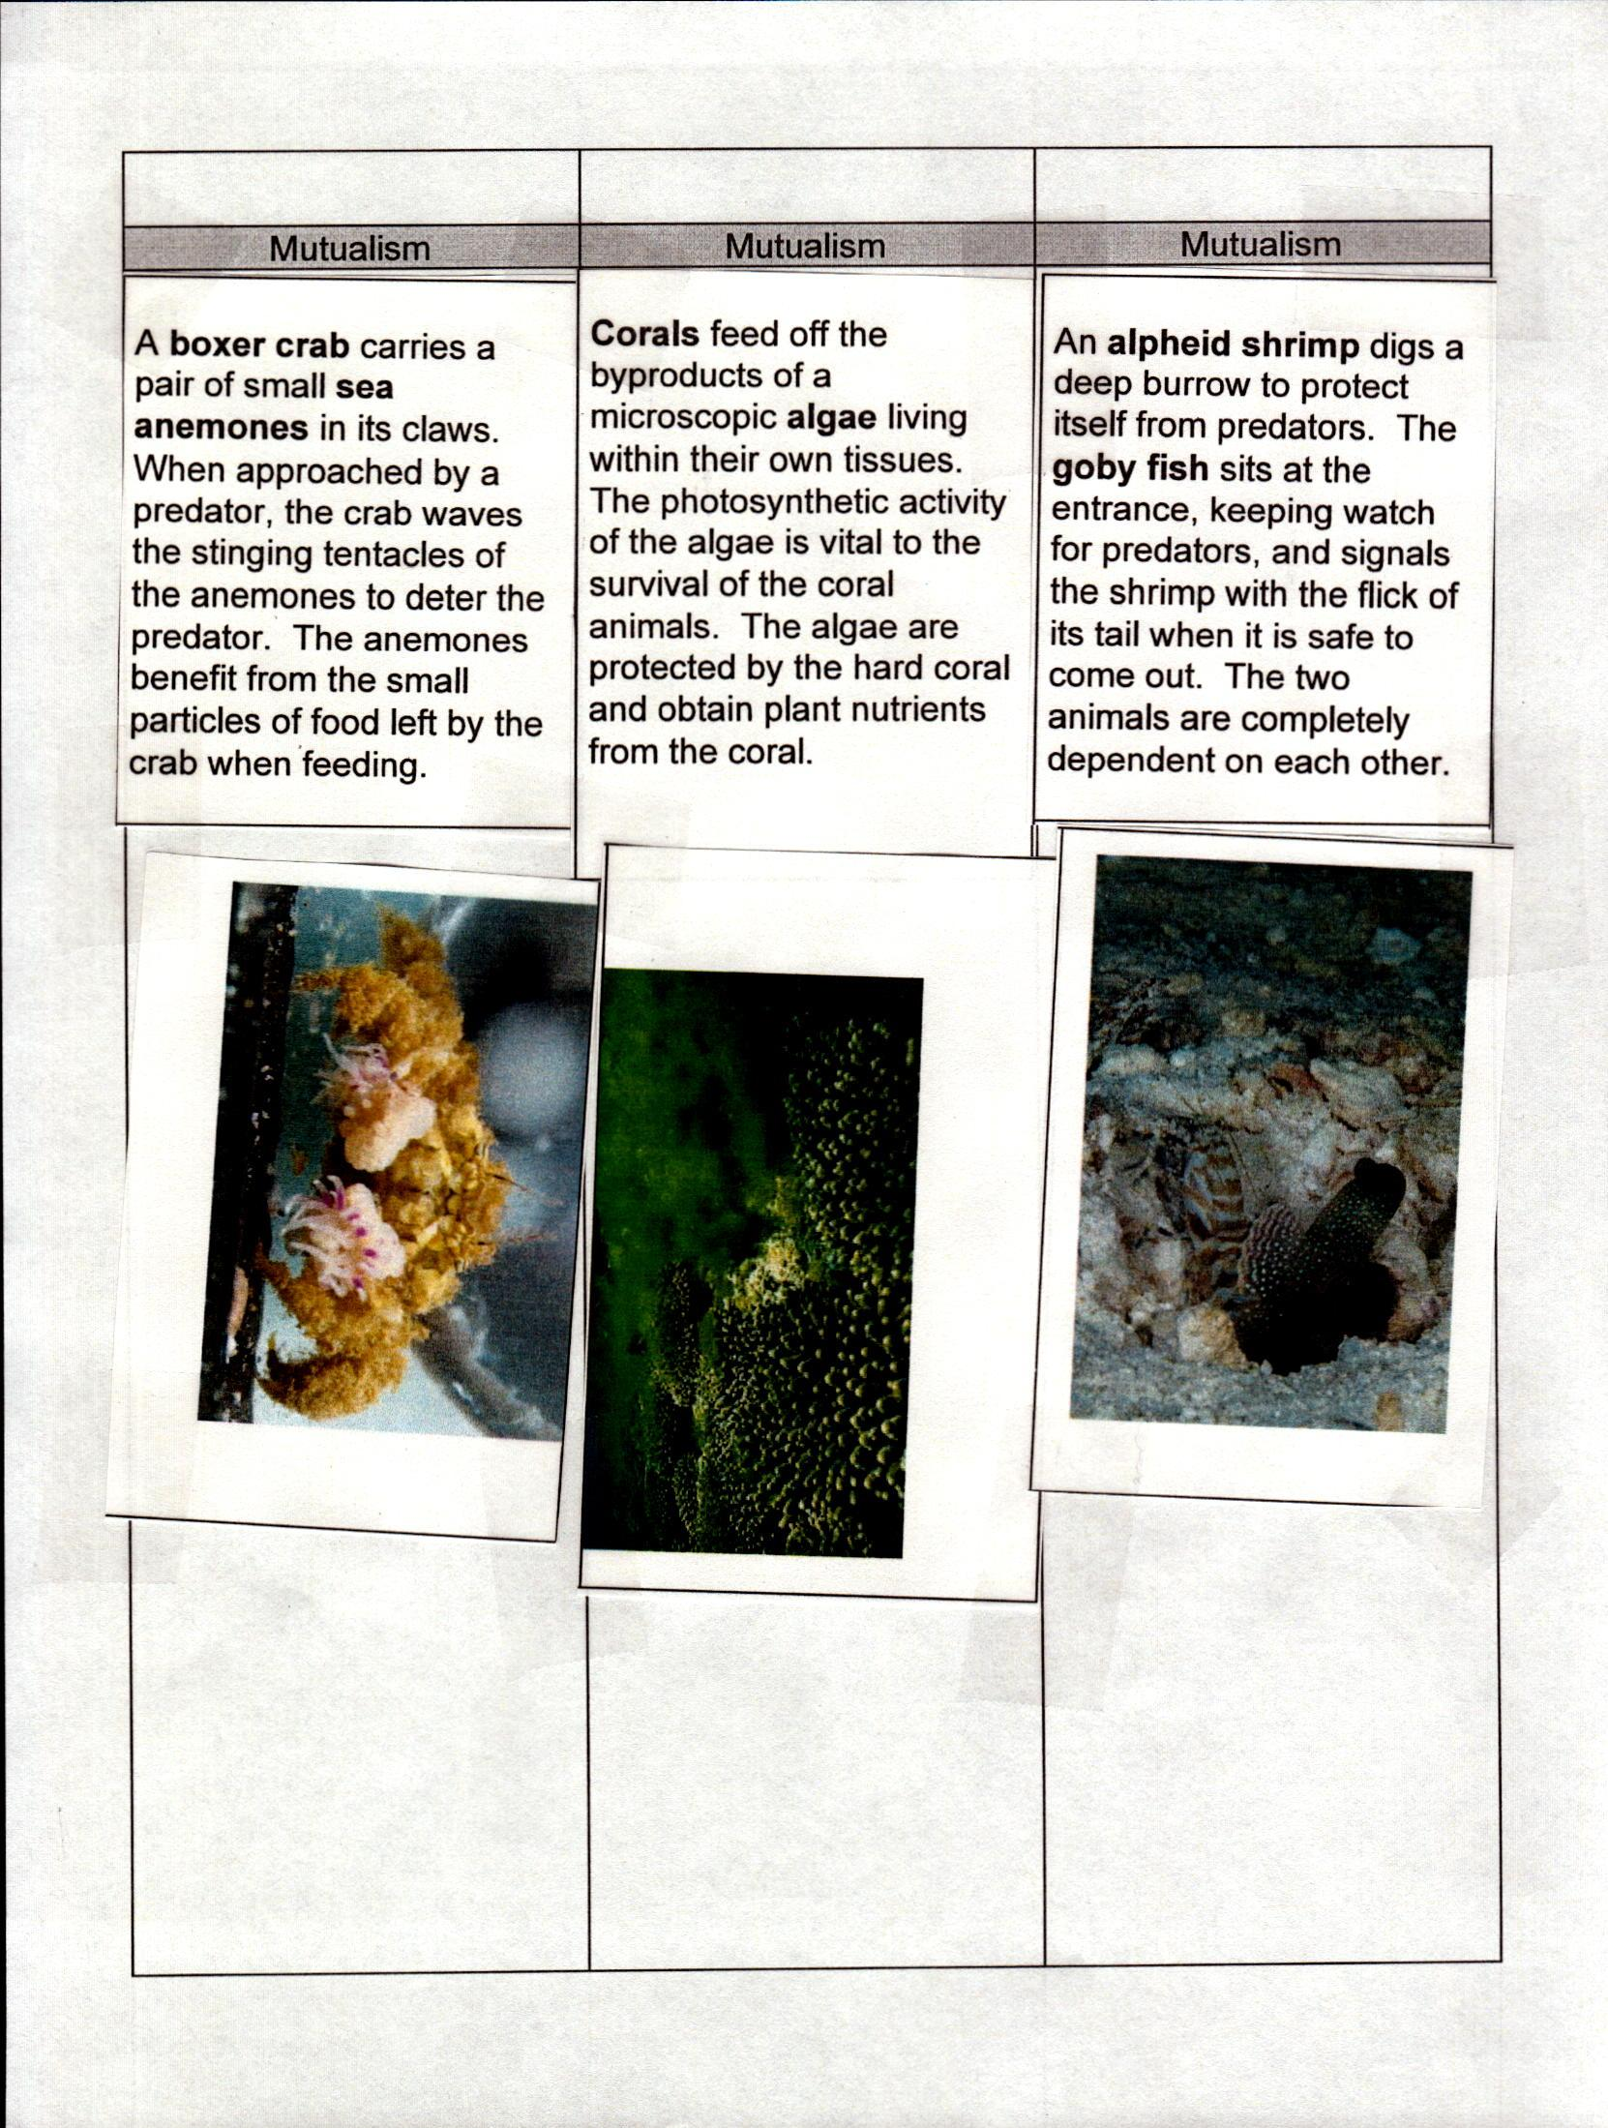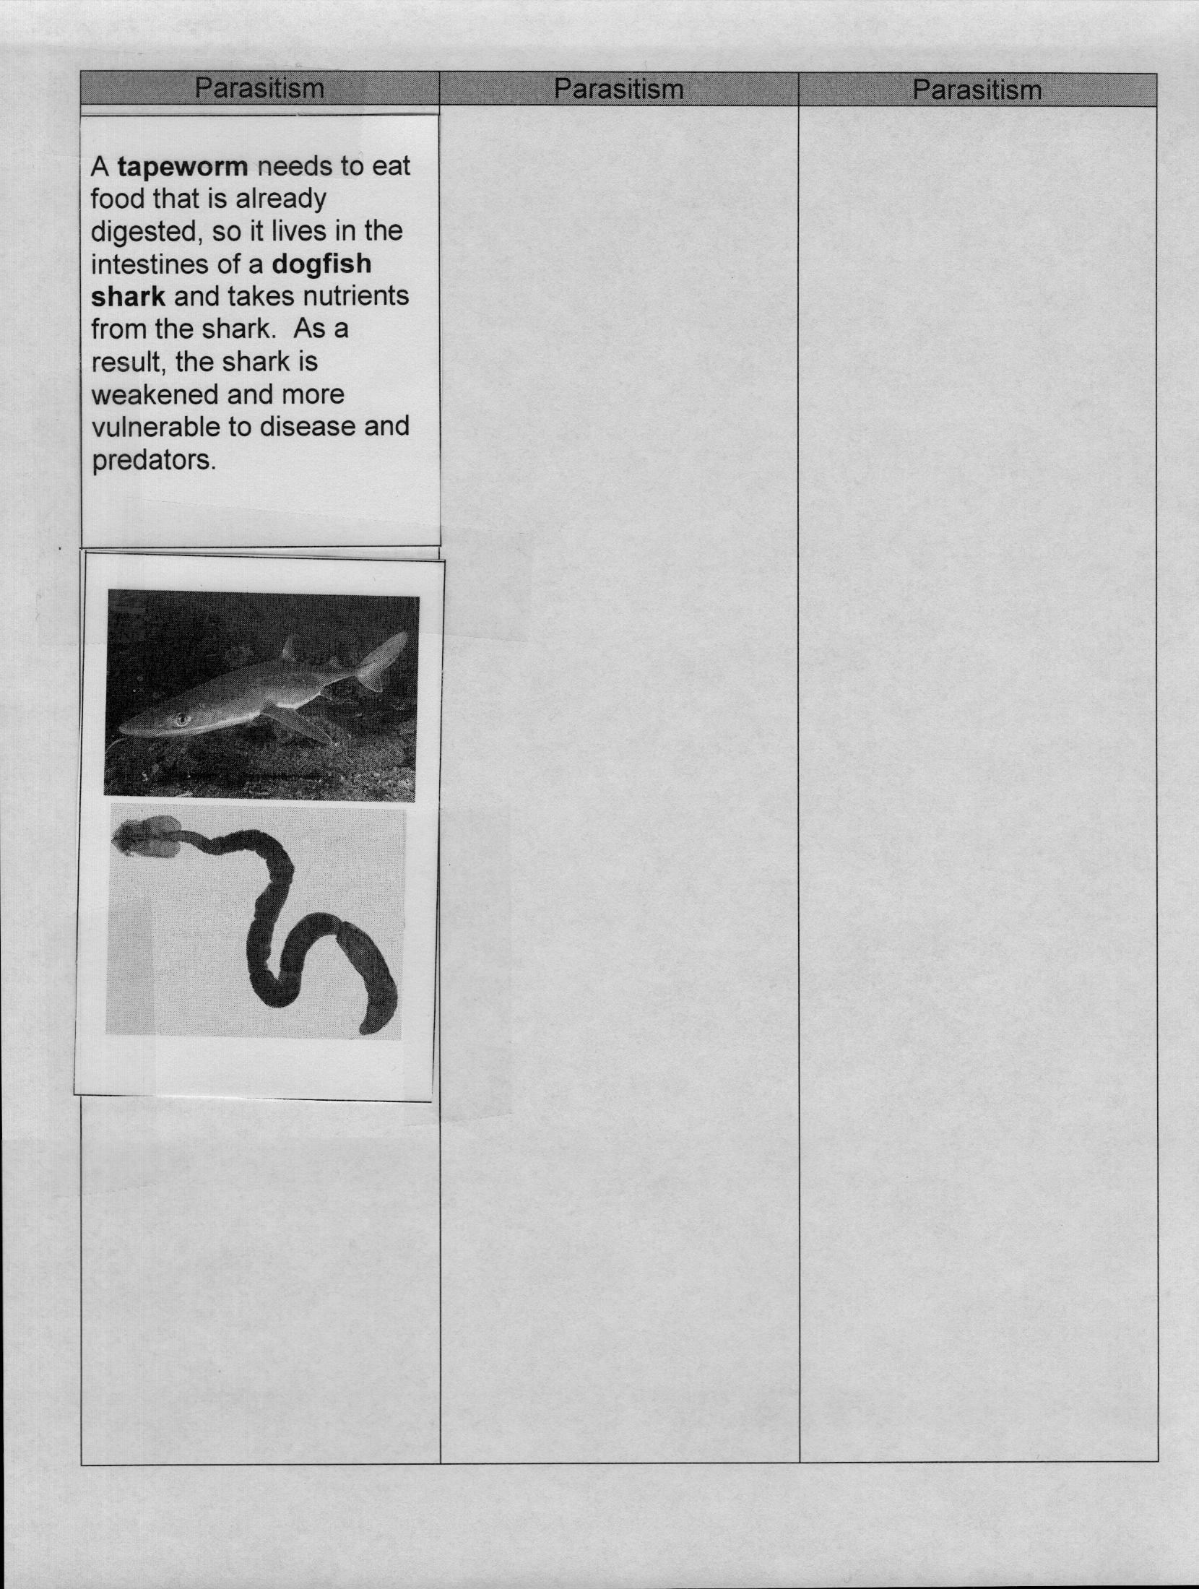
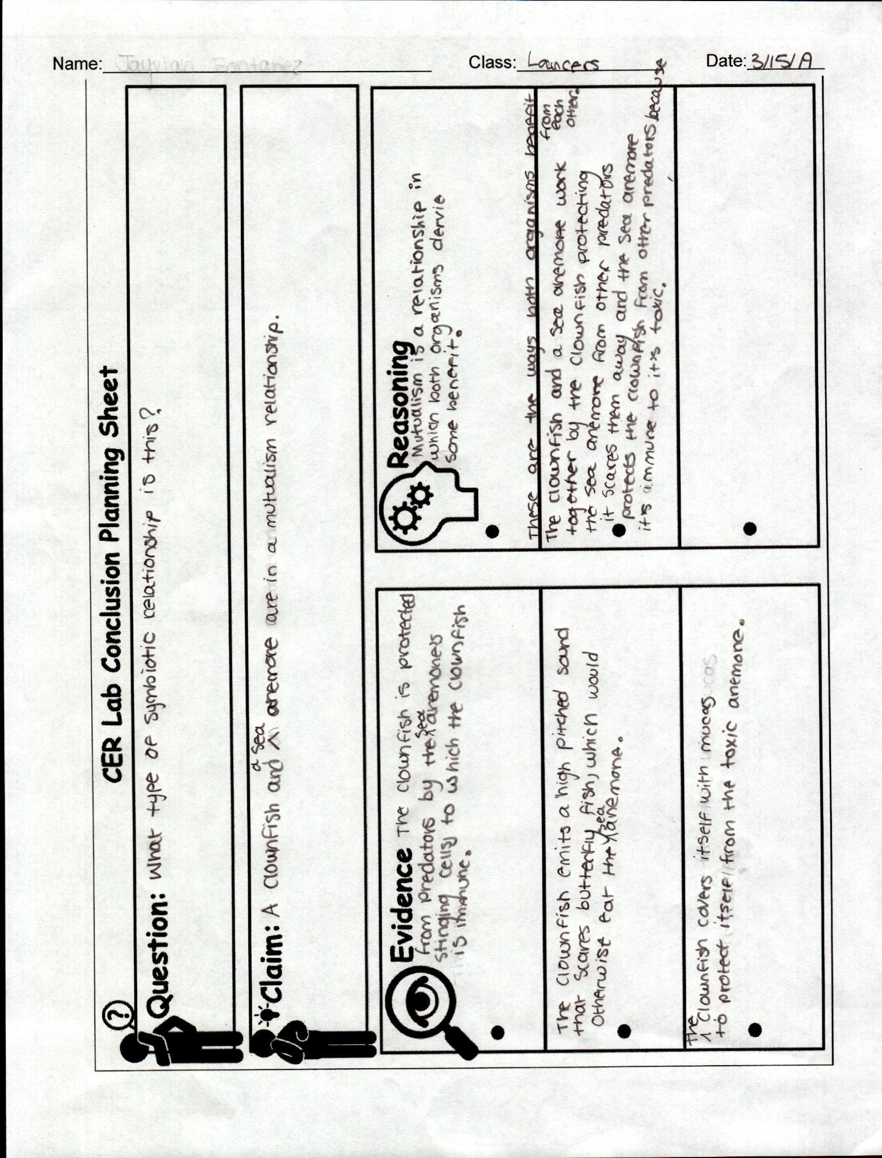
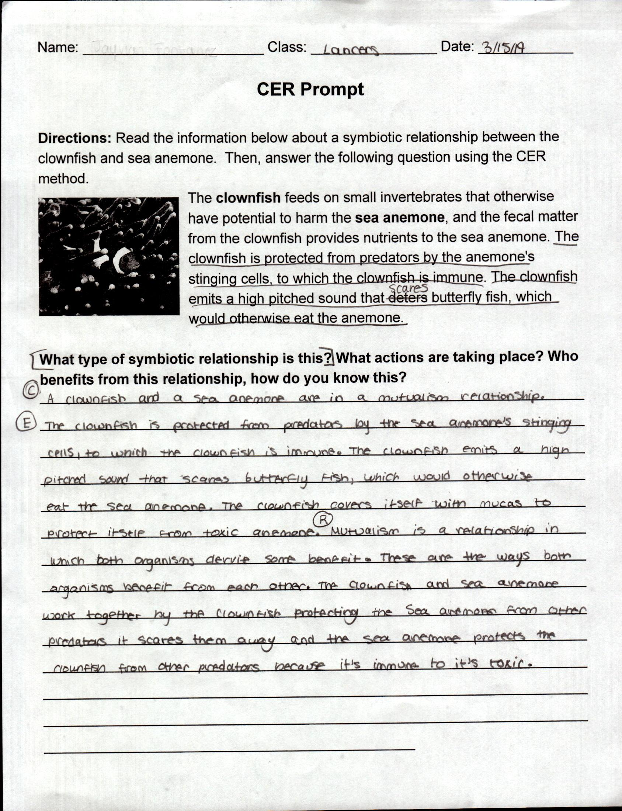

Name:__________________________________ Class:_______________ Date:________

Symbiosis Vocabulary

Term & Picture | Definition | Write a sample sentence that includes the example of the relationship from yesterday’s videos. | Reference Word
Competition

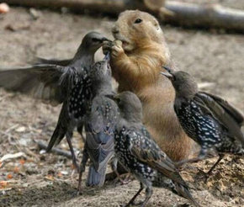

Predation

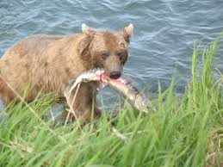

Symbiosis

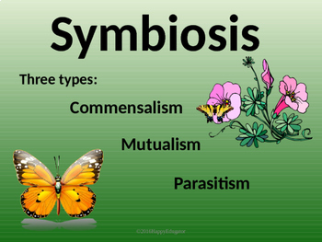

Term & Picture | Definition | Write a sample sentence that includes the example of the relationship from yesterday’s videos. | Reference Word
Mutualism

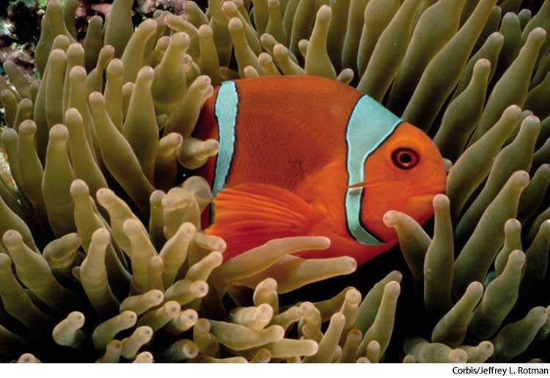

Commensalism

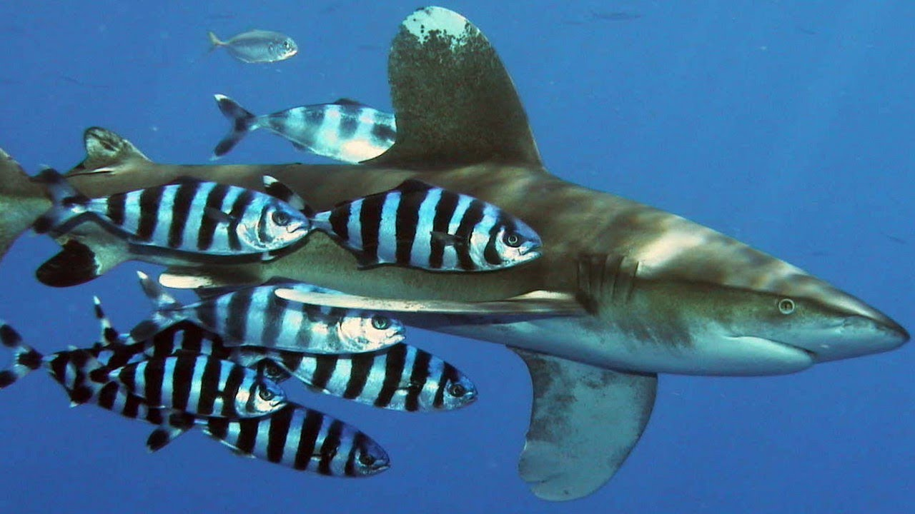

Parasitism

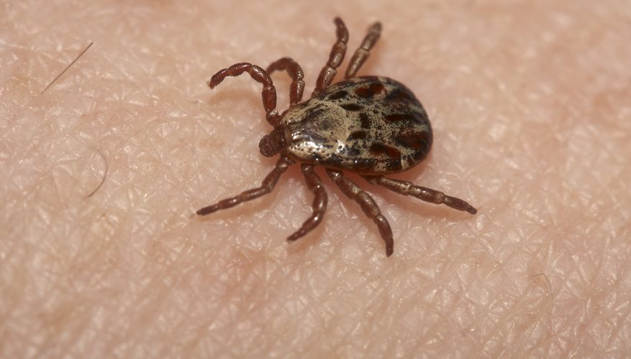

Name:__________________________________ Class:_______________ Date:________

National Geographic Videos - Symbiotic Relationships

Video: Fish Thieves | Other organism involved | What actions are taking place? | Which organism(s) are benefiting from the action?
Monk Seal

Video: Caribbean Cleaners | Other organism involved | What actions are taking place? | Which organism(s) are benefiting from the action?
Cleaner Gobies

Pedersen Shrimp

Creole Wrasse

Video: Giving Fish a Bath | Other organism involved | What actions are taking place? | Which organism(s) are benefiting from the action?
Fish of Coral Reef

Video: Clownfish and Sea Anemone | Other organism involved | What actions are taking place? | Which organism(s) are benefiting from the action?
Anemone

Name:__________________________________ Class:_______________ Date:________

National Geographic Videos - CER Writing Prompt

Below is a picture of a lemon shark with remoras. What actions are taking place? Which organism(s) are benefitting from these actions? How do you know this?

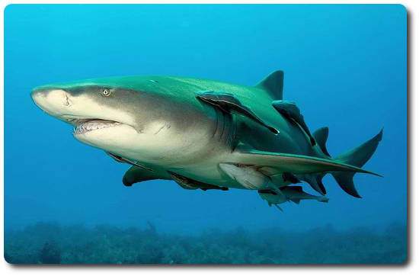

Symbiotic Interactions Matching Activity

Directions: Cut out the scenario cards and image cards. Then, read each scenario carefully. Match the scenario to the corresponding image and then paste both under the correct heading. You will have some headings leftover. Be prepared to defend your choices!

An alpheid shrimp digs a deep burrow to protect itself from predators. The goby fish sits at the entrance, keeping watch for predators, and signals the shrimp with the flick of its tail when it is safe to come out. The two animals are completely dependent on each other. | A tapeworm needs to eat food that is already digested, so it lives in the intestines of a dogfish shark and takes nutrients from the shark. As a result, the shark is weakened and more vulnerable to disease and predators. | A boxer crab carries a pair of small sea anemones in its claws. When approached by a predator, the crab waves the stinging tentacles of the anemones to deter the predator. The anemones benefit from the small particles of food left by the crab when feeding.
A pearlfish spends the day inside the intestines of a sea cucumber. The fish emerges from the sea cucumber at night to feed on small crustaceans. The pearlfish gets a safe place to live. The sea cucumber does not benefit from this relationship, nor is it harmed. | Some species of barnacles attach themselves to sea turtles or whales. As the whales or sea turtles travel, the barnacles gain access to food in the nutrient-rich waters. The host neither benefits nor is harmed by its riders. | Corals feed off the byproducts of a microscopic algae living within their own tissues. The photosynthetic activity of the algae is vital to the survival of the coral animals. The algae are protected by the hard coral and obtain plant nutrients from the coral.

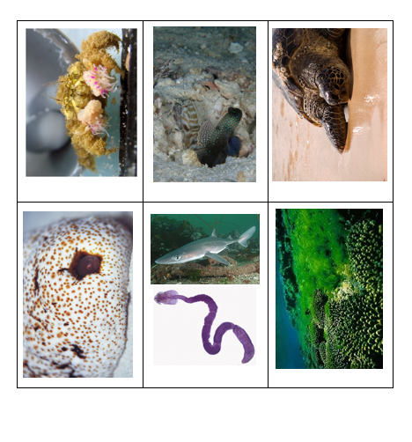

Name:__________________________________ Class:_______________ Date:________

Commensalism | Commensalism | Commensalism

Name:__________________________________ Class:_______________ Date:________

Mutualism | Mutualism | Mutualism
Name:__________________________________ Class:_______________ Date:________

Parasitism | Parasitism | Parasitism

Name:__________________________________ Class:_______________ Date:________

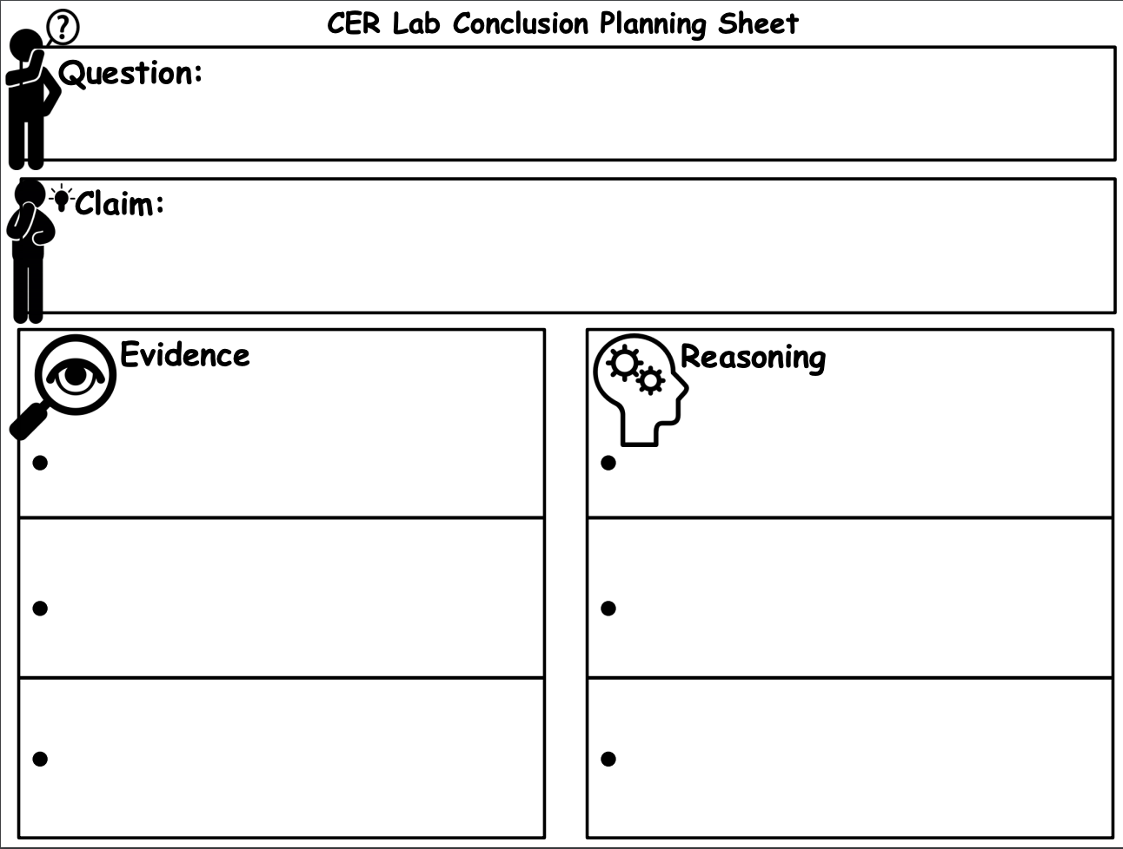

Name:__________________________________ Class:_______________ Date:________
CER Rubric
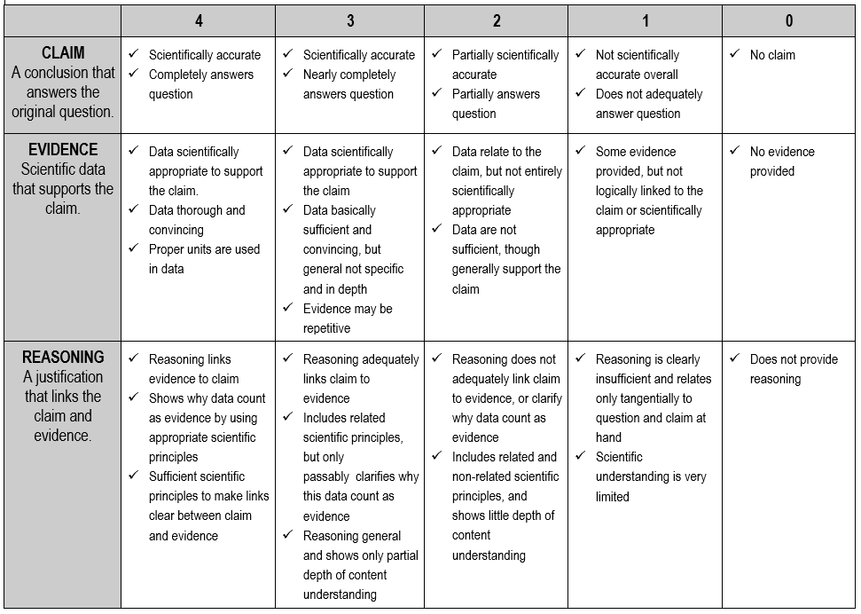
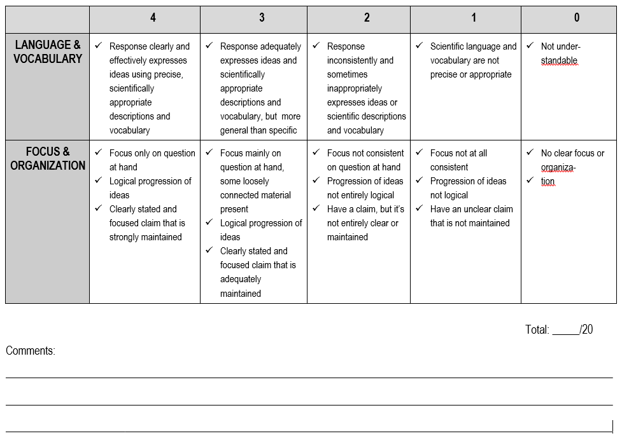

Name: _______________________ Class: ________________ Date: ____________

CER Prompt

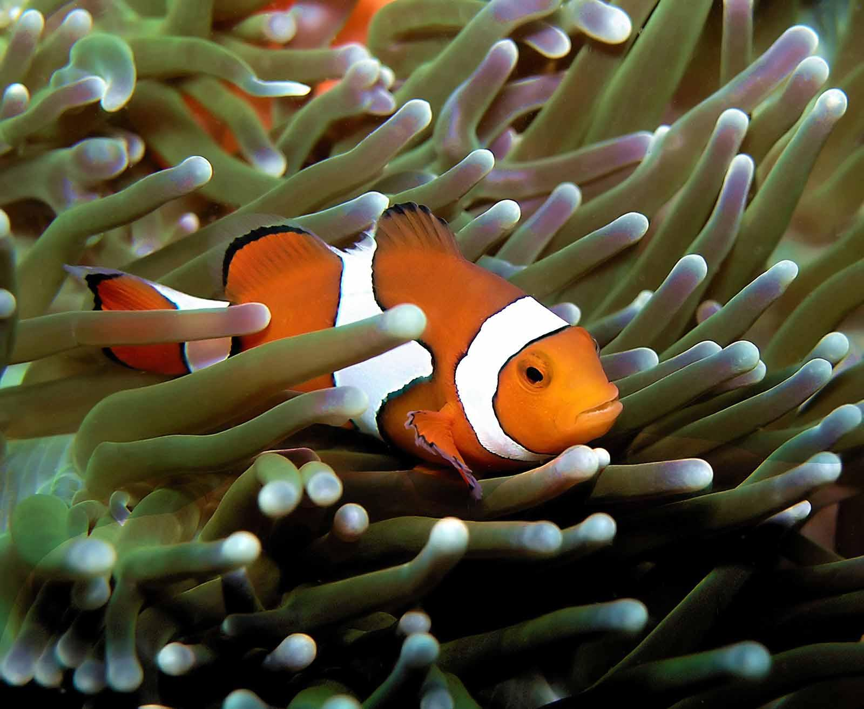
Directions: Read the information below about a symbiotic relationship between the clownfish and sea anemone. Then, answer the following question using the CER method.
The clownfish feeds on small invertebrates that otherwise have potential to harm the sea anemone, and the fecal matter from the clownfish provides nutrients to the sea anemone. The clownfish is protected from predators by the anemone's stinging cells, to which the clownfish is immune. The clownfish emits a high pitched sound that deters butterfly fish, which would otherwise eat the anemone.

What type of symbiotic relationship is this? What actions are taking place? Who benefits from this relationship, how do you know?

________________________________________________________________________________________________________________________________________________________________________________________________________________________________________________________________________________________________________________________________________________________________________________________________________________________________________________________________________________________________________________________________________________________________________________________________________________________________________________________________________________________________________________________________________________________________________________________________________________________________________________________________________________________________________________________________________________________________________________________________________________________________________________________________________________________________________________________________________________________________________________________

