Task-level phenomenon:
In this lesson, the specific phenomenon is Hurricane Michael in the Florida Panhandle.

Synopsis of high-quality task:
This task could be included in a unit on weather. The goal of this task is to analyze and interpret data in order to explain why certain significant weather events (e.g., tornadoes, hurricanes, blizzards)occur in particular areas and not in random locations. Students will use data to create a climate map and use this map to identify patterns/conditions of each of the four main air masses. They will also develop a map that shows significant weather events in history and eventually draw conclusions from all maps to construct an explanation why these events happen in particular areas and not in random locations.

This task has four parts. Explaining the phenomenon of increased frequency of a significant weather event in particular areas is the goal and should always be a part of the assessment of this lesson, as it is most applicable to the standard.

Anticipated student time spent on task: 3 class sessions, 55mins each

Type of Task (check one):
____ 1. Investigation/experimentation/design challenge
_X__ 2. Data representation, analysis, and interpretation
____ 3. Explanation

Student task structure(s): small group work

STE Standards and Science and Engineering Practices:

8.MS-ESS2-5. Interpret basic weather data to identify patterns in air mass interactions and the relationship of those patterns to local weather.
Clarification Statements:
- Data includes temperature, pressure, humidity, precipitation, and wind.
- Examples of patterns can include air masses flow from regions of high pressure to low pressure, and how sudden changes in weather can result when different air masses collide.
- Data can be provided to students (such as in weather maps, data tables, diagrams, or visualizations) or obtained through field observations or laboratory experiments.
State Assessment Boundary:
- Specific names of cloud types or weather symbols used on weather maps are not expected in state assessment.

Science and Engineering Practices:
- Analyzing and interpreting data
- Constructing explanations

Prior Knowledge:
Previous Standard from Strand Map:
7.MS-ESS2-4. Develop a model to explain how the energy of the Sun and Earth’s gravity drive the cycling of water, including changes of state, as it moves through multiple pathways in Earth’s hydrosphere.
Clarification Statement:
- Examples of models can be conceptual or physical.
State Assessment Boundary:
- A quantitative understanding of the latent heats of vaporization and fusion is not expected in state assessment.

Previous Topics:
- Basic weather data includes temperature, pressure, humidity, precipitation, and wind.
- Weather and climate are different. Weather describes short-term changes, while climate refers to patterns in weather over time.

Tornado Alley is an informal name given to the area of the United States where tornadoes most frequently occur. For a tornado to occur, a thunderstorm must first happen. This thunderstorm is often the result of two different air masses coming in contact with one another. The Hurricane Belt is an informal name given to an area in the Atlantic Ocean often affected by hurricanes. For a hurricane to occur a tropical cyclone must form. Tropical cyclones form from thunderstorms. Again, thunderstorms are often the result of two different air masses coming in contact with one another. A snowbelt is an informal name given to an area where heavy snowfall occurs. This heavy snowfall is often a result of lake-effect snow and produces blizzard-like conditions. For blizzards to occur, different air masses move past one another.

Air masses play a significant role* in creating/sustaining the significant weather events as described above. These significant weather events occur in different places and each type of event occurs more often in particular areas. There are fewer occurrences of these significant weather events outside of these designated areas.

*There are additional factors involved in the occurrence of tornadoes, hurricanes, blizzards, and other significant weather events (e.g., vigorous updraft and rotation for a tornado).
Connections to the real-world:
- Significant weather events, such as tornadoes, hurricanes, and blizzards, cause catastrophic damage; it’s important to be able to forecast their potential destruction and thus, to be able to identify the various types of air masses
- These significant weather events typically occur in certain areas of the world when specific conditions exist/specific air masses are in place

Mastery and Language Goals:

Learning Objective:
- Analyze and interpret climate data to identify the characteristics of different air mass types
- Construct an explanation for why significant weather events happen in certain areas of the North America more often than others.

Performance Objective:
- Create model representing information from climate data (PART I)
- Identify patterns on the map to determine typical weather in areas across North America (PART II)
- Determine general weather conditions where significant weather events typically form (PART III)
- Construct an explanation from evidence to show why certain significant weather events occur more often in particular areas (e.g., tornado alley, hurricane belt) (PART IV)

Language Objective:
- Discuss characteristics of air masses in small groups.
- Construct a written explanation for why significant weather events occur more often in particular areas.

Teacher Instructions:

INTRODUCTION (~15 min)
- Students read about a story about visiting the Florida Panhandle during a hurricane and watch a video, Extreme 4K Video of Hurricane Michael. Ask students to write down their notice and wonderings.
- Discuss - Please note that when discussing, all ideas are acceptable, including those that are incorrect. The Look For points below are what students are working towards in this task. However, be prepared if students come with this prior knowledge.
  - Why do hurricanes seem to always strike Florida?
LOOK FOR: In this section you are eliciting student ideas and can collect them on the board.
    - Hot temperatures
    - Thunderstorms happen often
    - It has many coastal areas
  - Are there other significant weather events that affect only certain areas of the world?
LOOK FOR: In this section you are eliciting student ideas and can collect them on the board.
    - Tornadoes
    - Blizzards
- Why do tornadoes most often happen in a midwest area of the United States, commonly called Tornado Alley?
- Why does heavier amounts of snow typically fall in Northeast areas along the “snowbelt”?
- Why do blizzards occur most often in the Northeast?

PART I (~40 min)
- Frame the activity by telling students they are to create a map that shows patterns in climate data in order to determine why significant weather events occur in different places and why each type of event occurs more often in particular areas.
- Ask students to use prior knowledge of latitude and longitude to plot the location of 18 different locations across North America.
- Ask students to continue plotting the provided data about each of these cities.
- This is up to the student to decide how to display this information. There is no specific expectation here. Students are doing this for the first time and thus, there will be great variation.
- Emphasize the importance of representing the data in ways that make sense to another student.
- LOOK FOR: data plotted using coordinates; generalized categories: warm temperatures versus cold temperatures, high precipitation versus low precipitation
- As students finish, complete a gallery walk. Ask students to make improvements to their maps as they deem necessary based on what they observed during their walk.
- As a large group, draw general conclusions about relationships between average temperatures and average precipitation amounts.

PART II (~55 min)
- Using the map from Part I, ask students to identify areas that are warm, cold, humid, rainy, and dry.
- Ask students to make general conclusions about conditions that oftentimes appear together.
- Using information from the supplemental resources, identify these combinations as common air masses; define conditions for each air mass type.
- Using the map from Part I, ask students to identify and label six distinct air masses.
- Have students peer edit maps until correct labels are applied.

PART III (~30 min)
- Before starting this part, arrange students into small groups. Assign each group a significant weather event: tornadoes, hurricanes, or significant snow event.
- On the same map from Part I, ask students to plot the location and frequency of their assigned significant weather events using the data given.
- Have students indicate on their map locations of high rates of tornadoes, hurricanes, or snow totals over a few inches. These areas can be shaded and/or connected by different shapes or colors.
- Have students present their maps to the larger group. Ask students to focus on the likely locations of the assigned significant weather events.
- As groups present, have students complete a gallery walk. Ask students to analyze and compare the air mass types that often exist where significant weather events occur.

PART IV (~25 min)
- Remind students of the original question - why do significant weather events happen in certain areas of the world more often than others?
- Students use the maps to discuss their findings in their groups. Students should take notes on their discussion. For support, teachers could provide
  - Graphic organizers for writing
    - Possible example: CER - Claim would be that significant weather events occur when two different air masses collide and the evidence is the patterns on the maps that were created that show high frequencies of events happening where the potential for different air masses to exist. The reasoning is that significant weather events occur as a result of colliding air masses. Describing the air masses involved in these significant weather events also provides reasoning.
- Students write explanations about why significant weather events happen in certain areas of the world more often than others. Students can write more robust explanations by combining their explanations with supplemental resources.
Instructional Materials/Resources/Tools:
- Student handout (included below)
Task Sources:

Weather Data
- World Meteorological Organization World Weather Information Service
https://worldweather.wmo.int

Resources
- Wind Simulator by MIT via an approved Open Source Initiative License
https://www.oercommons.org/courses/wind-simulator-2
- Real-time Wind All Over the World by Cameron Beccario (author) via email
https://earth.nullschool.net
- University of Iowa the Storm Project - Air Masses by Alan Czarnetzki, Professor of Meteorology and STORM Project Director at the University of Northern Iowa via email
https://uni.edu/storm/activities/level1/act12.shtml
- Education Service District 112 Tornado Alley - CC BY-NC-ND 4.0 oercommons.s3.amazonaws.com/media/editor/159002/TornadoAlley-MIddleSchool_1MLtrF5.pdf
- TeachEngineering Air Under Pressure by Zain Alexander Iqbal, Digital Media and Technical Editor for TeachEngineering, Integrated Teaching and Learning Laboratory at the University of Colorado at Boulder via email
https://www.oercommons.org/courses/air-under-pressure/view
- TeachEngineering Stormy Skies by Zain Alexander Iqbal, Digital Media and Technical Editor for TeachEngineering, Integrated Teaching and Learning Laboratory at the University of Colorado at Boulder via email
https://www.oercommons.org/courses/stormy-skies/view

Supplemental Resources
- Air Masses and Fronts from Introductory Meteorology by Penn State College of Earth and Mineral Sciences CC BY-NC-SA 4.0
https://www.e-education.psu.edu/meteo3/l3_p5.html
- Changing Weather from Earth Science by Lumen Learning CC BY 4.0
https://courses.candelalearning.com/earthscienceck12/chapter/changing-weather/

Accessibility and Supports:
Provide students with claim, evidence, and reasoning graphic organizer (included below) for Part IV

Sample Student Work:

Sample #1
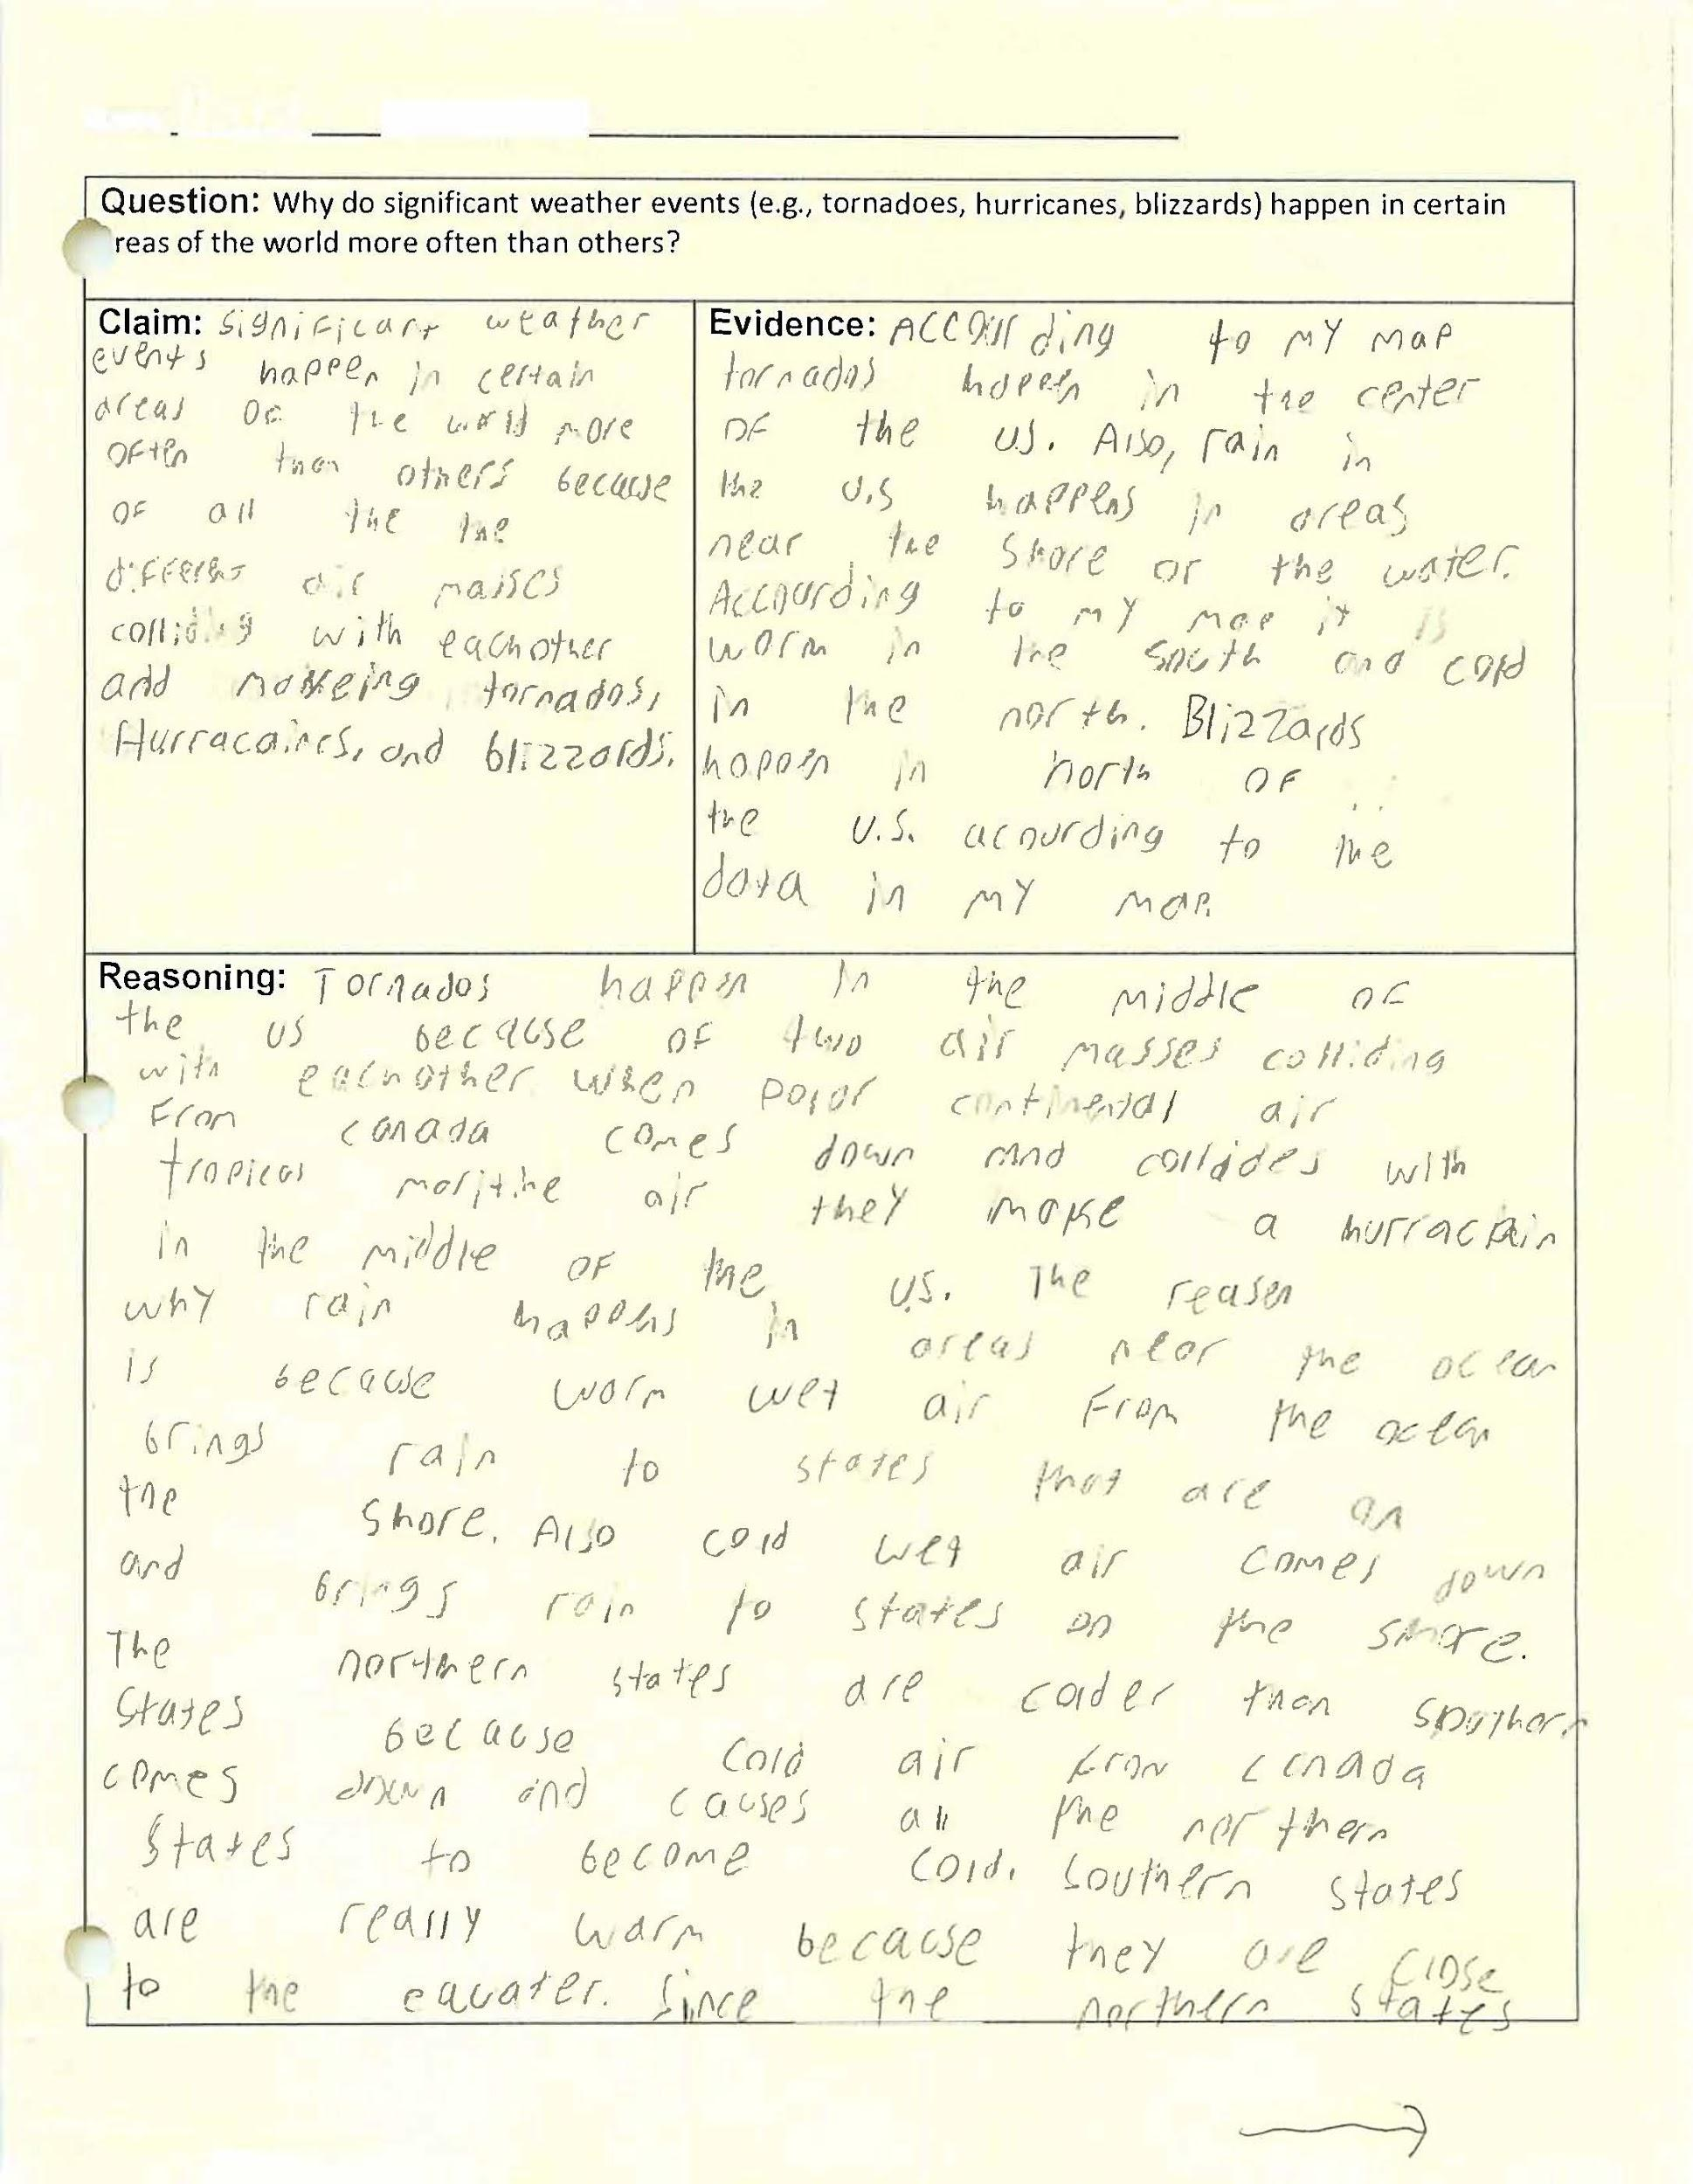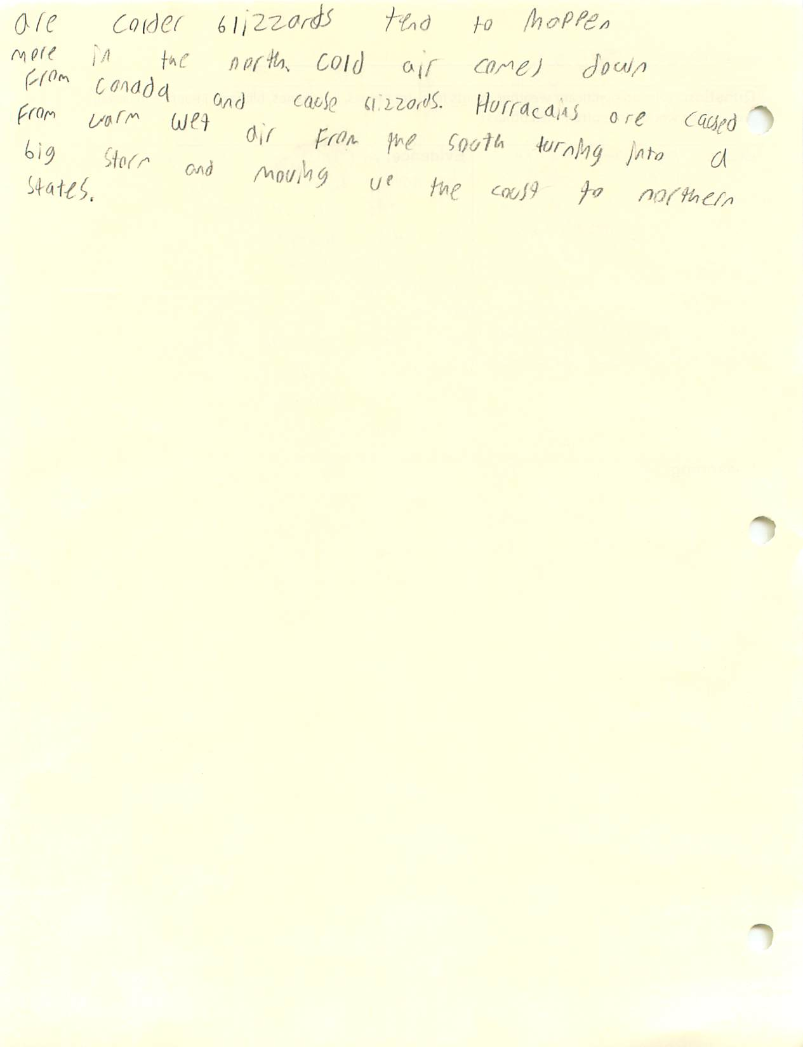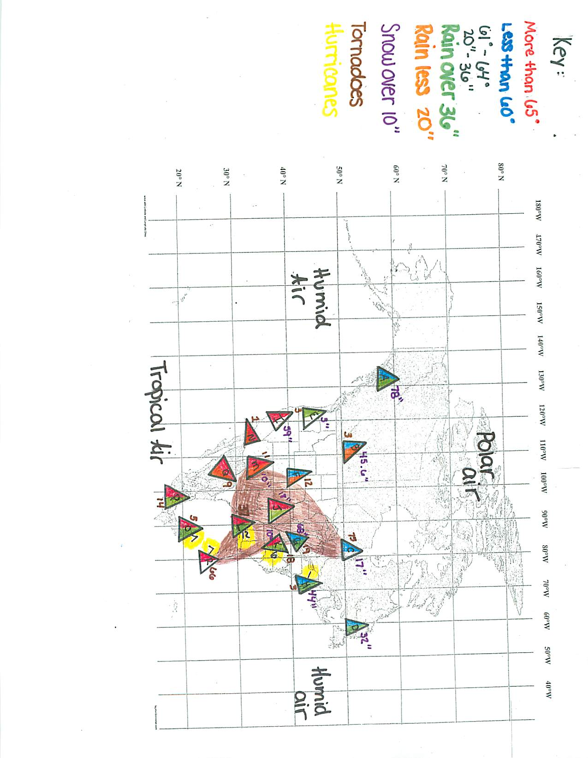

Sample #2
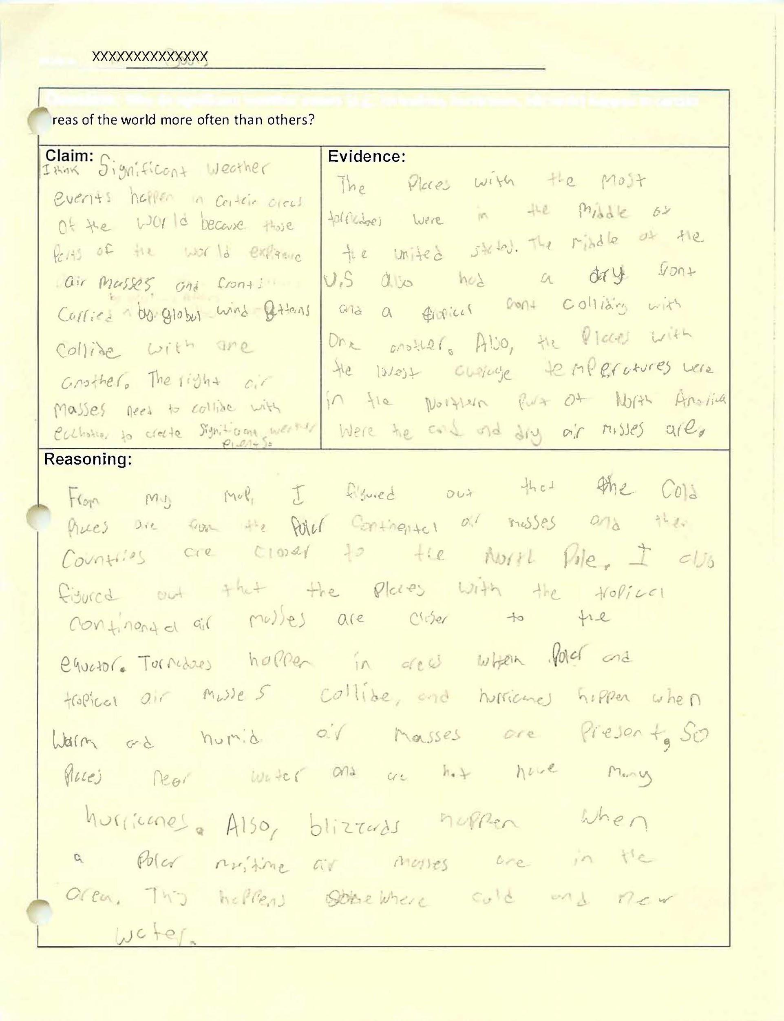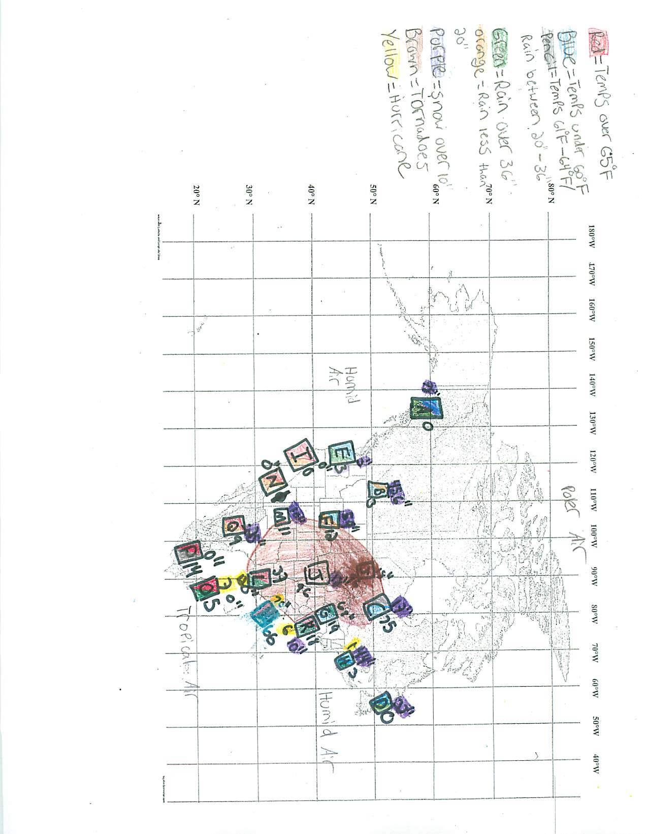

Sample #3
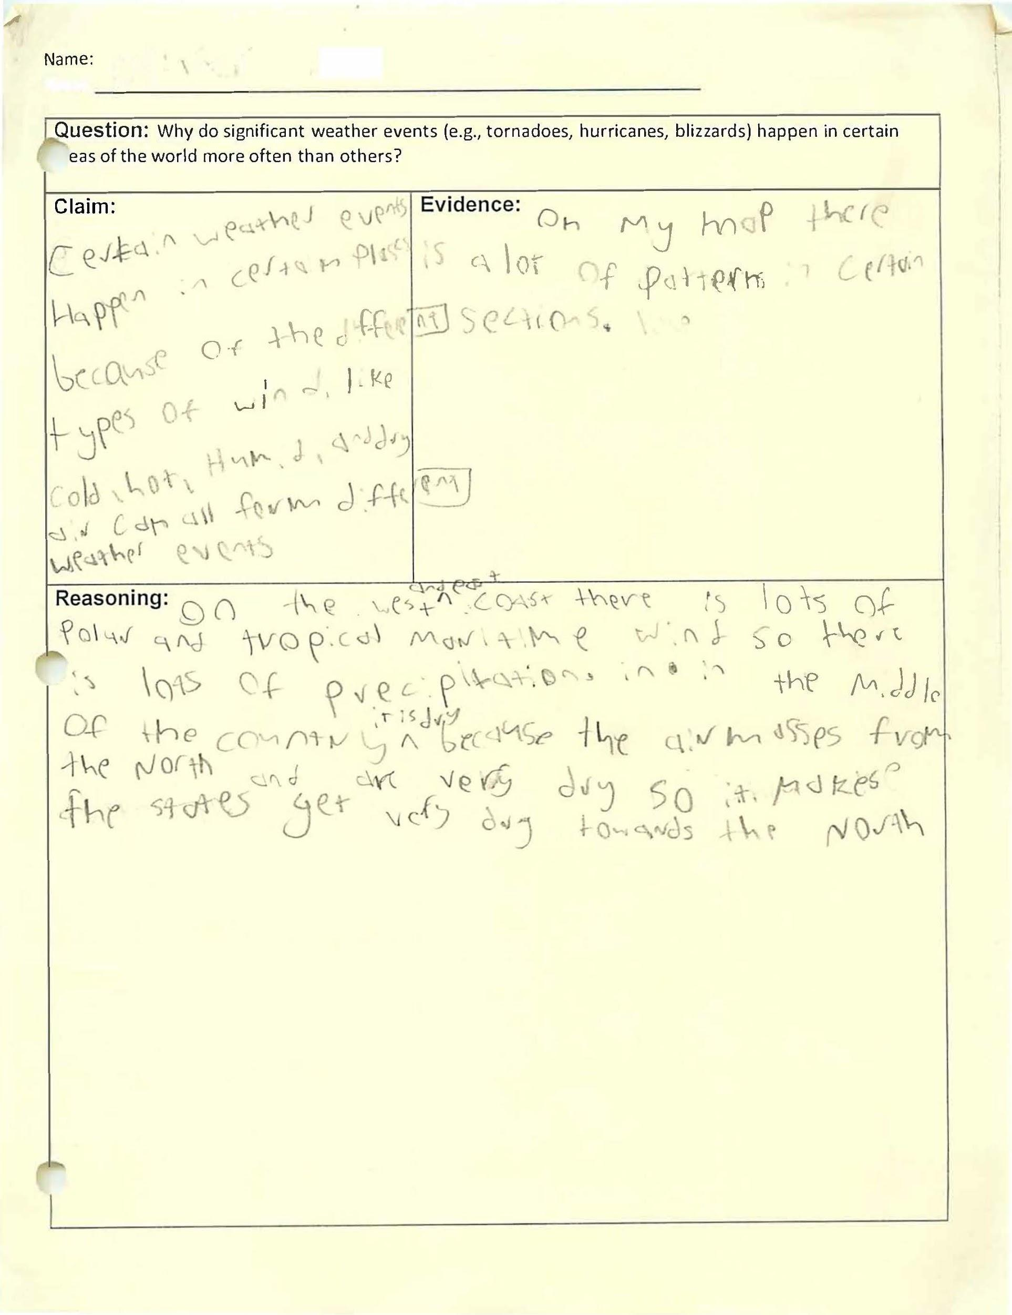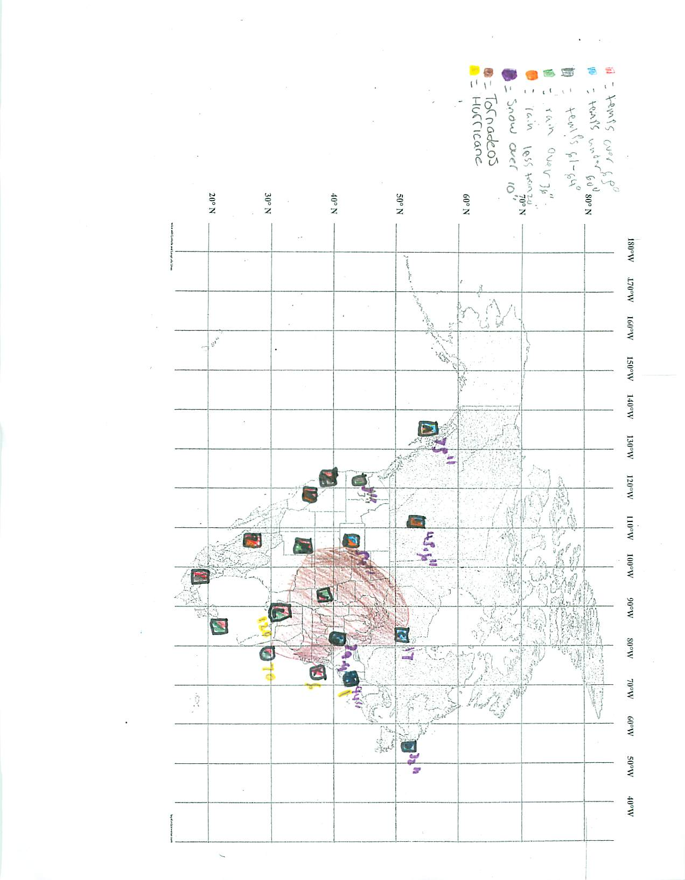

Prompt: Why Do Significant Weather Events Happen in Certain Areas of North America More Often than Others?

Name:____________________________________________________________________________________

Objectives:
- Construct a map from given climate data
- Identify patterns on the map to determine typical weather in areas across North America
- To the map, add data representing past 20 year average of significant weather events
- Determine general weather conditions where significant weather events typically form
- Construct an explanation from evidence to show why certain significant weather events occur more often in particular areas (e.g., tornado alley, hurricane belt)

Introduction
It was a family wedding on the Florida Panhandle in October that we had to go to. The wedding was on the beach Sunday night, a beautiful evening with fabulous weather. Rarely does our family go on vacation, so this was to be an extended vacation. However, we woke up on Monday morning to weather reports that greatly concerned Mom and Dad. Tropical depression Michael had strengthened overnight and was heading into the Gulf of Mexico. It was on a track and heading right for us. Because we had flown down and been transported by the hotel from the airport, we had no car and our plane tickets were not valid until Thursday. Most of my extended family was in the same situation as well. So, that is when the scurrying began. Trying to change plane tickets and rent cars proved to be impossible. Everyone was trying to leave the area, despite the fact that there was full sun and warm temperatures. As Monday turned into Tuesday, it was easy to see how the surf had changed and that danger was impending. The sea was more violent and there was ample caution being provided to avoid entering the water. As it became abundantly clear that we were not going to be able to leave the area, we needed to find shelter. The hotel made arrangements for all of their remaining guests. Michael reached 155 mph peak winds as it approached the Florida Panhandle just before making landfall on Wednesday. It had become the strongest storm of the season, a Category 4 Hurricane.

Extreme 4K Video of Hurricane Michael

Hurricane Alley
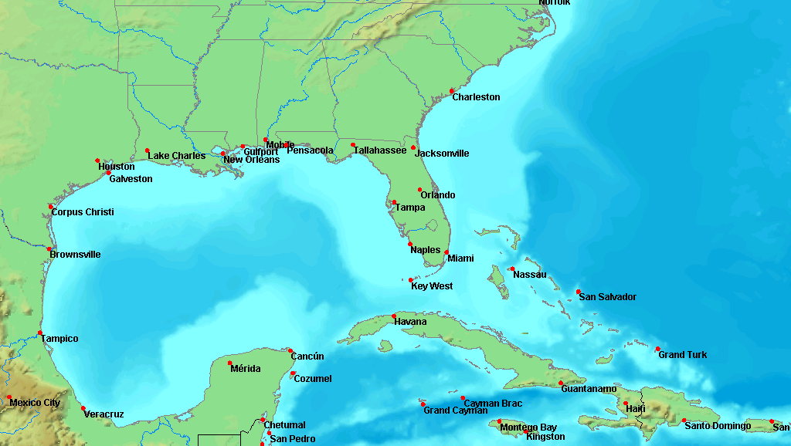

Image from Wikimedia Commons via CC0-1.0

Tornado Alley

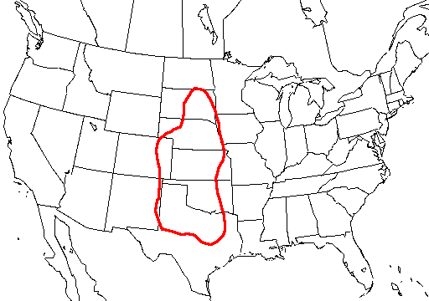
Image from Wikimedia Commons via CC0-1.0
Snowbelt
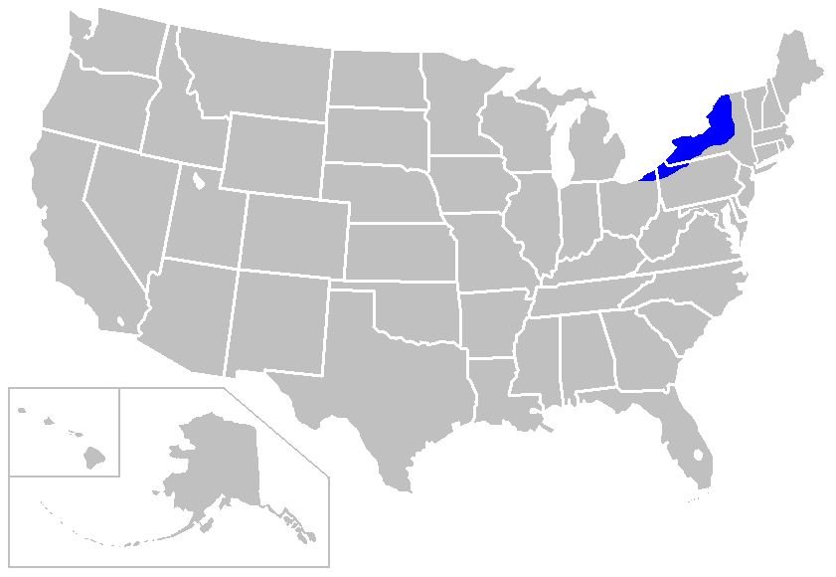
Image from Wikimedia Commons via CC0-1.0
Part I

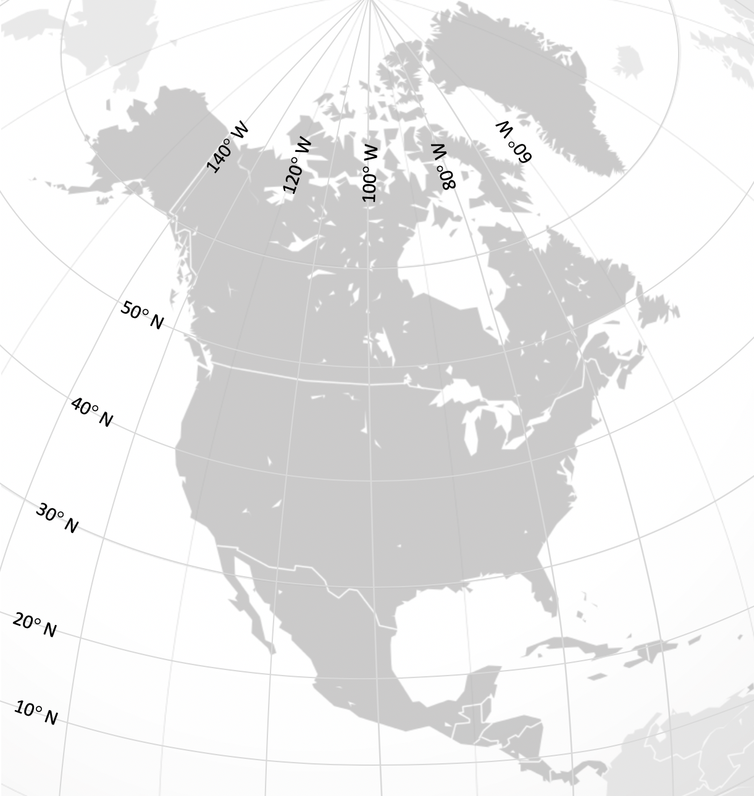
Image from Wikimedia Commons via CC0-1.0
Locations to be Plotted on Map
Location | Coordinates  (°N Latitude, °W Longitude)
A | 58° N, 134° W
B | 53° N, 113° W
C | 52° N, 81° W
D | 53° N, 57° W
E | 45° N, 122° W
F | 41° N, 105° W
G | 41° N, 81° W
H | 42° N, 71° W
I | 38° N, 122° W
J | 39° N, 96° W
K | 37° N, 77° W
L | 30° N, 90° W
M | 35° N, 107° W
N | 33° N, 117° W
O | 21° N, 87° W
P | 19° N, 99° W
Q | 28° N, 106° W
R | 28° N, 80° W

Average High Temperatures and Precipitation to be Plotted on Map (Past 3 Decades)
Location | City | Country | High Temperature (°F) | Precipitation (inches)
A | Juneau, AK | United States | 48.1° | 62.3”
B | Edmonton | Canada | 48.8° | 17.9”
C | Fort Albany | Canada | 41.2° | 22”
D | Cartwright | Canada | 40.2° | 42.3”
E | Portland, OR | United States | 63.2° | 36”
F | Cheyenne, WY | United States | 58.6° | 15.9”
G | Cleveland, OH | United States | 59.1° | 39.9”
H | Boston, MA | United States | 59° | 42.2”
I | San Francisco, CA | United States | 65.1° | 20.1”
J | Topeka, KS | United States | 66.1° | 36.5”
K | Richmond, VA | United States | 69.6° | 43.6”
L | New Orleans, LA | United States | 77.8° | 61.1”
M | Albuquerque, NM | United States | 68.8° | 9.5”
N | San Diego, CA | United States | 69.7° | 10.3”
O | Cancun | Mexico | 86° | 51.2”
P | Mexico City | Mexico | 75.2° | 24.5”
Q | Chihuahua | Mexico | 77.2° | 17.6”
R | Melbourne, FL | United States | 81.9° | 51.9”

Part II
- Using the map you created in Part I, identify areas that are warm, cold, humid, rainy, and dry.
WARM | COLD | HUMID | RAINY | DRY

- Do any of these conditions regularly appear together (e.g., warm and dry, cold and rainy)? If so, identify which.
CONDITION | LOCATION | LOCATION | LOCATION  (if necessary) | LOCATION  (if necessary)
EXAMPLE  WARM AND DRY | EXAMPLE  LOCATION 1 | EXAMPLE  LOCATION 2
Part III
Significant Weather Events to be Plotted on Map
Location | City | Country | Tornadoes Per Year (20 Year Average) | Hurricanes  (20 Year Total) | Major Snow Event (inches)
A | Juneau, AK | United States | 0 | 0 | 78”
B | Edmonton | Canada | 3 | 0 | 45.6”
C | Fort Albany | Canada | 75  (All of Ontario) | 0 | 17”
D | Cartwright | Canada | 0 (All of Newfoundland) | 0 | 32”
E | Portland, OR | United States | 3 | 0 | 3”
F | Cheyenne, WY | United States | 12 | 0 | 59”
G | Cleveland, OH | United States | 19 | 0 | 68”
H | Boston, MA | United States | 3 | 1 | 44”
I | San Francisco, CA | United States | 0 | 0 | 0”
J | Topeka, KS | United States | 96 | 0 | 18”
K | Richmond, VA | United States | 18 | 6 | 10”
L | New Orleans, LA | United States | 37 | 12 | 0”
M | Albuquerque, NM | United States | 11 | 0 | 10”
N | San Diego, CA | United States | 1 | 0 | 0”
O | Cancun | Mexico | 5 | 7 | 0”
P | Mexico City | Mexico | 14 | 0 | 0”
Q | Chihuahua | Mexico | 9 | 0 | 0.25”
R | Melbourne, FL | United States | 66 | 7 | 0”

- Which air masses do you think existed when a tornado struck Moore, Oklahoma on May 20, 2013? Explain why.

- Which air masses do you think existed when Hurricane Katrina made landfall on Florida and Louisiana in August 2005? Explain why.

- Which air masses do you think existed when the Blizzard of 1978 struck New England, New Jersey, and the New York metropolitan area? Explain why.

Part IV

Question: Why do significant weather events (e.g., tornadoes, hurricanes, blizzards) happen in certain areas of the world more often than others?
Claim:

Evidence:

Reasoning:

